Factors associated with depression among healthcare workers during the COVID-19 pandemic: A systematic review and meta-analysis

Supplement Materials

List of Supplement Figures and Table

Fig. S1 Forest plots of factors significantly associated with depression among HCWs during the COVID-19 pandemic 2
Fig. S2 Forest plots of factors not significantly associated with depression among HCWs during the COVID-19 pandemic 5
Fig. S3 Sensitivity analysis 6
Fig. S4 Nurse subgroup analysis 7
Fig. S5 Female subgroup analysis 10
Fig. S6 Being a frontline worker subgroup analysis 14
Fig. S7 History of mental diseases subgroup analysis 16
Fig. S8 Health anxiety due to COVID-19 subgroup analysis 19
Fig. S9 Funnel plot 21
Table S1 The detailed search strategy 24

Fig. S1 Forest plots of factors significantly associated with depression among HCWs during the COVID-19 pandemic
1.1 Nurse
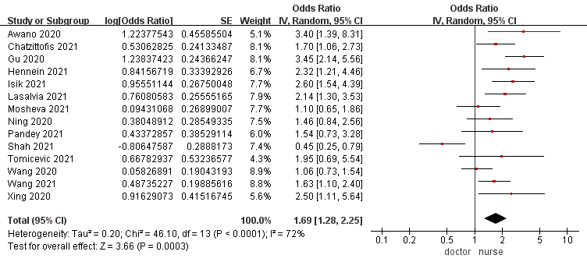

1.2 Female
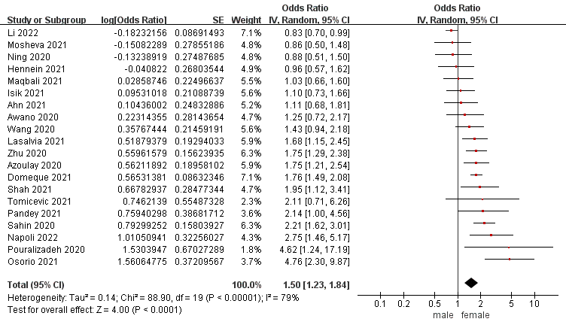

1.3 Being a frontline worker
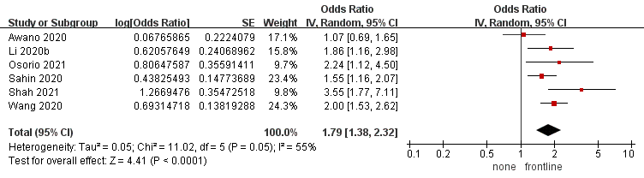

1.4 Health anxiety due to COVID-19
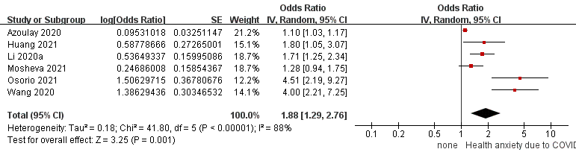
1.5 Insufficient personal protective equipment
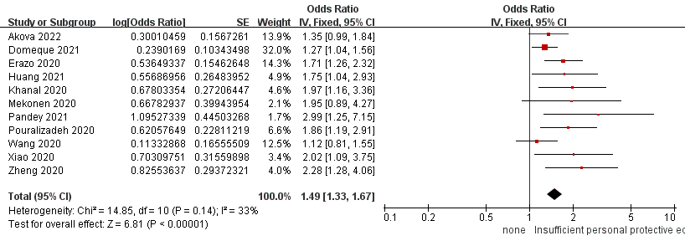

1.6 History of mental diseases
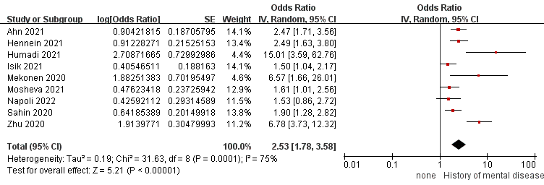

1.7 Working in isolation wards
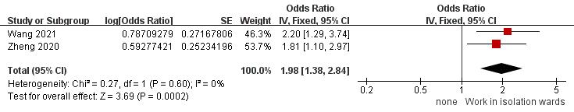

1.8 Single
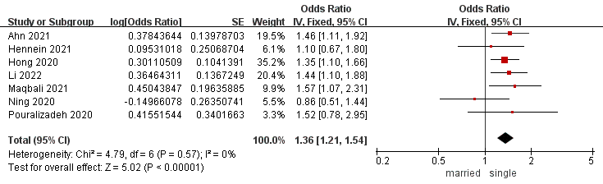

1.9 Positive professional prospect
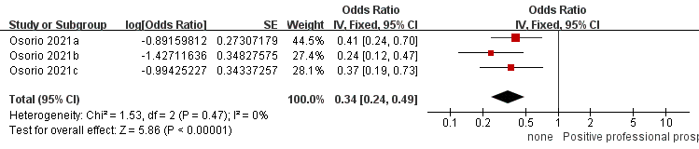

Fig. S2 Forest plots of factors not significantly associated with depression among HCWs during the COVID-19 pandemic
2.1Contact confirmed or suspected COVID-19 patient
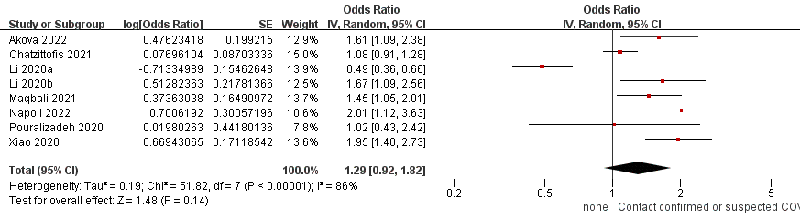

2.2Have a relative confirmed or suspected COVID-19
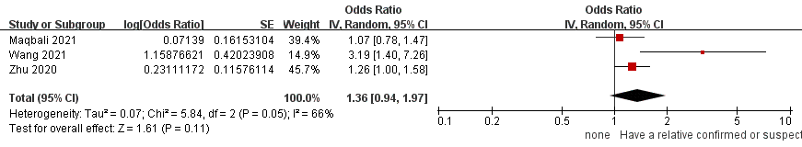
2.3History of chronic diseases
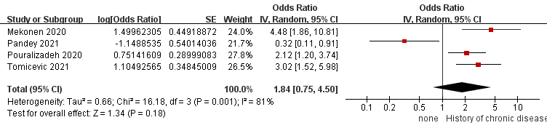
2.4＞40years
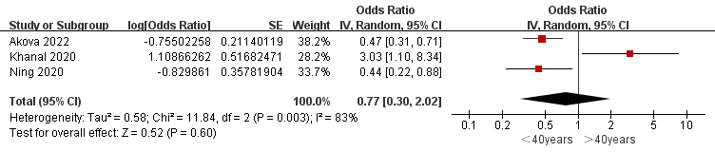

Fig. S3 Sensitivity analysis
By iteratively removing each literature on high heterogeneity risk factors(I²≥50% or P≤0.1, containing female, being a frontline worker, history of mental disease, health anxiety due to COVID-19, and being a nurse), it was found that significant heterogeneity reduction was only observed when removing Shah’s research in nurse’s factor and Awano’s research in frontline worker’s factor.

3.1 Remove Shah 2021’s research in nurse’s factor
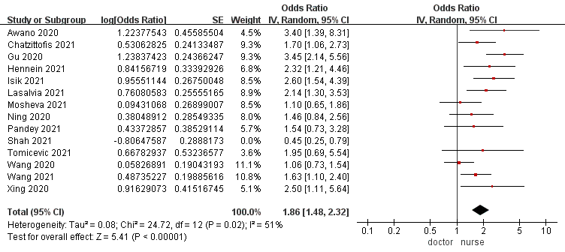
3.2 Remove Awano 2020’s research in frontline worker’s factor
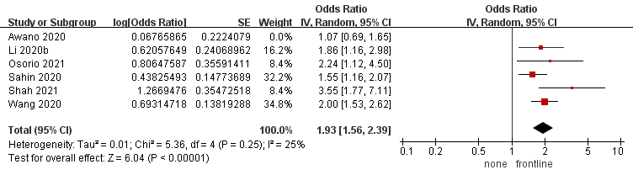

Fig. S4 Nurse subgroup analysis
We performed subgroup analyses according to "region"(style 1), "profession"(style 2), "frontline or not"(style 3) and "diagnostic tool"(style 4). The population will be divided into at least two groups; otherwise, subgroup analysis of this kind will be excluded. Fig4s-Fig8s display the subgroup analysis of high heterogeneity factors(I²≥50% or P≤0.1, containing being a nurse, female, being a frontline worker, history of mental disease, and health anxiety due to COVID-19).

4.1 Style1 The population was divided into four subgroups: Asia, America, Europe, and Africa.
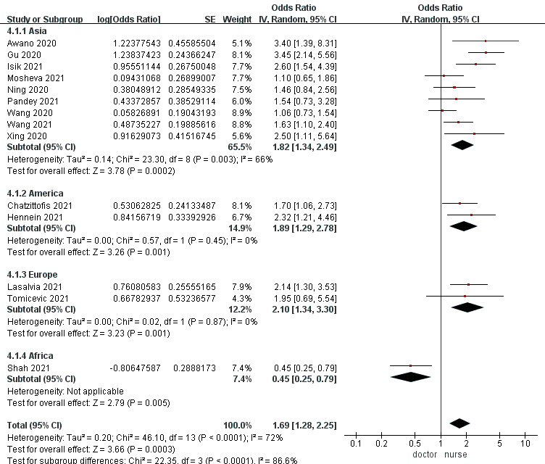

4.2 Style3 The study subjects were divided into three subgroups: frontline, non-frontline, and a combination of frontline and non-frontline.
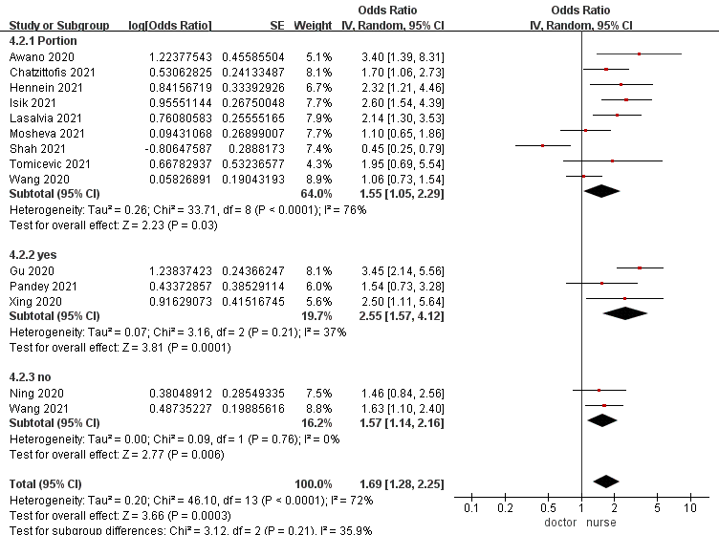

4.3 Style 4 The study subjects were divided into four subgroups: CES-D, DASS, PHQ-9, and SDS.
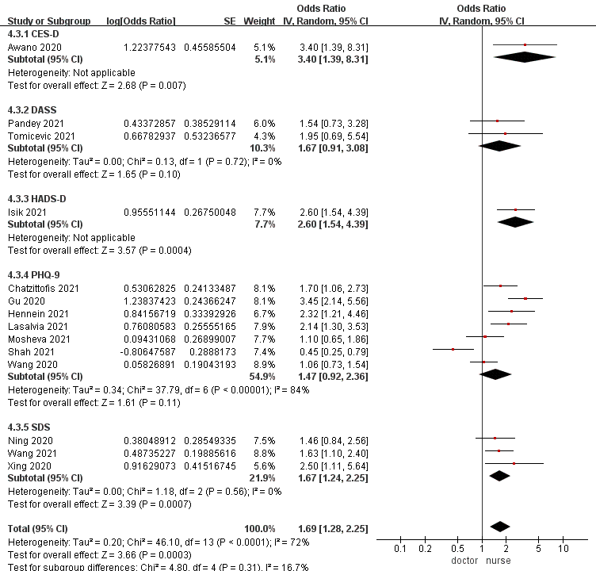

Fig. S5 Female subgroup analysis

5.1 Style1 The population was divided into four subgroups: Asia, America, Europe, and Africa.
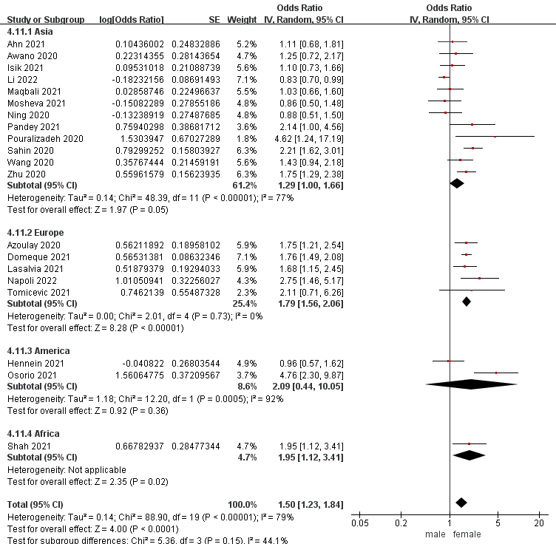

5.2 Style2 The study subjects were divided into three subgroups: doctors, nurses, and a combination of doctors and nurses.
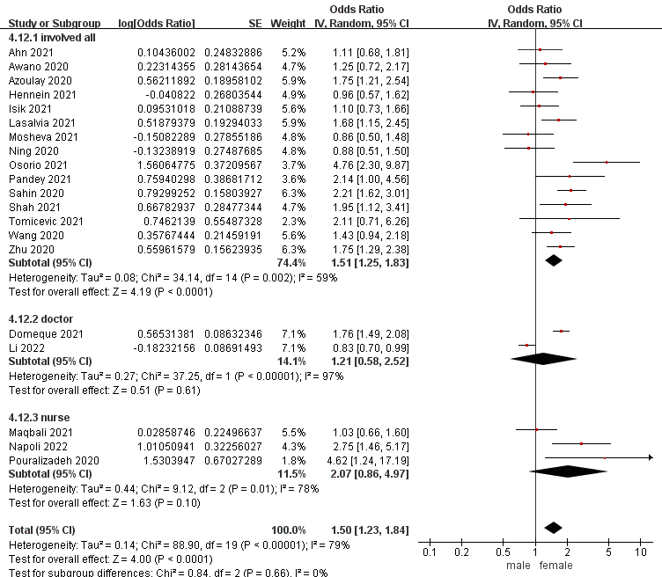

5.3 Style3 The study subjects were divided into three subgroups: frontline, non-frontline, and a combination of frontline and non-frontline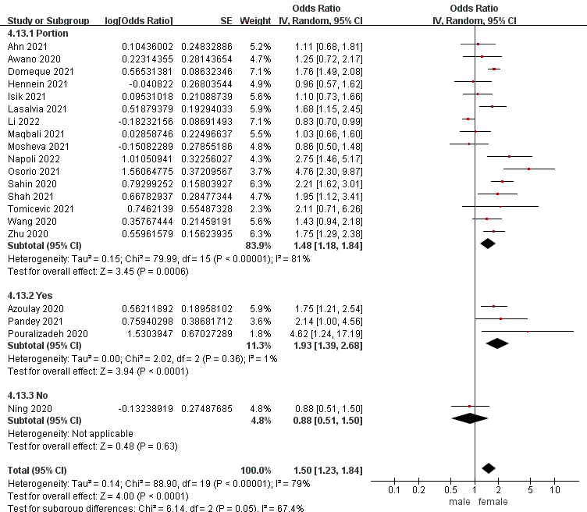

5.4 Style 4 The study subjects were divided into four subgroups: CES-D, DASS, PHQ-9, and HADS-D.
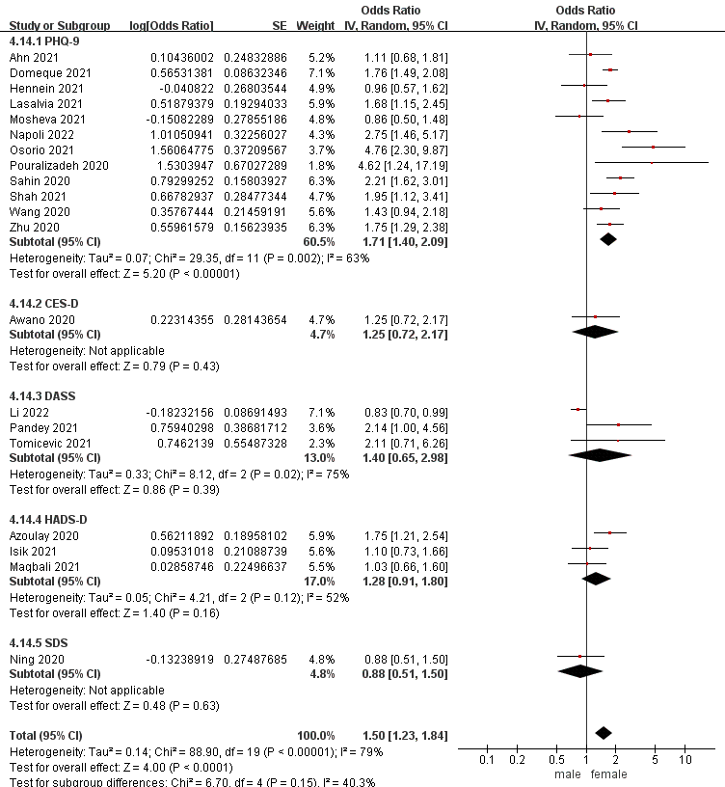

Fig. S6 Being a frontline worker subgroup analysis

6.1 Style1 The population was divided into three subgroups: Asia, America, and Africa.
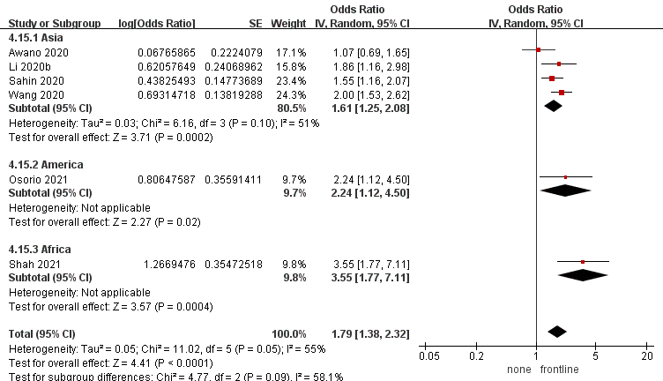

6.2 Style2 The study subjects were divided into two subgroups: nurses, and a combination of the nurses and doctor.
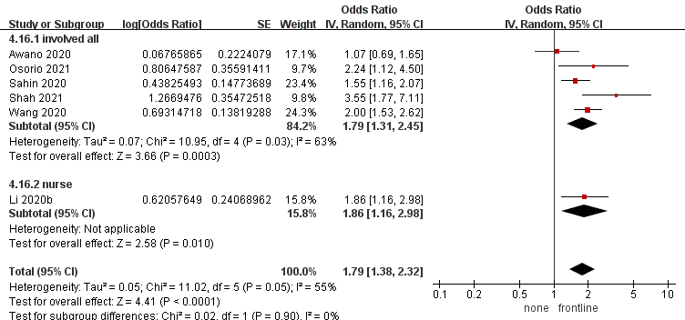

6.3 Style 4 The study subjects were divided into three subgroups: CES-D, DASS, and PHQ-9.
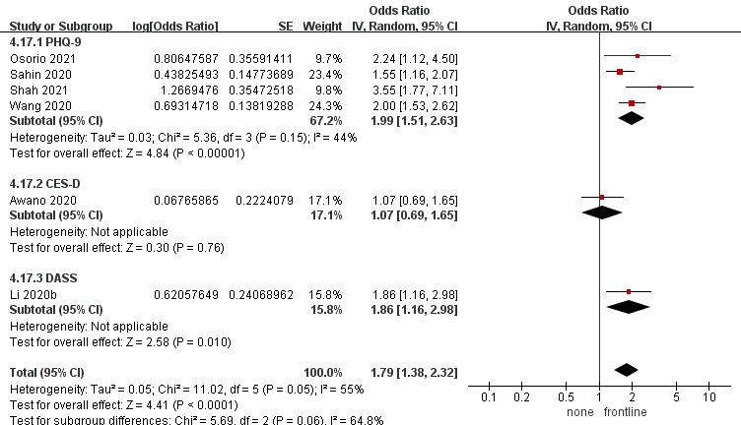

Fig. S7 History of mental diseases subgroup analysis
7.1 Style1 The population was divided into three subgroups: Asia, America, Europe, and Africa.
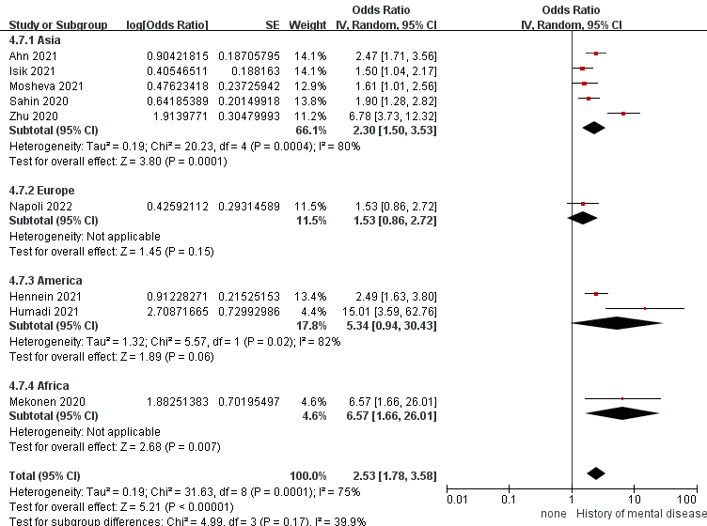

7.2 Style2 The study subjects were divided into three subgroups: doctors, nurses, and a combination of the nurses and doctor.
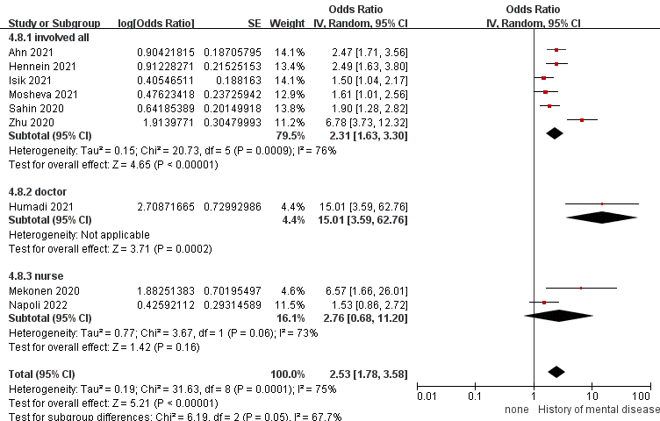

7.3 Style3 The study subjects were divided into two subgroups: non-frontline, and a combination of frontline and non-frontline.
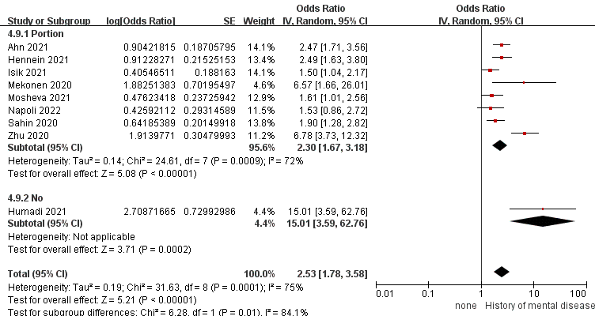

7.4 Style4 The study subjects were divided into two subgroups: HADS-D, PHQ-9, and DASS.
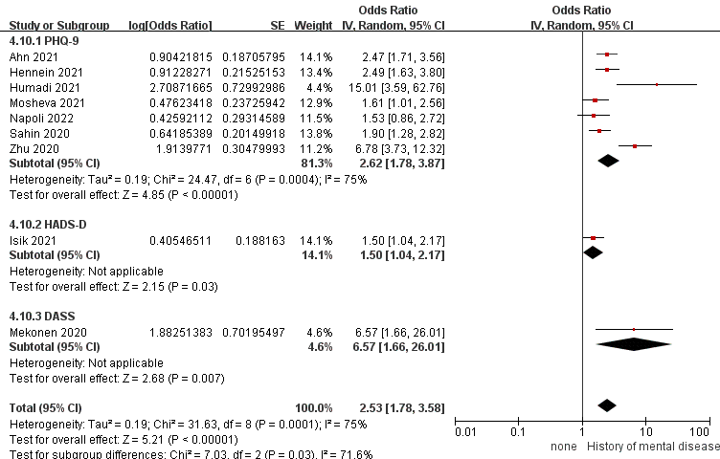

Fig. S8 Health anxiety due to COVID-19 subgroup analysis
8.1 Style1 The population was divided into three subgroups: Asia, America, and Europe.
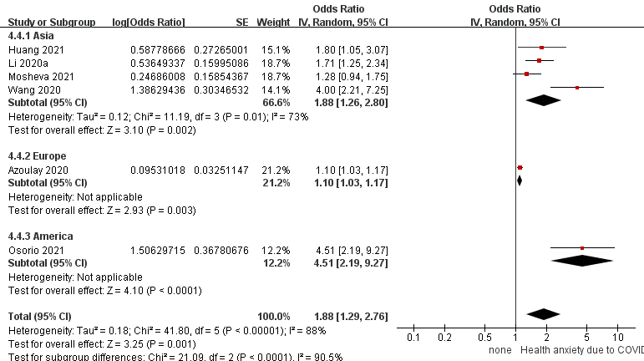

8.2 Style3 The study subjects were divided into two subgroups: non-frontline, and a combination of frontline and non-frontline.
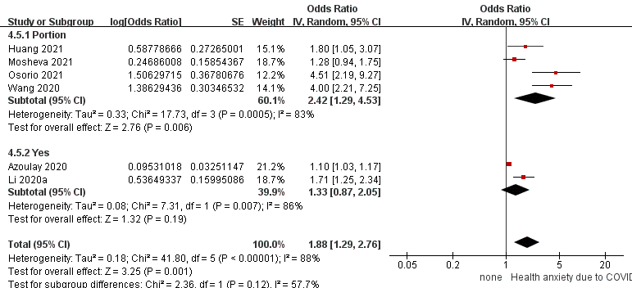

8.3 Style 4 The study subjects were divided into three subgroups: HADS-D, SDS, and PHQ-9.
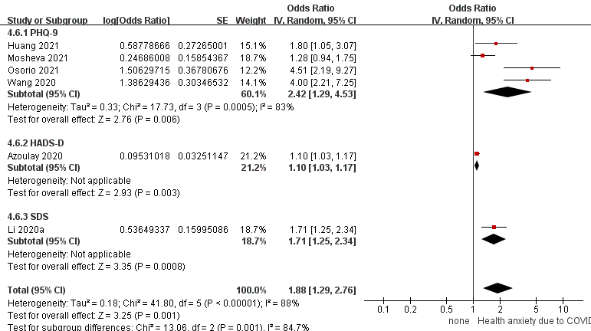

Fig. S9 Funnel plot
9.1 Female funnel plot
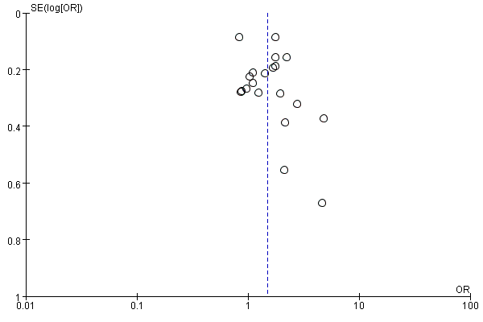

9.2 Nurse funnel plot
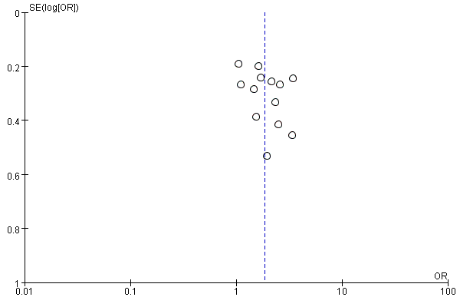

9.3 Single funnel plot
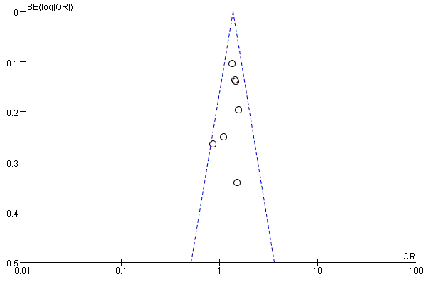

9.4 Contact confirmed or suspected COVID-19 patient
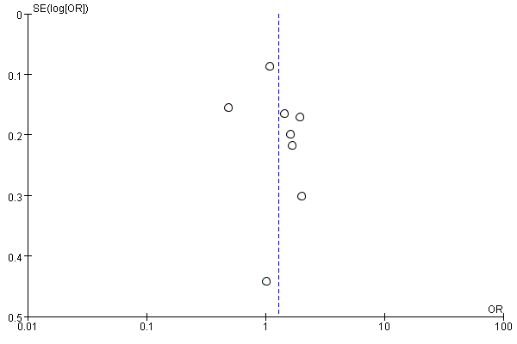

9.5 Insufficient personal protective equipments
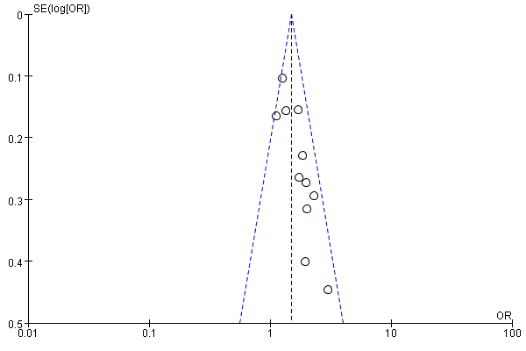

9.6 History of mental disease
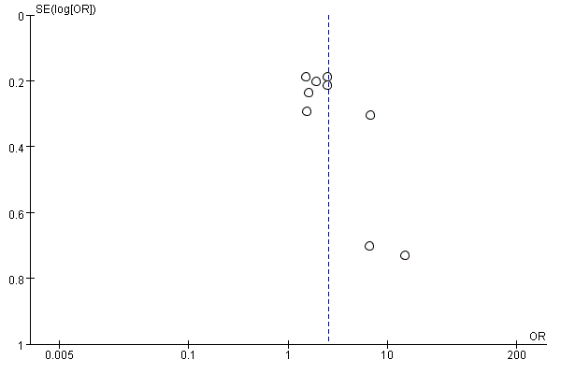

Table S1 The detailed search strategy

Database | Search strategy
Pubmed | 1 ("Depression"[MeSH Terms] OR ("Depressions"[Title/Abstract] OR "depressive symptoms"[Title/Abstract] OR "depressive symptom"[Title/Abstract] OR "symptom depressive"[Title/Abstract] OR "symptoms depressive"[Title/Abstract] OR "emotional depression"[Title/Abstract] OR "depression emotional"[Title/Abstract] OR (("depressed"[All Fields] OR "Depression"[MeSH Terms] OR "Depression"[All Fields] OR "Depressions"[All Fields] OR "depression s"[All Fields] OR "depressive disorder"[MeSH Terms] OR ("Depressive"[All Fields] AND "disorder"[All Fields]) OR "depressive disorder"[All Fields] OR "depressivity"[All Fields] OR "Depressive"[All Fields] OR "depressively"[All Fields] OR "depressiveness"[All Fields] OR "depressives"[All Fields]) AND "Emotional"[Title/Abstract]) OR (("emoting"[All Fields] OR "emotion s"[All Fields] OR "emotions"[MeSH Terms] OR "emotions"[All Fields] OR "emotion"[All Fields] OR "Emotional"[All Fields] OR "emotive"[All Fields]) AND "Depressions"[Title/Abstract])))  2 ("COVID-19"[MeSH Terms] OR ("COVID-19"[Title/Abstract] OR "covid 19 virus disease"[Title/Abstract] OR "covid 19 virus disease"[Title/Abstract] OR (("COVID-19"[All Fields] OR "COVID-19"[MeSH Terms] OR "covid 19 vaccines"[All Fields] OR "covid 19 vaccines"[MeSH Terms] OR "covid 19 serotherapy"[All Fields] OR "covid 19 serotherapy"[Supplementary Concept] OR "covid 19 nucleic acid testing"[All Fields] OR "covid 19 nucleic acid testing"[MeSH Terms] OR "covid 19 serological testing"[All Fields] OR "covid 19 serological testing"[MeSH Terms] OR "covid 19 testing"[All Fields] OR "covid 19 testing"[MeSH Terms] OR "SARS-CoV-2"[All Fields] OR "SARS-CoV-2"[MeSH Terms] OR "severe acute respiratory syndrome coronavirus 2"[All Fields] OR "nCoV"[All Fields] OR "2019-nCoV"[All Fields] OR (("Coronavirus"[MeSH Terms] OR "Coronavirus"[All Fields] OR "CoV"[All Fields]) AND 2019/11/01:3000/12/31[Date - Publication])) AND "virus diseases"[Title/Abstract]) OR "disease covid 19 virus"[Title/Abstract] OR "virus disease covid 19"[Title/Abstract] OR "covid 19 virus infection"[Title/Abstract] OR "covid 19 virus infection"[Title/Abstract] OR "covid 19 virus infections"[Title/Abstract] OR (("infect"[All Fields] OR "infectability"[All Fields] OR "infectable"[All Fields] OR "infectant"[All Fields] OR "infectants"[All Fields] OR "infected"[All Fields] OR "infecteds"[All Fields] OR "infectibility"[All Fields] OR "infectible"[All Fields] OR "infecting"[All Fields] OR "infection s"[All Fields] OR "Infections"[MeSH Terms] OR "Infections"[All Fields] OR "Infection"[All Fields] OR "infective"[All Fields] OR "infectiveness"[All Fields] OR "infectives"[All Fields] OR "infectivities"[All Fields] OR "infects"[All Fields] OR "pathogenicity"[MeSH Subheading] OR "pathogenicity"[All Fields] OR "infectivity"[All Fields]) AND "covid 19 virus"[Title/Abstract]) OR "virus infection covid 19"[Title/Abstract] OR "2019 ncov infection"[Title/Abstract] OR "2019 ncov infection"[Title/Abstract] OR "2019 ncov infections"[Title/Abstract] OR "infection 2019 ncov"[Title/Abstract] OR "coronavirus disease 19"[Title/Abstract] OR "coronavirus disease 19"[Title/Abstract] OR "2019 novel coronavirus disease"[Title/Abstract] OR "2019 novel coronavirus infection"[Title/Abstract] OR "2019 ncov disease"[Title/Abstract] OR "2019 ncov disease"[Title/Abstract] OR "2019 ncov diseases"[Title/Abstract] OR "disease 2019 ncov"[Title/Abstract] OR "COVID19"[Title/Abstract] OR "coronavirus disease 2019"[Title/Abstract] OR "disease 2019 coronavirus"[Title/Abstract] OR "sars coronavirus 2 infection"[Title/Abstract] OR "sars cov 2 infection"[Title/Abstract] OR "sars cov 2 infection"[Title/Abstract] OR "sars cov 2 infections"[Title/Abstract] OR "covid 19 pandemic"[Title/Abstract] OR "covid 19 pandemic"[Title/Abstract] OR "covid 19 pandemics"[Title/Abstract] OR "pandemic covid 19"[Title/Abstract]))  3 ("Physicians"[MeSH Terms] OR ("Physician"[Title/Abstract] OR "doctor"[Title/Abstract] OR "doctors"[Title/Abstract]) OR "Nurses"[MeSH Terms] OR ("Nurse"[Title/Abstract] OR "personnel nursing"[Title/Abstract] OR "nursing personnel"[Title/Abstract] OR "registered nurses"[Title/Abstract] OR "nurse registered"[Title/Abstract] OR "nurses registered"[Title/Abstract] OR "registered nurse"[Title/Abstract]) OR "medical staff, hospital"[MeSH Terms] OR ("hospital medical staff"[Title/Abstract] OR "hospital medical staffs"[Title/Abstract] OR (("Staff"[All Fields] OR "staff s"[All Fields] OR "Staffs"[All Fields]) AND "hospital medical"[Title/Abstract]) OR (("Staff"[All Fields] OR "staff s"[All Fields] OR "Staffs"[All Fields]) AND "hospital medical"[Title/Abstract]) OR "medical staffs hospital"[Title/Abstract] OR "physicians junior"[Title/Abstract] OR "junior physician"[Title/Abstract] OR "junior physicians"[Title/Abstract] OR "physician junior"[Title/Abstract] OR "registrars hospital"[Title/Abstract] OR "hospital registrar"[Title/Abstract] OR "hospital registrars"[Title/Abstract] OR (("Registrar"[All Fields] OR "registrar s"[All Fields] OR "Registrars"[All Fields]) AND "Hospital"[Title/Abstract]) OR "attending physicians hospital"[Title/Abstract] OR "hospital attending physician"[Title/Abstract] OR "hospital attending physicians"[Title/Abstract] OR "attending physician hospital"[Title/Abstract]) OR "Medical Staff"[MeSH Terms] OR ("staff medical"[Title/Abstract] OR "staffs medical"[Title/Abstract] OR "medical staffs"[Title/Abstract]))  4 ("risk"[Title/Abstract] OR "risk"[MeSH Terms:noexp] OR "mortality"[Title/Abstract] OR "mortality"[MeSH Terms:noexp] OR "cohort"[Title/Abstract] OR (("relative"[Title/Abstract] AND "risk*"[Title/Abstract]) OR "relative risk"[Text Word] OR "risks"[Text Word] OR "cohort studies"[MeSH Terms:noexp] OR ("cohort"[Title/Abstract] AND "stud*"[Title/Abstract])))  5 1 AND 2 AND 3 AND 4
Web of Science | 1 TS=( 'depression' OR 'Depressions' OR 'Depressive Symptoms' OR 'Depressive Symptom' OR 'Symptom, Depressive' OR 'Symptoms, Depressive' OR 'Emotional Depression' OR 'Depression, Emotional' OR 'Depressions, Emotional' OR 'Emotional Depressions')  2 TS=( 'COVID-19' OR 'COVID 19' OR 'COVID-19 Virus Disease' OR 'COVID 19 Virus Disease' OR 'COVID-19 Virus Diseases' OR 'Disease, COVID-19 Virus' OR 'Virus Disease, COVID-19' OR 'COVID-19 Virus Infection' OR 'COVID 19 Virus Infection' OR 'COVID-19 Virus Infections' OR 'Infection, COVID-19 Virus' OR 'Virus Infection, COVID-19' OR '2019-nCoV Infection' OR '2019 nCoV Infection' OR '2019-nCoV Infections' OR 'Infection, 2019-nCoV' OR 'Coronavirus Disease-19' OR 'Coronavirus Disease 19' OR '2019 Novel Coronavirus Disease' OR '2019 Novel Coronavirus Infection' OR '2019-nCoV Disease' OR '2019 nCoV Disease' OR '2019-nCoV Diseases' OR 'Disease, 2019-nCoV' OR 'COVID19' OR 'Coronavirus Disease 2019' OR 'Disease 2019, Coronavirus' OR 'SARS Coronavirus 2 Infection' OR 'SARS-CoV-2 Infection' OR 'Infection, SARS-CoV-2' OR 'SARS CoV 2 Infection' OR 'SARS-CoV-2 Infections' OR 'COVID-19 Pandemic' OR 'COVID 19 Pandemic' OR 'COVID-19 Pandemics' OR 'Pandemic, COVID-19'))  3 TS=( 'physician' OR 'doctor' OR 'medical doctor' OR 'medical practitioner' OR 'physician associate' OR 'physicians' OR 'practitioner' OR 'nurses' OR 'anaesthetist nurse assistant' OR 'anesthetist nurse assistant' OR 'community health nurse' OR 'community health nurses' OR 'nurse, community health' OR 'nurse ' OR 'nurses, community health' OR 'nurses, public health' OR 'nursing assistance' OR 'public health nurse' OR 'public health nurses ' OR 'private physician' OR 'medical staff' OR 'Hospital Medical Staff' OR 'Hospital Medical Staffs' OR 'Staff, Hospital Medical' OR 'Staffs, Hospital Medical' OR 'Medical Staffs, Hospital' OR 'Physicians, Junior' OR 'Junior Physician' OR 'Junior Physicians' OR 'Physician, Junior' OR 'Registrars, Hospital' OR 'Hospital Registrar' OR 'Hospital Registrars' OR 'Registrar, Hospital' OR 'Attending Physicians, Hospital' OR 'Hospital Attending Physician' OR 'Hospital Attending Physicians' OR 'Attending Physician, Hospital'))  4 TS=( 'relative' OR 'risk' OR 'relative risk' OR 'cohort studies' OR 'cohort' OR 'stud')  5 1 AND 2 AND 3 AND 4
Cochrane Library | 1 MeSH descriptor: [Depression] explode all trees  2 (Depressions):ab,ti,kw OR (Depressive Symptoms):ab,ti,kw OR (Depressive Symptom):ab,ti,kw OR (Symptom, Depressive):ab,ti,kw OR (Symptoms, Depressive):ab,ti,kw OR (Emotional Depression):ab,ti,kw OR (Depression, Emotional):ab,ti,kw OR (Depressions, Emotional):ab,ti,kw OR (Emotional Depressions):ab,ti,kw  3 1 OR 2  4 (MeSH descriptor: [COVID-19] explode all trees)  5 (COVID 19):ab,ti,kw OR (COVID-19 Virus Disease):ab,ti,kw OR (COVID 19 Virus Disease):ab,ti,kw OR (COVID-19 Virus Diseases):ab,ti,kw OR (Disease, COVID-19 Virus):ab,ti,kw OR (Virus Disease, COVID-19):ab,ti,kw OR (COVID-19 Virus Infection):ab,ti,kw OR (COVID 19 Virus Infection):ab,ti,kw OR (COVID-19 Virus Infections):ab,ti,kw OR (Infection, COVID-19 Virus):ab,ti,kw OR (Virus Infection, COVID-19):ab,ti,kw OR (2019-nCoV Infection):ab,ti,kw OR (2019-nCoV Infections):ab,ti,kw OR (2019 nCoV Infection):ab,ti,kw OR (Infection, 2019-nCoV):ab,ti,kw OR (Coronavirus Disease-19):ab,ti,kw OR (Coronavirus Disease 19):ab,ti,kw OR (2019 Novel Coronavirus Disease):ab,ti,kw OR (2019 Novel Coronavirus Infection):ab,ti,kw OR (2019-nCoV Disease):ab,ti,kw OR (2019 nCoV Disease):ab,ti,kw OR (2019-nCoV Diseases):ab,ti,kw OR (Disease, 2019-nCoV):ab,ti,kw OR (COVID19):ab,ti,kw OR (Disease 2019, Coronavirus):ab,ti,kw OR (SARS Coronavirus 2 Infection):ab,ti,kw OR (SARS-CoV-2 Infection):ab,ti,kw OR (Infection, SARS-CoV-2):ab,ti,kw OR (SARS CoV 2 Infection):ab,ti,kw OR (SARS-CoV-2 Infections):ab,ti,kw OR (COVID-19 Pandemic):ab,ti,kw OR (COVID 19 Pandemic):ab,ti,kw OR (COVID-19 Pandemics):ab,ti,kw OR (Pandemic, COVID-19):ab,ti,kw OR (Coronavirus Disease 2019):ab,ti,kw  6 4 OR 5  7 (MeSH descriptor: [Nurses] explode all trees)  8 (anaesthesist nurse assistant):ab,ti,kw OR (anesthetist nurse assistant):ab,ti,kw OR (community health nurse):ab,ti,kw OR (community health nurses):ab,ti,kw OR (nurse, community health):ab,ti,kw OR (nurse):ab,ti,kw OR (nurses, community health):ab,ti,kw OR (nurses, public health):ab,ti,kw OR (nursing assistance):ab,ti,kw OR (public health nurse):ab,ti,kw OR (public health nurses):ab,ti,kw OR (private physician):ab,ti,kw  9 (physician):ab,ti,kw OR (doctor):ab,ti,kw OR (medical doctor):ab,ti,kw OR (medical practitioner):ab,ti,kw OR (physician associate):ab,ti,kw OR (physicians):ab,ti,kw OR (practitioner):ab,ti,kw  10 MeSH descriptor. [Medical Staff] explode all trees  11 (Hospital Medical Staff):ab,ti,kw OR (Hospital Medical Staffs):ab,ti,kw OR (Staff, Hospital Medical):ab,ti,kw OR (Staffs, Hospital Medical):ab,ti,kw OR (Medical Staffs, Hospital):ab,ti,kw OR (Physicians, Junior):ab,ti,kw OR (Junior Physician):ab,ti,kw OR (Junior Physicians):ab,ti,kw OR (Physician, Junior):ab,ti,kw OR (Registrars, Hospital):ab,ti,kw OR (Hospital Registrar):ab,ti,kw OR (Hospital Registrars):ab,ti,kw OR (Registrar, Hospital):ab,ti,kw OR (Attending Physicians, Hospital):ab,ti,kw OR (Hospital Attending Physician):ab,ti,kw OR (Hospital Attending Physicians):ab,ti,kw OR (Attending Physician, Hospital):ab,ti,kw  12 7 OR 8 OR 9 OR 10  13 (relative):ab,ti,kw OR (risk):ab,ti,kw OR (relative risk):ab,ti,kw OR (cohort studies):ab,ti,kw OR (cohort):ab,ti,kw OR (stud):ab,ti,kw OR  14 3 AND 6 AND 12 AND 13
Embase | 1 'depressions':ab,ti OR 'depressive symptoms':ab,ti OR 'depressive symptom':ab,ti OR 'symptom, depressive':ab,ti OR 'symptoms, depressive':ab,ti OR 'emotional depression':ab,ti OR 'depression, emotional':ab,ti OR 'depressions, emotional':ab,ti OR 'emotional depressions':ab,ti  2 'covid 19':ab,ti OR 'covid-19 virus disease':ab,ti OR 'covid 19 virus disease':ab,ti OR 'covid-19 virus diseases':ab,ti OR 'disease, covid-19 virus':ab,ti OR 'virus disease, covid-19':ab,ti OR 'covid-19 virus infection':ab,ti OR 'covid 19 virus infection':ab,ti OR 'covid-19 virus infections':ab,ti OR 'infection, covid-19 virus':ab,ti OR 'virus infection, covid-19':ab,ti OR '2019-ncov infection':ab,ti OR '2019 ncov infection':ab,ti OR '2019-ncov infections':ab,ti OR 'infection, 2019-ncov':ab,ti OR 'coronavirus disease-19':ab,ti OR 'coronavirus disease 19':ab,ti OR '2019 novel coronavirus disease':ab,ti OR '2019 novel coronavirus infection':ab,ti OR '2019-ncov disease':ab,ti OR '2019 ncov disease':ab,ti OR '2019-ncov diseases':ab,ti OR 'disease, 2019-ncov':ab,ti OR 'covid19':ab,ti OR 'coronavirus disease 2019':ab,ti OR 'disease 2019, coronavirus':ab,ti OR 'sars coronavirus 2 infection':ab,ti OR 'sars-cov-2 infection':ab,ti OR 'infection, sars-cov-2':ab,ti OR 'sars cov 2 infection':ab,ti OR 'sars-cov-2 infections':ab,ti OR 'covid-19 pandemic':ab,ti OR 'covid 19 pandemic':ab,ti OR 'covid-19 pandemics':ab,ti OR 'pandemic, covid-19':ab,ti  3 'medical doctor':ab,ti OR 'medical practitioner':ab,ti OR 'physician associate':ab,ti OR 'physicians':ab,ti OR 'practitioner':ab,ti OR 'doctor':ab,ti OR 'doctors':ab,ti OR 'nurse':ab,ti OR 'personnel, nursing':ab,ti OR 'nursing personnel':ab,ti OR 'registered nurses':ab,ti OR 'nurse, registered':ab,ti OR 'nurses, registered':ab,ti OR 'registered nurse':ab,ti OR 'hospital medical staff':ab,ti OR 'hospital medical staffs':ab,ti OR 'staff, hospital medical':ab,ti OR 'staffs, hospital medical':ab,ti OR 'medical staffs, hospital':ab,ti OR 'physicians, junior':ab,ti OR 'junior physician':ab,ti OR 'junior physicians':ab,ti OR 'physician, junior':ab,ti OR 'registrars, hospital':ab,ti OR 'hospital registrar':ab,ti OR 'hospital registrars':ab,ti OR 'registrar, hospital':ab,ti OR 'attending physicians, hospital':ab,ti OR 'hospital attending physician':ab,ti OR 'hospital attending physicians':ab,ti OR 'attending physician, hospital':ab,ti  4 'relative':ab,ti OR 'risk':ab,ti OR 'relative risk':ab,ti OR 'cohort studies':ab,ti OR 'cohort':ab,ti OR 'stud':ab,ti  5 1 AND 2 AND 3 AND 4
China National Knowledge Infrastructure (CNKI) | 1 主题: 新冠肺炎 +"COVID-19" + 新冠  2 主题: 医+ 护 + 医生 +护士 + 医务人员 + 医护人员  3 主题: 抑郁症 + 抑郁 + 抑郁障碍  4 摘要: 影响因素 +危险因素 + 相关因素 + 病因 + 因素 +影响 + 危险 + 相关 + 队列 +病例对照 + 横断面  5 1 AND 2 AND 3 AND 4
Wanfang | 1 主题: 抑郁症 or 抑郁 or 抑郁障碍  2 主题: 医 or 护 or 医生 or 护士 or 医务人员 or 医护人员  3 主题: 新冠肺炎 or COVID-19 or 新冠  4 主题: 影响因素 or 危险因素 or 相关因素 or 病因 or 因素 or 影响 or 危险 or 相关 队列 or 病例对照 or 横断面  5 1 and 2 and 3 and 4
China Science and Technology Journal Database (VIP) | 1 题目或关键词：抑郁症 OR 抑郁 OR 抑郁障碍  2 题目或关键词：医 OR 护 OR 医生 OR 护士 OR 医务人员 OR 医护人员  3 题目或关键词：新冠肺炎 OR ''COVID-19'' OR 新冠  4 摘要：影响因素 OR 危险因素 OR 相关因素 OR 病因 OR 因素 OR 影响 OR 危险 OR 相关 OR 队列 OR 病例对照 OR 横断面  5 1 and 2 and 3 and 4
Chinese Biomedical Literature Database (CBD) | 1 "抑郁"[中文标题:智能] OR "抑郁障碍"[中文标题:智能] OR "抑郁症"[中文标题:智能]  2 "医"[中文标题:智能] OR "护"[中文标题:智能] OR "医生"[中文标题:智能] OR "医护人员"[中文标题:智能] OR "医生 OR护士"[中文标题:智能]  3 "新冠肺炎"[中文标题:智能] OR "'COVID-19'"[中文标题:智能] OR "新冠"[中文标题:智能]  4 "影响因素"[摘要:智能] OR "危险因素"[摘要:智能] OR "相关因素"[摘要:智能] OR "病因"[摘要:智能] OR "因素"[摘要:智能] OR "影响"[摘要:智能] OR "危险"[摘要:智能] OR "相关"[摘要:智能] OR "队列"[摘要:智能] OR "病例对照"[摘要:智能] OR "横断面"[摘要:智能]  5 1 AND 2 AND 3 AND 4

