**Supplementary figure** General outline of the SINOPsy study with detailed description of each registry-system

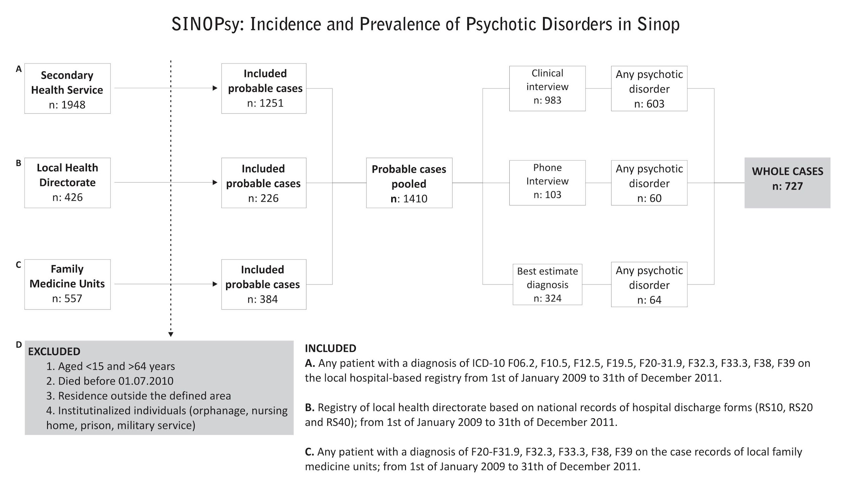

*RS: Initials of mental health (*ruh sağlığı*) in Turkish