Supplementary Material

**Supplementary Table 1**. Descriptive statistics of the study sample from the TEDS

**Supplementary Table 2**. Descriptive statistics of the study sample from the TwinsUK

**Supplementary Table 3.** Cross-lagged phenotypic correlation between BMI and MFQ

**Supplementary Figure 1a (left) & 1b (right).** Standardized path estimates of the phenotypic cross-lagged model showing the associations between variables over time.

### **Supplementary Table 4.** Standardized path estimates from the **bivariate** phenotypic cross-lagged panel models showing the associations between variables over time (TEDS)

### **Supplementary Table 1.** Descriptive statistics of the study sample from the TEDS

|  |  |  |  |
| --- | --- | --- | --- |
|  | total (pairs) | MZ (pairs) | DZ (pairs) |
|  | **n (%) / mean (SD)** | **n (%) / mean (SD)** | **n (%) / mean (SD)** |
| *N (%)* | **7658 (100%)** | **2729(35.6)** | **4929(64.4)** |
| MFQ |  |  |  |
| *age 12* | 2.32 (3.33) | 2.31 (3.34) | 2.32 (3.34) |
| *age 16* | 3.64 (4.44) | 3.52 (4.43) | 3.64 (4.44) |
| *age 21* | 4.47 (4.13) | 4.47 (4.19) | 4.47 (4.13) |
| BMI (kg/m2) |  |  |  |
| *age 12* | 17.84 (3.14) | 17.80 (2.97) | 17.86 (3.22) |
| *age 16* | 21.01 (3.24) | 20.96 (3.15) | 21.04 (3.28) |
| *age 21* | 23.45 (4.62) | 23.32 (4.54) | 23.50 (4.66) |

*Note.* MZ: monozygotic twin; DZ: dizygotic twin; MFQ: Mood and Feelings Questionnaire; BMI: body mass index.

### **Supplementary Table 2.** Descriptive statistics of the study sample from TwinsUK

|  |  |  |  |
| --- | --- | --- | --- |
|  | total (pairs) | MZ (pairs) | DZ (pairs) |
|  | **n (%) / mean (SD)** | **n (%) / mean (SD)** | **n (%) / mean (SD)** |
| *n* | 2775 (100) | 1738 (62.38) | 1037 (37.22) |
| Age | 58.7 (15.9) | 56.6 (16.6) | 62.6 (13.5) |
| Sex (female pairs) | 2450 (87.9) | 1496 (86.1) |  |

*Note.* MZ: monozygotic twin; DZ: dizygotic twin; HADS: Hospital Anxiety and Depression Scale; BMI: body mass index; BFP: body fat percentage; AFP: android region fat percentage; GFP: gynoid region fat percentage; VFP: Visceral fat percentage

### **Supplementary Table 3.** Cross-lagged phenotypic correlation between BMI and MFQ

|  |  |  |  |
| --- | --- | --- | --- |
| **Unadjusted path estimate** | | | |
| phenotype | phenotype | Path estimate | **95% CI2** |
| BMI age 12 | MFQ age 16 | **.15** | **.04; .27** |
| BMI age 16 | MFQ age 21 | -.01 | -.14; .12 |
|  |  |  |  |
| MFQ age 12 | BMI age 16 | **.01** | **.002; .03** |
| MFQ age 16 | BMI age 21 | **.02** | **.01; .03** |

*Note.* Phenotypic path estimated on unrelated individuals in the TEDS sample. 2Estimate unadjusted (*n*=7429*)*.

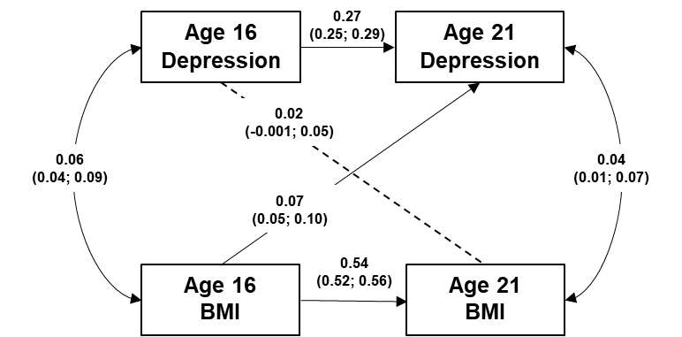

### **Supplementary Figure 1a (left) & 1b (right).** Standardized path estimates from the bivariate phenotypic cross-lagged model showing the associations between variables over time.

*Notes.* BMI, Body Mass Index. Values on single-headed arrows from age 12 to age 16 variables, and age 16 to age 21, are standardised partial regression coefficients. Values on double-headed arrows between variables within the same time point are correlation coefficients; the correlation at Time 2 is a residual, indexing the relationship between BMI and MFQ at age 16 (1a) or age 21 (1b) that is not explained by their association at age 12 (1a) or age 16 (1b). 95% confidence intervals in parentheses.

### **Supplementary Table 4.** Standardized path estimates from the **bivariate** phenotypic cross-lagged model showing the associations between variables over time (TEDS)

|  |  |  |
| --- | --- | --- |
|  |  |  |
|  | **Phenotypic Path Estimates** | **Correlations** |
| **Stability Paths** |  |  |
| BMI age 12 🡪 BMI Age 16 | 0.66 (0.64; 0.67) | - |
| MFQI age 12 🡪 MFQ Age 16 | 0.31 (0.29; 0.33) | - |
| BMI age 16 🡪 BMI Age 21 | 0.54 (0.52; 0.56) | - |
| MFQI age 16 🡪 MFQ Age 21 | 0.27 (0.25; 0.29) | - |
| **Cross-lagged paths** |  |  |
| BMI age 12 🡪 MFQ Age 16 | 0.08 (0.05; 0.11) | 0.13 (0.10; 0.15) |
| MFQ age 12 🡪 BMI Age 16 | 0.02 (0.01; 0.04) | 0.06 (0.03; 0.09) |
| BMI age 16 🡪 MFQ Age 21 | 0.07 (0.05; 0.10) | 0.06 (0.04; 0.09) |
| MFQ age 16 🡪 BMI Age 21 | 0.02 (-0.001; 0.05) | 0.04 (0.01; 0.07) |

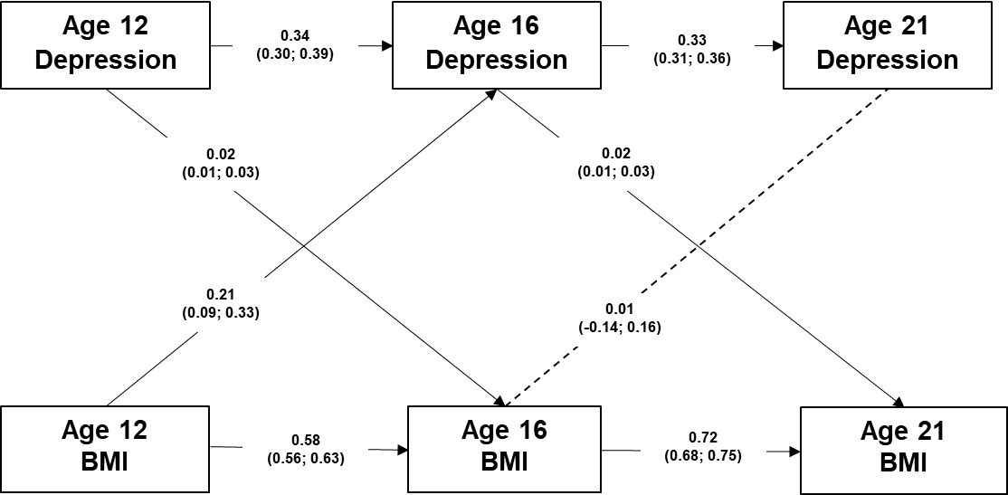

### **Supplementary Figure 2.** Path diagram presenting the phenotypic longitudinal paths between BMI and depression (TEDS) excluding those with BMI <18.5.

*Note.* *n* = 6680. Age, sex, and SEP regressed. Non-significant pathways are illustrated by dotted lines, 95% conﬁdence intervals shown in brackets. Model fit: comparative fit index [CFI], 0.96; Tucker-Lewis index [TLI], 0.84; standardized root mean square residual [SRMR], 0.030.

### **Supplementary Table 5.** Fit comparison for bivariate ACE models (TEDS)

|  |  |  |  |  |  |  |  |  |
| --- | --- | --- | --- | --- | --- | --- | --- | --- |
| **Age** | **Base model** | **Comparison model** | **-2LL** | **df** | **diff LL** | **diff df** | ***p*** | **AIC** |
| 12 | Saturated model | N/A | 89784.26 | 21302 | N/A | N/A | N/A | 89840.26 |
|  | Saturated model | **ACE model** | **89799.48** | **21319** | **15.23** | **17** | **.57** | **89821.48** |
| 16 | Saturated model | N/A | 68574.80 | 13551 | N/A | N/A | N/A | 68630.80 |
|  | Saturated model | ACE model | 68613.85 | 13568 | 39.05 | 17 | .001 | 68635.85 |
| 21 | Saturated model | N/A | 75725.45 | 16042 | N/A | N/A | N/A | 75781.45 |
|  | Saturated model | **ACE model** | **75753.98** | **16059** | **28.52782** | **17** | **0.039** | **75775.98** |

*Notes.* -2LL: Minus 2*log-likelihood of the comparison model; df: Degrees in freedom of the comparison model; AIC: Akaike's Information Criterion for the comparison model; dffLL: Change in minus 2*log-likelihood; dff df: Change in degrees of freedom; A: additive genetic influence; C: shared environmental influences; E: non-shared environmental influences.

### **Supplementary Table 6.** Fit comparison for multivariate ACE models (TwinsUK)

|  |  |  |  |  |  |  |  |  |
| --- | --- | --- | --- | --- | --- | --- | --- | --- |
| **Base model** | **Comparison model** | **ep** | **-2LL** | **df** | **diff LL** | **diff df** | ***p*** | **AIC** |
| Saturated model | N/A | 88 | 28459.85 | 14502 | N/A | N/A | N/A | 28635.85 |
| Saturated model | ACE model |  | 30419.02 | 14556 | 1959.167 | 54 | .00 | 30487.02 |
| Saturated model | AE model |  | 28548.23 | 14566 | 88.37502 | 64 | 0.02 | 28596.23 |
| ACE | AE model |  | 28548.23 | 14566 | -1870.79 | 10 | 1 | 28596.23 |
|  |  |  |  |  |  |  |  |  |

*Notes.* -2LL: Minus 2*log-likelihood of the comparison model; df: Degrees in freedom of the comparison model; AIC: Akaike's Information Criterion for the comparison model; dffLL: Change in minus 2*log-likelihood; dff df: Change in degrees of freedom; A:additive genetic influence; C: shared environmental influences; E: non-shared environmental influences.