Fig. S1 Sensitivity analysis.
Treatment Completion
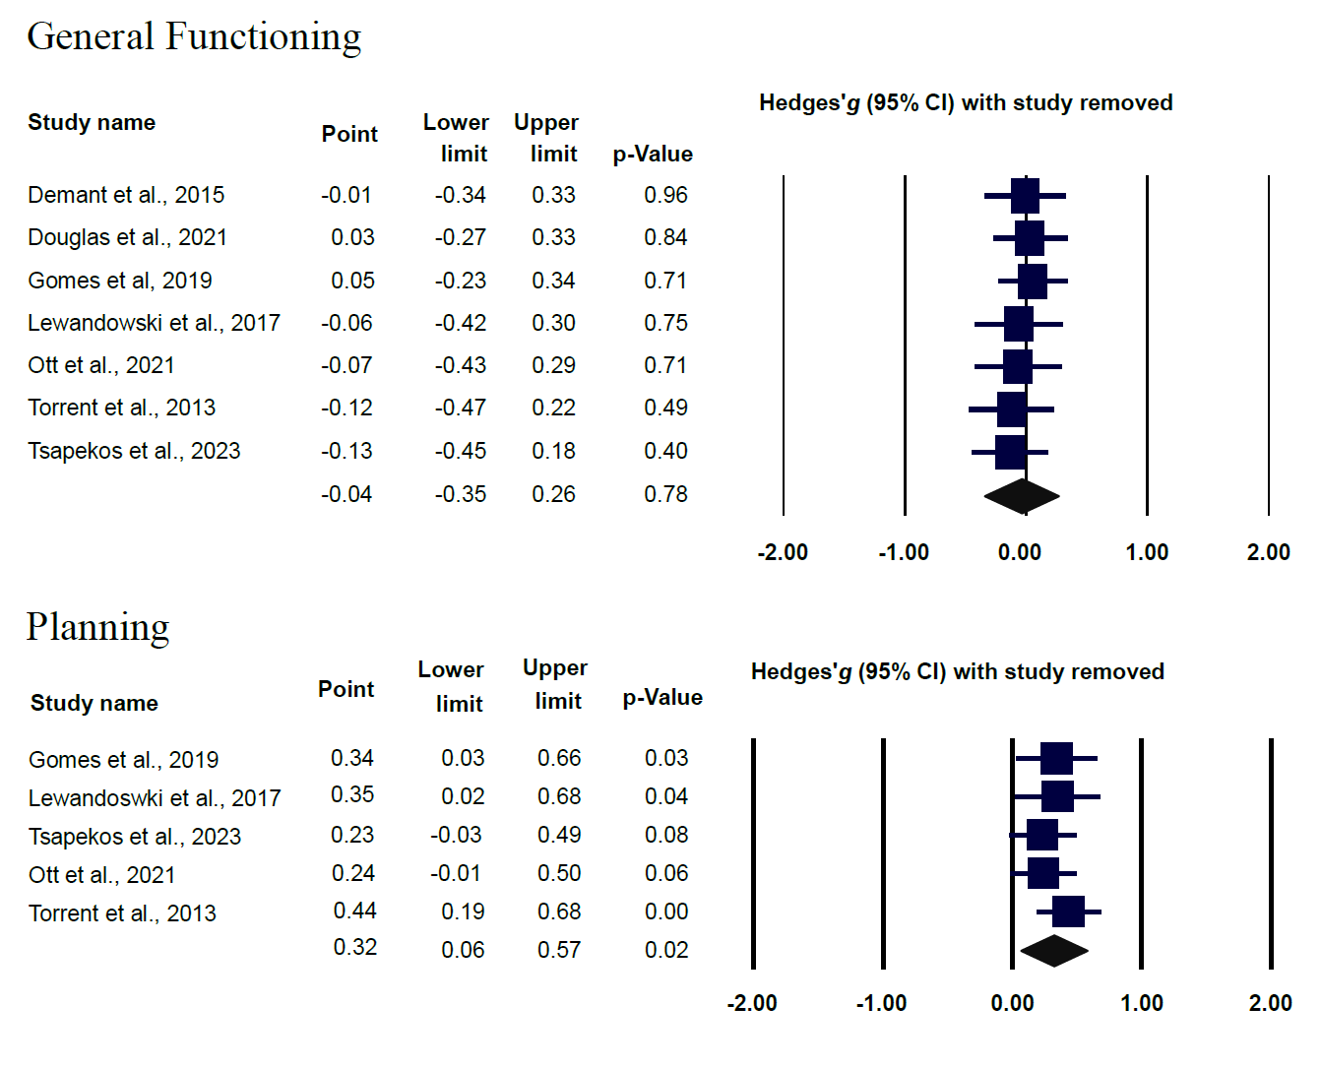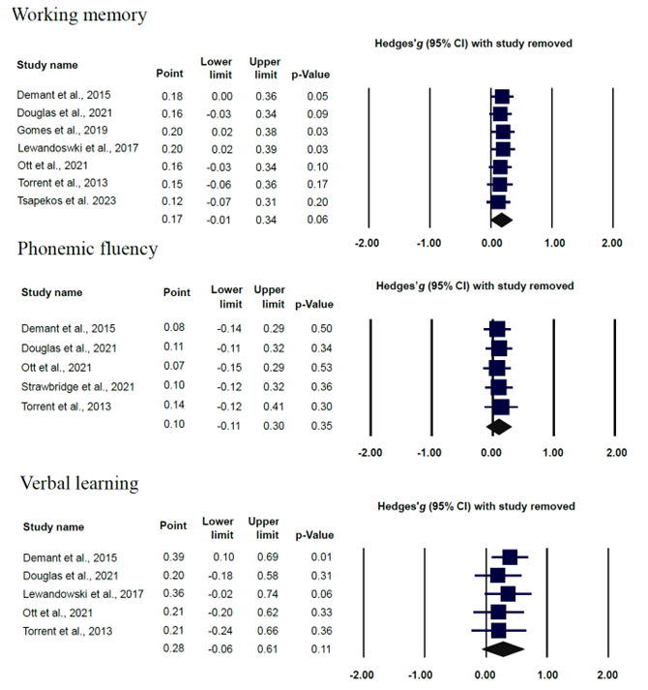
favours cg favours cr

Follow-up Assessment
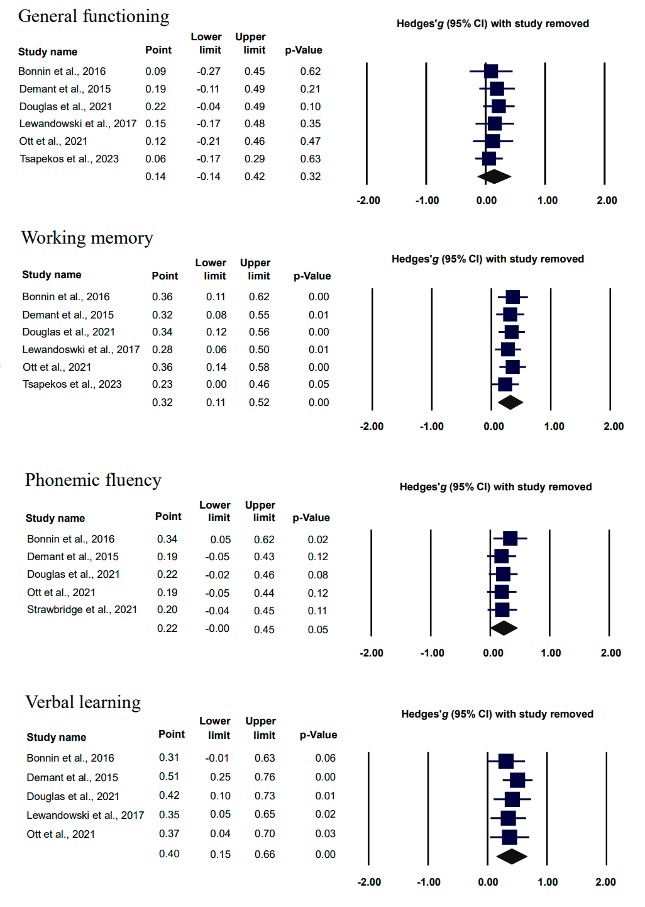
favours cg favours cr

CI, confidence interval; CG, control group; CR, cognitive remediation.

