Supplementary Information (SI) for “Altered topology of individual brain structural covariance networks in major depressive disorder”: Supplemental Methods, Figures, and Tables
SI Methods
Data preprocessing
Individual T1-weighted images were segmented into gray matter (GM), white matter, and cerebrospinal fluid. The Diffeomorphic Anatomical Registration Through Exponential Lie (DARTEL) algebra tool was then used to transform individual native space into standard Montreal Neurological Institute (MNI) space(Ashburner, 2007). Next, to obtained normalized GM volume images, the processed images were modulated by the nonlinear determinants derived from the spatial normalization procedure by DARTEL procedure. Finally, the shared modulated GM volume images were smoothed using an 8-mm full-width at half maximum (FWHM) Gaussian kernel for constructing individual structural covariance networks.
Constructing individual structural covariance networks
The processing workflow to obtain individual structural covariance network (SCN) in our study were summarized as follows:
1. The regional gray-matter volume (GMV) values of each region of interest were adjusted for covariates (e.g., age, gender, education, and total intracranial volume). And then we extracted the resulting regional GMV residuals.
2. Constructed group-based SCN of the HC group (SCN_{HC}).
3. Calculate the mean (M_{HC}) and standard deviation (SD_{HC}) values of each brain region in the HC group.
4. For a given subject, calculated the interregional effect size difference (ESD) for all pairs of regions in Eq.1.
$ESD\left(i,j\right)= \frac{|\left(x_{i}- M_{HC,i}\right)-\left(x_{j}- M_{HC,j}\right)|}{\sqrt{\frac{{SD}_{HC,i}^{2}-{SD}_{HC,j}^{2}}{2}}}$ (1)
where $x_{i}$ and $x_{j}$ be regional GMV values for regions i and j from a given subject, $M_{HC,i}$ and $M_{HC,j}$ be the mean regional GMV values of the normal group, and ${SD}_{HC,i}$ and ${SD}_{HC,j}$ be the corresponding standard deviations of the regional GMV values.
5. By viewing ESD (i, j) as z score(Kim, 2015) and applying Fisher transformation of $z=\frac{1}{2}\ln\left(\frac{1+R}{1-R}\right)$ to obtain correlation coefficient R in Eq.2.
$R(i,j)=\frac{\exp\left(2×ESD\left(i,j\right)\right)-1}{\exp\left(2×ESD\left(i,j\right)\right)+1}$ (2)
6. Calculate the individual weighting matrix between the given subject and the HC group in Eq.3.
$W\left(i,j\right)=1-R(i,j)$ (3)
7. Calculate the final individual SCN by an element-by-element multiplication between W and SCN_{HC} in Eq.4.
$M\left(i,j\right)=W\left(i,j\right).*{SCN}_{HC}(i,j)$ (4)
References
Ashburner, J. (2007). A fast diffeomorphic image registration algorithm. NeuroImage, 38(1), 95–113. https://doi.org/10.1016/j.neuroimage.2007.07.007
Kim, H.-Y. (2015). Statistical notes for clinical researchers: effect size. Restorative Dentistry & Endodontics, 40(4), 328. https://doi.org/10.5395/rde.2015.40.4.328

Supplementary Table
Table S1 Demographic characteristics for participants included in subgroup analysis
Group | Sample size(N) | Age (years),  mean (SD) | Sex (M/F) |  | Education (years), mean (SD) | HAMD | Illness duration (months), mean (SD)
FEDN vs. HC
FEDN | 268 | 31.877(11.699) | 97/171 |  | 11.892(3.598) | 21.959(5.881) | 17.785(31.86)
HC | 438 | 35.295(14.575) | 175/263 |  | 13.412(3.792)
t or χ²/p |  | -3.251/0.001** | 0.993/0.319 |  | 5.269/<0.001***
Recurrent MDD vs. HC
Recurrent | 261 | 36.149(13.309) | 106/155 |  | 11.245(3.551) | 18.75(7.959) | 88.364(85.926)
HC | 545 | 37.617(14.28) | 217/328 |  | 13.052(4.253)
t or χ²/p |  | -1.395/0.163 | 0.047/0.829 |  | 5.942/<0.001***
FEDN vs. Recurrent MDD
FEDN | 148 | 34.169(12.95) | 55/49 |  | 11.541(3.533) | 21.637(5.032) | 24.352(39.136)
Recurrent | 89 | 35.348(14.222) | 40/49 |  | 12.022(3.529) | 20.525(6.462) | 83.31(78.613)
t or χ²/p |  | -0.654/0.514 | -1.21/0.271 |  | -1.017/0.31 | 1.284/0.201 | 2.936/0.004**
FEDN vs. Medicated MDD
FEDN | 181 | 33.017(13.128) | 66/115 |  | 11.138(3.519) | 22.183(6.528) | 21.993(36.319)
Medicated | 149 | 37.926(13.435) | 52/115 |  | 10.779(3.462) | 19.877(6.609) | 59.595(70.97)
t or χ²/p |  | -3.345/0.001** | 1.1/0.294 |  | 0.931/0.353 | 3.155/0.002** | 1.127/0.261
long vs. short illness duration for all MDD
long | 191 | 34.838(14.176) | 58/133 |  | 10.812(3.845) | 22.313(7.295) | 3.034(1.925)
short | 267 | 38.266(13.609) | 103/133 |  | 10.843(3.746) | 21.31(6.166) | 81.127(70.911)
t or χ²/p |  | -2.612/0.009** | 7.923/0.005** |  | -0.087/0.931 | 1.498/0.135 | -1.257/0.209
long vs. short illness duration for FEDN
long | 66 | 33.697(12.914) | 20/46 |  | 11.818(3.782) | 21.692(5.926) | 1.668(0.788)
short | 88 | 33.727(10.803) | 34/46 |  | 12.25(3.668) | 21.693(3.905) | 38.591(42.638)
t or χ²/p |  | -0.016/0.987 | 2.308/0.129 |  | -0.713/0.477 | -0.001/0.999 | -1.156/0.25
Note: MDD: major depressive disorder; HC: health control; FEDN: first-episode drug naïve. *: p < 0.05, **: p < 0.01, ***: p < 0.001
Table S2 Group differences in Global network topological metrics
 | global metrics | T | P
 | σ | -2.538 | 0.011*
 | E_{glob} | 3.938 | <0.001***
MDD vs. HC | L_{p} | -4.025 | <0.001***
 | E_{loc} | -1.46 | 0.144
 | C_{p} | -1.025 | 0.306
FEDN vs. HC | σ | -1.91 | 0.057
 | E_{glob} | 1.606 | 0.109
 | L_{p} | -1.632 | 0.103
 | E_{loc} | -2.359 | 0.019*
 | C_{p} | -2.33 | 0.020*
Recurrent vs. HC | σ | -0.58 | 0.562
 | E_{glob} | 2.274 | 0.023*
 | L_{p} | -2.249 | 0.025*
 | E_{loc} | -1.367 | 0.172
 | C_{p} | -1.713 | 0.087
FEDN vs. Recurrent | σ | -0.244 | 0.808
 | E_{glob} | 0.159 | 0.873
 | L_{p} | -0.04 | 0.968
 | E_{loc} | 0.625 | 0.532
 | C_{p} | 0.378 | 0.706
Note: MDD: major depressive disorder; HC: health control; FEDN: first-episode drug naïve; σ: small-world index; E_{glob}: global efficiency; E_{loc}: local efficiency; L_{p}: path length; C_{p}: clustering coefficient. *: p < 0.05, **: p < 0.01, ***: p < 0.001.

Table S3 Effects of medication and illness duration on topological metrics.
 | global metrics | T | P
 | σ | 0.534 | 0.594
FEDN vs. Medicated MDD | E_{glob} | 0.295 | 0.769
 | L_{p} | -0.266 | 0.79
 | E_{loc} | -0.977 | 0.329
 | C_{p} | -1.485 | 0.139
Short vs. Long Duration for FEDN | σ | -0.373 | 0.71
 | E_{glob} | -0.273 | 0.785
 | L_{p} | 0.322 | 0.748
 | E_{loc} | -1.748 | 0.083
 | C_{p} | -0.959 | 0.339
Short vs. Long Duration for all MDD | σ | 0.197 | 0.844
 | E_{glob} | 0.451 | 0.652
 | L_{p} | 0.451 | 0.652
 | E_{loc} | 0.432 | 0.666
 | C_{p} | -1.202 | 0.23
Note: MDD: major depressive disorder; HC: health control; FEDN: first-episode drug naïve. σ: small-world index; E_{glob}: global efficiency; E_{loc}: local efficiency; L_{p}: path length; C_{p}: clustering coefficient.

Table S4 Group differences in Global network topological metrics based on group-level structural covariance network analysis
 | global metrics | T | P
 | σ | -0.996 | 0.326
 | E_{glob} | 0.977 | 0.335
MDD vs. HC | L_{p} | -0.996 | 0.326
 | E_{loc} | -1.513 | 0.262
 | C_{p} | -1.282 | 0.208
Note: MDD: major depressive disorder; HC: health control; σ: small-world index; E_{glob}: global efficiency; E_{loc}: local efficiency; L_{p}: path length; C_{p}: clustering coefficient. *: p < 0.05, **: p < 0.01, ***: p < 0.001.

Table S5 Leave-one-site-out cross-validation on alterations in global topological metrics between MDD and HC
Leave out site | Sample size(N) |  | E_{glob} |  | E_{loc} |  | σ |  | C_{p} |  | L_{p}
 | MDD | HC | t | P | t | P | t | P | t | P | t | P
1 | 1099 | 945 | 3.570 | <0.001 | -1.530 | 0.126 | -2.147 | 0.032 | -1.100 | 0.271 | -3.624 | <0.001
2 | 1143 | 989 | 3.791 | <0.001 | -1.302 | 0.193 | -2.331 | 0.020 | -0.869 | 0.385 | -3.868 | <0.001
6 | 1158 | 1004 | 4.197 | <0.001 | -1.462 | 0.144 | -2.310 | 0.021 | -1.172 | 0.241 | -4.227 | <0.001
7 | 1135 | 970 | 3.643 | <0.001 | -1.288 | 0.198 | -2.402 | 0.016 | -0.876 | 0.381 | -3.719 | <0.001
8 | 1098 | 944 | 3.599 | <0.001 | -1.375 | 0.169 | -2.288 | 0.022 | -0.943 | 0.346 | -3.657 | <0.001
9 | 1123 | 969 | 4.435 | <0.001 | -0.998 | 0.319 | -2.248 | 0.025 | -0.708 | 0.479 | -4.408 | <0.001
10 | 1123 | 986 | 3.629 | <0.001 | -1.223 | 0.222 | -2.430 | 0.015 | -0.700 | 0.484 | -3.721 | <0.001
11 | 1141 | 990 | 3.685 | <0.001 | -1.505 | 0.132 | -2.761 | 0.006 | -0.871 | 0.384 | -3.778 | <0.001
13 | 1148 | 1002 | 3.951 | <0.001 | -1.806 | 0.071 | -2.751 | 0.006 | -1.641 | 0.101 | -4.041 | <0.001
14 | 1109 | 987 | 3.766 | <0.001 | -1.393 | 0.164 | -2.354 | 0.019 | -1.087 | 0.277 | -3.876 | <0.001
15 | 1123 | 969 | 4.221 | <0.001 | -1.861 | 0.063 | -2.992 | 0.003 | -1.344 | 0.179 | -4.318 | <0.001
17 | 1126 | 975 | 3.814 | <0.001 | -1.705 | 0.088 | -2.495 | 0.013 | -1.436 | 0.151 | -3.918 | <0.001
18 | 1152 | 999 | 3.762 | <0.001 | -1.236 | 0.217 | -2.391 | 0.017 | -0.774 | 0.439 | -3.862 | <0.001
19 | 1122 | 983 | 3.715 | <0.001 | -1.194 | 0.233 | -2.221 | 0.026 | -0.941 | 0.347 | -3.825 | <0.001
20 | 891 | 768 | 4.364 | <0.001 | -1.329 | 0.184 | -2.536 | 0.011 | -0.916 | 0.360 | -4.569 | <0.001
21 | 1087 | 949 | 3.692 | <0.001 | -1.984 | 0.047 | -3.180 | 0.001 | -1.302 | 0.193 | -3.795 | <0.001
22 | 1143 | 999 | 3.802 | <0.001 | -1.281 | 0.200 | -2.592 | 0.010 | -0.772 | 0.440 | -3.898 | <0.001
23 | 1141 | 989 | 3.751 | <0.001 | -1.243 | 0.214 | -2.450 | 0.014 | -0.789 | 0.430 | -3.835 | <0.001
24 | 1141 | 988 | 3.641 | <0.001 | -1.403 | 0.161 | -2.350 | 0.019 | -0.845 | 0.398 | -3.729 | <0.001
25 | 1084 | 956 | 3.857 | <0.001 | -1.431 | 0.153 | -2.415 | 0.016 | -0.971 | 0.331 | -3.925 | <0.001
Note: MDD: major depressive disorder; HC: health control; σ: small-world index; E_{glob}: global efficiency; E_{loc}: local efficiency; L_{p}: path length; C_{p}: clustering coefficient.
Table S6 Group differences in Global network topological metrics for 2,126 adult participants
 | global metrics | T | P
 | σ | -2.52 | 0.012*
 | E_{glob} | 3.962 | <0.001***
MDD vs. HC | L_{p} | -4.025 | <0.001***
 | E_{loc} | -1.513 | 0.13
 | C_{p} | -1.054 | 0.292
FEDN vs. HC | σ | -1.736 | 0.083
 | E_{glob} | 1.528 | 0.127
 | L_{p} | -1.559 | 0.12
 | E_{loc} | -2.137 | 0.033*
 | C_{p} | -1.957 | 0.051
Recurrent vs. HC | σ | -0.696 | 0.487
 | E_{glob} | 2.271 | 0.023*
 | L_{p} | -2.218 | 0.027*
 | E_{loc} | -1.399 | 0.162
 | C_{p} | -1.692 | 0.091
FEDN vs. Recurrent | σ | -0.072 | 0.942
 | E_{glob} | -0.038 | 0.97
 | L_{p} | 0.11 | 0.912
 | E_{loc} | 0.868 | 0.387
 | C_{p} | 0.601 | 0.548
Note: MDD: major depressive disorder; HC: health control; FEDN: first-episode drug naïve. σ: small-world index; E_{glob}: global efficiency; E_{loc}: local efficiency; L_{p}: path length; C_{p}: clustering coefficient. *: p < 0.05, **: p < 0.01, ***: p < 0.001.

Table S7 Group differences in Global network topological metrics with medication usage as a covariate
 | global metrics | T | P
 | σ | -3.280 | 0.001**
 | E_{glob} | 2.400 | 0.017*
MDD vs. HC | L_{p} | -2.484 | 0.013*
 | E_{loc} | -3.659 | <0.001***
 | C_{p} | -2.892 | 0.004**
Note: MDD: major depressive disorder; HC: health control; σ: small-world index; E_{glob}: global efficiency; E_{loc}: local efficiency; L_{p}: path length; C_{p}: clustering coefficient. *: p < 0.05, **: p < 0.01, ***: p < 0.001.

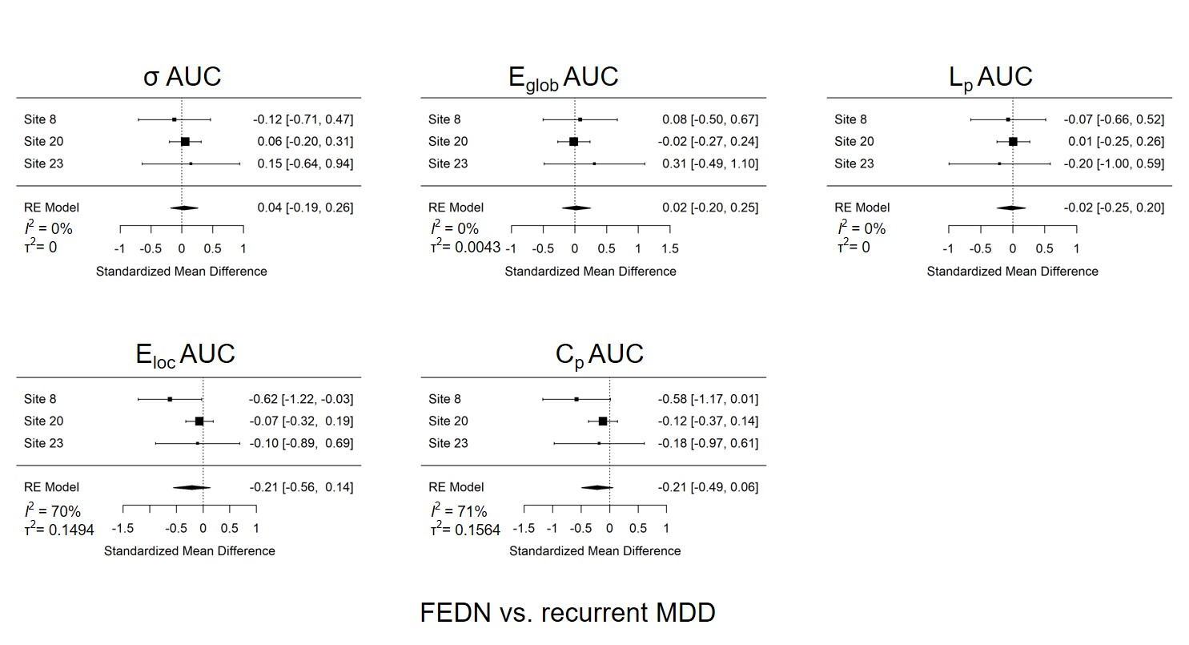
Supplementary Figures
Figure S1. Forest plots of effect size of each site generated by the meta-model in Reproducibility analysis: global topological metrics between FEDN MDD group and recurrent MDD group. Of note, for each comparison, only sites with sample size larger than 10 in each group were included.
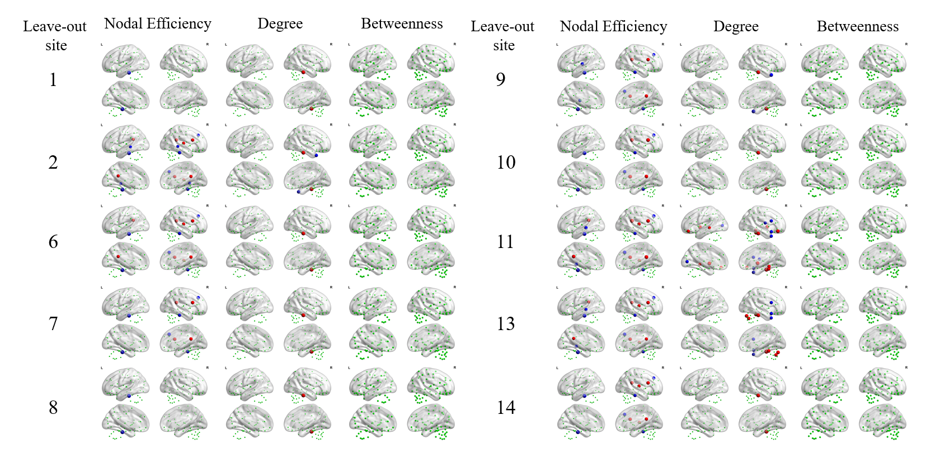
Figure S2. Leave-one-site-out cross-validation in efficiency, degree and betweenness at the nodal level between MDD and HC. The case-control differences in regional alterations were largely comparable when excluding data from different sites and were highly similar to the main findings. Insignificant nodes are shown as green spheres, whereas blue (MDD < HC) and red (MDD > HC) spheres denote significant differences after FDR correction. The size of the significant nodes reflects the effect sizes of group differences. Green spheres that are outside the brain indicate the nodes of cerebellum.
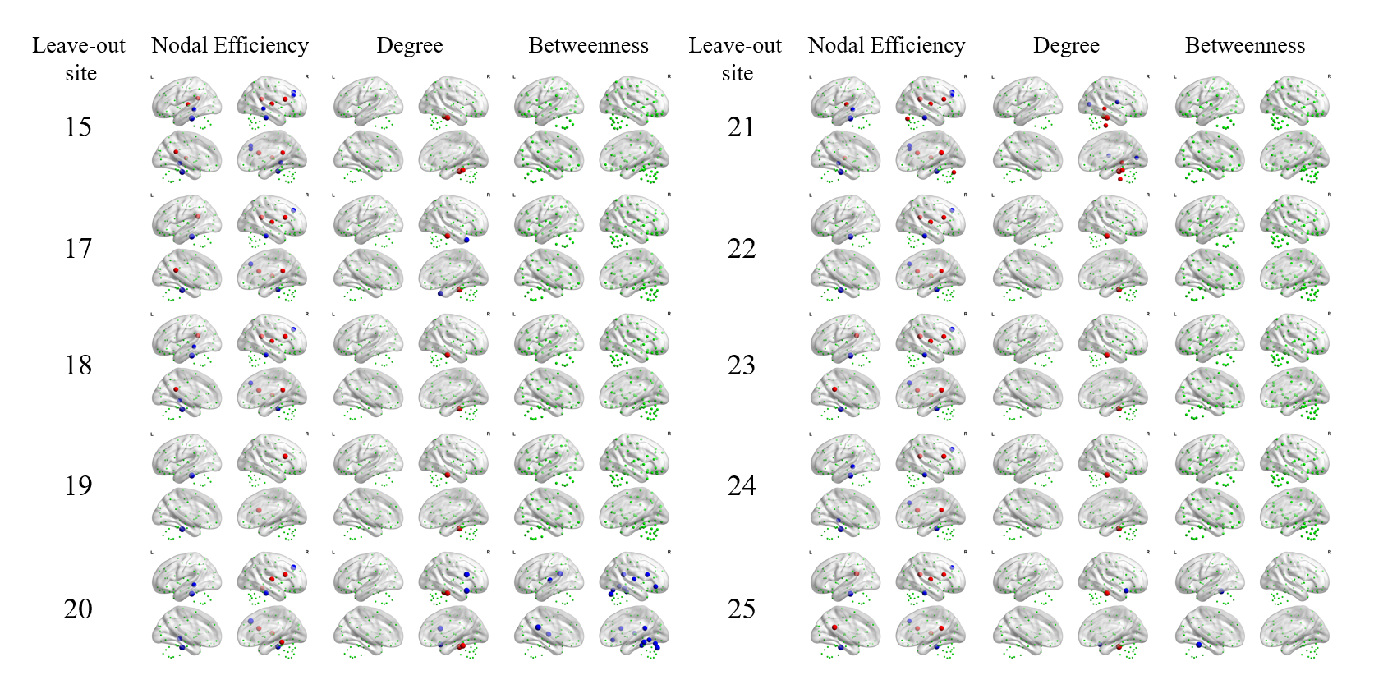 Figure S2. Continued

