Online Supplement Content
SA1. Glossary of terms 1
SA2. Literature search 5
SA3. Definition of exposure and outcome variables 8
SA4. Extracted variables 10
SA5. Newcastle-Ottawa scale for non-randomised studies 11
SA6. Full list of included studies 13
SA7. Excluded studies with reasons 19
SA8. Future lines of research 21
ST1. PRISMA 2020 statement and checklist 22
ST2. PRISMA 2020 for abstracts checklist 26
ST3. MOOSE guideline and checklist 27
ST4. Manuals codes for psychotic disorder diagnoses included 31
ST5. Description and measurement of social functioning and social cognition domains 32
ST6. Risk of bias and quality assessment of included studies 45
ST7. Risk of bias and quality assessment score 50
ST8. Meta-regressions for associations between childhood maltreatment with social functioning and social cognition in psychotic disorders 51
SF1. Forest plots 62
SF1a. Forest plots for the association between overall childhood maltreatment and social functioning domains 62
SF1b. Forest plots for the association between overall childhood maltreatment and social cognition domains 65
SF1c. Forest plots for the association between childhood maltreatment subtypes and social functioning domains 66
SF1d. Forest plots for the association between childhood maltreatment subtypes and social cognition domains 70
SF2. Sensitivity analyses for meta-analytical results with one study removed analysis 71
SF2a. Sensitivity analyses for overall childhood maltreatment and social functioning domains with one study removed analysis 71
SF2b. Sensitivity analyses for overall childhood maltreatment and social cognition domains with one study removed analysis 74
SF2c. Sensitivity analyses for childhood maltreatment subtypes and social functioning domains with one study removed analysis 75
SF2d. Sensitivity analyses for childhood maltreatment subtypes and social cognition domains with one study removed analysis 79
SF3. Funnel plots 80
SF3a. Funnel plots investigating publication bias for overall childhood maltreatment and social functioning domains 80
SF3b Funnel plots investigating publication bias for overall childhood maltreatment and social cognition domains 83
SF3c. Funnel plots investigating publication bias for childhood maltreatment subtypes and social functioning domains 84
SF3d. Funnel plots investigating publication bias for childhood maltreatment subtypes and social cognition domains 88
References 89

SA1. Glossary of terms

ACE: Adverse Childhood Exposure
AoM: Awareness of the Mind of the Other
BBTS: The Brief Betrayal Trauma Survey
BDHI: Buss-Durkee Hostility Inventory
BES: The Basic Empathy Scale
BLERT: Bell Lysaker Emotional Recognition Task
CAMIR-R: from French; CArtes-Modèles Individuels de Relations - Short form
CANSAS: Safety-to-others item of the Camberwell Assessment of Need Short Appraisal Schedule
CAQ: Childhood Abuse Questionnaire
CASH: The Comprehensive Assessment of Symptoms and History
CECA-Q: Childhood Experiences of Care and Abuse Questionnaire
CM: Childhood Maltreatment
CSA: Child sexual abuse
CT: Childhood Trauma
CTQ: Childhood Trauma Questionnaire
CTQ-SF: Childhood Trauma Questionnaire-Short Form
CSTQ: Childhood Sexual Trauma Questionnaire
DIP: Diagnostic Interview for Psychosis
DFAR: The Degraded Facial Affect Recognition Task
DSM: Diagnostic and Statistical Manual of Mental Disorders
DV: Domestic Violence
EA: Emotional Abuse
ECR-R: Experience in Close Relationships Revised
EmoBio: Emotion in Biological Motion
EN: Emotional Neglect
ERT: Emotion Recognition Task
ETISR-SF: The Early Trauma Inventory Self Report-Short Form
ExpTra-S: Screening of Early Traumatic Experiences in Patients with Severe Mental Illness
FAST: Functioning Assessment Short Test
FEEST: Facial Expressions of Emotion Stimuli and Tests
FEP: First Episode Psychosis
GAF: Global Assessment of Functioning
GAF-F: Global Assessment of Functioning-Function subscale
GAS: Global Assessment Scale
HCR-20: The Historical-Clinical-Risk Management-20
ICD: International Statistical Classification of Diseases and Related Health Problems
IIPI: The Indiana Psychiatric Illness Interview
INQ: Interpersonal Needs Questionnaire
ISMI: Internalised Stigma - Social Withdrawal
LHA-A: Lifetime History of Aggression Scale-Aggression subscale
MACE: Maltreatment and Abuse Chronology of Exposure Scale
MAS-A: Metacognition Assessment Scale-Abbreviated
MASC: Movie for the Assessment of Social Cognition
MASCaff: Movie for the Assessment of Social Cognition Affective
MASCcog: Movie for the Assessment of Social Cognition Cognitive
MASCexe: Movie for the Assessment of Social Cognition Over Mentalising Errors
MASCless: Movie for the Assessment of Social Cognition Under Mentalising Errors
MASCno: Movie for the Assessment of Social Cognition No Mentalising Errors
MINI: Mini International Neuropsychiatric Interview
MCCB: MATRICS Consensus Cognitive Battery
MOAS: Modified Overt Aggression Scale
MOOSE: Meta-analysis Of Observational Studies in Epidemiology
MSCEIT: Mayer-Salovery-Caruso Emotional Intelligence Test
NA: Non-Available
NS: Non-Significant
OPCRIT: Operational Criteria Checklist for Psychotic Illness and Affective Illness
PA: Physical Abuse
PAM: Psychosis Attachment Measure
PANSS: The Positive and Negative Syndrome Scale (PANSS) for Schizophrenia
PD: Psychotic Disorders
PERE: from Spanish; Prueba de Reconocimiento de Emociones or Emotion recognition Task
PFA: Pictures of Facial Affect
PN: Physical Neglect
PRISMA: Preferred Reporting Items for Systematic Reviews and Meta-Analyses
PSPS: Personal and Social Performance Scale
PsyQoL: Psychological Quality of Life
QoL: Quality of Life
QSF: Questionnaire of Social Functioning
RMET: Reading the Mind in the Eyes Task
RT: Reaction Time
SA: Sexual Abuse
SASS: Social Adaptation Self-evaluation Scale
SANS: Scale for the Assessment of Negative Symptoms
SAT-MC: Social Attribution Task-Multiple Choice
SCAN: Schedules for Clinical Assessment in Neuropsychiatry
SCID: Structured Clinical Interview for DSM
SCZ: Schizophrenia
SD: Standard Deviation
SECT: Social Emotional Cognition Task
SF-36: Short Form Health Survey (health-related quality of life)
SFS: Social Functioning Scale
SOFAS: Social and Occupational Functioning
SQoL: Quality of Life Questionnaire - Short Form
TAA: Trauma Assessment for Adults
TEC: Traumatic Experience Checklist
ToM: Theory of Mind
WHO/DAS: World Health Organisation Disability Assessment Schedule
WHOQOL_BREF: World Health Organisation Quality of Life

SA2. Literature search

Embase
('social functioning' OR 'social adaptation'/exp OR 'social adaptation' OR 'social behavior'/exp OR 'social behavior' OR 'social competence'/exp OR 'social competence' OR 'human relation'/exp OR 'human relation' OR 'social networks'/exp OR 'social networks' OR 'occupational functioning'/exp OR 'occupational functioning' 'employment'/exp OR employment OR 'community functioning' OR 'social cognition' OR 'attributional style' OR 'emotion recognition'/exp OR 'emotion recognition' OR 'self- regulation' OR 'theory of mind' OR 'face perception' OR 'facial recognition'/exp OR 'facial recognition' OR 'face discrimination'/exp OR 'face discrimination' OR 'social perception' OR 'emotion regulation' OR 'emotion perception' OR 'social inference') AND ('child abuse'/exp OR 'child abuse' OR 'children abuse' OR 'child neglect' OR 'children neglect' OR 'child physical abuse' OR 'children physical abuse' OR 'child sexual abuse'/exp OR 'child sexual abuse' OR 'children sexual abuse' OR 'child emotional abuse' OR 'children emotional abuse' OR 'childhood trauma'/exp OR 'childhood trauma' OR 'child maltreatment' OR 'children maltreatment' OR 'early life adversity'/exp OR 'early life adversity' OR 'domestic violence'/exp OR 'domestic violence' OR 'bullying'/exp OR bullying OR ctq OR ceca) AND ('psychosis'/exp OR psychosis OR 'schizophrenia'/exp OR schizophrenia OR schizoaffective OR 'schizoaffective psychosis'/exp OR 'schizoaffective psychosis” OR schizophreniform OR 'schizophreniform disorder'/exp OR 'schizophreniform disorder' OR psychotic OR 'major depression'/exp OR 'major depression' OR 'bipolar disorder'/exp OR 'bipolar disorder') Limits: [1990-2021]/py ([english]/lim OR [german]/lim OR [spanish]/lim) 'article'/it 'human'/de

PubMED
(‘social functioning’ OR ´Social Adjustment` [MeSH] OR ‘Social Behavior’ [MeSH] OR ‘Social skills’ [MeSH] OR ‘Interpersonal Relations’ [MeSH] OR 'social networks' OR ‘occupational functioning’ OR employment OR ‘community functioning’ OR ‘social cognition’ OR ‘attributional style’ OR ‘emotion recognition’ OR ‘self- regulation’ OR ‘theory of mind’ OR ‘face perception’ OR ‘face discrimination’ OR ‘social perception’ OR ‘emotion regulation’ OR ‘emotion perception’ OR ‘social inference’) AND (‘child* abuse’ OR ‘child* neglect’ OR ‘child* physical abuse’ OR ‘child* sexual abuse’ OR ‘child* emotional abuse’ OR ‘childhood trauma’ OR ‘child* maltreatment’ OR ‘early life adversity’ OR “domestic violence” OR bullying OR CTQ OR CECA) AND (psychosis OR schizophrenia OR schizoaffective OR schizophreniform OR psychotic OR major depression OR bipolar disorder) Filters: Journal article 1990-2021 Humans (species) Medline German, English, Spanish

PsycINFO
(“social functioning” OR “social adjustment” OR “social behavior” OR “social skills” OR “interpersonal relations” OR “human relation” OR “social networks” OR “occupational functioning” OR employment OR “community functioning” OR “social cognition” OR “attributional style” OR “emotion recognition” OR “self- regulation” OR “theory of mind” OR “face perception” OR “face discrimination” OR “social perception” OR “emotion regulation” OR “emotion perception” OR “social inference”) AND (“child abuse” OR “children abuse” OR “child neglect” OR “children neglect” OR “child physical abuse” OR “children physical abuse” “child sexual abuse” OR “children sexual abuse” OR “child emotional abuse” OR “children emotional abuse” OR “childhood trauma” OR “child maltreatment” OR “children maltreatment” OR “early life adversity” OR “domestic violence” OR bullying OR CTQ OR CECA) AND (psychosis OR schizophrenia OR schizoaffective OR schizophreniform OR psychotic OR “major depression” OR “bipolar disorder”) Limits: Scientific journals 1990-2021 Language: English, German, Spanish Humans

Web of Science (Core Collection)
TS=(“social functioning” OR “social adjustment” OR “social behavior” OR “social skills” OR “interpersonal relations’ OR “human relation” OR “social networks” OR “occupational functioning” OR employment OR “community functioning” OR “social cognition” OR “attributional style” OR “emotion recognition” OR “self- regulation” OR “theory of mind” OR “face perception” OR “face discrimination” OR “social perception” OR “emotion regulation” OR “emotion perception” OR “social inference”) AND TS=(“child abuse” OR (“children abuse” OR “child neglect” OR “children neglect” OR “child physical abuse” OR “children physical abuse” “child sexual abuse” OR “children sexual abuse” OR “child emotional abuse” OR “children emotional abuse” OR “childhood trauma” OR “child maltreatment” OR “children maltreatment” OR “early life adversity” OR “domestic violence” OR bullying OR CTQ OR CECA) AND TS=(psychosis OR schizophrenia OR schizoaffective OR schizophreniform OR psychotic OR “major depression” OR “bipolar disorder”) Limits: 1990-2021 Article English, German, Spanish

PILOTS
(“social functioning” OR “social adjustment” OR “social behavior” OR “social skills” OR “interpersonal relations” OR “human relation” OR “social networks” OR “occupational functioning” OR employment OR “community functioning” OR “social cognition” OR “attributional style” OR “emotion recognition” OR “self- regulation” OR “theory of mind” OR “face perception” OR “face discrimination” OR “social perception” OR “emotion regulation” OR “emotion perception” OR “social inference”) AND (“child abuse” OR “children abuse” OR “child neglect” OR “children neglect” OR “child physical abuse” OR “children physical abuse” “child sexual abuse” OR “children sexual abuse” OR “child emotional abuse” OR “children emotional abuse” OR “childhood trauma” OR “child maltreatment” OR “children maltreatment” OR “early life adversity” OR “domestic violence” OR bullying OR CTQ OR CECA) AND (psychosis OR schizophrenia OR schizoaffective OR schizophreniform OR psychotic OR “major depression” OR “bipolar disorder”) Limits: Scientific Journal 1990-2021 Language: English, German, Spanish

SA3. Definition of exposure and outcome variables

Exposure
Childhood maltreatment was defined based on previous definitions (Gilbert et al., 2009; Teicher & Samson, 2013; Zeanah & Humphreys, 2018) as: (a) Overall CM (or total CM) - cumulative scores of different traumas (abuse and neglect); (b) Physical abuse defined as acts of violence causing physical harm or injury, including physical punishment; (c) Sexual abuse defined as sexual acts including intercourse or touching toward a child; (d) Emotional abuse defined as verbal or behavioural assaults toward a child that might result in trauma including any humiliating name-calling by an adult or caregiver; (e) Physical neglect defined as caregivers’ failure to provide basic physical needs for the child including shelter, food, clothing or health-care; and (f) Emotional neglect defined as caregivers’ failure to meet the child’s fundamental emotional and psychological needs, including love, care, support, and belonging (see CM assessment and measures in the included studies in Table 1).
Outcomes
Social functioning outcomes were defined based on outcomes examined in the included studies, and on categorisations used in previous systematic reviews and meta-analysis in the field (Christy et al., 2022; de Winter et al., 2021; Fares-Otero et al., 2023): (a) Global Social Functioning: overall composite measures of global social functioning including a combination of social/community engagement, communication, independence, interpersonal relationships, and leisure activities (Monica Aas et al., 2016; de Winter et al., 2021), (b) Independent Living (competence and performance) (Lindgren et al., 2017; Monfort-Escrig & Pena-Garijo, 2021; Shah et al., 2014); (c) Occupational Functioning (academic, employment status, work engagement, productivity) (Lindgren et al., 2017); (d) Interpersonal Relations (social relationships, community/family functioning); and (e) Aggressive Behaviour including physical and verbal aggression (hostility, violence, criminality) (Bosqui et al., 2014), and f) Psychosocial Problems: Axis IV psychosocial and environmental problems (C.E. Ramsay, Flanagan, Gantt, Broussard, & Compton, 2011). Social cognition outcomes were defined as: (a) Theory of Mind: mentalising or ability to reason about mental states and understand intentions, dispositions, emotions, and beliefs of both oneself and others (Brüne, 2005; D. Kincaid et al., 2018); (b) Emotion Processing: (facial) emotion recognition and managing emotions (M Aas et al., 2017a); c) Attributional style/bias: Outcomes measuring the way in which individuals infer the causes of particular social events (Chalker et al., 2022; Kim et al., 2019); and d) Empathy: Outcomes measuring the ability to comprehend and share the emotions of others (Bonfils, Lysaker, Minor, & Salyers, 2017) (see a detailed description of social functioning and social cognition outcomes assessments in ST6).

SA4. Extracted variables

Author and publication year, country and region, sample size, diagnosis descriptive (n or % if reported), mean age (SD) and range in years, gender (% males), type and instrument for diagnosis (and criteria), follow-up period (if reported), mean age (SD) and duration (in years) of the illness, exposure (including type and timing of CM) and outcome (including domains of social functioning), variables measurement and instruments, valence of outcome and results used in meta-analysis (effect sizes, confidence intervals and p value), confounders, moderators, and mediators investigated in the included studies.

SA5. Newcastle-Ottawa scale for non-randomised studies

Selection (maximum 4 stars)
1. Representativeness of the sample
a. Truly representative of the average in the target population (all subjects or whole population, random sampling). *
b. Somewhat representative of the average in the target population (evidence that the sample is representative of the source population, non-random sampling). *
c. Selected group of users.
d. No description of the sampling strategy.
2. Sample size
a. Justified or satisfactory. *
b. Not justified.
3. Non-respondents
a. Comparability between respondents and non-respondents characteristics is established, or the response rate is satisfactory (> 60%) *
b. The response rate is unsatisfactory, or the comparability between respondents and non-respondents is unsatisfactory.
c. No description of the response rate or the characteristics of the responders and non-responders.
4. Ascertainment of the exposure (childhood maltreatment)
a. Validated measurement tool. *
b. Non-validated measurement tool, or not described.
Comparability (maximum 2 stars)

5. The subjects in different outcome groups are comparable,
based on the study design or analysis (confounding factors are controlled).
a. The study controls for gender (or analysis separated by gender). *
b. Study controls for any additional factor. *
c. The study does not adjust for any confounding factor.
Outcome (maximum 2 stars)
6. Assessment of the outcome (social functioning)
a. The study uses reliable and validated instruments as confirmed by reported psychometric measures (behavioural tasks or questionnaires). *
b. No description.
7. Statistical test
a. The statistical test used to analyse the data is clearly described and appropriate, and the measurement of the association is presented, including confidence intervals and the probability level (p value). *
b. Study reports descriptive statistics that allows calculating associations. *
c. The statistical test is not appropriate, not described or incomplete.

Note: In the Newcastle-Ottawa Scale (NOS) (Wells et al., 2014) adapted and validated (Epstein et al., 2018; R. Herzog et al., 2013; Mertz et al., 2013; Wickersham, Leightley, Archer, & Fear, 2020) for non-randomised studies (cross-sectional and longitudinal), a study can be awarded a maximum of one point (star) for each numbered item with the Selection and Exposure categories. A maximum of two points (stars) can be given for Comparability.

SA6. Full list of included studies

Aas M, Andreassen OA, Aminoff SR, et al. A history of childhood trauma is associated with slower improvement rates: Findings from a one-year follow-up study of patients with a first-episode psychosis. BMC Psychiatry. 2016;16:126-126. doi:10.1186/s12888-016-0827-4
Aas M, Kauppi K, Brandt CL, et al. Childhood trauma is associated with increased brain responses to emotionally negative as compared with positive faces in patients with psychotic disorders. Psychol Med. 2017;47(4):669-679. doi:10.1017/S0033291716002762
Akbey ZY, Yildiz M, Gündüz N. Is There Any Association Between Childhood Traumatic Experiences, Dissociation and Psychotic Symptoms in Schziophrenic Patients? Psychiatry Investig. 2019;16(5):346-354. doi:10.30773/pi.2019.02.10.2
Andrianarisoa M, Boyer L, Godin O, et al. Childhood trauma, depression and negative symptoms are independently associated with impaired quality of life in schizophrenia. Results from the national FACE-SZ cohort. Schizophrenia Research. 2017;185:173-181. doi:10.1016/j.schres.2016.12.021
Aydin O, Balikci K, Tas C, et al. The developmental origins of metacognitive deficits in schizophrenia. Psychiatry Res. 2016;245:15-21. doi:10.1016/j.psychres.2016.08.012
Bosqui TJ, Shannon C, Tiernan B, Beattie N, Ferguson J, Mulholland C. Childhood trauma and the risk of violence in adulthood in a population with a psychotic illness. J Psychiatr Res. 2014;54(1):121-125. doi:10.1016/j.jpsychires.2014.03.011
Boyette LL, van Dam D, Meijer C, et al. Personality compensates for impaired quality of life and social functioning in patients with psychotic disorders who experienced traumatic events. Schizophrenia Bulletin. 2014;40(6):1356-1365. doi:10.1093/schbul/sbu057
Brañas A, Lahera G, Barrigón ML, Canal-Rivero M, Ruiz-Veguilla M. Effects of childhood trauma on facial recognition of fear in psychosis. Rev Psiquiatr Salud Ment (Engl Ed). 2022;15(1):29-37. doi:10.1016/j.rpsmen.2022.01.001
Chalker SA, Parrish EM, Cano M, Kelsven S, Moore RC, Granholm E, ... Depp C. A. Childhood trauma associations with the interpersonal psychological theory of suicide and social cognitive biases in psychotic disorders. J Ner Ment Dis. 2022; 210(6): 432-438.
Cui Y, Kim SW, Lee BJ, et al. Negative Schema and Rumination as Mediators of the Relationship Between Childhood Trauma and Recent Suicidal Ideation in Patients With Early Psychosis. J Clin Psychiatry. 2019;80(3):17m12088. doi:10.4088/JCP.17m12088
Engelstad KN, Rund BR, Lau B, Vaskinn A, Torgalsbøen AK. Increased prevalence of psychopathy and childhood trauma in homicide offenders with schizophrenia compared to nonviolent individuals with schizophrenia. Nord J Psychiatry. 2019;73(8):501-508. doi:10.1080/08039488.2019.1656777
Faay MDM, van Os J, Genetic Risk and Outcome of Psychosis (GROUP) Investigators. Aggressive Behavior, Hostility, and Associated Care Needs in Patients With Psychotic Disorders: A 6-Year Follow-Up Study. Front Psychiatry. 2019;10:934. doi:10.3389/fpsyt.2019.00934
Garcia M, Montalvo I, Creus M, et al. Sex differences in the effect of childhood trauma on the clinical expression of early psychosis. Compr Psychiatry. 2016;68:86-96. doi:10.1016/j.comppsych.2016.04.004
Gil A, Gama CS, de Jesus DR, Lobato MI, Zimmer M, Belmonte-de-Abreu P. The association of child abuse and neglect with adult disability in schizophrenia and the prominent role of physical neglect. Child Abuse Negl. 2009;33(9):618-624. doi:10.1016/j.chiabu.2009.02.006
Haahr UH, Larsen TK, Simonsen E, et al. Relation between premorbid adjustment, duration of untreated psychosis and close interpersonal trauma in first-episode psychosis. Early Interv Psychiatry. 2018;12(3):316-323. doi:10.1111/eip.12315
Hachtel H, Fullam R, Malone A, Murphy BP, Huber C, Carroll A. Victimization, violence and facial affect recognition in a community sample of first-episode psychosis patients. Early Intervent Psychiatry. 2020;14(3):283-292. doi:10.1111/eip.12853
Hjelseng IV, Vaskinn A, Ueland T, et al. Childhood trauma is associated with poorer social functioning in severe mental disorders both during an active illness phase and in remission. Schizophr Res. Published online March 25, 2020:S0920-9964(20)30118-3. doi:10.1016/j.schres.2020.03.015
Hodann-Caudevilla RM, García JJM, Julián FAB. Childhood trauma and personal recovery in schizophrenia: Mediating role of experiential avoidance and insecure attachment. Clin Schizophr Relat Psychoses. 2021;15(2). doi:10.3371/CSRP.RMGJ.070421
Kilian S, Asmal L, Chiliza B, et al. Childhood adversity and cognitive function in schizophrenia spectrum disorders and healthy controls: evidence for an association between neglect and social cognition. Psychol Med. 2018;48(13):2186-2193. doi:10.1017/S0033291717003671
Kim Y, Kwon A, Min D, Kim S, Jin MJ, Lee SH. Neurophysiological and Psychological Predictors of Social Functioning in Patients with Schizophrenia and Bipolar Disorder. Psychiatry Investig. 2019;16(10):718-727. doi:10.30773/pi.2019.07.28
Kincaid D, Shannon C, Boyd A, et al. An investigation of associations between experience of childhood trauma and political violence and theory of mind impairments in schizophrenia. Psychiatry Res. 2018;270:293-297. doi:10.1016/j.psychres.2018.09.052
Lecomte T, Giguère CÉ, Cloutier B, Potvin S; Signature Consortium. Comorbidity Profiles of Psychotic Patients in Emergency Psychiatry. J Dual Diagn. 2020;16(2):260-270. doi:10.1080/15504263.2020.1713425
Li XB, Li QY, Liu JT, Zhang L, Tang YL, Wang CY. Childhood trauma associates with clinical features of schizophrenia in a sample of Chinese inpatients. Psychiatry Research. 2015;228(3):702-707. doi:10.1016/j.psychres.2015.06.001
Lindgren M, Mäntylä T, Rikandi E, et al. Childhood adversities and clinical symptomatology in first-episode psychosis. Psychiatry Res. 2017;258:374-381. doi:10.1016/j.psychres.2017.08.070
Lopez-Mongay D, Ahuir M, Crosas JM, et al. The Effect of Child Sexual Abuse on Social Functioning in Schizophrenia Spectrum Disorders. JOURNAL OF INTERPERSONAL VIOLENCE. 2021;36(7-8):NP3480-NP3494. doi:10.1177/0886260518779074
Lysaker PH, Gumley A, Brüne M, Vanheule S, Buck KD, Dimaggio G. Deficits in the ability to recognize one’s own affects and those of others: associations with neurocognition, symptoms and sexual trauma among persons with schizophrenia spectrum disorders. Conscious Cogn. 2011;20(4):1183-1192. doi:10.1016/j.concog.2010.12.018
Lysaker PH, Meyer PS, Evans JD, Clements CA, Marks KA. Childhood sexual trauma and psychosocial functioning in adults with schizophrenia. Psychiatric Services (Washington, DC). 2001;52(11):1485-1488. doi:10.1176/appi.ps.52.11.1485
Lysaker PH, Wright DE, Clements CA, Plascak-Hallberg CD. Neurocognitive and psychosocial correlates of hostility among persons in a post-acute phase of schizophrenia spectrum disorders. Compr Psychiatry. 2002;43(4):319-324. doi:10.1053/comp.2002.33493
Mansueto G, Schruers K, Cosci F, et al. Childhood adversities and psychotic symptoms: The potential mediating or moderating role of neurocognition and social cognition. SCHIZOPHRENIA RESEARCH. 2019;206:183-193. doi:10.1016/j.schres.2018.11.028
Monfort-Escrig C, Pena-Garijo J. Attachment Dimensions predict Social Functioning in persons with Schizophrenia-Spectrum Disorders, regardless of Symptom Severity. Actas Esp Psiquiatr. 2021;49(6):269-281.
Oakley C, Harris S, Fahy T, Murphy D, Picchioni M. Childhood adversity and conduct disorder: A developmental pathway to violence in schizophrenia. Schizophr Res. 2016;172(1):54-59. doi:10.1016/j.schres.2016.01.047
Ortega L, Montalvo I, Solé M, et al. Relationship between childhood trauma and social adaptation in a sample of young people attending an early intervention service for psychosis. Rev Psiquiatr Salud Ment. 2020;13(3):131-139. doi:10.1016/j.rpsm.2020.05.001
Pena-Garijo J, Monfort-Escrig C. The centrality of secure attachment within an interacting network of symptoms, cognition, and attachment dimensions in persons with schizophrenia-spectrum disorders: A preliminary study. Journal of Psychiatric Research. 2021;135:60-67. doi:10.1016/j.jpsychires.2021.01.002
Penney D, Pruessner M, Malla AK, Joober R, Lepage M. Severe childhood trauma and emotion recognition in males and females with first-episode psychosis [published online ahead of print, 2022 Apr 5]. Early Interv Psychiatry. 2022;10.1111/eip.13299. doi:10.1111/eip.13299
Quide Y, Cohen-Woods S, O’Reilly N, Carr VJ, Elzinga BM, Green MJ. Schizotypal personality traits and social cognition are associated with childhood trauma exposure. BRITISH JOURNAL OF CLINICAL PSYCHOLOGY. 2018;57(4):397-419. doi:10.1111/bjc.12187
Quide Y, Ong XH, Mohnke S, et al. Childhood trauma-related alterations in brain function during a Theory-of-Mind task in schizophrenia. Schizophr Res. 2017;189:162-168. doi:10.1016/j.schres.2017.02.012
Ramsay CE, Flanagan P, Gantt S, Broussard B, Compton MT. Clinical correlates of maltreatment and traumatic experiences in childhood and adolescence among predominantly African American, socially disadvantaged, hospitalized, first-episode psychosis patients. Psychiatry Res. 2011;188(3):343-349. doi:10.1016/j.psychres.2011.05.019
Rokita KI, Dauvermann MR, Mothersill D, et al. Childhood trauma, parental bonding, and social cognition in patients with schizophrenia and healthy adults. Journal of Clinical Psychology. 2021;77(1):241-253. doi:10.1002/jclp.23023
Rosenberg SD, Lu W, Mueser KT, Jankowski MK, Cournos F. Correlates of adverse childhood events among adults with schizophrenia spectrum disorders. Psychiatric Services. 2007;58(2):245-253. doi:10.1176/appi.ps.58.2.245
Schalinski I, Teicher MH, Carolus AM, Rockstroh B. Defining the impact of childhood adversities on cognitive deficits in psychosis: An exploratory analysis. Schizophr Res. 2018;192:351-356. doi:10.1016/j.schres.2017.05.014
Shah S, Mackinnon A, Galletly C, et al. Prevalence and impact of childhood abuse in people with a psychotic illness. Data from the second Australian National Survey of Psychosis. Schizophr Res. 2014;159(1):20-26. doi:10.1016/j.schres.2014.07.011
Spence W, Mulholland C, Lynch G, McHugh S, Dempster M, Shannon C. Rates of childhood trauma in a sample of patients with schizophrenia as compared with a sample of patients with non-psychotic psychiatric diagnoses. J Trauma Dissociation. 2006;7(3):7-22. doi:10.1300/J229v07n03_02
Spidel A, Lecomte T, Greaves C, Sahlstrom K, Yuille JC. Early psychosis and aggression: Predictors and prevalence of violent behaviour amongst individuals with early onset psychosis. Int J Law Psychiatry. 2010;33(3):171-176. doi:10.1016/j.ijlp.2010.03.007
Swanson JW, Swartz MS, Van Dorn RA, et al. A national study of violent behavior in persons with schizophrenia. Arch Gen Psychiatry. 2006;63(5):490-499. doi:10.1001/archpsyc.63.5.490
Sweeney S, Air T, Zannettino L, Galletly C. Gender Differences in the Physical and Psychological Manifestation of Childhood Trauma and/or Adversity in People with Psychosis. Front Psychol. 2015;6:1768-1768. doi:10.3389/fpsyg.2015.01768
Trauelsen AM, Bendall S, Jansen JE, et al. Childhood adversities: Social support, premorbid functioning and social outcome in first-episode psychosis and a matched case-control group. Aust N Z J Psychiatry. 2016;50(8):770-782. doi:10.1177/0004867415625814
Trauelsen AM, Gumley A, Jansen JE, et al. Does childhood trauma predict poorer metacognitive abilities in people with first-episode psychosis? Psychiatry Research. 2019;273:163-170. doi:10.1016/j.psychres.2019.01.018
Trotta A, Murray RM, David AS, et al. Impact of Different Childhood Adversities on 1-Year Outcomes of Psychotic Disorder in the Genetics and Psychosis Study. Schizophr Bull. 2016;42(2):464-475. doi:10.1093/schbul/sbv131
Turner S, Harvey C, Hayes L, et al. Childhood adversity and clinical and psychosocial outcomes in psychosis. Epidemiol Psychiatr Sci. 2019;29:e78-e78. doi:10.1017/S2045796019000684
van Nierop M, Bak M, de Graaf R, et al. The functional and clinical relevance of childhood trauma-related admixture of affective, anxious and psychosis symptoms. Acta Psychiatr Scand. 2016;133(2):91-101. doi:10.1111/acps.12437
Vaskinn A, Melle I, Aas M, Berg AO. Sexual abuse and physical neglect in childhood are associated with affective theory of mind in adults with schizophrenia. SCHIZOPHRENIA RESEARCH-COGNITION. 2021;23. doi:10.1016/j.scog.2020.100189
Vila-Badia R, Del Cacho N, Butjosa A, et al. Prevalence and types of childhood trauma in first episode psychosis patients. Relation with clinical onset variables. J Psychiatr Res. 2022;146:102-108. doi:10.1016/j.jpsychires.2021.12.033
Weijers J, Fonagy P, Eurelings-Bontekoe E, Termorshuizen F, Viechtbauer W, Selten JP. Mentalizing impairment as a mediator between reported childhood abuse and outcome in nonaffective psychotic disorder. Psychiatry Res. 2018;259:463-469. doi:10.1016/j.psychres.2017.11.010

SA7. Excluded studies with reasons

Characteristics of studies not included in meta-analysis but fulfilling inclusion criteria and included in the systematic review*
Country/ Region | Study | n (PD) | Mean Age (SD) in years | Sex (% male) | PD diagnosis % or n (if reported) | Instrument and criteria used for PD diagnosis | Instrument to assess CM | Type of CM | Instrument to assess social domain | Outcome | NOS score (Max=8)
Korea/Asia | Cui et al. 2019(Cui et al., 2019) | 314 | 27.46 (7.21) | 43 | 64.3% SCZ, 15.6% Schizophreniform, 2.9% Schizoaffective, 13.4% other SCZ spectrum, 1.3% delusional, 2.5% brief PD | MINI based on DSM-5 | ETISR-SF | Overall CM | BES | Empathy | 5
USA/North America | Ramsay et al. 2011(Ramsay, Flanagan, Gantt, Broussard, & Compton, 2011) | 61 | NA (NA) | 72.1 | 20 SCZ paranoid type, 9 schizophreniform disorder, 9 PD non-specified, 7 SCZ undifferentiated type, 7 schizoaffective (depressive type), 3 schizoaffective (bipolar type), 2 SCZ disorganised type, 2 brief PD, 2 delusional disorder | SCID-I based on DSM-IV | CTQ-SF  TEC  Parental harsh Discipline Score  Violence exposure 12-18 years (scale of seven questions) | Overall CM, PA, SA, EA, EP, PN  Parental harsh discipline | Axis IV problems | Psychosocial problems | 5

Note: BES = The Basic Empathy Scale, CT = Childhood Trauma, CTQ-SF = Childhood Trauma Questionnaire (short form), EA = Emotional Abuse, EN = Emotional Neglect, ETISR-SF = The Early Trauma Inventory Self Report-Short Form, FEP = First Episode Psychosis, MINI = Mini International Neuropsychiatric Interview, NA = Not available, PD = Psychotic Disorder, PA = Psychical Abuse, PN = Physical Neglect, SCZ = Schizophrenia, SCID-I = Structured Clinical Interview for DSM Disorders - Axis I, SA = Sexual Abuse, TEC = Traumatic Experience Checklist, *Empathy and psychosocial problems were considered social cognition and social functioning domains, but data could not be meta-analysed. The full list of excluded studies (not included neither in systematic review nor in meta-analysis) with reasons is available from NEF-O upon reasonable request.

SA8. Future lines of research

Research priorities include a deeper understanding of factors that explain findings observed in this meta-analysis. This requires a detailed assessment of social domains and all subtypes of CM, and the investigation of potential mediating and moderating factors in the association between CM and social outcomes. Next to factors already reported in the literature (e.g., sex, timing of CM), the role of genetic factors (Teicher, Gordon, & Nemeroff, 2022; Teicher & Samson, 2013), brain functions (Colich et al., 2022; J. I. Herzog et al., 2020; Russotti et al., 2021), characteristics of the family/social environment, and available social support should be explored.
Longitudinal research designs are needed to provide stronger evidence about the potential role of subsequent social stressors and other forms of maltreatment (e.g., domestic violence). These designs should also gather more details about the exposure (e.g., frequency of adverse event types, and victim’s relationship to perpetrator), to further improve our understanding of relationships between CM with social outcomes in PD.
Our findings underlie the need for new approaches (Heriot-Maitland, Wykes, & Peters, 2022) that may enhance the efficacy of social interventions and promote generalization to improvements in real-world functioning. Group-based mobile interventions (Dabit, Quraishi, Jordan, & Biagianti, 2021) may also represent novel approaches for improving social functioning in PD. It is unclear yet whether patients with CM undergoing such interventions really show better social functioning in real life and whether this impacts social outcomes. This would require validating new social endpoints that are appropriate for clinical trials, and conducting longitudinal, larger, and ideally multisite studies using rigorous methods and common assessments.
Finally, more global representation is needed in the evidence base. Cross-national research collaborations that include researchers from currently underrepresented regions (e.g., Africa, Asia, and Latin America) represent a key opportunity in this regard and can also support replication of findings across laboratories and countries to strengthen reliability and generalisability of findings, taking cultural factors into account between CM and social functions (Pfaltz et al., 2022).

ST1. PRISMA 2020 statement and checklist

Section and Topic | Item # | Checklist item | Location where item is reported
TITLE
Title | 1 | Identify the report as a systematic review. | Cover page
ABSTRACT
Abstract | 2 | See the PRISMA 2020 for Abstracts checklist. | Abstract
INTRODUCTION
Rationale | 3 | Describe the rationale for the review in the context of existing knowledge. | Introduction
Objectives | 4 | Provide an explicit statement of the objective(s) or question(s) the review addresses. | Introduction
METHODS
Eligibility criteria | 5 | Specify the inclusion and exclusion criteria for the review and how studies were grouped for the syntheses. | Methods
Information sources | 6 | Specify all databases, registers, websites, organisations, reference lists and other sources searched or consulted to identify studies. Specify the date when each source was last searched or consulted. | Methods
Search strategy | 7 | Present the full search strategies for all databases, registers, and websites, including any filters and limits used. | Methods  Supplement
Selection process | 8 | Specify the methods used to decide whether a study met the inclusion criteria of the review, including how many reviewers screened each record and each report retrieved, whether they worked independently, and if applicable, details of automation tools used in the process. | Methods
Data collection process | 9 | Specify the methods used to collect data from reports, including how many reviewers collected data from each report, whether they worked independently, any processes for obtaining or confirming data from study investigators, and if applicable, details of automation tools used in the process. | Methods
Data items | 10a | List and define all outcomes for which data were sought. Specify whether all results that were compatible with each outcome domain in each study were sought (e.g., for all measures, time points, analyses), and if not, the methods used to decide which results to collect. | Methods Supplement
 | 10b | List and define all other variables for which data were sought (e.g., participant and intervention characteristics, funding sources). Describe any assumptions made about any missing or unclear information. | Methods Supplement
Study risk of bias assessment | 11 | Specify the methods used to assess risk of bias in the included studies, including details of the tool(s) used, how many reviewers assessed each study and whether they worked independently, and if applicable, details of automation tools used in the process. | Methods Supplement
Effect measures | 12 | Specify for each outcome the effect measure(s) (e.g., risk ratio, mean difference) used in the synthesis or presentation of results. | Methods
Synthesis methods | 13a | Describe the processes used to decide which studies were eligible for each synthesis (e.g., tabulating the study intervention characteristics and comparing against the planned groups for each synthesis (item #5)). | Methods
 | 13b | Describe any methods required to prepare the data for presentation or synthesis, such as handling of missing summary statistics, or data conversions. | Methods
 | 13c | Describe any methods used to tabulate or visually display results of individual studies and syntheses. | Methods
 | 13d | Describe any methods used to synthesise results and provide a rationale for the choice(s). If meta-analysis was performed, describe the model(s), method(s) to identify the presence and extent of statistical heterogeneity, and software package(s) used. | Methods
 | 13e | Describe any methods used to explore possible causes of heterogeneity among study results (e.g., subgroup analysis, meta-regression). | Methods
 | 13f | Describe any sensitivity analyses conducted to assess robustness of the synthesised results. | Methods
Reporting bias assessment | 14 | Describe any methods used to assess risk of bias due to missing results in a synthesis (arising from reporting biases). | Methods
Certainty assessment | 15 | Describe any methods used to assess certainty (or confidence) in the body of evidence for an outcome. | Methods
RESULTS
Study selection | 16a | Describe the results of the search and selection process, from the number of records identified in the search to the number of studies included in the review, ideally using a flow diagram. | Figure 1 Results
 | 16b | Cite studies that might appear to meet the inclusion criteria, but which were excluded, and explain why they were excluded. | Results  Supplement
Study characteristics | 17 | Cite each included study and present its characteristics. | Results  Supplement
Risk of bias in studies | 18 | Present assessments of risk of bias for each included study. | Results Supplement
Results of individual studies | 19 | For all outcomes, present, for each study: (a) summary statistics for each group (where appropriate) and (b) an effect estimate and its precision (e.g., confidence/credible interval), ideally using structured tables or plots. | Results Supplement
Results of syntheses | 20a | For each synthesis, briefly summarise the characteristics and risk of bias among contributing studies. | Results Supplement
 | 20b | Present results of all statistical syntheses conducted. If meta-analysis was done, present for each the summary estimate and its precision (e.g., confidence/credible interval) and measures of statistical heterogeneity. If comparing groups, describe the direction of the effect. | Results Supplement
 | 20c | Present results of all investigations of possible causes of heterogeneity among study results. | Results Supplement
 | 20d | Present results of all sensitivity analyses conducted to assess the robustness of the synthesised results. | Results Supplement
Reporting biases | 21 | Present assessments of risk of bias due to missing results (arising from reporting biases) for each synthesis assessed. | Results Supplement
Certainty of evidence | 22 | Present assessments of certainty (or confidence) in the body of evidence for each outcome assessed. | Results
DISCUSSION
Discussion | 23a | Provide a general interpretation of the results in the context of other evidence. | Discussion
 | 23b | Discuss any limitations of the evidence included in the review. | Discussion
 | 23c | Discuss any limitations of the review processes used. | Discussion
 | 23d | Discuss implications of the results for practice, policy, and future research. | Discussion
OTHER INFORMATION
Registration and protocol | 24a | Provide registration information for the review, including register name and registration number, or state that the review was not registered. | Abstract Methods
 | 24b | Indicate where the review protocol can be accessed, or state that a protocol was not prepared. | Abstract Methods
 | 24c | Describe and explain any amendments to information provided at registration or in the protocol. | Methods
Support | 25 | Describe sources of financial or non-financial support for the review, and the role of the funders or sponsors in the review. | Funding
Competing interests | 26 | Declare any competing interests of review authors. | Competing interest declaration
Availability of data, code and other materials | 27 | Report which of the following are publicly available and where they can be found: template data collection forms; data extracted from included studies; data used for all analyses; analytic code; any other materials used in the review. | Article information

ST2. PRISMA 2020 for abstracts checklist

Section and Topic | Item # | Checklist item | Reported (Yes/No)
TITLE
Title | 1 | Identify the report as a systematic review. | Yes
BACKGROUND
Objectives | 2 | Provide an explicit statement of the main objective(s) or question(s) the review addresses. | Yes
METHODS
Eligibility criteria | 3 | Specify the inclusion and exclusion criteria for the review. | Yes
Information sources | 4 | Specify the information sources (e.g., databases, registers) used to identify studies and the date when each was last searched. | Yes
Risk of bias | 5 | Specify the methods used to assess risk of bias in the included studies. | Yes
Synthesis of results | 6 | Specify the methods used to present and synthesise results. | Yes
RESULTS
Included studies | 7 | Give the total number of included studies and participants and summarise relevant characteristics of studies. | Yes
Synthesis of results | 8 | Present results for main outcomes, preferably indicating the number of included studies and participants for each. If meta-analysis was done, report the summary estimate and confidence/credible interval. If comparing groups, indicate the direction of the effect (i.e. which group is favored). | Yes
DISCUSSION
Limitations of evidence | 9 | Provide a brief summary of the limitations of the evidence included in the review (e.g. study risk of bias, inconsistency and imprecision). | Yes
Interpretation | 10 | Provide a general interpretation of the results and important implications. | Yes
OTHER
Funding | 11 | Specify the primary source of funding for the review. | Yes
Registration | 12 | Provide the register name and registration number. | Yes

ST3. MOOSE guideline and checklist

Criteria |  | Brief description of how the criteria were handled in the meta-analysis
Reporting of background should include
√ | Problem definition | To study them magnitude and consistency of associations between overall childhood maltreatment and its subtypes and social functioning and social cognition domains in individuals with psychotic disorders, and to examine mediators and moderators in these relationships.
√ | Hypothesis statement | We hypothesised that there is a negative association between childhood maltreatment and social functioning and social cognition so that childhood maltreatment would be related to poorer social outcomes in individuals with psychotic disorders.
√ | Description of study outcomes | Social functioning: Global, Independent living, Occupational functioning, Interpersonal relations, Aggressive behaviour, and Psychosocial problems. Social cognition: Theory of mind, Emotion processing, Attribution style/bias, and Empathy.
√ | Type of exposure or intervention used | Studies included were original articles investigating individuals with psychotic disorders exposed to childhood maltreatment (no intervention).
√ | Type of study designs used | Cross-sectional and longitudinal studies (only with baseline data).
√ | Study population | Individuals with psychotic disorders (schizophrenia spectrum disorders, affective psychoses) defined according to international and established criteria (DSM, ICD).
Reporting of search strategy should include
√ | Qualifications of searchers | The credentials of the investigators/reviewers are indicated in the author list and in the acknowledgements.
√ | Search strategy, including time period included in the synthesis and keywords | We used specific keywords relative to the type of the diverse social functioning and social cognition domains, child maltreatment, and diagnoses of interest (psychotic disorders). A second step involved manual search of the reference lists of the retrieved articles.
√ | Databases and registries searched | Embase, PubMed (Medline), Web of Science, PsycINFO, and PILOTS.
√ | Search software used, name and version, including special features | Zotero 5.0.96.3, Ryann
√ | Use of hand searching | We hand-searched bibliographies of retrieved papers for additional references.
√ | List of citations located and those excluded, including justifications | Details of the literature search process are outlined in the PRISMA flowchart.
√ | Method of addressing articles published in languages other than English | The search included abstract in English, German, or Spanish.
√ | Method of handling abstracts and unpublished studies | Abstracts and unpublished studies (grey literature) were excluded.
√ | Description of any contact with authors | We contacted all the corresponding authors to provide additional data for the meta-analysis when needed.
Reporting of methods should include
√ | Description of relevance or appropriateness of studies assembled for assessing the hypothesis to be tested | Detailed inclusion and exclusion criteria were described in the methods section.
√ | Rationale for the selection and coding of data | Data extracted from each of the studies were related to the population characteristics, study design, exposure, outcome, and effect of confounders, mediators and moderators reported in the included studies.
√ | Assessment of confounding | Meta-regressions were used to examine the quantitative influence of several predefined variables and quality of studies. Additionally, we qualitatively estimate the influence of confounders in the association between childhood maltreatment and social functioning and social cognition in psychotic disorders.
√ | Assessment of study quality, including blinding of quality assessors; stratification or regression on possible predictors of study results | We adapted the Newcastle-Ottawa Scale for the evaluation of non-randomised studies. This tool has been adopted in recent meta-analyses.
√ | Assessment of heterogeneity | Heterogeneity was assessed using the Q-test and I² index.
√ | Description of statistical methods in sufficient detail to be replicated | Random effect meta-analyses. Description of methods of meta-analyses, sensitivity analyses, meta-regressions and assessment of publication bias were fully detailed in the methods.
√ | Provision of appropriate tables and graphics | We included the PRISMA flow-chart and several tables to describe the literature search and its results. Several tables and forest/funnel plots, and figures were used to describe the main findings of the analyses.
Reporting of results should include
√ | Graph summarising individual study estimates and overall estimate | We have appended illustrative table 2 in the main text. Additional tables were presented as supplementary material to fully describe the results.
√ | Table giving descriptive information for each study included | Table 1
√ | Results of sensitivity testing | Sensitivity analyses (one-study-removal) were reported in the main text and plots were appended in the supplementary results.
√ | Indication of statistical uncertainty of findings | We did report mean estimates for the main outcome, pooled 95% CI, and prediction intervals.
Reporting of discussion should include
√ | Quantitative assessment of bias | Descriptions of quantitative assessment of bias are detailed in the methods; results are described in the main text, and funnel plots are appended in the supplementary materials.
√ | Justification for exclusion | Exclusion criteria about publication type, language, diagnosis definition of psychotic disorder, measures and instruments for childhood maltreatment and social functioning and social cognition, the presence of treatment outcomes, a relationship between childhood maltreatment and social functioning and social cognition in psychotic disorders (or descriptive statistics that allows calculating associations) reported, or any meta-analytical data provided, are detailed in methods, while discussed in the discussion.
√ | Assessment of quality of included studies | The assessment of quality of included studies, using the Newcastle-Ottawa Quality Assessment Scale is detailed in the supplement, and results of the quality assessment, that we entered in meta-regression analyses are discussed in the discussion.
Reporting of conclusions should include
√ | Consideration of alternative explanations for observed results | We discussed alternative explanations for our findings, specifically considering potential methodological shortcomings.
√ | Generalisation of the conclusions | We have clearly addressed the generalisation of the conclusions in the discussion section.
√ | Guidelines for future research | We have suggested possible streams of future research in the discussion.
√ | Disclosure of funding source | We added a funding disclosure for the undertaking of this systematic review and meta-analysis.

ST4. Manuals codes for psychotic disorder diagnoses included

Diagnosis | Code used within ICD-10 | Code used within DSM-IV | Code used within DSM-5
Schizophrenia | F20 | 295.10/295.20/295.30/295.60 | 295.90
Brief psychotic disorder | F23 | - | 298.8
Schizophreniform disorder | F20.81 | - | 295.40
Schizoaffective disorder | F25.0 bipolar type  F25.1 depressive type | 295.70 | 295.70
Psychosis not otherwise specified | F29 | 298.9 | 298.9
Bipolar disorder with psychotic features | F31.2/31.5 | 296.04/296.44/296.54/296.64 | 296.44/296.54
Major depressive disorder with psychotic features | F33.0 | 296.24/296.34 | 296.24/296.34

ST5. Description and measurement of social functioning and social cognition domains

Social Functioning
Global social functioning
Definition: Outcomes measuring global (or general) social functioning in a social setting or role in any social domain, social skills, and leisure activities
Instrument / Measurement | Description
GAF: Global Assessment of Functioning. Overall social, and occupational level of adjustment over a score ranging from 0–100 on axis V of the DSM-IV. Higher scores reflect better functioning | Level of social and occupational functioning of patients with PD; global indicator of social dysfunction (Pedersen & Karterud, 2012)
GAF-F (Split-version)(Pedersen, Hagtvet, & Karterud, 2007): Global Assessment of Functioning - Function subscale | Function: Relational functioning, social and occupational functioning level over a score ranging from 0 (severely impaired) –100 (extremely high functioning)
GAS: Global Assessment Scale | Overall functional adjustment, with higher scores reflecting better functioning
Multidimensional Scale | Global role performance across multiple domains: paid and unpaid work, study, and activities of daily living, weekly or daily contact with family and friends, global independent functioning, with functioning rated relative to community norms, and social support
PSP: Personal and Social Performance scale. The interviewer scores the participant from one (absent) to six (very severe) on four dimensions of social functioning: socially useful activities including personal and social relationships, disturbing or disruptive and aggressive behaviour. Based on these ratings, they then score the participant on a single scale ranging from 0 to 100 using set criteria | Global social functioning over the previous month involving socially useful activities, personal and social relationships, disturbing and aggressive behaviour
QoL Instrumental Role – social role subscale | Quality and global social functioning in a defined social role such a parent, student, or worker
QSF: Questionnaire of Social Functioning-16 items, which include frequency (8 items) and satisfaction (8 items) of social behaviours such as working and relationships, rated using a five-point Likert scale (ranging 1–5) where a higher score indicates greater social functioning | Frequency and satisfaction of social behaviours such as working and relationships, where a higher score indicates greater social functioning
SASS: Social Adaptation Self-evaluation Scale 21-item | Motivation and social behaviour in several areas: work, leisure, motivation, and interests
SFS: The Social Functioning Scale - 76 items across 7 subscales (mean score: 100, Standard deviation: 15)(Birchwood, Smith, Cochrane, Wetton, & Copestake, 1990) | Social functioning over the past 3 months in areas of functioning essential for successful community maintenance in individuals with schizophrenia. The subscales involve Independence-Competence (ability to perform skills necessary for independent living), Independence-Performance (the actual performance of the same skills necessary for independent living), and Employment (engagement in productive employment or structured program of daily activity). A high score indicates a higher frequency of a skill or a certain behaviour, which indicates better social functioning
WHO/DAS(Gil et al., 2009): Word Health Organisation Disability Assessment Schedule | Global behaviour: Level of daily activity, agility, and social withdrawal. Involvement in household chores, emotional and sexual life, maternal/paternal role, social contacts, occupational performance, interest in information, and behaviour in case of emergency
Independent Living
Definition: Outcomes measuring autonomy or independent living and behaviour, housing, accommodation, global independent living, independent competence, and performance, financial management
Instrument / Measurement | Description
Homelessness and Mental Health Survey – Independent living | Having no regular residence or as living in a shelter or on the street over the past six months
Living status | Current living status
SFS: The Social Functioning Scale (self-administered questionnaire)(Birchwood et al., 1990) -76 items, 7 subscales- evaluates Interpersonal Behaviour and Communication, and Prosocial Activities over the past 3 months in areas of functioning essential for successful community maintenance in individuals with schizophrenia. A high score indicates a higher frequency of a skill or a certain behaviour, which indicates better social functioning | The subscales involve Independence-Competence (ability to perform skills necessary for independent living), Independence-Performance (the actual performance of the same skills necessary for independent living). A high score indicates a higher frequency of a skill or a certain behaviour, which indicates better social functioning
SQoL-18: The Quality of Life in Schizophrenia-18 (self-administered) questionnaire – Autonomy subscale ranges from 0 indicating the lowest QoL to 100 indicating the highest QoL | Autonomy, independent living
Occupational Functioning
Definition: Outcomes measuring vocational functioning, involvement into (competitive) employment/work
Instrument / Measurement | Description
Employment / Unemployment | Status
Occupational status | Current occupational status
SFS: The Social Functioning Scale - 76 items across 7 subscales (mean score: 100, Standard deviation: 15)(Birchwood et al., 1990) | Social functioning over the past 3 months in areas of functioning essential for successful community maintenance in individuals with schizophrenia. The subscales involve Employment (engagement in productive employment or structured program of daily activity). A high score indicates a higher frequency of a skill or a certain behaviour, which indicates better social functioning
SHIP interview - 32 modules involving Functioning, quality of life, education, employment, accommodation, or housing | Employment
SOFAS: Social and Occupational Functioning Assessment Scale | Individual's level of social and occupational functioning
Strauss-Carpenter Scale(Strauss & Carpenter, 1974) – work functioning | Work abilities
Work functioning | Questions on whether the participant was working at the time of the survey and whether the client had worked in the past year
Interpersonal Relations
Definition: Outcomes measuring social relationships, community functioning, engagement in recreational activities with others, interpersonal behaviour (vs. social isolation)
Instrument / Measurement | Description
ECR-R: Experience in Close Relationships-revised (self-report) measure | Attachment anxiety and avoidance styles
INQ: Interpersonal Needs Questionnaire. The INQ is a 15-item self-report measure assessing interpersonal beliefs (i.e., thwarted belongingness and perceived burdensomeness). The thwarted belongingness subscale consists of nine items measuring participants' sense of not belonging, and the perceived burdensomeness subscale consists of six items measuring participants' view of themselves as burden to others. Higher scores indicate greater thwarted belongingness or perceived burdensomeness | Interpersonal beliefs
Multidimensional Scale. Role performance across multiple domains: paid and unpaid work, study, and activities of daily living, weekly or daily contact with family and friends, global independent functioning, with functioning rated relative to community norms, and social support | Role performance in weekly or daily contact with family and friends, global independent functioning, with functioning rated relative to community norms, and social support
PAM: Psychosis Attachment Measure | Anxious and avoidant adult attachment in a romantic relationship in individuals with PD
QoL: Interpersonal Relations subscore containing items such as social network, social initiative, and socio sexual function | Interpersonal and social functioning
SANS: Scale for the Assessment of Negative Symptoms related to social relations, within each domain rating separate symptoms from 0 (absent) to 5 (severe) | Ability to feel intimacy and closeness, relationship with friends and peers
SASS: Social Adaptation Self-evaluation Scale 21-item | Motivation and social behaviour in several areas: work, leisure, motivation, and interests
SFS: The Social Functioning Scale - 76 items across 7 subscales (mean score: 100, Standard deviation: 15) (Birchwood et al., 1990) | Social functioning over the past 3 months in areas of functioning essential for successful community maintenance in individuals with schizophrenia. A high score indicates a higher frequency of a skill or a certain behaviour, which indicates better social functioning
SQoL-18: The Quality of Life in Schizophrenia-18 (self-administered) questionnaire - Family and friends’ relationships subscore | Family and friends’ relationships
Strauss-Carpenter Scale (Strauss & Carpenter, 1974) | Meeting friends last year
WHO/DAS (Gil et al., 2009): Word Health Organisation Disability Assessment Schedule | Maternal/paternal role, social contacts
Aggressive Behaviour
Definition: Outcomes measuring aggression, violence, and criminality
Instrument / Measurement | Description
Buss-Durkee Hostility Inventory (BDHI): self-report instrument that asks participants to rate on a five-point scale the degree to which 75 statements are true or untrue about themselves, with higher ratings reflecting greater levels of hostility. Responses to items are summed and averaged to provide seven subscales: assault, resentment, indirect hostility, suspiciousness, irritability, negativism, and verbal hostility. Two distinct indexes of hostility are obtained: behavioural and attitudinal. The behavioural index is computed by averaging the assault and verbal subscales, which capture hostile behaviour expressed directly by words or actions. The attitudinal index is computed by averaging the resentment, indirect, suspiciousness, irritability, and negativism subscales and contains items that capture hostility indirectly expressed through attitudes or inaction | Hostility
Clinical Research Form – aggressive behaviour | Aggressive behaviour
GRVS.: Gunn-Robertson Violence Scale(GUNN & ROBERTSON, 1976) rates nine different types of offending behaviours (including violence) on a five-point scale. Several facets of violence including frequency, severity, victim injury and legal consequences. Severity of violence history, comprising nine axes of anti-social or criminal behaviour; each axis can be given zero to four points. On the violence axis, a score of zero equals ‘No convictions. Never gets into fights’, while higher numbers refer to increasingly more severe violence. The highest score, four, is described as ‘One or more severely violent episodes in which someone’s life or health has been seriously endangered | Violence
HCR-20: Historical Clinical Risk assessment – Risk of violence | Aggressive behaviour
LHA-A: Lifetime History of Aggression Scale Aggression subscale (the Self-Directed Aggression subscale score is removed from the total score) | Aggressive episodes towards other people since the age of 13 until the data collection
MacArthur Community Violence Interview | Violent behaviour at two levels of severity during the past 6 months: minor violence, corresponding to simple assault without injury or weapon use; and serious violence, corresponding to any assault using a lethal weapon or resulting in injury, any threat with a lethal weapon in hand, or any sexual assault
MOAS: Modified Overt Aggression Scale | History of violence (i.e., verbal, physical and any violence — verbal and physical combined
Opiate Treatment Index – section Criminality | Perpetration of crime or offending
PANSS (Positive and Negative Syndrome Scale): Positive subscale- item Hostility (scored on a scale of 1–7). Hostility can include a relatively mild to moderate expression of violence | Verbal and nonverbal expressions of anger and resentment, including sarcasm, passive aggressive behaviour, verbal abuse, and assault
Psychosocial Problems
Axis IV: Psychosocial problems determined after the entire research assessment including questions on the patient's income, housing situation, and educational attainment; extensive clinical interviewing; and a thorough review of the patient's medical chart | A psychosocial or environmental problem may be an environmental difficulty or deficiency, a familial or other interpersonal stress, an inadequacy of social support or personal resources, or other problem relating to the context in which a person's difficulties have developed
Social Cognition (Green et al., 2008; Pinkham et al., 2014)
Theory of Mind
Definition: Outcomes measuring Theory of Mind (or mentalising), i.e., the ability to reason about mental states and understand intentions, dispositions, emotions, and beliefs of both self and others. involves higher-order social cognitive processes to facilitate accurate understanding of others' thoughts, emotions, and intentions (i.e., mental states), which in turn facilitates adaptive social behaviour (Brüne, 2005)
Instrument / Measurement | Description
HT: Hinting Task, comprising ten short passages presenting an interaction between two characters that ends with one of the characters dropping a hint. The subject is asked what the character really meant. Correctly identified hints were scored 2; in case of an incorrect response, a more obvious hint was added, and the subsequent correct response was scored 1; incorrect responses were scored 0. The outcome measure was the sum of the scores of the ten items (range 0–20) | Ability to infer real intentions behind indirect speech utterances (mental state reasoning)
Gardner Hinting Task. It is comprised of 10 scenarios involving social interactions between two characters, all of which entail an indirect message or hint being conveyed. Each scenario is presented verbally, and participants are then asked to identify the intended message | Mentalising
MAS-A: The Metacognition Assessment Scale-Abbreviated - Awareness of the Mind of the other (or Understanding of Other´s Mind). The Awareness of the Mind of the other, is a 7-point Likert scale which taps the ability to think about and form ideas about others in an increasingly plausible manner | To understand mental states of self and others, to consider that others might have their own perspectives and motives, different from oneself, and to use this knowledge to solve problems and to master social situations
MASC: Movie for the Assessment of Social Cognition - Cognitive ToM – Accuracy | Cognitive ToM entails a cognitive understanding of what the other knows or thinks (knowledge about beliefs)
RMET: Reading the Mind in the Eyes task: 36 images of people´s eyes region of the face and participants are asked to choose one word out of four that best describes what the person in the picture is thinking or feeling | Ability to infer emotions or mental states of others from facial expressions (mental state decoding)
Visual-Cartoon Affective ToM task: Participants are required to report whether the protagonist's affect would be expected to have changed according to the circumstances, by specifically indicating whether the affective state of the protagonist would be expected to be the same as, better, or worse than, the previous picture in the cartoon sequence. Pictures were free of direct emotional cues such as characters' facial expressions to avoid simple activation of emotion perception networks | Mentalising
Emotion Processing
Definition: Outcomes measuring the ability to identify and understand emotions of others and to manage emotions of oneself
Instrument / Measurement | Description
Behavioural assessment of face stimuli using a well-established emotional face matching paradigm (Hariri, Mattay, et al., 2002; Hariri, Tessitore, Mattay, Fera, & Weinberger, 2002; Ousdal et al., 2012) | Facial emotion recognition accuracy of negative and positive facial expressions
BLERT: Bell–Lysaker emotional recognition task. Participants are presented with videotaped segments and asked to correctly identify two positive, four negative and one neutral emotion presented by an actor on a video tape. Scores are available for the number of correctly identified emotions, ranging from 0 to 21. A score of ‘‘17’’ or greater indicates intact ability to recognise the emotions of others | Ability to recognise the emotions of others
DFAR: The Degraded Facial Affect Recognition Task (DFAR) is a measure of emotion recognition. The task consists of 64 items, with 16 facial images shown for each emotion category (8 per intensity setting). Subjects are asked to identify the expression on each face | This performance-based social cognition task measures emotional face recognition in degraded photographs
ERT: Emotion Recognition Task—short version: computerised task, implemented in the Cambridge Neuropsychological Test Automated Battery (Robbins et al., 1994). The task includes five practice trials and 48 assessed trials of male and female facial expressions of eight different intensities. Participants are instructed to correctly identify emotions presented on the screen by choosing one out of six names of emotional expressions | The overall ability to recognise emotions
FEEST: Facial Expressions of Emotion- Stimuli and Tests. Participants are required to identify six basic emotions from the original Ekman series (happiness, sadness, anger, fear, surprise, and disgust) presented in a still photographic format | Static facial emotion perception (emotion processing)
MSCEIT-ME Mayer–Salovey–Caruso Emotional Intelligence Test-Managing Emotions (MCCB = MATRICS Consensus Cognitive Battery). The cognitive battery for measuring cognitive performance and change in schizophrenia (MCCB): Social Cognition domain | The managing emotions component of the MSCEIT has been selected for assessing social cognition due to its relatively stronger relationship to functional status (Nuechterlein et al., 2008)
PERE (from Spanish; Prueba de Evaluación de Reconocimiento de Emociones) includes 56 pictures to evaluate the perception of six basic emotions: joy, sadness, anger, surprise, fear, disgust, and a neutral expression | The total number of adequately recognised emotional expressions
SECT: Social Emotional Cognition Task. Performance accuracy-based task assessing facial affect emotion recognition, or the emotional processing aspects of social cognition. The SECT contains 48 trials and represents three different types of stimuli, each conveying emotion for 15 s. The first consists of computer-generated male faces that portray various facial expressions. The second depicts pictures (at close range) of female and male eyes that are displaying typical emotions, and the third is a control task depicting eye gaze. Some trials involve discrimination between facial affect intensity for the same emotion (e.g., mild vs. extreme fear), while others involve discrimination of facial affect presentations for different emotions (e.g., fear vs. neutral expressions) | Facial emotion recognition, or the emotional processing aspects of social cognition
PFA: Pictures of Facial Affect | Information on the ability to perceive facial emotions
Attributional style/bias
SAT-MC: Social Attribution Task-Multiple Choice consists of a 64-s animation that shows a social drama played by a large triangle, small triangle, and small circle. The animation is shown twice, and 19 multiple-choice questions about the actions are answered by the participants after the second viewing | Process of inferring the causes of events or behaviours
Empathy
BES: Basic Empathy Scale – 20 items, including BES-Affective, BES-Cognitive and BES-Total subscales | The BES consists of 20 items rated using a five-point Likert scale (scoring 1–5), in which a higher score indicates higher empathic ability. It includes the Affective (e.g., the capacity to experience the emotions of another), and Cognitive (e.g., the capacity to comprehend the emotions of another) traits

ST6. Risk of bias and quality assessment of included studies

Two independent reviewers used an adapted version of the Newcastle-Ottawa Scale (NOS) for non-randomised studies to assess the quality of included studies; discrepancies were resolved thorough consensus. Details on this scale can be found in the NOS scoring section in ST7. Studies were assessed based on three broad domains: 1) Selection of participants (representativeness of exposed samples; sample size, non-response rate or non-responders compared, and ascertainment of exposure; 2) Comparability involving appropriate control for confounders; 3) Assessment of outcome based on validated scales, and statistical analysis clearly described and allowing to calculate associations.
The maximum number of scores for each domain was 4 for Selection, 2 for Comparability, and 2 for Outcome. Total quality scores ranged from 0 to 8, with a higher score representing better quality. We rated the overall quality according to specific combinations of results across the three domains, according to the scale adaptation for cross-sectional studies (Modesti et al., 2016). Studies scoring 5 points, that is, 2 points in selection, 1 point in comparability, and 2 points in outcome were considered as “fair” quality. Studies scoring 6, that is, 3 points in Selection, 1 point in Comparability, and 2 points in Outcome were classified as “good” quality. “High” quality studies scored > 6, that is, 3 or 4 points in Selection, 1 or 2 points in Comparability, and 2 points in Outcome (see definitions of each domain and scoring of the NOS assessment in SA5 and ST5, and the quality assessment of the included studies bellow in ST7).
The representativeness of samples was mixed, and most of the included studies did not report either on non-response or a priori power analyses or otherwise justified their sample sizes. Twenty-nine studies controlled for confounders in their analysis and found a statistically significant, negative association between CM and social functioning in PD. A wide range of confounders were considered such as family income and socioeconomic status (Turner et al., 2019), residence (city vs. rural area) (Li et al., 2015), parental styles (Rokita et al., 2021), attachment dimensions (Hjelseng et al., 2020), first-degree relative mental illness (A.M. Trauelsen et al., 2019). Also, child premorbid social, cognitive (Hodann-Caudevilla, García, & Julián, 2021), and academic functioning (Monica Aas et al., 2016), IQ (Vaskinn, Melle, Aas, & Berg, 2021), educational level (yeas of education) (Schalinski, Teicher, Carolus, & Rockstroh, 2018) as well as gender (Kim et al., 2019; Monfort-Escrig & Pena-Garijo, 2021; van Nierop et al., 2016), sex (Brañas A., Lahera G., Barrigón M.L., Canal-Rivero M., & Ruiz-Veguilla M., 2019; Quide et al., 2018; Sweeney, Air, Zannettino, & Galletly, 2015), ethnicity (Rosenberg, Lu, Mueser, Jankowski, & Cournos, 2007), age at psychosis onset (Penney, Pruessner, Malla, Joober, & Lepage, 2022), duration of the illness (Mansueto et al., 2019), severity of positive symptoms ( Lysaker, Wright, Clements, & Plascak-Hallberg, 2002), type of PD diagnosis (Aas et al., 2017), psychopathy, lifetime substance use disorders (Oakley, Harris, Fahy, Murphy, & Picchioni, 2016), cannabis use (Mansueto et al., 2019) and antipsychotic medication (Kim et al., 2019) were considered (see Table 1). Many studies did not fully report results from statistical tests, e.g., omitting named effect estimates, p values, or measures of precision if appropriate (such as standard errors or confidence intervals).

Study | Selection | Comparability | Outcome | NOS stars
Aas et al. 2016 (Monica Aas et al., 2016) | **** | * | ** | 7
Aas et al. 2017 (Aas et al., 2017) | *** |  | ** | 5
Akbey et al. 2019 (Akbey, Yildiz, & Gündüz, 2019) | ** |  | ** | 4
Andrianarisoa et al. 2017 (Andrianarisoa et al., 2017) | *** | ** | ** | 7
Aydin et al. 2016 (Aydin et al., 2016) | ** |  | ** | 4
Bosqui et al. 2014 (Bosqui et al., 2014) | *** | ** | ** | 7
Boyette et al. 2014 (Boyette et al., 2014) | *** |  | ** | 5
Brañas et al. 2022 (Brañas, Lahera, Barrigón, Canal-Rivero, & Ruiz-Veguilla, 2022) | ** | * | ** | 5
Chalker et al. 2022 (Chalker et al., 2022) | ** | ** | ** | 6
Cui et al. 2019 (Cui et al., 2019) | *** |  | ** | 5
Engelstad et al. 2019 (Engelstad, Rund, Lau, Vaskinn, & Torgalsbøen, 2019) | ** |  | ** | 4
Faay et al. 2020 (Faay, van Os, & Genetic Risk and Outcome of Psychosis (GROUP) Investigators, 2019) | *** |  | ** | 5
Garcia et al. 2016 (Garcia et al., 2016) | ** | * | ** | 5
Gil et al. 2009 (Gil et al., 2009) | ** |  | ** | 4
Haar et al. 2016 (Haahr et al., 2018) | *** |  | ** | 5
Hachtel et al. 2018 (Hachtel et al., 2020) | *** | * | ** | 6
Hjelseng et al. 2020 (Hjelseng et al., 2020) | *** | * | ** | 6
Hodann-Caudevilla et al. 2021 (Hodann-Caudevilla et al., 2021) | ** | * | ** | 5
Kilian et al. 2018 (Kilian et al., 2018) | *** |  | ** | 5
Kim et al. 2019 (Kim et al., 2019) | ** | * | ** | 4
Kincaid et al. 2018 (Kincaid et al., 2018) | ** | * | ** | 5
Lecomte et al. 2020 (Lecomte, Giguère, Cloutier, Potvin, & Signature Consortium, 2020) | ** | * | ** | 5
Li et al. 2015 (Li et al., 2015) | **** | ** | ** | 8
Lindgren et al. 2017 (Lindgren et al., 2017) | *** | * | ** | 6
Lopez-Mongay et al. 2018 (Lopez-Mongay et al., 2021) | ** | * | ** | 5
Lysaker et al. 2001 (P. H. Lysaker, Meyer, Evans, Clements, & Marks, 2001) | ** |  | ** | 4
Lysaker et al. 2002 (Lysaker, Wright, Clements, & Plascak-Hallberg, 2002) | * | * | ** | 4
Lysaker et al. 2011 (Paul H Lysaker et al., 2011) | * | * | ** | 4
Mansueto et al. 2019 (Mansueto et al., 2019) | *** | ** | ** | 7
Monfort-Escrig et al. 2021(Monfort-Escrig & Pena-Garijo, 2021) | * | ** | ** | 5
Oakley et al. 2016 (Oakley et al., 2016) | *** |  | ** | 5
Ortega et al. 2020 (Ortega et al., 2020) | ** |  | ** | 4
Pena-Garijo et al. 2021(Pena-Garijo & Monfort-Escrig, 2021) | * | * | ** | 4
Penney et al. 2022 (Penney et al., 2022) | ** | ** | ** | 6
Quide et al. 2018 (Quide et al., 2018) | ** | * | ** | 5
Quide et al. 2017 (Quidé et al., 2017) | ** |  | ** | 4
Ramsay et al. 2011 (Claire E. Ramsay et al., 2011) | *** |  | ** | 5
Rokita et al. 2021 (Rokita et al., 2021) | ** | * | ** | 5
Rosenberg et al. 2007 (Rosenberg, Lu, Mueser, Jankowski, & Cournos, 2007) | *** | ** | ** | 7
Schalinski et al. 2018 (Schalinski et al., 2018) | ** | ** | ** | 6
Shah et al. 2014 (Shah et al., 2014) | *** | ** | * | 6
Spence et al. 2006 (Spence et al., 2006) | ** |  | ** | 4
Spidel et al. 2010 (Spidel, Lecomte, Greaves, Sahlstrom, & Yuille, 2010) | ** |  | ** | 4
Swanson et al. 2006 (Swanson et al., 2006) | **** |  | ** | 6
Sweeney et al. 2015 (Sweeney, Air, Zannettino, & Galletly, 2015) | *** | * | ** | 6
Trauelsen et al. 2016 (Anne Marie Trauelsen et al., 2016) | ** | * | ** | 5
Trauelsen et al. 2019 (A.M. Trauelsen et al., 2019) | *** | ** | ** | 7
Trotta et al. 2015 (Trotta et al., 2016) | ** |  | ** | 4
Turner et al. 2019 (Turner et al., 2019) | **** | ** | ** | 8
Van Nierop et al. 2015 (van Nierop et al., 2016) | *** | * | ** | 6
Vaskinn et al. 2021 (Vaskinn, Melle, Aas, & Berg, 2021) | ** | * | ** | 5
Vila-Badia et al. 2021 (Vila-Badia et al., 2022) | **** |  | ** | 6
Weijers et al. 2018 (Weijers et al., 2018) | ** |  | ** | 4

ST7. Risk of bias and quality assessment score

Newcastle-Ottawa Scale Criteria  Cross-sectional studies | Maximum score = 8
Selection | 4
Sample representative of target sample (e.g., all eligible or random sample)? | 1
Sample size justified or satisfactory? | 1
Non-response rate is defined satisfactory, and characteristics of responders/non-responders compared? | 1
Ascertainment of exposure (i.e., childhood maltreatment) is valid and/or well described? | 1
Comparability | 2
Controls for gender | 1
Controls for any additional factor | 1
Outcome | 2
Assessment of outcome with validated tool? | 1
Statistical test clearly described and appropriate, and/or descriptive statistics that allows calculating associations? | 1

ST8. Meta-regressions for associations between childhood maltreatment with social functioning and social cognition in psychotic disorders

Meta-regressions were conducted by overall maltreatment and subtypes. The following variables were explored as potential moderating variables: 1) mean age; 2) proportion of males; 3) diagnosis of non-affective (schizophrenia) vs. affective (i.e., schizoaffective, affective with psychotic features) samples; 4) FEP = first-episode psychosis (< 2 years illness duration) vs. chronic psychotic disorder samples; 5) use of a structured clinical interview vs. unstructured clinical judgment for psychotic disorder diagnosis; 6) use of CTQ as childhood maltreatment measure or not (to allow for estimated potential bias related to studies using other instruments); 7) use of self-report as social functioning outcome measure or not to allow for estimated potential bias related to studies using other instruments (questionnaires, clinician judgment); 8) use of behavioural data as social cognition outcome measure or not to allow for estimated potential bias related to studies using other instruments (questionnaires, clinician judgment); 9) study quality score (NOS).

Social Functioning: The magnitude of the association between Physical Neglect and Global Social Functioning (n = 6, k = 6, B = -0.013, 95% CI [-0.021; 0.002], p = 0.025) decreased with proportion of males (vs. females). The association between Emotional Neglect and Global Social Functioning (n = 6, k = 6, B = -0.415, 95% CI [-0.826; -0.004], p = 0.048) decreased with using self-report (vs. clinical judgment) to assess social functioning. The association between overall CM and Independent Living decreased with study quality (NOS rating) (n = 8, k = 8, B = -0.132, 95% CI [-0.023; -0.038], p = 0.006). The association between overall CM and Interpersonal Relations (n = 9, k = 9) increased with non-affective (vs. affective) PD samples (B = 0.135, 95% CI [0.050; 0.221], p = 0.002), and decreased with using CTQ vs. any other instrument to assess CM (B = -0.138, CI 95% [-0.216; -0.061], p = 0.001). Finally, the magnitude of the association between Physical Abuse and Aggressive Behaviour (n = 6, k = 6) increased with proportion of males (vs. females) (B = 0.074, 95% CI [0.011; 0.014], p = 0.021), with non-affective (vs. affective) PD samples (B = 0.245, 95% CI [0.094; 0.396], p = 0.015), and with the use of self-report (vs. clinical judgment) to assess social functioning (B = 0.243, 95% CI [0.028; 0.457], p = 0.027).
Social Cognition: The magnitude of the association between overall CM and Theory of Mind increased with CTQ (vs. any other instrument to assess CM) (n = 6, k = 6, B = 0.291, 95% CI [0.046; 0.536], p = 0.020) and study quality (NOS rating) (n = 6, k = 6, B = 0.093, 95% CI [0.004; 0.183], p = 0.042). Association between Overall CM and Emotion Processing increased with increasing age (n = 6, k = 6, B = 0.012, 95% CI [-0.001; 0.024], p = 0.032). Results are detailed below in Table ST8.

Social Functioning outcomes | Moderators | n (k) | B | SE | 95% CI | Z-value | p-value
Global Social Functioning
Overall CM | Mean age | 18 (18) | 0.004 | 0.003 | -0.005; 0.010 | 0.74 | 0.462
 | Sex (% male) | 19 (19) | -0.003 | 0.003 | -0.085; 0.002 | -1.09 | 0.277
 | Non-affective vs. affective psychoses | 19 (19) | -0.075 | 0.081 | -0.234; -0.085 | -0.92 | 0.359
 | FEP vs. chronic PD samples | 19 (19) | 0.0012 | 0.059 | -0.113; 0.116 | 0.02 | 0.983
 | Structured interview vs. unstructured clinical rating for PD diagnosis | 19 (19) | 0.098 | 0.058 | -0.016; 0.212 | 1.68 | 0.093
 | CTQ vs. any other instrument to assess CM | 19 (19) | -0.042 | 0.049 | -0.138; 0.054 | -0.86 | 0.391
 | Self-report vs. clinician judgment to assess social functioning | 19 (19) | -0.008 | 0.049 | -0.097; 0.095 | -0.02 | 0.988
 | Study quality (NOS rating) | 19 (19) | 0.022 | 0.023 | -0.023; 0.067 | 0.96 | 0.337
Physical abuse | Mean age | 7 (7) | 0.010 | 0.008 | -0.007; 0.026 | 1.16 | 0.246
 | Sex (% male) | 7 (7) | -0.002 | 0.006 | -0.014; 0.010 | -0.29 | 0.770
 | Non-affective vs. affective psychoses | 7 (7) | -0.091 | 0.112 | -0.311; -0.128 | -0.81 | 0.415
 | FEP vs. chronic PD samples | 7 (7) | 0.006 | 0.161 | -0.310; 0.321 | 0.04 | 0.969
 | Structured interview vs. clinical judgment for PD diagnosis | 7 (7) | 0.116 | 0.091 | -0.062; 0.294 | 1.28 | 0.200
 | CTQ vs. any other instrument to assess CM | 7 (7) | -0.143 | 0.090 | -0.032; 0.033 | -1.59 | 0.111
 | Self-report vs. clinician judgment to assess social functioning | 7 (7) | 0.246 | 0.223 | -0.192; 0.684 | 1.10 | 0.271
 | Study quality (NOS rating) | 7 (7) | -0.072 | 0.034 | -0.139; -0.005 | -2.11 | 0.035
Sexual abuse | Mean age | 7 (7) | -0.009 | 0.007 | -0.022; 0.005 | -1.26 | 0.207
 | Sex (% male) | 8 (8) | -0.002 | 0.005 | -0.012; 0.008 | -0.40 | 0.692
 | Non-affective vs. affective psychoses | 8 (8) | 0.027 | 0.099 | -0.167; 0.222 | 0.27 | 0.783
 | FEP vs. chronic PD samples | 8 (8) | -0.005 | 0.148 | -0.296; 0.286 | -0.03 | 0.958
 | Structured interview vs. unstructured clinical judgment for PD diagnosis | 8 (8) | -0.047 | 0.097 | -0.237; 0.143 | -0.48 | 0.630
 | CTQ vs. any other instrument to assess CM | 8 (8) | -0.069 | 0.109 | -0.028; 0.145 | -0.63 | 0.529
 | Self-report vs. clinician judgment to assess social functioning | 8 (8) | 0.222 | 0.217 | -0.203; 0.647 | 1.02 | 0.306
 | Study quality (NOS rating) | 8 (8) | 0.036 | 0.042 | -0.047; 0.119 | 0.86 | 0.391
Emotional abuse | Mean age | 6 (6) | -0.007 | 0.007 | -0.021; 0.007 | -0.94 | 0.349
 | Sex (% male) | 6 (6) | -0.031 | 0.005 | -0.013; 0.007 | -0.61 | 0.542
 | Non-affective vs. affective psychoses | 6 (6) | 0.090 | 0.094 | -0.093; 0.273 | 0.96 | 0.336
 | FEP vs. chronic PD samples | 6 (6) | -0.164 | 0.128 | -0.416; 0.087 | -1.28 | 0.201
 | Structured interview vs. unstructured clinical judgment for PD diagnosis | 6 (6) | 0.164 | 0.128 | -0.087; 0.416 | 1.28 | 0.201
 | CTQ vs. any other instrument to assess CM* | 6 (6) | - | - | - | - | -
 | Self-report vs. clinician judgment to assess social functioning | 6 (6) | 0.051 | 0.210 | -0.036; 0.462 | 0.24 | 0.808
 | Study quality (NOS rating) | 6 (6) | 0.039 | 0.040 | -0.004; 0.118 | 0.99 | 0.324
Physical neglect | Mean age | 6 (6) | -0.004 | 0.010 | -0.023; 0.015 | -0.40 | 0.690
 | Sex (% male) | 6 (6) | -0.013 | 0.005 | -0.021; 0.002 | -2.25 | 0.025
 | Non-affective vs. affective psychoses | 6 (6) | 0.891 | 0.125 | -0.155; -0.333 | 0.72 | 0.474
 | FEP vs. chronic PD samples | 6 (6) | -0.050 | 0.178 | -0.399; 0.301 | -0.28 | 0.783
 | Structured interview vs. unstructured clinical judgment for PD diagnosis | 6 (6) | 0.045 | 0.178 | -0.301; 0.399 | 0.28 | 0.783
 | CTQ vs. any other instrument to assess CM* | 6 (6) | - | - | - | - | -
 | Self-report vs. clinician judgment to assess social functioning | 6 (6) | 0.233 | 0.231 | -0.022; 0.687 | 1.01 | 0.313
 | Study quality (NOS rating) | 6 (6) | 0.066 | 0.471 | -0.026; 0.159 | 1.40 | 0.160
Emotional neglect | Mean age | 6 (6) | -0.004 | 0.009 | -0.002; 0.013 | -0.49 | 0.626
 | Sex (% male) | 6 (6) | 0.009 | 0.005 | -0.009; 0.019 | 1.78 | 0.076
 | Non-affective vs. affective psychoses | 6 (6) | 0.031 | 0.121 | -0.210; 0.268 | 0.25 | 0.800
 | FEP vs. chronic PD samples | 6 (6) | -0.063 | 0.160 | -0.376; 0.250 | -0.39 | 0.693
 | Structured interview vs. unstructured clinical judgment for PD diagnosis | 6 (6) | 0.063 | 0.160 | -0.250; 0.376 | 0.39 | 0.693
 | CTQ vs. any other instrument to assess CM* | 6 (6) | - | - | - | - | -
 | Self-report vs. clinician judgment to assess social functioning | 6 (6) | -0.415 | 0.210 | -0.826; -0.004 | -1.98 | 0.048
 | Study quality (NOS rating) | 6 (6) | 0.010 | 0.053 | -0.094; 0.114 | 0.19 | 0.851
Independent Living
Overall CM | Mean age | 7 (7) | 0.001 | 0.011 | -0.022; 0.209 | -0.06 | 0.951
 | Sex (% male) | 8 (8) | -0.003 | 0.009 | -0.021; 0.014 | -0.36 | 0.717
 | Non-affective vs. affective psychoses | 8 (8) | 0.062 | 0.139 | -0.211; 0.335 | 0.44 | 0.657
 | FEP vs. chronic PD samples | 8 (8) | -0.259 | 0.167 | -0.585; 0.068 | -1.55 | 0.121
 | Structured interview vs. unstructured clinical judgment for PD diagnosis | 8 (8) | 0.301 | 0.154 | -0.005; 0.602 | 1.96 | 0.050
 | CTQ vs. any other instrument to assess CM | 8 (8) | -0.100 | 0.136 | -0.370; 0.166 | -0.74 | 0.460
 | Self-report vs. clinician judgment to assess social functioning | 8 (8) | -0.027 | 0.015 | -0.038; 0.273 | -0.18 | 0.859
 | Study quality (NOS rating) | 8 (8) | -0.132 | 0.048 | -0.023; -0.038 | -2.75 | 0.006
Occupational Functioning
Overall CM | Mean age | 12 (13) | 0.007 | 0.004 | -0.011; 0.016 | 01.71 | 0.087
 | Sex (% male) | 11 (11) | 0.002 | 0.004 | -0.007; 0.102 | 0.34 | 0.733
 | Non-affective vs. affective psychoses | 12 (13) | -0.117 | 0.113 | -0.340; -0.105 | -1.03 | 0.302
 | FEP vs. chronic PD samples | 12 (13) | 0.073 | 0.069 | -0.061; 0.208 | 1.07 | 0.286
 | Structured interview vs. unstructured clinical judgment for PD diagnosis | 12 (13) | -0.001 | 0.075 | -0.149; 0.146 | -0.02 | 0.986
 | CTQ vs. any other instrument to assess CM | 12 (13) | 0.052 | 0.077 | -0.100; 0.203 | 0.67 | 0.503
 | Self-report vs. clinician judgment to assess social functioning | 12 (13) | 0.103 | 0.060 | -0.015; 0.221 | 1.71 | 0.088
 | Study quality (NOS rating) | 12 (13) | 0.024 | 0.033 | -0.040; 0.089 | 0.74 | 0.461
Interpersonal Relations
Overall CM | Mean age | 9 (9) | 0.004 | 0.006 | -0.007; 0.015 | 0.72 | 0.469
 | Sex (% male) | 9 (9) | -0.001 | 0.004 | -0.008; 0.055 | -0.37 | 0.712
 | Non-affective vs. affective psychoses | 9 (9) | 0.135 | 0.046 | 0.050; 0.221 | 3.11 | 0.002
 | FEP vs. chronic PD samples | 9 (9) | -0.021 | 0.093 | -0.203; 0.161 | -0.23 | 0.822
 | Structured interview vs. unstructured clinical judgment for PD diagnosis | 9 (9) | 0.130 | 0.094 | -0.053; 0.313 | 1.39 | 0.164
 | CTQ vs. any other instrument to assess CM | 9 (9) | -0.138 | 0.040 | -0.216; -0.061 | -3.50 | 0.001
 | Self-report vs. clinician judgment to assess social functioning | 9 (9) | -0.060 | 0.067 | -0.190; 0.071 | -0.90 | 0.370
 | Study quality (NOS rating) | 9 (9) | -0.001 | 0.037 | -0.074; 0.071 | -0.04 | 0.971
Sexual abuse | Mean age | 7 (7) | -0.007 | 0.007 | -0.002; 0.007 | -0.97 | 0.331
 | Sex (% male) | 7 (7) | 0.002 | 0.004 | -0.005; 0.009 | 0.58 | 0.565
 | Non-affective vs. affective psychoses | 7 (7) | 0.121 | 0.091 | -0.057; 0.299 | 1.33 | 0.184
 | FEP vs. chronic PD samples | 7 (7) | -0.202 | 0.128 | -0.452; 0.048 | -1.58 | 0.113
 | Structured interview vs. unstructured clinical judgment for PD diagnosis | 7 (7) | 0.080 | 0.105 | -0.127; 0.287 | 0.76 | 0.449
 | CTQ vs. any other instrument to assess CM | 7 (7) | -0.114 | 0.148 | -0.404; 0.176 | -0.77 | 0.441
 | Self-report vs. clinician judgment to assess social functioning | 7 (7) | -0.007 | 0.183 | -0.365; 0.352 | -0.04 | 0.970
 | Study quality (NOS rating) | 7 (7) | 0.058 | 0.049 | -0.038; 0.154 | 1.18 | 0.238
Aggressive Behaviour
Overall CM | Mean age | 5 (5) | -0.003 | 0.006 | -0.012; 0.012 | -0.04 | 0.970
 | Sex (% male) | 6 (6) | 0.001 | 0.006 | -0.011; 0.014 | 0.17 | 0.864
 | Non-affective vs. affective psychoses | 6 (6) | 0.037 | 0.107 | -0.173; 0.248 | 0.35 | 0.727
 | FEP vs. chronic PD samples + | 6 (6 | - | - | - | - | -
 | Structured interview vs. unstructured clinical judgment for PD diagnosis | 6 (6) | 0.025 | 0.107 | -0.184; 0.235 | 0.24 | 0.813
 | CTQ vs. any other instrument to assess CM | 6 (6) | 0.025 | 0.107 | -0.184; 0.235 | 0.24 | 0.813
 | Self-report vs. clinician judgment to assess social functioning | 6 (6) | -0.025 | 0.107 | -0.235; 0.184 | -0.24 | 0.813
 | Study quality (NOS rating) | 6 (6) | -0.009 | 0.032 | -0.071; 0.054 | -0.27 | 0.786
Physical abuse | Mean age | 6 (6) | -0.074 | 0.008 | -0.023; 0.008 | -0.93 | 0.352
 | Sex (% male) | 6 (6) | 0.074 | 0.003 | 0.011; 0.014 | 2.32 | 0.021
 | Non-affective vs. affective psychoses | 6 (6) | 0.245 | 0.077 | 0.094; 0.396 | 3.18 | 0.015
 | FEP vs. chronic PD samples | 6 (6) | -0.179 | 0.155 | -0.483; 0.125 | -1.15 | 0.248
 | Structured interview vs. unstructured clinical judgment for PD diagnosis | 6 (6) | 0.117 | 0.104 | -0.086; 0.320 | 1.13 | 0.260
 | CTQ vs. any other instrument to assess CM | 6 (6) | 0.117 | 0.104 | -0.086; 0.320 | 1.13 | 0.259
 | Self-report vs. clinician judgment to assess social functioning | 6 (6) | 0.243 | 0.109 | 0.028; 0.457 | 2.22 | 0.027
 | Study quality (NOS rating) | 6 (6) | -0.043 | 0.047 | -0.136; 0.049 | -0.92 | 0.359
Sexual abuse | Mean age | 5(5) | 0.000 | 0.008 | -0.015; 0.016 | 0.04 | 0.967
 | Sex (% male) | 5(5) | 0.003 | 0.004 | -0.047; 0.011 | 0.77 | 0.439
 | Non-affective vs. affective psychoses | 5(5) | 0.066 | 0.114 | -0.156; 0.289 | 0.58 | 0.560
 | FEP vs. chronic PD samples | 5(5) | -0.028 | 0.153 | -0.273; 0.328 | 0.18 | 0.858
 | Structured interview vs. unstructured clinical judgment for PD diagnosis | 5(5) | -0.07 | 0.089 | -0.246; 0.101 | -0.82 | 0.414
 | CTQ vs. any other instrument to assess CM | 5(5) | -0.072 | 0.089 | -0.246; 0.101 | -0.82 | 0.414
 | Self-report vs. clinician judgment to assess social functioning | 5(5) | -0.028 | 0.153 | -0.328; 0.273 | -0.18 | 0.858
 | Study quality (NOS rating) | 5(5) | -0.039 | 0.038 | -0.113; 0.035 | -1.04 | 0.298

Social Cognition outcomes | Moderators | n (k) | B | SE | 95% CI | Z-value | p-value
Theory of Mind
Overall CM | Mean age | 6 (6) | -0.004 | 0.010 | -0.002; 0.015 | -0.45 | 0.651
 | Sex (% male) | 6 (6) | 0.022 | 0.016 | -0.011; 0.538 | 1.32 | 0.186
 | Non-affective vs. affective psychoses # | 6 (6) | - | - | - | - | -
 | FEP vs. chronic PD samples | 6 (6) | -0.194 | 0.140 | -0.469; 0.081 | -1.38 | 0.167
 | Structured interview vs. unstructured clinical judgment for PD diagnosis | 6 (6) | - | - | - | - | -
 | CTQ vs. any other instrument to assess CM | 6 (6) | 0.291 | 0.125 | 0.046; 0.536 | 2.33 | 0.020
 | Behaviour data vs. any other instrument to assess social cognition | 6 (6) | 0.194 | 0.140 | -0.081; 0.469 | 1.38 | 0.167
 | Study quality (NOS rating) | 6 (6) | 0.093 | 0.005 | 0.004; 0.183 | 2.04 | 0.042
Sexual abuse | Mean age | 6 (6) | -0.014 | 0.009 | -0.019; 0.016 | -0.16 | 0.875
 | Sex (% male) | 6 (6) | 0.008 | 0.004 | -0.001; 0.017 | 1.93 | 0.053
 | Non-affective vs. affective psychoses | 6 (6) | -0.118 | 0.111 | -0.336; 0.099 | -1.06 | 0.287
 | FEP vs. chronic PD samples | 6 (6) | -0.156 | 0.142 | -0.433; 0.122 | -1.10 | 0.271
 | Structured interview vs. unstructured clinical judgment for PD diagnosis | 6 (6) | -0.045 | 0.124 | -0.288; 0.198 | -0.36 | 0.716
 | CTQ vs. any other instrument to assess CM | 6 (6) | 0.236 | 0.140 | -0.038; 0.510 | 1.69 | 0.091
 | Behaviour data vs. any other instrument to assess social cognition | 6 (6) | 0.172 | 0.115 | -0.054; 0.397 | 1.49 | 0.136
 | Study quality (NOS rating) | 6 (6) | 0.038 | 0.050 | -0.060; 0.014 | 0.76 | 0.449
Emotion Processing
Overall CM | Mean age | 6 (6) | 0.012 | 0.006 | 0.001; 0.024 | 2.15 | 0.032
 | Sex (% male) | 6 (6) | -0.003 | 0.016 | -0.034; 0.029 | -0.16 | 0.870
 | Non-affective vs. affective psychoses # | 5 (5) | - | - | - | - | -
 | FEP vs. chronic PD samples | 6 (6) | 0.075 | 0.153 | -0.225; 0.376 | 0.49 | 0.624
 | Structured interview vs. unstructured clinical judgment for PD diagnosis | 6 (6) | -0.092 | 0.112 | -0.312; 0.127 | -0.82 | 0.411
 | CTQ vs. any other instrument to assess CM | 6 (6) | 0.578 | 0.138 | -0.214 to 0.329 | 0.42 | 0.676
 | Behaviour data vs. any other instrument to assess social cognition -- | 6 (6) | - | - | - | - | -
 | Study quality (NOS rating) | 6 (6) | -0.092 | 0.112 | -0.312; 0.127 | -0.82 | 0.411

Note: k number of effect sizes; bold values indicate statically significant (p < .05); FEP = First Episode Psychosis; PD = Psychotic Disorder, CTQ = Childhood Maltreatment Questionnaire; CM = Childhood Maltreatment; NOS = Newcastle Ottawa Scale; Affective psychosis samples involve individuals with schizoaffective disorders, affective disorders with psychotic features or any other different from schizophrenia; FEP = First Episode Psychosis (illness duration < 2 years); structured interview for the PD diagnosis involves SCID or any other different from an unstructured clinician judgment; *Only the CTQ was used to assess CM in the included studies, +Only FEP samples in the included studies; # Only diagnosis of affective psychosis in the included studies; -- Only data coming from behavioural tasks to assess social cognition in the included studies.

SF1. Forest plots

SF1a. Forest plots for the association between overall childhood maltreatment and social functioning domains

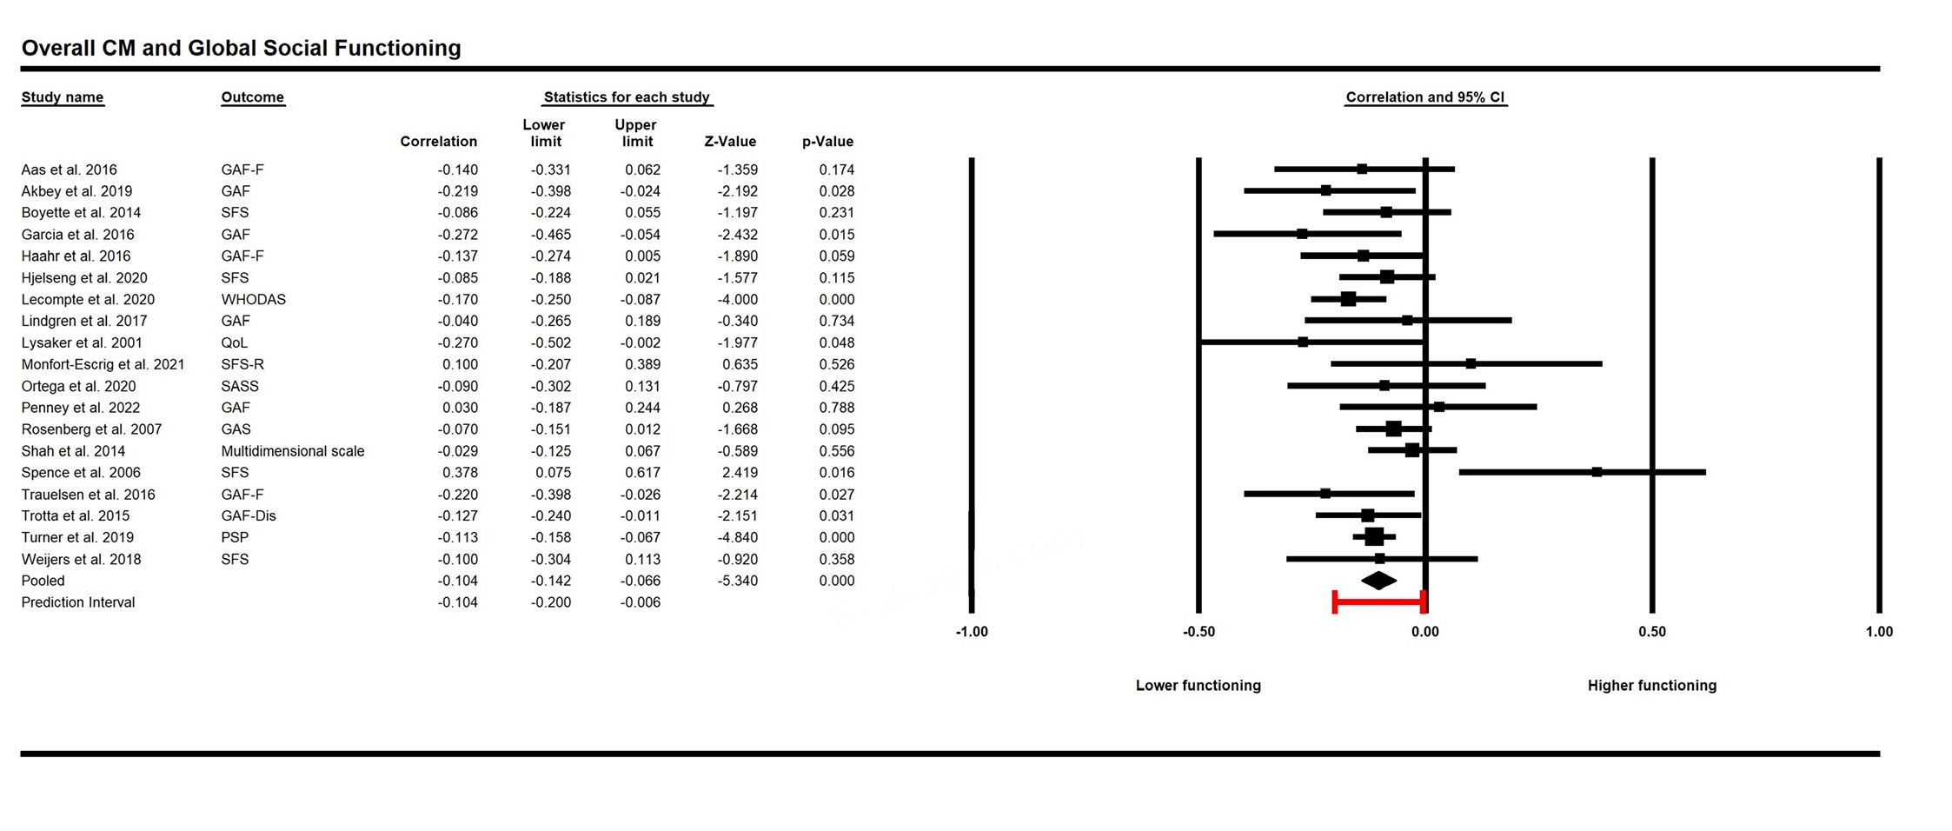
SF1a1. Forest plot for the association between overall childhood maltreatment and global social functioning

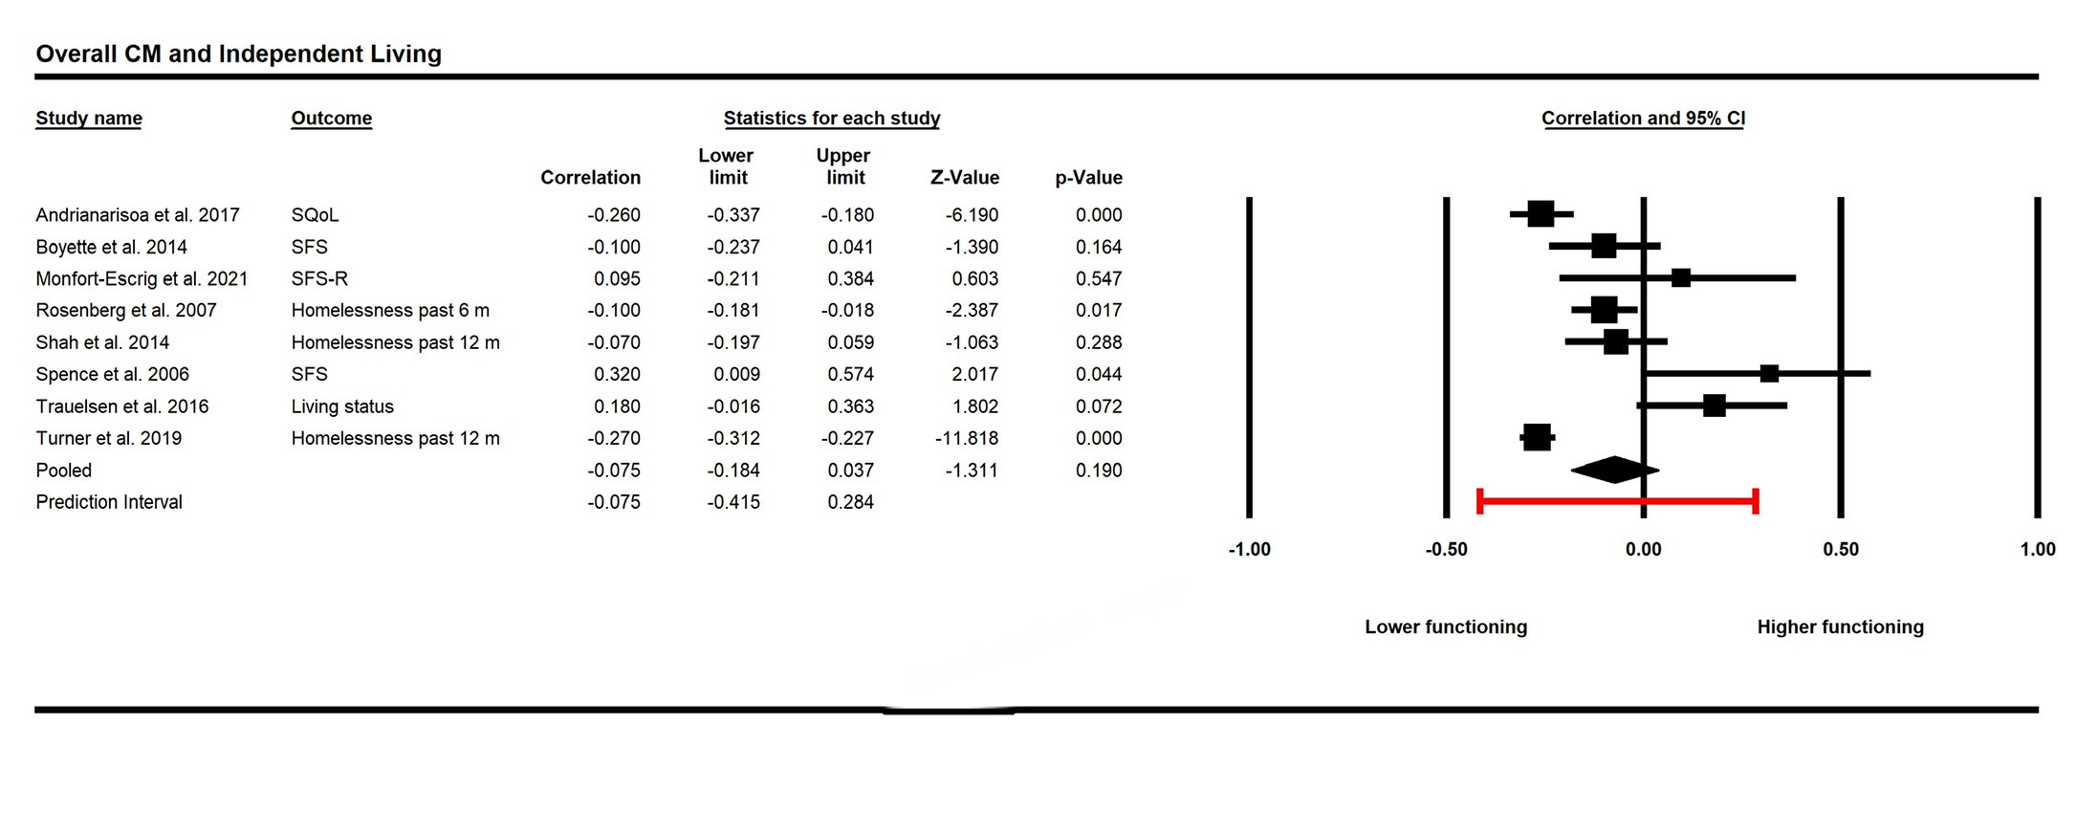
SF1a2. Forest plot for the association between overall childhood maltreatment and independent living

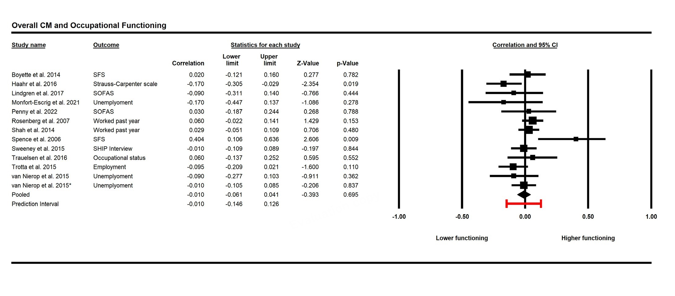
SF1a3. Forest plot for the association between overall childhood maltreatment and occupational functioning
Note: *Two effect sizes from two different populations in the same study were meta-analysed

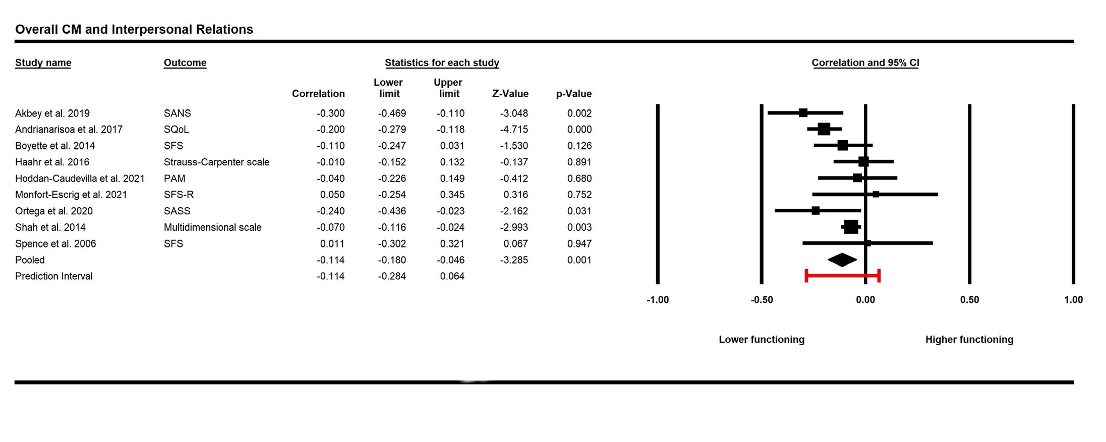
SF1a4. Forest plot for the association between overall childhood maltreatment and interpersonal relations

Note. Prediction interval of main analyses show that for the association between overall CM and Interpersonal Relations confidence interval passed 0. This indicates that there is likelihood that a fraction of the analysed population may have no association between overall CM and interpersonal relations.

SF1a5. Forest plot for the association between overall childhood maltreatment and aggressive behaviour

SF1b. Forest plots for the association between overall childhood maltreatment and social cognition domains

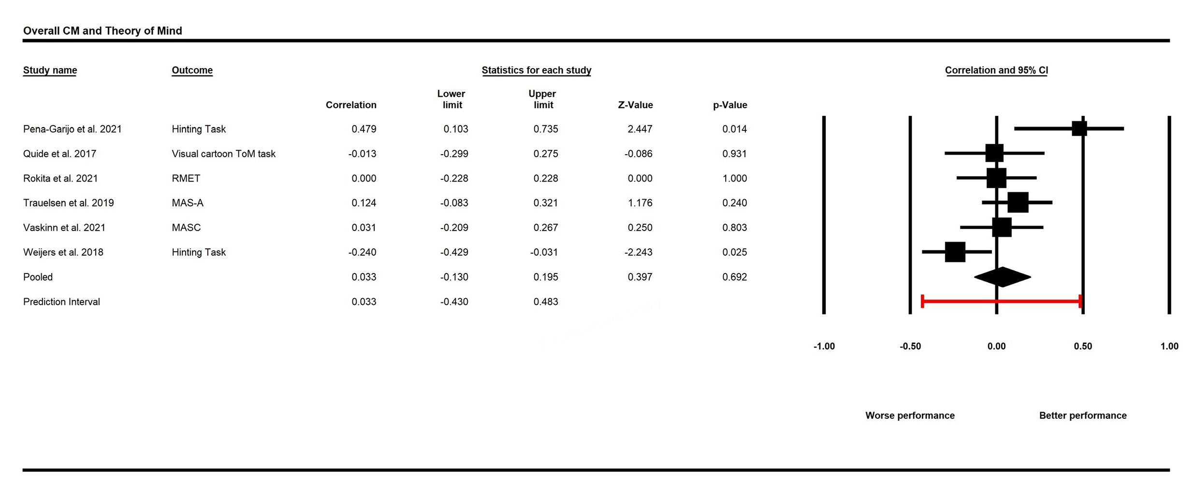
SF1b1. Forest plot for the association between overall childhood maltreatment and theory of mind

SF1b2. Forest plot for the association between overall childhood maltreatment and emotion processing

SF1c. Forest plots for the association between childhood maltreatment subtypes and social functioning domains

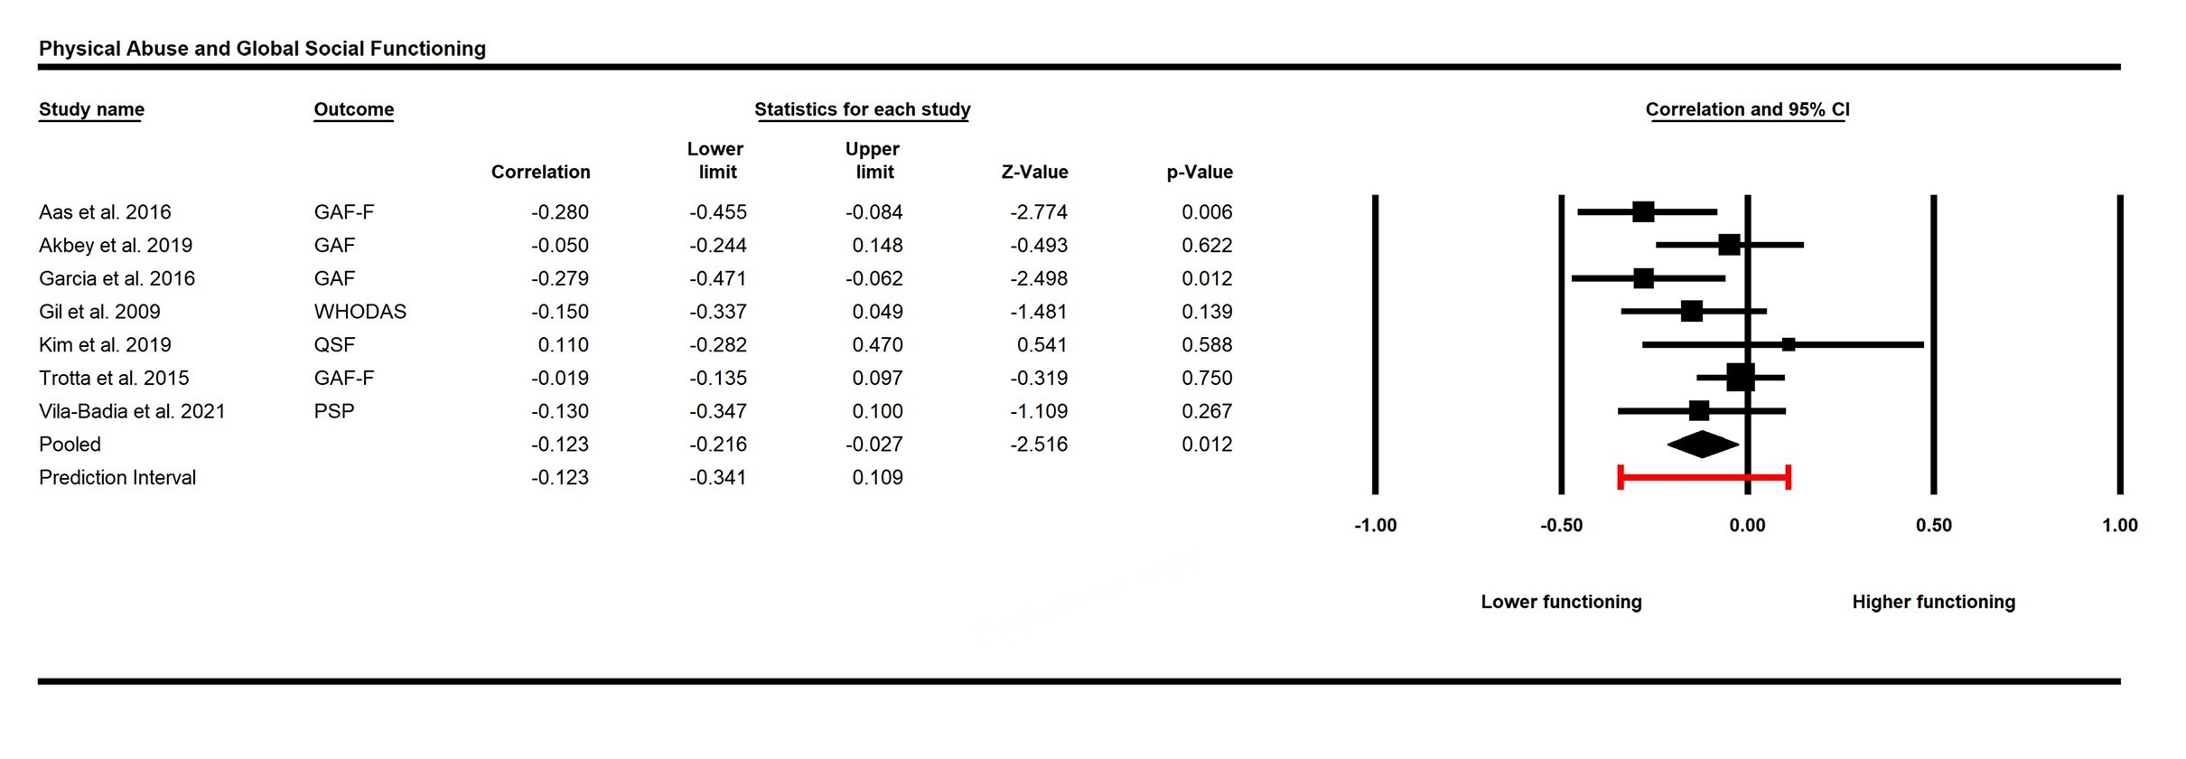
SF1c1. Forest plot for the association between physical abuse and global social functioning

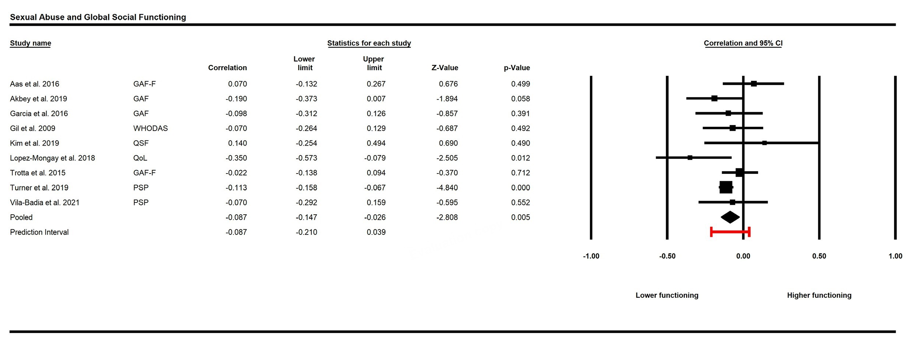
SF1c2. Forest plot for the association between sexual abuse and global social functioning

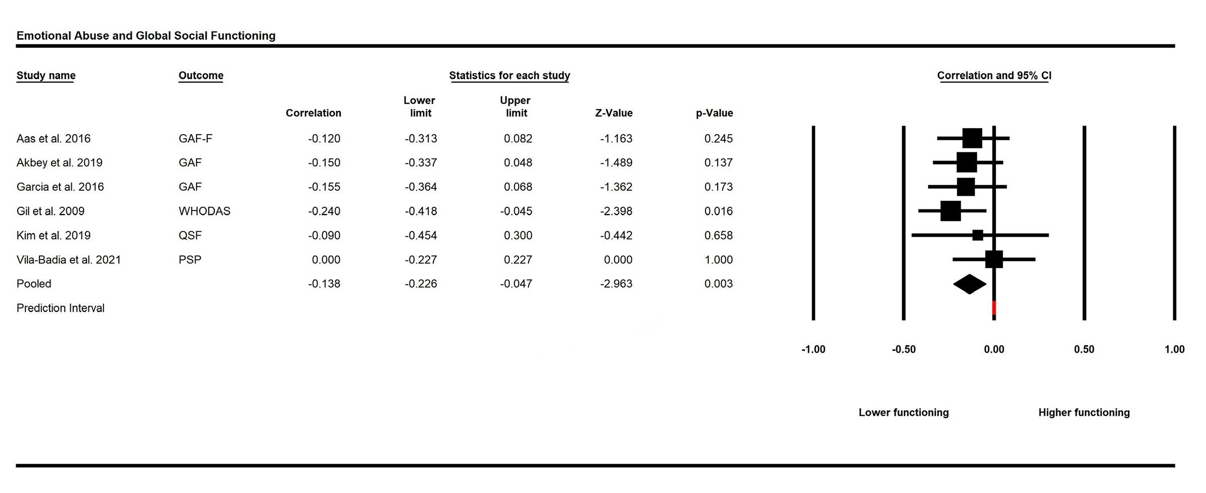
SF1c3. Forest plot for the association between emotional abuse and global social functioning

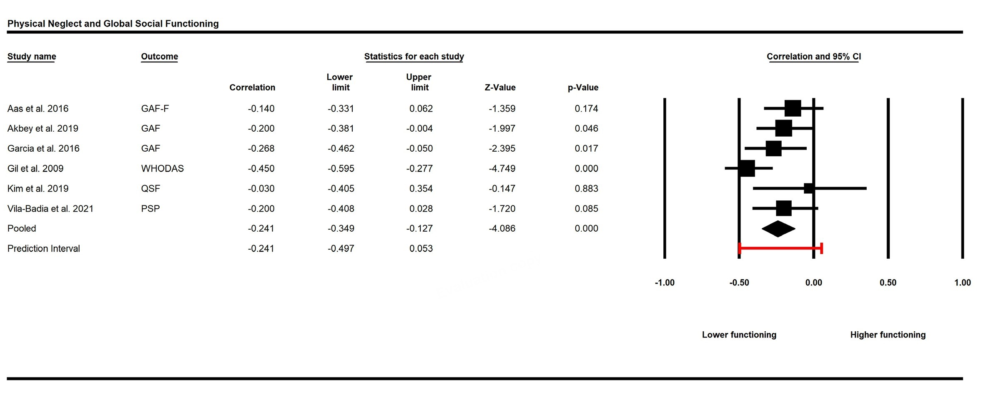
SF1c4. Forest plot for the association between physical neglect and global social functioning

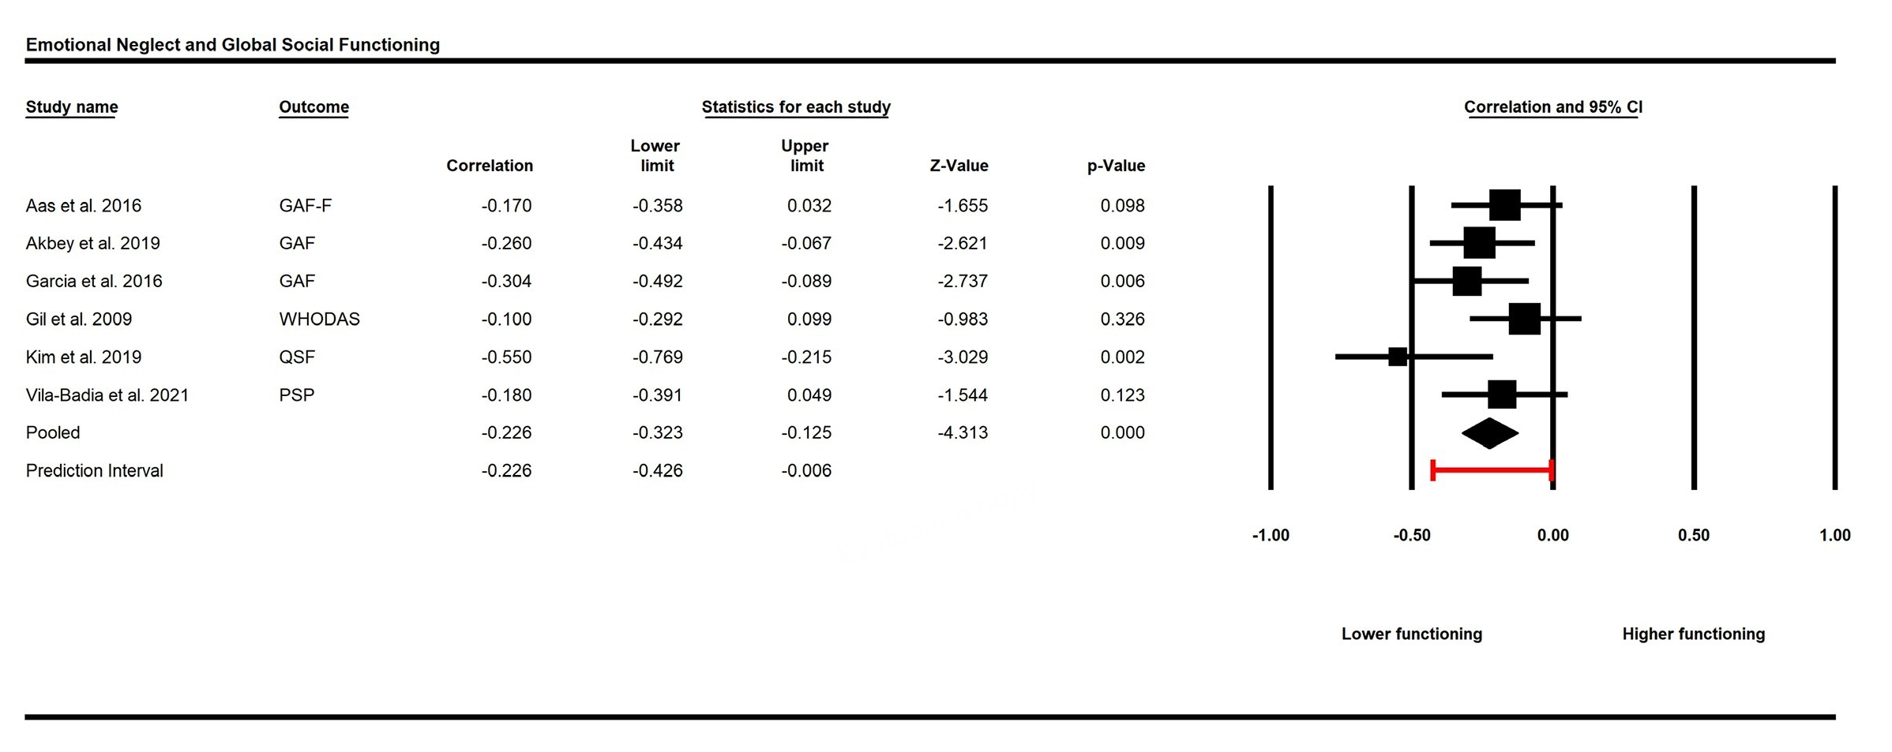
SF1c5. Forest plot for the association between emotional neglect and global social functioning

Note. Prediction intervals of main analyses show that for the associations between most CM subtypes (except for Emotional Neglect) and Global Social Functioning confidence interval passed 0. This indicates that there is likelihood that a fraction of the analysed populations may have no association between physical/emotional/sexual abuse and physical neglect and global social functioning.

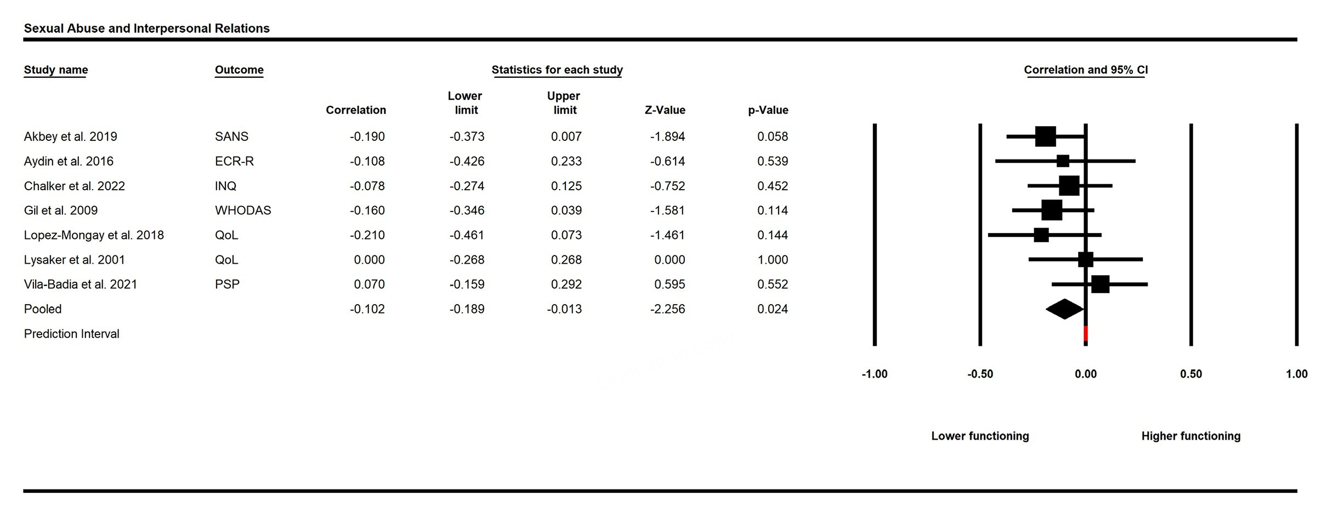
SF1c6. Forest plot for the association between sexual abuse and interpersonal relations

Note. Prediction interval of main analysis show that for the association between most Sexual Abuse and Interpersonal Relations confidence interval passed 0. This indicates that there is likelihood that a fraction of the analysed population may have no association between sexual abuse and interpersonal relations.
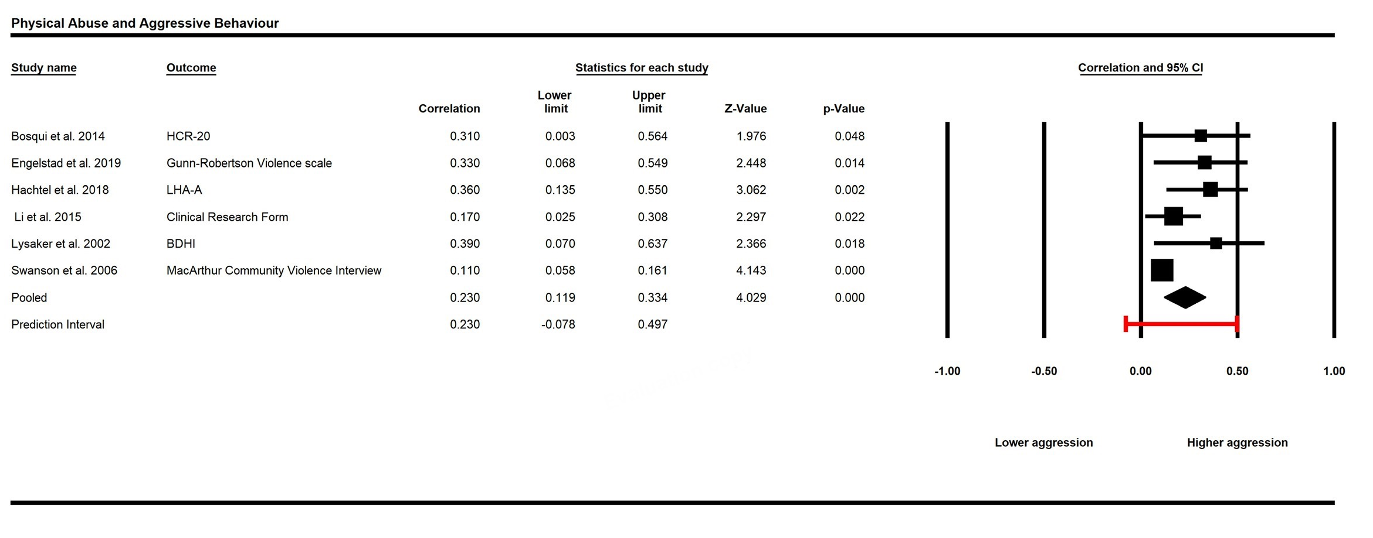
SF1c6. Forest plot for the association between physical abuse and aggressive behaviour

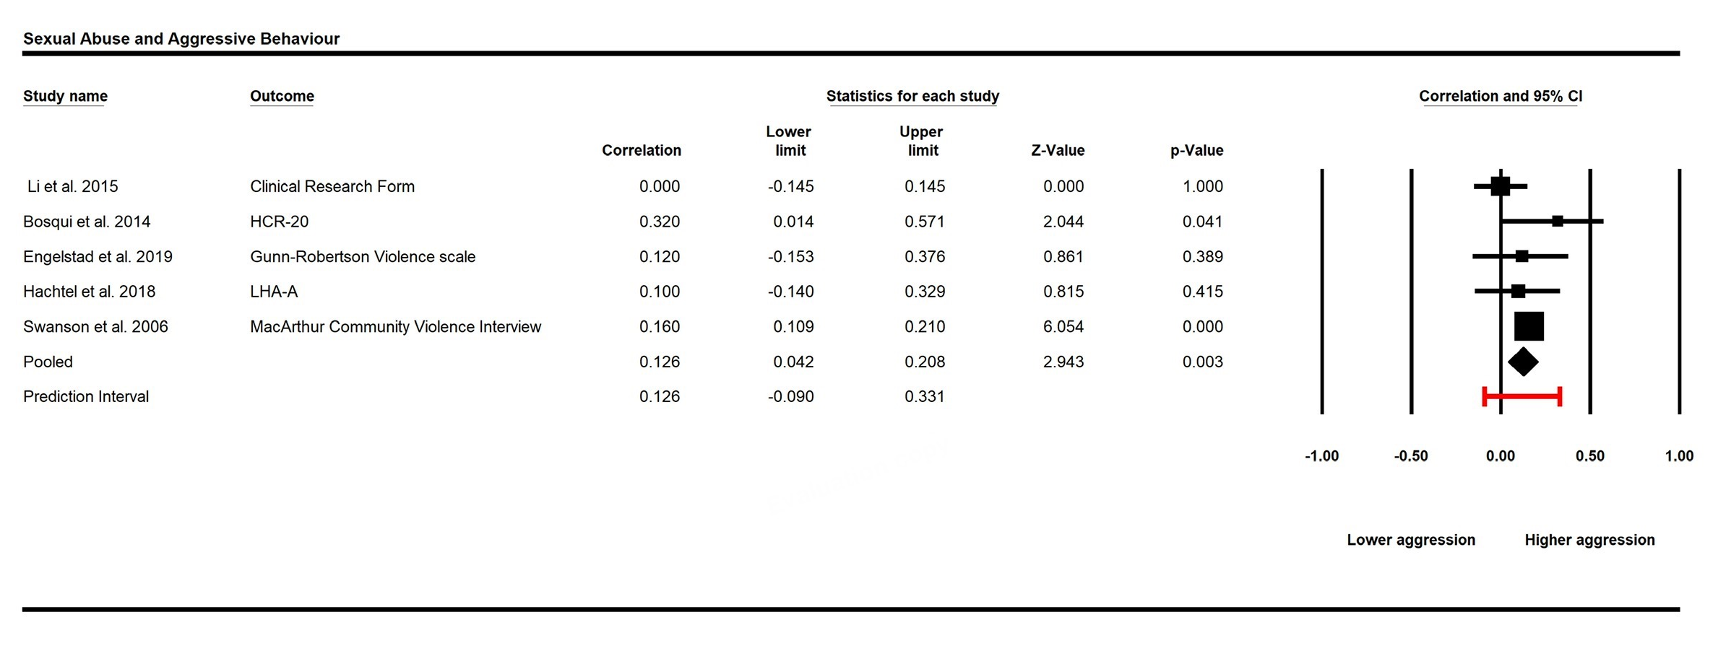

SF1c8. Forest plot for the association between sexual abuse and aggressive behaviour

Note. Prediction interval of main analyses show that for the association between CM subtypes and Aggressive Behaviour confidence interval passed 0. This indicates that there is likelihood that a fraction of the analysed population may have no association between physical/sexual abuse and aggressive behaviour.

SF1d. Forest plots for the association between childhood maltreatment subtypes and social cognition domains

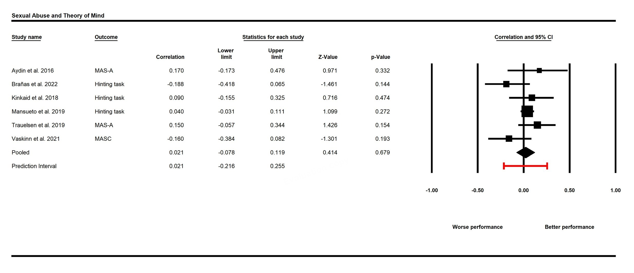

SF1d1. Forest plot for the association between sexual abuse and theory of mind

SF2. Sensitivity analyses for meta-analytical results with one study removed analysis

One-study-removed analysis did not change the patterns of most results with a few exceptions.
Social functioning: For the association between Overall CM and Independent Living, the removal of Spence et al. (r = -0.109 [95% CI = -0.213, -0.003], p = 0.043) and Trauelsen et al. (r = -0.115 [95% CI = -0.217, -0.010, p = 0.032] led to a negative association which were not observed with the inclusion of these studies. For the association between Sexual Abuse and Interpersonal Relations, the removal of Akbey et al. (r = -0.080 [95% CI = -0.177, 0.019, p = 0.115] led to a non-significant association.
Social cognition: For the association between Overall CM and Emotion Processing, the removal of Quidé et al. (r = -0.131 [95% CI = -0.253, -0.005, p = 0.032] led to a negative association which was not observed with the inclusion of this study.

SF2a. Sensitivity analyses for overall childhood maltreatment and social functioning domains with one study removed analysis

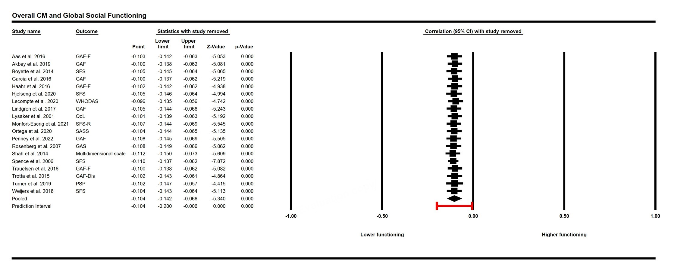
SF2a1. One study removed analysis for the association between overall childhood maltreatment and global social functioning

SF2a2. One study removed analysis for the association between overall childhood maltreatment and independent living

SF2a3. One study removed analysis for the association between overall childhood maltreatment and occupational functioning
Note: *Two effect sizes from two different populations from the same study were pooled

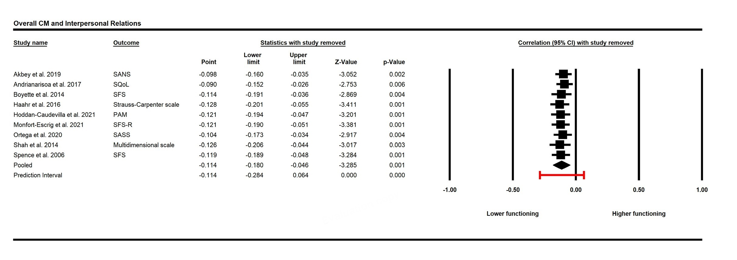
SF2a4. One study removed analysis for the association between overall childhood maltreatment and interpersonal relations

SF2a5. One study removed analysis for the association between overall childhood maltreatment and aggressive behaviour

SF2b. Sensitivity analyses for overall childhood maltreatment and social cognition domains with one study removed analysis

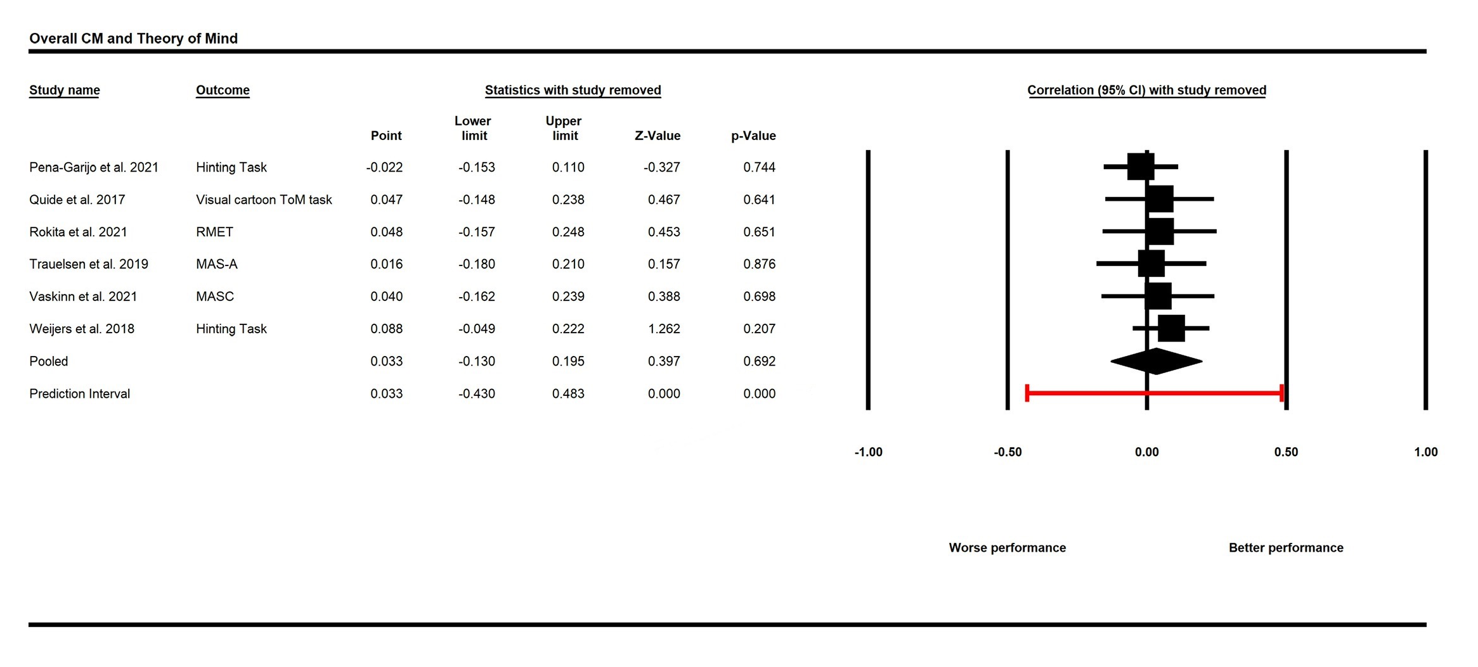
SF2b1. One study removed analysis for the association between overall childhood maltreatment and theory of mind

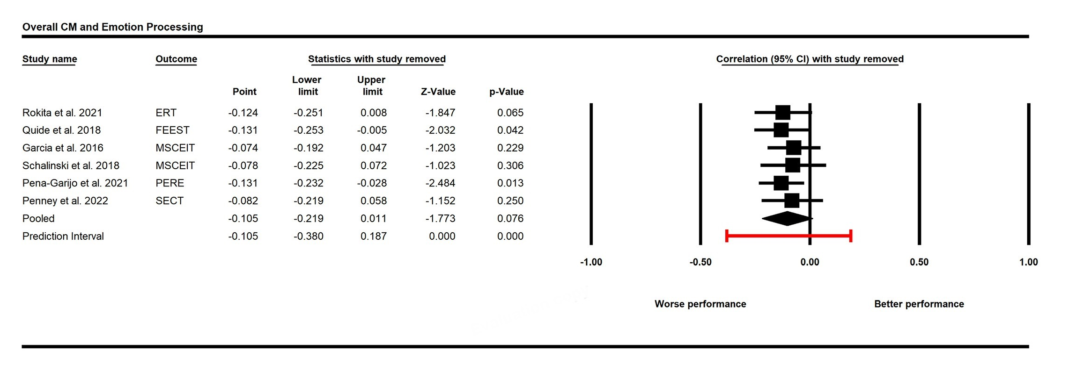
SF2b2. One study removed analysis for the association between overall childhood maltreatment and emotion processing

SF2c. Sensitivity analyses for childhood maltreatment subtypes and social functioning domains with one study removed analysis

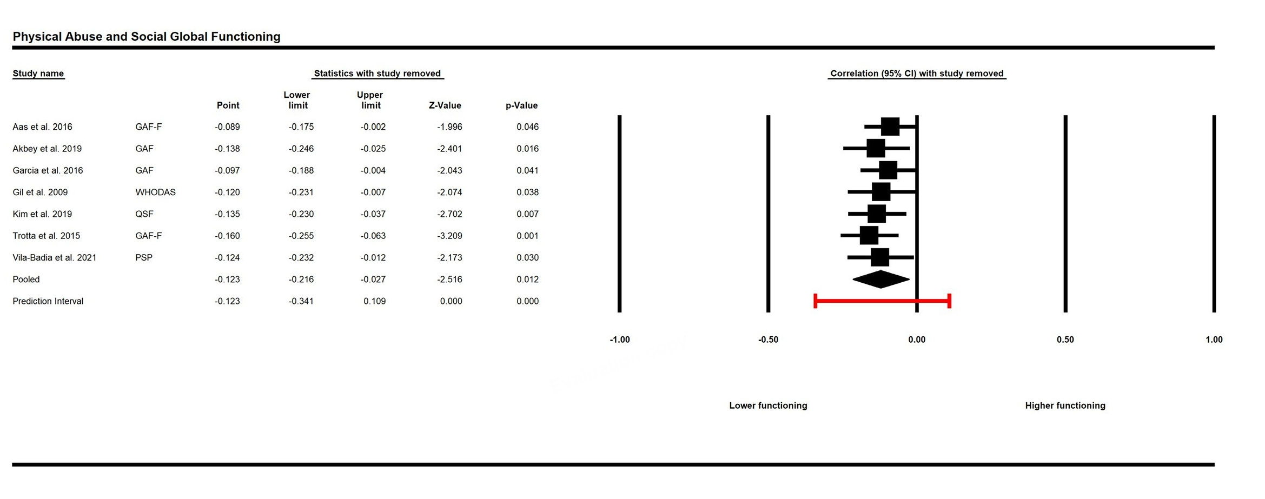

SF2c1. One study removed analysis for the association between physical abuse and global social functioning

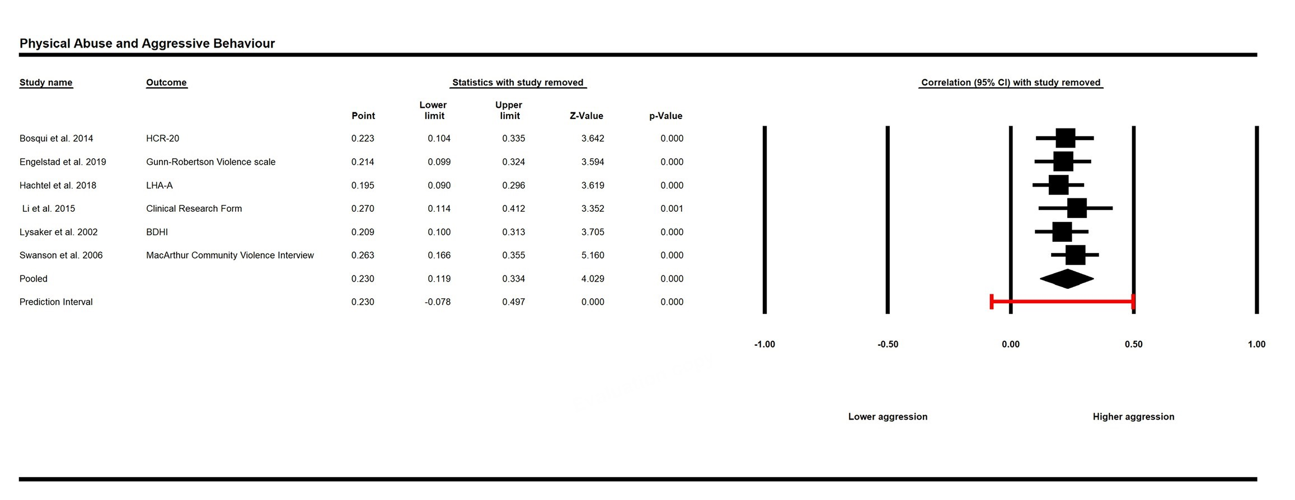

SF2c2. One study removed analysis for the association between physical abuse and aggressive behaviour

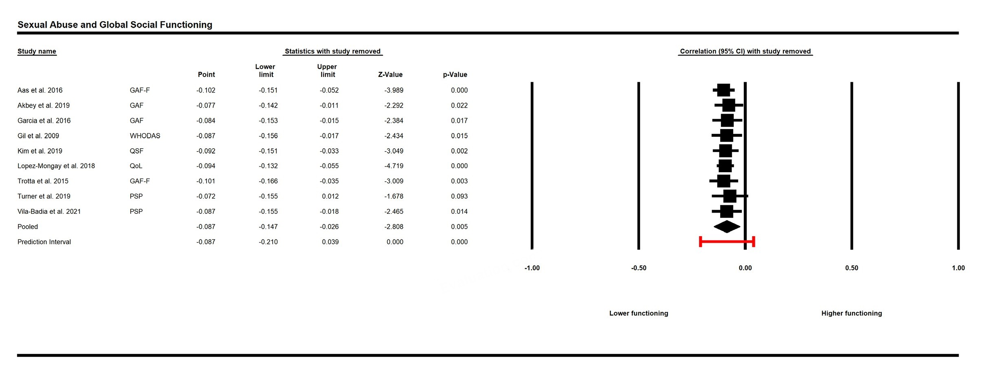
SF2c3. One study removed analysis for the association between sexual abuse and global social functioning

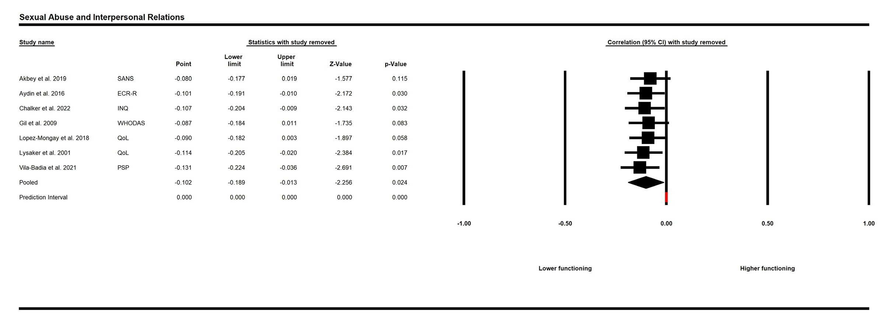

SF2c4. One study removed analysis for the association between sexual abuse and interpersonal relations

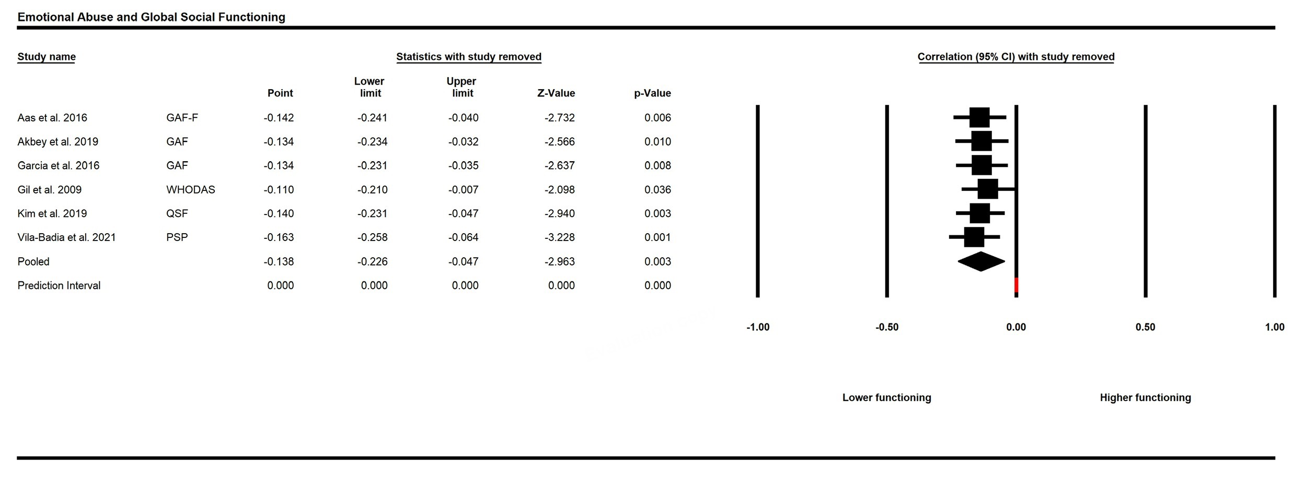
SF2c5. One study removed analysis for the association between emotional abuse and global social functioning

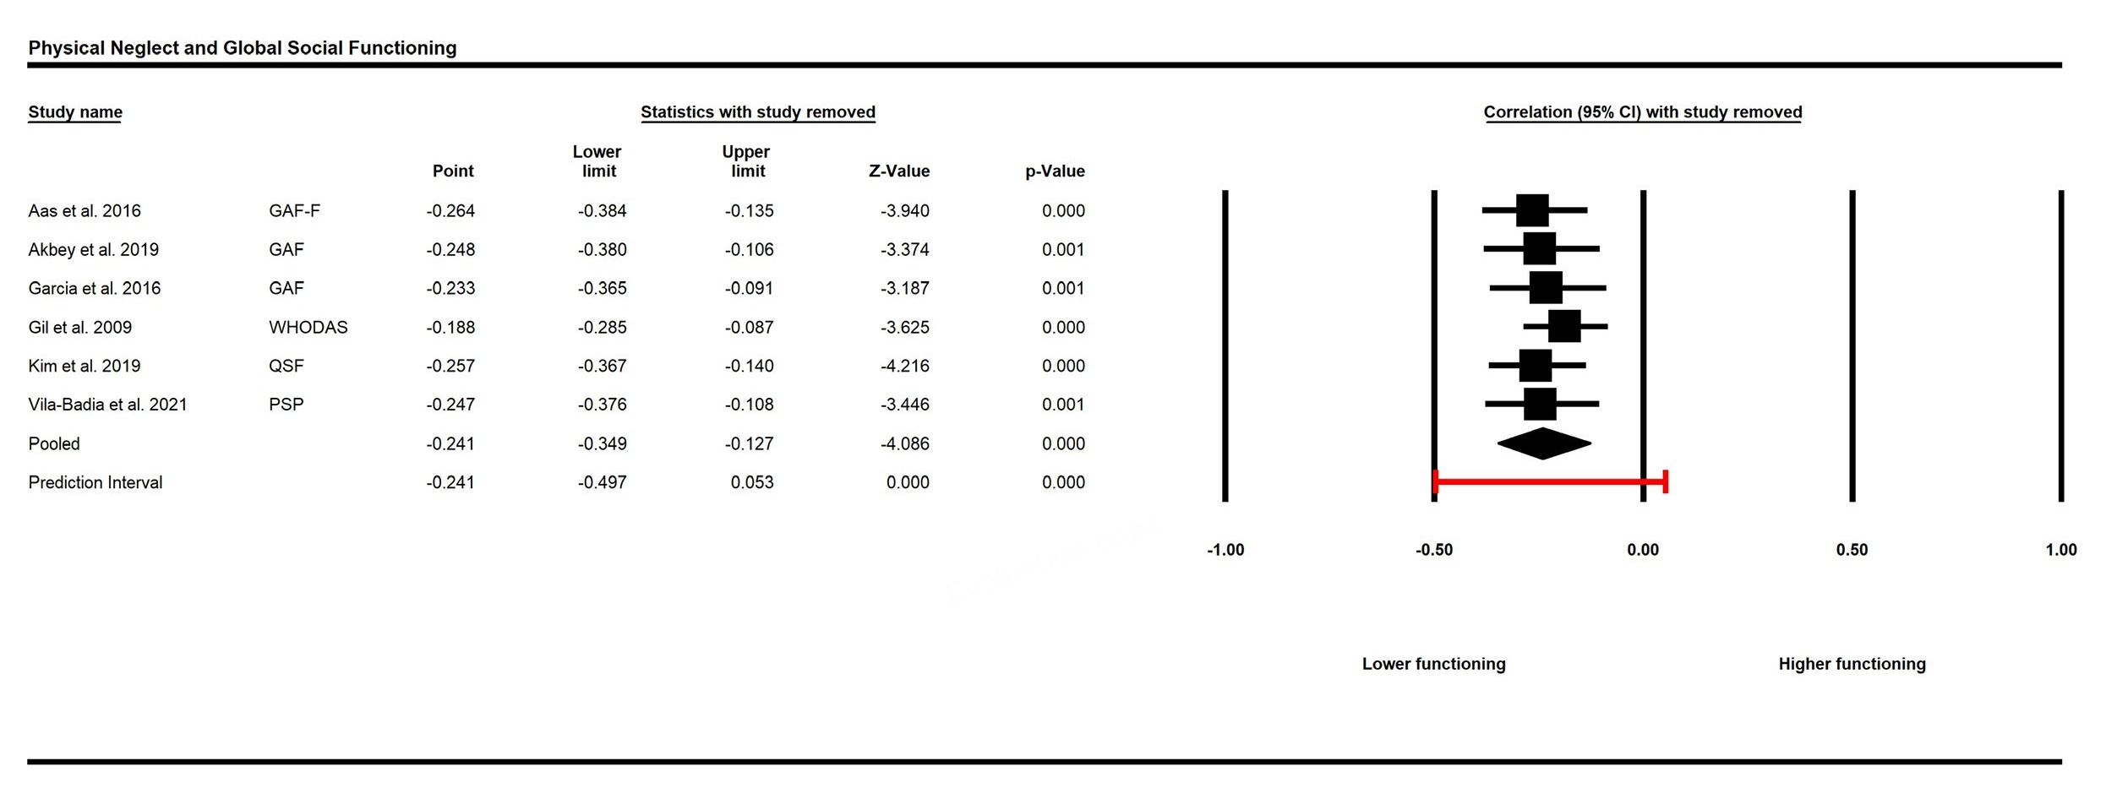
SF2c6. One study removed analysis for the association between physical neglect and global social functioning

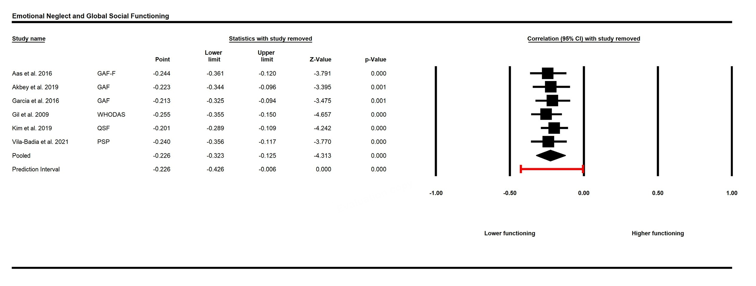
SF2c7. One study removed analysis for the association between emotional neglect and global social functioning

SF2d. Sensitivity analyses for childhood maltreatment subtypes and social cognition domains with one study removed analysis

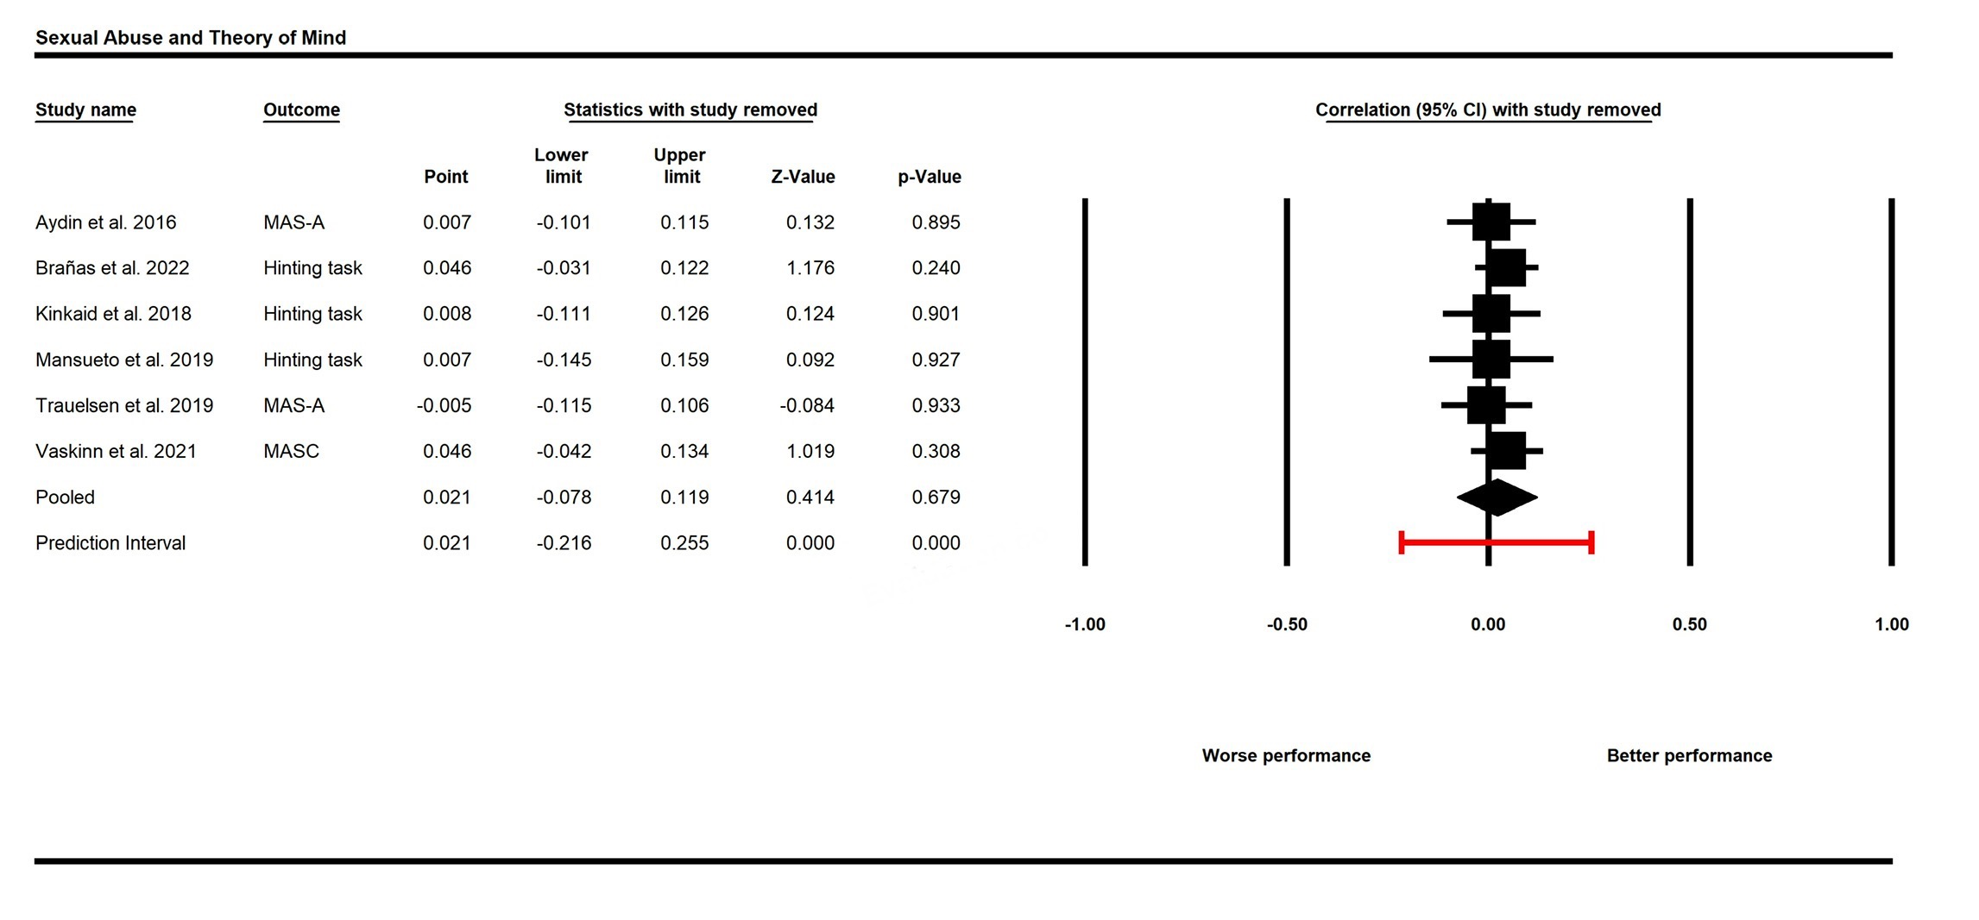
SF2d1. One study removed analysis for the association between emotional neglect and global social functioning

SF3. Funnel plots

SF3a. Funnel plots investigating publication bias for overall childhood maltreatment and social functioning domains

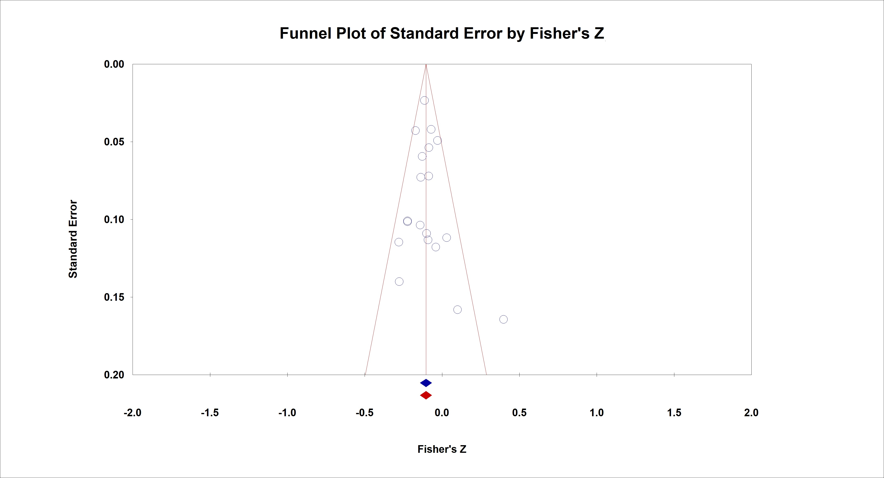
SF3a1. Funnel plot investigating publication bias for overall childhood maltreatment and global social functioning
Egger´s Test (-0.53, p = 0.602); Trim-and-Fill = corrected estimate does not change

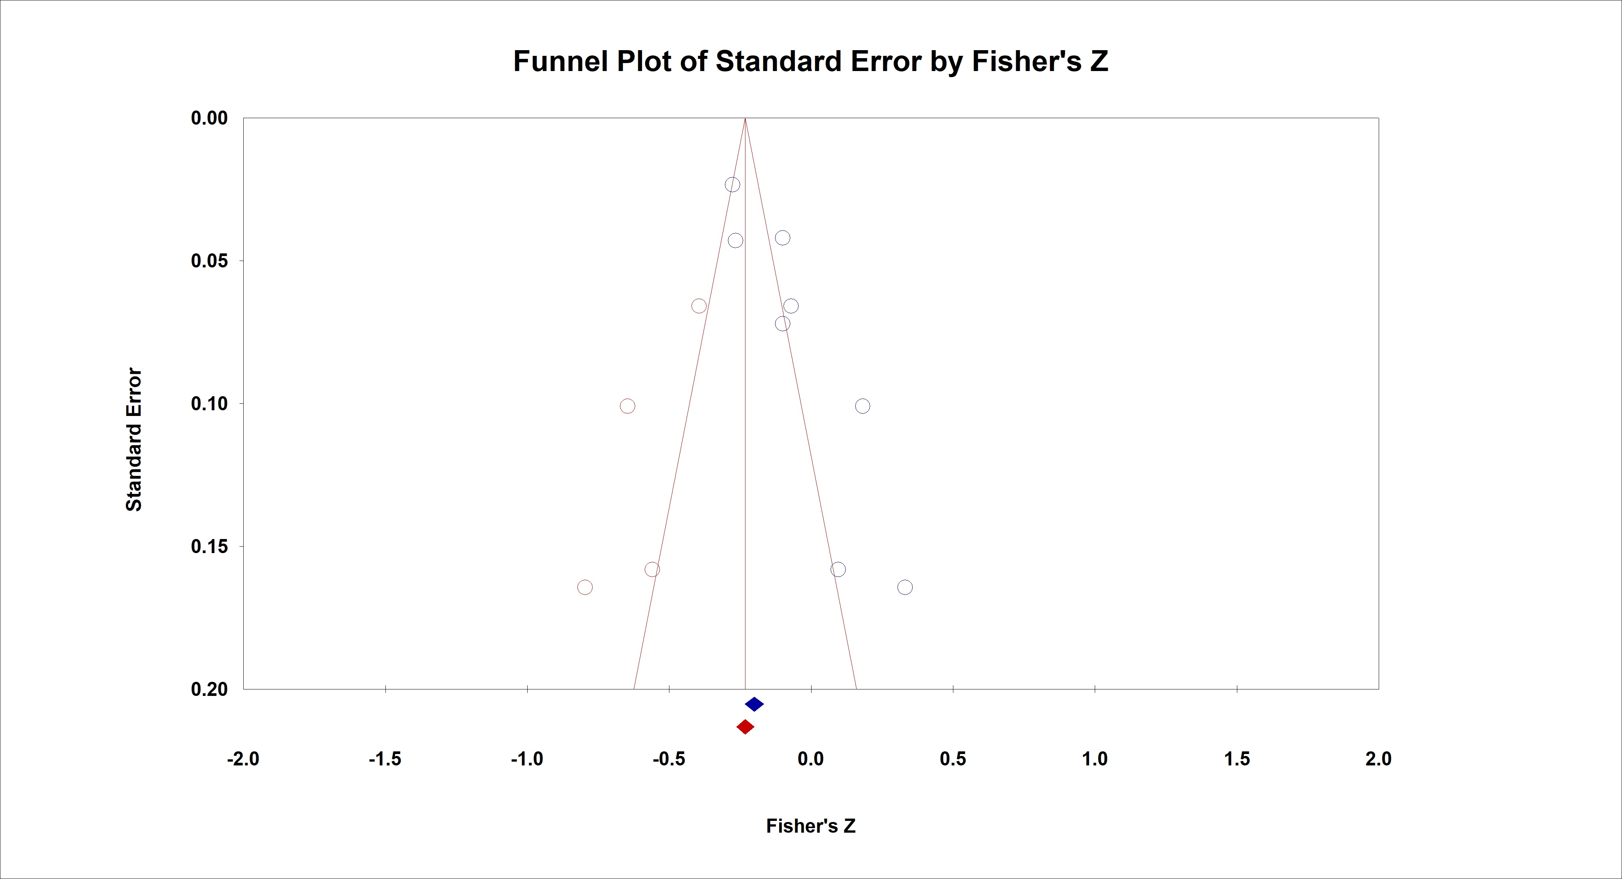
SF3a2. Funnel plot investigating publication bias for overall childhood maltreatment and independent living
Egger´s Test (4.60, p = 0.004); Trim-and-Fill = corrected estimate (-0.211; [CI = -0.315; -0.103])
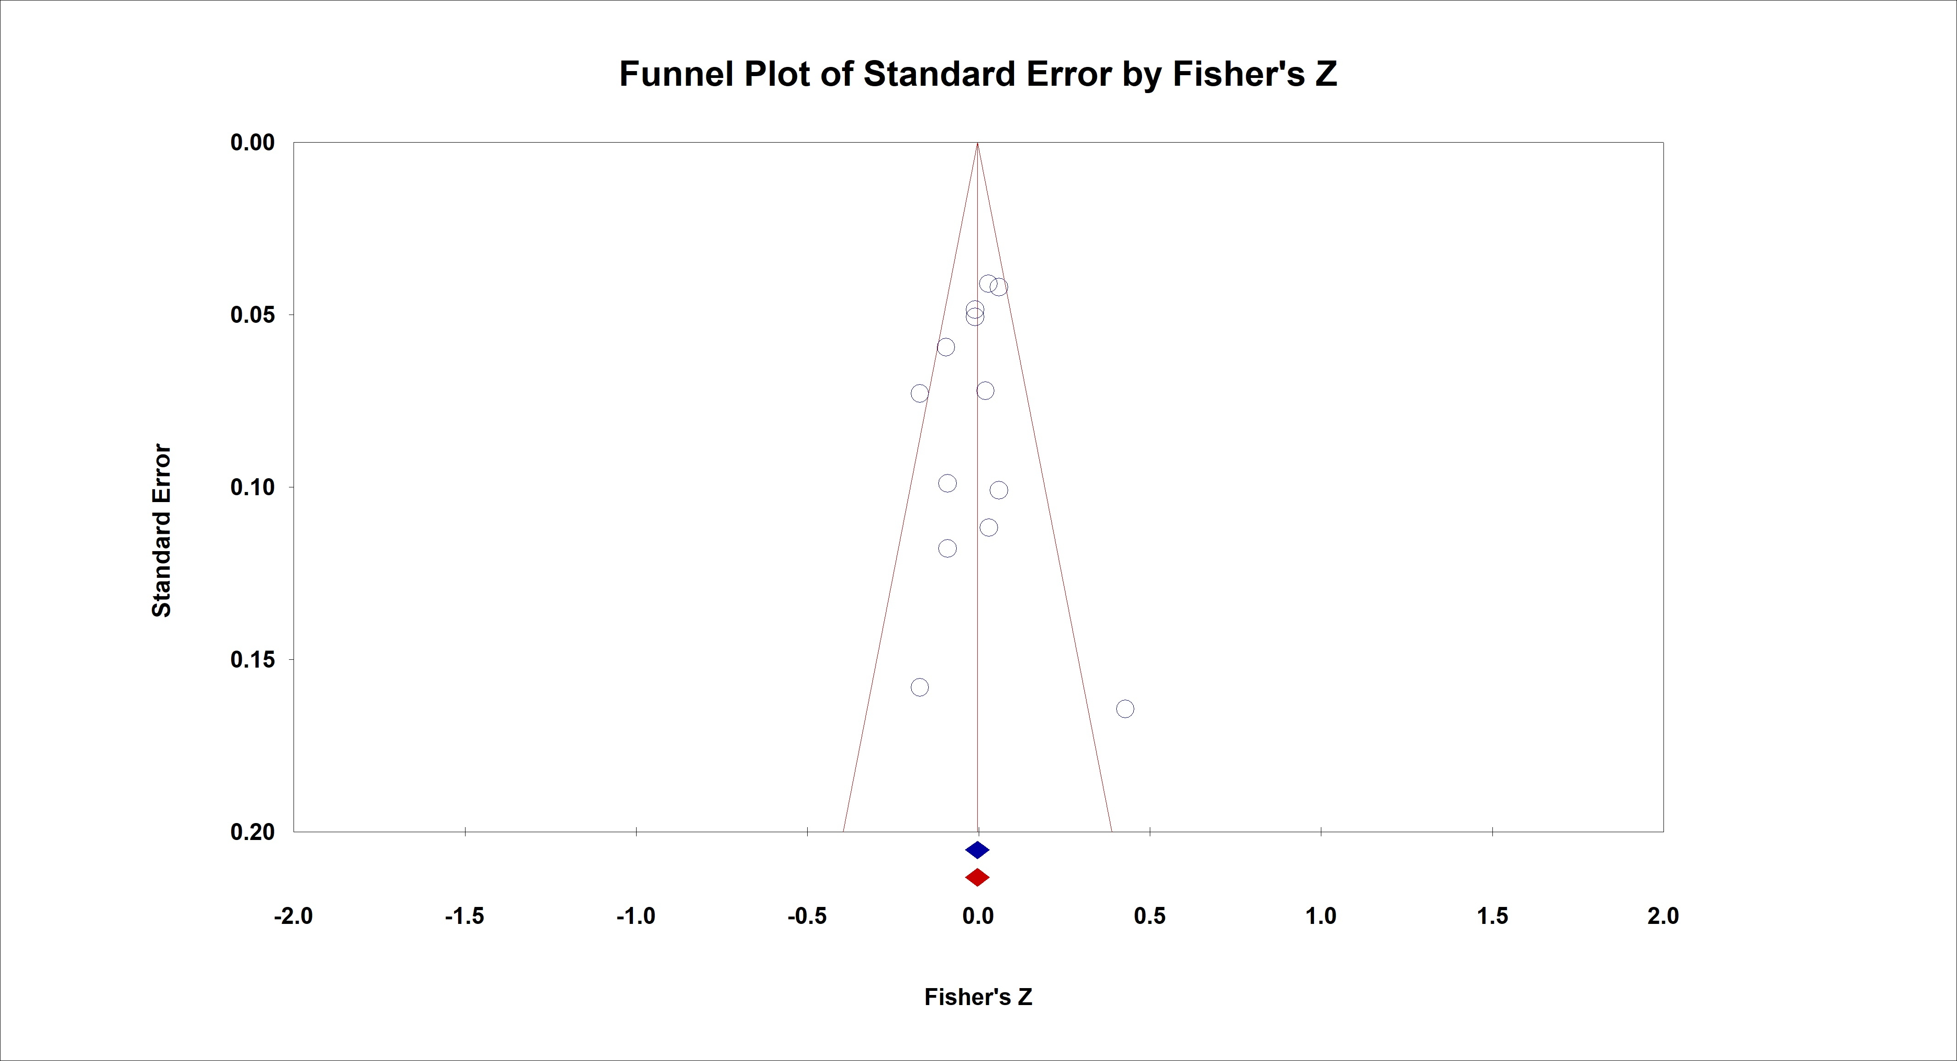
SF3a3. Funnel plot investigating publication bias for overall childhood maltreatment and occupational functioning
Egger´s Test (0.305, p = 0.766); Trim-and-Fill = corrected estimate does not change

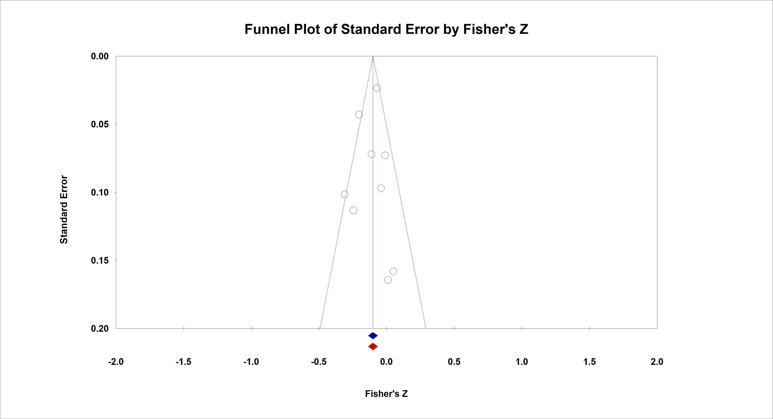
SF3a4. Funnel plot investigating publication bias for overall childhood maltreatment and interpersonal relations
Egger´s Test (0.397, p = 0.704); Trim-and-Fill = corrected estimate does not change

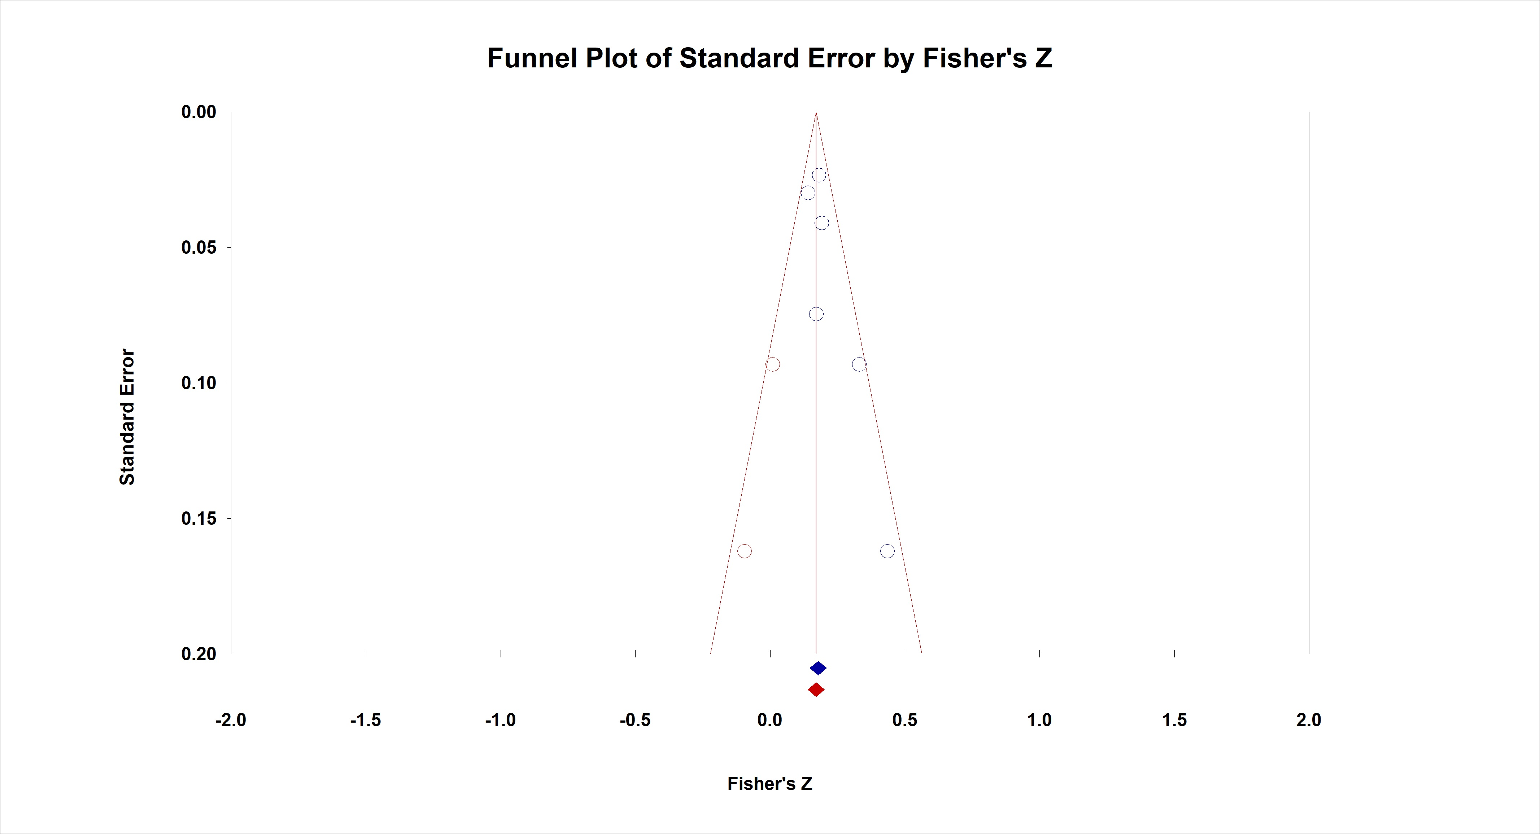
SF3a5. Funnel plot investigating publication bias for overall childhood maltreatment and aggressive behaviour
Egger´s Test (2.126, p = 0.101); Trim-and-Fill = corrected estimate (0.169; [CI = 0.117; 0.220])

SF3b Funnel plots investigating publication bias for overall childhood maltreatment and social cognition domains

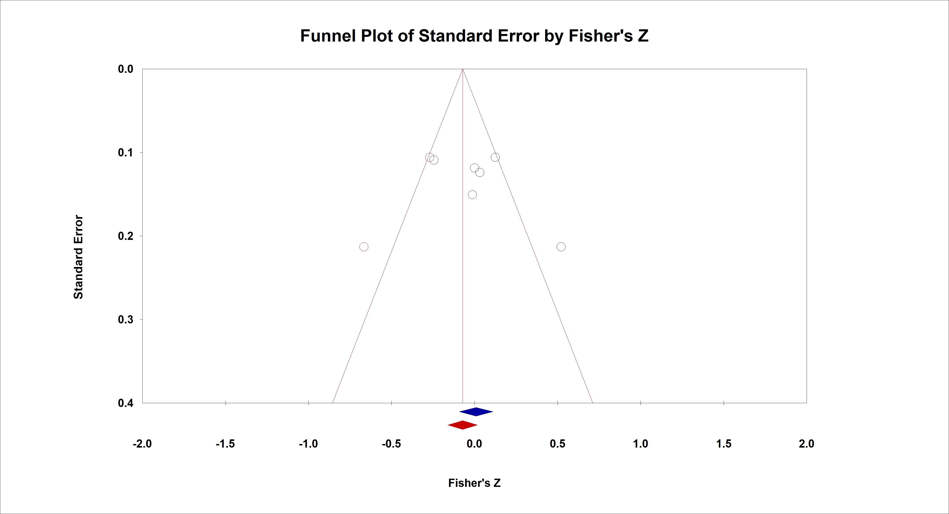
SF3b1. Funnel plot investigating publication bias for overall childhood maltreatment and theory of mind
Egger´s Test (1.602, p = 0.184); Trim-and-Fill = corrected estimate (-0.065 [CI = -0.239; 0.112])

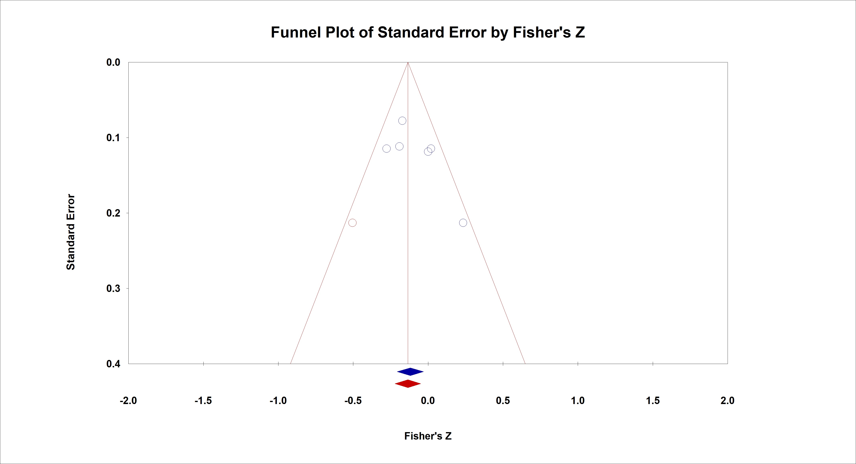
SF3b2. Funnel plot investigating publication bias for overall childhood maltreatment and emotion processing
Egger´s Test (1.622, p = 0.180); Trim-and-Fill = corrected estimate (-0.129 [-0.249, -0.004])

SF3c. Funnel plots investigating publication bias for childhood maltreatment subtypes and social functioning domains

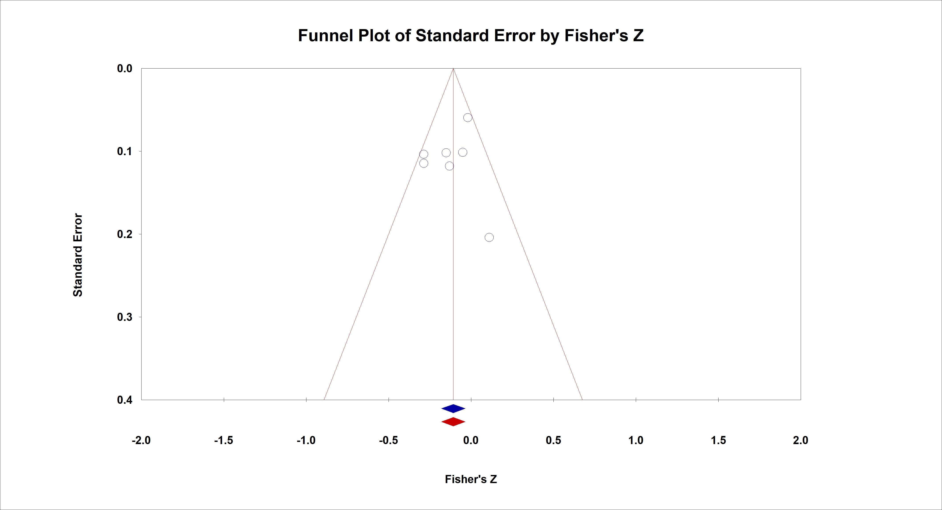
SF3c1. Funnel plot investigating publication bias for physical abuse and global social functioning
Egger´s Test (0.687, p = 0.523); Trim-and-Fill = corrected estimate does not change

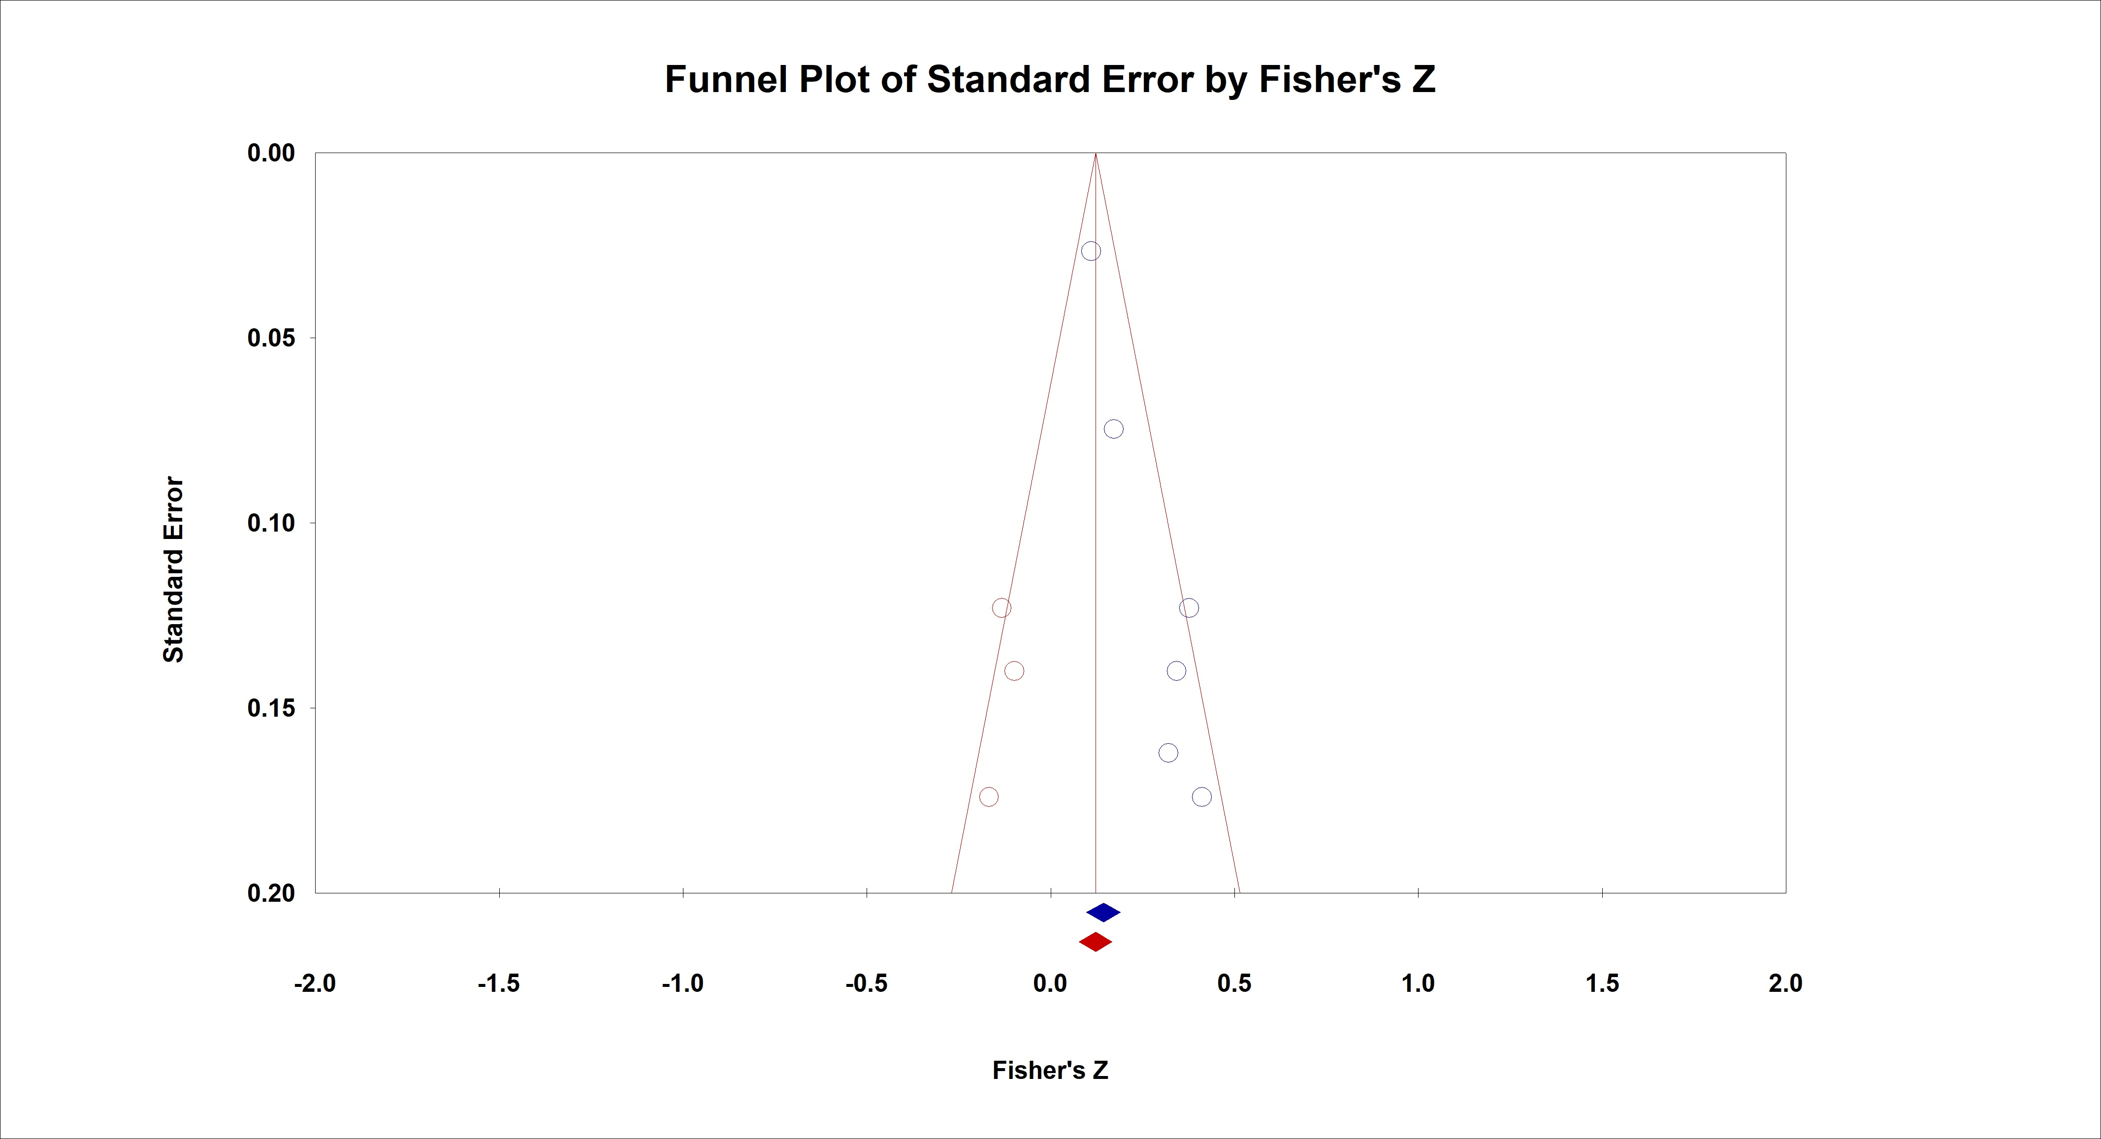
SF3c2. Funnel plot investigating publication bias for physical abuse and aggressive behaviour
Egger´s Test (7.54, p = 0.002); Trim-and-Fill = corrected estimate (0.142 [0.031; 0.251])
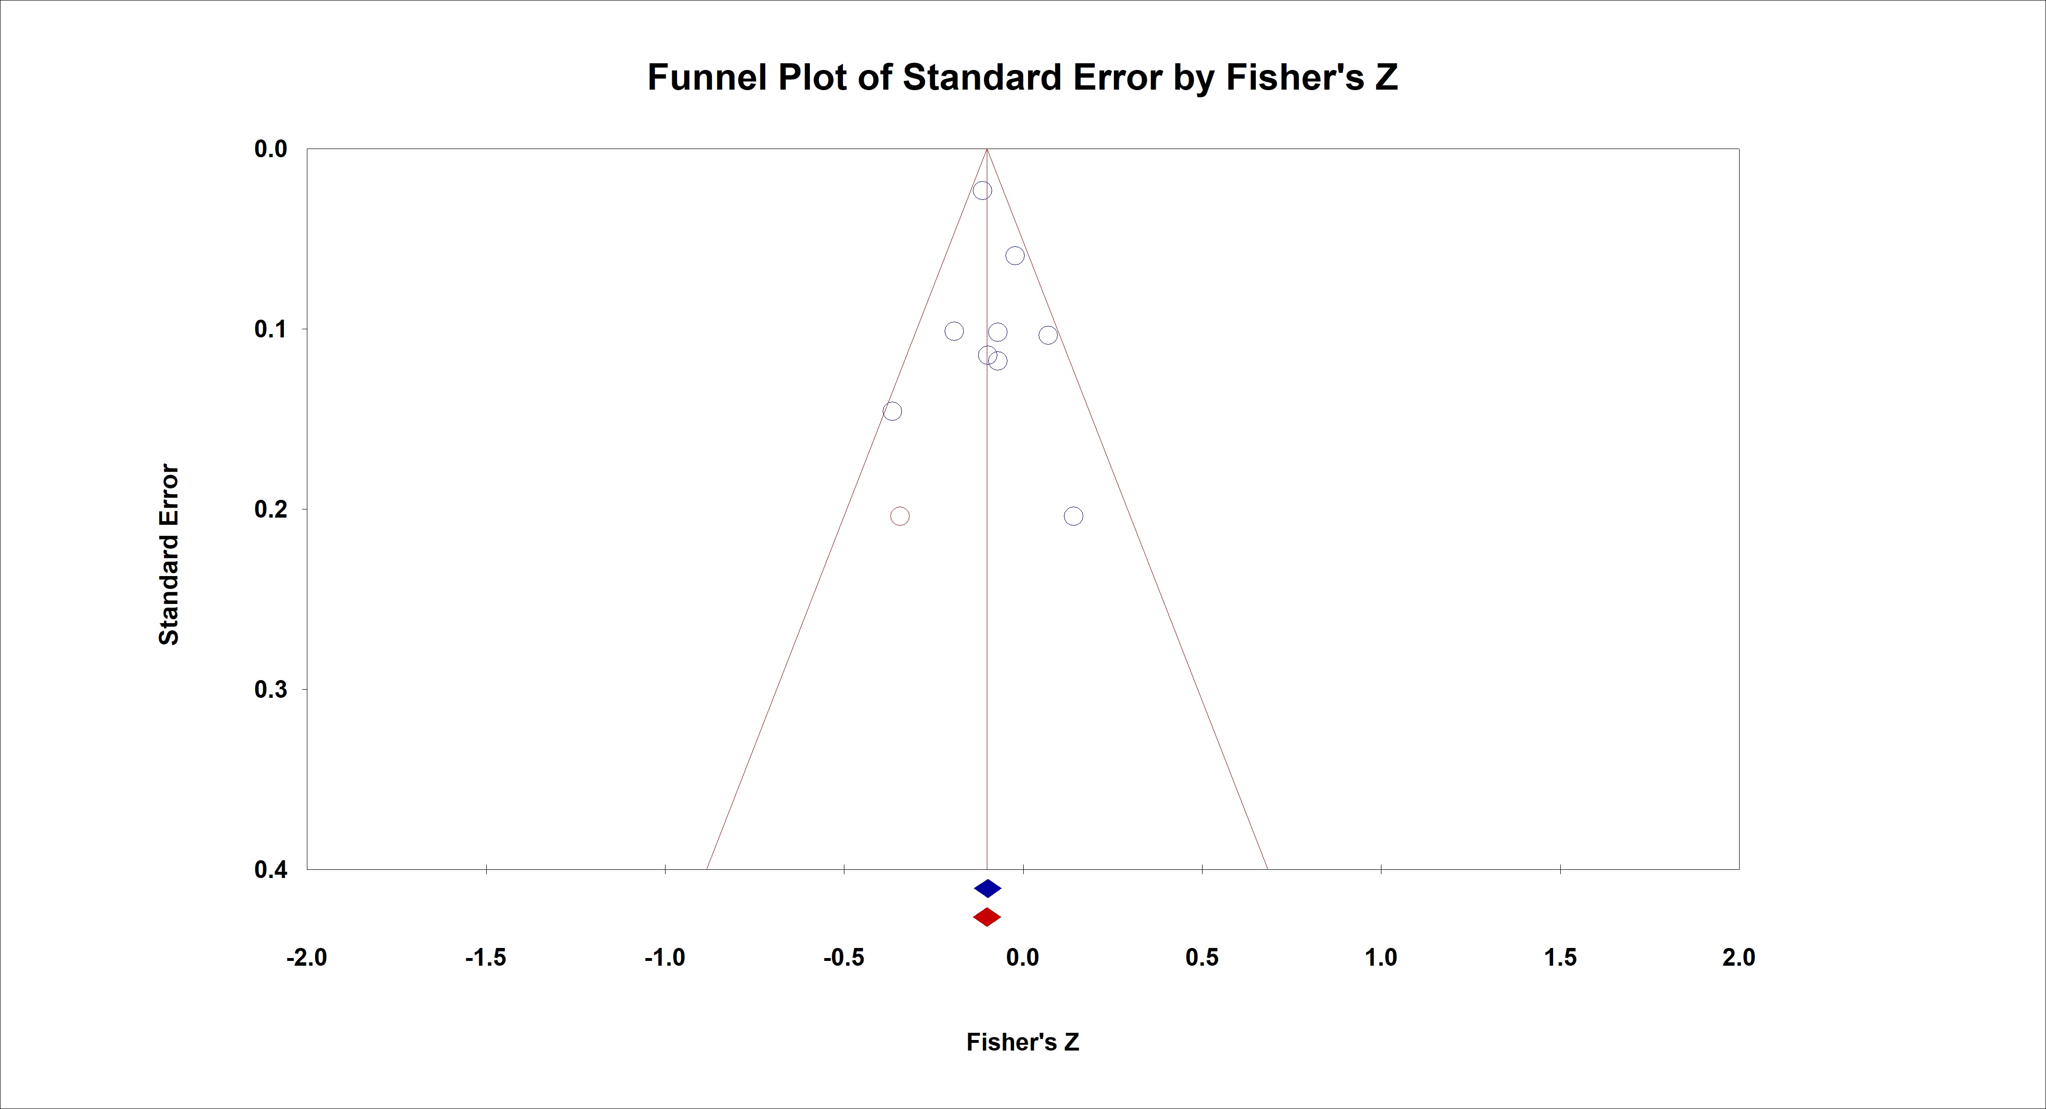
SF3c3. Funnel plot investigating publication bias for sexual abuse and global social functioning
Egger´s Test (0.549, p = 0.600); Trim-and-Fill = corrected estimate (-0.092 [CI = -0.153; -0.031])

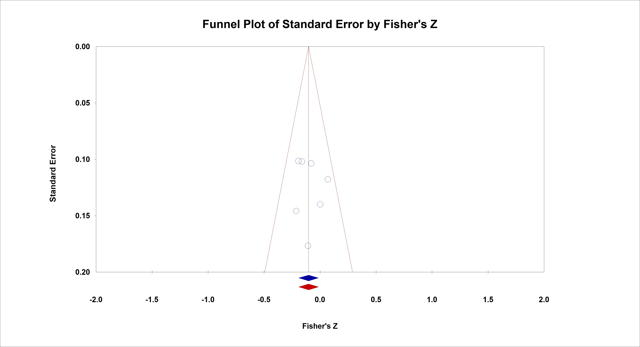
SF3c4. Funnel plot investigating publication bias for sexual abuse and interpersonal relations
Egger´s Test (0.345, p = 0.744); Trim-and-Fill = corrected estimate does not change

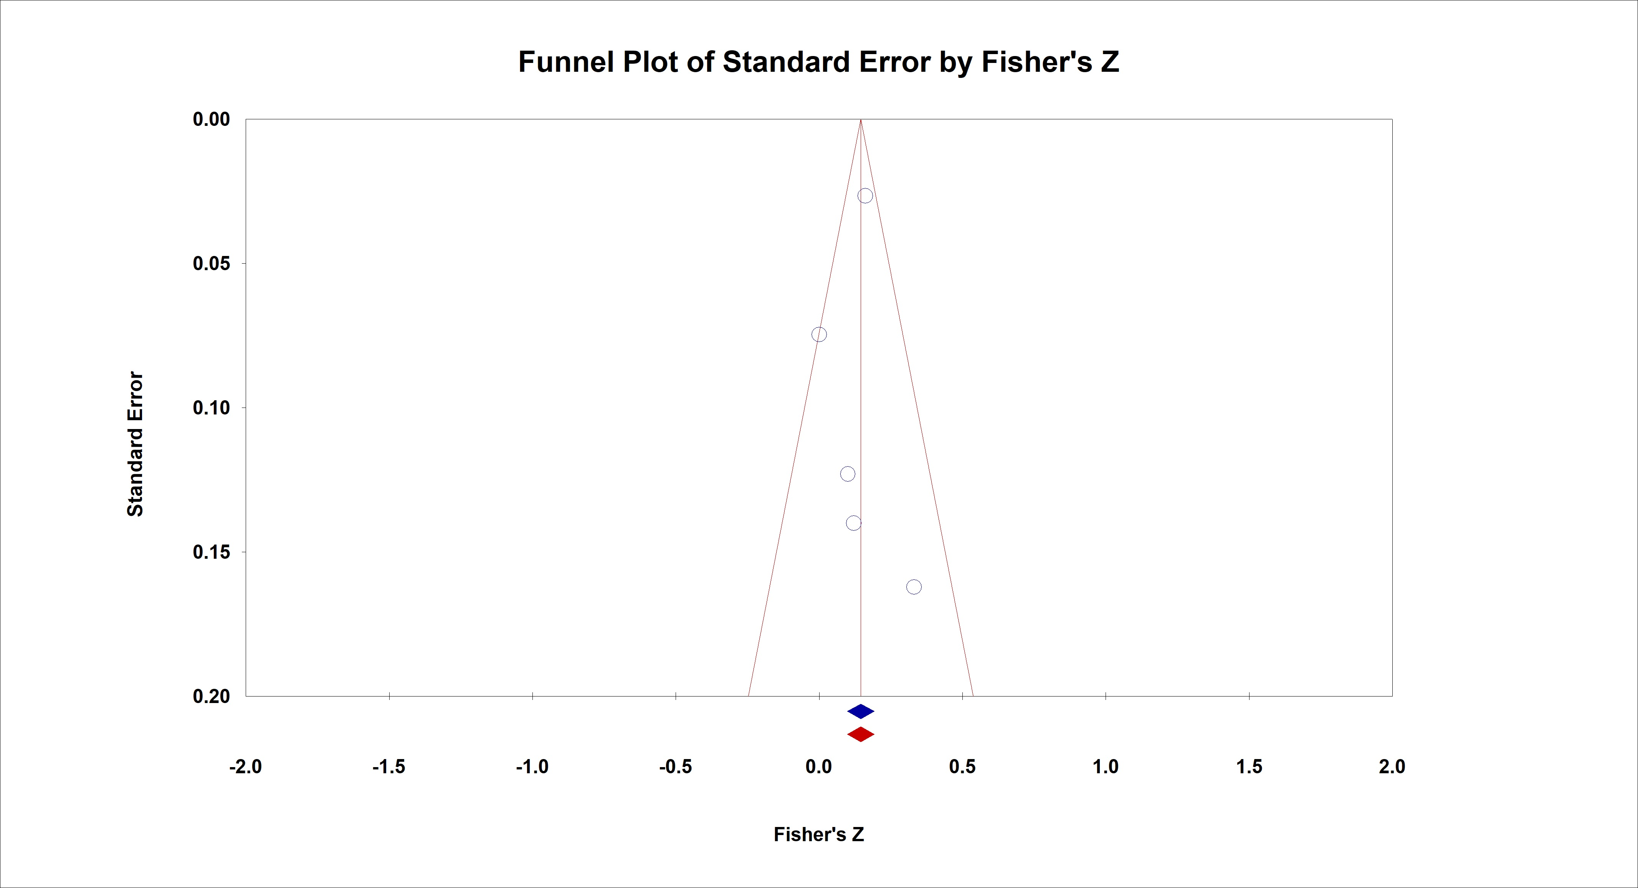
SF3c5. Funnel plot investigating publication bias for sexual abuse and aggressive behaviour
Egger´s Test (0.376, p = 0.732); Trim-and-Fill = corrected estimate does not change

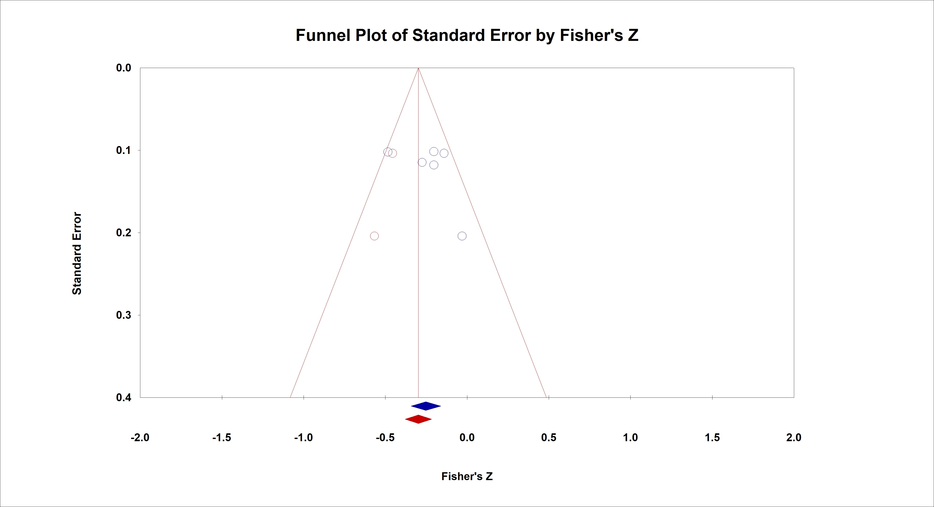
SF3c6. Funnel plot investigating publication bias for physical neglect and global social functioning
Egger´s Test (0.966, p = 0.389); Trim-and-Fill = corrected estimate (-0.288 [CI = -0.389; -0.179])

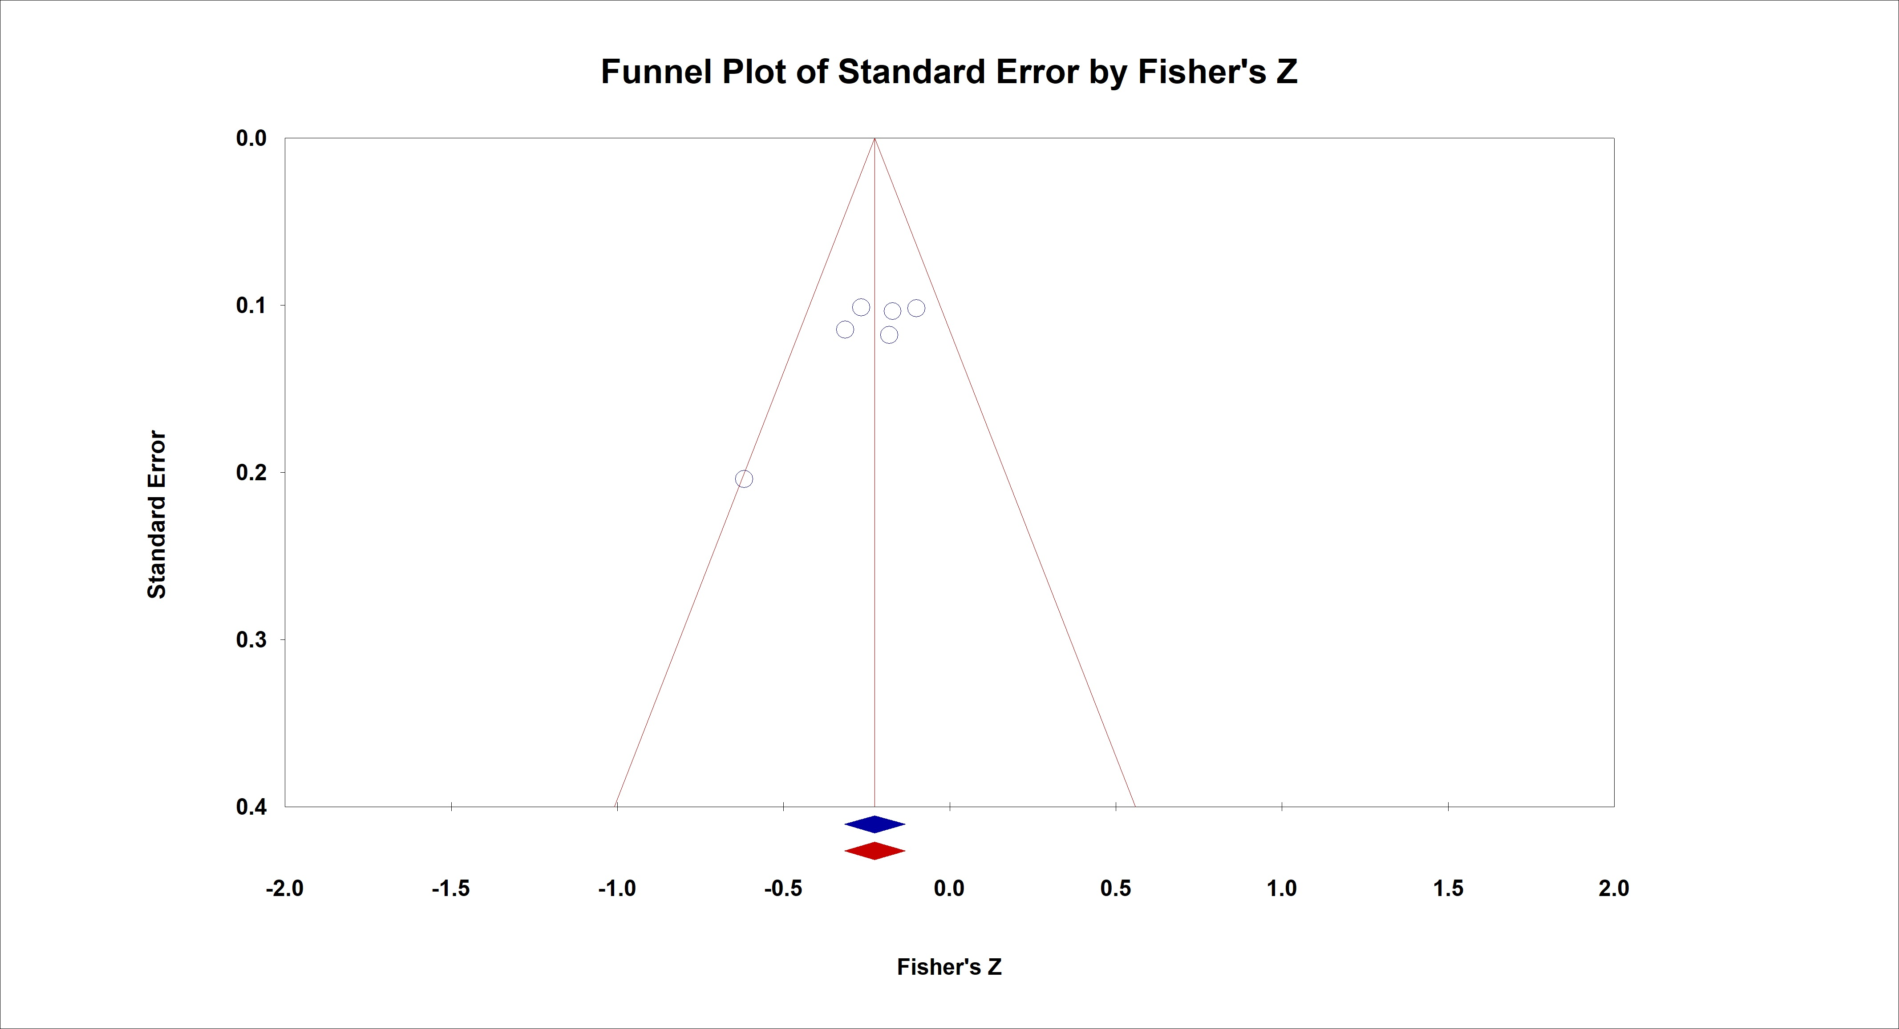
SF3c7. Funnel plot investigating publication bias for emotional neglect and global social functioning
Egger´s Test (2.772, p = 0.0502); Trim-and-Fill = corrected estimate does not change

SF3d. Funnel plots investigating publication bias for childhood maltreatment subtypes and social cognition domains

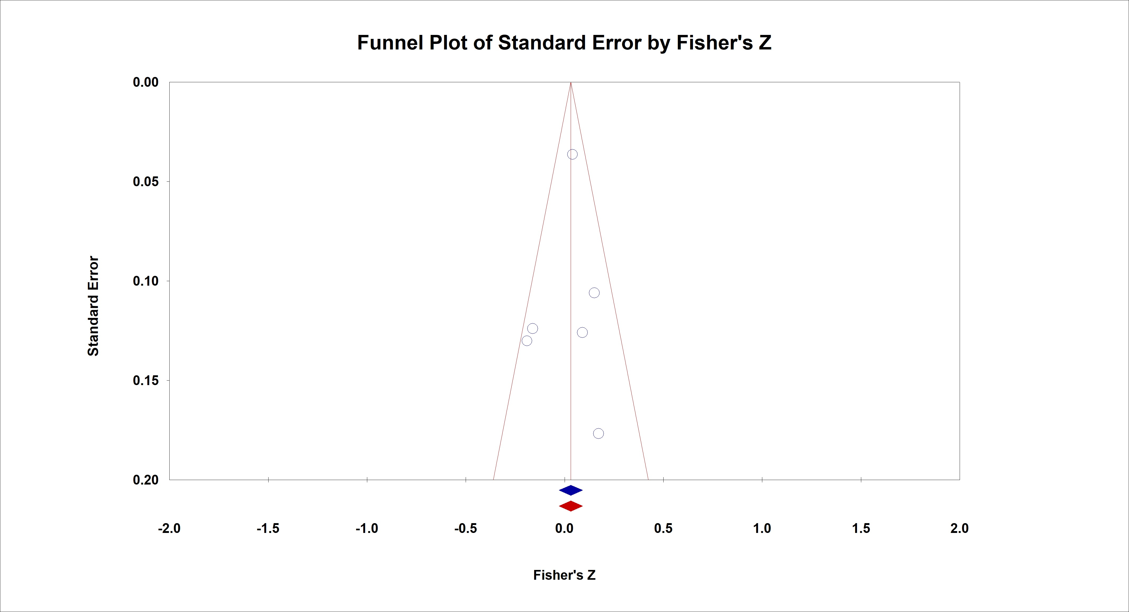
SF3d1. Funnel plot investigating publication bias for sexual abuse and theory of mind
Egger´s Test (0.333, p = 0.756); Trim-and-Fill = corrected estimate does not change

References

Aas, M, Kauppi, K., Brandt, C. L., Tesli, M., Kaufmann, T., Steen, N. E., … Melle, I. (2017a). Childhood trauma is associated with increased brain responses to emotionally negative as compared with positive faces in patients with psychotic disorders. Psychological Medicine, 47(4), 669–679. https://doi.org/10.1017/S0033291716002762
Aas, Monica, Andreassen, O. A., Aminoff, S. R., Færden, A., Romm, K. L., Nesvåg, R., … Melle, I. (2016). A history of childhood trauma is associated with slower improvement rates: Findings from a one-year follow-up study of patients with a first-episode psychosis. BMC Psychiatry, 16, 126–126. https://doi.org/10.1186/s12888-016-0827-4
Akbey, Z. Y., Yildiz, M., & Gündüz, N. (2019). Is There Any Association Between Childhood Traumatic Experiences, Dissociation and Psychotic Symptoms in Schziophrenic Patients? Psychiatry Investigation, 16(5), 346–354. https://doi.org/10.30773/pi.2019.02.10.2
Andrianarisoa, M., Boyer, L., Godin, O., Brunel, L., Bulzacka, E., Aouizerate, B., … FACE-SCZ Group. (2017). Childhood trauma, depression and negative symptoms are independently associated with impaired quality of life in schizophrenia. Results from the national FACE-SZ cohort. Schizophrenia Research, 185, 173–181. https://doi.org/10.1016/j.schres.2016.12.021
Aydin, O., Balikci, K., Tas, C., Aydin, P. U., Danaci, A. E., Brüne, M., & Lysaker, P. H. (2016). The developmental origins of metacognitive deficits in schizophrenia. Psychiatry Research, 245, 15–21. https://doi.org/10.1016/j.psychres.2016.08.012
Birchwood, M., Smith, J., Cochrane, R., Wetton, S., & Copestake, S. (1990). The Social Functioning Scale. The development and validation of a new scale of social adjustment for use in family intervention programmes with schizophrenic patients. The British Journal of Psychiatry: The Journal of Mental Science, 157, 853–859. https://doi.org/10.1192/bjp.157.6.853
Bonfils, K. A., Lysaker, P. H., Minor, K. S., & Salyers, M. P. (2017). Empathy in schizophrenia: A meta-analysis of the Interpersonal Reactivity Index. Psychiatry Research, 249, 293–303. https://doi.org/10.1016/j.psychres.2016.12.033
Bosqui, T. J., Shannon, C., Tiernan, B., Beattie, N., Ferguson, J., & Mulholland, C. (2014). Childhood trauma and the risk of violence in adulthood in a population with a psychotic illness. Journal of Psychiatric Research, 54(1), 121–125. https://doi.org/10.1016/j.jpsychires.2014.03.011
Boyette, L.-L., van Dam, D., Meijer, C., Velthorst, E., Cahn, W., de Haan, L., … Myin-Germeys, I. (2014). Personality compensates for impaired quality of life and social functioning in patients with psychotic disorders who experienced traumatic events. Schizophrenia Bulletin, 40(6), 1356–1365. https://doi.org/10.1093/schbul/sbu057
Brañas, A., Lahera, G., Barrigón, M. L., Canal-Rivero, M., & Ruiz-Veguilla, M. (2022). Effects of childhood trauma on facial recognition of fear in psychosis. Revista De Psiquiatria Y Salud Mental, 15(1), 29–37. https://doi.org/10.1016/j.rpsmen.2022.01.001
Brüne, M. (2005). “Theory of Mind” in Schizophrenia: A Review of the Literature. Schizophrenia Bulletin, 31(1), 21–42. https://doi.org/10.1093/schbul/sbi002
Chalker, S. A., Parrish, E. M., Cano, M., Kelsven, S., Moore, R. C., Granholm, E., … Depp, C. A. (2022). Childhood Trauma Associations With the Interpersonal Psychological Theory of Suicide and Social Cognitive Biases in Psychotic Disorders. The Journal of Nervous and Mental Disease, 210(6), 432–438. https://doi.org/10.1097/NMD.0000000000001462
Christy, A., Cavero, D., Navajeeva, S., Murray-O’Shea, R., Rodriguez, V., Aas, M., … Alameda, L. (2022). Association Between Childhood Adversity and Functional Outcomes in People With Psychosis: A Meta-analysis. Schizophrenia Bulletin, sbac105. https://doi.org/10.1093/schbul/sbac105
Colich, N. L., Hanford, L. C., Weissman, D. G., Allen, N. B., Shirtcliff, E. A., Lengua, L., … McLaughlin, K. A. (2022). Childhood Trauma, Earlier Pubertal Timing, and Psychopathology in Adolescence: The Role of Corticolimbic Development. Developmental Cognitive Neuroscience, 101187. https://doi.org/10.1016/j.dcn.2022.101187
Cui, Y., Kim, S.-W., Lee, B. J., Kim, J. J., Yu, J.-C., Lee, K. Y., … Chung, Y.-C. (2019). Negative Schema and Rumination as Mediators of the Relationship Between Childhood Trauma and Recent Suicidal Ideation in Patients With Early Psychosis. The Journal of Clinical Psychiatry, 80(3), 17m12088. https://doi.org/10.4088/JCP.17m12088
Dabit, S., Quraishi, S., Jordan, J., & Biagianti, B. (2021). Improving social functioning in people with schizophrenia-spectrum disorders via mobile experimental interventions: Results from the CLIMB pilot trial. Schizophrenia Research: Cognition, 26, 100211. https://doi.org/10.1016/j.scog.2021.100211
de Winter, L., Couwenbergh, C., van Weeghel, J., Hasson-Ohayon, I., Vermeulen, J. M., Mulder, C. L., … Veling, W. (2021). Changes in social functioning over the course of psychotic disorders-A meta-analysis. Schizophrenia Research, 239, 55–82. https://doi.org/10.1016/j.schres.2021.11.010
Engelstad, K. N., Rund, B. R., Lau, B., Vaskinn, A., & Torgalsbøen, A.-K. (2019). Increased prevalence of psychopathy and childhood trauma in homicide offenders with schizophrenia compared to nonviolent individuals with schizophrenia. Nordic Journal of Psychiatry, 73(8), 501–508. https://doi.org/10.1080/08039488.2019.1656777
Epstein, S., Roberts, E., Sedgwick, R., Finning, K., Ford, T., Dutta, R., & Downs, J. (2018). Poor school attendance and exclusion: A systematic review protocol on educational risk factors for self-harm and suicidal behaviours. BMJ Open, 8(12), e023953. https://doi.org/10.1136/bmjopen-2018-023953
Faay, M. D. M., van Os, J., & Genetic Risk and Outcome of Psychosis (GROUP) Investigators. (2019). Aggressive Behavior, Hostility, and Associated Care Needs in Patients With Psychotic Disorders: A 6-Year Follow-Up Study. Frontiers in Psychiatry, 10, 934. https://doi.org/10.3389/fpsyt.2019.00934
Fares-Otero, N. E., De Prisco, M., Oliva, V., Radua, J., Halligan, S. L., Vieta, E., & Martinez-Aran, A. (2023). Association between childhood maltreatment and social functioning in individuals with affective disorders: A systematic review and meta-analysis. Acta Psychiatrica Scandinavica, n/a(n/a). https://doi.org/10.1111/acps.13557
Garcia, M., Montalvo, I., Creus, M., Cabezas, Á., Solé, M., Algora, M. J., … Labad, J. (2016). Sex differences in the effect of childhood trauma on the clinical expression of early psychosis. Comprehensive Psychiatry, 68, 86–96. https://doi.org/10.1016/j.comppsych.2016.04.004
Gil, A., Gama, C. S., de Jesus, D. R., Lobato, M. I., Zimmer, M., & Belmonte-de-Abreu, P. (2009). The association of child abuse and neglect with adult disability in schizophrenia and the prominent role of physical neglect. Child Abuse & Neglect, 33(9), 618–624. https://doi.org/10.1016/j.chiabu.2009.02.006
Gilbert, R., Widom, C. S., Browne, K., Fergusson, D., Webb, E., & Janson, S. (2009). Burden and consequences of child maltreatment in high-income countries. Lancet (London, England), 373(9657), 68–81. https://doi.org/10.1016/S0140-6736(08)61706-7
Green, M. F., Penn, D. L., Bentall, R., Carpenter, W. T., Gaebel, W., Gur, R. C., … Heinssen, R. (2008). Social cognition in schizophrenia: An NIMH workshop on definitions, assessment, and research opportunities. Schizophrenia Bulletin, 34(6), 1211–1220. https://doi.org/10.1093/schbul/sbm145
GUNN, J., & ROBERTSON, G. (1976). DRAWING A CRIMINAL PROFILE. The British Journal of Criminology, 16(2), 156–160. https://doi.org/10.1093/oxfordjournals.bjc.a046713
Haahr, U. H., Larsen, T. K., Simonsen, E., Rund, B. R., Joa, I., Rossberg, J. I., … Melle, I. (2018). Relation between premorbid adjustment, duration of untreated psychosis and close interpersonal trauma in first-episode psychosis. Early Intervention in Psychiatry, 12(3), 316–323. https://doi.org/10.1111/eip.12315
Hachtel, H., Fullam, R., Malone, A., Murphy, B. P., Huber, C., & Carroll, A. (2020). Victimization, violence and facial affect recognition in a community sample of first-episode psychosis patients. Early Intervention in Psychiatry, 14(3), 283–292. https://doi.org/10.1111/eip.12853
Hariri, A. R., Mattay, V. S., Tessitore, A., Kolachana, B., Fera, F., Goldman, D., … Weinberger, D. R. (2002). Serotonin transporter genetic variation and the response of the human amygdala. Science (New York, N.Y.), 297(5580), 400–403. https://doi.org/10.1126/science.1071829
Hariri, A. R., Tessitore, A., Mattay, V. S., Fera, F., & Weinberger, D. R. (2002). The Amygdala Response to Emotional Stimuli: A Comparison of Faces and Scenes. NeuroImage, 17(1), 317–323. https://doi.org/10.1006/nimg.2002.1179
Heriot-Maitland, C., Wykes, T., & Peters, E. (2022). Trauma and Social Pathways to Psychosis, and Where the Two Paths Meet. Frontiers in Psychiatry, 12. Retrieved from https://www.frontiersin.org/articles/10.3389/fpsyt.2021.804971
Herzog, J. I., Thome, J., Demirakca, T., Koppe, G., Ende, G., Lis, S., … Schmahl, C. (2020). Influence of Severity of Type and Timing of Retrospectively Reported Childhood Maltreatment on Female Amygdala and Hippocampal Volume. Scientific Reports, 10(1), 1903. https://doi.org/10.1038/s41598-020-57490-0
Herzog, R., Álvarez-Pasquin, M. J., Díaz, C., Del Barrio, J. L., Estrada, J. M., & Gil, Á. (2013). Are healthcare workers’ intentions to vaccinate related to their knowledge, beliefs and attitudes? A systematic review. BMC Public Health, 13(1), 154. https://doi.org/10.1186/1471-2458-13-154
Hjelseng, I. V., Vaskinn, A., Ueland, T., Lunding, S. H., Reponen, E. J., Steen, N. E., … Aas, M. (2020). Childhood trauma is associated with poorer social functioning in severe mental disorders both during an active illness phase and in remission. Schizophrenia Research, S0920-9964(20)30118-3. https://doi.org/10.1016/j.schres.2020.03.015
Hodann-Caudevilla, R. M., García, J. J. M., & Julián, F. A. B. (2021). Childhood trauma and personal recovery in schizophrenia: Mediating role of experiential avoidance and insecure attachment. Clinical Schizophrenia and Related Psychoses, 15(2). https://doi.org/10.3371/CSRP.RMGJ.070421
Kilian, S., Asmal, L., Chiliza, B., Olivier, M. R., Phahladira, L., Scheffler, F., … Emsley, R. (2018). Childhood adversity and cognitive function in schizophrenia spectrum disorders and healthy controls: Evidence for an association between neglect and social cognition. Psychological Medicine, 48(13), 2186–2193. https://doi.org/10.1017/S0033291717003671
Kim, Y., Kwon, A., Min, D., Kim, S., Jin, M. J., & Lee, S.-H. (2019). Neurophysiological and Psychological Predictors of Social Functioning in Patients with Schizophrenia and Bipolar Disorder. Psychiatry Investigation, 16(10), 718–727. https://doi.org/10.30773/pi.2019.07.28
Kincaid, D., Shannon, C., Boyd, A., Hanna, D., McNeill, O., Anderson, R., … Mulholland, C. (2018). An investigation of associations between experience of childhood trauma and political violence and theory of mind impairments in schizophrenia. Psychiatry Research, 270, 293–297. https://doi.org/10.1016/j.psychres.2018.09.052
Lecomte, T., Giguère, C.-É., Cloutier, B., Potvin, S., & Signature Consortium. (2020). Comorbidity Profiles of Psychotic Patients in Emergency Psychiatry. Journal of Dual Diagnosis, 1–11. https://doi.org/10.1080/15504263.2020.1713425
Li, X.-B., Li, Q.-Y., Liu, J.-T., Zhang, L., Tang, Y.-L., & Wang, C.-Y. (2015). Childhood trauma associates with clinical features of schizophrenia in a sample of Chinese inpatients. Psychiatry Research, 228(3), 702–707. https://doi.org/10.1016/j.psychres.2015.06.001
Lindgren, M., Mäntylä, T., Rikandi, E., Torniainen-Holm, M., Morales-Muñoz, I., Kieseppä, T., … Suvisaari, J. (2017a). Childhood adversities and clinical symptomatology in first-episode psychosis. Psychiatry Research, 258, 374–381. https://doi.org/10.1016/j.psychres.2017.08.070
Lopez-Mongay, D., Ahuir, M., Crosas, J. M., Blas Navarro, J., Antonio Monreal, J., Obiols, J. E., & Palao, D. (2021). The Effect of Child Sexual Abuse on Social Functioning in Schizophrenia Spectrum Disorders. Journal of Interpersonal Violence, 36(7–8), NP3480–NP3494. (WOS:000630100900027). https://doi.org/10.1177/0886260518779074
Lysaker, P. H., Meyer, P. S., Evans, J. D., Clements, C. A., & Marks, K. A. (2001). Childhood sexual trauma and psychosocial functioning in adults with schizophrenia. Psychiatric Services (Washington, D.C.), 52(11), 1485–1488. https://doi.org/10.1176/appi.ps.52.11.1485
Lysaker, Paul H, Gumley, A., Brüne, M., Vanheule, S., Buck, K. D., & Dimaggio, G. (2011). Deficits in the ability to recognize one’s own affects and those of others: Associations with neurocognition, symptoms and sexual trauma among persons with schizophrenia spectrum disorders. Consciousness and Cognition, 20(4), 1183–1192. https://doi.org/10.1016/j.concog.2010.12.018
Lysaker, Paul H, Wright, D. E., Clements, C. A., & Plascak-Hallberg, C. D. (2002a). Neurocognitive and psychosocial correlates of hostility among persons in a post-acute phase of schizophrenia spectrum disorders. Comprehensive Psychiatry, 43(4), 319–324. https://doi.org/10.1053/comp.2002.33493
Mansueto, G., Schruers, K., Cosci, F., van Os, J., Alizadeh, B. Z., Bartels-Velthuis, A. A., … van Winkel, R. (2019). Childhood adversities and psychotic symptoms: The potential mediating or moderating role of neurocognition and social cognition. Schizophrenia Research, 206, 183–193. https://doi.org/10.1016/j.schres.2018.11.028
Mertz, D., Kim, T. H., Johnstone, J., Lam, P.-P., Science, M., Kuster, S. P., … Loeb, M. (2013). Populations at risk for severe or complicated influenza illness: Systematic review and meta-analysis. BMJ (Clinical Research Ed.), 347, f5061. https://doi.org/10.1136/bmj.f5061
Modesti, P. A., Reboldi, G., Cappuccio, F. P., Agyemang, C., Remuzzi, G., Rapi, S., … Settings, E. W. G. on C. R. in L. R. (2016). Panethnic Differences in Blood Pressure in Europe: A Systematic Review and Meta-Analysis. PLOS ONE, 11(1), e0147601. https://doi.org/10.1371/journal.pone.0147601
Monfort-Escrig, C., & Pena-Garijo, J. (2021). Attachment Dimensions predict Social Functioning in persons with Schizophrenia-Spectrum Disorders, regardless of Symptom Severity. Actas Espanolas de Psiquiatria, 49(6), 269–281.
Nuechterlein, K. H., Green, M. F., Kern, R. S., Baade, L. E., Barch, D. M., Cohen, J. D., … Marder, S. R. (2008). The MATRICS Consensus Cognitive Battery, part 1: Test selection, reliability, and validity. The American Journal of Psychiatry, 165(2), 203–213. https://doi.org/10.1176/appi.ajp.2007.07010042
Oakley, C., Harris, S., Fahy, T., Murphy, D., & Picchioni, M. (2016). Childhood adversity and conduct disorder: A developmental pathway to violence in schizophrenia. Schizophrenia Research, 172(1), 54–59. https://doi.org/10.1016/j.schres.2016.01.047
Ortega, L., Montalvo, I., Solé, M., Creus, M., Cabezas, Á., Gutiérrez-Zotes, A., … Labad, J. (2020). Relationship between childhood trauma and social adaptation in a sample of young people attending an early intervention service for psychosis. Revista de Psiquiatria Y Salud Mental, 13(3), 131–139. https://doi.org/10.1016/j.rpsm.2020.05.001
Ousdal, O. T., Anand Brown, A., Jensen, J., Nakstad, P. H., Melle, I., Agartz, I., … Andreassen, O. A. (2012). Associations between variants near a monoaminergic pathways gene (PHOX2B) and amygdala reactivity: A genome-wide functional imaging study. Twin Research and Human Genetics: The Official Journal of the International Society for Twin Studies, 15(3), 273–285. https://doi.org/10.1017/thg.2012.5
Pedersen, G., Hagtvet, K. A., & Karterud, S. (2007). Generalizability studies of the Global Assessment of Functioning-Split version. Comprehensive Psychiatry, 48(1), 88–94. https://doi.org/10.1016/j.comppsych.2006.03.008
Pedersen, G., & Karterud, S. (2012). The symptom and function dimensions of the Global Assessment of Functioning (GAF) scale. Comprehensive Psychiatry, 53(3), 292–298. https://doi.org/10.1016/j.comppsych.2011.04.007
Pena-Garijo, J., & Monfort-Escrig, C. (2021). The centrality of secure attachment within an interacting network of symptoms, cognition, and attachment dimensions in persons with schizophrenia-spectrum disorders: A preliminary study. Journal of Psychiatric Research, 135, 60–67. https://doi.org/10.1016/j.jpsychires.2021.01.002
Penney, D., Pruessner, M., Malla, A. K., Joober, R., & Lepage, M. (2022). Severe childhood trauma and emotion recognition in males and females with first-episode psychosis. Early Intervention in Psychiatry. https://doi.org/10.1111/eip.13299
Pfaltz, M. C., Halligan, S. L., Haim-Nachum, S., Sopp, M. R., Åhs, F., Bachem, R., … Seedat, S. (2022). Social Functioning in Individuals Affected by Childhood Maltreatment: Establishing a Research Agenda to Inform Interventions. Psychotherapy and Psychosomatics, 1–14. https://doi.org/10.1159/000523667
Pinkham, A. E., Penn, D. L., Green, M. F., Buck, B., Healey, K., & Harvey, P. D. (2014). The social cognition psychometric evaluation study: Results of the expert survey and RAND panel. Schizophrenia Bulletin, 40(4), 813–823. https://doi.org/10.1093/schbul/sbt081
Quide, Y., Cohen-Woods, S., O’Reilly, N., Carr, V. J., Elzinga, B. M., & Green, M. J. (2018). Schizotypal personality traits and social cognition are associated with childhood trauma exposure. British Journal of Clinical Psychology, 57(4), 397–419. https://doi.org/10.1111/bjc.12187
Quidé, Y., Ong, X. H., Mohnke, S., Schnell, K., Walter, H., Carr, V. J., & Green, M. J. (2017). Childhood trauma-related alterations in brain function during a Theory-of-Mind task in schizophrenia. Schizophrenia Research, 189, 162–168. https://doi.org/10.1016/j.schres.2017.02.012
Ramsay, C.E., Flanagan, P., Gantt, S., Broussard, B., & Compton, M. T. (2011). Clinical correlates of maltreatment and traumatic experiences in childhood and adolescence among predominantly African American, socially disadvantaged, hospitalized, first-episode psychosis patients. Psychiatry Research, 188(3), 343–349. https://doi.org/10.1016/j.psychres.2011.05.019
Robbins, T. W., James, M., Owen, A. M., Sahakian, B. J., McInnes, L., & Rabbitt, P. (1994). Cambridge Neuropsychological Test Automated Battery (CANTAB): A factor analytic study of a large sample of normal elderly volunteers. Dementia (Basel, Switzerland), 5(5), 266–281. https://doi.org/10.1159/000106735
Rokita, K. I., Dauvermann, M. R., Mothersill, D., Holleran, L., Holland, J., Costello, L., … Donohoe, G. (2021). Childhood trauma, parental bonding, and social cognition in patients with schizophrenia and healthy adults. Journal of Clinical Psychology, 77(1), 241–253. https://doi.org/10.1002/jclp.23023
Rokita, K. I., Holleran, L., Dauvermann, M. R., Mothersill, D., Holland, J., Costello, L., … Donohoe, G. (2020). Childhood trauma, brain structure and emotion recognition in patients with schizophrenia and healthy participants. Social Cognitive and Affective Neuroscience, 15(12), 1325–1339. https://doi.org/10.1093/scan/nsaa160
Rosenberg, S. D., Lu, W., Mueser, K. T., Jankowski, M. K., & Cournos, F. (2007). Correlates of adverse childhood events among adults with schizophrenia spectrum disorders. Psychiatric Services, 58(2), 245–253. https://doi.org/10.1176/appi.ps.58.2.245
Russotti, J., Warmingham, J. M., Duprey, E. B., Handley, E. D., Manly, J. T., Rogosch, F. A., & Cicchetti, D. (2021). Child maltreatment and the development of psychopathology: The role of developmental timing and chronicity. Child Abuse & Neglect, 120, 105215. https://doi.org/10.1016/j.chiabu.2021.105215
Schalinski, I., Teicher, M. H., Carolus, A. M., & Rockstroh, B. (2018). Defining the impact of childhood adversities on cognitive deficits in psychosis: An exploratory analysis. Schizophrenia Research, 192, 351–356. https://doi.org/10.1016/j.schres.2017.05.014
Shah, S., Mackinnon, A., Galletly, C., Carr, V., McGrath, J. J., Stain, H. J., … Morgan, V. A. (2014). Prevalence and impact of childhood abuse in people with a psychotic illness. Data from the second Australian National Survey of Psychosis. Schizophrenia Research, 159(1), 20–26. https://doi.org/10.1016/j.schres.2014.07.011
Spence, W., Mulholland, C., Lynch, G., McHugh, S., Dempster, M., & Shannon, C. (2006). Rates of childhood trauma in a sample of patients with schizophrenia as compared with a sample of patients with non-psychotic psychiatric diagnoses. Journal of Trauma and Dissociation, 7(3), 7–22. https://doi.org/10.1300/J229v07n03_02
Spidel, A., Lecomte, T., Greaves, C., Sahlstrom, K., & Yuille, J. C. (2010). Early psychosis and aggression: Predictors and prevalence of violent behaviour amongst individuals with early onset psychosis. International Journal of Law and Psychiatry, 33(3), 171–176. https://doi.org/10.1016/j.ijlp.2010.03.007
Strauss, J. S., & Carpenter, W. T., Jr. (1974). The Prediction of Outcome in Schizophrenia: II. Relationships Between Predictor and Outcome Variables: A Report From the WHO International Pilot Study of Schizophrenia. Archives of General Psychiatry, 31(1), 37–42. https://doi.org/10.1001/archpsyc.1974.01760130021003
Swanson, J. W., Swartz, M. S., Van Dorn, R. A., Elbogen, E. B., Wagner, H. R., Rosenheck, R. A., … Lieberman, J. A. (2006). A national study of violent behavior in persons with schizophrenia. Archives of General Psychiatry, 63(5), 490–499. https://doi.org/10.1001/archpsyc.63.5.490
Sweeney, S., Air, T., Zannettino, L., & Galletly, C. (2015). Gender Differences in the Physical and Psychological Manifestation of Childhood Trauma and/or Adversity in People with Psychosis. Frontiers in Psychology, 6, 1768–1768. https://doi.org/10.3389/fpsyg.2015.01768
Teicher, M. H., Gordon, J. B., & Nemeroff, C. B. (2022). Recognizing the importance of childhood maltreatment as a critical factor in psychiatric diagnoses, treatment, research, prevention, and education. Molecular Psychiatry, 27(3), 1331–1338. https://doi.org/10.1038/s41380-021-01367-9
Teicher, M. H., & Samson, J. A. (2013). Childhood maltreatment and psychopathology: A case for ecophenotypic variants as clinically and neurobiologically distinct subtypes. The American Journal of Psychiatry, 170(10), 1114–1133. https://doi.org/10.1176/appi.ajp.2013.12070957
Trauelsen, A.M., Gumley, A., Jansen, J. E., Pedersen, M. B., Nielsen, H.-G. L., Haahr, U. H., & Simonsen, E. (2019). Does childhood trauma predict poorer metacognitive abilities in people with first-episode psychosis? Psychiatry Research, 273, 163–170. https://doi.org/10.1016/j.psychres.2019.01.018
Trauelsen, Anne Marie, Bendall, S., Jansen, J. E., Nielsen, H.-G. L., Pedersen, M. B., Trier, C. H., … Simonsen, E. (2016). Childhood adversities: Social support, premorbid functioning and social outcome in first-episode psychosis and a matched case-control group. The Australian and New Zealand Journal of Psychiatry, 50(8), 770–782. https://doi.org/10.1177/0004867415625814
Trotta, A., Murray, R. M., David, A. S., Kolliakou, A., O’Connor, J., Di Forti, M., … Fisher, H. L. (2016). Impact of Different Childhood Adversities on 1-Year Outcomes of Psychotic Disorder in the Genetics and Psychosis Study. Schizophrenia Bulletin, 42(2), 464–475. https://doi.org/10.1093/schbul/sbv131
Turner, S., Harvey, C., Hayes, L., Castle, D., Galletly, C., Sweeney, S., … Spittal, M. J. (2019). Childhood adversity and clinical and psychosocial outcomes in psychosis. Epidemiology and Psychiatric Sciences, 29, e78–e78. https://doi.org/10.1017/S2045796019000684
van Nierop, M., Bak, M., de Graaf, R., Ten Have, M., van Dorsselaer, S., Genetic Risk and Outcome of Psychosis (GROUP) Investigators, & van Winkel, R. (2016). The functional and clinical relevance of childhood trauma-related admixture of affective, anxious and psychosis symptoms. Acta Psychiatrica Scandinavica, 133(2), 91–101. https://doi.org/10.1111/acps.12437
Vaskinn, A., Melle, I., Aas, M., & Berg, A. O. (2021). Sexual abuse and physical neglect in childhood are associated with affective theory of mind in adults with schizophrenia. Schizophrenia Research-Cognition, 23.
Vila-Badia, R., Del Cacho, N., Butjosa, A., Serra Arumí, C., Esteban Santjusto, M., Abella, M., … Usall, J. (2022). Prevalence and types of childhood trauma in first episode psychosis patients. Relation with clinical onset variables. Journal of Psychiatric Research, 146, 102–108. https://doi.org/10.1016/j.jpsychires.2021.12.033
Weijers, J., Fonagy, P., Eurelings-Bontekoe, E., Termorshuizen, F., Viechtbauer, W., & Selten, J. P. (2018). Mentalizing impairment as a mediator between reported childhood abuse and outcome in nonaffective psychotic disorder. Psychiatry Research, 259, 463–469. https://doi.org/10.1016/j.psychres.2017.11.010
Wells, G., Wells, G., Shea, B., Shea, B., O’Connell, D., Peterson, J., … Petersen, J. (2014). The Newcastle-Ottawa Scale (NOS) for Assessing the Quality of Nonrandomised Studies in Meta-Analyses. Retrieved from https://www.semanticscholar.org/paper/The-Newcastle-Ottawa-Scale-(NOS)-for-Assessing-the-Wells-Wells/c293fb316b6176154c3fdbb8340a107d9c8c82bf
Wickersham, A., Leightley, D., Archer, M., & Fear, N. T. (2020). The association between paternal psychopathology and adolescent depression and anxiety: A systematic review. Journal of Adolescence, 79, 232–246. https://doi.org/10.1016/j.adolescence.2020.01.007
Zeanah, C. H., & Humphreys, K. L. (2018). Child Abuse and Neglect. Journal of the American Academy of Child and Adolescent Psychiatry, 57(9), 637–644. https://doi.org/10.1016/j.jaac.2018.06.007

