SUPPLEMENTAL DATA

Antidepressant drugs | Patients (n (%))
SSRI | 175 (38.0)
Paroxetine | 28 (6.1)
Fluoxetine | 12 (2.6)
Escitalopram | 74 (16.1)
Citalopram | 44 (9.6)
Sertraline | 17 (3.7)
SNRI | 177 (38.5)
Duloxetine | 14 (3.0)
Venlafaxine | 162 (35.2)
Milnacipran | 1 (0.2)
TCA | 38 (8.3)
Clomipramine | 31 (6.7)
Amoxapine | 1 (0.2)
Amitriptyline | 5 (1.1)
Imipramine | 1 (0.2)
Others | 70 (15.2)
Mianserine | 5 (1.1)
Mirtazapine | 23 (5.0)
Tianeptine | 2 (0.4)
Iproniazid | 5 (1.1)
Moclobemide | 1 (0.2)
Agomelatine | 12 (2.6)
Physical treatment (ECT or rTMS) | 22 (4.8)
Supplemental Table S1. Antidepressant treatment received by patients in the METADAP cohort. SSRI: Selective Serotonin Reuptake Inhibitors – SNRI: Serotonin-Norepinephrine Reuptake Inhibitors – TCA: Tricyclic Antidepressant – ECT: Electroconvulsive therapy – rTMS: Repetitive Transcranial Magnetic Simulation.

 | Healthy controls (n=893) | MDE patients at baseline (n=460) | MDE patients at M3 (n=238) | MDE patients at M6 (n=173)
Metabolites | Values (m(SD)) | Values (m(SD)) | Values (m(SD)) | Values (m(SD))
Short chain acylcarnitines
C3 | 0.34 (0.10) | 0.35 (0.13) | 0.36 (0.14) | 0.35 (0.12)
C4 | 0.22 (0.09) | 0.23 (0.13) | 0.26 (0.19) | 0.25 (0.12)
C4-OH | 0.04 (0.02) | 0.05 (0.02) | 0.04 (0.02) | 0.04 (0.03)
C5 | 0.14 (0.04) | 0.13 (0.04) | 0.13 (0.05) | 0.13 (0.05)
Medium chain acylcarnitines
C6 | 0.06 (0.02) | 0.05 (0.02) | 0.06 (0.03) | 0.06 (0.02)
C9 | 0.08 (0.03) | 0.08 (0.03) | 0.09 (0.03) | 0.09 (0.03)
C10 | 0.32 (0.14) | 0.22 (0.11) | 0.27 (0.13) | 0.28 (0.13)
Long chain acylcarnitines
C14:1 | 0.13 (0.04) | 0.10 (0.04) | 0.12 (0.14) | 0.12 (0.04)
C16 | 0.11 (0.03) | 0.09 (0.03) | 0.10 (0.03) | 0.10 (0.02)
C18 | 0.04 (0.01) | 0.04 (0.01) | 0.04 (0.01) | 0.04 (0.01)
C18:1 | 0.12 (0.03) | 0.11 (0.04) | 0.11 (0.03) | 0.11 (0.03)
C18:2 | 0.05 (0.02) | 0.04 (0.01) | 0.04 (0.01) | 0.04 (0.01)
Supplemental Table S2. Plasma concentration values of acylcarnitines in healthy controls and MDE patients during follow-up. M3: at 3 months – M6: at 6 months – m: mean – SD: Standard deviation – Metabolite concentrations were not log2 transformed to facilitate comparison with laboratory standards – Metabolite abbreviations are defined in Table 2 – Values are in µM.

 | MDE patients at baseline vs.  Healthy controls |  | MDE patients at M3 vs.  Healthy controls |  | MDE patients at M6 vs.  Healthy controls
Metabolites | Estimated difference (SE) | p | Estimated difference (SE) | p | Estimated difference (SE) | p
Short chain acylcarnitines
C3 | 0.02 (0.02) | 0.31 | 0.05 (0.03) | 0.07 | 0.00 (0.03) | 0.93
C4 | 0.03 (0.03) | 0.36 | 0.17 (0.04) | 0.0002 | 0.12 (0.05) | 0.01
C4-OH | 0.26 (0.03) | 9.4E-15 | 0.17 (0.04) | 4.5E-5 | 0.08 (0.05) | 0.08
C5 | -0.19 (0.02) | 1.4E-14 | -0.17 (0.03) | 1.5E-7 | -0.18 (0.04) | 6.5E-7
Medium chain acylcarnitines
C6 | -0.24 (0.03) | 5.5E-14 | -0.07 (0.04) | 0.11 | -0.08 (0.05) | 0.09
C9 | -0.04 (0.03) | 0.20 | 0.16 (0.04) | 5.5E-6 | 0.15 (0.04) | 0.0002
C10 | -0.58 (0.04) | <2E-16 | -0.25 (0.05) | 1.7E-7 | -0.17 (0.05) | 0.002
Long chain acylcarnitines
C14:1 | -0.40 (0.03) | <2E-16 | -0.15 (0.03) | 1.4E-5 | -0.09 (0.04) | 0.03
C16 | -0.24 (0.02) | <2E-16 | -0.15 (0.03) | 7.4E-9 | -0.12 (0.03) | 5.4E-5
C18 | -0.17 (0.02) | 1.6E-14 | -0.10 (0.03) | 0.0006 | -0.05 (0.03) | 0.15
C18:1 | -0.15 (0.03) | 4.1E-9 | -0.14 (0.03) | 1.5E-5 | -0.09 (0.03) | 0.02
C18:2 | -0.26 (0.03) | <2E-16 | -0.26 (0.04) | 3.8E-11 | -0.20 (0.04) | 8.9E-6
Supplemental Table S3. Difference of plasma levels of acylcarnitines between healthy controls and MDE patients during follow-up. Linear regression adjusted for age, gender, total blood cholesterol, glycemia and BMI were performed – M3: at 3 months – M6: at 6 months – SE: Standard error – Metabolite concentrations were log2 transformed – Metabolite abbreviations are defined in Table 2 – Bold p-value: Significance after Bonferroni corrections. As reported in table 1 and in the “Material and methods” section, these acylcarnitine species were analyzed as quantitative variables.

Metabolites | Healthy controls  (n=893) | MDE patients  at baseline (n=460) | p-value | MDE patients  at M3 (n=238) | p-value  Control | p-value  Baseline | MDE patients  at M6 (n=173) | p-value  Control | p-value  Baseline
Short chain acylcarnitines
C3-OH (%(n)) | 99.9 (892) | 99.3 (457) | 0.99 | 97.9 (233) | 0.99 | 0.15 | 98.8 (171) | 0.88 | 0.60
C3:1 (%(n)) | 98.0 (875) | 79.6 (366) | <2E-16 | 77.7 (185) | <2E-16 | 0.40 | 80.3 (139) | 1.4E-11 | 0.63
C4:1 (%(n)) | 88.9 (794) | 60.2 (277) | <2E-16 | 65.1 (155) | 4.6E-15 | 0.35 | 61.8 (107) | 3.3E-12 | 0.58
C5-DC (%(n)) | 70.9 (632) | 50.4 (232) | 2.9E-13 | 48.3 (115) | 2.0E-12 | 0.35 | 53.2 (92) | 2.7E-6 | 0.51
C5-M-DC (%(n)) | 89.9 (802) | 85.0 (391) | 0.03 | 84.5 (201) | 0.02 | 0.89 | 86.7 (150) | 0.31 | 0.54
C5-OH (%(n)) | 75.1 (669) | 42.2 (194) | <2E-16 | 42.9 (102) | <2E-16 | 0.76 | 44.5 (77) | 1.8E-13 | 0.67
C5:1 (%(n)) | 98.5 (879) | 94.8 (436) | 0.002 | 95.8 (228) | 0.01 | 0.51 | 96.0 (166) | 0.14 | 0.35
C5:1-DC (%(n)) | 92.2 (822) | 80.2 (369) | 3.1E-8 | 80.3 (191) | 6.9E-9 | 0.79 | 82.7 (143) | 0.004 | 0.18
Medium chain acylcarnitines
C6:1 (%(n)) | 92.7 (828) | 83.3 (383) | 3.2E-6 | 85.3 (203) | 0.0004 | 0.67 | 86.1 (149) | 0.02 | 0.28
C7-DC (%(n)) | 41.4 (370) | 79.1 (364) | <2E-16 | 70.1 (167) | 1.5E-10 | 0.04 | 75.1 (130) | 1.1E-9 | 0.48
C8 (%(n)) | 38.0 (339) | 51.3 (236) | 8.3E-8 | 33.2 (79) | 0.33 | 0.0002 | 36.4 (63) | 0.55 | 0.005
C10:1 (%(n)) | 86.8 (775) | 91.1 (419) | 0.05 | 84.9 (202) | 0.46 | 0.04 | 88.4 (153) | 0.77 | 0.26
C10:2 (%(n)) | 97.4 (870) | 92.8 (427) | 0.0001 | 89.5 (213) | 5.4E-6 | 0.14 | 90.8 (157) | 9.2E-5 | 0.24
C12 (%(n)) | 47.7 (426) | 72.4 (333) | 3.7E-15 | 51.7 (123) | 0.49 | 4.5E-5 | 48.0 (83) | 0.33 | 1.9E-6
C12-DC (%(n)) | 100 (893) | 100 (460) | - | 100 (238) | - | - | 100 (174) | - | -
C12:1 (%(n)) | 77.5 (692) | 92.8 (427) | 3.7E-9 | 88.7 (211) | 0.02 | 0.10 | 90.2 (156) | 0.01 | 0.38
Long chain acylcarnitines
C14 (%(n)) | 51.1 (456) | 78.5 (361) | <2E-16 | 56.3 (134) | 0.13 | 3.1E-7 | 59.0 (102) | 0.04 | 0.0001
C14:1-OH (%(n)) | 56.4 (504) | 94.8 (436) | <2E-16 | 89.1 (212) | 9.9E-15 | 0.01 | 91.3 (158) | 3.2E-12 | 0.30
C14:2 (%(n)) | 12.3 (110) | 42.0 (193) | <2E-16 | 24.8 (59) | 0.0001 | 0.0001 | 20.8 (36) | 0.13 | 2.9E-5
C14:2-OH (%(n)) | 78.9 (704) | 92.4 (425) | 7.5E-8 | 89.1 (212) | 0.02 | 0.09 | 93.6 (162) | 0.0002 | 0.39
C16-OH (%(n)) | 89.1 (796) | 95.7 (440) | 0.0001 | 95.8 (228) | 0.003 | 0.97 | 97.1 (168) | 0.004 | 0.41
C16:1 (%(n)) | 84.3 (753) | 93.0 (428) | 2.2E-6 | 89.5 (213) | 0.03 | 0.31 | 92.5 (160) | 0.03 | 0.82
C16:1-OH (%(n)) | 74.5 (665) | 90.9 (418) | 3.6E-10 | 88.7 (211) | 0.0003 | 0.28 | 87.3 (151) | 0.002 | 0.32
C16:2 (%(n)) | 78.9 (705) | 90.7 (417) | 1.5E-7 | 86.1 (205) | 0.07 | 0.06 | 89.6 (155) | 0.01 | 0.77
C16:2-OH (%(n)) | 100 (893) | 98.5 (7) | 0.99 | 99.2 (236) | 1.00 | 0.57 | 100 (173) | 1.00 | 0.99
C18:1-OH (%(n)) | 99.9 (892) | 99.3 (457) | 0.08 | 99.6 (237) | 0.15 | 0.89 | 100 (173) | 1.00 | 1.00
Supplemental Table S4. Numbers of subjects under the lower limit of quantification for acylcarnitines in healthy controls and MDD patients during follow-up. Logistic regression adjusted for age, gender, BMI, total blood cholesterol, glycemia and antidepressant class were performed – MDE: Major depressive episode – M3: at 3 months – M6: at 6 months – n: number of subjects – P control: compared to healthy controls – P baseline: compared to MDE patients at baseline – Metabolite abbreviations are defined in Table 2 – Bold p-value: Significance after Bonferroni corrections. As reported in table 1 and in the “Material and methods” section, these acylcarnitine species were analyzed as qualitative variables.

Metabolites | rho | p | Adjusted-p
Correlation with HDRS total score
C3 | -0.079 | 0.02 | 0.21
C4 | -0.099 | 0.003 | 0.02
C4-OH | 0.110 | 0.001 | 0.02
C5 | -0.058 | 0.09 | 0.65
C6 | -0.105 | 0.002 | 0.02
C9 | -0.141 | 3.1E-5 | 2.9E-5
C10 | -0.201 | 2.3E-9 | 3.9E-7
C14:1 | -0.247 | 1.9E-13 | 1.1E-7
C16 | -0.116 | 0.0006 | 0.05
C18 | -0.129 | 0.0001 | 0.01
C18:1 | -0.015 | 0.67 | 0.62
C18:2 | -0.006 | 0.86 | 0.84
Correlation with QIDS-SR total score
C3 | -0.092 | 0.008 | 0.02
C4 | -0.065 | 0.06 | 0.13
C4-OH | 0.084 | 0.01 | 0.24
C5 | -0.049 | 0.15 | 0.64
C6 | -0.099 | 0.004 | 0.007
C9 | -0.169 | 7.2E-7 | 1.7E-6
C10 | -0.206 | 1.5E-9 | 5.4E-9
C14:1 | -0.215 | 2.4E-10 | 1.2E-8
C16 | -0.133 | 1.0E-4 | 0.003
C18 | -0.165 | 1.5E-6 | 0.0002
C18:1 | -0.042 | 0.22 | 0.28
C18:2 | -0.041 | 0.23 | 0.49
Supplemental Table S5. Correlation between HDRS total score, QIDS-SR total score and plasma acylcarnitine levels in depressed patients at baseline, M3 and M6. Spearman’s correlation tests were performed for bivariate analyses – Linear regressions adjusted for age, gender, BMI, blood total cholesterol and glycemia were performed for multivariate analyses – Acylcarnitine concentrations were log2 transformed – HDRS: Hamilton Depression Rating Scale – QIDS-SR: Quick Inventory of Depressive Symptoms-Self-Report – Bold p-value: Significance after Bonferroni corrections.

 | MDE patients at M3 vs.  MDE patients at baseline |  | MDE patients at M6 vs.  MDE patients at baseline
Metabolites | Estimated change (SE) | p | Estimated change (SE) | p
Short chain acylcarnitines
C3 | 0.01 (0.01) | 0.39 | -0.00 (0.01) | 0.83
C4 | 0.04 (0.02) | 0.01 | 0.01 (0.01) | 0.15
C4-OH | -0.03 (0.02) | 0.05 | -0.03 (0.01) | 0.002
C5 | 0.01 (0.01) | 0.61 | -0.00 (0.01) | 0.93
Medium chain acylcarnitines
C6 | 0.04 (0.01) | 0.003 | 0.02(0.01) | 0.03
C9 | 0.06 (0.01) | 7.9E-6 | 0.03 (0.01) | 0.0005
C10 | 0.09 (0.02) | 7.7E-7 | 0.05 (0.01) | 2.7E-7
Long chain acylcarnitines
C14:1 | 0.06 (0.01) | 5.6E-7 | 0.04 (0.01) | 5.7E-8
C16 | 0.01 (0.01) | 0.19 | 0.01 (0.01) | 0.10
C18 | 0.02 (0.01) | 0.12 | 0.01 (0.01) | 0.02
C18:1 | -0.01 (0.01) | 0.44 | 0.00 (0.01) | 0.96
C18:2 | -0.01 (0.01) | 0.60 | 0.00 (0.01) | 0.93
Supplemental Table S6. Changes of plasma levels of acylcarnitines in depressed patients during follow-up. Linear regression adjusted for age, gender, BMI, total blood cholesterol, glycemia and antidepressant class were performed – M3: at 3 months – M6: at 6 months – SE: Standard error – Metabolite concentrations were log2 transformed – Metabolite abbreviations are defined in Table 2 – Bold p-value: Significance after Bonferroni corrections

 | Responders vs. non-responders at M3 |  | Remitters vs. non-remitters at M3
Metabolites | Estimated difference (SE) | p | Estimated difference (SE) | p
Acylcarnitines at baseline
C3 | -0.15 (0.30) | 0.63 | -0.03 (0.33) | 0.92
C4 | -0.50 (0.22) | 0.02 | -0.17 (0.24) | 0.48
C4-OH | -0.18 (0.22) | 0.41 | -0.04 (0.24) | 0.86
C5 | -0.13 (0.32) | 0.69 | 0.05 (0.35) | 0.89
C6 | -0.13 (0.27) | 0.63 | -0.68 (0.31) | 0.03
C9 | 0.03 (0.27) | 0.92 | 0.35 (0.30) | 0.25
C10 | -0.19 (0.22) | 0.40 | -0.12 (0.25) | 0.63
C14:1 | -0.31 (0.34) | 0.37 | -0.24 (0.38) | 0.52
C16 | 0.34 (0.39) | 0.39 | -0.40 (0.43) | 0.35
C18 | 0.25 (0.34) | 0.46 | 0.12 (0.37) | 0.74
C18:1 | -0.08 (0.30) | 0.80 | -0.36 (0.33) | 0.28
C18:2 | -0.44 (0.33) | 0.18 | -0.43 (0.36) | 0.22
Acylcarnitines at M3
C3 | 0.20 (0.31) | 0.52 | -0.17 (0.34) | 0.62
C4 | -0.38 (0.21) | 0.07 | -0.21 (0.23) | 0.36
C4-OH | -0.30 (0.22) | 0.18 | -0.28 (0.25) | 0.27
C5 | 0.29 (0.30) | 0.33 | -0.09 (0.32) | 0.77
C6 | -0.61 (0.26) | 0.02 | -0.62 (0.29) | 0.03
C9 | -0.35 (0.31) | 0.27 | -0.05 (0.34) | 0.88
C10 | -0.47 (0.22) | 0.03 | -0.26 (0.24) | 0.28
C14:1 | -0.29 (0.33) | 0.38 | -0.36 (0.36) | 0.32
C16 | 0.16 (0.38) | 0.68 | -0.73 (0.42) | 0.08
C18 | -0.02 (0.35) | 0.96 | -0.13 (0.37) | 0.72
C18:1 | -0.46 (0.33) | 0.17 | -0.64 (0.37) | 0.08
C18:2 | -0.49 (0.33) | 0.14 | -0.48 (0.34) | 0.17
Supplemental Table S7. Acylcarnitine levels according to response and remission status at M3. Linear regression adjusted for age, gender, BMI, total blood cholesterol, glycemia and antidepressant class were performed – Acylcarnitine concentrations were log2 transformed – M3: At 3 months – SE: Standard Error – Response was a decrease of at least 50% from baseline in the HDRS score – Remission was a HDRS score lower or equal to 7 – The absence of Bold P-value indicates the absence of significance after Bonferroni corrections.

 | Responders vs. non-responders at M6 |  | Remitters vs. non-remitters at M6
Metabolites | Estimated difference (SE) | p | Estimated difference (SE) | p
Acylcarnitines at baseline
C3 | -0.20 (0.37) | 0.59 | 0.27 (0.35) | 0.45
C4 | -0.05 (0.29) | 0.87 | 0.26 (0.27) | 0.33
C4-OH | -0.36 (0.29) | 0.21 | -0.40 (0.27) | 0.14
C5 | 0.24 (0.41) | 0.55 | 0.37 (0.39) | 0.34
C6 | -0.37 (0.34) | 0.28 | -0.39 (0.33) | 0.24
C9 | -0.16 (0.35) | 0.66 | -0.02 (0.32) | 0.95
C10 | 0.11 (0.29) | 0.70 | -0.08 (0.29) | 0.79
C14:1 | 0.13 (0.44) | 0.76 | 0.02 (0.41) | 0.96
C16 | 0.22 (0.51) | 0.66 | 0.40 (0.48) | 0.41
C18 | 0.31 (0.45) | 0.49 | 0.07 (0.44) | 0.88
C18:1 | -0.04 (0.40) | 0.92 | 0.19 (0.38) | 0.61
C18:2 | -0.27 (0.40) | 0.51 | -0.07 (0.38) | 0.84
Acylcarnitines at M6
C3 | 0.40 (0.42) | 0.35 | 0.75 (0.40) | 0.06
C4 | -0.05 (0.31) | 0.87 | 0.10 (0.29) | 0.72
C4-OH | -0.02 (0.28) | 0.92 | 0.27 (0.26) | 0.31
C5 | -0.21 (0.35) | 0.54 | 0.18 (0.34) | 0.59
C6 | -0.23 (0.34) | 0.51 | 0.13 (0.31) | 0.68
C9 | 0.11 (0.37) | 0.77 | 0.67 (0.36) | 0.06
C10 | 0.02 (0.28) | 0.95 | 0.08 (0.25) | 0.75
C14:1 | 0.03 (0.44) | 0.95 | 0.09 (0.41) | 0.82
C16 | 0.15 (0.50) | 0.77 | 0.70 (0.48) | 0.14
C18 | -0.26 (0.39) | 0.51 | 0.64 (0.38) | 0.09
C18:1 | -0.92 (0.46) | 0.05 | -0.21 (0.40) | 0.60
C18:2 | -0.13 (0.40) | 0.74 | 0.08 (0.37) | 0.84
Supplemental Table S8. Acylcarnitine levels according to response and remission status at M6. Linear regression adjusted for age, gender, BMI, total blood cholesterol, glycemia and antidepressant class were performed – Acylcarnitine concentrations were log2 transformed – M6: At 6 months – SE: Standard Error – Response was a decrease of at least 50% from baseline in the HDRS score – Remission was a HDRS score lower or equal to 7 – The absence of Bold P-value indicates the absence of significance after Bonferroni corrections.

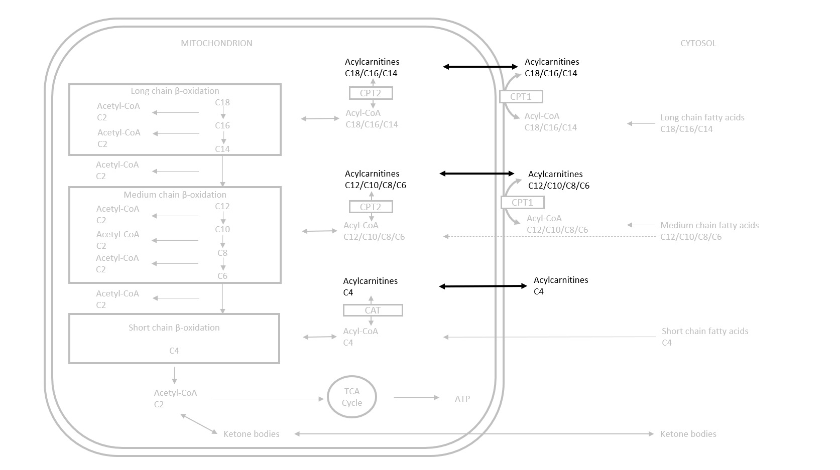
Supplemental Figure S1. Simplified representation of roles of acylcarnitines in fatty acid β-oxidation. Carnitines allow the carrier of medium and long chain fatty acids (acyl- moieties) into the mitochondrial matrix thought its acylcarnitine form. In case of deficiency of acyl-CoA (for example, in increased fatty acid β-oxidation), acylcarnitines provide acyl- moieties to coenzyme A (CoA) to reconstitute acyl-CoA and releases the L-carnitine. In case of excess of acyl-CoA (for example in decreased fatty acid β-oxidation), L-carnitine retrieves the acyl moieties to constitute acylcarnitines and releases CoA. CPT: Carnitine Palmitoyltransferase. CAT: Carnitine Acetyltransferase. TCA: Tricarboxylic acid cycle. The black font metabolites were evaluated in this work. The grey font metabolites were not evaluated in the present study.

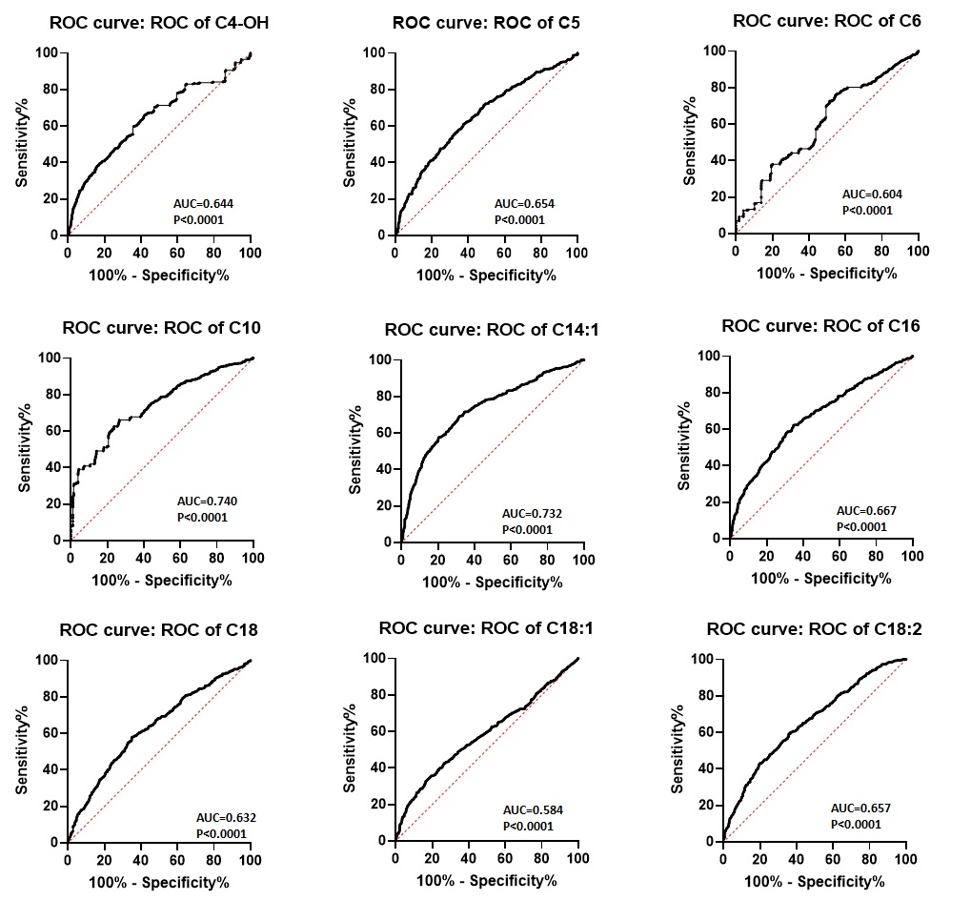
Supplemental Figure S2. Receiver operating characteristic curves for acylcarnitines with significant differences between healthy controls and depressed patients. ROC: Receiver operating characteristic – AUC: Aera under the curve – Metabolite abbreviations are defined in Table 2.

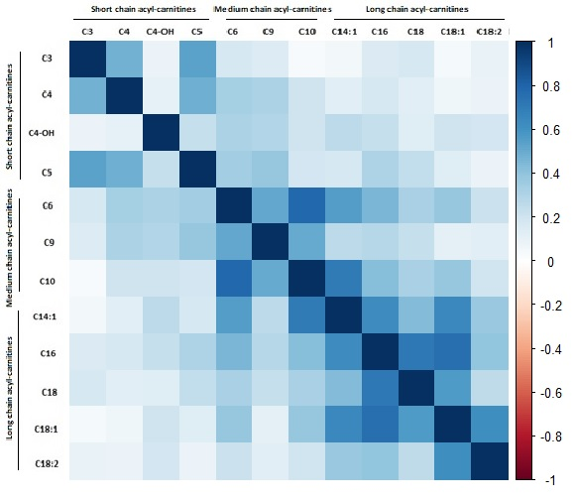
Supplemental Figure S3. Correlation plot of acylcarnitines in healthy controls. Blue represents positive correlations and red represents negative correlations – Acylcarnitine concentrations were log2 transformed – The first cluster (C3, C4, C4-OH, C5) was short chain acylcarnitines – The second cluster (C6, C9, C10, C14:1, C16, C18, C18:1, C18:2) was medium and long chain acylcarnitines –Metabolite abbreviations are defined in Table 2.

