**Supplementary Materials**

**A computational neuroimaging study of reinforcement learning**

**and goal-directed exploration in schizophrenia spectrum disorders**

**List of Supplemental Materials**

Supplemental Methods

S1: Verbatim Task Instructions

S2: Code for Generating Reward Frequency and Magnitude by time per task condition

Supplemental Results

S1: Results of Analyses in Samples of “Good Fitters”

S2: Results of Analyses Using Parameters from Sticky-choice Model

S3: Points Earned by Group

S4: Model Comparison for Individual Subjects

S5: Correlations among Trial-Wise Parameter Values

Supplemental Tables

S1: Points Earned by Condition

S2: Model Comparison for Individual Subjects

S3: Win and No-Win Shifts by Group

S4: Correlations Between Behavioral and Computational Measures of Goal-Directed Behavior

S5: Parameter Estimates from Computational Model

S6: Regressions Predicting Explorer Status by Diagnosis and Premorbid IQ Estimates from the Wechsler Test of Adult Reading (WTAR).

S7: Correlations between model-free and model-based RL measures and RPE-evoked signals in ventral striatum.

S8: Results of regression analysis with diagnosis and WTAR Scaled Score, as well as the interaction term, as predictors, and rlPFC activity as the predicted variable.

S9: Spearman correlation analyses of relationships between standardized antipsychotic medication dose and measures of interest pertaining to symptoms, behavior, or neural activity among PSZ.

S10: Comparison of results using parameters from original model, parameters from original model only in good-fitters, and parameters from sticky choice model.

Supplemental Figures

S1: Correlations between Trial-Wise Parameter Values

S2: Raw Trial-Wise Response Time by Condition

S3: Actual vs. Simulated Behavior

S4: Neural responses to RPEs

**Supplemental Methods**

**S1: Verbatim Task Instructions**

**In this game you will see a clock on the screen.**

**The second hand will be sweeping**

**around the clock face.**

**You need to press a button before**

**the second hand gets all the way**

**around the clock face.**

**You can win points**

**by pressing any button**

**before the hand makes a full turn.**

**Your goal is to win**

**as many points as you can**

**Sometimes you will win lots of points**

**when you press the button,**

**but sometimes you won’t win any at all,**

**even if you press the button in time.**

**The number of points you can win**

**depends when you hit the button.**

**Try to figure out when is the best time**

**to press the button**

**in order to win the most points.**

**If you don’t press a button before the second hand**

**swings all the way around the clock**

**you will not win ANY points.**

**At the end of the game you will earn bonus money in**

**proportion to the number of points you earned!**

**Do you have any questions**

**before we begin the game**

**S2: Code for Generating Reward Frequency and Magnitude by time per task condition**

% This code generates the values for the graphs in figure 1 and

% demonstrates how reward probability and reward magnitude vary with

% response time for the task conditions.

% this ensures that the frequency is not 100% even for a theoretical response of 0ms

Shift = 700;

% represents the RT at which the frequency of reward would be zero for CEV

rt_extended = 7000;

% k is just a constant that sets affect the overall magnitude of rewards in CEV and IEV conditions

K = 37;

% response window in milliseconds

time_elapsed = [1:5000];

for time = 1:5000

CEV_freq(time) = 1-((time+Shift)/rt_extended);

IEV_freq(time) = CEV_freq(time) +(CEV_freq(time) *(0.25*sin((time*pi)/5000)));

DEV_freq(time)= (2*CEV_freq(time))-(IEV_freq(time));

CEVR_freq(time) = (rt_extended*K)/(200*(rt_extended-(time+Shift)));

CEV_mag(time) = (rt_extended*K)/(rt_extended-(time+Shift));

DEV_mag(time) = 10*log(time+Shift);

IEV_mag(time) =(2*CEV_mag(time))-(DEV_mag(time));

CEVR_mag(time) =200*(1-((time+Shift)/rt_extended));

end

CEV_EV = CEV_freq.*CEV_mag;

IEV_EV = IEV_freq.*IEV_mag;

DEV_EV = DEV_freq.*DEV_mag;

CEVR_EV = CEVR_freq.*CEVR_mag;

figure;

%EV Figure

plot(time_elapsed,CEV_EV)

hold on

plot(time_elapsed,IEV_EV)

hold on

plot(time_elapsed,DEV_EV)

hold on

plot(time_elapsed,CEVR_EV)

hold off

xlabel('time (ms'); ylabel('Expected Value');

figure;

%Magnitude Figure

plot(time_elapsed,CEV_mag)

hold on

plot(time_elapsed,IEV_mag)

hold on

plot(time_elapsed,DEV_mag)

hold on

plot(time_elapsed,CEVR_mag)

hold off

xlabel('time (ms'); ylabel('# Points Gained');

figure;

%Magnitude Figure

plot(time_elapsed,CEV_freq)

hold on

plot(time_elapsed,IEV_freq)

hold on

plot(time_elapsed,DEV_freq)

hold on

plot(time_elapsed,CEVR_freq)

hold off

xlabel('time (ms'); ylabel('Probability');

**Supplemental Results**

**S1: Results of Analyses in Samples of “Good Fitters”**

According to our goodness-of-fit measure (decrease in AIC), 25 patients (from the original sample of 29 patients and 32 controls (from 36) remained in the reduced sample. Almost all effects observed in the full sample were seen in the reduced sample (see table below).

*Model-free measures of RL.* In the reduced sample , model-free analyses revealed that PSZ showed a trend reduced DEV acceleration, from the first to the last block of trials, relative to controls (t52 = 1.833, p=0.072), whereas patients and controls did not differ in their increases in mean response latencies, from the first to the last block of trials, in the IEV condition, when expected value (and reward frequency) increased with response latency (t52 = 1.115, p=0.270). Patients and controls also showed similar performance in the CEV and CEVr conditions, where expected value did not change as a function of response latency (both t-values < 1.5).

When we examined effects of symptom severity and intellectual capacity on model-free measures of RL, we found that our measure of motivational deficits in PSZ (mean scores of items from the Avolition/Anhedonia/Asociality subscales of the SANS) correlated significantly with slowing in the IEV condition over the course of blocks (ρ = 0.472, p = 0.023; Table S8). That was true of our measure of premorbid IQ (WTAR scaled score) in PSZ, as well (ρ = 0.408, p = 0.048).

*Model-based measures of RL.* With regard to RL, we compared PSZ and controls on the contrast in learning rates for positive and negative RPEs ([αP - αN]). Importantly, we found that the contrast in learning rates ([αP - αN]) correlated significantly with the [DEV acceleration - IEV deceleration] contrast in both PSZ (ρ = 0.585, p = 0.003), but not controls (ρ = 0.188, p = 0.321; Table S8). When we compared PSZ and controls on the [αP - αN] contrast, we found that an independent-samples t-test was not significant (t55 = 1.672; p = 0.100).

*Neural RPE signals evident in VS.* Given that prior research has demonstrated a role of the VS in the representation of value and signaling of RPEs, we hypothesized a similar finding in the present study. Indeed, the results were indicative of the VS tracking RPE magnitude and valence. These whole-brain results were consistent with the results of our ROI analysis of VS tracking RPE magnitude and valence (t53 = 4.248, p < 0.001, for one-sample t-test). Furthermore, a stronger VS RPE signal was observed in controls who showed greater DEV acceleration (ρ = -0.451, p = 0.012; but not PSZ, ρ = ‑0.081; Table S8). Consistent with prior findings from our lab, however, there was no significant effect of diagnosis on RPE-related VS activity evident from either whole-brain or ROI analyses (t52 = -0.385, p = 0.702).

*Model-free measures of exploration*. When we examined relationships between clinical measures and experimental measures of exploration, we observed that mean RT shifts following zero outcomes (non-wins), in the IEV condition trended toward a significant correlation with the severity of motivational deficits in PSZ (ρ = 0.385, p = 0.077). In both PSZ and controls, mean RT shifts following IEV non-wins correlated with WTAR scaled scores (ρ = 0.464, p = 0.022, in PSZ; ρ = 0.371, p = 0.040, in HCs).

**S2: Results of Analyses Using Parameters from Sticky-choice Model**

*Model-based measures of RL.* When we compared PSZ and controls on the [αP - αN] contrast, we found that an independent-samples t-test was not significant (t61 = 0.766; p = 0.446). However, we found that the contrast in learning rates ([αP - αN]) correlated significantly with the [DEV acceleration - IEV deceleration] contrast in PSZ (ρ = 0.580, p = 0.001; but not controls: ρ = 0.182, p = 0.382).

*Neural RPE signals evident in VS.* Given that prior research has demonstrated a role of the VS in the representation of value and signaling of RPEs, we hypothesized a similar finding in the present study. Indeed, the results were indicative of the VS tracking RPE magnitude and valence. These whole-brain results were consistent with the results of our ROI analysis of VS tracking RPE magnitude and valence (t58 = 3.961, p < 0.001, for one-sample t-test). Furthermore, a stronger VS RPE signal was observed in controls who showed greater DEV acceleration (ρ = 0.401, p = 0.021; but not PSZ, ρ = ‑0.045). Consistent with prior findings from our lab, however, there was no significant effect of diagnosis on RPE-related VS activity evident from either whole-brain or ROI analyses (t57 = -1.370, p = 0.176).

*Relationships among rlPFC uncertainty-driven exploration signals, motivational deficits, and intellectual dysfunction*. When examining relationships among and motivational deficits and intellectual dysfunction, we observed that uncertainty-driven exploration signals in rlPFC did not correlate significantly with Current IQ (from the WASI) in either controls (ρ = -0.131, p = 0.460; Table S8) or PSZ (ρ = -0.025, p = 0.907), and no relationship was observed between rlPFC activity and measures of motivation deficits.

**S3: Points Earned by Group**

Average numbers of points earned per run for SZ patients and HCs are reported in Table S1. SZ patients and HCs did not significantly differ in average points earned across the whole task, or when including only the DEV and IEV runs.

**S4: Model Comparison for Individual Subjects**

Model fit statistics, for each individual subject, are reported in Table S2. Three models were tested. An intercept model, where RT was predicted only by K (the subject’s average RT), the original model, and a model similar to the original that included our sticky choice parameter. As can be seen from the table most subjects show improved fit for the original and sticky choice models compared to a model that solely includes an intercept model (the subject’s average RT, K). However, there was not much difference in fit between the original and the sticky choice models. Thus, in the manuscript we describe results from the original model.

**S5: Correlations among Trial-Wise Parameter Values**

We examined potential correlations between trial-wise estimates of PE, mean uncertainty, and relative uncertainty generated from our computational model. We conducted correlations between these three variables within each subject. The resulting histograms are provided below. As can be discerned from the graphs in Figure S1, there were minimal correlations (mean r-value near 0) between relative uncertainty and prediction error, and between mean uncertainty and prediction error.

Correlations between mean and relative uncertainty showed greater range. This is to be expected. Subjects with high levels of mean uncertainty across the task will generally show a negative association between relative and mean uncertainty (the resulting difference between two large numbers is small). In contrast, subjects with low levels of mean uncertainty across the task will generally show a positive association between relative and mean uncertainty.

With regard to the neuroimaging analyses, separate GLMs were conducted for relative uncertainty, mean uncertainty, and PE. This reduces effects of collinearity between predictors.

**Supplemental Tables**

**S1: Points Earned by Group**

|  |  |  |  |  |  |  |
| --- | --- | --- | --- | --- | --- | --- |
|  | Healthy Controls | | Schizophrenia Patients | | t-value | p-value |
|  | Mean | SD | Mean | SD |  |  |
| **Overall Task** | 1496.669 | 133.55 | 1519.259 | 196.305 | -0.551 | 0.584 |
| *IEV* | 1456.786 | 318.389 | 1407.052 | 418.498 | 0.54 | 0.591 |
| *DEV* | 1572.111 | 239.195 | 1604.776 | 303.627 | -0.485 | 0.629 |

Note: IEV: Increasing Expected Value Condition; DEV: Decreasing Expected Value Condition; SD: Standard Deviation

**S2: Model Comparison for Individual Subjects**

|  |  |  |  |  |  |  |  |  |  |  |  |  |  |  |  |
| --- | --- | --- | --- | --- | --- | --- | --- | --- | --- | --- | --- | --- | --- | --- | --- |
|  |  | **Sum of Squared Error** | | | **Fit Improvement (SSE)** | | | | **Akaike Information Criterion** | | | | **Fit Improvement (AIC)** | | |
| **Subject** | **Group** | **Intercept** | **Original** | **Sticky** | | **Original vs. Intercept** | **Sticky**  **vs.**  **Intercept** | **Original**  **vs.**  **Sticky** | | **Intercept** | **Original** | **Sticky** | **Original vs. Intercept** | **Sticky**  **vs. Intercept** | **Original vs. Sticky** |
| 12352 | HC | 16962.0 | 11228.5 | 11131.2 | | 33.8% | 34.4% | -0.6% | | 4676.6 | 4490.6 | 4486.4 | -186.0 | -190.2 | 4.2 |
| 12405 | HC | 18625.8 | 13194.6 | 13194.6 | | 29.2% | 29.2% | 0.0% | | 4721.5 | 4568.0 | 4568.0 | -153.5 | -153.5 | 0.0 |
| 12519 | HC | 22318.8 | 13013.7 | 13013.7 | | 41.7% | 41.7% | 0.0% | | 4808.3 | 4561.4 | 4561.4 | -246.9 | -246.9 | 0.0 |
| 12541 | HC | 17047.6 | 16349.8 | 16122.2 | | 4.1% | 5.4% | -1.3% | | 4679.0 | 4670.9 | 4664.2 | -8.1 | -14.8 | 6.7 |
| 12546 | HC | 17039.1 | 6686.9 | 6635.7 | | 60.8% | 61.1% | -0.3% | | 4678.8 | 4241.8 | 4238.1 | -437.0 | -440.7 | 3.7 |
| 12568 | HC | 16555.4 | 12241.7 | 12241.7 | | 26.1% | 26.1% | 0.0% | | 4664.9 | 4532.0 | 4532.0 | -132.9 | -132.9 | 0.0 |
| 12594 | HC | 17781.7 | 16539.4 | 16539.4 | | 7.0% | 7.0% | 0.0% | | 4699.2 | 4676.5 | 4676.5 | -22.8 | -22.8 | 0.0 |
| 12669 | HC | 14825.2 | 14419.5 | 14366.6 | | 2.7% | 3.1% | -0.4% | | 4612.0 | 4610.6 | 4608.9 | -1.3 | -3.1 | 1.8 |
| 12670 | HC | 18136.1 | 17498.8 | 17498.8 | | 3.5% | 3.5% | 0.0% | | 4708.7 | 4703.5 | 4703.5 | -5.2 | -5.2 | 0.0 |
| 12671 | HC | 17781.0 | 16870.0 | 16856.2 | | 5.1% | 5.2% | -0.1% | | 4699.2 | 4686.0 | 4685.6 | -13.2 | -13.6 | 0.4 |
| 12675 | HC | 17183.4 | 16713.5 | 16707.3 | | 2.7% | 2.8% | 0.0% | | 4682.8 | 4681.5 | 4681.3 | -1.3 | -1.5 | 0.2 |
| 12677 | HC | 18070.9 | 10530.0 | 10530.0 | | 41.7% | 41.7% | 0.0% | | 4707.0 | 4459.7 | 4459.7 | -247.2 | -247.2 | 0.0 |
| 12678 | HC | 14947.3 | 7696.5 | 7679.2 | | 48.5% | 48.6% | -0.1% | | 4615.9 | 4309.3 | 4308.2 | -306.6 | -307.7 | 1.1 |
| 12684 | HC | 20906.7 | 20521.0 | 20521.0 | | 1.8% | 1.8% | 0.0% | | 4777.0 | 4780.0 | 4780.0 | 3.1 | 3.1 | 0.0 |
| 12691 | HC | 18509.6 | 17467.1 | 17467.1 | | 5.6% | 5.6% | 0.0% | | 4718.5 | 4702.7 | 4702.7 | -15.8 | -15.8 | 0.0 |
| 12693 | HC | 18073.3 | 17287.0 | 17173.3 | | 4.4% | 5.0% | -0.6% | | 4707.1 | 4697.7 | 4694.5 | -9.4 | -12.5 | 3.2 |
| 12700 | HC | 19130.5 | 15775.6 | 15711.1 | | 17.5% | 17.9% | -0.3% | | 4734.3 | 4653.8 | 4651.8 | -80.6 | -82.5 | 2.0 |
| 12706 | HC | 17937.9 | 16875.5 | 16754.0 | | 5.9% | 6.6% | -0.7% | | 4703.4 | 4686.1 | 4682.7 | -17.3 | -20.8 | 3.5 |
| 12730 | HC | 19758.7 | 19401.5 | 19393.5 | | 1.8% | 1.8% | 0.0% | | 4749.8 | 4753.1 | 4752.9 | 3.2 | 3.0 | 0.2 |
| 12733 | HC | 21109.7 | 15427.9 | 15402.4 | | 29.9% | 27.0% | -0.2% | | 4781.6 | 4643.1 | 4642.3 | -138.5 | -139.3 | 0.8 |
| 12734 | HC | 14627.2 | 14004.5 | 14004.5 | | 4.3% | 4.3% | 0.0% | | 4605.5 | 4596.6 | 4596.6 | -8.9 | -8.9 | 0.0 |
| 12735 | HC | 21793.4 | 10848.1 | 10845.7 | | 50.2% | 50.2% | 0.0% | | 4796.9 | 4474.0 | 4473.9 | -322.9 | -323.0 | 0.1 |
| 12752 | HC | 17055.5 | 12881.3 | 12881.1 | | 24.5% | 24.5% | 0.0% | | 4679.2 | 4556.5 | 4556.5 | -122.7 | -122.7 | 0.0 |
| 12758 | HC | 14314.5 | 14254.2 | 14254.2 | | 0.4% | 0.4% | 0.0% | | 4595.1 | 4605.1 | 4605.1 | 10.0 | 10.0 | 0.0 |
| 12770 | HC | 17828.9 | 10984.4 | 10921.8 | | 38.4% | 38.7% | -0.4% | | 4700.5 | 4480.0 | 4477.3 | -220.5 | -223.2 | 2.7 |
| 13018 | HC | 20822.1 | 15959.5 | 15959.5 | | 23.4% | 23.4% | 0.0% | | 4775.0 | 4659.3 | 4659.3 | -115.7 | -115.7 | 0.0 |
| 13067 | HC | 18517.8 | 8886.2 | 8886.2 | | 52.0% | 52.0% | 0.0% | | 4718.7 | 4378.3 | 4378.3 | -340.4 | -340.4 | 0.0 |
| 13095 | HC | 18921.1 | 16226.1 | 16226.1 | | 14.2% | 14.2% | 0.0% | | 4729.1 | 4667.3 | 4667.3 | -61.8 | -61.8 | 0.0 |
| 13096 | HC | 18483.4 | 16866.9 | 16866.9 | | 8.7% | 8.7% | 0.0% | | 4717.8 | 4685.9 | 4685.9 | -31.9 | -31.9 | 0.0 |
| 13100 | HC | 15384.3 | 12091.6 | 12067.1 | | 21.4% | 21.6% | -0.2% | | 4629.7 | 4526.1 | 4525.2 | -103.6 | -104.6 | 1.0 |
| 13152 | HC | 18269.7 | 13194.9 | 13194.9 | | 27.8% | 27.8% | 0.0% | | 4712.2 | 4568.0 | 4568.0 | -144.2 | -144.2 | 0.0 |
| 13175 | HC | 13686.8 | 11643.3 | 11538.6 | | 14.9 | 15.7 | -0.9% | | 4573.6 | 4508.0 | 4503.7 | -65.6 | -69.9 | 4.3 |
| 13199 | HC | 18302.2 | 17872.5 | 17872.5 | | 2.3% | 2.3% | 0.0% | | 4713.1 | 4713.7 | 4713.7 | 0.6 | 0.6 | 0.0 |
| 13210 | HC | 21141.1 | 13922.8 | 13915.8 | | 34.1% | 34.2% | 0.0% | | 4782.3 | 4593.8 | 4593.6 | -188.5 | -188.7 | 0.2 |
| 13212 | HC | 19359.2 | 10656.1 | 10653.4 | | 45.0% | 45.0% | 0.0% | | 4740.0 | 4465.5 | 4465.3 | -274.6 | -274.7 | 0.1 |
| 13253 | HC | 20684.0 | 18577.8 | 18577.8 | | 10.2% | 10.2% | 0.0% | | 4771.8 | 4732.3 | 4732.3 | -39.5 | -39.5 | 0.0 |
| 12380 | SZ | 18213.2 | 18117.3 | 18117.3 | | 0.5% | 0.5% | 0.0% | | 4710.8 | 4720.2 | 4720.2 | 9.5 | 9.5 | 0.0 |
| 12390 | SZ | 17150.1 | 16370.0 | 16262.7 | | 4.5% | 5.2% | -0.6% | | 4681.9 | 4671.5 | 4668.4 | -10.3 | -13.5 | 3.2 |
| 12425 | SZ | 25495.3 | 14646.9 | 14615.7 | | 42.6% | 42.7% | -0.1% | | 4872.2 | 4618.2 | 4617.1 | -254.0 | -255.1 | 1.0 |
| 12427 | SZ | 11887.9 | 11601.0 | 11528.5 | | 2.4% | 3.0% | -0.6% | | 4506.0 | 4506.2 | 4503.2 | 0.3 | -2.7 | 3.0 |
| 12463 | SZ | 13175.2 | 11753.1 | 11753.1 | | 10.8% | 10.8% | 0.0% | | 4555.3 | 4512.5 | 4512.5 | -42.8 | -42.8 | 0.0 |
| 12468 | SZ | 12425.4 | 11154.1 | 11152.3 | | 10.2% | 10.2% | 0.0% | | 4527.2 | 4487.4 | 4487.3 | -39.8 | -39.9 | 0.1 |
| 12481 | SZ | 21172.9 | 10932.2 | 10856.7 | | 48.4% | 48.7% | -0.4% | | 4783.0 | 4477.7 | 4474.4 | -305.3 | -308.6 | 3.3 |
| 12505 | SZ | 19124.1 | 7579.4 | 7492.1 | | 60.4% | 60.8% | -0.5% | | 4734.2 | 4301.9 | 4296.4 | -432.2 | -437.8 | 5.6 |
| 12609 | SZ | 17430.1 | 16624.8 | 16624.8 | | 4.6% | 4.6% | 0.0% | | 4689.7 | 4679.0 | 4679.0 | -10.7 | -10.7 | 0.0 |
| 12614 | SZ | 13362.4 | 12912.4 | 12841.3 | | 3.4% | 3.9% | -0.5% | | 4562.1 | 4557.7 | 4555.0 | -4.4 | -7.1 | 2.6 |
| 12616 | SZ | 15798.1 | 14835.7 | 14835.7 | | 6.1% | 6.1% | 0.0% | | 4642.5 | 4624.3 | 4624.3 | -18.2 | -18.2 | 0.0 |
| 12645 | SZ | 18596.9 | 11231.3 | 11189.8 | | 39.6% | 39.8% | -0.2% | | 4720.8 | 4490.7 | 4488.9 | -230.1 | -231.8 | 1.8 |
| 12679 | SZ | 17417.9 | 17298.2 | 17280.0 | | 0.7% | 0.8% | -0.1% | | 4689.3 | 4698.0 | 4697.5 | 8.7 | 8.2 | 0.5 |
| 12787 | SZ | 19767.3 | 13572.6 | 13572.6 | | 31.3% | 31.3% | 0.0% | | 4750.1 | 4581.6 | 4581.6 | -168.5 | -168.5 | 0.0 |
| 12790 | SZ | 16524.3 | 15435.0 | 15435.0 | | 6.6% | 6.6% | 0.0% | | 4664.0 | 4643.3 | 4643.3 | -20.7 | -20.7 | 0.0 |
| 12833 | SZ | 15069.6 | 11122.2 | 11057.0 | | 26.2% | 26.6% | -0.4% | | 4619.8 | 4486.0 | 4483.2 | -133.8 | -136.6 | 2.8 |
| 12834 | SZ | 21579.9 | 13582.4 | 13582.4 | | 37.1% | 37.1% | 0.0% | | 4792.2 | 4581.9 | 4581.9 | -210.2 | -210.2 | 0.0 |
| 12863 | SZ | 12237.7 | 11883.5 | 11883.5 | | 2.9% | 2.9% | 0.0% | | 4519.9 | 4517.8 | 4517.8 | -2.1 | -2.1 | 0.0 |
| 12864 | SZ | 15607.4 | 14097.1 | 14097.1 | | 9.7% | 9.7% | 0.0% | | 4636.6 | 4599.8 | 4599.8 | -36.9 | -36.9 | 0.0 |
| 12874 | SZ | 16179.0 | 12470.3 | 12425.0 | | 22.9% | 23.2% | -0.3% | | 4653.9 | 4540.9 | 4539.2 | -113.0 | -114.7 | 1.7 |
| 12882 | SZ | 10532.5 | 9411.5 | 9401.5 | | 10.6% | 10.7% | -0.1% | | 4447.9 | 4405.9 | 4405.3 | -42.0 | -42.5 | 0.5 |
| 12900 | SZ | 14136.3 | 12512.4 | 12512.4 | | 11.5% | 11.5% | 0.0% | | 4589.1 | 4542.5 | 4542.5 | -46.6 | -46.6 | 0.0 |
| 12906 | SZ | 20402.7 | 5611.2 | 5600.2 | | 72.5% | 72.6% | -0.1% | | 4765.2 | 4157.6 | 4156.7 | -607.6 | -608.6 | 0.9 |
| 12942 | SZ | 18841.5 | 15001.6 | 15001.6 | | 20.4% | 20.4% | 0.0% | | 4727.0 | 4629.6 | 4629.6 | -97.4 | -97.4 | 0.0 |
| 12953 | SZ | 18540.9 | 17764.8 | 17725.9 | | 4.2% | 4.4% | -0.2% | | 4719.3 | 4710.8 | 4709.7 | -8.5 | -9.6 | 1.1 |
| 12962 | SZ | 7868.3 | 7729.0 | 7729.0 | | 1.8% | 1.8% | 0.0% | | 4307.9 | 4311.3 | 4311.3 | 3.4 | 3.4 | 0.0 |
| 13063 | SZ | 9998.8 | 9221.2 | 9150.2 | | 7.8% | 8.5% | -0.7% | | 4422.9 | 4396.0 | 4392.3 | -26.9 | -30.6 | 3.7 |
| 13125 | SZ | 14192.5 | 12027.5 | 12027.5 | | 15.3% | 15.3% | 0.0% | | 4591.0 | 4523.6 | 4523.6 | -67.4 | -67.4 | 0.0 |
| 13134 | SZ | 15928.5 | 15456.0 | 15456.0 | | 3.0% | 3.0% | 0.0% | | 4646.4 | 4644.0 | 4644.0 | -2.5 | -2.5 | 0.0 |

**S3: Win and No-Win Shifts by Group**

|  |  |  |  |  |  |  |
| --- | --- | --- | --- | --- | --- | --- |
|  | HC | | SZ | | Test Statistic | |
|  | Mean | SE | Mean | SE | t-value | p-value |
| IEV_NWshift | -525.371 | 74.847 | -481.664 | 84.9 | -0.387 | 0.7 |
| DEV_NWshift | -249.837 | 53.39 | -169.186 | 35.378 | -1.193 | 0.238 |
| IEV_WinShift | 255.211 | 32.355 | 250.275 | 39.002 | 0.098 | 0.922 |
| DEV_WinShift | 199.926 | 39.538 | 82.136 | 35.329 | 2.167 | 0.034 |

**S4: Correlations Between Behavioral and Computational Measures of Goal-Directed Behavior**

|  |  |  |  |  |  |  |
| --- | --- | --- | --- | --- | --- | --- |
|  |  | PSZ |  |  | HCs |  |
|  |  | [αP - αN] | ε |  | [αP - αN] | ε |
| DEV Acceleration |  | -0.606** | -0.028 |  | -0.262 | -0.062 |
| IEV Deceleration |  | -0.325 | 0.165 |  | -0.197 | 0.216 |
| [DEV - IEV] Contrast |  | 0.580** | -0.027 |  | 0.342** | -0.066 |
| DEV No-win Shift |  | -0.063 | 0.165 |  | 0.196 | 0.018 |
| IEV No-win Shift |  | -0.174 | 0.029 |  | 0.287 | 0.046 |

Abbreviations/Notation: DEV Acceleration, RT change from first 10 trials to last 10 trials, Decreasing Expected Value condition; IEV Deceleration, RT change from first 10 trials to last 10 trials, Increasing Expected Value condition; [DEV - IEV] Contrast, Difference between DEV Acceleration and IEV Deceleration; DEV No-win Shift, Mean RT change after non-win (0 points) in DEV condition; IEV No-win Shift, Mean RT change after non-win (0 points) in IEV condition; **, effect significant at p < 0.01.

**S5: Parameter Estimates from Computational Models.**

|  |  |  |  |  |  |
| --- | --- | --- | --- | --- | --- |
|  | HC | (N=36) | SZ | (N=29) |  |
|  | Mean | (SD) | Mean | (SD) | p of t |
| Original |  |  |  |  |  |
| ε | 926.1018 | (1930.1255) | 863.2246 | (1276.1241) | 0.530 |
| αP | 0.2173 | (0.2525) | 0.2161 | (0.3157) | 0.541 |
| αN | 0.2259 | (0.3212) | 0.3208 | (0.4204) | 0.536 |
| [αP - αN] | -0.0087 | (0.3495) | -0.1047 | (0.3623) | 0.283 |
|  |  |  |  |  |  |
| Sticky Choice |  |  |  |  |  |
| ε | -299.4236 | 3494.8621 | -640.5515 | 2377.0033 | 0.658 |
| αP | 0.2176 | 0.2499 | 0.2263 | 0.3224 | 0.904 |
| αN | 0.2329 | 0.3326 | 0.3096 | 0.4052 | 0.412 |
| [αP - αN] | -0.0154 | 0.3573 | -0.0833 | 0.3431 | 0.446 |

Abbreviations/Notation: ε, Explore parameter (contribution of relative uncertainty to RT change); αP, Learning rate for positive RPEs (Go); αN, Learning rate for negative RPEs (NoGo); [αP - αN], Contrast in learning rates for positive and negative RPEs.

**S6: Regressions Predicting Explorer Status by Diagnosis and Premorbid IQ Estimates from the** **Wechsler Test of Adult Reading (WTAR).**

|  |  |  |  |  |  |
| --- | --- | --- | --- | --- | --- |
|  | ß (S.E.) | Wald | df | *p*-value | expß (OR) |
| Diagnosis | 12.04 (6.97) | 2.98 | 1 | 0.08 | 169729.43 |
| WTAR | 0.12 (0.06) | 4.33 | 1 | 0.04 | 1.13 |
| Diagnosis X WTAR | -0.09 (0.06) | 2.62 | 1 | 0.11 | 0.91 |

**S7: Correlations between model-free and model-based RL measures and RPE-evoked signals in ventral striatum.**

|  |  |  |  |  |
| --- | --- | --- | --- | --- |
|  |  | PSZ |  | HCs |
| DEV Acceleration |  | -0.069 |  | -0.438** |
| IEV Deceleration |  | -0.215 |  | -0.300 |
| [DEV - IEV] Contrast |  | 0.261 |  | 0.507** |
| [αP - αN] |  | 0.228 |  | 0.281 |

Abbreviations/Notation: DEV Acceleration, RT change from first 10 trials to last 10 trials, Decreasing Expected Value condition; IEV Deceleration, RT change from first 10 trials to last 10 trials, Increasing Expected Value condition; [DEV - IEV] Contrast, Difference between DEV Acceleration and IEV Deceleration; [αP - αN], Contrast in learning rates for positive and negative RPEs; **, effect significant at p < 0.01.

**S8: Results of regression analysis with diagnosis and WTAR Scaled Score, as well as the interaction term, as predictors, and rlPFC activity as the predicted variable.**

|  |  |  |  |  |  |
| --- | --- | --- | --- | --- | --- |
|  | Standardized ß | t | *p*-value | 95% CI - Lower | 95% CI - Upper |
| Diagnosis | 2.34 | 2.15 | 0.04 | 0.77 | 22.23 |
| WTAR Scaled Score | 1.23 | 2.30 | 0.03 | 0.03 | 0.37 |
| Diagnosis X WTAR Scaled Score | -2.09 | -1.94 | 0.06 | -0.19 | 0.003 |

**S9:** **Spearman correlation analyses of relationships between standardized antipsychotic medication dose and measures of interest pertaining to symptoms, behavior, or neural activity among PSZ.**

|  |  |  |
| --- | --- | --- |
|  | ⍴ | p |
| **Standard Cognitive Measures** |  |  |
| **WTAR** **Scaled Score** | 0.124 | 0.539 |
| **Model-free Experimental Measures** |  |  |
| **DEV Acceleration** | -0.137 | 0.497 |
| **IEV Deceleration** | -0.082 | 0.685 |
| **DEV No-win Shift** | -0.097 | 0.630 |
| **IEV No-win Shift** | 0.098 | 0.627 |
| **Model-based Experimental Measures** |  |  |
| **Explore Parameter (ε)** | 0.220 | 0.260 |
| **[αP - αN]** | 0.357 | 0.062 |
| **rlPFC Relative Uncertainty Response** | 0.159 | 0.438 |

Abbreviations/Notation: WTAR, Wechsler Test of Adult Reading; WRAT, DEV, Decreasing Expected Value condition; IEV, Increasing Expected Value condition; [αP - αN], Contrast in learning rates for positive and negative RPEs. rlPFC, rostrolateral prefrontal cortex.

**S10: Comparison of results using** **parameters from original model, parameters from original model only in good-fitters, and parameters from sticky choice model.**

|  |  |  |  |  |  |  |  |  |  |
| --- | --- | --- | --- | --- | --- | --- | --- | --- | --- |
|  | **Original Model** | | | | | **Sticky-Choice Model** | | | |
|  | **All Subjects** | **Subjects Showing**  **Good Model Fits** | | | | **All**  **Subjects** | | | |
|  | **Shows Effect** | **Shows Effect** | **Statistic** | | **p** | **Shows Effect** | **Statistic** | | **p** |
| **Model-free measures of RL** |  |  |  |  |  |  |  |  |  |
| **Reduced DEV acceleration in PSZ** | ✓ | ✓ | t = | -1.833 | 0.072 | N/A |  |  |  |
| **IEV slowing correlated significantly with AAA** | ✓ | ✓ | ⍴ = | 0.472 | 0.023 | N/A |  |  |  |
| **IEV slowing correlated significantly with WTAR scaled score in PSZ** | ✓ | ✓ | ⍴ = | 0.408 | 0.048 | N/A |  |  |  |
|  |  |  |  |  |  |  |  |  |  |
| **Model-based measures of RL** |  |  |  |  |  |  |  |  |  |
| **VS tracking of RPE magnitude and valence** | ✓ | ✓ | t = | 4.248 | <0.001 | ✓ | t = | 3.961 | <0.001 |
| **No between group diff in VS RPE signal** | ✓ | ✓ | t = | -0.385 | 0.702 | ✓ | t = | -1.370 | 0.176 |
| **Stronger VS RPE signal was observed in controls who showed greater DEV acceleration** | ✓ | ✓ | ⍴ = | -0.451 | 0.012 | ✓ | ⍴ = | -0.401 | 0.021 |
| **[aP - aN] correlated significantly with the [DEV acceleration - IEV deceleration] in PSZ** | ✓ | ✓ | ⍴ = | 0.585 | 0.003 | ✓ | ⍴ = | 0.580 | 0.001 |
| **[aP - aN] correlated significantly with the [DEV acceleration - IEV deceleration] in HC** | ✓ | X | ⍴ = | 0.188 | 0.321 | X | ⍴ = | 0.182 | 0.302 |
|  |  |  |  |  |  |  |  |  |  |
| **Model-free measures of Exploration** |  |  |  |  |  |  |  |  |  |
| **RT shifts following non-wins, in IEV, correlated with AAA in PSZ** | ✓ | ✓ | ⍴ = | 0.385 | 0.077 | N/A |  |  |  |
| **Mean RT shifts following IEV non-wins correlated with WTAR scaled scores in PSZ** | ✓ | ✓ | ⍴ = | 0.464 | 0.022 | N/A |  |  |  |
| **Mean RT shifts following IEV non-wins correlated with WTAR scaled scores in HC** | ✓ | ✓ | ⍴ = | 0.371 | 0.040 | N/A |  |  |  |
|  |  |  |  |  |  |  |  |  |  |
| **Model-based measures of Exploration** |  |  |  |  |  |  |  |  |  |
| **rlPFC uncertainty-driven exploration signals correlated with IQ in PSZ** | ✓ | ✓ | ⍴ = | 0.422 | 0.045 | X | ⍴ = | -0.025 | 0.907 |
| **rlPFC uncertainty-driven exploration signals correlated with IQ in HC** | ✓ | ✓ | ⍴ = | 0.323 | 0.076 | X | ⍴ = | -0.131 | 0.460 |
| **Diagnosis, by itself, did not predict Explorer Status** | ✓ | ✓ | β = | 7.680 | 0.240 | ✓ | β = | 0.360 | 0.510 |
| **Together, RLPFC_RU and Dx predict Explorer Status** | ✓ | ✓ | β = | -0.780 | 0.020 | ✓ | β = | -0.650 | 0.050 |

**Supplemental Figures**

**S1: Correlations among Trial-Wise Parameter Values**

**

Histograms indicate correlations between mean and relative uncertainty had considerable range. Subjects with high levels of mean uncertainty across the task generally showed a negative association between relative and mean uncertainty (the resulting difference between two large numbers is small), while subjects with low levels of mean uncertainty across the task generally showed a positive association between relative and mean uncertainty. By contrast, we observed minimal correlations (mean r-value near 0) between relative uncertainty and prediction error, and between mean uncertainty and prediction error.

**S2: Raw Trial-Wise Response Time Data by Condition**

**S3: Actual vs. Simulated Behavior.**

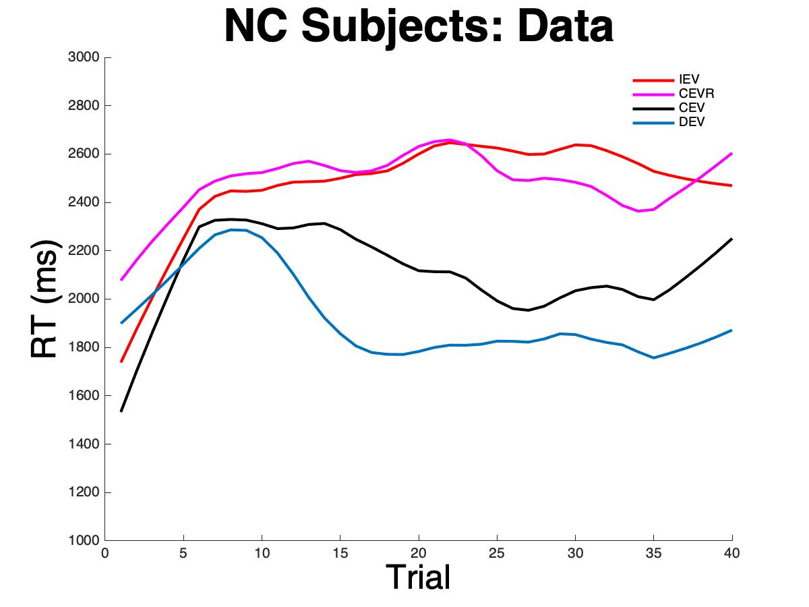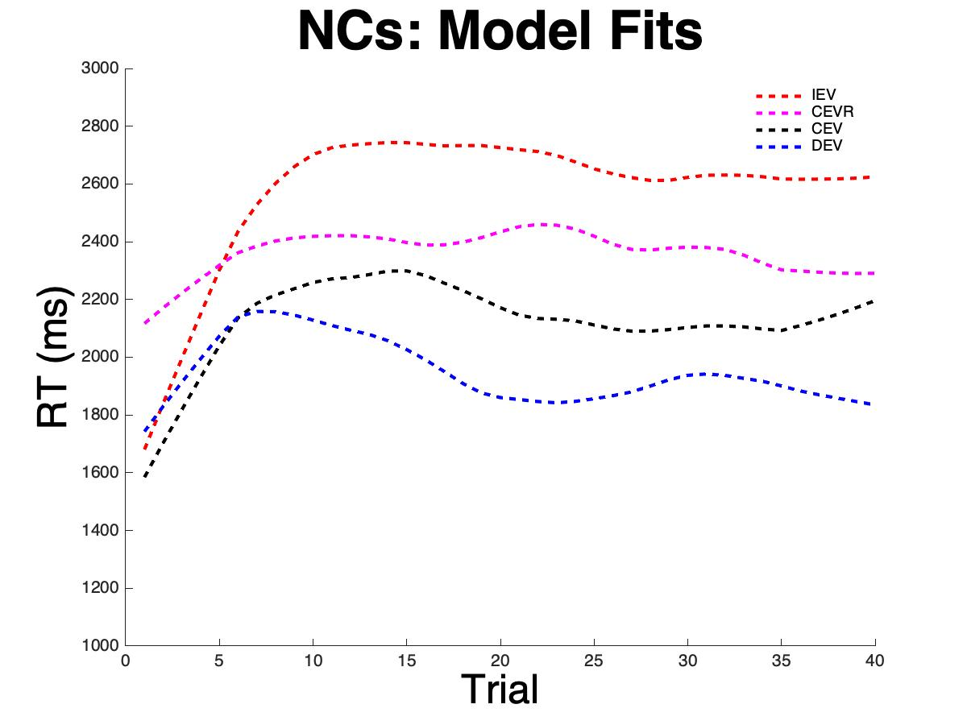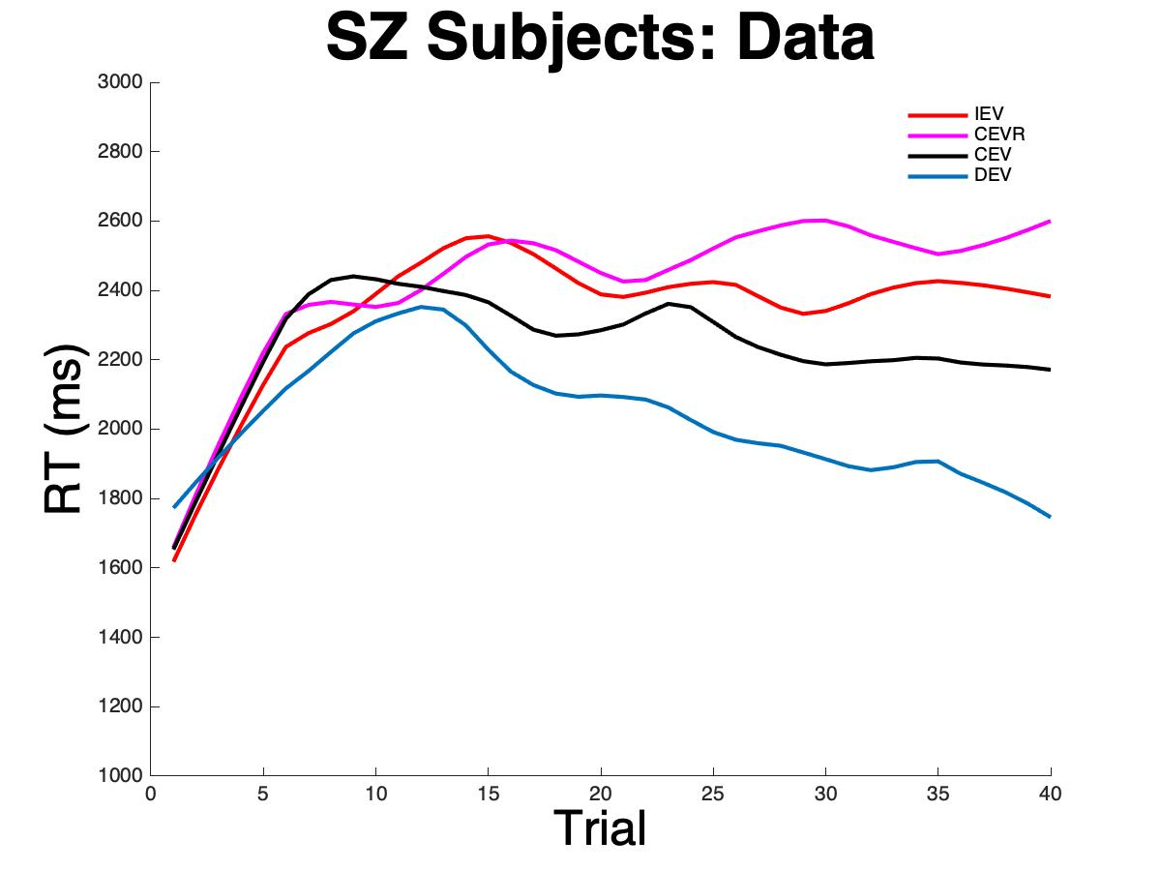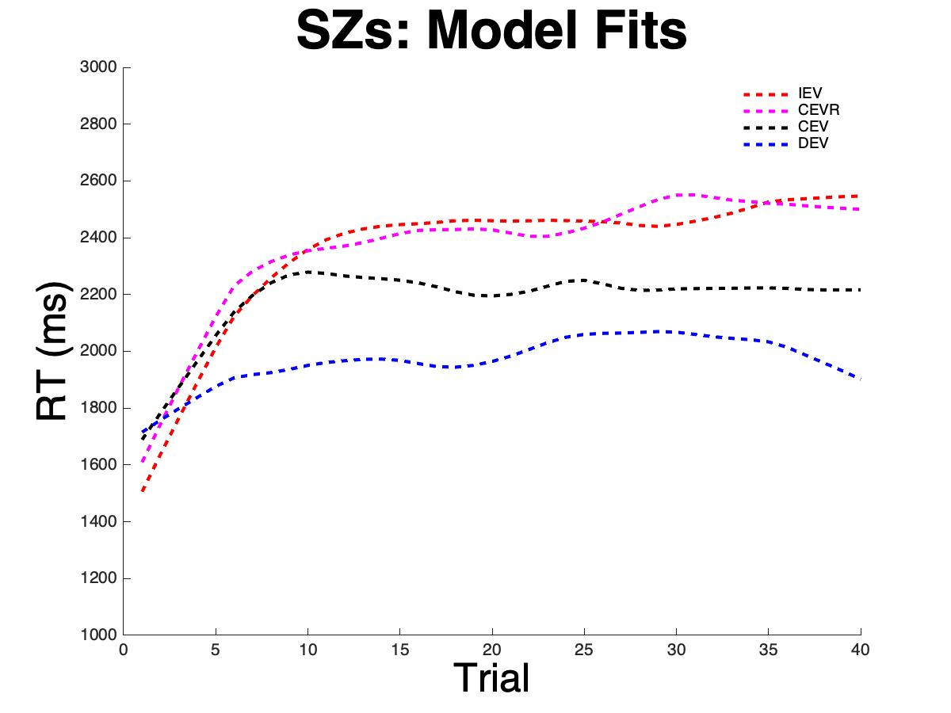

Simulations using the original computational model recapitulated non-model-based analyses of actual participant data, where participants in both groups showed the longest end-of-block response times in the IEV and CEVr conditions and the shortest end-of-block response times in the DEV and CEV conditions.

**S4: Neural responses to RPEs**

1-sample t-test. Brain cut at y = 7. Warm colors represent positive associations between BOLD activation and prediction error signaling.