Supplementary results appendix

Adherence and attrition

Supplementary Figure 1
Data loss at post-treatment (T₁) and 4-month follow-up (T₂)
T₂ Data loss (n=32; 28.1%)
EQ-5D: 24 missing
BAI: 24 missing
Cost: 21 missing
T₂ Data loss (n=43; 36.8%)
EQ-5D: 38 missing
BAI: 37 missing
Cost: 30 missing
T₁ Data loss (n=28; 23.9%)
EQ-5D: 26 missing
BAI: 22 missing
Cost: 25 missing
T₁ Data loss (n=24; 21.1%)
EQ-5D: 16 missing
BAI: 11 missing
Cost: 19 missing

114 allocated to TAU and included in intention to-treat-analysis
117 allocated to tCBT+TAU and included in intention-to-treat analysis
231 randomized

Supplementary Table 1
Logistic regression results for baseline factors associated with data loss at 4-month follow-up (T₂)

 | Clinical outcome not available |  | Cost data available
Baseline characteristic | Exp(B) | p-value | Exp(B) | p-value
Sociodemographic
Age | 0.993 | 0.636 | 1.038 | 0.030
Canadian citizenship (ref : no) | 0.652 | 0.698 | 2.825 | 0.397
Education (ref : University)
High school or less | 1.143 | 0.804 | 0.873 | 0.817
Collegial or vocational | 1.316 | 0.456 | 0.838 | 0.661
Sex (ref : men) | 1.072 | 0.888 | 1.058 | 0.916
Marital status (ref : single)
In a relationship | 0.905 | 0.765 | 1.510 | 0.254
Health system mental health cost | 1.000 | 0.840 | 1.001 | 0.450
Limited societal mental health cost | 1.000 | 0.872 | 1.000 | 0.033
Clinical
Did not take psychotropic medication (ref : Did take) | 2.259 | 0.030 | 0.528 | 0.123
Perceived mental health (ref : average or less)
Very good or better | 1.354 | 0.670 | 0.852 | 0.854
Good | 1.432 | 0.325 | 0.601 | 0.192
Perceived physical health (ref : average or less)
Very good or better | 0.797 | 0.664 | 4.143 | 0.014
Good | 0.896 | 0.801 | 1.862 | 0.165
EQ-5D utility index | 0.311 | 0.335 | 2.432 | 0.495
Beck Anxiety Inventory score | 1.043 | 0.011 | 1.008 | 0.676
Intervention
Assigned to tCBT+TAU (ref : TAU) | 1.895 | 0.054 | 0.507 | 0.059

Outcomes

Supplementary Figure 2
Mean adjusted costs incurred for mental health reasons at post-treatment (T₁) and 4-month follow-up (T₂)

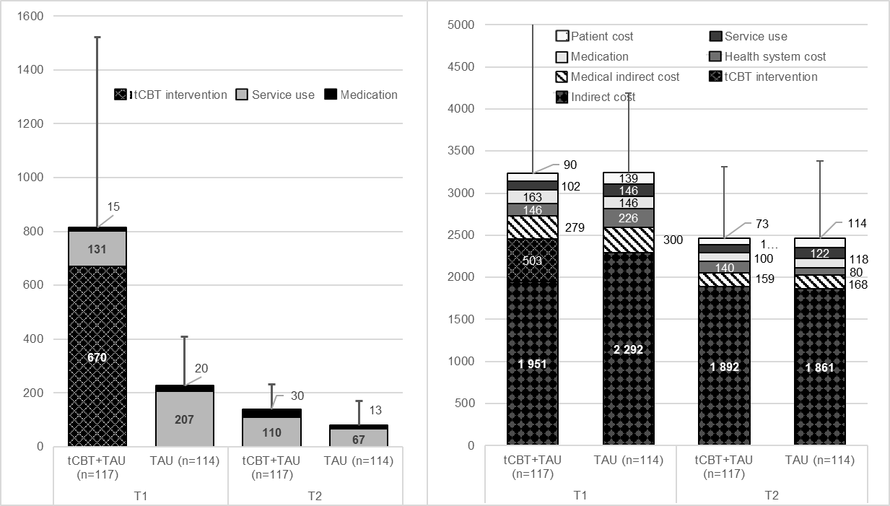
B)
A)
Note. A) Cost from the health system perspective. B) Supplementary cost incurred from the limited societal perspective. Medical indirect cost includes patient time and transportation. Indirect cost includes presenteeism and long-term absences. Patient cost includes day-to-day assistance and natural products. Adjusted values were obtained by GEE and error bars represents the superior CI95% on the total cost. T₁ = Post-treatment; T₂ = 4-month follow-up.

Supplementary Figure 3
Effectiveness of tCBT

Note. A) Mean adjusted utility index value. The area under the curve represents the number of QALY. B) Mean adjusted AFD value. The area under the curve represents the number of AFDs. Adjusted values were obtained by GEE. T₀ = Baseline; T₁ = Post-treatment; T₂ = 4-month follow-up.
.
Supplementary Figure 4
Impact of adding training cost on the probability that tCBT+TAU will be cost effective compared to TAU
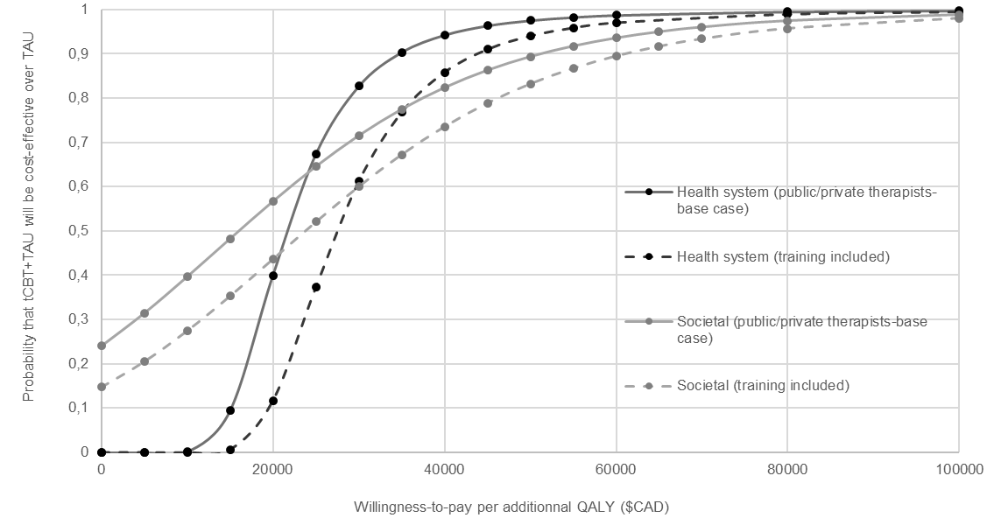
A)
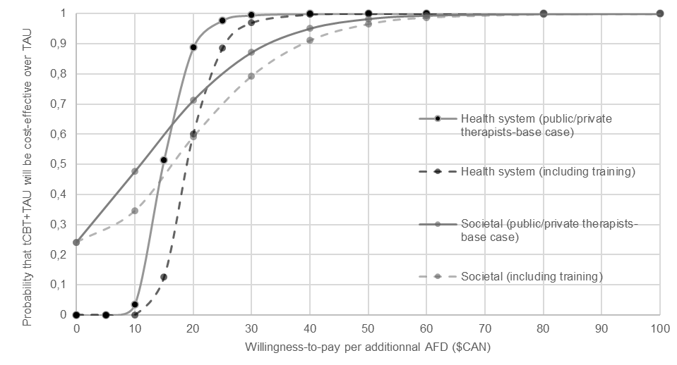
B)
Note. A) QALY and B) AFD as outcome. Adjusted for baseline: costs, clinical variable (utility index or BAI score according to the model), age, sex, study region, time of inclusion in the study, comorbid anxiety disorders based on those included in the study, comorbid mental health disorders as per the ADIS-5 and occupation. Dotted lines represent sensitivity analysis where costs of training was considered. Data were obtained by linear regression.

Supplementary Figure 5
Cost-effectiveness acceptability curve of tCBT+TAU compared to TAU from the health system perspective on a 12-month time horizon
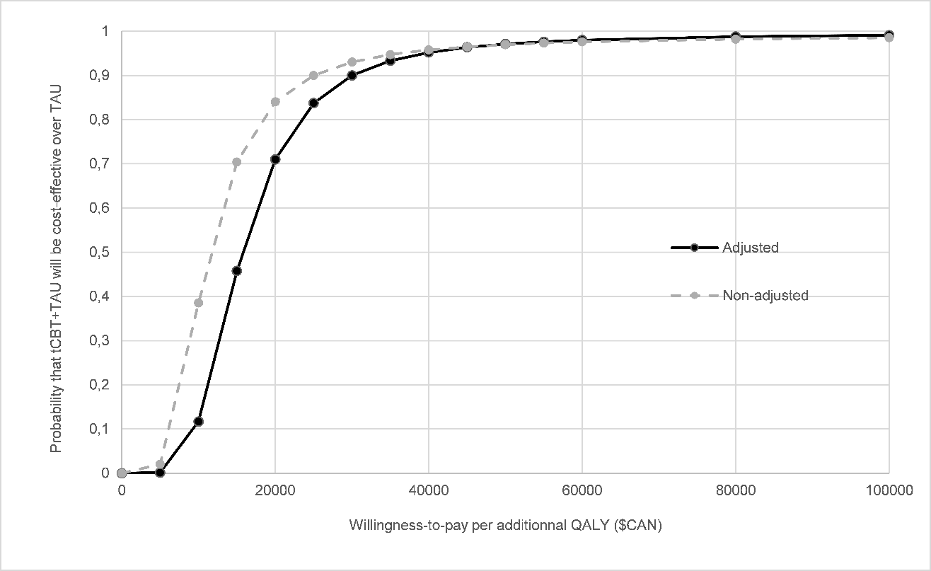
B)
A)
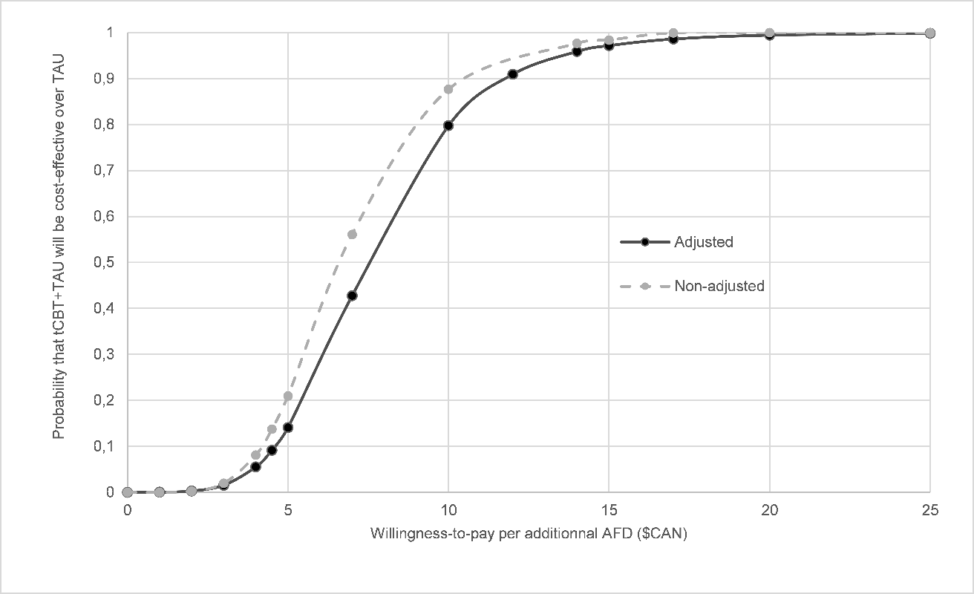
Note. A) QALY and B) AFD as outcome. Adjusted for baseline: costs, clinical variable (utility index or BAI score according to the model), age, sex, study region, time of inclusion in the study, comorbid anxiety disorders based on those included in the study, comorbid mental health disorders as per the ADIS-5 and occupation. Dotted lines represent non-adjusted results. Data were obtained by linear regression.

