Supplementary Materials for: Different trajectories of depression, anxiety and anhedonia symptoms in the first 12 months of the COVID-19 pandemic in a UK longitudinal sample
Table S1. A summary of UK-based studies examining mental health trajectories during COVID-19
 | Authors | Year | Sample | Characteristics | Statistical technique | Measures | Timing | Finding
(Bu, Steptoe, & Fancourt, 2020) |  | 2020 | 38,217 | COVID -19 Social Study | Latent growth modelling | Loneliness UCLA-3 | March 2020 - Sept 2020 | Four distinctive latent classes of loneliness trajectories.
(Saunders, Buckman, Fonagy, & Fancourt, 2021) | Saunders | 2021 | 21 938 | COVID-19 Social Study | Latent growth modelling | GAD-7, PHQ-9 | 21st March 2020 and 10th July 2020; | Four trajectories of depression and five for anxiety were identified. 30% of participants experienced trajectories with symptoms in the clinical range during lockdown, and did not follow the average curve or majority group, highlighting the importance of differential trajectories.
(Fancourt, Steptoe, & Bu, 2021) | Fancourt | 2021 | 36 520 | COVID-19 Social Study | Latent growth modelling | GAD-7, PHQ-9 | March 23, and Aug 9 | 3 class solutions. Risks of moderate  and severe depressive symptom  trajectories were significantly higher  among people experiencing abuse or  low social support, individuals with low  socioeconomic position, and those with  preexisting mental and physical health  conditions.
(Iob, Frank, Steptoe, & Fancourt, 2020) | Iob | 2020 | 51 417 | COVID-19 Social Study | Latent growth modelling | PHQ-9 | March 21 to April 2, 2020 | Risks of moderate and severe depressive symptom trajectories were significantly higher among people experiencing abuse or low social support, individuals with low socioeconomic position, and those with pre-existing mental and physical health conditions.
(Fluharty, Bu, Steptoe, & Fancourt, 2021) | Fluharty | 2021 | 26,505 | COVID-19 Social Study | Growth-curve modelling | GAD-7, PHQ-9 | 1st March and 14th August, 2020 | Symptoms decreased over time for all coping strategies, but only socially-supportive coping was associated with a faster decrease in anxiety and depressive symptoms, indicating a potential protective effect of social support on psychological distress.
(Bu, Mak, Fancourt, & Paul, 2022) | Bu | 2022 | 21 874 | COVID-19 Social Study - Keyworkers | Latent growth modelling | GAD-7, PHQ-9 | 21 March 2020 to 22 February 2021 | keyworkers in the essential services category had consistently higher levels of depressive and anxiety symptoms than non-keyworkers across the whole of the study period.
(Ellwardt & Präg, 2021) | Ellwardt | 2021 | 15, 914 | UK Household Longitudinal Study | latent class mixture modelling | GHQ-12 | pre covid 2020 - mid 2021 | 4 different trajectories of distress: continuously low, temporarily elevated, repeatedly elevated, and continuously elevated distress.
(Pierce et al., 2020) | Pierce | 2021 | 19 763 | UK Household Longitudinal Study | latent class mixed models | General Health Questionnaire | April 2020 - Oct 2020 | five distinct mental health trajectories up to October 2020.
(Stroud & Gutman, 2021) | Stroud | 2021 | 880 | Understanding Society COVID-19 survey | Growth curve modelling | GHQ-12 | April to November 2020 | For females, their mental health was lowest in April but gradually improved until September, when it began to decline again. Males, in contrast, had a relatively stable trajectory of mental health across the pandemic.
(Hu & Gutman, 2021) | Hu | 2021 | 419 | Understanding Society COVID-19 survey, | Growth curve modelling | Loneliness | June to November 2020 | U-shaped self-reported loneliness trajectory from June to November 2020
(McPherson, McAloney-Kocaman, McGlinchey, Faeth, & Armour, 2021) | McPherson | 2021 | 1958 | COVID-19 Psychological Wellbeing Study | Growth mixture modelling | GAD-7, PHQ-9 | March 23rd 2020 | 4-class model for anxiety, depression, and CV19TS symptomology

Dimensional symptom models: confirmatory factor analysis reporting
Rules for determining best model fit were specified a priori (see preregistration). In our pre-registration, we also described plans to test a tripartite model of symptoms (general distress, positive affect, anxious arousal) if supported by factor analyses.

In our pre-registration, we outlined our plans for testing a dimensional model of depression and anxiety symptoms, the tripartite model (see Table S3 for model specification and Figure S1 for item level correlations). We carried out confirmatory factor analysis of the tripartite model, which had adequate item loading (all >.20). In this model, General distress was correlated with a large effect size with both positive affect (.74) and anxious arousal (.97). Positive affect and anxious arousal were also correlated with a large effect size (.65). However, the model failed to reach pre-specified thresholds for adequate model fit (Tucker-Lewis Index = .835, less than the required >.90 adequate threshold; RMSEA = .097, greater than the required ≤ .08 adequate threshold).

Given a lack of items assessing physiological arousal, a 2-factor CFA was also carried out, assessing model fit for a ‘positive affect’ and ‘negative affect’ model. In the two-factor model, the positive and negative affect factors were correlated with a large effect size (.72). This model too demonstrated insufficient model fit (TLI = .833, RMSEA =.097; see Table S4). Therefore, trajectory modeling was conducted not on latent factors, but on total scores for PHQ-9, GAD-7 and MASQ-AD.

Across all outcome measures, all model fit indices identified the piecewise trajectories with pairwise correlations as the best model fit (see Table S5), so these models were carried forward.

Table S2. Model specification for the Tripartite Depression and Anxiety Model

General distress | Positive affect | Anxious arousal*
GAD-7: Not being able to stop or control worrying | MASQ_AD: Felt successful | GAD-7: Feeling nervous, anxious or on edge
GAD-7: Worrying too much about different things | MASQ_AD: Felt really happy | GAD-7: Trouble relaxing
GAD-7: Becoming easily annoyed or irritable | MASQ_AD: Felt optimistic | GAD-7: Being so restless that it is hard to sit still
GAD-7: Feeling afraid as if something awful might happen | MASQ_AD: Felt like I was having a lot of fun | PHQ-9: Moving or speaking so slowly that other people could have noticed? Or the opposite - being so fidgety or restless that you have been moving around a lot more than usual
PHQ-9: Feeling down, depressed, or hopeless | MASQ_AD: Felt like I accomplished a lot
PHQ-9: Trouble falling or staying asleep, or sleeping too much | MASQ_AD: Felt like I had a lot to look forward to
PHQ-9: Feeling tired or having little energy | MASQ_AD: Felt really talkative
PHQ-9: Poor appetite or overeating | MASQ_AD: Felt really ‘up’ or lively
PHQ-9: Feeling bad about yourself - or that you are a failure or have let yourself or your family down | MASQ_AD: Felt like I had a lot of energy
PHQ-9: Trouble concentrating on things, such as reading the newspaper or watching television | MASQ_AD: Felt really good about myself
PHQ-9: Thoughts that you would be better off dead, or of hurting yourself in some way | PHQ-9: Little interest or pleasure in doing things
* These items were moved to the general distress (aka negative affect) factor for the two-factor model tested

Correlation matrix
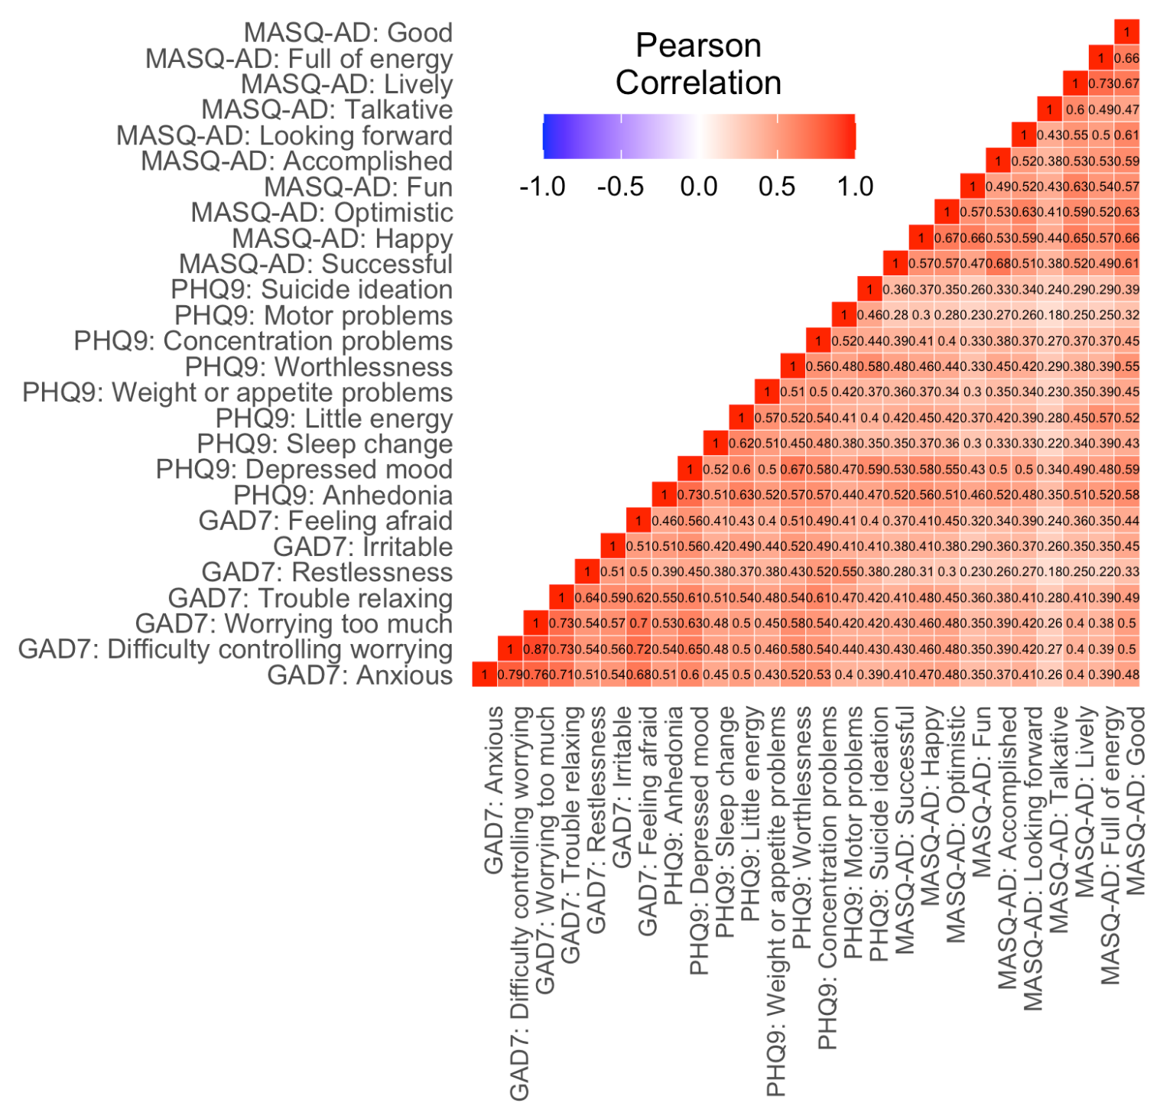

Figure S1. Correlation matrix of GAD7, PHQ9 and MASQ-AD items in the RAMP baseline sample (N = 10900). The strength of the correlation is indicated by the saturation of each cell.

Table S3. Fit indices for two and three factor models

 | df | CFI (> .90) | TLI (> .90) | RMSEA (≤ .08) [CI] | SRMR (≤ .08)
Three-factor | 296 | .850 | .835 | .097 [.096, .098] | .064
Two-factor | 298 | .846 | .833 | .097 [.096, .099] | .067

Table S4. Standardised item factor loadings for the 3- and 2-factor models
 | 3-factor model |  |  | 2-factor model
Questionnaire item | General distress | Positive affect | Anxious arousal | Negative affect | Positive affect
GAD7: Difficulty controlling worrying | 0.862 |  |  | 0.869
GAD7: Worrying too much | 0.855 |  |  | 0.861
GAD7: Irritable | 0.689 |  |  | 0.688
GAD7: Feeling afraid | 0.756 |  |  | 0.760
PHQ9: Depressed mood | 0.798 |  |  | 0.789
PHQ9: Sleep change | 0.619 |  |  | 0.615
PHQ9: Little energy | 0.678 |  |  | 0.669
PHQ9: Weight or appetite problems | 0.610 |  |  | 0.605
PHQ9: Worthlessness | 0.726 |  |  | 0.720
PHQ9: Concentration problems | 0.702 |  |  | 0.700
PHQ9: Suicide ideation | 0.574 |  |  | 0.569
MASQ-AD: Successful |  | 0.719 |  |  | 0.718
MASQ-AD: Happy |  | 0.805 |  |  | 0.807
MASQ-AD: Optimistic |  | 0.768 |  |  | 0.769
MASQ-AD: Fun |  | 0.718 |  |  | 0.720
MASQ-AD: Accomplished |  | 0.712 |  |  | 0.711
MASQ-AD: Looking forward |  | 0.722 |  |  | 0.722
MASQ-AD: Talkative |  | 0.578 |  |  | 0.579
MASQ-AD: Lively |  | 0.800 |  |  | 0.802
MASQ-AD: Full of energy |  | 0.752 |  |  | 0.752
MASQ-AD: Good |  | 0.836 |  |  | 0.835
PHQ9: Anhedonia |  | 0.702 |  |  | 0.699
GAD7: Anxious |  |  | 0.828 | 0.820
GAD7: Trouble relaxing |  |  | 0.854 | 0.648
GAD7: Restlessness |  |  | 0.680 | 0.832
PHQ9: Motor problems |  |  | 0.583 | 0.574

Trajectory modeling: Latent Growth Curve Modelling (LGCM)
Multiple random sets of starting values were used to avoid the local maxima/local solution problem (Hipp & Bauer, 2006), ensuring the highest log-likelihood value was replicated at least twice. Starting values were originally planned to be 1000 random sets of starting values (see https://osf.io/xm5cs/), carrying forward 250 starting seeds with the highest log-likelihood to the final stage optimisation (L. K. Muthén, 2017). However, due to computational demands, these values were reduced to 500 random sets, and 125 starting seeds in analyses presented here. Finally, analyses using the top two seeds with the best log likelihood values from the replication stage were rerun to ensure there was no evidence for a local maxima problem (using ‘optseed’ in Mplus; Wickrama et al., 2016). Once the optimal number of subgroups was identified, trajectories were examined and interpreted. Finally, analyses using the top two seeds with the best log likelihood values from the replication stage were rerun to ensure there was no evidence for a local maxima problem (using ‘optseed’ in Mplus; Wickrama et al., 2016).

Table S5. Model fit parameters from LGCM for linear, quadratic and piecewise trajectory types, with and without pairwise correlations between residuals of contiguous timepoints. Rows in bold indicate the selected model for each outcome variable.
Trajectory type | Pairwise correlations | Observations | Parameters | AIC | BIC | CFI (>.95) | TLI (>.95) | SRMR  (≤.08) | RMSEA Estimate (≤.06)
PHQ-9
Linear | No | 42006 | 21 | 1786100 | 1786282 | 0.956 | 0.960 | 0.021 | 0.040
Linear | Yes | 42006 | 36 | 1774121 | 1774432 | 0.985 | 0.984 | 0.016 | 0.025
Quadratic | No | 42006 | 25 | 1781344 | 1781560 | 0.968 | 0.970 | 0.017 | 0.035
Quadratic | Yes | 42006 | 39 | 1772577 | 1772914 | 0.989 | 0.988 | 0.013 | 0.022
Piecewise | No | 42006 | 36 | 1774531 | 1774842 | 0.985 | 0.984 | 0.010 | 0.025
Piecewise | Yes | 42006 | 46 | 1770170 | 1770568 | 0.995 | 0.994 | 0.009 | 0.015
GAD-7
Linear | No | 41445 | 21 | 1671934 | 1672116 | 0.960 | 0.963 | 0.021 | 0.037
Linear | Yes | 41445 | 36 | 1661947 | 1662258 | 0.986 | 0.985 | 0.016 | 0.024
Quadratic | No | 41445 | 25 | 1667841 | 1668056 | 0.971 | 0.972 | 0.018 | 0.032
Quadratic | Yes | 41445 | 40 | 1660647 | 1660992 | 0.989 | 0.988 | 0.013 | 0.021
Piecewise | No | 41445 | 36 | 1661334 | 1661645 | 0.988 | 0.987 | 0.009 | 0.022
Piecewise | Yes | 41445 | 46 | 1658013 | 1658410 | 0.996 | 0.996 | 0.008 | 0.013
MASQ-AD
Linear | No | 32892 | 20 | 1806998 | 1807166 | 0.943 | 0.948 | 0.046 | 0.056
Linear | Yes | 32892 | 34 | 1799404 | 1799690 | 0.968 | 0.967 | 0.043 | 0.044
Quadratic | No | 32892 | 24 | 1802466 | 1802668 | 0.958 | 0.961 | 0.044 | 0.048
Quadratic | Yes | 32892 | 38 | 1797427 | 1797746 | 0.975 | 0.973 | 0.042 | 0.040
Piecewise | No | 32892 | 35 | 1796887 | 1797181 | 0.978 | 0.977 | 0.026 | 0.037
Piecewise | Yes | 32892 | 40 | 1795036 | 1795372 | 0.984 | 0.982 | 0.032 | 0.032

Descriptive statistics for outcomes measures at each wave
Table S6 presents the mean and standard deviation of scores on outcomes measures across timepoints. Table S7 presents results of normality tests across outcomes variables at each timepoint. All values of skewness and kurtosis fell within +/-2, which is considered acceptable for normal distribution.

Table S6. Descriptive statistics for GAD-7, PHQ-9 and MASQ-AD at each timepoint
 |  |  | GAD-7 |  |  |  | PHQ-9 |  |  |  | MASQ-AD
 | Sample |  | N | Mean | SD |  | N | Mean | SD |  | N | M | SD
7-Apr-20 | COPING |  | 29765 | 5.76 | 5.85 |  | 30313 | 7.43 | 6.78 |  | NA | NA | NA
 | RAMP |  | 10022 | 8.4 | 6.15 |  | 10027 | 10.42 | 7.05 |  | NA | NA | NA
 | Combined |  | 39787 | 6.42 | 6.03 |  | 40340 | 8.18 | 6.97 |  | NA | NA | NA
19-May-20 | COPING |  | 16680 | 4.7 | 5.22 |  | 16760 | 6.49 | 6.34 |  | 16643 | 24.64 | 8.69
 | RAMP |  | 4941 | 6.3 | 5.6 |  | 4942 | 8.08 | 6.51 |  | 4400 | 26.75 | 8.58
 | Combined |  | 21621 | 5.07 | 5.35 |  | 21702 | 6.86 | 6.42 |  | 21043 | 25.08 | 8.71
2-Jun-20 | COPING |  | 19320 | 4.55 | 5.16 |  | 19370 | 6.2 | 6.27 |  | 19482 | 25.14 | 8.57
 | RAMP |  | 5442 | 6.14 | 5.55 |  | 5452 | 7.92 | 6.54 |  | 4950 | 26.39 | 8.78
 | Combined |  | 24762 | 4.9 | 5.29 |  | 24822 | 6.58 | 6.37 |  | 24432 | 25.39 | 8.63
16-Jun-20 | COPING |  | 18467 | 4.44 | 5.12 |  | 18485 | 6.2 | 6.31 |  | 18424 | 25.15 | 8.73
 | RAMP |  | 4980 | 5.96 | 5.5 |  | 4979 | 7.86 | 6.54 |  | 4455 | 26.46 | 8.76
 | Combined |  | 23447 | 4.77 | 5.24 |  | 23464 | 6.55 | 6.4 |  | 22879 | 25.41 | 8.75
30-Jun-20 | COPING |  | 17611 | 4.35 | 5.1 |  | 17646 | 6.09 | 6.27 |  | 17721 | 25.35 | 8.72
 | RAMP |  | 4634 | 5.84 | 5.53 |  | 4644 | 7.68 | 6.53 |  | 4204 | 26.73 | 8.81
 | Combined |  | 22245 | 4.66 | 5.23 |  | 22290 | 6.42 | 6.36 |  | 21925 | 25.62 | 8.76
14-Jul-20 | COPING |  | 16216 | 4.17 | 5.06 |  | 16212 | 5.79 | 6.27 |  | 16216 | 25.09 | 8.93
 | RAMP |  | 4264 | 5.6 | 5.5 |  | 4265 | 7.3 | 6.41 |  | 3865 | 26.28 | 9.06
 | Combined |  | 20480 | 4.47 | 5.19 |  | 20477 | 6.1 | 6.33 |  | 20081 | 25.32 | 8.97
28-Jul-20 | COPING |  | 15021 | 4 | 4.98 |  | 15020 | 5.51 | 6.13 |  | 15024 | 25.01 | 9
 | RAMP |  | 4041 | 5.52 | 5.49 |  | 4049 | 7.23 | 6.52 |  | 3714 | 26.29 | 9.25
 | Combined |  | 19062 | 4.32 | 5.13 |  | 19069 | 5.88 | 6.26 |  | 18738 | 25.27 | 9.06
25-Aug-20 | COPING |  | 15957 | 3.98 | 5.02 |  | 15955 | 5.59 | 6.29 |  | 15954 | 24.55 | 8.97
 | RAMP |  | 3142 | 5.32 | 5.41 |  | 3142 | 6.98 | 6.39 |  | 2872 | 25.59 | 9.21
 | Combined |  | 19099 | 4.2 | 5.11 |  | 19097 | 5.82 | 6.32 |  | 18826 | 24.71 | 9.02
22-Sep-20 | COPING |  | 15259 | 4.03 | 5.01 |  | 15255 | 5.37 | 6.11 |  | 15249 | 25.25 | 8.9
 | RAMP |  | 3806 | 5.69 | 5.44 |  | 3806 | 7.08 | 6.4 |  | 3444 | 26.05 | 9.15
 | Combined |  | 19065 | 4.36 | 5.14 |  | 19061 | 5.71 | 6.21 |  | 18693 | 25.4 | 8.95
20-Oct-20 | COPING |  | 16529 | 4.32 | 5.19 |  | 16525 | 5.98 | 6.48 |  | 16525 | 25.43 | 8.8
 | RAMP |  | 3655 | 5.91 | 5.52 |  | 3656 | 7.57 | 6.48 |  | 3269 | 27.11 | 8.9
 | Combined |  | 20184 | 4.61 | 5.29 |  | 20181 | 6.26 | 6.51 |  | 19794 | 25.71 | 8.84
17-Nov-20 | COPING |  | 16407 | 4.32 | 5.16 |  | 16408 | 6.01 | 6.43 |  | 16399 | 26.44 | 8.73
 | RAMP |  | 3636 | 5.85 | 5.49 |  | 3635 | 7.75 | 6.54 |  | 3251 | 27.73 | 8.75
 | Combined |  | 20043 | 4.59 | 5.26 |  | 20043 | 6.32 | 6.49 |  | 19650 | 26.66 | 8.75
15-Dec-21 | COPING |  | 15933 | 4.25 | 5.14 |  | 15934 | 5.95 | 6.43 |  | 15931 | 25.81 | 8.76
 | RAMP |  | 3362 | 5.75 | 5.4 |  | 3364 | 7.54 | 6.43 |  | 3024 | 27.21 | 8.68
 | Combined |  | 19295 | 4.51 | 5.21 |  | 19298 | 6.23 | 6.46 |  | 18955 | 26.03 | 8.76
12-Jan-21 | COPING |  | 16028 | 4.44 | 5.23 |  | 16027 | 6.23 | 6.5 |  | 16021 | 27.68 | 8.51
 | RAMP |  | 3159 | 5.82 | 5.45 |  | 3161 | 7.88 | 6.64 |  | 2798 | 28.51 | 8.43
 | Combined |  | 19187 | 4.67 | 5.29 |  | 19188 | 6.5 | 6.56 |  | 18819 | 27.8 | 8.5
9-Feb-21 | COPING |  | 15910 | 4.32 | 5.24 |  | 15909 | 6.36 | 6.65 |  | 15912 | 26.57 | 8.68
 | RAMP |  | 3243 | 5.62 | 5.45 |  | 3243 | 7.77 | 6.56 |  | 2895 | 27.88 | 8.59
 | Combined |  | 19153 | 4.54 | 5.3 |  | 19152 | 6.6 | 6.65 |  | 18807 | 26.77 | 8.68
9-Mar-21 | COPING |  | 15580 | 4.21 | 5.18 |  | 15582 | 6.08 | 6.6 |  | 15574 | 26.46 | 8.79
 | RAMP |  | 2813 | 5.36 | 5.42 |  | 2813 | 7.35 | 6.49 |  | 2534 | 27.28 | 8.85
 | Combined |  | 18393 | 4.38 | 5.24 |  | 18395 | 6.27 | 6.6 |  | 18108 | 26.57 | 8.8
6-Apr-21 | COPING |  | 14957 | 3.98 | 5.06 |  | 14959 | 5.92 | 6.58 |  | 14960 | 25.31 | 8.91
 | RAMP |  | 0 | NA | NA |  | 0 | NaN | NA |  | 0 | NaN | NA
 | Combined |  | 14957 | 3.98 | 5.06 |  | 14959 | 5.92 | 6.58 |  | 14960 | 25.31 | 8.91
Note: RAMP data was unavailable for the final follow-up , hence the NaN/NA 0 values

Table S7. Normality tests for outcomes scores across timepoints

 | GAD7 |  | PHQ9 |  | MASQ-AD
 | skew | kurtosis | skew | kurtosis | skew | kurtosis
Baseline | 0.81 | -0.42 | 0.77 | -0.32 | -0.38 | -0.49
Follow up 03 | 1.11 | 0.42 | 0.99 | 0.22 | -0.21 | -0.64
Follow up 04 | 1.17 | 0.61 | 1.05 | 0.36 | -0.28 | -0.62
Follow up 05 | 1.20 | 0.68 | 1.05 | 0.36 | -0.27 | -0.63
Follow up 06 | 1.25 | 0.82 | 1.08 | 0.45 | -0.29 | -0.64
Follow up 07 | 1.31 | 1.00 | 1.16 | 0.67 | -0.28 | -0.65
Follow up 08 | 1.35 | 1.14 | 1.22 | 0.83 | -0.29 | -0.65
Follow up 09 | 1.40 | 1.25 | 1.23 | 0.80 | -0.22 | -0.72
Follow up 10 | 1.35 | 1.15 | 1.28 | 1.01 | -0.31 | -0.61
Follow up 11 | 1.25 | 0.74 | 1.13 | 0.47 | -0.33 | -0.62
Follow up 12 | 1.26 | 0.86 | 1.12 | 0.49 | -0.42 | -0.51
Follow up 13 | 1.29 | 0.91 | 1.13 | 0.50 | -0.36 | -0.56
Follow up 14 | 1.24 | 0.77 | 1.07 | 0.33 | -0.56 | -0.30
Follow up 15 | 1.29 | 0.87 | 1.04 | 0.23 | -0.43 | -0.49
Follow up 16 | 1.35 | 1.10 | 1.15 | 0.55 | -0.44 | -0.49
Follow up 17 | 1.47 | 1.46 | 1.24 | 0.75 | -0.28 | -0.63

Table S8. Proportion of total sample included in LGCM solutions
 |  | PHQ-9 |  | GAD-7 |  | MASQ-AD
 | Class | Count | Proportion | Count | Proportion | Count | Proportion
2-class model | 1 | 31854 | 0.76 | 10139 | 0.24 | 8897 | 0.27
 | 2 | 10152 | 0.24 | 31306 | 0.76 | 23995 | 0.73
3-class model | 1 | 8500 | 0.20 | 29921 | 0.72 | 9049 | 0.28
 | 2 | 3203 | 0.08 | 4192 | 0.10 | 23086 | 0.70
 | 3 | 30303 | 0.72 | 7332 | 0.18 | 757 | 0.02
4-class model | 1 | 4341 | 0.10 | 28640 | 0.69 | 592 | 0.02
 | 2 | 25364 | 0.60 | 6064 | 0.15 | 22299 | 0.68
 | 3 | 6977 | 0.17 | 3854 | 0.09 | 8764 | 0.27
 | 4 | 5324 | 0.13 | 2887 | 0.07 | 1237 | 0.04
5-class model | 1 | 4540 | 0.11 | 27001 | 0.65 | 562 | 0.02
 | 2 | 26291 | 0.63 | 2769 | 0.07 | 8791 | 0.27
 | 3 | 4480 | 0.11 | 2241 | 0.05 | 22099 | 0.67
 | 4 | 3318 | 0.08 | 4663 | 0.11 | 781 | 0.02
 | 5 | 3377 | 0.08 | 4771 | 0.12 | 659 | 0.02
6-class model | 1 | 4772 | 0.11 | 4949 | 0.12 | 687 | 0.02
 | 2 | 1504 | 0.04 | 1579 | 0.04 | 1086 | 0.03
 | 3 | 3843 | 0.09 | 3581 | 0.09 | 430 | 0.01
 | 4 | 2097 | 0.05 | 26697 | 0.64 | 21290 | 0.65
 | 5 | 26284 | 0.63 | 2129 | 0.05 | 8957 | 0.27
 | 6 | 3506 | 0.08 | 2510 | 0.06 | 442 | 0.01
7-class model | 1 | 2252 | 0.05 | 1382 | 0.03 | 479 | 0.01
 | 2 | 1587 | 0.04 | 3304 | 0.08 | 16781 | 0.51
 | 3 | 26245 | 0.62 | 1387 | 0.03 | 10892 | 0.33
 | 4 | 4796 | 0.11 | 5011 | 0.12 | 491 | 0.01
 | 5 | 2832 | 0.07 | 1374 | 0.03 | 908 | 0.03
 | 6 | 1080 | 0.03 | 2153 | 0.05 | 2673 | 0.08
 | 7 | 3214 | 0.08 | 26834 | 0.65 | 668 | 0.02

Model selection decision tree

Figure S2. Decision tree for model selection (assuming all models converged, models that failed to converge were also discarded)

Scree plots
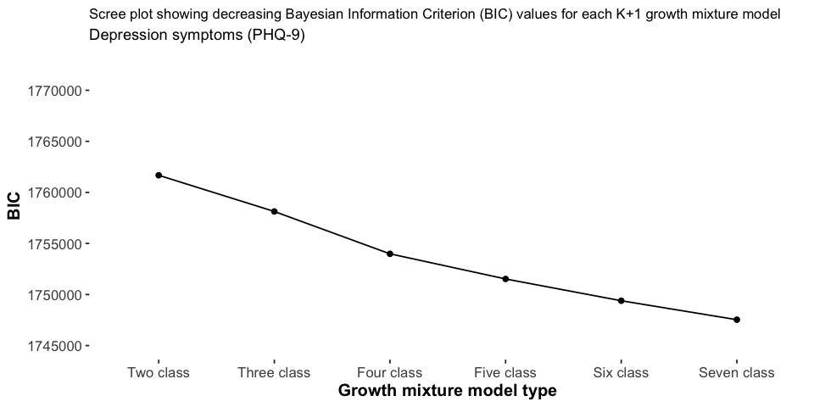
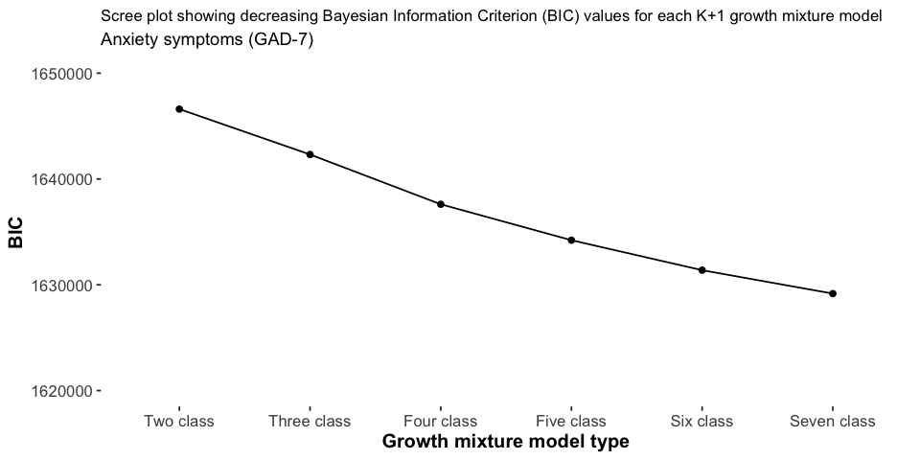

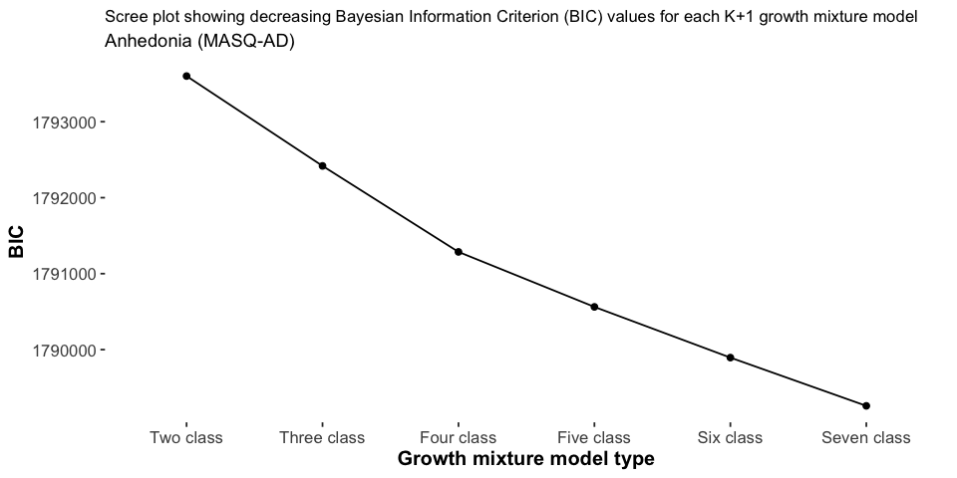

Figure S3. Scree plots for the PHQ scores, the GAD-7 scores and the MASQ-AD scores.

Table S9. Multinomial regression results - PHQ model, bold values indicate statistically significant effects (p < .05). Class 2 reflects the low and stable symptom class group.
 | Class 1 (vs. Class 2) |  |  |  | Class 3 (vs. Class 2) |  |  |  | Class 4 (vs. Class 2)
Predictor | B | p | RRR | 95% CI | B | p | RRR | 95% CI | B | p | RRR | 95% CI
Intercept | -4.10 | .000 | 0.02 | 0.01, 0.02 | -2.34 | .000 | 0.10 | 0.08, 0.11 | -2.74 | .000 | 0.06 | 0.05, 0.08
Age in years
16-18 (vs. 26-35) | 2.46 | .000 | 11.68 | 8.14, 16.76 | 1.22 | .000 | 3.40 | 2.38, 4.84 | 1.57 | .000 | 4.79 | 3.38, 6.80
19-25 (vs. 26-35) | 0.76 | .000 | 2.14 | 1.76, 2.59 | 0.42 | .000 | 1.52 | 1.30, 1.78 | 0.62 | .000 | 1.85 | 1.57, 2.19
36-45 (vs. 26-35) | -0.32 | .000 | 0.72 | 0.61, 0.86 | -0.25 | .000 | 0.78 | 0.69, 0.88 | -0.37 | .000 | 0.69 | 0.60, 0.79
46-55 (vs. 26-35) | -0.31 | .000 | 0.74 | 0.63, 0.87 | -0.39 | .000 | 0.67 | 0.60, 0.76 | -0.58 | .000 | 0.56 | 0.49, 0.64
56-65 (vs. 26-35) | -0.87 | .000 | 0.42 | 0.34, 0.52 | -0.66 | .000 | 0.52 | 0.45, 0.59 | -0.68 | .000 | 0.50 | 0.43, 0.59
66-70 (vs. 26-35) | -1.74 | .000 | 0.18 | 0.08, 0.38 | -1.13 | .000 | 0.32 | 0.22, 0.47 | -0.87 | .000 | 0.42 | 0.28, 0.61
71+ (vs. 26-35) | -1.10 | .007 | 0.33 | 0.15, 0.74 | -1.25 | .000 | 0.29 | 0.17, 0.48 | -0.93 | .000 | 0.40 | 0.24, 0.66
Gender
Female (vs. male) | 0.01 | .854 | 1.01 | 0.88, 1.17 | 0.20 | .000 | 1.23 | 1.11, 1.36 | 0.39 | .000 | 1.48 | 1.31, 1.67
Non-binary/Prefer to self define (vs. male) | 0.46 | .043 | 1.59 | 1.02, 2.48 | 0.45 | .029 | 1.57 | 1.05, 2.35 | 0.66 | .003 | 1.93 | 1.25, 2.96
Ethnicity
Minoritised ethnic community (vs. white) | 0.23 | .087 | 1.26 | 0.97, 1.63 | 0.19 | .064 | 1.20 | 0.99, 1.47 | 0.18 | .109 | 1.20 | 0.96, 1.49
Employment
Retired (vs. employed) | 1.27 | .001 | 3.57 | 1.74, 7.33 | 0.40 | .210 | 1.49 | 0.80, 2.77 | 0.51 | .127 | 1.67 | 0.87, 3.21
Student (vs. employed) | 1.39 | .005 | 4.03 | 1.53, 10.60 | 0.31 | .552 | 1.37 | 0.49, 3.81 | 0.46 | .398 | 1.59 | 0.54, 4.65
Unemployed (vs. employed) | 1.60 | .000 | 4.97 | 4.08, 6.07 | 0.87 | .000 | 2.40 | 2.01, 2.86 | 0.87 | .000 | 2.39 | 1.96, 2.90
Employment change
Decreased employment (vs. no change) | 0.55 | .000 | 1.73 | 1.47, 2.03 | 0.25 | .000 | 1.28 | 1.13, 1.44 | 0.50 | .000 | 1.65 | 1.45, 1.88
Furloughed (vs. no change) | 0.47 | .000 | 1.60 | 1.36, 1.88 | 0.31 | .000 | 1.36 | 1.21, 1.53 | 0.31 | .000 | 1.37 | 1.20, 1.56
Increased employment (vs. no change) | 0.13 | .282 | 1.14 | 0.90, 1.44 | 0.17 | .066 | 1.18 | 0.99, 1.41 | 0.03 | .813 | 1.03 | 0.83, 1.27
Key worker status
Government key worker (vs. not key worker) | 0.07 | .319 | 1.07 | 0.94, 1.22 | 0.08 | .081 | 1.08 | 0.99, 1.19 | -0.05 | .302 | 0.95 | 0.86, 1.05
Prior mental health diagnosis
Anxiety disorder (vs. no diagnosis) | 0.86 | .000 | 2.37 | 2.03, 2.78 | 0.55 | .000 | 1.74 | 1.57, 1.92 | 0.53 | .000 | 1.70 | 1.52, 1.91
Depressive disorder (vs. no diagnosis) | 1.70 | .000 | 5.46 | 4.54, 6.55 | 1.09 | .000 | 2.97 | 2.67, 3.30 | 1.04 | .000 | 2.82 | 2.50, 3.19
Eating disorder (vs. no diagnosis) | 0.72 | .000 | 2.06 | 1.74, 2.45 | 0.50 | .000 | 1.65 | 1.42, 1.92 | 0.46 | .000 | 1.58 | 1.34, 1.87
OCRD (vs. no diagnosis) | 0.57 | .000 | 1.77 | 1.49, 2.09 | 0.15 | .060 | 1.16 | 0.99, 1.36 | 0.30 | .000 | 1.35 | 1.14, 1.59
Psychotic disorder (vs. no diagnosis) | -0.15 | .389 | 0.86 | 0.61, 1.21 | -0.16 | .317 | 0.85 | 0.62, 1.17 | -0.57 | .004 | 0.56 | 0.38, 0.83
Personality disorder (vs. no diagnosis) | 1.07 | .000 | 2.92 | 2.31, 3.68 | 0.43 | .000 | 1.54 | 1.22, 1.94 | 0.42 | .001 | 1.53 | 1.19, 1.97
Bipolar disorder (vs. no diagnosis) | 0.65 | .000 | 1.92 | 1.48, 2.48 | 0.55 | .000 | 1.74 | 1.38, 2.19 | 0.47 | .000 | 1.60 | 1.23, 2.07
PTSD (vs. no diagnosis) | 0.58 | .000 | 1.79 | 1.52, 2.11 | 0.34 | .000 | 1.41 | 1.22, 1.63 | 0.45 | .000 | 1.57 | 1.34, 1.84
ASD (vs. no diagnosis) | 0.81 | .000 | 2.26 | 1.60, 3.18 | 0.55 | .001 | 1.74 | 1.26, 2.40 | 0.57 | .001 | 1.78 | 1.26, 2.51

Table S10. Multinomial regression results - GAD model, bold values indicate statistically significant effects (p < .05). Class 1 is the low and stable symptom class
 | Class 2 (vs. Class 1) |  |  |  | Class 3 (vs. Class 1) |  |  |  | Class 4 (vs. Class 1)
Predictor | B | p | RRR | 95% CI | B | p | RRR | 95% CI | B | p | RRR | 95% CI
Intercept | -3.24 | .000 | 0.04 | 0.03, 0.05 | -2.94 | .000 | 0.05 | 0.04, 0.06 | -3.57 | .000 | 0.03 | 0.02, 0.03
Age in years
16-18 (vs. 26-35) | 1.27 | .000 | 3.57 | 2.68, 4.75 | 0.99 | .000 | 2.69 | 1.96, 3.71 | 0.46 | .040 | 1.59 | 1.02, 2.47
19-25 (vs. 26-35) | 0.53 | .000 | 1.69 | 1.45, 1.97 | 0.34 | .000 | 1.40 | 1.18, 1.68 | 0.30 | .004 | 1.36 | 1.10, 1.67
36-45 (vs. 26-35) | -0.32 | .000 | 0.73 | 0.64, 0.83 | -0.28 | .000 | 0.76 | 0.65, 0.88 | 0.05 | .576 | 1.05 | 0.89, 1.23
46-55 (vs. 26-35) | -0.39 | .000 | 0.67 | 0.59, 0.77 | -0.54 | .000 | 0.58 | 0.50, 0.68 | -0.04 | .659 | 0.96 | 0.82, 1.13
56-65 (vs. 26-35) | -0.75 | .000 | 0.47 | 0.40, 0.56 | -0.66 | .000 | 0.52 | 0.43, 0.61 | -0.43 | .000 | 0.65 | 0.54, 0.79
66-70 (vs. 26-35) | -2.16 | .000 | 0.12 | 0.05, 0.25 | -0.75 | .001 | 0.47 | 0.31, 0.73 | -0.56 | .026 | 0.57 | 0.35, 0.93
71+ (vs. 26-35) | -0.99 | .002 | 0.37 | 0.20, 0.70 | -0.51 | .060 | 0.60 | 0.36, 1.02 | -0.26 | .376 | 0.77 | 0.43, 1.38
Gender
Female (vs. male) | 0.27 | .000 | 1.31 | 1.16, 1.48 | 0.52 | .000 | 1.68 | 1.46, 1.93 | 0.33 | .000 | 1.40 | 1.21, 1.61
Non-binary/Prefer to self define (vs. male) | 0.57 | .002 | 1.77 | 1.24, 2.53 | 0.18 | .494 | 1.19 | 0.72, 1.98 | 0.42 | .083 | 1.53 | 0.95, 2.47
Ethnicity
Minoritised ethnic community (vs. white) | 0.03 | .776 | 1.03 | 0.83, 1.29 | 0.15 | .205 | 1.16 | 0.92, 1.47 | 0.09 | .533 | 1.09 | 0.83, 1.42
Employment
Retired (vs. employed) | 0.66 | .054 | 1.93 | 0.99, 3.75 | -0.90 | .134 | 0.41 | 0.13, 1.32 | 0.29 | .453 | 1.34 | 0.62, 2.89
Student (vs. employed) | 0.95 | .027 | 2.58 | 1.11, 5.96 | 0.19 | .745 | 1.21 | 0.38, 3.85 | 0.37 | .529 | 1.45 | 0.46, 4.63
Unemployed (vs. employed) | 0.81 | .000 | 2.25 | 1.91, 2.66 | 0.00 | .977 | 1.00 | 0.81, 1.25 | 0.25 | .030 | 1.28 | 1.02, 1.61
Employment change
Decreased employment (vs. no change) | 0.41 | .000 | 1.50 | 1.32, 1.71 | 0.26 | .000 | 1.29 | 1.12, 1.49 | 0.17 | .041 | 1.18 | 1.01, 1.39
Furloughed (vs. no change) | 0.30 | .000 | 1.35 | 1.18, 1.54 | 0.19 | .008 | 1.21 | 1.05, 1.40 | 0.28 | .000 | 1.33 | 1.14, 1.55
Increased employment (vs. no change) | 0.27 | .005 | 1.31 | 1.09, 1.59 | 0.11 | .355 | 1.11 | 0.89, 1.39 | 0.02 | .867 | 1.02 | 0.80, 1.30
Key worker status
Government key worker (vs. not key worker) | -0.04 | .493 | 0.96 | 0.87, 1.07 | -0.09 | .123 | 0.92 | 0.82, 1.02 | 0.11 | .084 | 1.11 | 0.99, 1.26
Prior mental health diagnosis
Anxiety disorder (vs. no diagnosis) | 1.30 | .000 | 3.66 | 3.21, 4.18 | 0.88 | .000 | 2.42 | 2.12, 2.77 | 0.96 | .000 | 2.61 | 2.25, 3.03
Depressive disorder (vs. no diagnosis) | 0.66 | .000 | 1.94 | 1.70, 2.21 | 0.34 | .000 | 1.41 | 1.24, 1.61 | 0.64 | .000 | 1.89 | 1.62, 2.20
Eating disorder (vs. no diagnosis) | 0.51 | .000 | 1.66 | 1.44, 1.92 | 0.38 | .000 | 1.46 | 1.23, 1.73 | 0.30 | .002 | 1.34 | 1.12, 1.62
OCRD (vs. no diagnosis) | 0.51 | .000 | 1.66 | 1.44, 1.92 | 0.35 | .000 | 1.42 | 1.19, 1.68 | 0.31 | .001 | 1.36 | 1.13, 1.63
Psychotic disorder (vs. no diagnosis) | -0.20 | .194 | 0.82 | 0.61, 1.11 | -0.35 | .090 | 0.71 | 0.47, 1.06 | -0.01 | .941 | 0.99 | 0.68, 1.43
Personality disorder (vs. no diagnosis) | 0.73 | .000 | 2.08 | 1.71, 2.52 | 0.27 | .040 | 1.31 | 1.01, 1.68 | 0.46 | .000 | 1.59 | 1.23, 2.05
Bipolar disorder (vs. no diagnosis) | 0.33 | .003 | 1.39 | 1.12, 1.73 | 0.31 | .025 | 1.36 | 1.04, 1.77 | 0.31 | .027 | 1.36 | 1.03, 1.78
PTSD (vs. no diagnosis) | 0.46 | .000 | 1.59 | 1.38, 1.82 | 0.38 | .000 | 1.47 | 1.24, 1.73 | 0.23 | .010 | 1.26 | 1.06, 1.51
ASD (vs. no diagnosis) | 0.44 | .003 | 1.56 | 1.17, 2.08 | 0.28 | .128 | 1.33 | 0.92, 1.91 | 0.65 | .000 | 1.91 | 1.35, 2.70

Table S11. Multinomial regression results - MASQ model, bold values indicate statistically significant effects (p < .05). Class 3 is the low and stable symptom class
 | Class 1 (vs. Class 3) |  |  |  | Class 2 (vs. Class 3) |  |  |  | Class 4 (vs. Class 3)
Predictor | B | p | RRR | 95% CI | B | p | RRR | 95% CI | B | p | RRR | 95% CI
Intercept | -3.41 | .000 | 0.03 | 0.02, 0.05 | -0.07 | .258 | 0.93 | 0.82, 1.06 | -3.18 | .000 | 0.04 | 0.03, 0.06
Age in years
16-18 (vs. 26-35) | -0.20 | .709 | 0.82 | 0.28, 2.38 | 0.15 | .434 | 1.17 | 0.79, 1.71 | 0.47 | .183 | 1.60 | 0.80, 3.20
19-25 (vs. 26-35) | -0.24 | .311 | 0.78 | 0.49, 1.25 | -0.03 | .700 | 0.97 | 0.81, 1.15 | 0.08 | .661 | 1.08 | 0.75, 1.56
36-45 (vs. 26-35) | 0.05 | .756 | 1.05 | 0.76, 1.46 | 0.12 | .053 | 1.13 | 1.00, 1.29 | -0.02 | .878 | 0.98 | 0.74, 1.30
46-55 (vs. 26-35) | -0.30 | .090 | 0.74 | 0.53, 1.05 | 0.23 | .000 | 1.26 | 1.12, 1.42 | 0.15 | .273 | 1.16 | 0.89, 1.51
56-65 (vs. 26-35) | -0.36 | .068 | 0.70 | 0.47, 1.03 | 0.13 | .043 | 1.14 | 1.00, 1.29 | 0.23 | .108 | 1.26 | 0.95, 1.66
66-70 (vs. 26-35) | -0.94 | .080 | 0.39 | 0.14, 1.12 | -0.09 | .462 | 0.92 | 0.73, 1.15 | -0.16 | .612 | 0.85 | 0.46, 1.57
71+ (vs. 26-35) | -0.72 | .243 | 0.49 | 0.15, 1.63 | -0.10 | .473 | 0.90 | 0.68, 1.19 | 0.46 | .140 | 1.59 | 0.86, 2.93
Gender
Female (vs. male) | 0.47 | .002 | 1.60 | 1.19, 2.15 | 0.40 | .000 | 1.50 | 1.37, 1.63 | 0.95 | .000 | 2.60 | 2.06, 3.28
Non-binary/Prefer to self define (vs. male) | 0.55 | .289 | 1.73 | 0.63, 4.79 | 0.41 | .071 | 1.51 | 0.97, 2.35 | 0.59 | .242 | 1.81 | 0.67, 4.90
Ethnicity
Minoritised ethnic community (vs. white) | 0.04 | .883 | 1.04 | 0.60, 1.80 | -0.12 | .235 | 0.89 | 0.73, 1.08 | 0.14 | .496 | 1.15 | 0.77, 1.74
Employment
Retired (vs. employed) | 0.56 | .469 | 1.74 | 0.39, 7.85 | 0.41 | .082 | 1.51 | 0.95, 2.40 | -0.47 | .535 | 0.63 | 0.14, 2.73
Student (vs. employed) | 1.49 | .143 | 4.45 | 0.60, 32.77 | 0.72 | .333 | 2.06 | 0.48, 8.87 | 1.36 | .181 | 3.88 | 0.53, 28.23
Unemployed (vs. employed) | 0.45 | .082 | 1.57 | 0.94, 2.62 | 0.80 | .000 | 2.23 | 1.79, 2.77 | 0.32 | .173 | 1.37 | 0.87, 2.16
Employment change
Decreased employment (vs. no change) | 0.02 | .927 | 1.02 | 0.72, 1.43 | 0.06 | .264 | 1.07 | 0.95, 1.19 | 0.23 | .064 | 1.26 | 0.99, 1.60
Furloughed (vs. no change) | -0.16 | .371 | 0.85 | 0.60, 1.21 | -0.02 | .744 | 0.98 | 0.88, 1.10 | 0.16 | .206 | 1.17 | 0.92, 1.49
Increased employment (vs. no change) | -0.16 | .539 | 0.85 | 0.50, 1.43 | -0.11 | .212 | 0.89 | 0.75, 1.07 | -0.10 | .639 | 0.91 | 0.61, 1.36
Key worker status
Government key worker (vs. not key worker) | -0.14 | .281 | 0.87 | 0.68, 1.12 | -0.06 | .157 | 0.94 | 0.87, 1.02 | -0.01 | .937 | 0.99 | 0.82, 1.20
Prior mental health diagnosis
Anxiety disorder (vs. no diagnosis) | 0.45 | .003 | 1.57 | 1.16, 2.11 | 0.43 | .000 | 1.53 | 1.39, 1.69 | 0.24 | .030 | 1.28 | 1.02, 1.59
Depressive disorder (vs. no diagnosis) | 1.01 | .000 | 2.75 | 2.02, 3.75 | 0.86 | .000 | 2.35 | 2.14, 2.59 | 0.66 | .000 | 1.93 | 1.55, 2.39
Eating disorder (vs. no diagnosis) | 0.41 | .053 | 1.50 | 0.99, 2.28 | 0.36 | .000 | 1.44 | 1.19, 1.73 | 0.32 | .067 | 1.38 | 0.98, 1.96
OCRD (vs. no diagnosis) | -0.18 | .438 | 0.84 | 0.54, 1.31 | 0.01 | .869 | 1.02 | 0.85, 1.21 | -0.22 | .253 | 0.80 | 0.55, 1.17
Psychotic disorder (vs. no diagnosis) | -0.69 | .166 | 0.50 | 0.19, 1.33 | -0.32 | .071 | 0.72 | 0.51, 1.03 | 0.17 | .612 | 1.19 | 0.61, 2.31
Personality disorder (vs. no diagnosis) | 0.58 | .054 | 1.79 | 0.99, 3.24 | 0.55 | .001 | 1.73 | 1.26, 2.36 | 0.51 | .067 | 1.66 | 0.96, 2.87
Bipolar disorder (vs. no diagnosis) | 0.39 | .208 | 1.48 | 0.80, 2.71 | 0.21 | .156 | 1.23 | 0.92, 1.63 | -0.13 | .670 | 0.88 | 0.48, 1.60
PTSD (vs. no diagnosis) | 0.12 | .576 | 1.12 | 0.75, 1.69 | 0.10 | .280 | 1.10 | 0.93, 1.31 | -0.07 | .706 | 0.93 | 0.65, 1.33
ASD (vs. no diagnosis) | 0.39 | .365 | 1.48 | 0.64, 3.44 | 0.39 | .047 | 1.47 | 1.00, 2.16 | 0.04 | .929 | 1.04 | 0.45, 2.40

Predictors of trajectory group membership

For depression symptoms (PHQ-9), we had two classes with moderate symptoms (Class 3, increasing then decreasing pattern; Class 4, decreasing then increasing pattern). As for Class 1 (high and stable symptoms), the strongest predictor of membership of these two classes was younger age (particularly 16-18 years). For anxiety symptoms (GAD-7), younger age was also a significant predictor of the two moderate symptom classes, albeit much smaller in size than seen for PHQ-9 symptoms. For the MASQ-AD symptom groups, in contrast to the PHQ-9 and GAD-7, younger age was not a significant predictor of high or moderate symptom class membership.

For depression and anxiety moderate or high symptom class membership, somewhat unsurprisingly, having a prior diagnosis of depression in the case of depressive symptom classes, or anxiety in the case of anxiety symptoms classes, were the most pronounced predictors from the category “pre-existing mental health diagnosis”. For anhedonia symptoms, having a previous diagnosis of depression was the strongest diagnosis-related predictor of being in one of the moderate or high symptom class groups.

Employment status
In addition to gender differences (see main manuscript), there were some differences between how retirement status predicted class membership for depression and anxiety. For depression, retired status predicted membership of the high and stable symptom class, but not the other two time-varying classes (Class 3, increasing then decreasing pattern; Class 4 decreasing then increasing pattern). For anxiety symptom classes, retired status was not a predictor of any class membership. Decreased employment or furloughed employment was a predictor of class membership of all three depression class symptoms and anxiety class symptoms, relative to the low and stable classes. Only for the high and stable group for anxiety symptoms was increased employment a significant predictor of class membership. For anhedonia symptoms, reporting an unemployed status was a significant predictor of membership of the high and stable class only. No other employment status associations were significant, in contrast to that seen for the depression and anxiety symptom classes.

Discussion

Retirement status predicted membership of the “high and stable” trajectory group for depression but not anxiety. Previous work has shown that poorer mental health is not an inevitability post retirement. In fact, a large population-level study showed that when retirement is statutory or voluntary, it is associated with improved mental health (Jokela et al., 2010). We might speculate that retirement, and the reduced social contacts associated with lockdowns, may explain the effect we reported related to depressive symptoms. The association between retirement and poor anxiety symptom trajectories may be less apparent compared to the other employment groups (student, unemployed) who may plausibly face greater uncertainty and financial concerns.

Additional references

Bu, F., Mak, H. W., Fancourt, D., & Paul, E. (2022). Comparing the mental health trajectories of four different types of keyworkers with non-keyworkers: 12-month follow-up observational study of 21 874 adults in England during the COVID-19 pandemic. The British Journal of Psychiatry, 220(5), 287-294. doi:10.1192/bjp.2021.205
Bu, F., Steptoe, A., & Fancourt, D. (2020). Loneliness during a strict lockdown: Trajectories and predictors during the COVID-19 pandemic in 38,217 United Kingdom adults. Social Science & Medicine, 265, 113521. doi:10.1016/j.socscimed.2020.113521
Ellwardt, L., & Präg, P. (2021). Heterogeneous mental health development during the COVID-19 pandemic in the United Kingdom. Scientific Reports, 11(1), 15958. doi:10.1038/s41598-021-95490-w
Fancourt, D., Steptoe, A., & Bu, F. (2021). Trajectories of anxiety and depressive symptoms during enforced isolation due to COVID-19 in England: a longitudinal observational study. Lancet Psychiatry, 8(2), 141-149. doi:10.1016/s2215-0366(20)30482-x
Fluharty, M., Bu, F., Steptoe, A., & Fancourt, D. (2021). Coping strategies and mental health trajectories during the first 21 weeks of COVID-19 lockdown in the United Kingdom. Social Science & Medicine, 279, 113958. doi:10.1016/j.socscimed.2021.113958
Hu, Y., & Gutman, L. M. (2021). The trajectory of loneliness in UK young adults during the summer to winter months of COVID-19. Psychiatry Research, 303, 114064. doi:10.1016/j.psychres.2021.114064
Iob, E., Frank, P., Steptoe, A., & Fancourt, D. (2020). Levels of Severity of Depressive Symptoms Among At-Risk Groups in the UK During the COVID-19 Pandemic. JAMA Network Open, 3(10), e2026064-e2026064. doi:10.1001/jamanetworkopen.2020.26064
Jokela, M., Ferrie, J. E., Gimeno, D., Chandola, T., Shipley, M. J., Head, J., . . . Kivimäki, M. (2010). From midlife to early old age: health trajectories associated with retirement. Epidemiology, 21(3), 284-290. doi:10.1097/EDE.0b013e3181d61f53
McPherson, K. E., McAloney-Kocaman, K., McGlinchey, E., Faeth, P., & Armour, C. (2021). Longitudinal analysis of the UK COVID-19 Psychological Wellbeing Study: Trajectories of anxiety, depression and COVID-19-related stress symptomology. Psychiatry Res, 304, 114138. doi:10.1016/j.psychres.2021.114138
Pierce, M., Hope, H., Ford, T., Hatch, S., Hotopf, M., John, A., . . . Abel, K. M. (2020). Mental health before and during the COVID-19 pandemic: a longitudinal probability sample survey of the UK population. Lancet Psychiatry, 7(10), 883-892. doi:10.1016/s2215-0366(20)30308-4
Saunders, R., Buckman, J. E., Fonagy, P., & Fancourt, D. (2021). Understanding different trajectories of mental health across the general population during the COVID-19 pandemic. Psychological Medicine, 1-9. doi:10.1017/S0033291721000957
Stroud, I., & Gutman, L. M. (2021). Longitudinal changes in the mental health of UK young male and female adults during the COVID-19 pandemic. Psychiatry Research, 303, 114074. doi:10.1016/j.psychres.2021.114074

