Supplementary online content

Donker et al: Automated mobile virtual reality cognitive behavior therapy for aviophobia in a natural setting: A randomized clinical trial.
Figure SF1. Screenshots from the VR-CBT app and VR environment
Table ST1. Comparison of missing-outcome participants to non-missing-outcome participants after randomization
Table ST2. Inferential statistics of treatment outcome measures, complete cases (n = 121–123)
Video SV1. Video of the VR environment.

Figure SF1. Screenshots from the VR-CBT app and VR environment
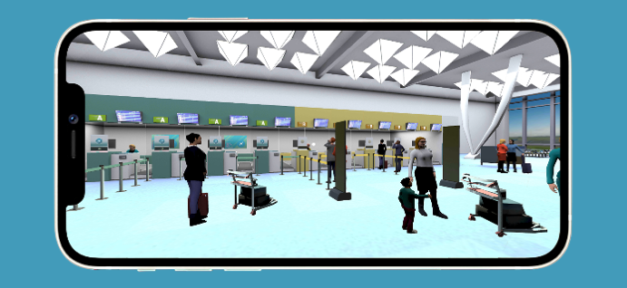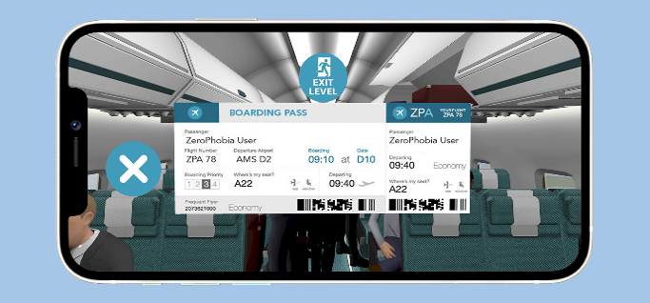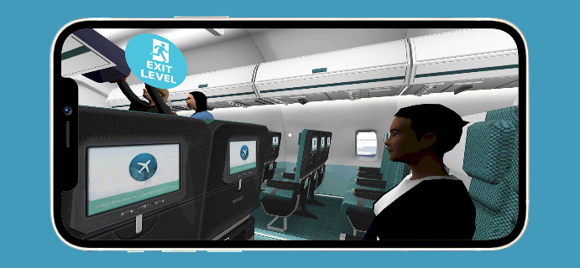

Table ST1. Comparison of missing-outcome participants to non-missing-outcome participants after randomizationª

 | Non-missing (n = 123) |  | Missing (n = 30) |  | p value
 | Mean | SD | Mean | SD
Demographic variables
Age | 42.34 | 12.49 | 39.73 | 10.56 | 0.29
 | n | % | n | %
Female | 105 | 85.37 | 22 | 73.33 | 0.12
Education
Primary | 1 | 0.81 | 1 | 3.33 | 0.28
Secondary | 21 | 17.07 | 0 | 0.00 | 0.015
Postsecondary | 101 | 82.11 | 29 | 96.67 | 0.046
Psychotropic medication | 8 | 6.50 | 3 | 10.00 | 0.51
Primary outcome - baseline
 | Mean | SD | Mean | SD
FAS | 105.34 | 18.67 | 106.13 | 20.89 | 0.84
Secondary outcome - baseline
FAM | 68.32 | 16.61 | 70.00 | 18.01 | 0.63
BAI | 13.50 | 10.44 | 17.41 | 15.00 | 0.24
PHQ | 4.32 | 3.59 | 5.62 | 4.81 | 0.18
ª Abbreviations: FAS = Flight Anxiety Situations Questionnaire; FAM = Flight Anxiety Modality Questionnaire; BAI = Beck Anxiety Inventory; PHQ = Patient Health Questionnaire.

Table ST2. Inferential statistics of treatment outcome measures, complete cases (n = 121–123)ª

 | VR treatment group  (n = 40–54) |  |  |  | Wait-list control group (n = 68–69) |  | p value^{b} | Effect size (Cohen’s d) (95% CI)
Primary outcome (M, SD) | Baseline | Post-test | 3-month FU | 12-month FU | Baseline | Post-test |  | Between, post-test | Within, Baseline-3-month FU ^{c} | Within, Baseline-12-month FU ^{c}
FAS | 106.11 (17.95) | 82.46 (20.71) | 78.36 (22.22) | 83.28 (21.35) | 104.74 (19.32) | 104.06 (22.86) | <0.0001 | 0.98  (0.61–1.36) | 1.14  (0.46–1.81) | 1.12  (0.46–1.79)
Secondary outcomes (M, SD)
FAM | 68.09 (14.73) | 69.91 (19.03) | 52.62 (17.50) | 57.13 (16.55) | 68.49 (18.04) | 69.91 (19.03) | <0.0001 | 0.66  (0.29–1.02) | 0.78  (0.31–1.25) | 0.70  (0.06–1.34)
BAI | 12.00 (11.72) | 13.06 (13.53) | 8.22 (6.90) | 10.40 (10.27) | 11.42 (11.87) | 14.59 (14.49) | 0.554 | 0.11  (-0.25–0.47) | 0.35  (-0.10–0.81) | 0.09  (-0.53– .71)
PHQ | 3.39 (3.96) | 3.17 (3.36) | 3.76 (3.20) | 3.43 (3.71) | 4.28 (4.46) | 4.18 (4.14) | 0.152 | 0.26  (-0.10–0.62) | 0.04  (-0.42–0.49) | -0.05  (-0.67– -0.57)
ª Abbreviations: VR = Virtual Reality; FAS = Flight Anxiety Situations Questionnaire; FAM = Flight Anxiety Modality Questionnaire; BAI = Beck Anxiety Inventory; PHQ = Patient Health Questionnaire; FU = follow-up.
^{b} t-test comparisons of baseline and post-test scores for complete cases (two-tailed).
^{c} Within-group effect sizes are based on participants who responded at both baseline and the applicable follow-up time point

