Appendices

The Effects of Psychological Treatment for Depression among People not Actively Seeking Help: A Meta-analysis

Ruiying Zhao, Amarnath Arpana, Eirini Karyotaki, Sascha Y. Struijs, Pim Cuijpers

Contents
Appendices 1
Appendix A. Amendments to the Protocol 2
Appendix B. Full search strings 3
Appendix C. References of the included studies 7
Appendix D. Proportions of the included studies 10
Appendix E. Description of sample of included studies 12
Appendix F. Funnel plots 13
F.1. Funnel plot for effects of psychotherapy compared with control groups 13
F.2. Funnel plot for proportion of participants in the trial from the number of participants who received the depression questionnaires 14
F.3. Funnel plot for proportion of participants in the trial from the number of participants who completed the depression questionnaires 15
Appendix G. Standardized regression coefficients of effect size: Multivariate meta-regression analysis 16
Appendix H. Long-term effects of psychotherapies for depression: Hedges’g 17
Appendix I. Forest plots 18
I.1. Forest plot for proportion of participants in the trial from the number of participants who received the depression questionnaires 18
I.2. Forest plot for proportion of participants in the trial from the number of participants who completed the depression questionnaires 19
Appendix J. Pooled proportion of participants in the trial from the number of participants who received the depression questionnaires 20
Appendix K. Post-hoc analysis for number of sessions 21

Appendix A. Amendments to the Protocol

According to the protocol, the originally planned aims were examining the effects of psychological treatments for adults with depression when patients were recruited from systematic screening and how many patients have to be screened to have one more positive outcome. Based on previous meta-analyses, we expected that the psychotherapies are not more effective when compared to control conditions. Besides, the initially planned data extraction included:
- the number of people that are enrolled in the program and eligible to be screened;
- the number of people that completed the questionnaires or screening tools;
- the number scoring positive (of those screened, the number of patients with scores at or above the screening cut-off).
Following this, the originally planned analyses included: calculating the number of people that need to be enrolled, that need to complete the questionnaires, and that need to score positive to get one more positive effect.
However, when we started full-text screening, we found it is complicated to define systematic screening in a trial. Therefore, we reformulated the study design and measured variables. In the current study, we examined the effects of psychological treatments among people in any setting not actively seeking help but who were approached by researchers and screened for trial eligibility. Besides since the mixed results of the previous studies, we couldn’t make a hypothesis before the analysis. In addition to the main analyses of intervention effects, we explored the proportion of participants in the trial from the number of participants who received the depression questionnaires and the proportion of participants in the trial from the number of participants who completed the depression questionnaires.
Instead of extracting “the number of patients with scores at or above the screening cut-off”, we extracted the number of patients who were randomized in the trial.

Appendix B. Full search strings

PubMed
Psychotherapy [MH] OR psychotherap*[All Fields] OR cbt[All Fields] OR "behavior therapies"[All Fields] OR "behavior therapy"[All Fields] OR "behavior therapeutic"[All Fields] OR "behavior therapeutical"[All Fields] OR "behavior therapeutics"[All Fields] OR "behavior therapeutist"[all Fields] OR "behavior therapeutists"[All Fields] OR "behavior treatment"[All Fields] OR "behavior treatments"[All Fields] OR "behaviors therapies"[All Fields] OR "behaviors therapy"[All Fields] OR "behaviors therapeutics"[All Fields] OR "behaviors therapeutic"[All Fields] OR "behaviors therapeutical"[All Fields] OR "behaviors therapeutist"[All Fields] OR "behaviors therapeutists"[All Fields] OR "behaviors treatment"[All Fields] OR "behaviors treatments"[All Fields] OR "behavioral therapies"[All Fields] OR "behavioral therapy"[All Fields] OR "behavioral therapeutics"[All Fields] OR "behavioral therapeutic"[All Fields] OR "behavioral therapeutical"[All Fields] OR "behavioral therapeutist"[All Fields] OR "behavioral therapeutists"[All Fields] OR "behavioral treatment"[All Fields] OR "behavioral treatments"[All Fields] OR "behaviour therapies"[All Fields] OR "behaviour therapy"[All Fields] OR "behaviour therapeutic"[All Fields] OR "behaviour therapeutical"[All Fields] OR "behaviour therapeutics"[All Fields] OR "behaviour therapeutist"[all Fields] OR "behaviour therapeutists"[All Fields] OR "behaviour treatment"[All Fields] OR "behaviour treatments"[All Fields] OR "behaviours therapies"[All Fields] OR "behaviours therapy"[All Fields] OR "behaviours therapeutics"[All Fields] OR "behaviours therapeutic"[All Fields] OR "behaviours therapeutical"[All Fields] OR "behaviours therapeutist"[All Fields] OR "behaviours therapeutists"[All Fields] OR "behaviours treatment"[All Fields] OR "behaviours treatments"[All Fields] OR "behavioural therapies"[All Fields] OR "behavioural therapy"[All Fields] OR "behavioural therapeutics"[All Fields] OR "behavioural therapeutic"[All Fields] OR "behavioural therapeutical"[All Fields] OR "behavioural therapeutist"[All Fields] OR "behavioural therapeutists"[All Fields] OR "behavioural treatment"[All Fields] OR "behavioural treatments"[All Fields] OR "cognition therapies"[All Fields] OR "cognition therapie"[All Fields] OR "cognition therapy"[All Fields] OR "cognition therapeutical"[All Fields] OR "cognition therapeutic"[All Fields] OR "cognition therapeutics"[All Fields] OR "cognition therapeutist"[All Fields] OR "cognition therapeutists"[All Fields] OR "cognition treatment"[All Fields] OR "cognition treatments"[All Fields] OR psychodynamic[All Fields] OR Psychoanalysis[MH] OR psychoanalysis[All Fields] OR psychoanalytic*[All Fields] OR counselling[All Fields] OR counseling[All Fields] OR Counseling[MH] OR "problem-solving"[All Fields] OR mindfulness[All Fields] OR (acceptance[All Fields] AND commitment[All Fields] ) OR "assertiveness training"[All Fields] OR "behavior activation"[All Fields] OR "behaviors activation"[All Fields] OR "behavioral activation"[All Fields] OR "cognitive therapies"[All Fields] OR "cognitive therapy"[All Fields] OR "cognitive therapeutic"[All Fields] OR "cognitive therapeutics"[All Fields] OR "cognitive therapeutical"[All Fields] OR "cognitive therapeutist"[All Fields] OR "cognitive therapeutists"[All Fields] OR "cognitive treatment"[All Fields] OR "cognitive treatments"[All Fields] OR "cognitive restructuring"[All Fields] OR (("compassion-focused"[All Fields] OR "compassion-focussed"[All Fields]) AND (therapy[SH] OR therapies[All Fields] OR therapy[All Fields] OR therape*[All Fields] OR therapis*[All Fields]OR Therapeutics [OR treatment*[All Fields])) OR ((therapy[SH] OR therapies[All Fields]
OR therapy [All Fields] OR therape*[All Fields] OR therapis*[All Fields] OR Therapeutics[MH] OR treatment*[All Fields]) AND constructivist*[All Fields]) OR "metacognitive therapies"[All Fields] OR "metacognitive therapy"[All Fields] OR "metacognitive therapeutic"[All Fields] OR "metacognitive therapeutics"[All Fields] OR "metacognitive therapeutical"[All Fields] OR "metacognitive therapeutist"[All Fields] OR "metacognitive therapeutists"[All Fields] OR "metacognitive treatment"[All Fields] OR "metacognitive treatments"[All Fields] OR "meta-cognitive therapies"[All Fields] OR "meta-cognitive therapy"[All Fields] OR "meta-cognitive therapeutic"[All Fields] OR "meta-cognitive therapeutics"[All Fields] OR "meta-cognitive therapeutical"[All Fields] OR "meta-cognitive therapeutist"[All Fields] OR "meta-cognitive therapeutists"[All Fields] OR "meta-cognitive treatment"[All Fields] OR "meta-cognitive treatments"[All Fields] OR "solution-focused therapies"[All Fields] OR "solution-focused therapy"[All Fields] OR "solution-focused therapeutic"[All Fields] OR "solution-focused therapeutics"[All Fields] OR "solution-focused therapeutical"[All Fields] OR "solution focused therapies"[All Fields] OR "solution focused therapy"[All Fields] OR "solution focused therapeutic"[All Fields] OR "solution focused therapeutics"[All Fields] OR "solution focused therapeutical"[All Fields]OR "solution-focussed therapies"[All Fields] OR "solution-focussed therapy"[All Fields] OR "solution-focussed therapeutic"[All Fields] OR "solution-focussed therapeutics"[All Fields] OR "solution-focussed therapeutical"[All Fields]OR "solution focussed therapies"[All Fields] OR "solution focussed therapy"[All Fields] OR "solution focussed therapeutic"[All Fields] OR "solution focussed therapeutics"[All Fields] OR "solution focussed therapeutical"[All Fields] OR "self-control therapies"[All Fields] OR "self-control therapy"[All Fields] OR "self-control therapeutics"[All Fields] OR "self-control therapeutical"[All Fields] OR "self-control therapeutic"[All Fields] OR "self- control training"[All Fields] OR "self-control trainings"[All Fields] OR "self control therapies"[All Fields] OR "self control therapy"[All Fields] OR "self control therapeutics"[All Fields] OR "self control therapeutical"[All Fields] OR "self control therapeutic"[All Fields] OR "self control training"[All Fields] OR "self control trainings"[All Fields]
AND
(Depressive Disorder[MH] OR Depression[MH]OR dysthymi*[All Fields] OR "affective disorder"[All Fields]OR "affective disorders"[All Fields] OR "mood disorder"[All Fields] OR "mood disorders"[All Fields] OR depression*[All Fields] OR depressive*[All Fields] OR "dysthymic disorder"[MeSH Terms])
Limits: RCTs

Embase
#1 'psychotherapy'/exp OR 'psychotherapy' OR 'psychotherapies' OR 'psychotherapeutics' OR 'psychotherapeutical' OR 'cognitive therapy'/exp OR 'cognitive behavior therapy'/exp OR 'behavior therapy'/exp OR ́cbt ́ OR ́cognitive behavioural therapy ́ OR ́cognitive behavioural therapies ́ OR cognitive behavioral therapy ́ OR 'cognitive behavioral therapies' OR 'behavior therapy' OR 'behavior therapies' OR 'behaviour therapy' OR 'behaviour therapies' OR 'cognition therapy' OR 'cognitive therapies' OR 'cognitive therapy' OR 'cognitive therapeutic' OR 'cognitive therapeutics' OR 'cognitive therapeutical' OR 'cognitive therapeutist' OR 'cognitive therapeutists' OR 'cognitive treatment' OR 'cognitive treatments' OR 'cognitive restructuring' OR 'cognition therapies' OR 'cognition therapie' OR 'cognition therapeutical' OR 'cognition therapeutic' OR 'cognition therapeutics' OR 'cognition therapeutist' OR 'cognition therapeutists' OR 'cognition treatment' OR 'cognition treatments' OR 'behavior therapeutic' OR 'behavior therapeutical' OR 'behavior therapeutics' OR 'behavior therapeutist' OR 'behavior therapeutists' OR 'behavior treatment' OR 'behavior treatments' OR 'behaviors therapies' OR 'behaviors therapy' OR 'behaviors therapeutics' OR 'behaviors therapeutic' OR 'behaviors therapeutical' OR 'behaviors therapeutist' OR 'behaviors therapeutists' OR 'behaviors treatment' OR 'behaviors treatments' OR 'behavioral therapies' OR 'behavioral therapy' OR 'behavioral therapeutics' OR 'behavioral therapeutic' OR 'behavioral therapeutical' OR 'behavioral therapeutist' OR 'behavioral therapeutists' OR 'behavioral treatment' OR 'behavioral treatments' OR 'behaviour therapeutic' OR 'behaviour therapeutical' OR 'behaviour therapeutics' OR 'behaviour therapeutist' OR 'behaviour therapeutists' OR 'behaviour treatment' OR 'behaviour treatments' OR 'behaviours therapies' OR 'behaviours therapy' OR 'behaviours therapeutics' OR 'behaviours therapeutic' OR 'behaviours therapeutical' OR 'behaviours therapeutist' OR 'behaviours therapeutists' OR 'behaviours treatment' OR 'behaviours treatments' OR 'behavioural therapies' OR 'behavioural therapy' OR 'behavioural therapeutics' OR 'behavioural therapeutic' OR 'behavioural therapeutical' OR 'behavioural therapeutist' OR 'behavioural therapeutists' OR 'behavioural treatment' OR 'behavioural treatments' OR 'behavior activation' OR 'behaviors activation' OR 'behavioral activation' OR 'behaviour activation' OR 'behaviours activation' OR 'behavioural activation' OR 'psychoanalytic therapy'/exp OR 'psychodynamic' OR 'psychodynamical' OR 'psychoanalysis' OR 'psychoanalytical' OR 'counselling'/exp OR 'counseling'/exp OR 'counselling' OR 'counseling' OR 'problem-solving' OR 'problem solving' OR 'supportive therapy' OR 'metacognitive therapy' OR 'metacognitive therapies' OR 'metacognitive therapeutic' OR 'metacognitive therapeutics' OR 'metacognitive therapeutical' OR 'metacognitive therapeutist' OR 'metacognitive therapeutists' OR 'metacognitive treatment' OR 'metacognitive treatments' OR 'meta-cognitive therapy' OR 'meta-cognitive therapies' OR 'meta-cognitive therapeutic' OR 'meta-cognitive therapeutics' OR 'meta-cognitive therapeutical' OR 'meta-cognitive therapeutist' OR 'meta-cognitive therapeutists' OR 'meta-cognitive treatment' OR 'meta-cognitive treatments' OR 'solution-focused therapies' OR 'solution focused therapies' OR 'solution-focussed therapies' OR 'solution focused therapies' OR 'solution- focused therapy' OR 'solution focused therapy' OR 'solution-focussed therapy' OR 'solution focused therapy' OR 'solution-focused therapeutic' OR 'solution focused therapeutic' OR 'solution-focussed therapeutic' OR 'solution focussed therapeutic' OR 'solution-focused therapeutics' OR 'solution focused therapeutics' OR 'solution-focussed therapeutics' OR 'solution focused therapeutics' OR 'solution-focused therapeutical' OR 'solution focused therapeutical' OR 'solution-focussed therapeutical' OR 'solution focused therapeutical' OR 'self-control therapies' OR 'self control therapies' OR 'self-control therapy' OR 'self control therapy' OR 'self-control therapeutics' OR 'self control therapeutics' OR 'self-control therapeutical' OR 'self control therapeutical' OR 'self-control therapeutic' OR 'self control therapeutic' OR 'self-control training' OR 'self control training' OR 'self control trainings' OR 'self-control trainings' OR 'mindfulness' OR 'acceptance commitment' OR 'acceptance and commitment' OR 'assertiveness training'
#2 'compassion-focused' OR 'compassion-focussed' OR 'compassion focused' OR 'compassion focussed' OR 'constructivist' OR 'constructivists'
#3 'therapies' OR 'therapy' OR 'therapeutics' OR 'therapist' OR 'treatment' OR 'treatments'
#4 Combine: #2 AND #3
#5: #1 OR #4
#6 'depressive disorder'/exp OR 'depression'/exp OR 'depressive' OR 'major depression'/exp OR 'major depressive disorder'/exp OR 'depression' OR 'depressions' OR 'depressive' OR 'dysthymic disorder'/exp OR 'dysthymic disorder' OR 'dysthymia'/exp OR 'dysthymic' OR 'mood disorder'/exp OR 'affective disorder'/exp OR 'affective disorder' OR 'affective disorders' OR 'mood disorder' OR 'mood disorders'
Combine: #5 AND #6
Limits: RCTs

PsycINFO
(DE "Psychotherapy" OR "Psychotherapy" OR "psychotherapies" OR "psychotherapeutic" OR "psychotherapeutical" OR "psychotherapeutics" OR DE "Behavior Therapy" OR DE "Cognitive Behavior Therapy" OR "CBT" OR "behavior therapies" OR "behavior therapy" OR "behavior therapeutic" OR "behavior therapeutical" OR "behavior therapeutics"
OR "behavior therapeutist" OR "behavior therapeutists" OR "behavior treatment" OR "behavior treatments" OR "behaviors therapies" OR "behaviors therapy" OR "behaviors therapeutics" OR "behaviors therapeutic" OR "behaviors therapeutical" OR "behaviors therapeutist" OR "behaviors therapeutists" OR "behaviors treatment" OR "behaviors treatments" OR "behavioral therapies" OR "behavioral therapy" OR "behavioral therapeutics" OR "behavioral therapeutic" OR "behavioral therapeutical" OR "behavioral therapeutist" OR "behavioral therapeutists" OR "behavioral treatment" OR "behavioral treatments" OR "behaviour therapies" OR "behaviour therapy" OR "behaviour therapeutic" OR "behaviour therapeutical" OR "behaviour therapeutics" OR "behaviour therapeutist" OR "behaviour therapeutists" OR "behaviour treatment" OR "behaviour treatments" OR "behaviours therapies" OR "behaviours therapy" OR "behaviours therapeutics" OR "behaviours therapeutic" OR "behaviours therapeutical" OR "behaviours therapeutist" OR "behaviours therapeutists" OR "behaviours treatment" OR "behaviours treatments" OR "behavioural therapies" OR "behavioural therapy" OR "behavioural therapeutics" OR "behavioural therapeutic" OR "behavioural therapeutical" OR "behavioural therapeutist" OR "behavioural therapeutists" OR "behavioural treatment" OR "behavioural treatments" OR "cognition therapies" OR "cognition therapie" OR "cognition therapy" OR "cognition therapeutical" OR "cognition therapeutic" OR "cognition therapeutics" OR "cognition therapeutist" OR "cognition therapeutists" OR "cognition treatment" OR "cognition treatments" OR "cognitive therapies" OR "cognitive therapy" OR "cognitive therapeutic" OR "cognitive therapeutics" OR "cognitive therapeutical" OR "cognitive therapeutist" OR "cognitive therapeutists" OR "cognitive treatment" OR "cognitive treatments" OR "cognitive restructuring" OR DE "Emotion Focused Therapy" OR DE "Psychoanalysis" OR "psychoanalysis" OR "psychoanalytic" OR "psychoanalytical "OR DE "Psychodynamic Psychotherapy" OR "psychodynamic" OR DE "Psychotherapeutic Counseling" OR "counselling" OR "counseling" OR "problem-solving" OR "problem solving" OR "mindfulness" OR ("acceptance" AND "commitment") OR "assertiveness training" OR "behavior activation" OR "behaviors activation" OR "behavioral activation" OR "behaviour activation" OR "behaviours activation" OR "behavioural activation" OR "metacognitive therapies" OR "metacognitive therapy" OR "metacognitive therapeutic" OR "metacognitive therapeutics" OR "metacognitive therapeutical" OR "metacognitive therapeutist" OR "metacognitive therapeutists" OR "metacognitive treatment" OR "metacognitive treatments" OR "meta-cognitive therapies" OR "meta-cognitive therapy" OR "meta-cognitive therapeutic" OR "meta-cognitive therapeutics" OR "meta-cognitive therapeutical" OR "meta-cognitive therapeutist" OR "meta-cognitive therapeutists" OR "meta-cognitive treatment" OR "meta-cognitive treatments" OR DE "Solution Focused Therapy" OR "solution- focused therapies" OR "solution-focused therapy" OR "solution-focused therapeutic" OR "solution-focused therapeutics" OR "solution-focused therapeutical" OR "solution-focussed therapies" OR "solution-focussed therapy" OR "solution-focussed therapeutic" OR "solution-focussed therapeutics" OR "solution-focussed therapeutical" OR "solution focused therapies" OR "solution focused therapy" OR "solution focused therapeutic" OR "solution focused therapeutics" OR "solution focused therapeutical" OR "solution focussed therapies" OR "solution focussed therapy" OR "solution focussed therapeutic" OR "solution focussed therapeutics" OR "solution focussed therapeutical" OR "self- control therapies" OR "self-control therapy" OR "self-control therapeutics" OR "self-control therapeutical" OR "self- control therapeutic" OR "self-control training" OR "self-control trainings" OR "self control therapies" OR "self control therapy" OR "self control therapeutics" OR "self control therapeutical" OR "self control therapeutic" OR "self control training" OR "self control trainings" OR (("compassion-focused" OR "compassion-focussed" OR "compassion focused" OR "compassion focussed") AND ("therapies" OR "therapy" OR "therapie" OR "therapist" OR "therapists" OR "therapeut" OR "treatment" OR "treatments")) OR ("constructivist" AND ("therapies" OR "therapy" OR "therapie" OR "therapist" OR "therapists" OR "therapeut" OR "treatment" OR "treatments")))
AND
(DE "Depression (Emotion)" "depressive disorder" OR "depression" OR "depressions" OR "depressive" OR DE "Major Depression" OR "major depression" OR "major depressive disorder" OR DE "Dysthymic Disorder" OR "Dysthymia" OR " dysthymic disorder" OR DE "Affective Disorders" OR "Affective Disorder" OR "affective disorders" OR "Mood Disorder" OR "Mood disorders")
Limits: Methodology is ME=(treatment outcome/clinical trial): papers

Cochrane
#1 MeSH descriptor: [Depressive Disorder] explode all trees : 6, 777
#2 ''depress*'' (Word variations have been searched) : 51, 768
#3 #1or#2 :51,783
#4 ''major depressive disorder'' (Word variations have been searched) : 5, 435
#5 #3or#4 :51,783
#6 MeSH descriptor: [Dysthymic Disorder] explode all trees : 129
#7 ''dysthymi*'' (Word variations have been searched) : 649
#8 #6or#7 :649
#9 #5or#8 :51,800
#10 ''mood disorder'' (Word variations have been searched) :4, 034
#11 ''affective disorder'' (Word variations have been searched) : 2, 882
#12 #10or#11:6,055
#13 #9or#12:53,227
#14 MeSH descriptor: [Psychotherapy] explode all trees : 13, 568
#15 ''psychotherap*'' (Word variations have been searched) : 7, 758
#16 ''CBT'' (Word variations have been searched) : 2, 029
#17 ''Cognitive Behav* therap* (Word variations have been searched) : 8, 893
#18 #14or#15or#16or#17 :20,795
#19 'psychodynamic'' (Word variations have been searched) : 469
#20 MeSH descriptor: [Psychoanalysis] explode all trees : 13
#21 ''psychoanaly*'' (Word variations have been searched) : 345
#22 MeSH descriptor: [Counseling] explode all trees : 2, 783
#23 ''counseling*'' (Word variations have been searched) : 6, 913
#24 ''problem solving'' (Word variations have been searched) : 2, 867
#25 #18or#19or#20or#21or#22or#23or#24 :28,149
#26 ''acceptance commitment'' (Word variations have been searched) : 168
#27 ''assertiveness training'' (Word variations have been searched) :231
#28 ''behavior activation'' (Word variations have been searched) : 663
#29 ''mindfulness'' (Word variations have been searched) : 466
#30 ''metacognitive therap*'' (Word variations have been searched) :56
#31 ''solution focused therap*'' (Word variations have been searched) :858
#32 ''self control training'' (Word variations have been searched): 5850
#33 #25or#26or#27or#28or#29or#30or#31or#32 :32,748
#34 ''Randomized Controlled Trial'':ti,ab,kw (Word variations have been searched) : 120, 901
#35 #13 and #33 and #34 in Trials

Appendix C. References of the included studies

Ammerman, R. T., Putnam, F. W., Altaye, M., Teeters, A. R., Stevens, J., & Van Ginkel, J. B. (2013). Treatment of depressed mothers in home visiting: Impact on psychological distress and social functioning. Child Abuse and Neglect, 37(8), 544–554. https://doi.org/10.1016/j.chiabu.2013.03.003
Beutel, M. E., Weißflog, G., Leuteritz, K., Wiltink, J., Haselbacher, A., Ruckes, C., … Brähler, E. (2014). Efficacy of short-term psychodynamic psychotherapy (STPP) with depressed breast cancer patients: Results of a randomized controlled multicenter trial. Annals of Oncology, 25(2), 378–384. https://doi.org/10.1093/annonc/mdt526
Burns, Alison, O’Mahen, H., Baxter, H., Bennert, K., Wiles, N., Ramchandani, P., … Evans, J. (2013). A pilot randomised controlled trial of cognitive behavioural therapy for antenatal depression. BMC Psychiatry, 13(1), 1. https://doi.org/10.1186/1471-244X-13-33
Burns, Alistair, Banerjee, S., Morris, J., Woodward, Y., Baldwin, R., Proctor, R., … Horan, M. (2007). Treatment and prevention of depression after surgery for hip fracture in older people: Randomized, controlled trials. Journal of the American Geriatrics Society, 55(1), 75–80. https://doi.org/10.1111/j.1532-5415.2007.01016.x
Cooper, P. J., Murray, L., Wilson, A., & Romaniuk, H. (2003). Controlled trial of the short- and long-term effect of psychological treatment of post-partum depression. I. Impact on maternal mood. British Journal of Psychiatry, 182(MAY), 412–419. https://doi.org/10.1192/bjp.182.5.412
Dekker, R. L., Moser, D. K., Peden, A. R., & Lennie, T. A. (2012). Cognitive therapy improves three-month outcomes in hospitalized patients with heart failure. Journal of Cardiac Failure, 18(1), 10–20. https://doi.org/10.1016/j.cardfail.2011.09.008
Desautels, C., Savard, J., Ivers, H., Savard, M. H., & Caplette-Gingras, A. (2018). Treatment of depressive symptoms in patients with breast cancer: A randomized controlled trial comparing cognitive therapy and bright light therapy. Health Psychology, 37(1), 1–13. https://doi.org/10.1037/hea0000539
Doering, L. V., Chen, B., Cross Bodán, R., Magsarili, M. C., Nyamathi, A., & Irwin, M. R. (2013). Early cognitive behavioral therapy for depression after cardiac surgery. Journal of Cardiovascular Nursing, 28(4), 370–379. https://doi.org/10.1097/JCN.0b013e31824d967d
Evans, R. L., & Connis, R. T. (1995). Comparison of Brief Group Therapies for Depressed Cancer Patients Receiving Radiation Treatment. Public Health Reports (Washington, D.C. : 1974), 110(3), 306–311.
Farshi, N., Hasanpour, S., Mirghafourvand, M., & Esmaeilpour, K. (2020). Effect of self-care counselling on depression and anxiety in women with endometriosis: a randomized controlled trial. BMC Psychiatry, 20(1), 391. https://doi.org/10.1186/s12888-020-02795-7
Freedland, K. E., Skala, J. A., Carney, R. M., Rubin, E. H., Lustman, P. J., Dávila-Román, V. G., … Hogue, C. W. (2009). Treatment of depression after coronary artery bypass surgery a randomized controlled trial. Archives of General Psychiatry, 66(4), 387–396. https://doi.org/10.1001/archgenpsychiatry.2009.7
Fuhr, D. C., Weobong, B., Lazarus, A., Vanobberghen, F., Weiss, H. A., Singla, D. R., … Patel, V. (2019). Delivering the Thinking Healthy Programme for perinatal depression through peers: an individually randomised controlled trial in India. The Lancet Psychiatry, 6(2), 115–127. https://doi.org/10.1016/S2215-0366(18)30466-8
Furukawa, T. A., Horikoshi, M., Kawakami, N., Kadota, M., Sasaki, M., Sekiya, Y., … Grothaus, L. C. (2012). Telephone cognitive-behavioral therapy for subthreshold depression and presenteeism in workplace: A randomized controlled trial. PLoS ONE, 7(4), e35330. https://doi.org/10.1371/journal.pone.0035330
Gellis, Z. D., McGinty, J., Tierney, L., Jordan, C., Burton, J., & Misener, E. (2008). Randomized controlled trial of problem-solving therapy for minor depression in home care. Research on Social Work Practice, 18(6), 596–606. https://doi.org/10.1177/1049731507309821
Goodman, J. H., Prager, J., Goldstein, R., & Freeman, M. (2015). Perinatal Dyadic Psychotherapy for postpartum depression: a randomized controlled pilot trial. Archives of Women’s Mental Health, 18(3), 493–506. https://doi.org/10.1007/s00737-014-0483-y
Herrmann-Lingen, C., Beutel, M. E., Bosbach, A., Deter, H. C., Fritzsche, K., Hellmich, M., … Albus, C. (2016). A Stepwise Psychotherapy Intervention for Reducing Risk in Coronary Artery Disease (SPIRR-CAD): Results of an observer-blinded, multicenter, randomized trial in depressed patients with coronary artery disease. Psychosomatic Medicine, 78(6), 704–715. https://doi.org/10.1097/PSY.0000000000000332
Holden, J. M., Sagovsky, R., & Cox, J. L. (1989). Counselling in a general practice setting: Controlled study of heath visitor intervention in treatment of postnatal depression. British Medical Journal, 298(6668), 223–226. https://doi.org/10.1136/bmj.298.6668.223
Hou, Y., Hu, P., Zhang, Y., Lu, Q., Wang, D., Yin, L., … Zou, X. (2014). Cognitive behavioral therapy in combination with systemic family therapy improves mild to moderate postpartum depression. Revista Brasileira de Psiquiatria, 36(1), 47–52. https://doi.org/10.1590/1516-4446-2013-1170
Joling, K. J., Van Hout, H. P. J., Van’t Veer-Tazelaar, P. J., Van Der Horst, H. E., Cuijpers, P., Van De Ven, P. M., & Van Marwijk, H. W. J. (2011). How effective is bibliotherapy for very old adults with subthreshold depression? A randomized controlled trial. American Journal of Geriatric Psychiatry, 19(3), 256–265. https://doi.org/10.1097/JGP.0b013e3181ec8859
Kamga, H., McCusker, J., Yaffe, M., Sewitch, M., Sussman, T., Strumpf, E., … Freeman, E. E. (2017). Self-care tools to treat depressive symptoms in patients with age-related eye disease: a randomized controlled clinical trial. Clinical and Experimental Ophthalmology, 45(4), 371–378. https://doi.org/10.1111/ceo.12890
Kim, Y. H., Choi, K. S., Han, K., & Kim, H. W. (2018). A psychological intervention programme for patients with breast cancer under chemotherapy and at a high risk of depression: A randomised clinical trial. Journal of Clinical Nursing, 27(3–4), 572–581. https://doi.org/10.1111/jocn.13910
Lamers, F., Jonkers, C. C. M., Bosma, H., Kempen, G. I. J. M., Meijer, J. A. M. J., Penninx, B. W. J. H., … Van Eijk, J. T. M. (2010). A minimal psychological intervention in chronically III elderly patients with depression: A randomized trial. Psychotherapy and Psychosomatics, 79(4), 217–226. https://doi.org/10.1159/000313690
Lerner, D., Adler, D. A., Rogers, W. H., Chang, H., Greenhill, A., Cymerman, E., & Azocar, F. (2015). A randomized clinical trial of a telephone depression intervention to reduce employee presenteeism and absenteeism. Psychiatr Serv, 66(6), 570–577. https://doi.org/10.1176/appi.ps.201400350
Lexis, M. A. S., Jansen, N. W. H., Huibers, M. J. H., Van Amelsvoort, L. G. P. M., Berkouwer, A., Ton, G. T. A., … Kant, Ij. (2011). Prevention of long-term sickness absence and major depression in high-risk employees: A randomised controlled trial. Occupational and Environmental Medicine, 68(6), 400–407. https://doi.org/10.1136/oem.2010.057877
Lloyd-Williams, M., Shiels, C., Ellis, J., Abba, K., Gaynor, E., Wilson, K., & Dowrick, C. (2018). Pilot randomised controlled trial of focused narrative intervention for moderate to severe depression in palliative care patients: DISCERN trial. Palliative Medicine, 32(1), 206–215. https://doi.org/10.1177/0269216317711322
Lund, C., Schneider, M., Garman, E. C., Davies, T., Munodawafa, M., Honikman, S., … Susser, E. (2020). Task-sharing of psychological treatment for antenatal depression in Khayelitsha, South Africa: Effects on antenatal and postnatal outcomes in an individual randomised controlled trial. Behaviour Research and Therapy, 130(September), 103466. https://doi.org/10.1016/j.brat.2019.103466
Lundgren, J. G., Dahlström, Ö., Andersson, G., Jaarsma, T., Köhler, A. K., & Johansson, P. (2016). The effect of guided web-based cognitive behavioral therapy on patients with depressive symptoms and heart failure: A pilot randomized controlled trial. Journal of Medical Internet Research, 18(8), 1–20. https://doi.org/10.2196/jmir.5556
Lynch, D. J., Tamburrino, M. B., & Rollin Nagel. (1997). Telephone counseling for patients with minor depression: Preliminary findings in a family practice setting. The Journal of Family Practice, 44(3), 293–298.
Lynch, D., Tamburrino, M., Nagel, R., & Smith, M. K. (2004). Telephone-based treatment for family practice patients with mild depression. Psychological Reports, 94(3 I), 785–792. https://doi.org/10.2466/pr0.94.3.785-792
Milgrom, J., Holt, C. J., Gemmill, A. W., Ericksen, J., Leigh, B., Buist, A., & Schembri, C. (2011). Treating postnatal depressive symptoms in primary care: A randomised controlled trial of GP management, with and without adjunctive counselling. BMC Psychiatry, 11, 95. https://doi.org/10.1186/1471-244X-11-95
Milgrom, J., Negri, L. M., Gemmill, A. W., McNeil, M., & Martin, P. R. (2005). A randomized controlled trial of psychological interventions for postnatal depression. Br J Clin Psychol, 44(Pt4), 529–542. https://doi.org/10.1348/014466505X34200.
Mohammadreza Davoudi, Taheri, A. A., Foroughi, A. A., Ahmadi, S. M., & Heshmati, K. (2020). Effectiveness of acceptance and commitment therapy (ACT) on depression and sleep quality in painful diabetic neuropathy: a randomized clinical trial. J Diabetes Metab Disord, 19, 1081–1088. https://doi.org/10.1007/s40200-020-00609-x
Mossey, J. M., Knott, K. A., Higgins, M., & Talerico, K. (1996). Effectiveness of a psychosocial intervention, interpersonal counseling, for subdysthymic depression in medically ill elderly. J Gerontol A Biol Sci Med Sci, 51(4), 172–178. https://doi.org/10.1093/gerona/51a.4.m172
Neugebauer, R., Kline, J., Markowitz, J. C., Bleiberg, K. L., Baxi, L., Rosing, M. A., … Keith, J. (2006). Pilot randomized controlled trial of interpersonal counseling for subsyndromal depression following miscarriage. Journal of Clinical Psychiatry, 67(8), 1299–1304. https://doi.org/10.4088/JCP.v67n0819
Ngai, F. W., Wong, P. W. C., Leung, K. Y., Chau, P. H., & Chung, K. F. (2015). The Effect of Telephone-Based Cognitive-Behavioral Therapy on Postnatal Depression: A Randomized Controlled Trial. Psychotherapy and Psychosomatics, 84(5), 294–303. https://doi.org/10.1159/000430449
Nollett, C. L., Bray, N., Bunce, C., Casten, R. J., Edwards, R. T., Hegel, M. T., … Margrain, T. H. (2016). Depression in visual impairment trial (Depvit): A randomized clinical trial of depression treatments in people with low vision. Investigative Ophthalmology and Visual Science, 57(10), 4247–4254. https://doi.org/10.1167/iovs.16-19345
O’Mahen, H., Himle, J. A., Fedock, G., Henshaw, E., & Flynn, H. (2013). A pilot randomized controlled trial of cognitive behavioral therapy for perinatal depression adapted for women with low incomes. Depression and Anxiety, 30(7), 679–687. https://doi.org/10.1002/da.22050
O’Neil, A., Taylor, B., Sanderson, K., Cyril, S., Chan, B., Hawkes, A. L., … Oldenburg, B. (2014). Efficacy and Feasibility of a Tele-health Intervention for Acute Coronary Syndrome Patients with Depression: Results of the “MoodCare” Randomized Controlled Trial. Annals of Behavioral Medicine, 48(2), 163–174. https://doi.org/10.1007/s12160-014-9592-0
Onuigbo, L. N., Eseadi, C., Ebifa, S., Ugwu, U. C., Onyishi, C. N., & Oyeoku, E. K. (2019). Effect of Rational Emotive Behavior Therapy Program on Depressive Symptoms Among University Students with Blindness in Nigeria. Journal of Rational - Emotive and Cognitive - Behavior Therapy, 37(1), 17–38. https://doi.org/10.1007/s10942-018-0297-3
Pibernik-Okanović, M., Hermanns, N., Ajduković, D., Kos, J., Prašek, M., Šekerija, M., & Lovrenčić, M. V. (2015). Does treatment of subsyndromal depression improve depression-related and diabetes-related outcomes? A randomised controlled comparison of psychoeducation, physical exercise and enhanced treatment as usual. Trials, 16(1), 1–13. https://doi.org/10.1186/s13063-015-0833-8
Richards, S. H., Dickens, C., Anderson, R., Richards, D. A., Taylor, R. S., Ukoumunne, O. C., … Campbell, J. (2018). Assessing the effectiveness of Enhanced Psychological Care for patients with depressive symptoms attending cardiac rehabilitation compared with treatment as usual (CADENCE): A pilot cluster randomised controlled trial. Trials, 19(1), 211. https://doi.org/10.1186/s13063-018-2576-9
Salamanca-Sanabria, A., Richards, D., Timulak, L., Connell, S., Perilla, M. M., Parra-Villa, Y., & Castro-Camacho, L. (2020). A culturally adapted cognitive behavioral internet-delivered intervention for depressive symptoms: Randomized controlled trial. JMIR Mental Health, 7(1). https://doi.org/10.2196/13392
Schulberg, H. C., Block, M. R., Madonia, M. J., Scott, C. P., Rodriguez, E., Imber, S. D., … Coulehan, J. L. (1996). Treating major depression in primary care practice. Eight-month clinical outcomes. Arch Gen Psychiatry, 53(10), 913–919. https://doi.org/10.1001/archpsyc.1996.01830100061008
Sheeber, L. B., Seeley, J. R., Feil, E. G., Betsy Davis, Sorensen, E., Kosty, D. B., & Lewinsohn, P. M. (2012). Development and Pilot Evaluation of an Internet-Facilitated Cognitive-Behavioral Intervention for Maternal Depression. Journal of Consulting and Clinical Psychology, 80(5), 739–749. https://doi.org/https://doi.org/10.1037/a0028820
Sikander, S., Ahmad, I., Atif, N., Zaidi, A., Vanobberghen, F., Weiss, H. A., … Rahman, A. (2019). Delivering the Thinking Healthy Programme for perinatal depression through volunteer peers: a cluster randomised controlled trial in Pakistan. The Lancet Psychiatry, 6(2), 128–139. https://doi.org/10.1016/S2215-0366(18)30467-X
Strong, V., Waters, R., Hibberd, C., Murray, G., Wall, L., Walker, J., … Sharpe, M. (2008). Management of depression for people with cancer (SMaRT oncology 1): a randomised trial. The Lancet, 372(9632), 40–48. https://doi.org/10.1016/S0140-6736(08)60991-5
Van Schaik, A., Van Marwijk, H., Adèr, H., Van Dyck, R., De Haan, M., Penninx, B., … Buitenamstel, G. G. Z. (2006). Interpersonal psychotherapy for elderly patients in primary care. American Journal of Geriatric Psychiatry, 14(9), 777–786. https://doi.org/10.1097/01.JGP.0000199341.25431.4b
Vázquez, F. L., López, L., Torres, Á. J., Otero, P., Blanco, V., Díaz, O., & Páramo, M. (2020). Analysis of the components of a cognitive-behavioral intervention for the prevention of depression administered via conference call to nonprofessional caregivers: A randomized controlled trial. International Journal of Environmental Research and Public Health, 17(6). https://doi.org/10.3390/ijerph17062067
Verduyn, C., Barrowclough, C., Roberts, J., Tarrier, N., & Harrington, R. (2003). Maternal depression and child behaviour problems Randomised placebo-controlled trial of a cognitive-behavioural group intervention. British Journal of Psychiatry, 183(OCT.), 342–348. https://doi.org/10.1192/bjp.183.4.342
Wickberg, B., & Hwang, C. P. (1996). Counselling of postnatal depression: A controlled study on a population based Swedish sample. Journal of Affective Disorders, 39(3), 209–216. https://doi.org/10.1016/0165-0327(96)00034-1
Xie, J., He, G., Ding, S., Pan, C., Zhang, X., Zhou, J., & Iennaco, J. D. (2019). A randomized study on the effect of modified behavioral activation treatment for depressive symptoms in rural left-behind elderly. Psychotherapy Research, 29(3), 372–382. https://doi.org/10.1080/10503307.2017.1364444
Zhao, Y., Munro-Kramer, M. L., Shi, S., Wang, J., & Zhao, Q. (2019). Effects of antenatal depression screening and intervention among Chinese high-risk pregnant women with medically defined complications: A randomized controlled trial. Early Intervention in Psychiatry, 13(5), 1090–1098. https://doi.org/10.1111/eip.12731

Appendix D. Proportions of the included studies
Study | N enrolled | N screened | N randomized | Prop1 | Prop2 | Screening tool
Ammerman, 2013a | 1768 | 1240 | 93 | 0.05 | 0.08 | epds
Beutel, 2014 | 5989 | 1306 | 157 | 0.03 | 0.12 | hads
Burns, 2007 | 594 | 293 | 293 | 0.49 | 1.00 | gds
Burns, 2013 | 5409 | 5409 | 36 | 0.01 | 0.01 | other
Cooper, 2003 | 3222 | 3222 | 193 | 0.06 | 0.06 | epds
Davoudi, 2020 | 149 | 76 | 50 | 0.34 | 0.66 | bdi
Dekker, 2012 | 80 | 80 | 42 | 0.53 | 0.53 | bdiii
Desautels, 2017 | 2635 | 743 | 62 | 0.02 | 0.08 | hads
Doering, 2013 | 731 | 729 | 81 | 0.11 | 0.11 | bdi
Evans, 1995 | 95 | 95 | 78 | 0.82 | 0.82 | cesd
Farshi, 2020 | 332 | 332 | 76 | 0.23 | 0.23 | bdiii
Freedland, 2009 | 2955 | 2823 | 123 | 0.04 | 0.04 | bdi
Fuhr, 2019 | 6409 | 6369 | 280 | 0.04 | 0.04 | pgq9
Furukawa, 2012 | 4916 | 3105 | 118 | 0.02 | 0.04 | k6
Gellis, 2008 | 618 | 618 | 69 | 0.11 | 0.11 | cesd
Goodman, 2015 |  | 790 | 42 |  | 0.05 | epds
Herrmann-Lingen, 2016 | 18542 | 15582 | 570 | 0.03 | 0.04 | hads
Holden, 1989 | 734 | 734 | 55 | 0.07 | 0.07 | epds
Hou, 2014 | 1713 | 1713 | 249 | 0.15 | 0.15 | epds
Joling, 2011 | 325 | 275 | 170 | 0.52 | 0.62 | cesd
Kamga, 2017 | 1223 | 258 | 80 | 0.07 | 0.31 | pgq9
Kim, 2018 | 152 | 152 | 60 | 0.39 | 0.39 | cesd
Lamers, 2010 | 8326 | 5578 | 361 | 0.04 | 0.06 | pgq9
Lerner, 2015 | 18102 | 17306 | 431 | 0.02 | 0.02 | pgq9
Lexis, 2011 | 23973 | 8892 | 139 | 0.01 | 0.02 | hads
Lloyd-Williams, 2018 |  | 284 | 57 |  | 0.20 | pgq9
Lund, 2019 | 2187 | 2187 | 425 | 0.19 | 0.19 | epds
Lundgren, 2016 | 2855 | 64 | 50 | 0.02 | 0.78 | pgq9
Lynch, 1997 | 275 | 239 | 29 | 0.11 | 0.12 | other
Lynch et al, 2004 |  | 1752 | 54 |  | 0.03 | other
Milgrom, 2005 |  | 4148 | 192 |  | 0.05 | epds
Milgrom, 2011 | 3531 | 3531 | 68 | 0.02 | 0.02 | epds
Mossey, 1996 | 1804 | 1530 | 89 | 0.05 | 0.06 | gds
Neugebauer, 2006 | 97 | 72 | 19 | 0.20 | 0.26 | hamd
Ngai, 2015 | 5670 | 1605 | 397 | 0.07 | 0.25 | epds
Nollett, 2016 | 1008 | 1008 | 85 | 0.08 | 0.08 | gds
O'Mahen, 2013 - I | 2382 | 1421 | 55 | 0.02 | 0.04 | epds
O'Neil, 2014 | 3071 | 387 | 121 | 0.04 | 0.31 | pgq9
Onuigbo, 2019 | 105 | 98 | 65 | 0.62 | 0.66 | bdiii
Pibernik, 2015 | 4858 | 1740 | 209 | 0.04 | 0.12 | pgq2
Richards, 2018 | 1228 | 614 | 30 | 0.02 | 0.05 | pgq9
Salamanca-Sanabria, 2020 | 604 | 604 | 214 | 0.35 | 0.35 | pgq9
Schulberg, 1996 |  | 7652 | 276 |  | 0.04 | cesd
Sheeber, 2012 | 793 | 555 | 70 | 0.09 | 0.13 | cesd
Sikander, 2019 | 1910 | 1731 | 570 | 0.30 | 0.33 | pgq9
Strong, 2008 | 8153 | 8153 | 200 | 0.02 | 0.02 | hads
Van Schaik, 2006 | 6719 | 4301 | 143 | 0.02 | 0.03 | gds
Vázquez, 2020 | 603 | 603 | 219 | 0.36 | 0.36 | cesd
Verduyn, 2003 | 3692 | 2248 | 119 | 0.03 | 0.05 | bdi
Wickberg, 1996 | 1874 | 1655 | 41 | 0.02 | 0.02 | epds
Xie, 2019 | 317 | 317 | 80 | 0.25 | 0.25 | gds
Zhao, 2019 | 1524 | 1524 | 352 | 0.23 | 0.23 | epds
Note. Indicators of the columns:
- N enrolled: the number of people who enrolled in the study and received depression questionnaires
- N screened: the number of people who got screened using depression scales and completed/responded to the scale
- N randomized: the number of people who got randomized
- Prop1: the proportion of participants in the trial from the total number of participants who received the depression questionnaires
- Prop2: the proportion of participants in the trial from the total number of participants who completed the depression questionnaires
- Screening tool: name of the questionnaire (bdi/bdiii: Beck Depression Inventory; cesd: Center for Epidemiologic Studies Depression Scale; epds: Edinburgh Postnatal Depression; gds: Geriatric Depression Scale; hads: Hospital Anxiety and Depression Scale; phq9: Patient Health Questionnaire– Depression).

Appendix E. Description of sample of included studies

In most studies, most participants were women (26.9% had between 50% and 75% women, and 55.8% had more than 75% women). Most studies (76.92%) were conducted in western countries (14 in the US, 10 in the UK, 10 in Europe, 3 in Australia, 2 in Canada, and 1 in South Korea), 12 were conducted in non-western countries (23.1%). A total of 6 studies (11.5%) were published between 1989 and 2000, 4 between 2001 and 2005 (7.7%), 7 between 2006 and 2010 (13.5%), 17 between 2011 and 2015 (32.7%), and 18 after 2016 (34.6%). Of the included 52 studies, 32 were focused on the adults’ population (61.5%), while the other 20 were focused on older people (38.5%). 37 studies (71.2%) were conducted in samples selected through a cut-off on a self-report scale. Only 14 (26.9%) used diagnostic interviews. Most studies (88.5%) were aimed at specific subgroups of depressed populations (46.2% were participants with both depression and comorbid general medical disorders, 28.9% were women with postpartum depression, and 13.5% belonged to another specific population), while 11.5% were aimed at general populations of depressed persons not otherwise specified. Most studies (86.5%) employed usual care, whereas 7 (13.5%) used other control conditions. Among 61 comparisons, half of the interventions were CBT, followed by non-directive supportive therapy (14.8%) and problem-solving therapy (9.83%). Most therapies used an individual (50.8%) format. Most studies had seven to twelve sessions (54.1%), whereas the rest had fewer (32.8%) or more sessions (13.1%). Among 52 included studies, the most used screening tool was the EPDS (23.1%), followed by the PHQ-9 (19.2%), the BDI or BDI-II (15.4%), and the CES-D (13.5%).

Appendix F. Funnel plots

F.1. Funnel plot for effects of psychotherapy compared with control groups

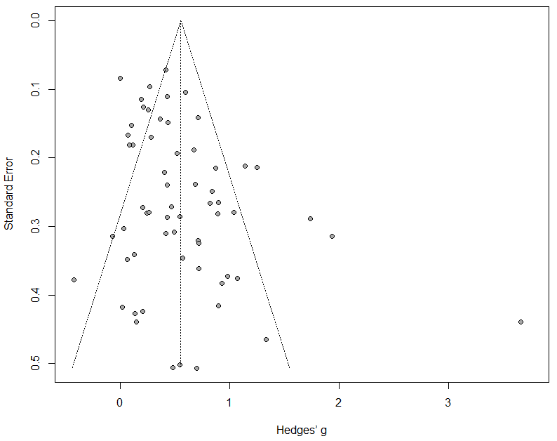

F.2. Funnel plot for proportion of participants in the trial from the number of participants who received the depression questionnaires

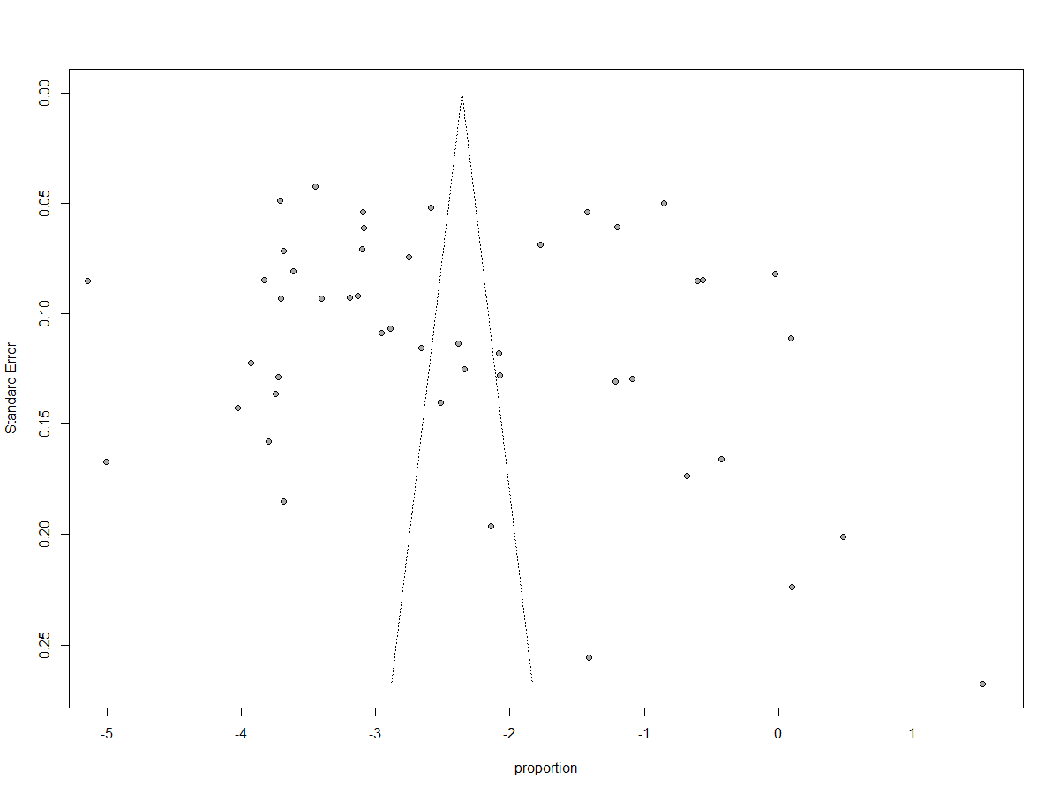

F.3. Funnel plot for proportion of participants in the trial from the number of participants who completed the depression questionnaires

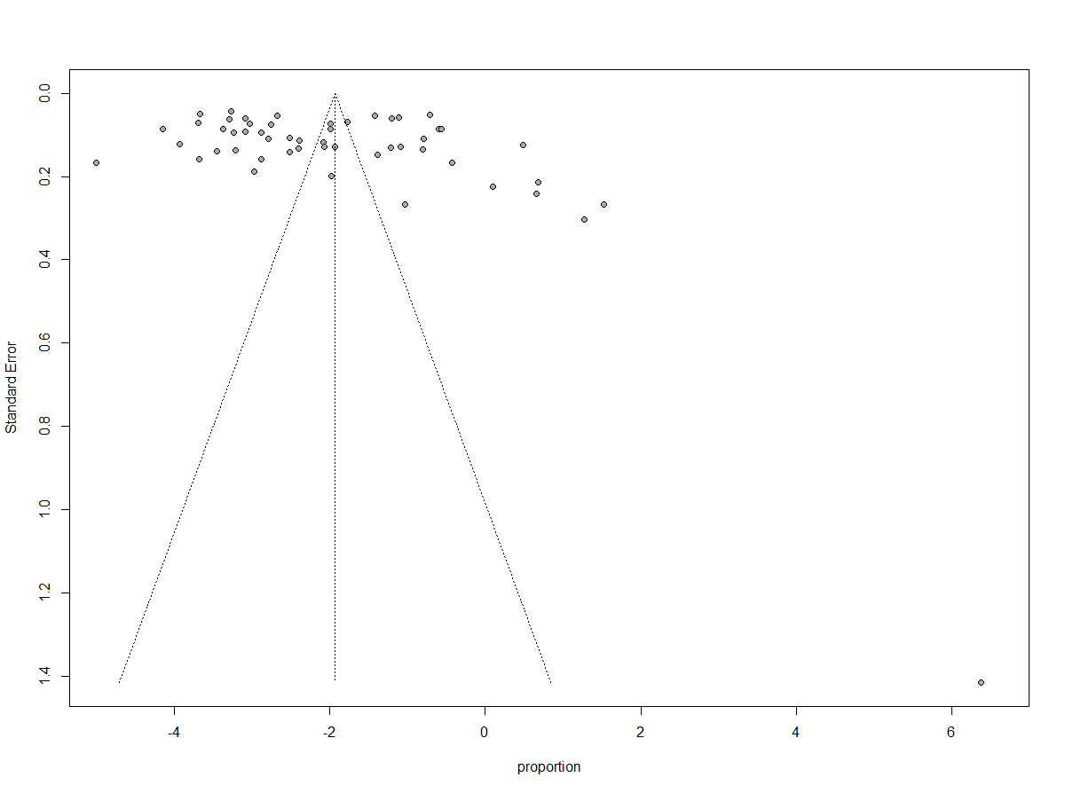

Appendix G. Standardized regression coefficients of effect size: Multivariate meta-regression analysis
 |  | Coeff | SE | p
Setting (other vs general medical) |  | 0.09 | 0.18 | 0.60
Age group (older vs younger adults) |  | -0.20 | 0.19 | 0.29
Publication year (continuous) |  | 0.00 | 0.01 | 0.68
Diagnosis (yes vs no) |  | 0.22 | 0.16 | 0.19
Risk of bias (low vs high) |  | 0.01 | 0.16 | 0.96
Psychotherapy type (other vs cbt) |  | -0.19 | 0.15 | 0.22
Intercept |  | -8.43 | 21.63 | 0.70

Appendix H. Long-term effects of psychotherapies for depression: Hedges’g

Long-term effects |  | Effect Size |  |  |  | Heterogeneity
 |  | N (comparisons) | g | 95% CI |  | I² | 95% CI |  | NNT
6-8 months FU |  | 25 | 0.33 | 0.14~0.52 |  | 75 | 63~83 |  | 9.83
9-12 months FU |  | 13 | 0.24 | 0.11~0.37 |  | 31 | 0~64 |  | 13.99
13-24 months FU |  | 7 | 0.32 | -0.19~0.82 |  | 92 | 87~96 |  | 10.23
>24 months FU |  | 3 | 0.18 | 0.15~0.21 |  | 0 | 0~0 |  | 18.85

Note. FU: follow-up

Appendix I. Forest plots

I.1. Forest plot for proportion of participants in the trial from the number of participants who received the depression questionnaires
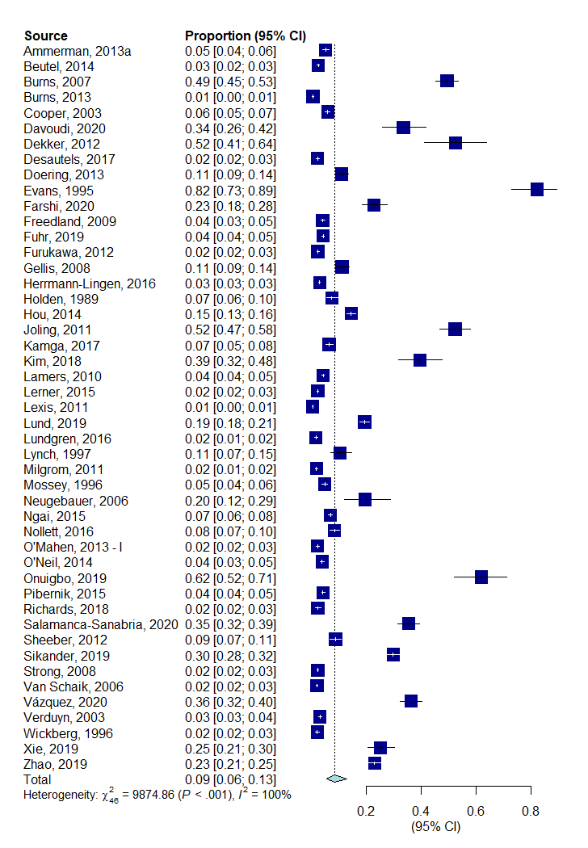

I.2. Forest plot for proportion of participants in the trial from the number of participants who completed the depression questionnaires
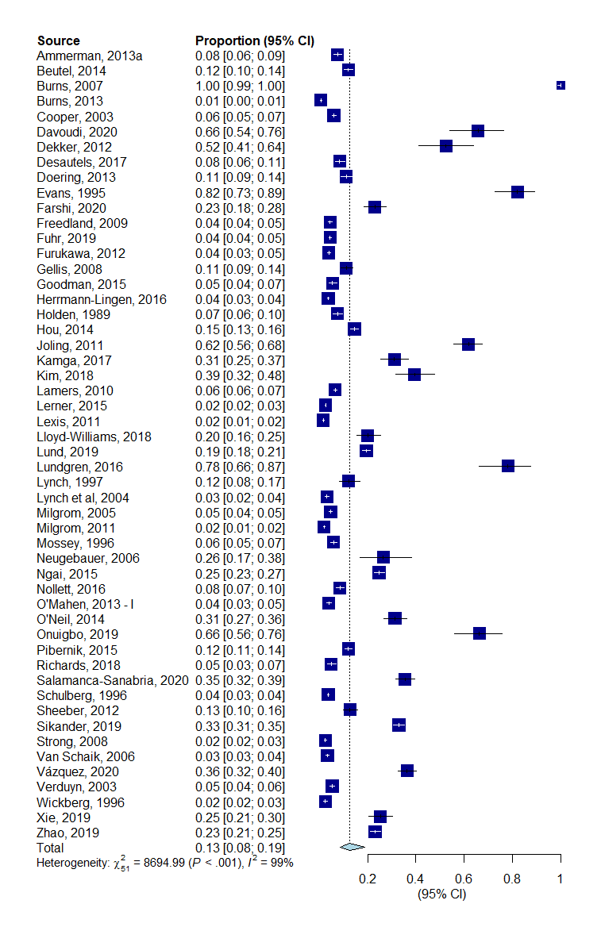

Appendix J. Pooled proportion of participants in the trial from the number of participants who received the depression questionnaires
 |  | Proportion |  |  |  | Heterogeneity
 |  | N (studies) | Prop | 95% CI |  | I² | 95% CI | p
All comparisons |  | 47 | 0.09 | 0.06~0.13 |  | 99.5 | 99.5~99.6
Adjusted for publication bias (add 2) |  | 49 | 0.08 | 0.05~0.12 |  | 99.5 | 99.5~99.6
Removing 36 outliers |  | 11 | 0.08 | 0.06~0.09 |  | 86.1 | 77.0~91.6
Only low risk of bias |  | 25 | 0.07 | 0.04~0.13 |  | 99.6 | 99.5~99.6
Subgroup analyses
Setting |  |  |  |  |  |  |  | 0.407
General medical |  | 21 | 0.10 | 0.06~0.15 |  | 99.4 | 99.4~99.5
Primary care |  | 3 | 0.12 | 0.01~0.68 |  | 99.7 | 99.7~99.8
Perinatal |  | 12 | 0.05 | 0.03~0.09 |  | 99.5 | 99.4~99.5
Other |  | 11 | 0.10 | 0.04~0.24 |  | 99.7 | 99.6~99.7
Age group |  |  |  |  |  |  |  | 0.428
Adults |  | 28 | 0.10 | 0.06~0.15 |  | 99.6 | 99.5~99.6
Elderly |  | 19 | 0.07 | 0.05~0.12 |  | 99.4 | 99.3~99.4
Diagnosis |  |  |  |  |  |  |  | 0.001
Cut-off |  | 34 | 0.11 | 0.07~0.17 |  | 99.6 | 99.5~99.6
Mood disorder |  | 13 | 0.04 | 0.03~0.06 |  | 98.6 | 98.3~98.9
Risk of bias |  |  |  |  |  |  |  | 0.255
low |  | 25 | 0.07 | 0.04~0.11 |  | 99.6 | 99.5~99.6
high |  | 22 | 0.11 | 0.06~0.17 |  | 99.5 | 99.5~99.6

Note. Prop: proportion.

Appendix K. Post-hoc analysis for number of sessions

 |  | Effect Size |  |  |  | Heterogeneity
 |  | N (comparisons) | g | 95% CI |  | I² | 95%CI |  | p ^{a)} |  | NNT
Number of sessions |  |  |  |  |  |  |  |  | 0.61
6 or fewer |  | 17 | 0.74 | 0.17~1.31 |  | 97 | 95~97 |  |  |  | 3.92
7 to 11 |  | 26 | 0.55 | 0.31~0.80 |  | 73 | 61~82 |  |  |  | 5.46
12 or more |  | 7 | 0.44 | 0.18~0.71 |  | 79 | 56~90 |  |  |  | 7.10

a) The p-value indicates whether the difference between subgroups is significant.

