Interpretation bias in health anxiety: A systematic review and meta-analysis

Online Supplementary Material

eMethods 1. PRISMA checklist
eMethods 2. Search strategy
eTable 1. Methodological quality assessment (The Joanna Briggs Institute Critical Appraisal Checklist for Analytical Cross-sectional Studies)
eTable 2. The result of methodological quality assessment
eFigure 1. Funnel plot
eFigure 2. Egger’ s regression test
eFigure 3. p-curve plot
eFigure 4. Funnel plot of sensitivity analysis
Project link. Availability of data, code and other materials
eMethods 1. PRISMA checklist
Section and Topic | Item # | Checklist item | Location where item is reported
TITLE
Title | 1 | Identify the report as a systematic review. | p1
ABSTRACT
Abstract | 2 | See the PRISMA 2020 for Abstracts checklist. | p3-4
INTRODUCTION
Rationale | 3 | Describe the rationale for the review in the context of existing knowledge. | p5-6
Objectives | 4 | Provide an explicit statement of the objective(s) or question(s) the review addresses. | p6-7
METHODS
Eligibility criteria | 5 | Specify the inclusion and exclusion criteria for the review and how studies were grouped for the syntheses. | p7-8
Information sources | 6 | Specify all databases, registers, websites, organisations, reference lists and other sources searched or consulted to identify studies. Specify the date when each source was last searched or consulted. | p7
Search strategy | 7 | Present the full search strategies for all databases, registers and websites, including any filters and limits used. | p7
Selection process | 8 | Specify the methods used to decide whether a study met the inclusion criteria of the review, including how many reviewers screened each record and each report retrieved, whether they worked independently, and if applicable, details of automation tools used in the process. | p7-8
Data collection process | 9 | Specify the methods used to collect data from reports, including how many reviewers collected data from each report, whether they worked independently, any processes for obtaining or confirming data from study investigators, and if applicable, details of automation tools used in the process. | p8
Data items | 10a | List and define all outcomes for which data were sought. Specify whether all results that were compatible with each outcome domain in each study were sought (e.g. for all measures, time points, analyses), and if not, the methods used to decide which results to collect. | p8
 | 10b | List and define all other variables for which data were sought (e.g. participant and intervention characteristics, funding sources). Describe any assumptions made about any missing or unclear information. | p8
Study risk of bias assessment | 11 | Specify the methods used to assess risk of bias in the included studies, including details of the tool(s) used, how many reviewers assessed each study and whether they worked independently, and if applicable, details of automation tools used in the process. | p9
Effect measures | 12 | Specify for each outcome the effect measure(s) (e.g. risk ratio, mean difference) used in the synthesis or presentation of results. | p9
Synthesis methods | 13a | Describe the processes used to decide which studies were eligible for each synthesis (e.g. tabulating the study intervention characteristics and comparing against the planned groups for each synthesis (item #5)). | p9
 | 13b | Describe any methods required to prepare the data for presentation or synthesis, such as handling of missing summary statistics, or data conversions. | p9
 | 13c | Describe any methods used to tabulate or visually display results of individual studies and syntheses. | p9
 | 13d | Describe any methods used to synthesize results and provide a rationale for the choice(s). If meta-analysis was performed, describe the model(s), method(s) to identify the presence and extent of statistical heterogeneity, and software package(s) used. | p9-10
 | 13e | Describe any methods used to explore possible causes of heterogeneity among study results (e.g. subgroup analysis, meta-regression). | p10
 | 13f | Describe any sensitivity analyses conducted to assess robustness of the synthesized results. | p10
Reporting bias assessment | 14 | Describe any methods used to assess risk of bias due to missing results in a synthesis (arising from reporting biases). | p10
Certainty assessment | 15 | Describe any methods used to assess certainty (or confidence) in the body of evidence for an outcome. | p10
RESULTS
Study selection | 16a | Describe the results of the search and selection process, from the number of records identified in the search to the number of studies included in the review, ideally using a flow diagram. | p10-11
 | 16b | Cite studies that might appear to meet the inclusion criteria, but which were excluded, and explain why they were excluded. | p10
Study characteristics | 17 | Cite each included study and present its characteristics. | p10-11
Risk of bias in studies | 18 | Present assessments of risk of bias for each included study. | p11
Results of individual studies | 19 | For all outcomes, present, for each study: (a) summary statistics for each group (where appropriate) and (b) an effect estimate and its precision (e.g. confidence/credible interval), ideally using structured tables or plots. | p11
Results of syntheses | 20a | For each synthesis, briefly summarise the characteristics and risk of bias among contributing studies. | p10-11
 | 20b | Present results of all statistical syntheses conducted. If meta-analysis was done, present for each the summary estimate and its precision (e.g. confidence/credible interval) and measures of statistical heterogeneity. If comparing groups, describe the direction of the effect. | p12
 | 20c | Present results of all investigations of possible causes of heterogeneity among study results. | p12
 | 20d | Present results of all sensitivity analyses conducted to assess the robustness of the synthesized results. | eTable 2 in the supplement
Reporting biases | 21 | Present assessments of risk of bias due to missing results (arising from reporting biases) for each synthesis assessed. | p11
Certainty of evidence | 22 | Present assessments of certainty (or confidence) in the body of evidence for each outcome assessed. | p11
DISCUSSION
Discussion | 23a | Provide a general interpretation of the results in the context of other evidence. | p13-16
 | 23b | Discuss any limitations of the evidence included in the review. | p17
 | 23c | Discuss any limitations of the review processes used. | p17
 | 23d | Discuss implications of the results for practice, policy, and future research. | p17-18
OTHER INFORMATION
Registration and protocol | 24a | Provide registration information for the review, including register name and registration number, or state that the review was not registered. | p7
 | 24b | Indicate where the review protocol can be accessed, or state that a protocol was not prepared. | p7
 | 24c | Describe and explain any amendments to information provided at registration or in the protocol. | p7
Support | 25 | Describe sources of financial or non-financial support for the review, and the role of the funders or sponsors in the review. | p19
Competing interests | 26 | Declare any competing interests of review authors. | p19
Availability of data, code and other materials | 27 | Report which of the following are publicly available and where they can be found: template data collection forms; data extracted from included studies; data used for all analyses; analytic code; any other materials used in the review. | in the supplement

eMethods 2. Search strategy

Web of Science
TS=(“health anxiety” OR “illness anxiety” OR hypochondri* OR “somatic symptom disorder” OR “somatoform disorders” OR “somatization disorder”) AND TS=(“interpret* bias” OR misinterpretation OR attribution OR misattribution OR evaluation OR information OR inferential OR judgement OR “cognitive appraisal*” OR appraisal* OR “cognitive misappraisal*” OR misappraisal* OR “negative cognition*” OR “cognitive bias*”)

PubMed
((“health anxiety”[All Fields] OR “illness anxiety”[All Fields] OR hypochondri*[All Fields] OR “somatic symptom disorder”[All Fields] OR “somatoform disorders”[All Fields] OR “somatization disorder”[All Fields])) AND ((“interpret* bias”[All Fields] OR misinterpretation[All Fields] OR attribution[All Fields] OR misattribution[All Fields] OR evaluation[All Fields] OR information[All Fields] OR inferential[All Fields] OR judgement[All Fields] OR “cognitive appraisal*”[All Fields] OR appraisal*[All Fields] OR “cognitive misappraisal*”[All Fields] OR misappraisal*[All Fields] OR “negative cognition*”[All Fields] OR “cognitive bias*”[All Fields]))

PsycINFO
(ab(“health anxiety” OR “illness anxiety” OR hypochondri* OR “somatic symptom disorder” OR “somatoform disorders” OR “somatization disorder”) OR ti(“health anxiety” OR “illness anxiety” OR hypochondri* OR “somatic symptom disorder” OR “somatoform disorders” OR “somatization disorder”)) AND (ab(“interpret* bias” OR misinterpretation OR attribution OR misattribution OR evaluation OR information OR inferential OR judgement OR “cognitive appraisal*” OR appraisal* OR “cognitive misappraisal*” OR misappraisal* OR “negative cognition*” OR “cognitive bias*”) OR ti(“interpret* bias” OR misinterpretation OR attribution OR misattribution OR evaluation OR information OR inferential OR judgement OR “cognitive appraisal*” OR appraisal* OR “cognitive misappraisal*” OR misappraisal* OR “negative cognition*” OR “cognitive bias*”))

Scopus
TITLE-ABS-KEY(“health anxiety” OR “illness anxiety” OR hypochondri* OR “somatic symptom disorder” OR “somatoform disorders” OR “somatization disorder”) AND TITLE-ABS-KEY(“interpret* bias” OR misinterpretation OR attribution OR misattribution OR evaluation OR information OR inferential OR judgement OR “cognitive appraisal*” OR appraisal* OR “cognitive misappraisal*” OR misappraisal* OR “negative cognition*” OR “cognitive bias*”)

CNKI
主题（健康焦虑＋疾病焦虑＋疑病＋躯体症状障碍＋躯体形式障碍＋躯体化障碍）AND 主题（解释偏向＋灾难化解释＋归因＋评估＋信息＋判断＋推理＋负面认知＋认知偏向）

VIP
题名或关键词=（健康焦虑＋疾病焦虑＋疑病＋躯体症状障碍＋躯体形式障碍＋躯体化障碍）与题名或关键词=（解释偏向＋灾难化解释＋归因＋评估＋信息＋判断＋推理＋负面认知＋认知偏向）

Wanfang
主题:(“健康焦虑”or“疾病焦虑”or“疑病”or“躯体症状障碍”or“躯体形式障碍”or“躯体化障碍”) and 主题:(“解释偏向”or“灾难化解释”or“归因”or“评估”or“信息”or“判断”or“推理”or“负面认知”or“认知偏向”)

Psyndex/PubPsych
LA=deu (Gesundheits?ngst OR Krankheits?ngst OR Hypochondr* OR “somatische Belastungsstörung” OR “somatoforme Störung” OR Somatisierungsstörung) AND (Interpretationsbias OR Fehlinterpretation OR Missattribution OR Attribution OR Fehlattribution OR Evaluation OR Information OR Schlussfolg* OR Beurteilung OR “kognitive Bewertung” OR Bewertung OR “kognitive Fehlbewertung” OR Fehlbewertung OR “negative Kognition” OR “kognitiver bias” OR “kognitive Verzerrung”) DT="Journal Article"

eTable 1. Methodological quality assessment (The Joanna Briggs Institute Critical Appraisal Checklist for Analytical Cross-sectional Studies)
 | Yes | No | Unclear | Not applicable
- Were the criteria for inclusion in the sample clearly defined? | □ | □ | □ | □
- Were the study subjects and the setting described in detail? | □ | □ | □ | □
- Was the exposure measured in a valid and reliable way? | □ | □ | □ | □
- Were objective, standard criteria used for measurement of the condition? | □ | □ | □ | □
- Were confounding factors identified? | □ | □ | □ | □
- Were strategies to deal with confounding factors stated? | □ | □ | □ | □
- Were the outcomes measured in a valid and reliable way? | □ | □ | □ | □
- Was appropriate statistical analysis used? | □ | □ | □ | □

eTable 2. The result of methodological quality assessment
Item | 1 | 2 | 3 | 4 | 5 | 6 | 7 | 8 | Score
Luo et al., 2018 | no | yes | not applicable | yes | yes | yes | unclear | yes | 5
Zhou et al., 2017 | no | yes | not applicable | yes | yes | no | unclear | yes | 4
Woud et al., 2016 | no | yes | not applicable | yes | yes | yes | yes | yes | 6
Bailer et al., 2016 | yes | yes | yes | yes | yes | yes | yes | yes | 8
Bailey & Wells, 2015 | no | yes | not applicable | yes | yes | no | yes | yes | 5
Weck et al., 2012 | unclear | yes | yes | yes | yes | yes | unclear | yes | 6
Fulton et al., 2011 | no | yes | not applicable | yes | yes | no | yes | yes | 5
Fergus & Valentiner, 2011 | no | yes | not applicable | yes | yes | no | yes | yes | 5
Marcus & Church, 2003 | no | yes | not applicable | yes | yes | yes | yes | yes | 6
Yan et al., 2019 | no | yes | yes | yes | yes | yes | yes | yes | 7
Houran et al., 2002 | no | yes | not applicable | yes | yes | yes | yes | yes | 6
Haenen et al., 2000 | yes | yes | yes | yes | yes | yes | yes | yes | 8
Rief et al., 1998 | no | yes | yes | yes | yes | yes | yes | yes | 7
MacLeod et al., 1998 | yes | yes | yes | yes | yes | yes | yes | yes | 8
Hadjistavropoulos et al., 1998 | yes | yes | yes | yes | yes | yes | yes | yes | 8
Chan et al., 2020 | yes | yes | not applicable | yes | yes | no | yes | yes | 6
Witthöft et al., 2016 | yes | yes | yes | yes | yes | yes | yes | yes | 8
Neng & Weck, 2015 | yes | yes | yes | yes | yes | yes | yes | yes | 8
Schmidt et al., 2013 | yes | yes | yes | yes | yes | yes | yes | yes | 8
Jasper & Witthöft, 2013 | no | yes | not applicable | yes | yes | yes | yes | yes | 6
Witthöft et al., 2012 | no | yes | not applicable | yes | yes | yes | yes | yes | 6
Weck et al., 2012 | yes | yes | yes | yes | yes | yes | yes | yes | 8
Gramling et al., 1996 | yes | yes | yes | yes | yes | yes | yes | yes | 8
Hitchcock & Mathews, 1992 | no | yes | not applicable | yes | yes | yes | yes | yes | 6
Schreiber et al., 2014 | yes | yes | yes | yes | yes | yes | yes | yes | 8
Weck & Hoefling, 2015 | yes | yes | yes | yes | yes | yes | yes | yes | 8
Bailey & Wells, 2016 | no | yes | yes | yes | yes | yes | unclear | yes | 6
Elhamiasl et al., 2020 | yes | yes | yes | yes | yes | yes | unclear | yes | 7
De Jong et al., 1998 | no | yes | yes | yes | yes | yes | yes | yes | 7
Hedman et al., 2016 | yes | yes | yes | yes | yes | yes | yes | yes | 8
Schwenzer & Mathiak, 2011 | no | yes | not applicable | yes | yes | yes | unclear | yes | 5
Schwenzer & Mathiak, 2012 | yes | yes | not applicable | yes | yes | yes | unclear | yes | 6
Smeets et al., 2000 | no | yes | yes | yes | yes | yes | yes | yes | 7
Bailer et al., 2013 | yes | yes | not applicable | yes | yes | yes | yes | yes | 7
Hiller et al., 1997 | yes | yes | not applicable | yes | no | no | yes | yes | 5
Sensky et al., 1998 | yes | yes | not applicable | yes | no | no | yes | yes | 5

eFigure 1. Funnel plot
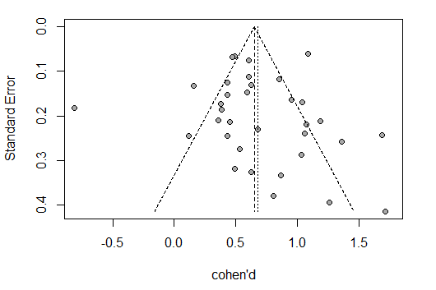

eFigure 2. Egger’ s regression test
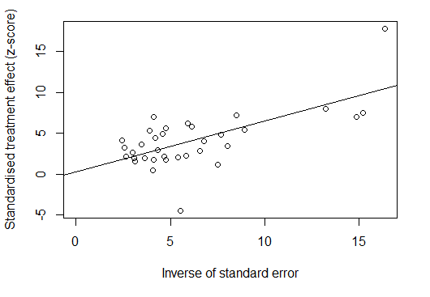

eFigure 3. p-curve plot
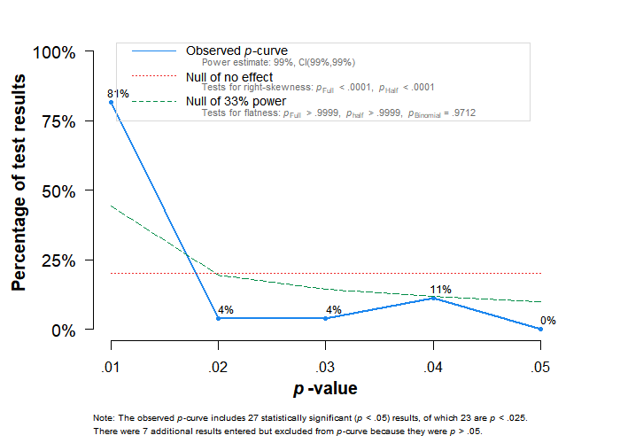

eFigure 4. Funnel plot of sensitivity analysis
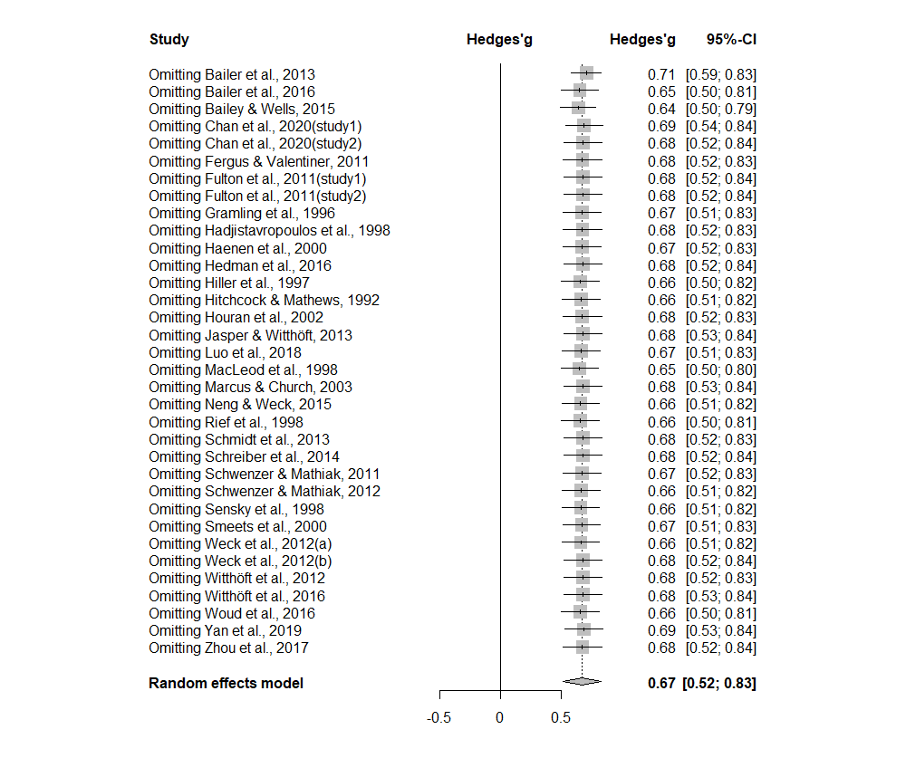

Project link. Availability of data, code and other materials

https://osf.io/xd9ey/?view_only=7f5aab33bf884b9883f66822b551df68

