Supplementary Figure 1: Voxel-based morphometry analyses illustrating the ANCOVA main effect of gender upon gray matter density (A), the ANCOVA interaction effect of gender x diagnosis (B).
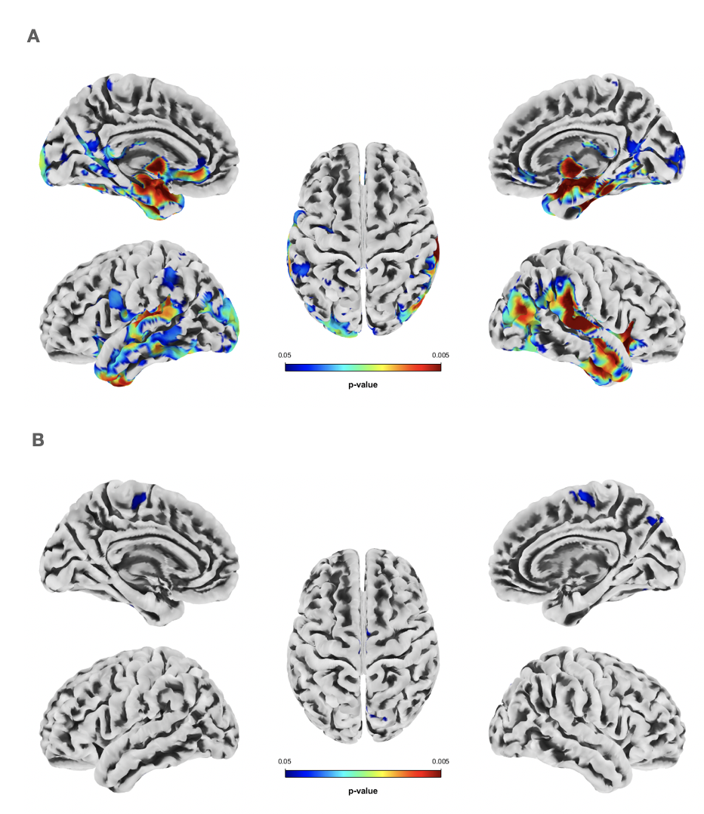

Supplementary Figure 2: Region of interest analyses illustrating sex differences in gray matter density (GMD) in the left dorsolateral prefrontal cortex, among the control group. (A) Box plot displaying mean and individual subject data points for both female and male control participants. (B) Association or dlPFC-GMD with behavioral approach and inhibition scores assessed by BAS and BIS for pre-adolescent control girls, and (C) the associations of dlPFC-GMD with behavioral approach and inhibition scores in pre-adolescent control boys. Models in B and C have been adjusted for total intracranial volume and pubertal status.

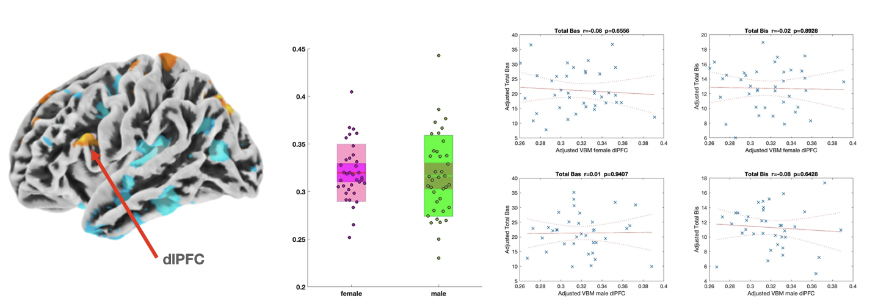
C
B
A
Girls (N=38)
Boys (N=36)

