Supplementary figure 1. Flowchart

Supplementary figure 1. Flowchart
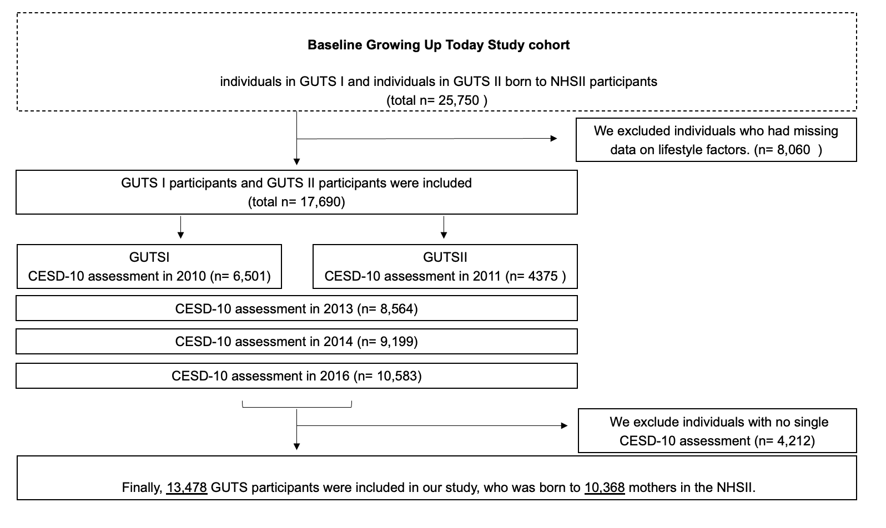

Supplementary Table 1. Baseline characteristics of included and excluded offspring

Supplementary Table 1. Baseline characteristic of included and excluded offspring
 | Group
Offspring Variables | Included offspring | Excluded offspring | P-value
No of children | 13,478 | 12,272
Sex |  |  | <0.01
Male | 36% | 59%
Female | 64% | 41%
Age in 2010†, years, mean (SD) | 18.98 (1.87) | 19.15 (1.87) | 0.6
Maternal Variables
Maternal antidepressant use at baseline, yes | 21% | 24% | 0.34
Lifestyle factors
Alternate healthy eating index 2010, diet score, mean (SD) | 24.49 (6.67) | 24.36 (6.85) | 0.44
Body mass index, kg/m², mean (SD) | 23.74 (4.51) | 24.06 (4.62) | <0.01
Moderate/vigorous-intensity exercise, hour/week, mean (SD) | 2.382 (3.355) | 2.296 (3.209) | 0.86
Alcohol intake, g/day, mean (SD) | 2.714 (5.231) | 2.701 (5.068) | 0.53
Smoking status, (%) |  |  | <0.01
Never smoker | 72% | 68%
Former smoker | 21% | 23%
Current smoker | 7% | 9%

Supplementary Table 2. Correlations between CESD scores at four-time points

Supplementary Table 2. Correlations between CESD scores at four time points
 | 1. | 2. | 3. | 4.
- CESD scores in 2010/2011 | 1.00
- CESD scores in 2013 | 0.51** | 1.00
- CESD scores in 2014 | 0.49** | 0.58** | 1.00
- CESD scores in 2016 | 0.45** | 0.52** | 0.54** | 1.00
Note. ** p-value <0.001.

Supplementary Table 3. Modification of the effect of maternal healthy lifestyle scores on offspring depression scores by offspring age

Supplementary Table 3. Modification of the effect of maternal healthy lifestyle scores on offspring depression scores by offspring age
 | Estimate | P- value
Offspring age > 18 years | 0.18 (-0.09, 0.45) | 0.19
Maternal healthy lifestyle scores | -0.15 (-0.09, -0.21) | <0.001
Offspring age > 18 years* Maternal healthy lifestyle scores | -0.14 (-0.06, -0.22) | <0.001

Supplementary Table 4. Modification of the effect of maternal healthy lifestyle scores on offspring depression scores by offspring sex

Supplementary Table 4. Modification of the effect of maternal healthy lifestyle scores on offspring depression scores by offspring sex
 | Estimate | P- value
Offspring female | 0.63 (0.24, 1.02) | 0.002
Maternal healthy lifestyle scores | 0.02 (-0.08, 0.12) | 0.73
Offspring female* Maternal healthy lifestyle scores | -0.18 (-0.30, -0.06) | 0.004

Supplementary Table 5. Association of offspring healthy lifestyle score with offspring depression score (CESD-10†)

Supplementary Table 5. Association of offspring healthy lifestyle score with offspring depression score (CESD-10†)
The offspring healthy lifestyle score
 |  | Offspring depression score (CESD-10)
 |  | Unadjusted model |  | Adjusted model
 |  | Estimate (95% CI) | P-value | Estimate (95% CI) | P-value
Healthy lifestyle score | 1 | 0 (Ref.) | - | 0 (Ref.) | -
 | 2 | -0.53 (-0.74, -0.33) | <0.001 | -0.55 (-0.74, -0.36) | <0.001
 | 3 | -0.97 (-1.17, -0.78) | <0.001 | -1.01 (-1.20, -0.83) | <0.001
 | 4 | -1.27 (-1.48, -1.48) | <0.001 | -1.31 (-1.50, -1.11) | <0.001
 | 5 (most healthy) | -1.73 (-2.06, -2.06) | <0.001 | -1.78 (-2.11, -1.45) | <0.001
The adjusted model adjusted for race/ethnicity, offspring age, and sex (boy/girl).

†Center for Epidemiological Studies Depression Scale-10 (CESD-10)

