Supplementary File 1

Additional Information on Chin, Kachin, and Rohingya refugees in Malaysia

There are currently over 150,430 refugees from Myanmar, including approximately 93,190 Rohingyas, 24,490 Chins, 9,730 Myanmar Muslims, 3,990 Rakhine & Arakanese, and other ethnicities from Myanmar. Rohingya, Chin, and Kachin although differ in their ethnicities and cultures, have all been subjected to a long history of persecution and discrimination in Myanmar. There are currently over 150,430 refugees from Myanmar living in Malaysia, including approximately 93,190 Rohingyas, 24,490 Chins, 9,730 Myanmar Muslims, 3,990 Rakhine & Arakanese, and other ethnicities from Myanmar. Rohingya, Chin, and Kachin refugees, although differ in their ethnicities and cultures, have been subjected to a long history of persecution and discrimination in Myanmar. There has been extensive documentation of widespread systematic human rights violations against ethnic minorities in Myanmar including extrajudicial killings, arbitrary arrest, detention, torture, forced labour, restrictions on movement, expression, and religious freedom, military conscription policies, extortion and confiscation of property. Many first arrived by boat in Thailand through dangerous travels over the Andaman Sea and were then smuggled or trafficked into Malaysia. They live throughout Peninsular Malaysia. All unauthorized foreigners, including persons fleeing Myanmar, are considered ‘illegal’ or ‘prohibited’ immigrants under the Immigration Act and therefore face ongoing threats of arrest and indefinite detention in deplorable conditions. For the most part, refugees in Malaysia live in overcrowded housing and under protracted conditions of statelessness with lack of access to educational opportunities, employment, and healthcare. Some refugees have lived for decades in Malaysia and have been able to set up some forms of livelihoods and/or receive remittances from relatives who managed to get resettled to Australia, Canada, Denmark, or Sweden but many continue to live in precarious economic situations. Those who have been detained in immigration detention are at risk of malnutrition, physical and mental abuse, assault, exploitation, extortion, and indefinite detention.

Supplemental File 2

Table 1. Theoretical Background and Treatment Strategies for Integrative Adapt Therapy (IAT) and Cognitive Behavioural Therapy (CBT)

IAT | CBT
45-minute, 6-weekly sessions | 45-minute, 6-weekly sessions
Delivered by trained lay counsellors | Delivered by trained lay counsellors
IAT is skills-based and includes 7 strategies (outlined hereunder) | CBT includes 6 strategies—drawn from WHO PM and with an additional component of cognitive reappraisal
The content of the therapy in which these techniques are applied draws specifically on the ADAPT model in which each pillar—and its psychosocial impact—are considered serially in relation to the individual’s personal experiences | The strategies are delivered sequentially over 6 sessions, each session is built on the previously learnt techniques
IAT focuses explicitly on the 5 psychosocial pillars of the ADAPT model: safety/security, losses and separation, injustice, role and identity disruptions, and existential meaning | CBT is primarily aimed at addressing maladaptive cognitive and behavioural patterns of responding to adversity, trauma
IAT makes more explicit an ecological perspective (ADAPT) in tracing in a thematic manner the major disruptions in psychosocial support systems that the refugee has experienced through his or her trajectory of displacement. In each case, the emphasis may differ depending on the issues identified by each individual | The content of the therapy varies, with each session focusing on learning new coping skills and building on previously learnt skills.
IAT Treatment Strategies | CBT Treatment Sessions
1. Psychoeducation  Highlight the common experiences of all refugees;  Link program to the ADAPT model;  Link the refugee experience to the 5 ADAPT domains;  Focus on building resilience and adaptive capacity to manage distress associated with the core refugee challenges avoiding labelling mental disorders;  Provide information about the program (duration, benefits, expectations). | Session 1: Psychoeducation  Introduction and confidentiality;  What is CBT;  Understanding how adversity impacts on mental health;  Managing stress;  Ending session.
2. Trauma narrative/modified exposure  Identity significant stressful life events and narrate these (traumatic) experiences in a coherent and chronological manner;  Link each set of events to each of the 5 ADAPT pillars where appropriate, including safety/security, attachments, justice, role transition/identity, and meaning; Normalize feelings of fear and anxiety;  Understand the link between past trauma and present and future challenges, linking these events to the ADAPT model. | Session 2: Problem-solving, managing stress  General review;  Managing problems;  Managing stress;  Ending session.
3. Problem solving  Identity at least 3 problems according to each ADAPT domain and focus on the one(s) most preoccupied with:  Explore the underlying feelings of distress and reactions to each problem;  Explore coping methods, strategies, and any existing barriers and/or perpetuating factors;  Brainstorm solutions and adopt a solution;  Commit to trying the solution in a step by step manner. | Session 3: Problem-solving, managing stress, and behavioural activation  General review;  Managing problems;  Get going, keep going;  Managing stress;  Ending the session.
4. Stress management  Apply strategies to manage stress: controlled breathing, progressive muscle relaxation incorporating locally salient metaphors and analogies. | Session 4: Problem-solving, managing stress, and behavioural activation, strengthening social support  General review; Managing problems;  Get going, keep going;  Strengthening social support;  Managing stress; Ending the session.
5. Emotion regulation  Apply emotion regulation strategies to deal with and build tolerance for distress associated with the disrupted ADAPT pillars:  Identify and label emotions/feelings using visually salient pictorial aids;  Normalize feelings of distress;  Accepting emotions/feelings and letting go without judgement;  Distancing self from unpleasant feelings. | Session 5: Problem-solving, managing stress, and behavioural activation, strengthening social support, cognitive reappraisal  General review;  Managing problems;  Get going, keep going;  Strengthening social support;  Managing stress;  Cognitive reappraisal;  Ending the session.
6. Cognitive reappraisal  Understand thoughts, feelings, and behaviour and how these are connected;  Identify and challenge unhelpful, negative thoughts/beliefs according to the experiences arising from the ADAPT pillars;  Understand and overcome gaps between expectations and reality with an emphasis on change in role transition and identity before and postmigration. | 6. Ending treatment  General review;  Staying well;  Imagining how to help others;  Looking to the future;  Ending the program.
7. Meaning making
Accepting the reality, recognizing and appreciating all small things in life;
Give hope;
Find meaning in life (what is worth living for, e.g., goals, dreams);
Committing to goals and a life worth living.
Note. ADAPT: Adaptation and Development After Persecution and Trauma; CBT: Cognitive Behavioural Therapy; IAT: Integrative Adapt Therapy. Adapted from Tay, A. K. et al. Theoretical background, first stage development and adaptation of a novel IAT for refugees. Epidemiology and Psychiatric Sciences, 1–8, doi:10.1017/S2045796019000416 (2019)

Supplemental File 3

Figure 1. Flowchart of Participants through Phases of a Randomized Trial (RCT) Comparing Integrative Adaptive Therapy (IAT) vs Cognitive Behavioural Therapy (CBT) amongst trauma-affected refugees from Myanmar living in Malaysia
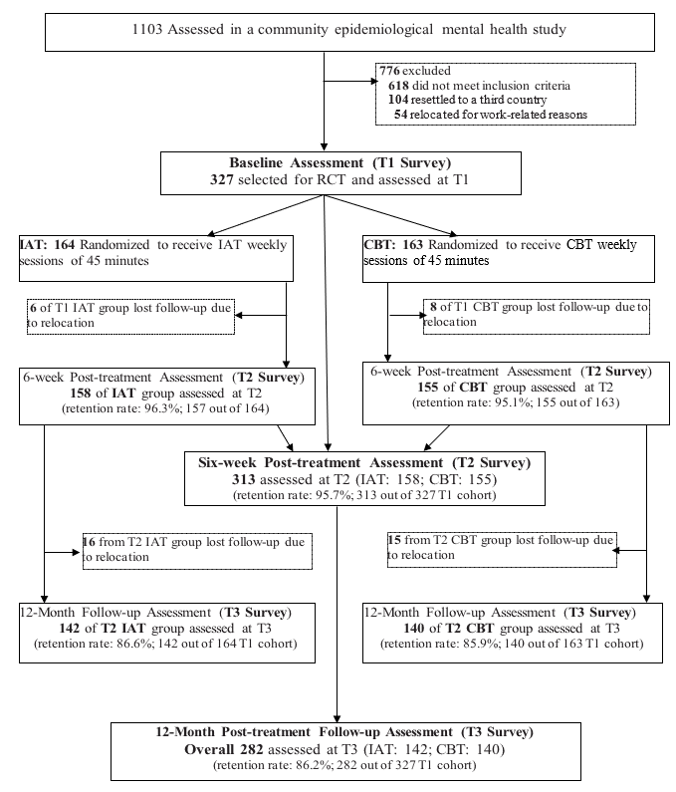

Supplemental File 4

Table 2a. Tests of Between – Subjects Effects: Results from 2x3 Factorial ANOVA for repeated measures
Main and  interaction effect | Dependent variables
 | PTSD |  | Depression |  | Anxiety |  | PCBD |  | Functional impairment
 | F | Sig. | F | Sig | F | Sig. | F | Sig. | F | Sig.
Assessment (T1,T2,T3) | 152.975 | <0.001 | 188.189 | <0.001 | 153.925 | <0.001 | 44.665 | <0.001 | 0.966 | 0.381
Therapy (IAT, CBT) | 2.175 | 0.141 | 0.300 | 0.584 | 0.803 | 0.370 | 1.150 | 0.284 | 3.810 | 0.051
Assessment * Therapy | 0.692 | 0.501 | 1.134 | 0.322 | 2.999 | 0.050 | 1.112 | 0.330 | 1.725 | 0.179
Adjusted R Squared | 0.248 |  | 0.286 |  | 0.251 |  | 0.124 |  | 0.004

