Supplemental Figure 4: Summary of the tetrahydrobiopterin pathway

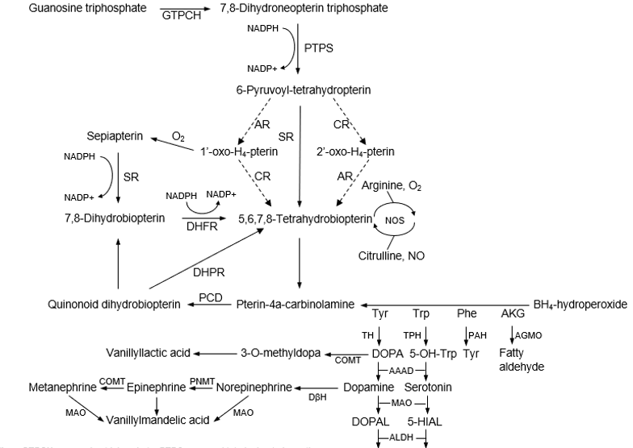
5-HIAA HVA

GTPCH= guanosine triphosphate, PTPS= pyruvoyl tetrahydropterin synthase, SR= sepiapterin reductase, DHFR= dihydrofolate reductase, DHPR= dihydropteridine reductase, PCD= pterin carbinolamine 4-dehydratase, CR= carbonyl reductase, AR= aldose reductase, AAAH= aromatic amino acid hydroxylase, AGMO= alkyl-glycerol monooxygenase, NOS= nitric oxide synthase, AAAD= aromatic amino acid decarboxylase, ALDH= aldehyde dehydrogenase, DβH= Dopamine-β-hydroxylase, AKG= alkylglycerol, 5-HIAA= 5-hydroxyindoleacetic acid, HVA= homovanillic acid, 5-HIAL= 5-hydroxyindoleacetaldehyde, MAO= monoamine oxidase, DOPA= levodopa, 5-OH-Trp= 5-hydroxy tryptophan, Tyr= tyrosine, Trp= tryptophan, Phe= phenylalanine, TH= tyrosine hydroxylase, TPH= tryptophan hydroxylase, PAH= phenylalanine hydroxylase, DOPAL= dihydroxyphenylacetic acid, COMT= catechol-O-methyltransferase, PNMT= phenylethanolamine n-methyltransferase.

