Supplemental Figure 3: Summary of folate pathway. Folinic acid (5-formyl-THF) enters the pathway without the action of DHFR and contributes active metabolites. 5-Methyl-THF is a distal metabolite.
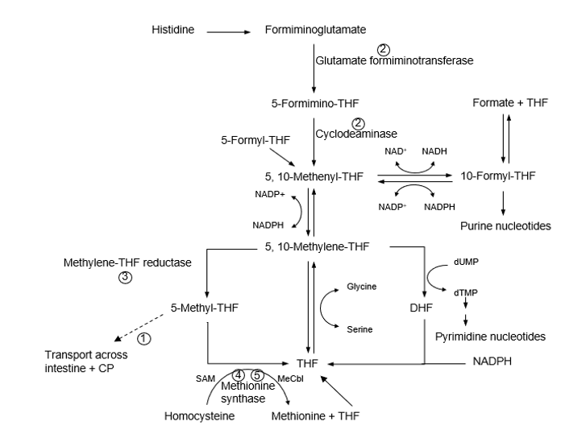

DHFR= dihydrofolate reductase, THF= tetrahydrofolate, DHF= dihydrofolate, dUMP= deoxy-uridine phosphate, dTMP= deoxy-thymidine phosphate, CP= choroid plexus, SAM= S-adenosylmethionine, NADP= nicotinamide adenine dinucleotide phosphate.

