mMMN ERF peak amplitude data distribution for outlier detection
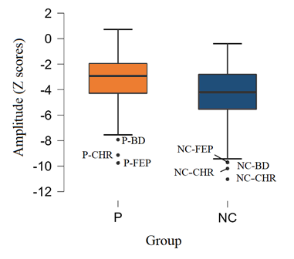
Figure Sup.1 Boxplots of mMMN ERF amplitude data. Dots outside the whiskers are outliers

Correlations
The correlation between IQ, measured by TIB, and mMMN parameters considered only controls to avoid biases linked to group differences in both IQ and mMMN data between patients and controls. After the exclusion of 6 participants because of IQ scores smaller than 1.5 inter-quartile difference, the correlation between IQ and ERF amplitude was not significant, r(118) = -.015, p = .873 (see Figure Sup.2). Similarly, the correlations with Theta power and Theta ITPC were not significant as well, r(118) = .009, p = .923, and r(118) = -.086, p = .359, respectively.
The correlation between socio-economic status measured by the Hollingshead index and mMMN parameters in controls showed no significant correlation with mMMN ERF amplitude r(124) = -.068, p = .448 (see Figure Sup.2), Theta power, r(124) = .050, p = .581, and Theta ITPC, r(124) = -.060, p = .510.
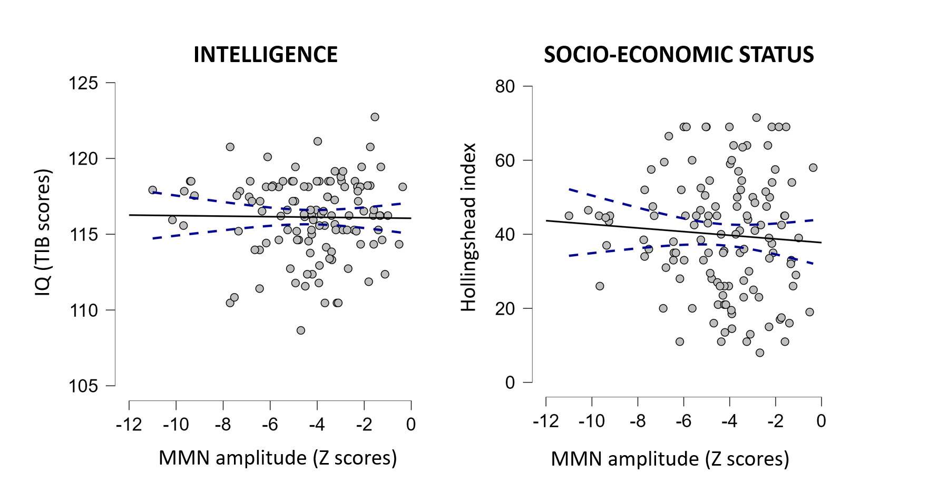
Figure Sup.2. Correlations with mMMN ERF amplitudes and intelligence or socio-economic status

Test of laterality and stimulus type
Event-related fields
The ANCOVA with Laterality (right vs. left) and Condition (standard vs. deviant) as within-participant factors, Group (P vs. NC) and Diagnostic Subgroup (SCZ, BD, FEP, and CHR) as between-participants factors, and Age as covariate showed that all the main effects, except Diagnostic Subgroup, were significant.
The results (see Figure Sup.3) of the within-participants factors showed a significant main effect of Laterality, F(1,254) = 13.41, p < .001, η²_{p} = .05, indicative that the brain response evoked by auditory stimuli was stronger on the right than the left auditory cortex, and a significant main effect of Condition, F(1,254) = 80.68, p < .001, η²_{p} = .24, showing that deviant stimuli evoked a larger brain response than standard stimuli. These within-participants effects were further qualified by the significant interaction Condition*Laterality, F(1,254) = 11.72, p < .001, η²_{p} = .04, meaning that the difference between deviant and standard stimuli was larger over the right than the left auditory region.
The analysis of the between-participants factors revealed that only the main effect of Group was significant, F(1,254) = 16.93, p < .001, η²_{p} = .06, while the main effect of Diagnostic Subgroup and the interaction Group*Diagnostic Subgroup were not significant, Fs < 1.45, ps > .230. The brain activity evoked by auditory stimuli was smaller in patients than controls.
Among the interactions between the within-participant factors and the between-participants factors only the interactions Condition*Group, F(1,254) = 22.77, p < .001, η²_{p} = .08, and Laterality*Group, F(1,254) = 5.19, p = .024, η²_{p} = .02, were significant. The first interaction revealed that the brain activity evoked by deviant stimuli was smaller in patients than controls, t(261) = 4.50, p < .001, d = 0.55, but the activity evoked by standard stimuli did not present any significant difference, t(261) = 1.16, p = .247, d = 0.14. The second interaction indicated that the brain activity reduction in patients was overall larger in the right auditory region, t(261) = 4.18, p < .001, d = 0.52, than the left auditory region, t(261) = 2.63, p = .009, d = 0.32. All other interactions between the factors were not significant, Fs < 3.87, ps > .051.
The covariate Age was significant, F(1,254) = 10.20, p < .001, η²_{p} = .04, and significantly interacted with Condition, F(1,254) = 7.77, p = .006, η²_{p} = .03. This interaction indicated that the correlation between Age and brain activity was larger for deviant stimuli, r = -.261, p < .001, than for standard stimuli, r = -.162, p = .009.
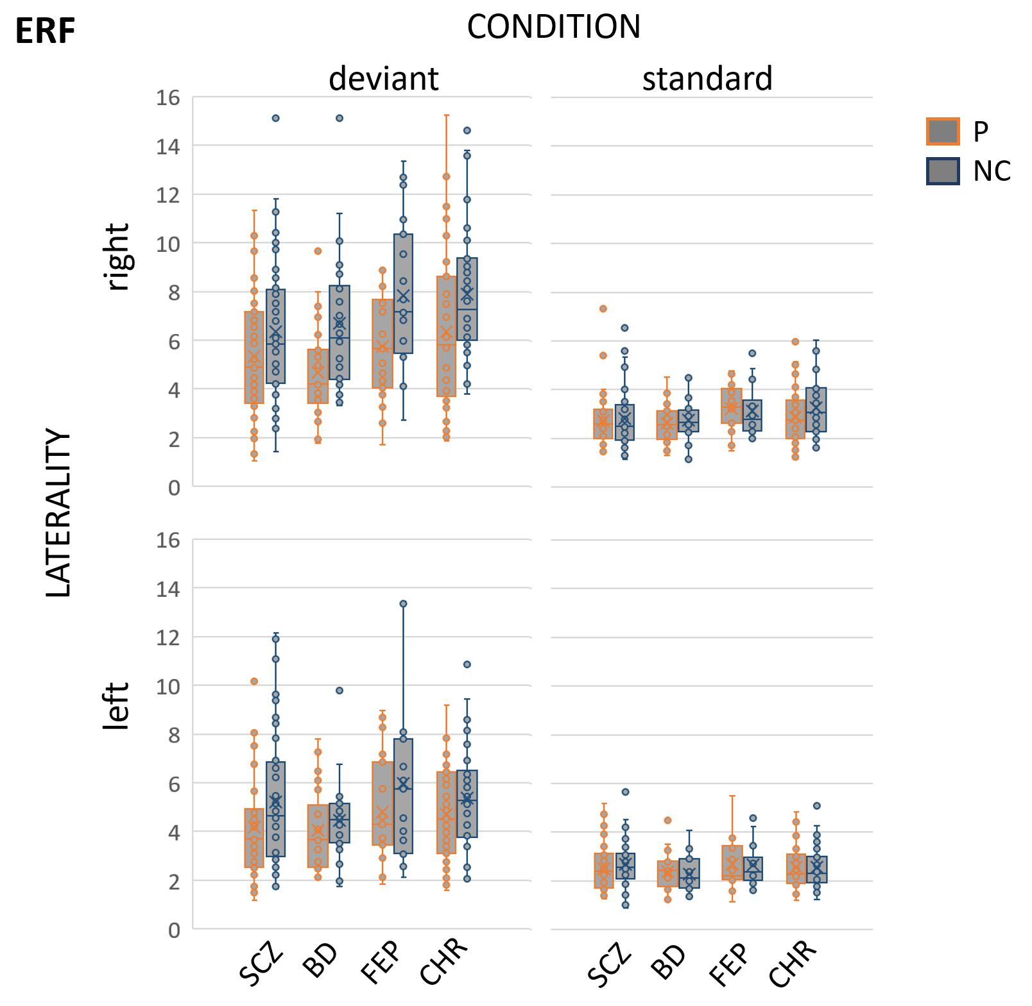
Figure sup.3. Box plots of maximum ERF mMMN values for people with psychosis and controls, separately according to laterality (left and right) and condition (deviant and standard)

Theta power
Theta-power was analyzed with an ANCOVA that considered Laterality (right vs. left) and Condition (standard vs. deviant) as within-participant factors, Group (P vs. NC) and Diagnostic Subgroup (SCZ, BD, FEP, and CHR) as between-participants, and Age as covariate.
Among the main effects (see Figure Sup.4), Condition, F(1,254) = 34.59, p < .001, η²_{p} = .12, Laterality, F(1, 254) = 17.37, p < .001, η²_{p} = .06, and Group, F(1,254) = 12.52, p = .001, η²_{p} = .05, were significant, but Diagnostic Subgroup was not significant, F(3,254) = 0.51, p = .678, η²_{p} = .01. The significant main effects indicated, higher power for the right than the left auditory areas, for deviant than standard stimuli, and for controls than patients. The interaction between Condition and Laterality was significant, F(1,254) = 4.75, p = .030, η²_{p} = .01, meaning that the difference between deviant and standard stimuli was larger over the right than the left auditory region. Among all the interactions of the design factors with Group and Diagnostic Subgroup only Condition*Group, F(1,254) = 8.87, p < .001, η²_{p} = .06 was significant, while all other interactions were not significant, Fs < 2.59, ps > .109. The significant interaction revealed that deviant stimuli evoked reduced activity in patients than controls, t(261) = 4.41, p < .001, d = 0.54, but the difference between patients and control was not significant for standard stimuli, t(261) = 0.76, p = .761, d = 0.04.
The effect of Age was not significant, F(1, 254) = 1.402, p = .237, η²_{p} = .01, and no other factor interacted with it, Fs(1,254) < 3.70, ps > .055.

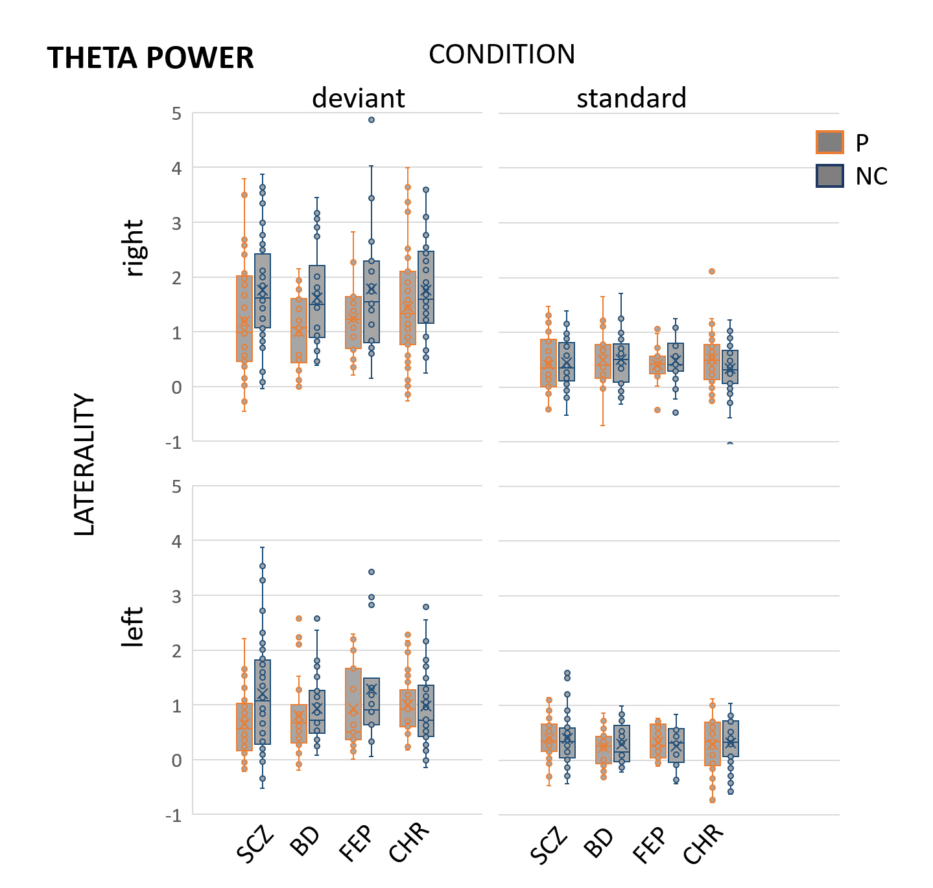

Figure Sup.4. Box plots of maximum Theta power mMMN values for people with psychosis and controls, separately according to laterality (left and right) and condition (deviant and standard)

Theta inter-trial phase coherence
Theta ITPC was analyzed with an ANCOVA that considered Laterality (right vs. left) and Condition (standard vs. deviant) as within-participant factors, Group (P vs. NC) and Diagnostic Subgroup (SCZ, BD, FEP, and CHR) as between-participants, and Age as covariate.
Among the main effects (see Figure Sup.5), Laterality, F(1,254) = 13.48, p < .001, η²_{p} = .05, Condition, F(1,254) = 71.71, p < .001, η²_{p} = .22, Group, F(1,254) = 25.70, p < .001, η²_{p} = .09, were significant, but Diagnostic Subgroup was not significant, F(3,254) = 1.44, p = .233, η²_{p} = .02. The significant main effects indicated higher ITPC for the right than the left auditory areas, for deviant than standard stimuli, and for controls than patients. Only the interaction between Condition and Group, F(1,254) = 18.09, p < .001, η²_{p} = .07, was significant (no other interaction was significant, Fs < 3.54, ps > .61). The significant interaction between Condition and Group, without any further interaction with Diagnostic Subgroup, revealed that the significant differences between patients and controls in ITPC was larger for deviant stimuli, t(261) = 5.70, p < .001, d = 0.70, than standard stimuli, t(261) = 2.34, p = .030, d = 0.29. Age was significant as a main effect, F(1,254) = 5.14, p = .024, η²_{p} = .02, but it did not interact with the other factors, Fs < 3.48, ps > .063.
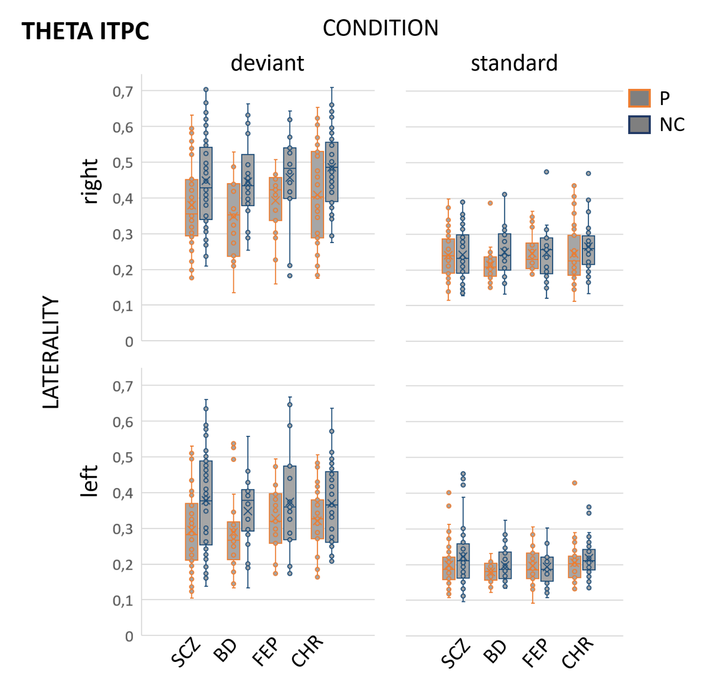
Figure Sup.5. Box plots of maximum Theta ITPC mMMN values for people with psychosis and controls, separately according to laterality (left and right) and condition (deviant and standard)

