Thalamocortical connectivity and its relationship with symptoms and cognition across the psychosis continuum
Supplementary Figures and Tables

Supplementary Table 1: Relationships between thalamocortical connectivity and symptomology and global cognition within diagnostic groups

 | CON |  | REL |  | BP |  | SCZ
A) Symptomatology ROIs | t-value | p-value | t-value | p-value | t-value | p-value | t-value | p-value
Left Middle Frontal Gyrus/Frontal Pole | 1.85 | 0.07 | -1.99 | 0.05 | -2.72 | 0.01 | -2.03 | 0.045
Anterior Cingulate Cortex | 1.90 | 0.06 | -2.76 | 0.007 | 0.16 | 0.87 | -1.75 | 0.08
Right Middle Frontal Gyrus/Frontal Pole | .94 | 0.35 | -2.51 | 0.01 | -1.02 | 0.32 | -2.38 | 0.02
B) Global Cognition ROIs
Right Insula/Temporal Cortex | 0.56 | 0.58 | 3.24 | 0.002 | 1.70 | 0.10 | 2.93 | 0.004
Anterior Cingulate Cortex/Right Frontal Pole | -0.35 | 0.73 | 1.99 | 0.05 | 1.42 | 0.17 | 3.45 | 0.0009

Note: A) Significant post-hoc relationships between symptoms and thalamo-LMFG connectivity were observed in the SCZ and BP groups, while the REL group showed a statistical trend (p=.05). The CON group showed a trend-level relationship in the opposite direction. Thalamo-ACC connectivity was driven by a significant relationship in the REL group, and a trend level relationship in the SCZ group. Significant thalamo-RMFG connectivity was observed in the SCZ and REL groups, but not the BP or CON groups. B) Significant post-hoc relationships between cognition and thalamo-insular connectivity were observed in the SCZ and REL groups, but not the BP or CON Groups. Thalamo-ACC connectivity relationships with cognition were only significant in the SCZ group, but demonstrated a statistical trend in the REL group (p=.05), and no relationships with BP or CON.

Supplementary Table 2: Relationship between ROIs and BPRS Symptom Subdomains

 | LMFG |  | ACC |  | R. Insula |  | Cerebellum 1 |  | Cerebell-  um 2
BPRS Subdomain | t-value | p | t-value | p | t-value | p | t-value | p | t-value | p
Positive | -4.27 | 0.00003 | -4.12 | 0.00005 | -4.47 | 0.00001 | -4.1 | 0.00006 | -4.75 | 0.000003
Negative | -2.24 | 0.03 | -2.96 | 0.003 | -3.45 | 0.0007 | -3.42 | 0.0007 | -3.29 | 0.001
Disorganized | -2.96 | 0.003 | -3.18 | 0.002 | -3.93 | 0.0001 | -3.3 | 0.001 | -4.63 | 0.000006
Depression | -4.84 | 0.00001 | -3.52 | 0.0005 | -2.67 | 0.008 | -4.29 | 0.00003 | -4.51 | 0.00001
Mania | -1.36 | 0.17 | 0.02 | 0.98 | 0.14 | 0.89 | -1.24 | 0.22 | -2.47 | 0.01

Supplementary Table 3: Relationship between ROIs and BACS Cognitive Subscales

 | L. Insula |  | R. Insula
 | t-value | p-value | t-value | p-value
BAC Verbal Learning & Memory | 3.28 | 0.001 | 3.87 | 0.0001
BAC Verbal Working Memory | 2.8 | 0.006 | 3.18 | 0.002
BAC Verbal Fluency | 4.58 | 0.000005 | 4.97 | 0.000001
BAC Processing Speed | 3.06 | 0.002 | 3.25 | 0.001
BAC Motor Speed | 3.07 | 0.002 | 3.22 | 0.001
BAC Problem Solving | 1.06 | 0.29 | 1.59 | 0.11

Supplementary Figure 1. Clusters significantly related to BPRS symptomatology subscales across groups
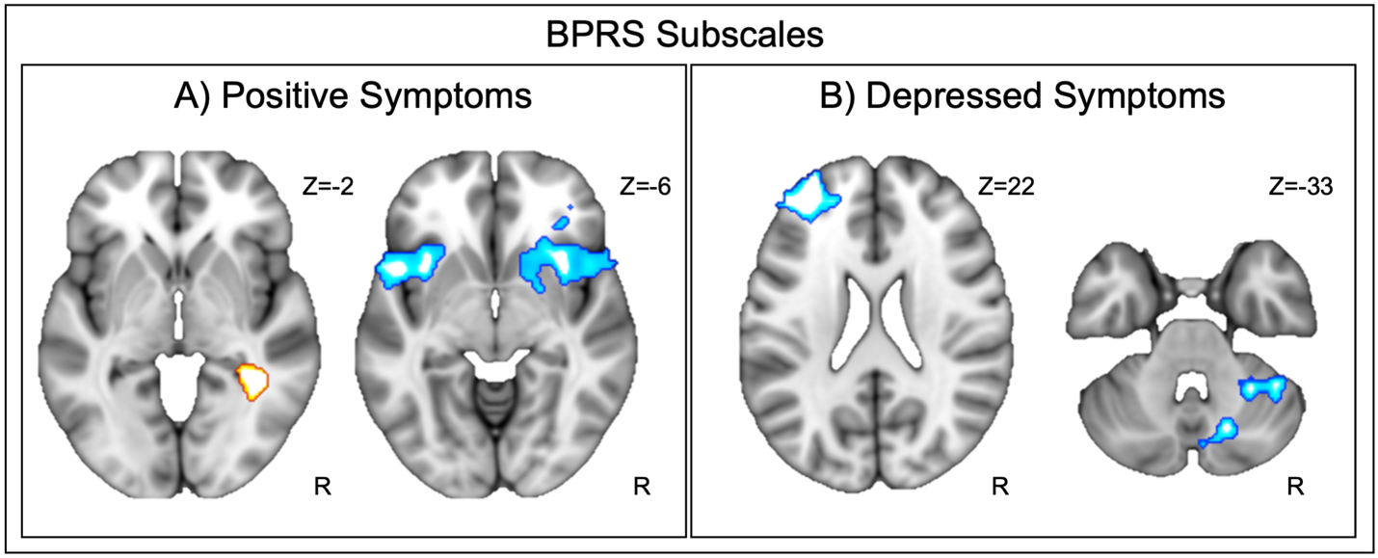
Note: Seeding from bilateral mediodorsal thalamus with covariates for age and gender, A) higher scores on the positive symptoms sub-domain on the BPRS showed reduced thalamocortical relationships with bilateral insula and increased connectivity to the right parahippocampal gyrus (FDR p<.01). B) Higher depressed symptoms on the BPRS showed reduced thalamocortical relationships with the left frontal pole and cerebellum (FDR p<.01). No other symptom domains from the BPRS showed significant whole-brain relationships.

Supplementary Table 4: Clusters significantly related to BPRS Positive and Depressed Symptoms

A) BPRS: Positive Symptoms | N-voxels | x | y | z | p-FDR
Left Insula | 1188 | -28 | 18 | 12 | 0.000004
Right Insula | 810 | 34 | 16 | -10 | 0.00009
Anterior Cingulate Cortex | 574 | 4 | 16 | 20 | 0.00004
Right Parahippocampal Gyrus | 516 | 30 | -56 | 16 | 0.001
B) BPRS: Depressed Symptoms | N-voxels | x | y | z | p-FDR
Left Frontal Pole | 511 | -32 | 52 | 22 | 0.002
Right Cerebellum | 431 | 14 | -76 | -20 | 0.002
Right Cerebellum | 430 | 28 | -46 | -38 | 0.002

Supplementary Figure 2. Clusters significantly related to BACS sub-domains across groups
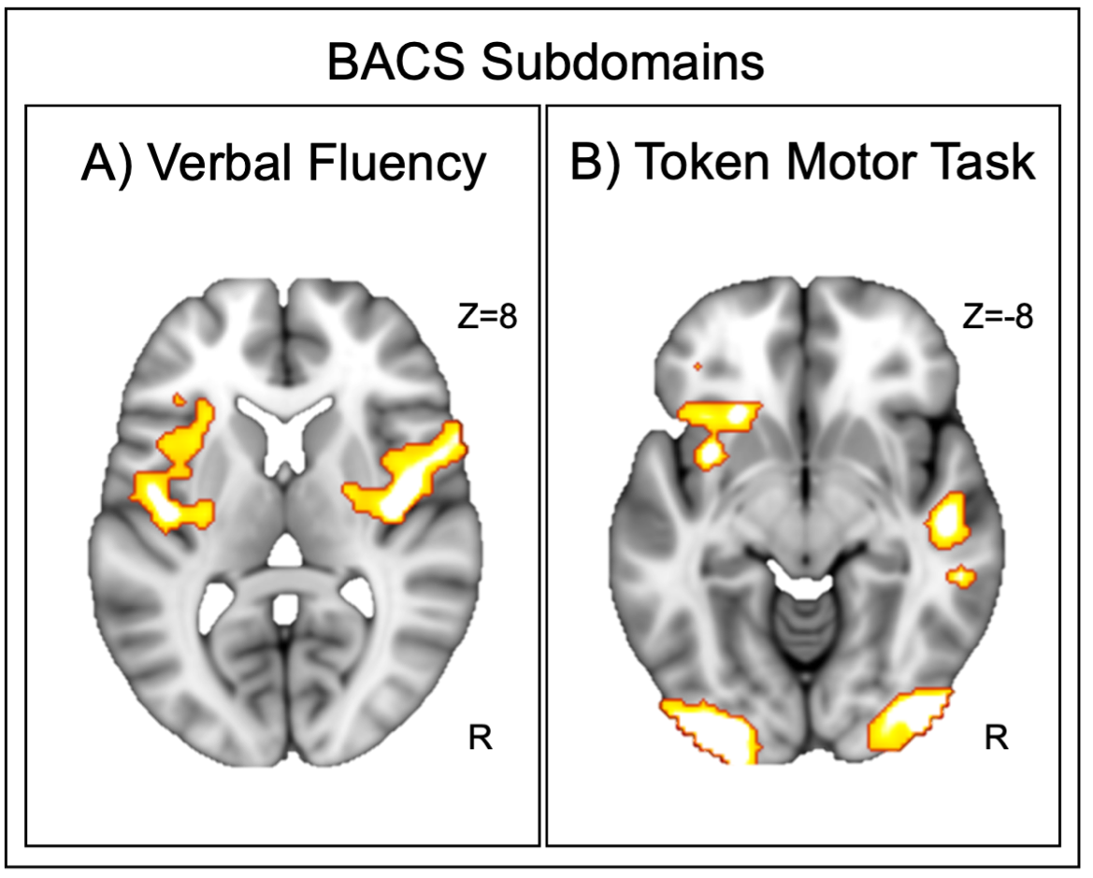
Note: Seeding from bilateral mediodorsal thalamus covarying for age and gender, A) higher scores on the BACS Verbal Fluency subtest showed a relationship with stronger thalamocortical connectivity to bilateral insula (FDR p<.01). B) Higher scores on the BACS Token Motor test showed a relationship with stronger thalamocortical connectivity to bilateral occipital cortex, left insula, and right middle temporal gyrus (FDR p<.01). No other cognitive sub-domain from the BACS showed significant whole-brain relationships.

Supplementary Table 5: Clusters significantly related to BACS Verbal Fluency and Token Motor Task

A) BACS: Verbal Fluency | N-voxels | x | y | z | p-FDR
Right Insula | 2583 | 42 | 8 | 4 | <.000001
Left Insula | 1806 | -62 | -28 | 24 | <.000001
B) BACS: Token Motor | N-voxels | x | y | z | p-FDR
Left Occipital Cortex | 1174 | -32 | -94 | -16 | 0.000004
Right Middle Temporal Gyrus | 913 | 56 | -44 | 6 | 0.00003
Left Insula | 732 | -34 | 6 | -10 | 0.0001
Right Occipital Cortex | 715 | 44 | -88 | -8 | 0.0001

