Stability of network structures
This supplement provides a summary of fitting the Ising network to the three non-overlapping follow ups assessments of last-year MD symptoms to examine the temporal stability of the network structure. To do this, we followed Santos, Kossakowski, Schwartz, and Fried (2018) and performed Ising temporal stability analysis. Since there is currently no single procedure available to test the difference of network structures over time, we used three different tests to assess the temporal stability of the networks (Van Borkulo et al., 2017): (1) differences in network structures, (2) correlations between adjacency matrices, and (3) the correlations for indices of strength centrality. In addition to the results of these three tests (Table A), we present graphically the estimated networks at each of the four-time points (Figures A – Figures F).
According to Table A, the network structure invariance test indicated that no statistically significant differences were detected (i.e. the network structure were stochastically similar across four-time points). The global strength invariance test also produced no statistically significant differences (i.e. connectivity of networks remained consistent across time). The adjacency matrices were moderately to highly correlated, with correlation ranges from 0.49 (T2-T4) to 0.75 (T1- T3).
The stability of centrality indices are presented in Fig F. To interpret Fig F, if the correlation remains quite high after dropping a varying numbers of participants, this can be considered as evidence for the stability of the centrality estimates in the original network. This was the case for strength centrality across all four times, but not for betweenness (T2 and T3) and closeness (T2 and T4). This means that betweenness and closeness did not display stability in parameter estimates. So, we used only the global strength invariance test for the assessment of the stability of network structures in table A.
These results indicate that network structure and strength centrality show at least moderate temporal stability.

Table A. Results of the network comparison test based on global strength and network invariance.
Networks |  | Network Invariance | Global Strength | Adjacency Matrices/Structures
Time point | Time point | p-value | p-value | correlation | p-value
T1 | T2 | 0.78 | 0.15 | 0.61 | 0.000
T1 | T3 | 0.66 | 0.48 | 0.75 | 0.000
T1 | T4 | 0.082 | 0.311 | 0.62 | 0.000
T2 | T3 | 0.268 | 0.307 | 0.55 | 0.000
T2 | T4 | 0.238 | 0.48 | 0.49 | 0.000
T3 | T4 | 0.68 | 0.853 | 0.69 | 0.000

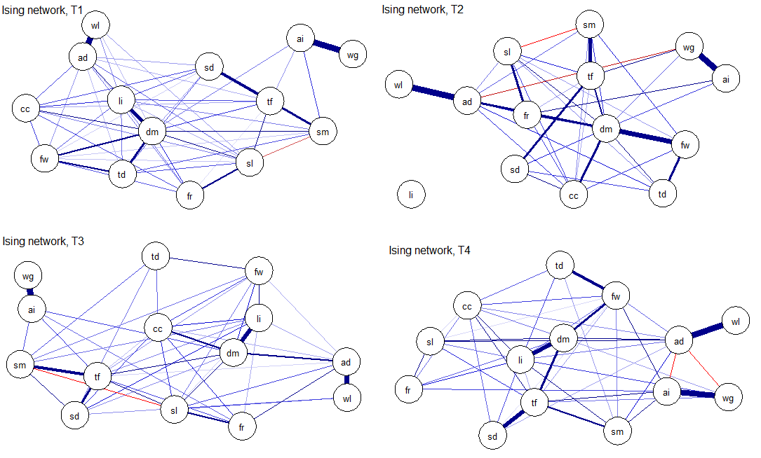

Fig A- Ising network structure of the MDD symptoms from T1 to T4.

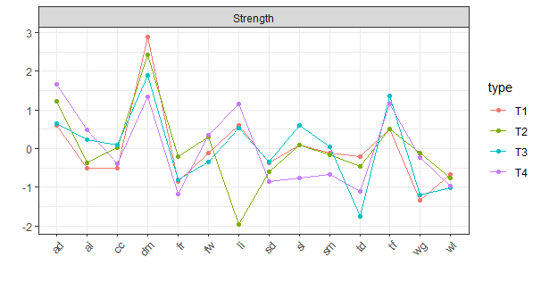
Figure B- Plot of the standardized strength centrality metrics for 14 disaggregated MDD symptoms (T1-T4).
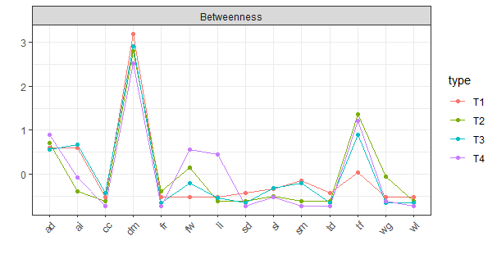
Figure C- Plot of the standardized betweenness centrality metrics for 14 disaggregated MDD symptoms (T1-T4).

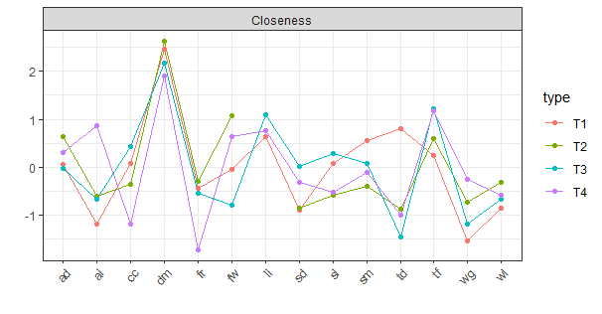
Figure D- Plot of the standardized closeness centrality metrics for 14 disaggregated MDD symptoms (T1-T4).

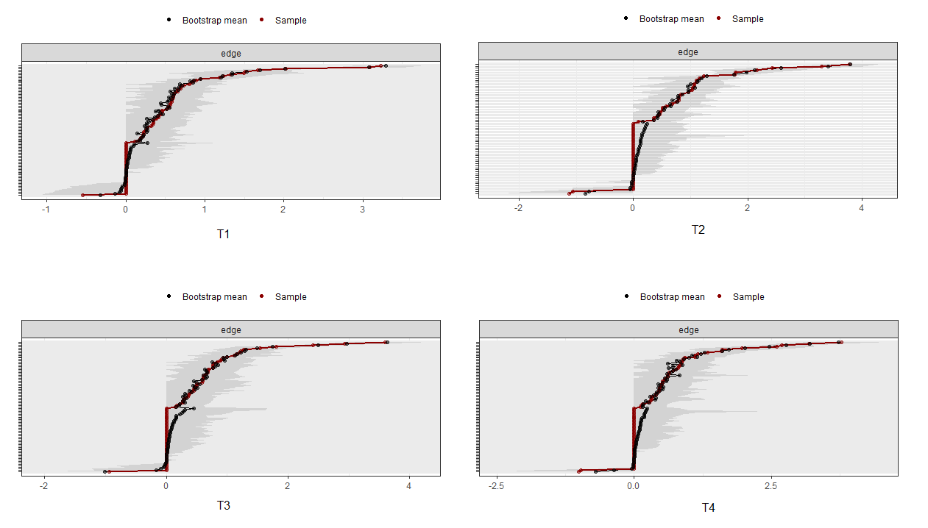

Figure E- The accuracy of estimated edges in the Ising network model for 14 disaggregated MDD symptoms (T1-T4).

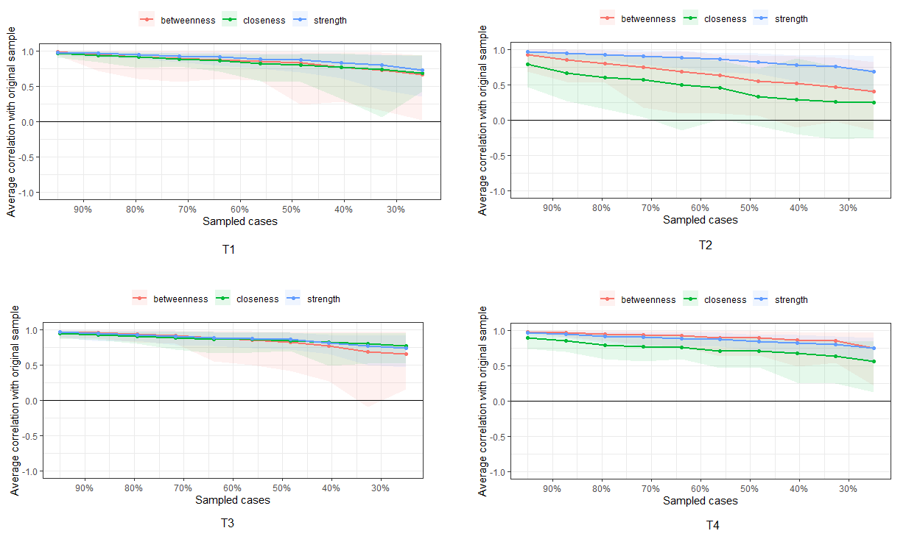
Figure F- Stability of the centrality metrics (strength, closeness, betweenness) in the Ising network model for 14 disaggregated MDD symptoms (T1-T4).

This is consistent with network literature and what Santos. et al (2018) conclude: ‘strength centrality has been considered as the most precisely estimated centrality measure in psychological networks, while betweenness and closeness only reach the threshold for reliable estimation in large or very large samples’.

