Analysis of aggregated symptoms

This supplement presents results of the network analyses for the set of aggregated symptoms and compares them to those obtained from the disaggregated network. Comparing the results of network plots and centrality plots, the two models display a good degree of consistency. Based on the estimated networks, except for the weight/ appetite symptoms (which have been collapsed across the 4 separate disaggregated symptoms), the strongest connections remain largely intact. The two centrality plots both indicate that the depressed mood (dm) symptom has the highest degree of centrality within the networks.
We also present weight adjacency matrix for both aggregated and disaggregated networks. This provides another way to compare the two network models. Additionally, each symptom prevalence is presented for both aggregated and disaggregated cases. The stability of centrality metrics and the accuracy of estimated edges are also presented for both networks.

Table A- MDD 14 disaggregated symptoms in VATSPSUD data
Criteria | MDD symptoms | abbreviation
MDD criterion 1 | Felt depressed mood, down or blue for a period lasting for at least 5 days | dm
MDD criterion 2 | Were uninterested/ unable to enjoy things lasting for a period lasting for at least 5 days | li
MDD criterion 3 | - Significant decrease in your appetite for a period lasting for at least 5 days | ad
 | - Significant increase in your appetite for a period lasting for at least 5 days | ai
 | - Significant decrease in your weight for a period lasting for at least 5 days | wl
 | - Significant increase in your weight for a period lasting for at least 5 days | wg
MDD criterion 4 | - Trouble sleeping nearly every night for a period lasting for at least 5 days | sl
 | - Slept considerably more nearly every day for a period lasting for at least 5 days | sm
MDD criterion 5 | - Felt fidgety/restless for a period lasting for at least 5 days | fr
 | - Felt slow down more than usual for a period lasting for at least 5 days | sd
MDD criterion 6 | Felt tired or fatigued for a period lasting for at least 5 days | tf
MDD criterion 7 | Feeling worthless or guilty about things for a period lasting for at least 5 days | fw
MDD criterion 8 | Had trouble concentrating/thinking for a period lasting for at least 5 days | cc
MDD criterion 9 | Thought about death /harming self for a period lasting for at least 5 days | td

Table B- MDD 9 aggregated symptoms in VATSPSUD data
Criteria | MDD symptoms | abbreviation
MDD criterion 1 | Felt depressed mood, down or blue for a period lasting for at least 5 days | dm
MDD criterion 2 | Were uninterested/ unable to enjoy things lasting for a period lasting for at least 5 days | li
MDD criterion 3 | Aggregated 4 weight/appetite symptom | wgt
MDD criterion 4 | Aggregated 2 sleep problems symptom | sls
MDD criterion 5 | Aggregated 2 psychomotor problems symptom | frs
MDD criterion 6 | Felt tired or fatigued for a period lasting for at least 5 days | tf
MDD criterion 7 | Feeling worthless or guilty about things for a period lasting for at least 5 days | fw
MDD criterion 8 | Had trouble concentrating/thinking for a period lasting for at least 5 days | cc
MDD criterion 9 | Thought about death /harming self for a period lasting for at least 5 days | td

Table C- Weight Adjacency Matrix from the Estimated Ising Network Model (disaggregated symptoms).
symptoms | dm | li | ad | ai | wl | wg | sl | sm | fr | sd | tf | fw | cc | td
dm | 0.00
li | 2.03 | 0.00
ad | 0.95 | 0.22 | 0.00
ai | 0.46 | 0.00 | 0.00 | 0.00
wl | 0.22 | 0.38 | 3.09 | 0.00 | 0.00
wg | 0.00 | 0.00 | 0.00 | 3.22 | 0.00 | 0.00
sl | 0.89 | 0.26 | 0.51 | 0.00 | 0.34 | 0.00 | 0.00
sm | 0.80 | 0.42 | 0.00 | 0.65 | 0.00 | 0.00 | -0.54 | 0.00
fr | 0.73 | 0.45 | 0.44 | 0.00 | 0.00 | 0.00 | 1.19 | 0.00 | 0.00
sd | 0.34 | 0.58 | 0.32 | 0.00 | 0.00 | 0.00 | 0.00 | 0.69 | 0.00 | 0.00
tf | 0.66 | 0.59 | 0.25 | 0.35 | 0.00 | 0.00 | 0.83 | 1.51 | 0.11 | 1.67 | 0.00
fw | 1.24 | 0.54 | 0.00 | 0.00 | 0.34 | 0.00 | 0.19 | 0.18 | 0.54 | 0.16 | 0.23 | 0.00
cc | 0.85 | 0.70 | 0.60 | 0.00 | 0.00 | 0.00 | 0.42 | 0.00 | 0.60 | 0.60 | 0.27 | 0.62 | 0.00
td | 1.49 | 0.46 | 0.22 | 0.00 | 0.00 | 0.00 | 0.58 | 0.56 | 0.00 | 0.56 | 0.00 | 1.33 | 0.00 | 0.00
Note. See Table A for symptom abbreviation descriptions.

Table D- Weight Adjacency Matrix in Ising Network Model (aggregated symptoms)
Node | dm | li | wgt | sls | frs | tf | fw | cc | td
dm | 0.00
li | 2.02 | 0.00
wgt | 1.01 | 0.33 | 0.00
sls | 0.93 | 0.45 | 0.68 | 0.00
frs | 0.71 | 0.49 | 0.57 | 0.85 | 0.00
tf | 0.59 | 0.65 | 0.45 | 1.10 | 0.74 | 0.00
fw | 1.19 | 0.57 | 0.00 | 0.26 | 0.51 | 0.23 | 0.00
cc | 0.86 | 0.72 | 0.33 | 0.38 | 0.86 | 0.27 | 0.64 | 0.00
td | 1.54 | 0.51 | 0.00 | 0.77 | 0.40 | 0.00 | 1.30 | 0.00 | 0.00
Note. See Table B for symptom abbreviations descriptions.

Table E- The prevalence of MDD disaggregated symptoms in VATSPSUD data
symptoms | % of the population displays MDD symptoms
dm | 38.1
li | 23.3
ad | 13.6
ai | 7.6
wl | 8.7
wg | 6.9
sl | 17.6
sm | 5.4
fr | 16.3
sd | 8.4
tf | 21.5
fw | 12
cc | 11.8
td | 4.4
Note. See Table A for symptom abbreviation descriptions.

Table F- The prevalence of MDD aggregated symptoms in VATSPSUD data
symptoms | % of the population displays MDD symptoms
dm | 38.1
li | 23.3
wgt | 25
sls | 21.5
frs | 21.4
tf | 21.5
fw | 12
cc | 11.8
td | 4.4
Note. See Table B for symptom abbreviation descriptions.

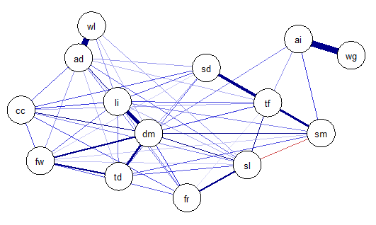
Figure A- Ising network model for 14 disaggregated MDD symptoms.
Symptom abbreviation information is presented in table A.

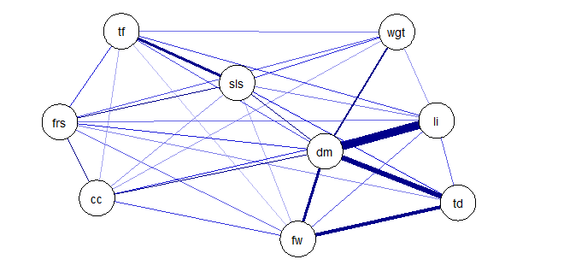
Figure B- Ising network model for 9 aggregated MDD symptoms.
Symptom abbreviation information is presented in table B.

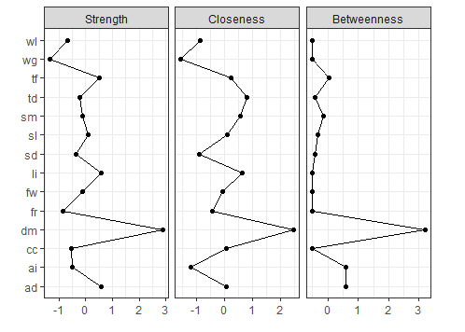
Figure C- Plot of the standardized centrality metrics (strength, closeness, betweenness) for the of 14 disaggregated MDD symptoms. Symptom abbreviation information is presented in table A.

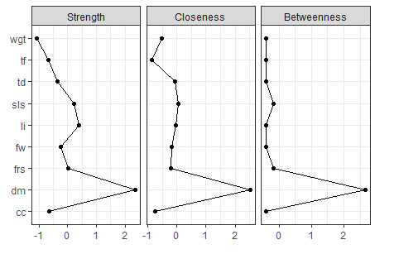
Figure D- Plot of the standardized centrality metrics (strength, closeness, betweenness) for the of 9 aggregated MDD symptoms. Symptom abbreviation information is presented in table B.

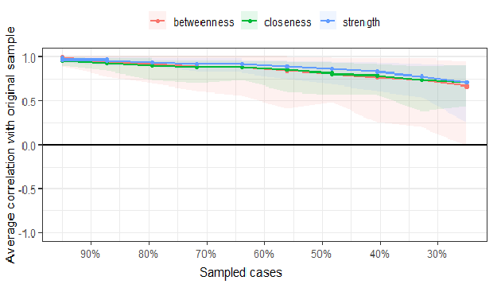
Figure E- The stability of centrality metrics (strength, closeness, betweenness) estimated in the Ising network model for 14 disaggregated MDD symptoms.

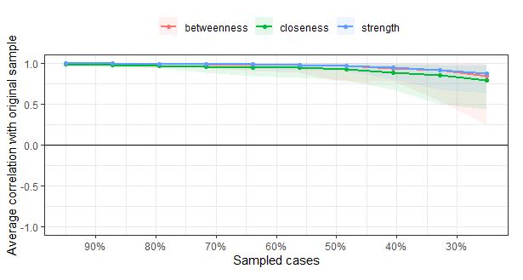
Figure F- The stability of centrality metrics (strength, closeness, betweenness) estimated in the Ising network model for 9 aggregated MDD symptoms.

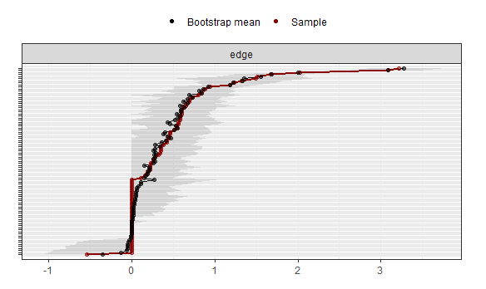
Figure G- The accuracy of estimated edges in the Ising network model for 14 disaggregated MDD symptoms.

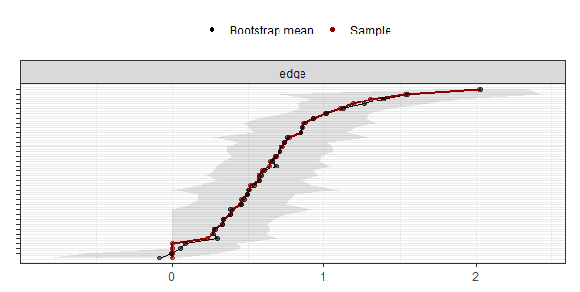
Figure H- The accuracy of estimated edges in the Ising network model for 9 aggregated MDD symptoms.

