Supplementary
Alternative Calculation of Concordance
When we compared the mean concordance between the first three minutes of the neutral script with the three-minute trauma script, a significant interaction between alexithymia and phase was found, F(1, 38) = 4.09, p = .05. No main effect was found for phase, F(1, 38) = 0.28, p = .60. Further, sex, F(1, 38) = 0.40, p = .53, age, F(1, 38) = 1.25, p = .27, and baseline mood, F(1, 38) = 0.244, p = .624, were not found to be covariates in this alternate model.

Participant Trauma Exposure
Table S-1
Lifetime Traumatic Events Endorsed by Participants
Event | Frequency
Natural disaster | 3
Transportation accident | 6
Serious accident at work, home, or during recreational activity | 1
Exposure to toxic substance | 1
Physical assault | 12
Assault with a weapon | 4
Sexual assault | 9
Other unwanted or uncomfortable sexual experience | 16
Captivity | 1
Life-threatening illness or injury | 8
Severe human suffering | 1
Sudden violent death | 3
Sudden accidental death | 6
Serious injury, harm, or death you caused to someone else | 3

Table S-2
Descriptive Statistics
Modality | Measures | Mean (SD) | Range
Self-Report
 | TAS-20 | 59.70 (2.33) | 33.00 - 85.00
 | PCL-5 | 38.67 (16.55) | 4.00 – 78.00
 | B-TMD | 17.95 (20.61) | -11.00 – 80.00
 | T-TMD | 32.09 (29.73)
Physiological
 | B-GSR | 2.33 (2.49) | 0.69 – 14.20
 | T-GSR | 3.43 (3.52) | 0.52 – 14.80
 | B-HR | 80.38 (15.30) | 54.60 – 115.00
 | T-HR | 81.39 (18.66) | 15.2 – 122.00
Concordance
 | B-GSR | 2.57 (1.68) | -1.49 – 6.67
 | T-GSR | 1.18 (1.42) | -6.06 – 5.26
 | B-HR | 2.65 (3.00) | 2.21 – 3.09
 | T-HR | 0.38 (3.00) | -5.82 – 6.18

Table S-3
Total Score Intercorrelations Table
 | 1 | 2 | 3 | 4 | 5 | 6 | 7 | 8 | 9 | 10
1.Age | -
2. Sex | .33** | -
3.TAS-20 | .06 | .-32 | -
4. PCL-5 | -.14 | -.17 | .51* | -
5. BGSR | -.25 | .18 | - .12 | .22 | -
6. TE-GSR | .22 | .06 | -.10 | .01 | -.29 | -
7. BHR | -.01 | -.35* | .11 | -.01 | .02 | .80 | -
8. TE-HR | .25 | .17 | .04 | -.41* | .35 | -.19 | .13 | -
9. BTMD | .22 | -.24 | .53** | .64** | -.19 | -.01 | .19 | -.09 | -
10. TE-TMD | .33* | -.10 | .57** | .67** | -.21 | -.03 | .13 | .00 | .93 | -
Note. TAS-20 = Toronto Alexithymia Scale; PCL-5 = PTSD Checklist for DSM-5; BGSR = Average Neutral Galvanic Skin Response; TE-GSR = Average Galvanic Skin Response; BHR = Average Neutral Heart Rate; TE-HR = Average Trauma script Heart Rate; BTMD = Total Neutral Mood Disturbance; TE-TMD = Total Trauma script Mood Disturbance.
* p < .05.
** p < .001.

Table S-4
Between Treatment-Seeking (n = 52) and Student Sample (n = 22) Comparisons
 | Students  Mean (SD) or *Frequency | Patients  Mean (SD) or *Frequency | Between-group differences
Age | 21.5 (5.21) | 37.43 (8.86) | t(67) = 7.81, p = .001
Sex (F) | 15* | 31* | X²(1) = 0.03, p = .85
TAS-20 | 62.47 (11.70) | 54.36 (13.06) | t(67) = 2.48, p = .02
PCL-5 | 39.30 (11.15) | 40.31 (18.72) | t(67) = 0.25, p = .80
Note. F = Females; TAS-20 = Toronto Alexithymia Scale-20 PCL-5 = PTSD checklist for the Diagnostic and Statistical Manual of Mental Disorders.
Between-Samples Manipulation Checks
Student Sample. A manipulation check suggested that the trauma script had its intended effect. There was a main effect for script phase, F(2, 36) = 19.01, p < .001, d = 0.52, with the neutral script reducing TMD (M = 2.58, SD = 14.55, d = 0.45), while the trauma script increased TMD (M = 19.53, SD = 21.81, d = 0.56; Figure S-1. Secondly, a main effect for phase was observed for GSR, F(1, 15) = 27.71, p = .001, d = 0.83, with higher values from neutral (M = 3.10, SD = 2.26) to trauma script (M = 5.67, SD = 3.76; Figure S-1. A further expected main effect for phase was observed for GSR-TMS concordance, F(1, 21) = 7.04, p = .02, d = 0.69, with greater concordance observed during the neutral script (M = 1.33, SD = 2.20), which reduced during the trauma script phase (M = -0.40, SD = 2.78; Figure S-1.
Patient Sample. A manipulation check suggested that the trauma script had its intended effect. There was a main effect for script phase, F(2, 32) = 17.15, p < .001, with the neutral script reducing TMD (M = 15.18, SD = 19.42, d = 0.38), while the trauma script increased TMD (M = 40.76, SD = 36.77, d = 0.56; Figure S-1. Secondly, a main effect for phase was observed for GSR, F(1, 22) = 12.50, p = .002, d = 0.10, with higher observed GSR during the trauma script (M = 2.31, SD = 2.95) compared to the neutral condition (M = 2.01, SD = 2.81; Figure S-1). However, no main effect for phase was observed for GSR-TMS concordance, F(1, 46) = 6.90, p = .12 (Figure S-1).

Figure S-1. Between-Samples Outcomes Across Experimental Phases. (A) Patient and student samples TMD changes across experimental phases; (B) Patient and student samples GSR changes across experimental phases; (C) Patient and student samples emotion response concordance changes across experimental phases.
*** Significant at p < .001.

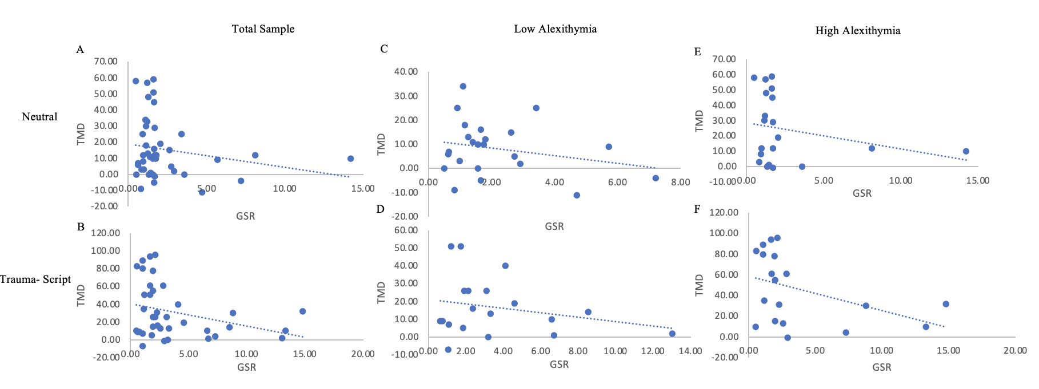
Figure S-2. Concordance Correlations Across Experimental Phases. (A) Total sample TMD and GSR correlations during neutral phase; (B) Total sample TMD and GSR correlations during trauma script phase; (C) Low Alexithymia TMD and GSR correlations during neutral phase; (D) Low Alexithymia TMD and GSR correlations during trauma script phase; (E) High Alexithymia TMD and GSR correlations during neutral phase; (F) High Alexithymia TMD and GSR correlations during trauma script phase.

