Details of studies chosen for meta-analysis-

a) Socio-demographic and symptom severity details-

Study name | Age | Sex | PANSSp | PANSSn
 | Mean (S.D.) | Male % | Mean (S.D.) | Mean (S.D.)
Fett,2012 | 39.7(8.41) | 55.00% | 11.48(3.63) | 9.79(3.69)
Fett,2016 | 17(1.21) | 58.00% | 1.81(0.86) | 1.93(0.91)
Fett,2019 | 17.57(1.27) | 100.00% | 1.91(0.91) | 2.01(1.04)
Gromann,2013 | 33.7(7.8) | NA | NA | NA
Gromann,2014 | 33.4(10.17) | 42.00% | NA | NA
Hansenn,2019 | 36.21(9.58) | 82.00% | 13.18(4.36) | 14.92(4.98)
Hansenn,2022 | 39.86(9.10) | 82.60% | 2.11(0.86) | 1.75(0.45)
Lemmers-jansen,2018 | 19.88(1.54) | 63.64% | 13.23(5.72) | 17.18(5.85)
Lemmers-jansen,2019 | 19.88(1.54) | 64% | 1.89(0.94) | 2.45(0.86}
Wisman van der-teen,2021 | 19.79(1.74) | 46.00% | 13.82(6.39) | 17.55(5.54)

b) Study characteristics-

1. Study type- Design of the study.
2. Comparisons- groups compared in the study. (CHR- Clinically High Risk individuals, Con- Controls, Early psy- Early psychosis, FEP- First Episode Psychosis, Rel- Relatives of psychotic patients, SCZ- Schizophrenia)
3. Opponent- The nature of the opponents in the trust game. Either human or ComputerU which denotes subjects playing against computers but instructed that they are playing against real human opponents. The numbers reported indicate the rounded off percentage of participants who believed that they were playing against a computer at the end of the game.
4. Feedback- Whether subjects received feedback about their investment in the trust game.
5. Currency- Currency used for investments in the trust game.
6. Diagnosis- Diagnosis of subjects chosen for the study.

All the studies involved trust game with three times the investment given to the trustees.

Study name | Study type | Comparisons | Opponent | Feedback | Currency | Diagnosis
 |  |  | (U=unaware)
Fett,2012 | Comparitive | psy vs rel vs con | Human | No | Euros | Psychosis
Fett,2016 | Comparitive | early psy vs con | ComputerU(14) | Yes | Pounds | Psychosis
Fett,2019 | Comparitive | early psy vs con | ComputerU(16) | Yes | Pounds | Psychosis
Gromann,2013 | Comparitive | psy vs con | ComputerU(NA) | Yes | Pounds | Psychosis
Gromann,2014 | Comparitive | Rel vs con | ComputerU(NA) | Yes | Euros | Relatives
Hansenn,2019 | Comparitive | SCZ vs rel vs con | ComputerU(21) | Yes | Pounds | SCZ
Hansenn,2022 | Comparitive | scz vs con | ComputerU(13) | Yes | Pounds | SCZ
Lemmers-jansen,2018 | Comparitive | FEP vs CHR vs con | ComputerU(10) | Yes | Pounds | Psychosis +CHR
Lemmers-jansen,2019 | Comparitive | Psy vs con | ComputerU(10) | Yes | Euros | Psychosis
Wisman van der-teen,2021 | Comparitive | FEP vs CHR vs con | ComputerU(6) | Yes | Euros | Psychosis+CHR

CHR- Clinically High Risk individuals, Con- Controls, Early psy- Early psychosis, FEP- First Episode Psychosis, Rel- Relatives of psychotic patients, SCZ- Schizophrenia
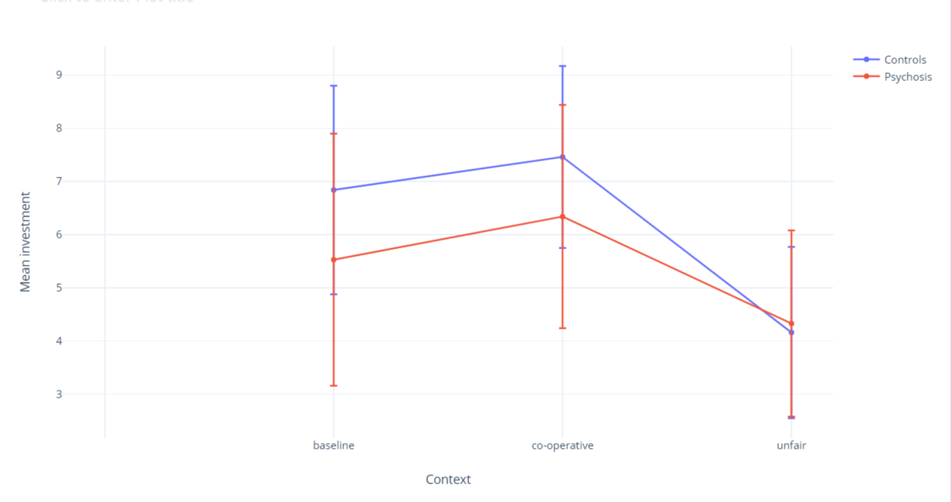
Figure S1: Bar graph showing change in investment with co-operative and unfair repayments (Y-axis- Mean investments from the studies included in meta-analysis; X-axis- Context ; Error bars show pooled standard deviation)

