Supplementary Material 4. Publication bias analysis.

Supplementary Material 4a. Funnel Plot of publication bias.

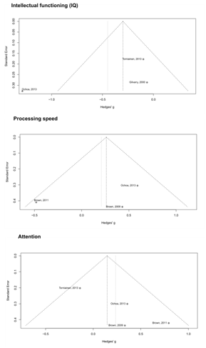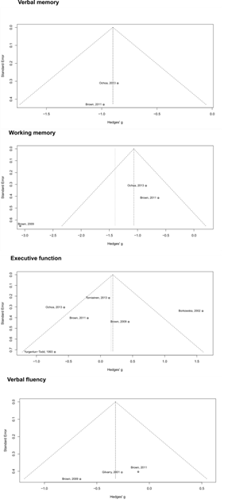

Supplementary Material 4b. Egger’s test to verify the publication bias in each cognitive function

Cognitive Domain | Egger’s test (95% CI) | p-value
Verbal memory | -6.37 (-12.45 – -2.40) | 0.55
Working memory | -5.93 (-13.18 – -1.31) | 0.35
Executive function | -0.41 (-6.48 – -5.66) | 0.90
Verbal fluency | -11.91 (-17.21 – -6.62) | 0.14
Intellectual functioning | -4.97 (-15.16 – -5.21) | 0.51
Processing speed | -4.39 (-16.74 – -7.95) | 0.60
Attention | 3.20 (1.05 – -5.36) | 0.10

