**Supplementary material**

|  |  |  |  |  |  |  |  |
| --- | --- | --- | --- | --- | --- | --- | --- |
| **Table 1** Correlation matrix for the cluster variables. | | | | | | |  |
| Variables | Speed | Att | WM | Ver_L | Vis_L | Reason | SocCog |
| Speed | **1** | 0.306 | 0.504 | 0.543 | 0.456 | 0.531 | 0.140 |
| Att | 0.306 | **1** | 0.422 | 0.308 | 0.371 | 0.314 | 0.032 |
| WM | 0.504 | 0.422 | **1** | 0.429 | 0.521 | 0.484 | 0.166 |
| Ver_L | 0.543 | 0.308 | 0.429 | **1** | 0.455 | 0.290 | 0.145 |
| Vis_L | 0.456 | 0.371 | 0.521 | 0.455 | **1** | 0.477 | 0.133 |
| Reason | 0.531 | 0.314 | 0.484 | 0.290 | 0.477 | **1** | 0.150 |
| SocCog | 0.140 | 0.032 | 0.166 | 0.145 | 0.133 | 0.150 | **1** |

Speed = Speed of processing; Att = Attention / Vigilance; WM = Working Memory; Ver_L = Verbal Learning; Vis_L = Visual Learning; Reason = Reasoning and Problem Solving; SocCog = Social Cognition

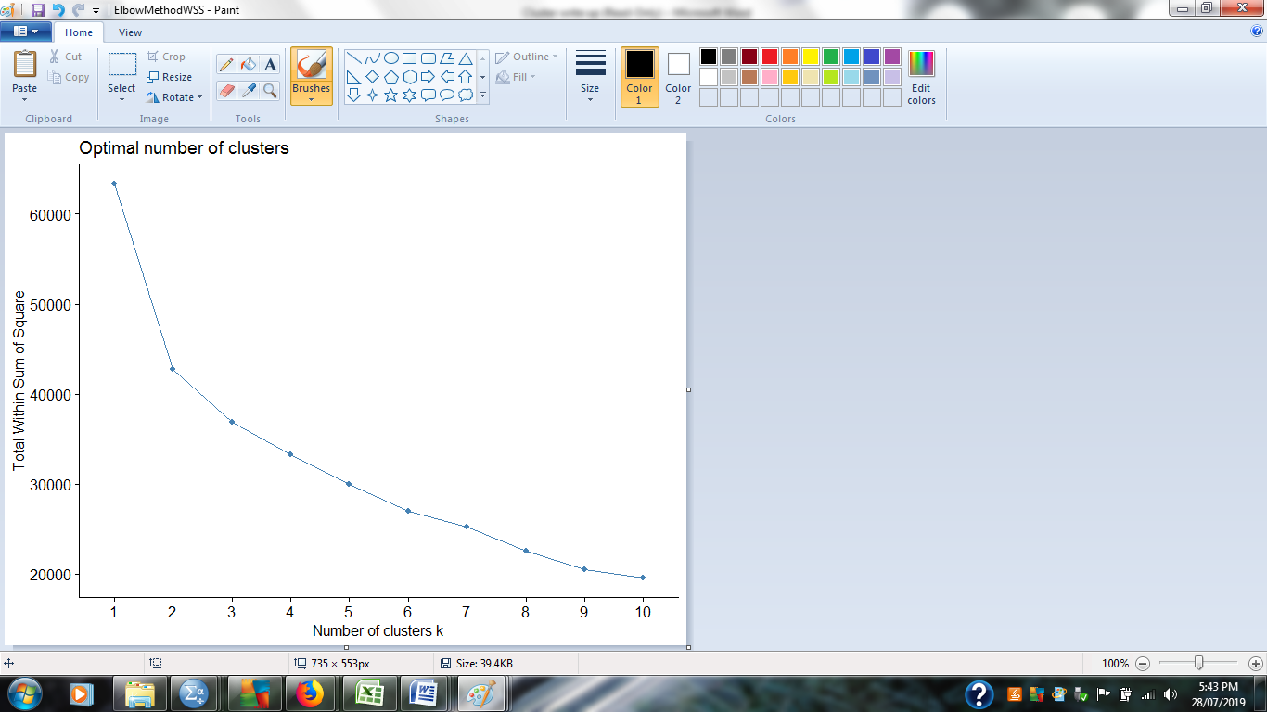

**Figure 1:** Optimal number of clusters

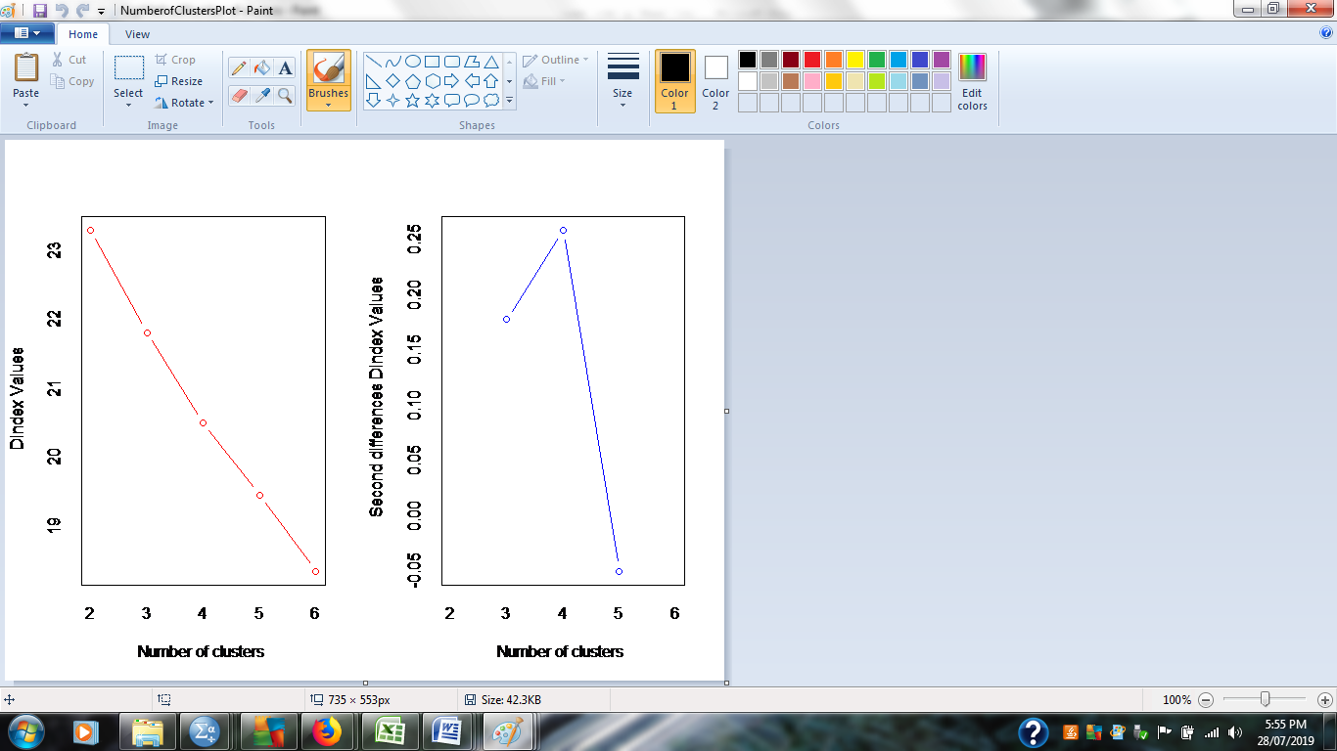

**Figure 2:** Number of clusters and D index values

**Figure 3**: Gap statistic method and number of clusters

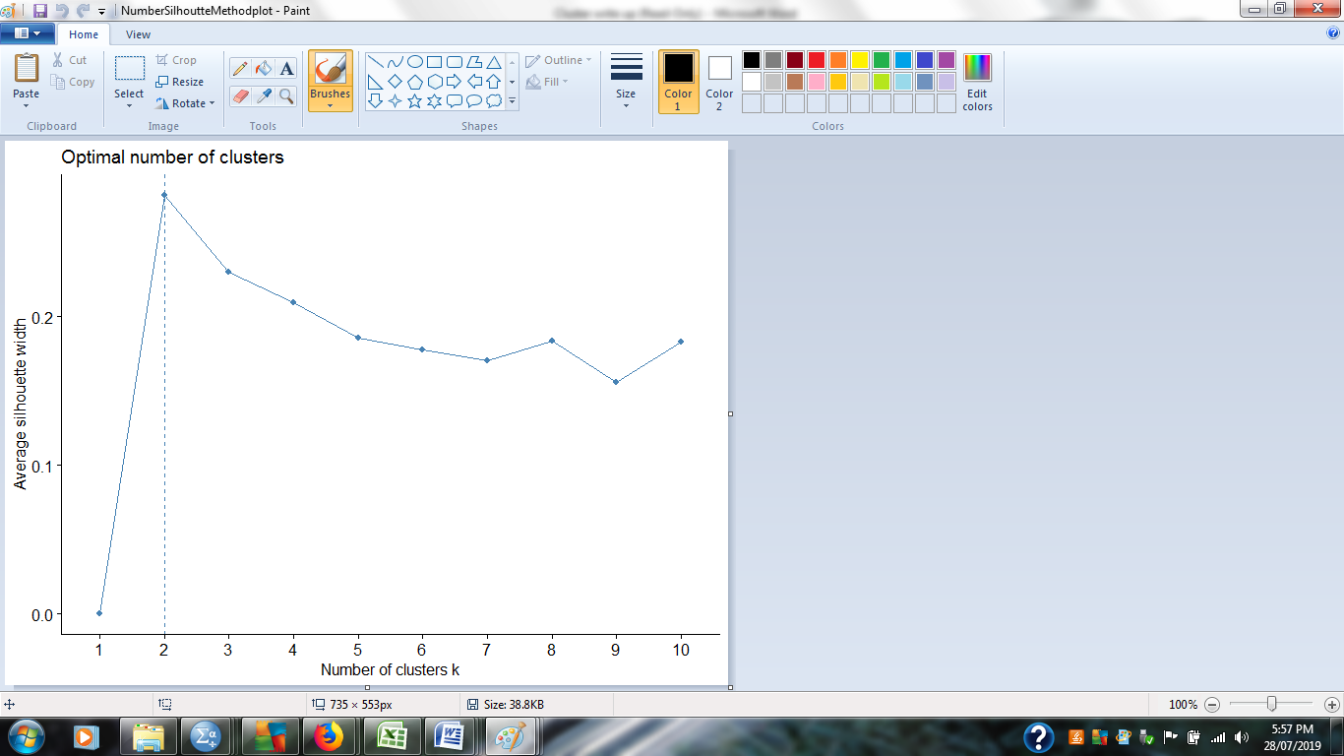

**Figure 4:** Average silhouette width and number of clusters

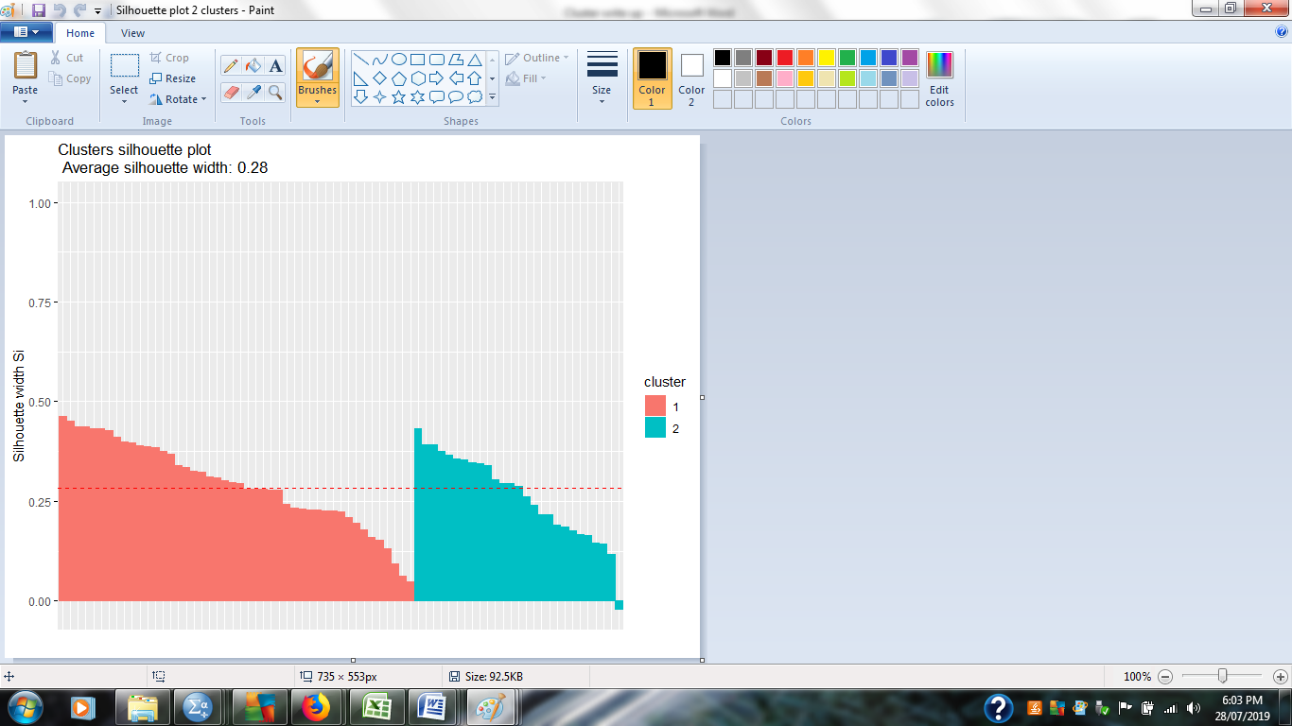

**Figure 5**: Clusters silhouette plot. Average silhouette width: 0.28



**Figure 6**. Telomere length displayed for each diagnostic group as well as healthy controls.



**Figure 7**. The algorithm (perplexity=5) has grouped the participants of the same cluster together (two clusters: pink and dark blue) based on the cognitive T scores.

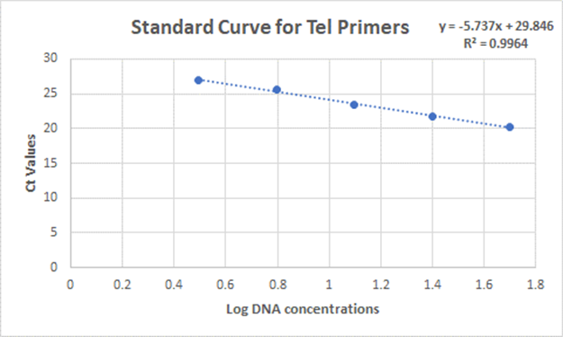

**Figure 8a.** Standard Curve for Tel primer sets

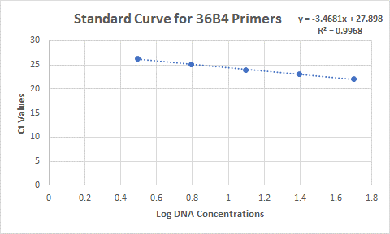

**Figure 8b.** Standard Curve for 36B4 primer sets