Supplementary Methods
Pain
MVC-related overall pain intensity was assessed using a verbal 0-10 numeric rating scale (NRS) to assess current pain in the ED. Verbal scores have advantages in acute care settings, and verbally administered NRSs have been validated as a substitute for visual analogue scales in acute pain measurement in the ED (Bijur, Latimer, & Gallagher, 2003). If participants reported pain, they were also asked whether the pain was related to the MVC; only MVC-related pain (greater than 99% of all pain reported) was included in the present analyses.
MVC-related somatic symptoms were assessed in the ED following the MVC. Participants responded by using a 0-10 NRS with 0 being “no problem” and 10 being “major problem.”
Whiplash symptom severity was assessed using the Quebec Classification of Whiplash Associated Disorders, a prognostic assessment tool. Participants answered questions about their neck tenderness, their ability to move their neck, and any radiating neck pain. Individual questions were used in prediction (vs a total score).

Psychological
Perceived social support was assessed using the multidimensional scale of perceived social support (MSPSS), a 12-item measure of perceived adequacy of social support from family, friends, and significant other. Scores range from 4-28, with a higher score indicating higher perceived support (Zimet, Dahlem, Zimet, & Farley, 1988).
Peritraumatic dissociation was assessed via the Michigan Critical Events Perception Scale (MCEPS). The MCEPS is a 5-item inventory that asks questions such as “I felt as if I were in a daze” or “I felt as if the events around the accident were happening to someone else.” Participants respond on a scale of 1-5 with 1 being “strongly disagree” and 5 being “strongly agree.” Total scores range from 5-25.
The tendency of the participants to catastrophize following MVC was assessed in the ED via the Pain Catastrophizing Scale (PCS). PCS is a 13-item inventory with questions such as “I can’t seem to get it out of my mind” or “I feel I can’t go on.” Participants responded on a scale of 0-4 with 0 being “not at all” and 4 being “all the time.” Total scores range from 0-52, with a score greater than 38 considered clinically relevant.
MVC-related peritraumatic distress was measured using the Peritraumatic Distress Inventory (PDI). The PDI is a 13-item inventory administered in the ED that asks questions about physiological distress experienced during MVC. Participants responded on a scale of 0-4 with 0 being “not true” and 4 being “extremely true.” Total scores range from 0-52. The optimal cut-off score for predicting significant distress is 23 (Bunnell, Davidson, & Ruggiero, 2018).
Expectations of physical and emotional recovery following MVC were assessed in the ED. Participants responded to questions about the expected amount of time they thought it would take to recover after MVC in the number of days they expected it would take to recover fully, and whether they were certain that they could recover fully on a scale of 0-10, with 10 representing the most certainty of recovery.
State trait anxiety and anger were assessed via the State Trait Personality Inventory (STPI). The STPI is a self-administered 10-item inventory that asks the participants questions such as “I am quick-tempered” or “I have a fiery temper”. Participants respond on a scale of 1-4, with 1 being “almost never” and 4 being “almost always.” Total scores range from 10-40.
Depressive symptoms were assessed via the Center for Epidemiologic Studies Depression (CESD) Scale, a 20-item inventory that asks questions such as “I was bothered by things that usually don’t bother me” and “I thought my life had been a failure” (Radloff, 1977). Participants respond on a scale of 1-4, with 1 being rarely/none and 4 being most/all time. Total scores range from 0-60. A score of 16-26 indicates mild depression while a score of 26 or more indicates substantial depressive symptoms (Geisser, Roth, & Robinson, 1997).
Accident fault was assessed via a series of questions. If the patient indicated that the accident was another person’s fault, they were asked about their anger towards that person. Example questions included “how angry or upset are you at them right now,” measured on a 1-4 scale, with 1 being not at all, and 4 being a lot, as well as “how strongly are you thinking of suing the person at fault for the collision,” measured on a 0-10 scale, with 0 being definitely will not sue, and 10 being definitely will sue.

Demographic
Sociodemographic information was collected at the time of the ED visit using a structured interview. Participant demographic characteristics (including age, sex, employment, income, and level of education) were obtained from participant self-report and the ED medical record.
An area deprivation index (ADI) was generated for each participant based on previously published protocols (Kind & Buckingham, 2018; Kind et al., 2014; Singh, 2003). In brief, participant addresses at the time of the ED visit were mapped to their respective Census Block Groups. Census Block Group data from the 2011-2015 American Community Survey provided the needed data, including information on variables such as median home value, single parent households with children, households with more than one person per room, median family income, and education level (Singh, 2003). This data was then converted into the ADI using factor analysis and principal component analyses. The final value is considered a ‘national percentile ranking’ and ranges from 1-100. Higher scores indicate higher levels of disadvantage.
Patient demographics were assessed at the ED time point. Demographic information such as height and weight were taken numerically. Highest education level was measured on a 1-6 scale, with 1 being <8 years, 2 being 8-11 years, 3 being high school, 4 being post high school training, not college, 5 being some college, and 6 being college graduate. Annual household income was measured on a 1-7 scale, with 1 being $0-$19,999, 2 being $20,000-$39,000, 3 being $40,000-$59,999, 4 being $60,000-$79,999, 5 being $80,000-$99,999, 6 being $100,000-$149,999, and 7 being >$150,000.

Event
A variety of psychological measures and events that occurred during the MVC were assessed using the University of Michigan Transportation Research Institute Questionnaire (UMTRI). Questions such as “did any part of your body hit or make contact with anything in your vehicle” or “how life threatening was your motor vehicle collision.” These questions were assessed at the time of the ED interview.
Health care utilization and general health was assessed via documentation of X-Rays, MRIs, CT scans, blood work, as well as physicians seen, and treatments administered.

General Health
Alcohol use was assessed using select questions from the Tolerance, Worries, Eye‐opener, Amnesia, and Kut‐down (TWEAK) test. This questionnaire has been shown to perform with higher specificity and sensitivity compared with similar tests when assessed in clinical settings (Chan, Pristach, Welte, & Russell, 1993). TWEAK is a 5-item inventory that asks questions designed to assess harmful drinking habits. Individual questions were binary and either had a scale of 0-1 or 0-2. Total scores range from 0-7.
Past medical history prior to MVC were extracted from medical records.
General health in the month prior to the MVC was measured using the Short Form Health Survey (SF12). At 6 weeks, 6 months, and 1 year this survey assesses current general health. The SF12 is a 12-item inventory that askes participants questions such as “have you felt calm and peaceful” and “did you have a lot of energy.” Participants respond on a scale of 1-5, with 1 being none of the time, and 5 being all the time.

Other
Interviewer assessments of patients were obtained in the ED. Questions include “on a scale of 1-10, how distressed does this person currently seem to you.” The interviewer responds on a scale of 1-10, with 1 being not distressed, and 10 being extremely distressed.

PTSS outcome definition
MVC-related PTSS were assessed six months following MVC using the Impact of Event Scale: Revised (IESR) (Weiss, 2007). This 22-item inventory includes avoidance, intrusion, and hyperarousal subscales. Participants respond to statements such as “you had trouble staying asleep” and “your feelings about the accident were kind of numb” on a scale of 0-4, with 0 being not at all and 4 being extremely. Scores range from 0-88; a validated cut-off of 33 was used to define individuals with substantial PTSS vs individuals with low PTSS scores (Creamer, Bell, & Failla, 2003).
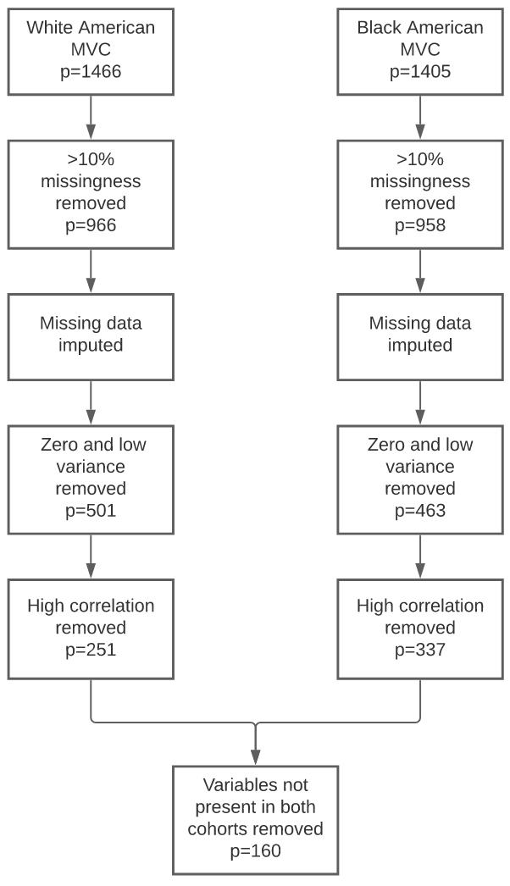
Supplementary Figure 1. Flow diagram showing the data cleaning methods used to prepare participant data for the current set of analyses. First, we removed covariates with >10% missingness. Then we used missForest, a nonparametric method, to perform data imputation. We performed statistical cleaning and scaled continuous covariates to be within the [0,1] range. Specifically, for statistical cleaning we removed covariates with low variance and high correlation. Variables were denoted as near zero variance if the fraction of unique values over the sample size was 10% and the ratio of the frequency of the most prevalent value to the frequency of the second most prevalent value was 19. Highly correlated variables with r > 0.75 were removed. Finally, variables not present in both cohorts were removed.
Supplementary Table 1. Resulting 160 variables derived following data cleaning, imputation, and variable reduction of both the White and Black American dataset. The selection probabilities were generated following 100 rounds of Monte Carlo cross validation of the training validation site splits. The variables are categorized by color: pain – red, psychological – blue, demographic – gray, event – black, general health – purple, other - brown.
Variable Name | Selection Probability
Pain severity (0-10 scale, NRS) | 0.84
Expected time to recover fully (days) | 0.74
Self identifies as Black American | 0.72
Felt like in a daze during event (1-5 scale, MCEPS Q3) | 0.71
Area Deprivation Index | 0.62
Perception of how life threatening the event was (0-10 scale) | 0.61
Felt restless due to event (0-10 scale, Somatic symptom) | 0.61
Cigarettes smoked (per day) | 0.57
Neck pain due to event (0-10 scale, NRS) | 0.56
Felt as if watching oneself during event (1-5 scale, MCEPS Q3) | 0.54
Chest/back made contact with the vehicle (Y/N, UMTRI) | 0.53
Catastrophizing about pain to wonder whether something serious may occur (0-4 scale, PCS Q13) | 0.52
Felt that might die (0-4 scale, PDI Q13) | 0.48
Expected time to recover physically (days) | 0.46
Felt frustrated or angry in ED (0-4 scale, PDI Q3) | 0.46
Ability to move neck limited by pain, stiffness, or soreness (Y/N, Quebec classification) | 0.46
Anxiously wanting the pain to go away (0-4 scale, PCS Q3) | 0.46
Education level (1-6 scale, demographics) | 0.45
Wanting to hit someone when frustrated (1-4 scale, STPI Q18) | 0.43
Whether received a CT scan in the ED (Y/N) | 0.39
Whether strapped to a board when transported to hospital (Y/N, UMTRI) | 0.39
Felt pain would never get better (0-4 scale, PCS Q3) | 0.38
Arms/hands made contact with the vehicle (Y/N, UMTRI) | 0.38
Felt as if the accident were happening to someone else (1-5 scale, MCEPS Q4) | 0.37
Respiration Rate in the ED | 0.37
Felt fearful (1-4 scale, CESD Q10) | 0.36
Felt people were unfriendly (1-4 scale, CESD Q15) | 0.35
Kept thinking of other painful events (0-4 scale, PCS Q7) | 0.35
Severity of right upper leg pain due to MVC (0-10, NRS) | 0.34
Sleep was restless (1-4 scale, CESD) | 0.32
Expected time to recover emotionally (days) | 0.31
Severity of right lower leg pain due to MVC (0-10, NRS) | 0.31
Felt sadness and grief (0-4 scale, PDI Q2) | 0.31
Appeared distressed by interviewer (1-10 scale) | 0.30
Radiology evaluation performed in the ED | 0.30
Felt like might pass out (0-4 scale, PDI Q12) | 0.29
Afraid that the pain would get worse (0-4 scale, PCS Q6) | 0.29
Felt like in a dream (1-5 scale, MCEPS Q5) | 0.29
Felt horrified by event (0-4 scale, PDI Q10) | 0.29
Enjoyed life (1-4 scale, CESD Q16) | 0.28
Felt there is nothing to due to reduce pain intensity (0-4 scale, PCS Q12) | 0.27
Felt guilt (0-4 scale, PDI Q5) | 0.26
Whether had diabetes (Y/N) | 0.26
Had taken over the counter pain medication in the past month (Y/N) | 0.26
Was bothered by things that usually do not bother them (1-4 scale, CESD Q1) | 0.25
Self identifies as Female or Male gender | 0.25
Quality of information obtained through interview (0-4 scale) | 0.25
Vehicle hit another (non-specified) object during event (Y/N, UMTRI) | 0.25
Amount of time it took to get to the Emergency Department following MVC | 0.24
Says nasty things when mad (1-4 scale, STPI Q14) | 0.22
Upper back pain due to event (0-10 scale, NRS) | 0.22
Given NSAID in the ED | 0.22
Prescribed NSAID in the ED | 0.22
Severity of headaches one month prior to event (0-10 scale, Somatic symptom) | 0.22
Felt about to lose control of emotions following event (0-4 scale, PDI Q8) | 0.22
Upper extremity injury present | 0.22
Knees made contact with the vehicle (Y/N, UMTRI) | 0.22
Non-specified musculoskeletal condition in medical history | 0.22
Alcohol tolerance based on three or more drinks to feel effect (Y/N, TWEAK) | 0.22
Assigning fault to the event (1 = own fault, 2 = another person's fault, 3 = nobody's fault) | 0.22
Felt fatigue due to event (0-10 scale, Somatic symptom) | 0.21
Patient age at time of event | 0.21
Right hip pain due to event (Y/N, NRS) | 0.21
Felt like talking less than usual (1-4 scale, CESD Q13) | 0.20
Head pain due to event (0-10 scale, NRS) | 0.20
Felt distracted (1-4 scale, CESD Q5) | 0.20
Had taken prescription pain medication in the past month (Y/N) | 0.20
Right upper arm pain due to event (0-10 scale, NRS) | 0.20
Type of vehicle involved in event | 0.20
Given opioid in the ED | 0.20
Vehicle hit truck during event (Y/N, UMTRI) | 0.19
Limited in work or other activities following event (1-5 scale, SF12 Q5) | 0.19
Legs made contact with the vehicle (Y/N, UMTRI) | 0.19
Felt as if passage of time was altered (1-5 scale, MCEPS Q1) | 0.19
Vehicle damage to the left side, forward of doors (Y/N, UMTRI) | 0.19
Overall health prior to event (1-5 scale, SF12 Q1) | 0.18
Unemployed (Y/N, Demographics) | 0.18
Given opioid prescription in the ED | 0.18
Experienced insomnia prior to event (0-10 scale, Somatic symptom) | 0.18
Number of people in vehicle during event, not including participant (UMTRI) | 0.18
Marijuana or hash use 3 months prior to event (Y/N, SAOM) | 0.17
Felt as if everything requires an effort (1-4 scale, CESD Q7) | 0.17
History of smoking cigarettes (Y/N, SOAM) | 0.17
Head/face made contact with the vehicle (Y/N, UMTRI) | 0.17
Vehicle hit passenger vehicle during event (Y/N, UMTRI) | 0.17
Felt ashamed of emotional reactions (0-4 scale, PDI Q6) | 0.16
Shoulder made contact with the vehicle (Y/N, UMTRI) | 0.16
Vehicle damage to the front end (Y/N, UMTRI) | 0.16
Vehicle damage to the left side, rear door (Y/N, UMTRI) | 0.16
Whether had asthma | 0.16
Body Mass Index (Demographics) | 0.16
Biggest complaint in ED was non-specified | 0.16
History of neck pain (Y/N) | 0.16
Feel the need to cut down on alcohol usage (Y/N, SOAM) | 0.16
Biggest complaint in ED was back pain | 0.15
Speed limit of the road at event (UMTRI) | 0.15
Had injury to the face (Y/N) | 0.15
Vehicle damage to the left side door (Y/N, UMTRI) | 0.15
Employed part time (Y/N, Demographics) | 0.15
Experienced poor appetite following event (1-4 scale, CESD Q2) | 0.15
Biggest complaint in ED was MVC | 0.15
Vehicle damage to the right side door (Y/N, UMTRI) | 0.15
Felt worried about the safety of others (0-4 scale, PDI Q7) | 0.15
Felt infuriated after doing good work but receiving a poor evaluation (1-4 scale, STPI Q20) | 0.15
Currently enrolled as a student (Y/N, Demographics) | 0.15
Pulse rate in ED | 0.15
Current relationship/marital status (1-4 scale, Demographics) | 0.14
Experienced physical reactions such as sweating, shaking, and pounding heart due to event (0-4 scale, PDI Q11) | 0.14
Self-reported loss of consciousness (excludes "didn't know" and "just a few seconds") | 0.14
Vehicle damage to the rear end (Y/N, UMTRI) | 0.14
Left hip pain is related to event (Y/N, NRS) | 0.14
Felt calm and peaceful (1-5, SF12 Q9) | 0.14
Hypertension/high blood pressure in medical history | 0.14
Annual household income (1-7 scale, Demographics) | 0.14
Source for medical history | 0.14
Lap belt, shoulder belt, or both used during event (1-3 scale, UMTRI) | 0.14
Left upper leg pain is related to event (Y/N, NRS) | 0.13
Is there a past medical history (Y/N) | 0.13
Lower extremity injury present (Y/N) | 0.13
Felt like cannot go on (0-4 scale, PCS Q2) | 0.13
Felt light sensitivity due to event (0-10 scale, Somatic symptom) | 0.13
Biggest complaint in ED was headache | 0.13
Number of alcoholic drinks consumed per week | 0.13
Had injury to the chest (Y/N) | 0.13
Airbag in dashboard on passenger side deployed (Y/N, UMTRI) | 0.13
Felt dizziness due to event (0-10 scale, Somatic symptom) | 0.13
Left upper arm pain is related to event (Y/N, NRS) | 0.13
Height in Feet | 0.12
Taking NSAID prior to event (Y/N) | 0.12
Height in Inches | 0.12
Biggest complaint in ED was neck pain | 0.12
Vehicle damage to the right side, forward of door (Y/N, UMTRI) | 0.12
Right jaw pain is related to event (Y/N, NRS) | 0.12
Felt afraid for their safety (0-4 scale, PDI Q4) | 0.12
Felt difficulty concentrating due to event (0-10 scale, Somatic symptom) | 0.12
Self-reported loss of consciousness (includes "didn't know" and "just a few seconds") | 0.12
Airbag deployed during event (Y/N, UMTRI) | 0.12
Left lower leg pain is related to event (Y/N, NRS) | 0.12
Vehicle damage to the right side, rear of door (Y/N, UMTRI) | 0.12
Systolic blood pressure in the ED | 0.12
Right lower arm pain is related to event (Y/N, NRS) | 0.12
Abdomen pain is related to event (Y/N, NRS) | 0.12
Left jaw pain is related to event (Y/N, NRS) | 0.12
Taking non-pain medications (Y/N) | 0.11
Felt furious when criticized in front of others (1-4 scale, STPI Q16) | 0.11
Had injury to the neck (Y/N) | 0.11
Felt helpless (0-4 scale, PDI Q1) | 0.11
Felt disliked (1-4 scale, CESD Q19) | 0.10
Did less work or other activities than usual (1-5 scale, SF12 Q7) | 0.10
Have a lot of energy (1-5 scale, SF12 Q10) | 0.10
Experienced crying spells (1-4 scale, CESD Q17) | 0.10
Felt annoyed when not given recognition for doing good work (1-4 scale, STPI Q10) | 0.10
Number of heavy drink days in the past 4 months (SOAM) | 0.10
Neck tenderness when pressed (Y/N) | 0.09
Felt worried whether pain will end (0-4 scale, PCS Q1) | 0.09
Felt downhearted and depressed (1-5 scale, SF12 Q11) | 0.09
Total number of body regions pertaining to fibromyalgia with pain one month prior to event (0-19 scale, RPS) | 0.09
Felt like cannot get going (1-4 scale, CESD Q20) | 0.08
CESD score greater than 26, indicating serious depression (Y/N, CESD) | 0.07
Diastolic blood pressure in the ED | 0.04

Supplementary Table 2. Baseline characteristics of participants from the current study of motor vehicle collision trauma survivors, including those who self-identified as Black American as well as those who self-identified as White American. Those with missing PTSS data at the 6-month follow-up timepoint who were excluded from the study (n=275) were compared to those with complete PTSS data at the 6-month follow-up timepoint and were included in the study (n=1546)
 | Lost to follow-up |  | Completed 6-month follow-up
 | n or mean | % or SD | n or mean | % or SD | p value*
Participants, n | 275 | - | 1546 | - | -
Females, n and % | 142 | 51.64% | 980 | 63.39% | <0.001
Age, years, mean and SD | 32.15 | 11.79 | 35.91 | 13.10 | <0.001
Education, n and % |  |  |  |  | <0.001
HS or less | 109 | 39.64% | 474 | 30.66%
Some college | 113 | 41.09% | 629 | 40.69%
College | 38 | 13.82% | 309 | 19.99%
Post-college | 11 | 4.00% | 134 | 8.67%
Collision characteristics, n and %
Driver | 197 | 71.64% | 1215 | 78.59% | .0109
Airbag deployed | 82 | 29.82% | 444 | 28.72% | 0.711
Front end | 125 | 45.45% | 694 | 44.89% | 0.862
Severe vehicle damage | 155 | 56.36% | 817 | 52.85% | 0.281
BMI, mean and SD | 28.40 | 7.16 | 28.89 | 7.09 | 0.296
SD = standard deviation, HS = high school, BMI = body mass index
*Two tailed two-sample t-tests for difference of means and Chi-square tests were used to determine the p-values for qualitative and categorical variables, respectively

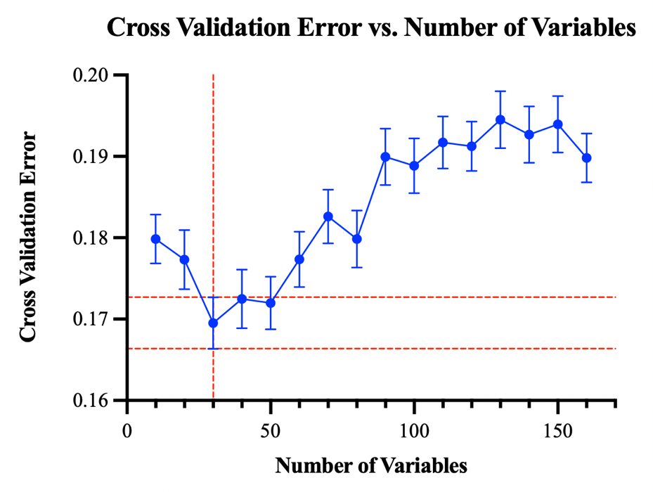
Supplementary Figure 2. Plot for cross validation error versus number of variables (p) on a given site split. The average error is shown for each p, along with standard error bars. The final number of variables is chosen by the one standard error rule, as the vertical dotted red line indicates. The horizontal dotted red lines indicate the acceptable range to choose the sparsest number of variables from. Note for this representative site split, a sparse number of thirty variables was chosen. When running this procedure on all of our data together, we also find that thirty variables are chosen.

Supplementary Table 3. Results of linear regression analyses for the top 30 variables identified via Monte Carlo cross validation. Since the predictors are normalized, the absolute value of the beta coefficient (β) indicates the strength of effect each respective variable has on the prediction of six-month posttraumatic stress symptoms (PTSS). The sign of the β coefficient suggests the direction of impact the feature selection has on PTSS outcome.
Variable Name | Variable Coefficient (β)
Pain severity | 0.04
Expected time to recover fully | -0.10
Area Deprivation Index | 0.07
Felt like in a daze during event | 0.03
Neck pain due to event | 0.09
Self identifies as Black American | 0.04
Perception of how life threatening the event was | 0.06
Felt restless due to event | 0.09
Chest/back made contact with the vehicle | 0.06
Cigarettes smoked per day | 0.00
Felt as if watching oneself during event | 0.07
Catastrophizing about pain to wonder whether something serious may occur | 0.05
Felt that might die | 0.02
Expected time to recover physically | 0.04
Angry or frustrated in ED | 0.06
Education level | -0.04
Anxiously wanting the pain to go away | 0.00
Ability to move neck limited by pain, stiffness, or soreness (Y/N, Quebec classification) | -0.01
Whether strapped to a board when transported to hospital | 0.05
Felt pain would never get better | 0.06
Wanting to hit someone when frustrated | 0.07
Felt fearful | 0.08
Arms/hands made contact with the vehicle | 0.04
Kept thinking of other painful events | 0.06
Whether received a CT scan in the ED | 0.06
Afraid that the pain would get worse | 0.04
Severity of right upper leg pain due to MVC | 0.01
Felt as if the accident were happening to someone else | 0.05
Respiration Rate in the ED | -0.03
Severity of right lower leg pain due to MVC | 0.03

Bijur, P. E., Latimer, C. T., & Gallagher, E. J. (2003). Validation of a verbally administered numerical rating scale of acute pain for use in the emergency department. Academic Emergency Medicine: Official Journal of the Society for Academic Emergency Medicine, 10(4), 390-392. doi:10.1111/j.1553-2712.2003.tb01355.x
Bunnell, B. E., Davidson, T. M., & Ruggiero, K. J. (2018). The Peritraumatic Distress Inventory: Factor structure and predictive validity in traumatically injured patients admitted through a Level I trauma center. Journal of Anxiety Disorders, 55, 8-13. doi:10.1016/j.janxdis.2018.03.002
Chan, A. W., Pristach, E. A., Welte, J. W., & Russell, M. (1993). Use of the TWEAK test in screening for alcoholism/heavy drinking in three populations. Alcoholism, Clinical and Experimental Research, 17(6), 1188-1192. doi:10.1111/j.1530-0277.1993.tb05226.x
Creamer, M., Bell, R., & Failla, S. (2003). Psychometric properties of the Impact of Event Scale—Revised. Behaviour Research and Therapy, 41(12), 1489-1496. doi:10.1016/j.brat.2003.07.010
Geisser, M. E., Roth, R. S., & Robinson, M. E. (1997). Assessing Depression among Persons with Chronic Pain Using the Center for Epidemiological Studies-Depression Scale and the Beck Depression Inventory: A Comparative Analysis. The Clinical Journal of Pain, 13(2), 163-170. doi:10.1097/00002508-199706000-00011
Kind, A. J., & Buckingham, W. R. (2018). Making Neighborhood-Disadvantage Metrics Accessible—The Neighborhood Atlas. The New England Journal of Medicine, 378(26), 2456-2458. doi:10.1056/NEJMp1802313
Kind, A. J., Jencks, S., Brock, J., Yu, M., Bartels, C., Ehlenbach, W., . . . Smith, M. (2014). Neighborhood Socioeconomic Disadvantage and 30-Day Rehospitalization: A Retrospective Cohort Study. Annals of Internal Medicine, 161(11), 765-774.
Radloff, L. S. (1977). The CES-D Scale: A Self-Report Depression Scale for Research in the General Population. Applied Psychological Measurement, 1(3), 385-401. doi:10.1177/014662167700100306
Singh, G. K. (2003). Area Deprivation and Widening Inequalities in US Mortality, 1969–1998. American Journal of Public Health, 93(7), 1137-1143. doi:10.2105/ajph.93.7.1137
Weiss, D. S. (2007). The Impact of Event Scale: Revised. In Cross-Cultural Assessment of Psychological Trauma and PTSD (pp. 219-238). Boston, MA: Springer.
Zimet, G. D., Dahlem, N. W., Zimet, S. G., & Farley, G. K. (1988). The Multidimensional Scale of Perceived Social Support. Journal of Personality Assessment, 52(1), 30-41. doi:10.1207/s15327752jpa5201_2

