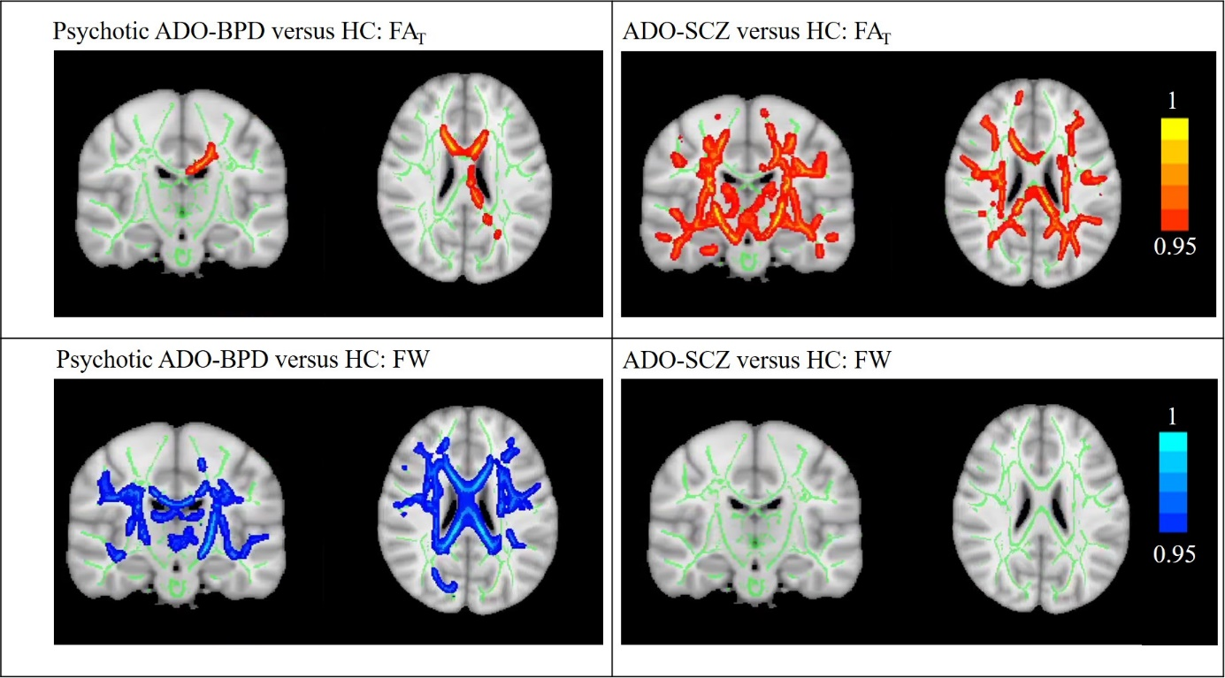
Supplementary Figure 1: Post-hoc tests for free-water (FW) corrected fractional anisotropy (FA_{T}) and FW values between 1) adolescent-onset bipolar disorder with psychosis (psychotic ADO-BPD) and healthy controls (HC) on the left and 2) between adolescent-onset schizophrenia (ADO-SCZ) and HC on the right (p<0.05, family-wise error corrected)
The white matter skeleton is displayed in green on top of an average of the registered FA images. Voxels that demonstrated significant group differences are thickened to increase visibility and are displayed in red for FA_{T} and in blue for FW. Images are presented in radiological convention and as “1 – family-wise error corrected p”; consequently, 1 is most significant.
FA_{T} abnormalities (top row) were spatially more widespread in ADO-SCZ (36% of the skeleton affected) than in psychotic ADO-BPD (3% of the skeleton affected). However, FW abnormalities were only present in psychotic ADO-BPD (23% of the skeleton affected).

Supplementary Table 1: Post-hoc comparison of FA_{T} and FW – averaged across significant voxels of the F-test – between HC, ADO-SCZ, and psychotic ADO-BPD (Bonferroni corrected)
 | HC versus ADO-SCZ | HC versus psychotic ADO-BPD | ADO-SCZ versus psychotic ADO-BPD
FA_{T} | ∆ = 0.024, [0.013, 0.034], p<.001 | ∆ = 0.018, [0.0032, 0.033], p=0.011 | ∆ = -0.0057, [-0.020, 0.0083], p=0.97
FW | ∆ = -0.0029, [-0.017, 0.012], p=1.00 | ∆ = -0.050, [-0.070, -0.030], p<.001 | ∆ = -0.047, [-0.066, -0.028], p<.001
Abbreviations: FA_{T} = free-water corrected fractional anisotropy, FW = free-water, HC = healthy controls, ADO-SCZ = adolescent-onset schizophrenia, psychotic ADO-BPD = adolescent-onset bipolar disorder with psychosis
After calculating an ANCOVA with the independent variable group (HC, ADO-SCZ, psychotic ADO-BPD), dependent variable FA_{T} or FW, and covariates age and sex, we calculated Bonferroni-corrected post-hoc comparisons to compare a) HC versus ADO-SCZ, b) HC versus psychotic ADO-BPD, and c) ADO-SCZ versus psychotic ADO-BPD.
Supplementary Table 1 displays the results of these post-hoc comparisons. A p-value < 0.05 and a 95% confidence interval (displayed in brackets) that does not include 0 indicate the statistical significance of the post-hoc test.

Supplementary Figure 2: Correlations between free-water corrected fractional anisotropy (FA_{T}) and age for healthy controls and the combined group of individuals with psychosis, separately. The graph shows that in healthy controls, FA_{T} increases with age (rho=.45, p=.0060). However, an increase in FA_{T} with age is not present in individuals with psychosis (rho=-.047, p=.71).

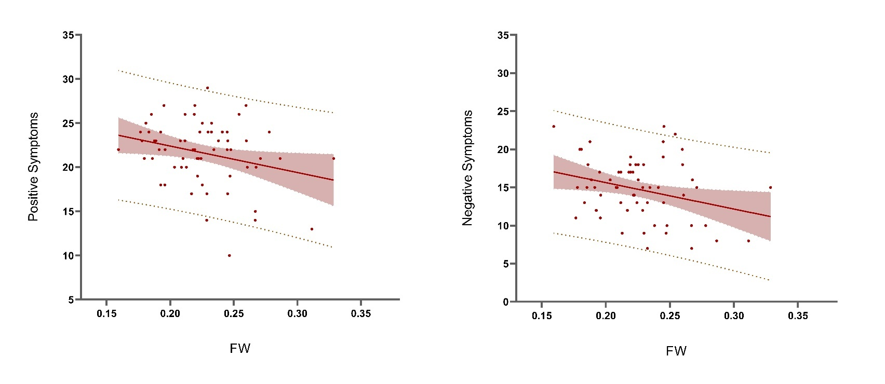
Supplementary Figure 3: Association between FW (free-water) and positive and negative symptoms measured by the Positive and Negative Syndrome Scale (PANSS). In the combined group of individuals with psychosis, higher FW indicates lower symptom severity.
Supplementary Table 2: Correlations of FA_{T} and FW with the age of onset, duration of illness, and FS-IQ
 | Clinical Variables |  | Test statistics
FA_{T} | Full-scale intelligent quotient  (FS-IQ) | HC  Individuals with psychosis  ADO-SCZ  Psychotic ADO-BPD | rho=0.12, p=0.50  rho=0.078, p=0.56  rho=0.076, p=0.63  rho=0.20, p=0.48
 | Duration of illness | Individuals with psychosis  ADO-SCZ  Psychotic ADO-BPD | rho=-0.036, p=0.78  rho=-0.071, p=0.63  rho=0.23, p=0.41
 | Age of onset | Individuals with psychosis  ADO-SCZ  Psychotic ADO-BPD | rho=0.037, p=0.77  rho=0.17, p=0.25  rho=-0.22, p=0.44
 | CPZEQ | Individuals with psychosis  ADO-SCZ  Psychotic ADO-BPD | rho=-0.25, p=0.050*  rho=-0.13, p=0.40  rho=-0.54, p=0.037*
FW | FS-IQ | HC  Individuals with psychosis  ADO-SCZ  Psychotic ADO-BPD | rho=0.071, p=0.68  rho=0.073, p=0.59  rho=-0.015, p=0.92  rho=-0.13, p=0.64
 | Duration of illness | Individuals with psychosis  ADO-SCZ  Psychotic ADO-BPD | rho=0.091, p=0.48  rho=0.43, p=0.002*  rho=0.37, p=0.18
 | Age of onset | Individuals with psychosis  ADO-SCZ  Psychotic ADO-BPD | rho=-0.31, p=0.012*  rho=-0.40, p=0.005*  rho=-0.31, p=0.27
 | CPZEQ | Individuals with psychosis  ADO-SCZ  Psychotic ADO-BPD | rho=-0.10, p=0.44  rho=-0.005, p=0.97  rho=0.11, p=0.70
Abbreviations: FA_{T} = free-water corrected fractional anisotropy, FW = free-water, HC = healthy individuals, ADO-SCZ = adolescent-onset schizophrenia, psychotic ADO-BPD = adolescent-onset bipolar disorder with psychosis, FS-IQ = full-scale intelligent quotient, CPZEQ = chlorpromazine equivalents
Please note that we utilized non-parametric Spearman correlations for all analyses because of the relatively small sample.
* Indicates statistical significance. Results should be considered with caution since correlations were not corrected for multiple comparisons.

