**Supplementary information**

**Supplementary Table 1.** Percentages of each diagnostic group in the low genetic risk, genetic BD and genetic SCZ groups.

|  |  |  |  |
| --- | --- | --- | --- |
|  | HCs (*n*=196) | FRs (*n*=70) | SCZ (*n*=173) |
| Low genetic risk | 41 (20.9%) | 11 (15.7%) | 11 (6.4%) |
| Genetic BD | 21 (10.7%) | 12 (17.1%) | 25 (14.5%) |
| Genetic SCZ | 16 (8.2%) | 11 (15.7%) | 30 (17.3%) |

SCZ, schizophrenia; BD, bipolar disorder; HC, healthy control; FR, first-degree relative of an SCZ patient.

**Supplementary Table 2.** Demographic characteristics among patients with SCZ, their FRs and HCs.

|  |  |  |  |  |  |
| --- | --- | --- | --- | --- | --- |
|  | HCs | FRs | SCZ |  |  |
| Variables | (*n*=154) | (*n*=60) | (*n*=143) | *p* values (*F* or *χ2*) | *post hoc* |
| Age (years) | 36.1 ± 14.9 | 59.7 ± 14.4 | 44.2 ± 13.6 | **8.33×10-23 (58.9)** | HC<SCZ<FR |
| Sex (male/female) | 100/54 | 20/40 | 63/80 | **1.50×10-5 (22.2)a** | - |
| Education (years) | 16.0 ± 2.4 | 12.9 ± 2.1 | 12.6 ± 2.1 | **6.20×10-35 (99.2)** | HC>FR, SCZ |
| Estimated premorbid IQ | 109.0 ± 7.6 | 99.9 ± 8.9 | 98.9 ± 10.7 | **1.71×10-18 (46.3)** | HC>FR, SCZ |
| Age at onset (years) | - | - | 27.3 ± 11.3 | - | - |
| DOI (years) | - | - | 16.8 ± 12.2 | - | - |
| CPZ-eq (mg/day) | - | - | 510.2 ± 489.3 | - | - |
| BPD-eq (mg/day) | - | - | 0.8 ± 2.4 | - | - |
| PANSS positive symptoms | - | - | 16.4 ± 6.2 | - | - |
| PANSS negative symptoms | - | - | 18.6 ± 6.9 | - | - |

HC, healthy control; FR, first-degree relative of an SCZ patient; SCZ, schizophrenia; IQ, intelligence quotient; DOI, duration of illness; CPZ-eq; total antipsychotic dosage in chlorpromazine equivalents; BPD-eq, biperiden equivalents of total antiparkinsonian drugs; PANSS, Positive and Negative Syndrome Scale. Complete demographic information was not obtained for all participants (estimated premorbid IQ in HCs, *n*=136 and in FRs, *n*=59). Means ± SD are shown. a *χ2* test. *P* values <0.05 are shown in boldface, and *post hoc* analysis was performed.

**Supplementary Table 3.** Cognitive scores assessed by the BACS among patients with SCZ, their FRs and HCs.

|  |  |  |  |  |  |
| --- | --- | --- | --- | --- | --- |
|  | HCs | FRs | SCZ |  |  |
|  | (*n*=154) | (*n*=60) | (*n*=143) | *p* values (*F2*,352) | *post hoc* |
| Composite score | 0.41 ± 0.05 | 0.18 ± 0.08 | -0.51 ± 0.05 | **6.53×10-37 (106.6)** | HC>FR>SCZ |
| Verbal memory | 0.53 ± 0.06 | 0.08 ± 0.10 | -0.61 ± 0.06 | **1.91×10-33 (94.0)** | HC>FR>SCZ |
| Digit sequencing | 0.43 ± 0.07 | 0.08 ± 0.12 | -0.49 ± 0.07 | **1.40×10-17 (43.4)** | HC>FR>SCZ |
| Token motor | 0.43 ± 0.07 | 0.28 ± 0.12 | -0.58 ± 0.07 | **1.05×10-22 (58.6)** | HC, FR>SCZ |
| Verbal fluency | 0.44 ± 0.07 | 0.13 ± 0.12 | -0.53 ± 0.07 | **5.40×10-20 (50.5)** | HC>FR>SCZ |
| Symbol coding | 0.46 ± 0.06 | 0.16 ± 0.10 | -0.57 ± 0.06 | **6.83×10-27 (71.8)** | HC>FR>SCZ |
| Tower of London | 0.16 ± 0.07 | 0.36 ± 0.12 | -0.32 ± 0.07 | **7.79×10-8 (17.2)** | HC, FR>SCZ |

HCs, healthy controls; FRs, first-degree relative of an SCZ patient; SCZ, schizophrenia. Means of standardized age- and sex-corrected scores ± SE are shown. *P* values <0.05 are shown in boldface, and *post hoc* analysis was performed.

**Supplementary Table 4.** Demographic characteristics among HCs in the low genetic risk group, SCZ patients in the genetic BD group and SCZ patients in the genetic SCZ group.

|  |  |  |  |  |  |
| --- | --- | --- | --- | --- | --- |
|  | HCs in the low genetic risk group | SCZ patients in the genetic BD group | SCZ patients in the genetic SCZ group |  |  |
| Variables | (*n*=29) | (*n*=16) | (*n*=26) | *p* values (*F* or *χ2*) | *post hoc* |
| Age (years) | 38.5 ± 15.2 | 42.1 ± 10.7 | 44.7 ± 16.8 | 0.31 (1.2) | - |
| Sex (male/female) | 17/12 | 6/10 | 13/13 | 0.40 (1.8)a | - |
| Education (years) | 15.9 ± 3.1 | 13.1 ± 2.4 | 12.6 ± 2.1 | **2.90×10-5 (12.2)** | HC>BD, SCZ |
| Estimated premorbid IQ | 108.9 ± 7.6 | 102.0 ± 11.1 | 97.0 ± 8.6 | **7.00×10-5 (11.2)** | HC>BD, SCZ |
| Age at onset (years) | - | 28.6 ± 10.1 | 30.2 ± 11.9 | 0.64 (0.2) | - |
| DOI (years) | - | 13.5 ± 10.7 | 14.4 ± 13.8 | 0.82 (0.1) | - |
| CPZ-eq (mg/day) | - | 487.2 ± 450.7 | 426.1 ± 330.1 | 0.62 (0.3) | - |
| BPD-eq (mg/day) | - | 1.4 ± 2.5 | 0.2 ± 0.8 | **0.033 (4.9)** | BD>SCZ |
| PANSS positive symptoms | - | 16.3 ± 5.7 | 15.7 ± 4.8 | 0.72 (0.1) | - |
| PANSS negative symptoms | - | 17.3 ± 7.4 | 18.5 ± 6.3 | 0.57 (0.3) | - |

HC, healthy control; SCZ, schizophrenia; BD, bipolar disorder, IQ, intelligence quotient; DOI, duration of illness; CPZ-eq; total antipsychotic dosage in chlorpromazine equivalents; BPD-eq, biperiden equivalents of total antiparkinsonian drugs; PANSS, Positive and Negative Syndrome Scale. Complete demographic information was not obtained for all participants (estimated premorbid IQ in low genetic risk, *n*=24). Means ± SD are shown. a *χ2* test. *P* values <0.05 are shown in boldface, and *post hoc* analysis was performed.

**Supplementary Table 5.** Cognitive scores assessed by the BACS among HCs in the low genetic risk group, SCZ patients in the genetic BD group, and SCZ patients in the genetic SCZ group.

|  |  |  |  |  |  |
| --- | --- | --- | --- | --- | --- |
|  | HCs in the low genetic risk group | SCZ patients in the genetic BD group | SCZ patients in the genetic SCZ group |  |  |
|  | (*n*=29) | (*n*=16) | (*n*=26) | *p* values (*F2,66*) | *post hoc* |
| Composite score | 0.55 ± 0.11 | -0.48 ± 0.15 | -0.53 ± 0.12 | **2.46×10-9 (27.2)** | HC>BD, SCZ |
| Verbal memory | 0.61 ± 0.15 | -0.41 ± 0.21 | -0.60 ± 0.16 | **1.95×10-6 (16.2)** | HC>BD, SCZ |
| Digit sequencing | 0.55 ± 0.15 | -0.54 ± 0.21 | -0.48 ± 0.16 | **1.01×10-5 (13.8)** | HC>BD, SCZ |
| Token motor | 0.63 ± 0.16 | -0.75 ± 0.21 | -0.51 ± 0.16 | **4.91×10-7 (18.2)** | HC>BD, SCZ |
| Verbal fluency | 0.48 ± 0.12 | -0.50 ± 0.17 | -0.64 ± 0.13 | **6.94×10-8 (21.4)** | HC>BD, SCZ |
| Symbol coding | 0.65 ± 0.15 | -0.38 ± 0.20 | -0.61 ± 0.15 | **3.12×10-7 (19.0)** | HC>BD, SCZ |
| Tower of London | 0.36 ± 0.18 | -0.31 ± 0.24 | -0.35 ± 0.19 | **0.015 (4.5)** | HC>BD, SCZ |

Means of standardized age- and sex-corrected scores ± SE are shown. *P* values <0.05 are shown in boldface, and *post hoc* analysis was performed. In *post hoc* analyses, HC, low genetic risk in HCs; BD, genetic BD in SCZ; and SCZ, genetic SCZ in SCZ.

**Supplementary Table 6.** Demographic characteristics between HCs in the no genetic risk group and SCZ patients in the no genetic risk group.

|  |  |  |  |
| --- | --- | --- | --- |
|  | HCs in the no genetic risk group | SCZ patients in the no genetic risk group |  |
| Variables | (*n*=97) | (*n*=91) | *p* values (*F* or *χ2*) |
| Age (years) | 35.9 ± 15.4 | 44.6 ± 13.7 | **7.35×10-5 (16.5)** |
| Sex (male/female) | 65/32 | 40/51 | **1.47×10-3 (10.1)a** |
| Education (years) | 16.0 ± 2.2 | 12.5 ± 2.2 | **5.24×10-22 (121.1)** |
| Estimated premorbid IQ | 108.8 ± 7.3 | 99.1 ± 10.6 | **4.13×10-11 (49.6)** |
| Age at onset (years) | - | 26.6 ± 11.4 | - |
| DOI (years) | - | 17.9 ± 12.3 | - |
| CPZ-eq (mg/day) | - | 522.3 ± 518.8 | - |
| BPD-eq (mg/day) | - | 0.9 ± 2.8 | - |
| PANSS positive symptoms | - | 16.7 ± 6.7 | - |
| PANSS negative symptoms | - | 18.5 ± 6.8 | - |

HC, healthy control; SCZ, schizophrenia; BD, bipolar disorder, IQ, intelligence quotient; DOI, duration of illness; CPZ-eq; total antipsychotic dosage in chlorpromazine equivalents; BPD-eq, biperiden equivalents of total antiparkinsonian drugs; PANSS, Positive and Negative Syndrome Scale. Complete demographic information was not obtained for all participants (estimated premorbid IQ in HCs in the no genetic risk group, *n*=87). Means ± SD are shown. a *χ2* test. *P* values <0.05 are shown in boldface, and *post hoc* analysis was performed.

**Supplementary Table 7.** Cognitive scores assessed by the BACS between HCs in the no genetic risk group and SCZ patients in the no genetic risk group.

|  |  |  |  |
| --- | --- | --- | --- |
|  | HCs in the no genetic risk group | SCZ patients in the no genetic risk group |  |
| Variables | (*n*=97) | (*n*=91) | *p* values (*F*1,184) |
| Composite score | 0.44 ± 0.06 | -0.40 ± 0.06 | **1.56×10-19 (103.2)** |
| Verbal memory | 0.61 ± 0.07 | -0.52 ± 0.07 | **3.29×10-21 (115.4)** |
| Digit sequencing | 0.45 ± 0.08 | -0.39 ± 0.09 | **1.81×10-10 (45.6)** |
| Token motor | 0.45 ± 0.09 | -0.48 ± 0.09 | **6.50×10-11 (48.2)** |
| Verbal fluency | 0.48 ± 0.09 | -0.43 ± 0.09 | **5.49×10-11 (48.6)** |
| Symbol coding | 0.46 ± 0.08 | -0.46 ± 0.08 | **3.79×10-13 (61.3)** |
| Tower of London | 0.22 ± 0.09 | -0.14 ± 0.09 | **5.18×10-3 (8.0)** |

Means of standardized age- and sex-corrected scores ± SE are shown. *P* values <0.05 are shown in boldface, and *post hoc* analysis was performed.

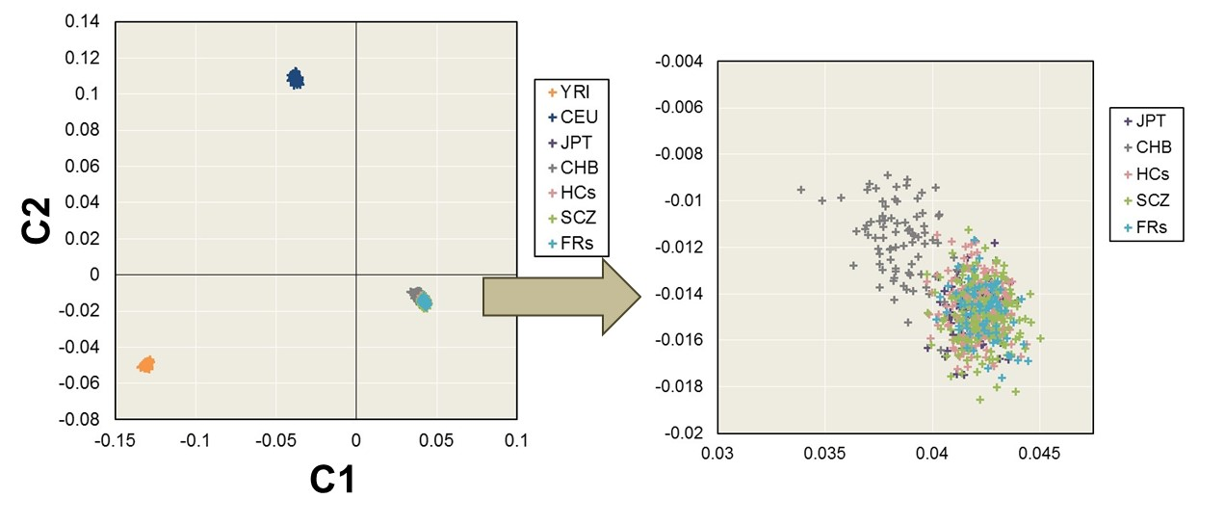

**Supplementary Figure 1.** Principal component analysis, components 1 (C1) and 2 (C2), of genotyping data in the study sample. To check for population stratification, we used genotype information from the JPT (Japanese in Tokyo, Japan), CHB (Han Chinese in Beijing, China), CEU (Utah residents with ancestors from Northern and Western Europe), and YRI (Yoruba in Ibadan, Nigeria) samples in HapMap 3 and our study samples (SCZ patients, FRs and HCs). SCZ, schizophrenia; FRs, first-degree relatives of patients with SCZ; HCs, healthy controls.

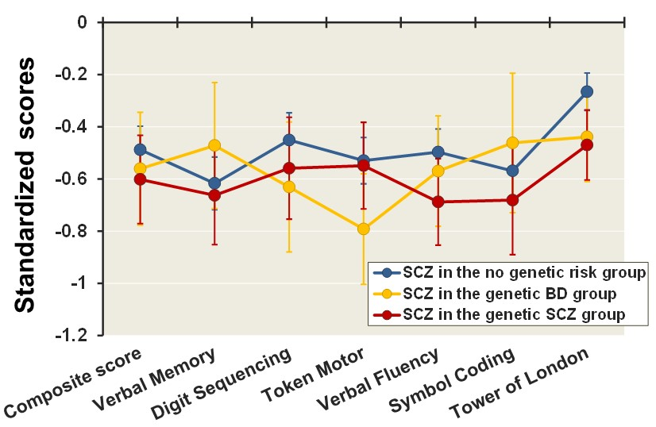

**Supplementary Figure 2.** Cognitive differences in composite scores and cognitive subtests among SCZ patients in the no genetic risk group, SCZ patients in the genetic BD group, and SCZ patients in the genetic SCZ group. Means of age- and sex-corrected scores ± SE are shown.



**Supplementary Figure 3.** Cognitive differences in composite scores and cognitive subtests between HCs in the no genetic risk group and SCZ patients in the no genetic risk group (blue), between HCs in the low genetic risk group and SCZ patients in the genetic BD group (yellow) and between HCs in the low genetic risk group and SCZ patients in the genetic SCZ group (red) after adjusting for BPD-eq and premorbid IQ as covariates. BPD-eq, biperiden equivalents of total antiparkinsonian drugs; IQ, intelligence quotient.