Figure 1
Illustration of cumulative depression over the 8 years pre-pregnancy for two women, both with a depression score during pregnancy of 7. Woman A (left) has a negative slope of depression scores with a decrease of 0.6 units per year and Woman B (right) has a positive slope with an increase of 0.2 per year.

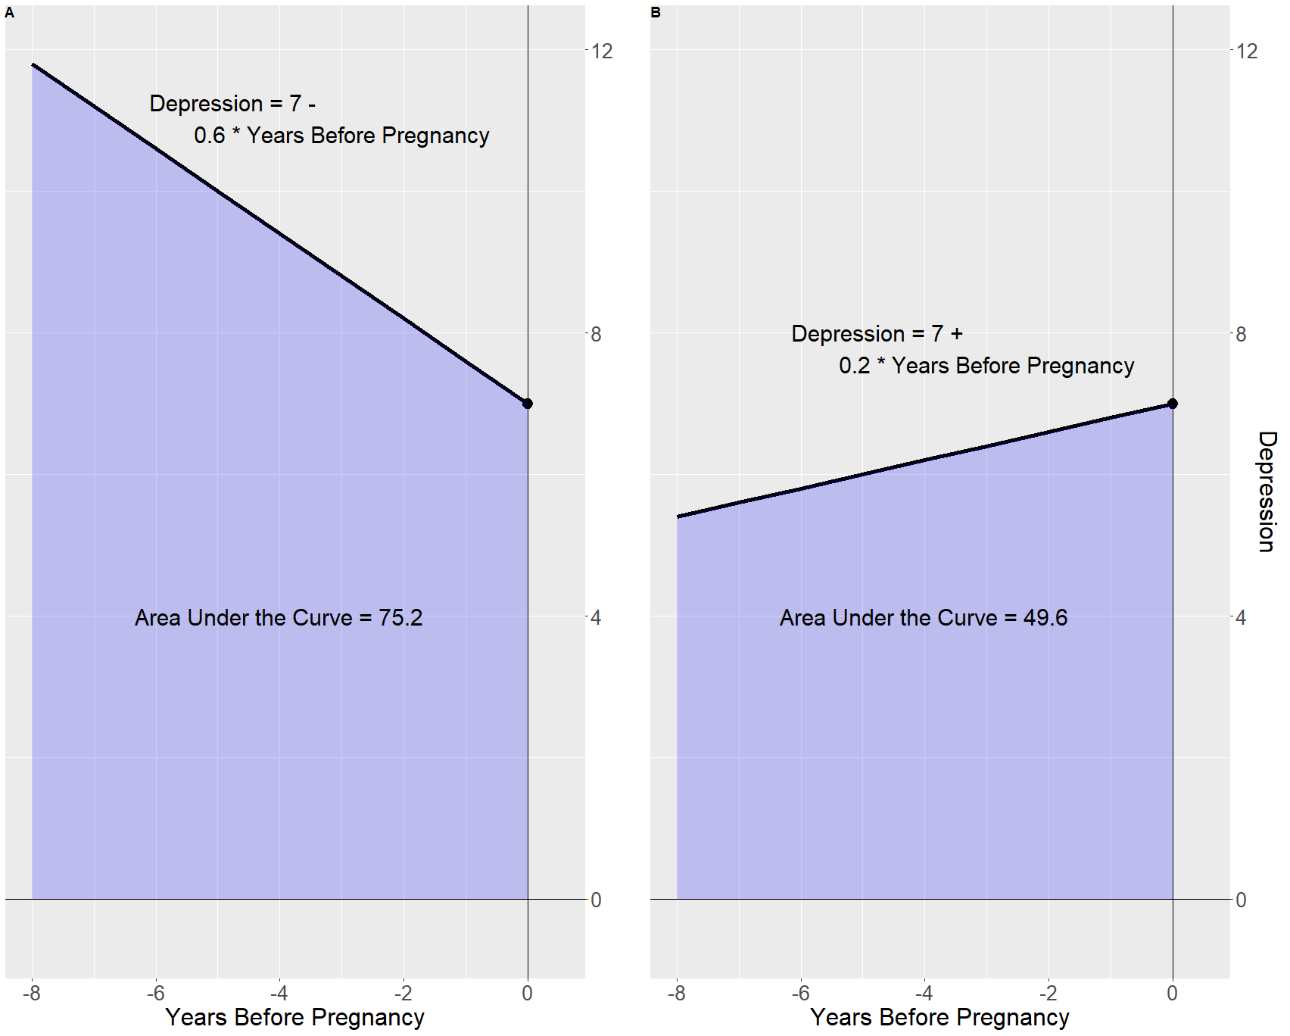

Figure 2
Illustration of the cumulative depression T-years pre-pregnancy for a woman with a slope in pre-pregnancy depression of “b”, and a pregnancy depression score of “a”.

