Supplemental Information

Cognitive Effort-based Decision Making in Major Depressive Disorder
Yuen-Siang Ang, Steven E. Gelda, Diego A. Pizzagalli

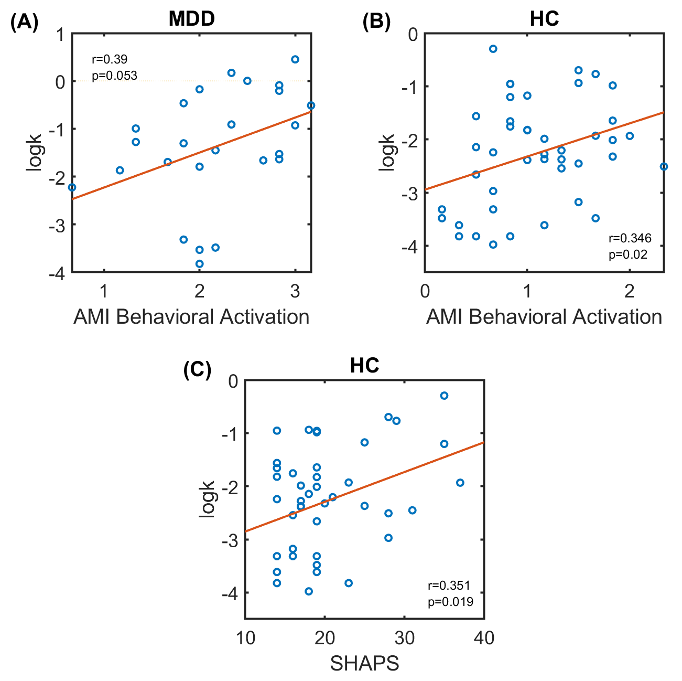
Supplemental Figure 1. Associations of logk with self-reported motivation and anhedonia. (A) There was a positive trending correlation between logk and the Apathy Motivation Index (AMI) Behavioral Activation subscale in the MDD group, suggesting that depressed patients who reported lower motivation in the behavioral domain were less willing to invest cognitive effort for reward on the task. (B) Within the healthy controls (HC), logk was significantly positively correlated with AMI Behavioral Activation subscale, which suggests that healthy individuals who had lower behavioral motivation exhibited lower willingness to exert cognitive effort in order to obtain reward. (C) In the HC group, there was a significant positive association between logk and total score on the Snaith Hamilton Pleasure Scale (SHAPS), suggesting that healthy participants who reported lower anhedonia were less willing to invest cognitive effort for reward.
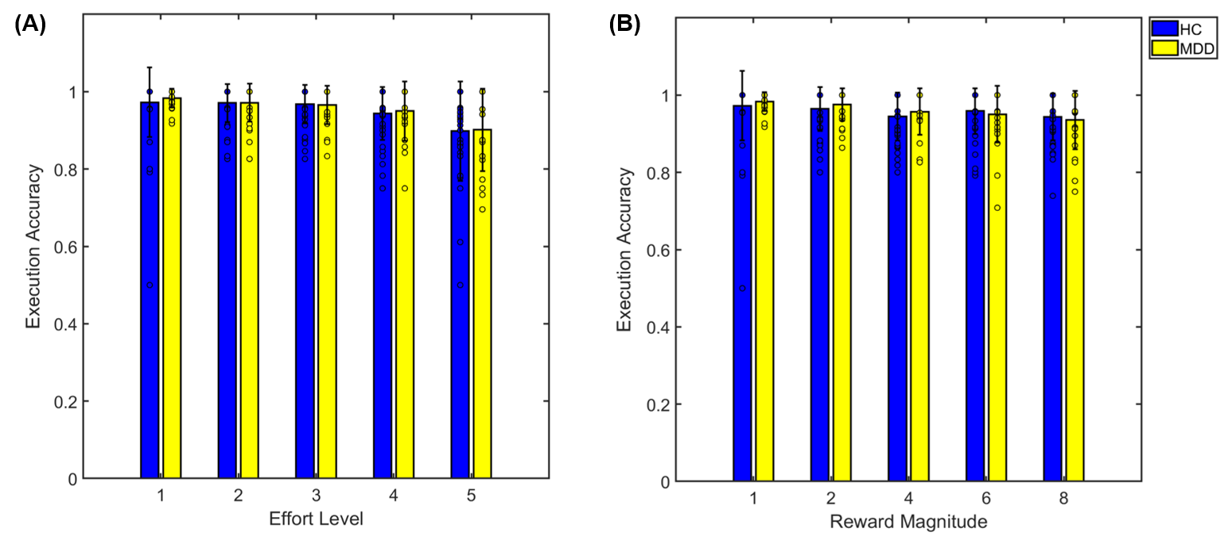
Supplemental Figure 2. Association of execution accuracies with effort and reward levels. (A) Participants overall had significantly lower execution accuracy when they had to remember 5 squares compared to other effort levels, but there were no significant differences in execution accuracy when remembering between 1–4 squares. Nevertheless, the mean accuracy at the effort level of 5 squares was still high at ~87%. (B) There were no differences in execution accuracy between the various reward magnitude levels. Dots within the bars represent individual participant data.

