Supplementary Material

Health technology program
The 6-month HTP program consisted of medication treatment guided by a computer decision support system for the prescriber, a smartphone application for patients that supported medication adherence and other coping strategies, a web-based patient and family psycho-educational intervention, and web-accessed cognitive behavioral therapy for paranoia and hallucinations. A mental health technology coach provided technical support, and developed a personalized, structured, relapse prevention plan with each participant that identified individual relapse precipitants and determined which HTP components should be employed to address them. Access to the interventions was insured by providing computers and Android smartphones to all patients.

Inverse probability of treatment weighting
Weighting by the inverse probabilities of treatment is a method based on propensity scores (Austin & Stuart, 2015), which are defined as the probability of receiving a treatment given measures of baseline covariates:
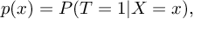
(1)
where T is an indicator variable that denotes the treatment received (T=0 for control treatment and T=1 for active treatment) and x is a vector of baseline covariates. Thus, the propensity score expresses the probability of receiving a treatment given a set of observed baseline covariates. Propensity scores are a way to address the confounding of the treatment effect that is often observed in quasi-experimental studies: treated participants will often differ systematically from untreated participants. This means that we cannot compute an unbiased estimate of the treatment effect simply by comparing outcomes between the two treatment groups:
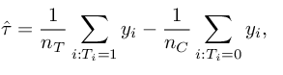
(2)
where nT and nC are the number of participants in the treatment and control group, respectively. When baseline confounders are present, the above treatment effect ̂τ will not be unbiased for the true population treatment effect. Under conditional exchangability, i.e., when Y(1),Y(0)⊥T|X, we assume that when we condition on all the necessary confounders X that have been measured at baseline, the treatment assignment T is independent of the potential outcome Y. Thus, by conditioning on propensity scores, it is possible to balance the measured baseline covariates so that the treatment and control groups are similar with respect to these covariates.
Inverse probability weights are one way of applying propensity scores. They are derived by taking the inverse of the propensity score:
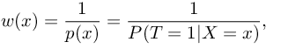
(3)
for treated individuals and
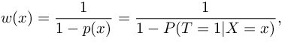
(4)
for untreated individuals. They create a synthetic sample in which the distribution of measured baseline covariates is independent of treatment assignment. To avoid that individuals with a propensity score close to 0 (i.e., those very unlikely to be treated) wound end up with overly large weights (which would make the weighted estimator unstable) we used stabilized IPTW. For treated individuals, the stabilized weights are calculated as follows:
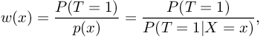
(5)
whereas for untreated subjects, they are given by
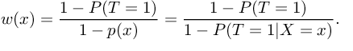
(6)

Supplementary Tables
Treatment | Time | Medication | Count | N | Percentage
SRG | Entry | any | 77 | 85 | 0.9
HTP | Entry | any | 324 | 356 | 0.9
SRG | Entry | clozapine | 8 | 85 | 0.1
HTP | Entry | clozapine | 35 | 356 | 0.1
SRG | Entry | LAI | 27 | 85 | 0.3
HTP | Entry | LAI | 110 | 356 | 0.3
SRG | 3mo | any | 64 | 80 | 0.8
HTP | 3mo | any | 272 | 308 | 0.9
SRG | 3mo | clozapine | 6 | 80 | 0.1
HTP | 3mo | clozapine | 37 | 308 | 0.1
SRG | 3mo | LAI | 28 | 80 | 0.3
HTP | 3mo | LAI | 89 | 308 | 0.3
SRG | 6mo | any | 68 | 81 | 0.8
HTP | 6mo | any | 289 | 330 | 0.9
SRG | 6mo | clozapine | 9 | 81 | 0.1
HTP | 6mo | clozapine | 48 | 330 | 0.1
SRG | 6mo | LAI | 24 | 81 | 0.3
HTP | 6mo | LAI | 93 | 330 | 0.3
Table S1: Medication overview

Supplementary Figures

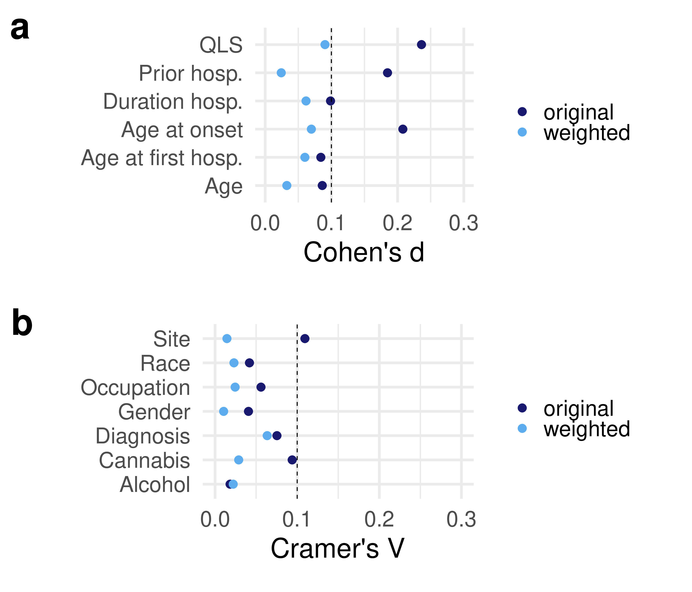
Figure S1: Balance diagnostics confirm removal of confounding. a, b. Continuous and categorical covariates were more similar after applying inverse propensity weights, indicated by weighted values being smaller than the cutoffs (indicated with dashed lines).

