Supplemental Materials
Davis et al. (2021). Childhood adversity, combat experiences, and military sexual trauma: a test and extension of the stress sensitization hypothesis among U.S. veterans

Supplemental Figure 1. Sample Recruitment and Follow-up Flow Chart
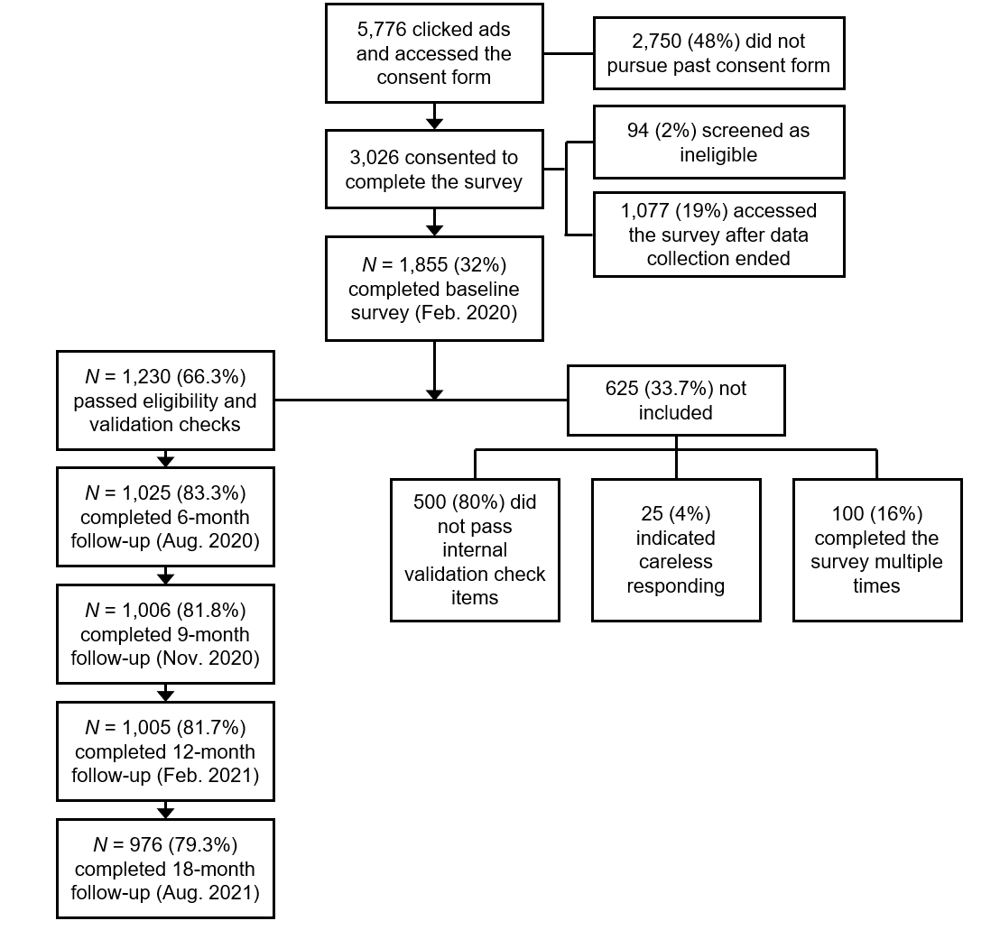

No. classes | -2 LL | AIC | BIC | aBIC | Entropy | VLRT | p | LMRT | p | BLRT | p
 |  |  | Childhood Adversity Latent Class Analysis
1 class | 4484.40 | 4492.40 | 45248.16 | 4500.16
2 class | 3270.64 | 3288.64 | 3334.67 | 3306.08 | 0.90 | 1213.76 | <.01 | 1180.58 | <.01 | 1213.76 | <.01
3 class | 3229.63 | 3257.63 | 3329.24 | 3284.77 | 0.86 | 41.01 | <.01 | 39.88 | <.01 | 41.01 | <.01
4 class | 3221.52 | 3259.52 | 3356.70 | 3296.35 | 0.85 | 8.11 | 0.04 | 7.89 | 0.04 | 8.11 | <.01
5 class | 3221.52 | 3269.52 | 3392.28 | 3316.04 | 0.82 | 0.00 | 0.32 | 0.00 | 0.33 | 0.00 | 1.00
 |  |  | Childhood Adversity and Veteran Specific Stressor Latent Class Analysis
1 class | 27524.53 | 27566.54 | 27673.95 | 27607.24
2 class | 24685.76 | 24771.76 | 24991.70 | 24855.11 | 0.913 | 2838.77 | <.01 | 2820.75 | <.01 | 2838.77 | <.01
3 class | 23902.44 | 24032.44 | 24364.90 | 24158.43 | 0.889 | 783.32 | <.01 | 778.35 | <.01 | 783.32 | <.01
4 class | 23431.05 | 23605.05 | 24050.04 | 23773.69 | 0.896 | 471.38 | <.01 | 468.39 | <.01 | 471.38 | <.01
5 class | 23076.28 | 23294.28 | 23851.79 | 23505.56 | 0.884 | 352.55 | <.01 | 352.52 | <.01 | 354.77 | <.01
6 class | 22786.65 | 23048.65 | 23718.69 | 23302.57 | 0.885 | 289.62 | <.01 | 287.78 | <.01 | 289.62 | <.01
7 class | 22563.71 | 22869.71 | 23652.27 | 23166.27 | 0.905 | 222.94 | 0.056 | 221.53 | 0.06 | 222.94 | <.01
 |  |  | Perceived Stress Growth Mixture Model
1 class | 31999.23 | 32021.23 | 32077.49 | 32042.55
2 class | 23261.62 | 23285.62 | 23345.72 | 23307.61 | 0.913 | 514.27 | <.01 | 490.921 | <.01 | 514.27 | <.01
3 class | 22582.48 | 22616.48 | 22701.62 | 22647.62 | 0.854 | 99.674 | 0.07 | 96.241 | 0.08 | 99.674 | <.01
4 class | 22526.41 | 22568.41 | 22673.59 | 22606.88 | 0.851 | 56.07 | 0.05 | 54.138 | 0.06 | 56.07 | <.01
Note: -2LL = negative 2 log likelihood; AIC = Akaike Information Criteria; BIC = Bayesian Information Criteria; aBIC = sample size adjusted Bayesian Information Criteria; LMRT = Lo-Mendell-Rubin test; BLRT = Bootstrapped log-likelihood ratio test.

Supplementary figure 2. Plot for childhood adversity and veteran specific stressors

