SUPPLEMENTARY MATERIAL

Figure S1. Questionnaire sequence for the COVID-19 sub-study, April 2020 to April 2021

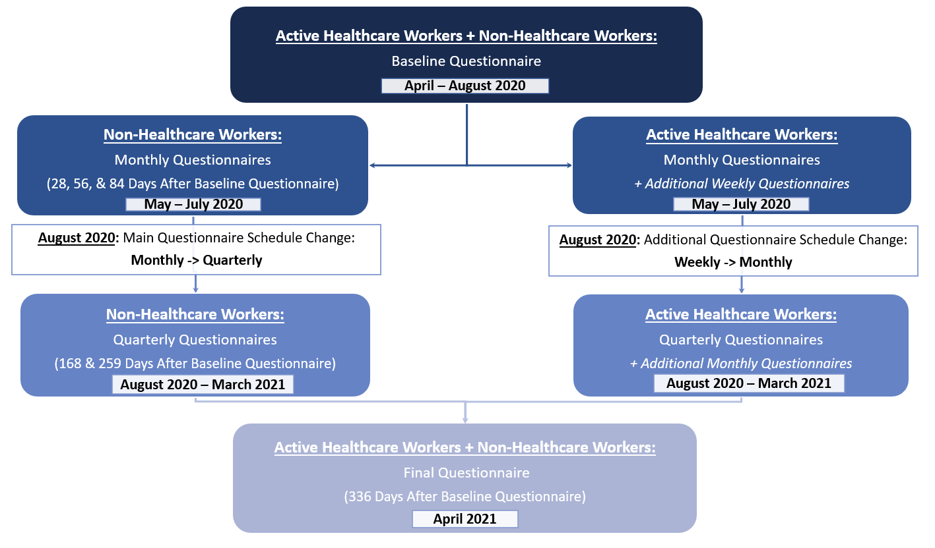

Figure S2. Inclusion and exclusion of the COVID-19 sub-study among three cohorts
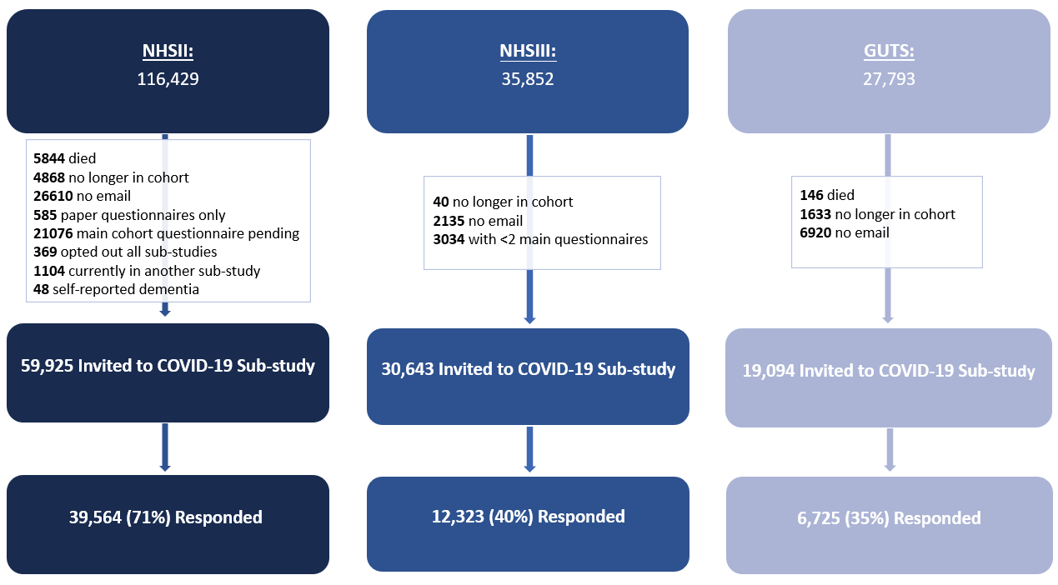

Table S1. Measure of chronic depression in the NHS II, NHS3, and GUTS main cohort questionnaires in the 10 years prior to the pandemic
 | History of depression
 | NHSII (3 waves) | NHS3 (6 waves) | GUTS (3 waves)
Self-reported physician diagnosis | 2011, 2013, 2015 | Module 1,3,4,5,7 | 2013, 2014, 2016
Use of antidepressants (in the past 2 years) | 2011, 2013, 2015 | Module 1 | 2013, 2014, 2016
Symptom screener (year, instrument) | 2013, CES-D-10 | Module 6, PHQ-9 | 2013, 2014, 2016,  CES-D-10
Note. NHS = Nurses’ Health Study; GUTS = Growing Up Today Study; CES-D-10 = 10-item Centre for Epidemiological Studies Depression Scale; PHQ-9 = 9-item Patient Health Questionnaire. The NHS3 is an open cohort, so modules are returned in different years

Table S2. Measure of covariates in the NHS II, NHS3, and GUTS main cohort questionnaires

 | NHSII | NHS3 | GUTS
Age, sex | Enrollment (1989) | Enrollment (2010-present) | Enrollment (1996 or 2004)ª
Racial/ethnic identity | Enrollment, 2005 | Enrollment | Enrollment
Marital status | 2009, 2013 | Enrollment | 2016
Partner’s education^{b} | 1999 | Enrollment | 2014
Height | Enrollment | Enrollment | Every follow up questionnaire
Weight and healthcare worker status | Baseline of COVID-19 sub-study | Baseline of COVID-19 sub-study | Baseline of COVID-19 sub-study
Smoking status | 2015 | Enrollment | 2016
History of diabetes, hypertension, high cholesterol, asthma, and cancer | Every follow up questionnaire | Every follow up questionnaire | Every follow up questionnaire
Note: BMI was derived using the most recent report of weight and height information.
ªThere were two waves of enrollment in GUTS, the first being 1996 (16,882 girls and boys between the ages of 9 and 14 years) and the second being 2004 (an additional 10,923 children between the ages of 10 and 17 years)
^{b}Participants’ own education attainment in GUTS
Table S3. Forms of distress at baseline by SARS‑CoV‑2 test results during 1 year of follow up (April 2020 to April 2021) in NHS II, NHS3, and GUTS, N=54,781

 |  | Positive SARS‑CoV‑2 test
 |  | No | Yes
 |  | N=51118 | N=3663
Probable depression (PHQ-2)
No (0 points) | N (%) | 24668 (48.4) | 1790 (49.0)
Subclinical symptoms (1-2 points) | N (%) | 19785 (38.8) | 1389 (38.0)
Yes (3-6 points) | N (%) | 6512 (12.8) | 477 (13.1)
Probable anxiety (GAD-2)
No (0 points) | N (%) | 18646 (36.6) | 1349 (36.9)
Subclinical symptoms (1-2 points) | N (%) | 21602 (42.4) | 1541 (42.1)
Yes (3-6 points) | N (%) | 10707 (21.0) | 767 (21.0)
Worry about COVID
Not at all/not very worried | N (%) | 12499 (24.5) | 1105 (30.2)
Somewhat worried | N (%) | 27946 (54.7) | 1957 (53.5)
Very worried | N (%) | 10620 (20.8) | 597 (16.3)
Non-healthcare workers only

 |  | N=32200 | N=1754
Perceived stress | Mean (SD) | 4.28 (2.83) | 4.24 (2.81)
Loneliness
Hardly ever (3 points) | N (%) | 8988 (28.1) | 489 (28.1)
Less than some of the time (4-5 points) | N (%) | 13362 (41.8) | 748 (43.0)
Some of the time or often (6-9 points) | N (%) | 9646 (30.2) | 502 (28.8)

Table S4. Association of indictors of distress with risk of COVID-19 hospitalization among persons with a positive SARS‑CoV‑2 test, April 2020 to April 2021, additionally adjusted for calendar month, excluding probable cases at baseline, or additionally adjusted for living alone
 | Main model: age, sex, race, healthcare worker status, and partner’s education | Model 2: main model, further adjusted for calendar month of positive SARS-CoV-2 test | Model 3: main model, excluding probable baseline SARS-CoV-2 cases | Model 4: main model, restricted to cases before vaccine availability | Model 5: main model, further adjusted for living alone
Chronic depression prior to the pandemic | 1.72 (1.20-2.46) | 1.70 (1.19-2.43) | 1.76 (1.21-2.54) | 1.77 (1.23-2.55) | 1.72 (1.20-2.46)
Forms at COVID study baseline
Probable depression (PHQ-2)
No (0 points) | 1.0 [Reference] | 1.0 [Reference] | 1.0 [Reference] | 1.0 [Reference] | 1.0 [Reference]
Subclinical symptoms (1-2 points) | 1.37 (0.95-1.99) | 1.37 (0.95-2.00) | 1.42 (0.96-2.08) | 1.32 (0.90-1.93) | 1.37 (0.94-1.99)
Yes (3-6 points) | 1.81 (1.08-3.03) | 1.82 (1.08-3.04) | 1.79 (1.04-3.07) | 1.78 (1.05-3.02) | 1.81 (1.08-3.02)
Depressive symptoms, continuous, per approximate IQR | 1.45 (1.17-1.81) | 1.45 (1.16-1.80) | 1.47 (1.17-1.85) | 1.45 (1.16-1.81) | 1.45 (1.17-1.81)
Probable anxiety (GAD-2)
No (0 points) | 1.0 [Reference] | 1.0 [Reference] | 1.0 [Reference] | 1.0 [Reference] | 1.0 [Reference]
Subclinical symptoms (1-2 points) | 1.21 (0.83-1.79) | 1.21 (0.82-1.79) | 1.20 (0.80-1.78) | 1.14 (0.77-1.68) | 1.22 (0.83-1.80)
Yes (3-6 points) | 1.34 (0.82-2.16) | 1.34 (0.82-2.16) | 1.34 (0.81-2.20) | 1.29 (0.79-2.11) | 1.34 (0.83-2.17)
Anxiety symptoms, continuous, per approximate IQR | 1.18 (0.94-1.48) | 1.18 (0.94-1.48) | 1.20 (095-1.51) | 1.18 (0.94-1.48) | 1.18 (0.94-1.48)
Worry about COVID
Not at all/not very worried | 1.0 [Reference] | 1.0 [Reference] | 1.0 [Reference] | 1.0 [Reference] | 1.0 [Reference]
Somewhat worried | 1.05 (0.69-1.58) | 1.03 (0.69-1.56) | 0.99 (0.65-1.51) | 1.07 (0.71-1.63) | 1.05 (0.70-1.58)
Very worried | 1.79 (1.12-2.86) | 1.80 (1.13-2.88) | 1.79 (1.11-2.90) | 1.79 (1.10-2.89) | 1.80 (1.13-2.88)
P trend* | 0.02 | 0.02 | 0.03 | 0.03 | 0.02
Loneliness
Hardly ever (3 points) | 1.0 [Reference] | 1.0 [Reference] | 1.0 [Reference] | 1.0 [Reference] | 1.0 [Reference]
Less than some of the time (4-5 points) | 1.33 (0.76-2.32) | 1.33 (0.76-2.32) | 1.30 (0.74-2.28) | 1.30 (0.74-2.27) | 1.33 (0.76-2.33)
Some of the time or often (6-9 points) | 1.81 (1.02-3.20) | 1.85 (1.05-3.28) | 1.76 (0.99-3.13) | 1.80 (1.01-3.20) | 1.83 (1.03-3.24)
Loneliness score, continuous, per approximate IQR | 1.29 (1.01-1.65) | 1.31 (1.03-1.67) | 1.26 (0.99-1.63) | 1.30 (1.02-1.66) | 1.30 (1.02-1.66)
Note. Distress items: depression (PHQ-2, yes/no), anxiety (Generalized Anxiety Disorder-2, yes/no), worried about COVID (not at all or not very worried, vs. somewhat worried or very worried), UCLA loneliness (yes/no). Perceived stress and loneliness were queried of non-active health care workers only. IQR, interquartile range
*P trend analysis used indicator levels as a continuous variable

