08 Dec 20
vaccination started

05 Nov 20
Entered 2nd national lockdown
06 Jan 21
Entered 3rd national lockdown
23 Mar 20
Entered 1st national lockdown
14 Sep 20
Rule of 6
Re-introduced

Mar 20 | Apr 20 | May 20 | Jun 20 | Jul 20 | Aug 20 | Sep 20 | Oct 20 | Nov 20 | Dec 20  02 Dec 20  2nd national lockdown ended | Jan 21 | Feb 21 | Mar 21  29 Mar 21  ‘Stay at home’  Ended, replaced by rule of 6 | Apr 21 | May 21 | Jun 21 | Jul 21
1 Jun 20
Outdoor gathering allowed
21 Jun 21
All legal restrictions removed
17 May 21
Outdoors: up to 30, indoors: rule of 6
31 Mar 21
Shielding ended
8 Mar 21
3rd national lockdown began to ease
03 Aug 20
Eat out help out scheme
4 Jul 20
Indoor gathering allowed
10 May 20
1st national lockdown began to ease

Source: Institute for Government, UK Parliament, GOV.UK
Figure S1. COVID-19 Lockdown and vaccination timeline in England (March 2020-July 2021)

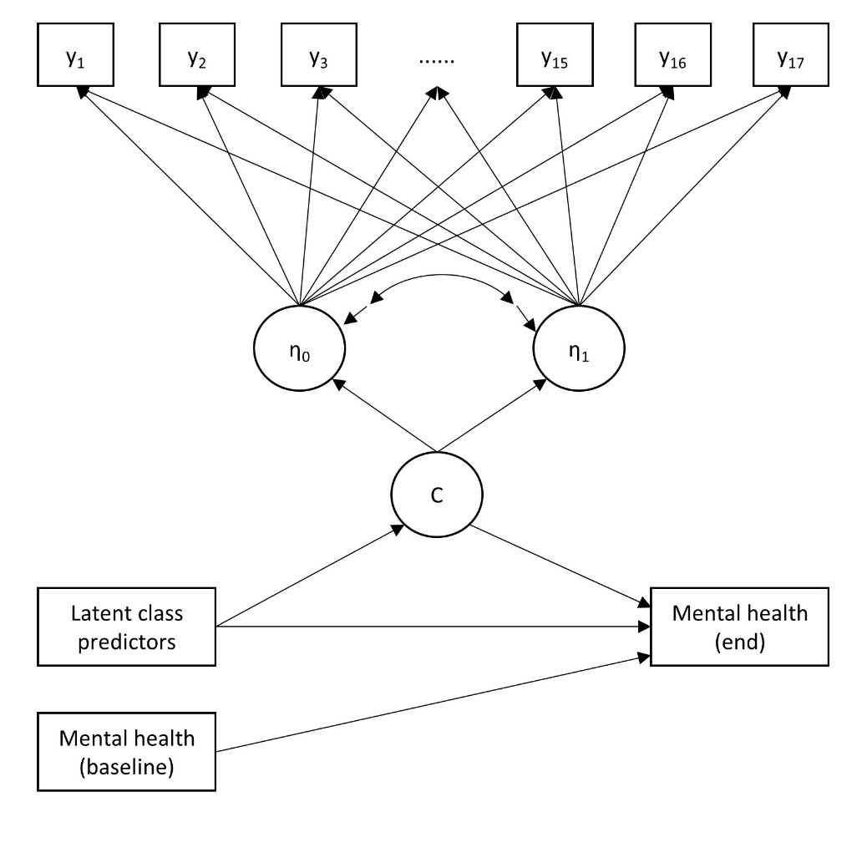
Figure S2. Full model: growth mixture model with covariates and distal outcomes

Table S1. Dates corresponding to different time points (months)
Date | Month
21/03/20-17/04/20 | 1
18/04/20-15/05/20 | 2
16/05/20-12/06/20 | 3
13/06/20-10/07/20 | 4
11/07/20-07/08/20 | 5
24/08/20-20/09/20 | 6
21/09/20-18/10/20 | 7
19/10/20-15/11/20 | 8
16/11/20-13/12/20 | 9
14/12/20-10/01/21 | 10
11/01/21-07/02/21 | 11
08/02/21-22/02/21 | 12
08/03/21-04/04/21 | 13
05/04/21-02/05/21 | 14
03/05/21-30/05/21 | 15
31/05/21-27/06/21 | 16
28/06/21-25/07/21 | 17

Table S2. Model fit indices for different model specifications
Model specification | BIC | ABIC | LMR-LR | ALMR-LR | Entropy
1-class GMM | 1,060,616 | 1,060,498 | NA | NA | NA
2-class GMM | 1,057,617 | 1,057,490 | <0.001 | <0.001 | 0.689
3-class GMM | 1,055,055 | 1,054,918 | 0.003 | 0.004 | 0.657
4-class GMM | 1,054,380 | 1,054,234 | 0.290 | 0.299 | 0.718

Table S3. Results from the one-step condition GMM (N=25,390)
 | Adaptive  (vs Home-confined)  C2 (vs C1) |  | Unconfined  (vs Home-confined)  C3 (vs. C1)
 | OR | 95% CI | OR | 95% CI
Women (vs. men) | 0.80 | [0.66-0.97] | 0.59 | [0.51-0.70]
Ethnic minority (vs. white) | 1.07 | [0.74-1.55] | 0.62 | [0.44-0.89]
Age: 30-45 (vs. 18-29) | 1.00 | [0.70-1.43] | 1.37 | [0.98-1.91]
Age: 46-59 (vs. 18-29) | 0.58 | [0.41-0.84] | 1.41 | [1.02-1.96]
Age: 60+ (vs. 18-29) | 0.59 | [0.41-0.85] | 1.74 | [1.25-2.43]
Education: A levels (vs. GCSEs or below) | 1.06 | [0.86-1.32] | 1.18 | [0.98-1.43]
Education: degree+ (vs. GCSEs or below) | 1.01 | [0.81-1.26] | 1.74 | [1.45-2.09]
Low income: <30k (vs. ≥30k) | 0.79 | [0.65-0.97] | 0.61 | [0.52-0.72]
Employed (vs. other) | 2.62 | [2.13-3.22] | 2.64 | [2.19-3.17]
Rural (vs. urban) | 1.23 | [1.00-1.51] | 0.96 | [0.81-1.14]
Own a dog (vs. none) | 0.99 | [0.79-1.25] | 2.84 | [2.37-3.41]
Living alone (vs with others) | 0.66 | [0.52-0.82] | 0.94 | [0.78-1.13]
Number of close friends | 1.05 | [1.01-1.08] | 1.06 | [1.03-1.10]
Frequency of social contacts | 1.40 | [1.29-1.51] | 1.45 | [1.35-1.56]
Physical health diagnosis (vs. no diagnosis) | 0.65 | [0.53-0.79] | 0.34 | [0.29-0.40]
Mental health diagnosis (vs. no diagnosis) | 0.60 | [0.48-0.76] | 0.57 | [0.47-0.69]
Personality: neuroticism | 1.03 | [1.00-1.05] | 1.02 | [1.00-1.04]
Personality: extraversion | 1.05 | [1.02-1.07] | 1.03 | [1.01-1.05]
Personality: openness | 0.98 | [0.95-1.00] | 0.96 | [0.94-0.99]
Personality: agreeableness | 0.99 | [0.96-1.02] | 0.96 | [0.94-0.99]
Personality: conscientiousness | 1.03 | [1.00-1.07] | 1.08 | [1.06-1.11]
COVID-19 stress minor (vs. none) | 1.19 | [0.96-1.46] | 0.92 | [0.78-1.09]
COVID-19 stress major (vs. none) | 0.95 | [0.76-1.19] | 0.57 | [0.47-0.69]

