Supplement to
Coping With COVID: Risk and Resilience Factors for Mental Health in a German Representative Panel Study
By Riepenhausen et al.

Table of contents:
- Supplementary Tables
  - Table S1. Studies on Mental Health During the COVID-19 Pandemic Using Representative Samples
  - Table S2. Information on Sample Size and Timing of Different Tranches
  - Table S3. Comparison Between Multiple Linear Regression With and Without Survey Weights to Allow for Interpretation of Unweighted LASSO Analysis
  - Table S4. Beta Coefficients and Standard Errors of Multiple Linear Regression Models (Outcome: ΔPHQ 2020)
  - Table S5. Beta Coefficients and Standard Errors of Multiple Linear Regression Models (Outcome: ΔPHQ 2021)
  - Table S6. Beta Coefficients and Standard Errors of Multiple Linear Regression Models (Outcome: ΔPHQ 2019; Control Analyses)
  - Table S7. Inclusion Frequencies and Average Beta Coefficients of 100 Repeated LASSO Runs
  - Table S8. Correlations Among Predictors
- Details on Predictor Selection
- LASSO Regularized Regression Analysis
- Specification Curve Analysis
- Linear Mixed Models
  - Table S9. Results of Linear Mixed Models
  - Figure S1. Marginal Effects
- References

- Supplementary Tables
Table S1
Studies on Mental Health During the COVID-19 Pandemic Using Representative Samples with Pre-Pandemic Baseline Measurement or Several Peri-Pandemic Survey Waves
Study | Country | Period of measurement | Baseline measurement | Instrument for mental health | Change in mental health
(Breslau et al., 2020) | USA | 05/2020 | 02/2019 (same sample) | Kessler-6 scale of mental distress | =
(Cheng et al., 2021)* | UK | 04-05/2020 | 2017-2018 (same sample) | GHQ-12 (general mental health problems) | + (particularly in working parents)
(Daly & Robinson, 2020) | USA | 03-07/2020 (8 waves in the same sample) | / | PHQ-4 (depressive & anxiety symptoms) | + (but quick recovery to baseline levels)
(Daly et al., 2020)* | UK | 04-06/2020 (3 waves in the same sample) | 2017-2019 (same sample) | GHQ-12 (general mental health problems) | + (particularly in young people, women, and people with high income and education)
(Daly et al., 2021) | USA | 03-04/2020 (2 waves in the same sample) | 2017-2018 (different sample) | PHQ-2 (depressive symptoms) | + (particularly in young people)
(Dawel et al., 2020) | Australia | 03/2020 | Comparison to validation studies of instruments | PHQ-9 (depressive symptoms) & GAD-7 (anxiety symptoms) | +
(Ettman et al., 2020) | USA | 03-04/2020 | 2017-2018 (different sample) | PHQ-9 (depressive symptoms) | +
(Holman et al., 2020) | USA | 03-04/2020 (3 waves in different samples) | / | Brief Symptom Inventory (depressive symptoms) | +
(Niedzwiedz et al., 2020)* | UK | 04/2020 | 2017-2019 (same sample) | GHQ-12 (general mental health problems) | +
(Peters et al., 2020) | Germany | 04-05/2020 | 2014-2019 (partly same sample) | PHQ-9 (depressive symptoms), GAD-7 (anxiety symptoms) & PHQ-Stress (perceived stress) | + (particularly in young women)
(Pieh et al., 2020) | Austria | 04/2020 | 2014 (different sample) | PHQ-9 (depressive symptoms) & GAD-7 (anxiety symptoms) | +
(Pierce et al., 2020)* | UK | 04/2020 | 2014-2018 (same sample) | GHQ-12 (general mental health problems) | + (particularly in young people, women, and people with children)
(Sibley et al., 2020) | New Zealand | 03-04/2020 | 10-12/2019 (different sample) | Kessler-6 scale of mental distress | +
(Twenge & Joiner, 2020) | USA | 04/2020 | 2018 (same sample) | Kessler-6 scale of mental distress | + (particularly in young people and people with children)
(van der Velden et al., 2020) | The Netherlands | 03/2020 | 03/2019 (same sample) | MHI-5 (anxiety and depressive symptoms) | =
(Winkler et al., 2020) | Czechia | 05/2020 | 2017 (different sample) | MINI psychiatric interview | +
(Zajacova et al., 2020) | Canada | 03+05/2020 (2 waves in different samples) | / | Self-rated mental health & GAD-7 (anxiety symptoms; only in May) | + (particularly in young people and women)
SOEP-CoV | Germany | 04-07/2020 (9 waves in different samples); 01-02/2021 (follow-up on all 9 waves) | 2016, 2019 (same sample) | PHQ-4 (depressive and anxiety symptoms)
Note. *same sample used in these studies. Change in mental health: increase (+), decrease (-) or no change (=) in symptoms.
Table S2
Information on Sample Size and Timing of Different Tranches
Year | Tranche | Time frame | Planned N | Actual N | N with non-zero survey weight
2020 | 1 | 01/04/2020-14/04/2020 | 3,000 | 1,687 | 1,680
2020 | 2 | 15/04/2020-28/04/2020 | 3,000 | 1,928 | 1,919
2020 | 3 | 29/04/2020-12/05/2020 | 2,000 | 978 | 977
2020 | 4 | 13/05/2020-26/05/2020 | 1,000 | 632 | 631
2020 | 5 | 27/05/2020-02/06/2020 | 600 | 308 | 308
2020 | 6 | 03/06/2020-09/06/2020 | 600 | 302 | 299
2020 | 7 | 10/06/2020-16/06/2020 | 600 | 286 | 285
2020 | 8 | 17/06/2020-23/06/2020 | 600 | 298 | 293
2020 | 9 | 24/06/2020-28/06/2020 | 600 | 265 | 265
2020 | 1-9 | 01/04/2020-28/06/2020 | 12,000 | 6,684 | 6,657
2021 |  | 18/01/2021-15/02/2021 | 6,684 | 6,006 | 5,981

Table S3
Comparison Between Multiple Linear Regression With and Without Survey Weights to Allow for Interpretation of Unweighted LASSO Analysis

 | ΔPHQ 2020 w | ΔPHQ 2020 unw | ΔPHQ 2021 w | ΔPHQ 2021 unw | ΔPHQ 2019 w | ΔPHQ 2019 unw
(Intercept) | 0.243 (0.174) | 0.030 (0.083) | -0.105 (0.138) | -0.121 (0.076) | -0.666 (0.149)*** | -0.646 (0.087)***
PREAP | -0.069 (0.052) | -0.118 (0.027)*** | 0.031 (0.040) | -0.009 (0.027) | -0.027 (0.046) | 0.003 (0.027)
PERSP | 0.083 (0.049) | 0.044 (0.024) | 0.011 (0.046) | 0.025 (0.026) | 0.101 (0.042)* | 0.056 (0.026)*
ACC | -0.069 (0.051) | -0.050 (0.024)* | -0.041 (0.040) | -0.030 (0.026) | -0.014 (0.045) | -0.019 (0.026)
PAC | -0.115 (0.044)** | -0.093 (0.025)*** | -0.119 (0.045)** | -0.083 (0.028)** | -0.069 (0.045) | -0.068 (0.025)**
SUPP | 0.161 (0.052)** | 0.192 (0.025)*** | 0.128 (0.046)** | 0.087 (0.028)** | 0.016 (0.046) | 0.027 (0.025)
CATA | 0.452 (0.052)*** | 0.430 (0.028)*** | 0.185 (0.050)*** | 0.157 (0.028)*** | 0.051 (0.044) | 0.051 (0.025)*
REC | -0.358 (0.058)*** | -0.278 (0.028)*** | -0.242 (0.046)*** | -0.184 (0.028)*** | -0.018 (0.051) | -0.047 (0.026)
OPT | -0.072 (0.063) | -0.085 (0.024)*** | -0.156 (0.042)*** | -0.161 (0.026)*** | -0.327 (0.041)*** | -0.299 (0.027)***
LOC | 0.000 (0.002) | 0.001 (0.001) | -0.001 (0.002) | -0.002 (0.001) | -0.002 (0.002) | -0.005 (0.001)***
NEU | 0.165 (0.053)** | 0.212 (0.024)*** | 0.246 (0.045)*** | 0.248 (0.026)*** | 0.519 (0.057)*** | 0.509 (0.034)***
Age: 18-24 | 0.645 (0.269)* | 0.556 (0.174)** | 1.043 (0.278)*** | 0.990 (0.211)*** | 0.185 (0.267) | 0.483 (0.174)**
Age: 25-34 | 0.448 (0.193)* | 0.325 (0.089)*** | 0.407 (0.164)* | 0.452 (0.101)*** | 0.168 (0.155) | 0.199 (0.095)*
Age: 35-44 | 0.085 (0.139) | 0.149 (0.070)* | 0.300 (0.141)* | 0.333 (0.081)*** | 0.026 (0.150) | 0.050 (0.078)
Age: 55-64 | 0.094 (0.126) | 0.033 (0.068) | -0.029 (0.130) | -0.089 (0.076) | -0.007 (0.120) | -0.021 (0.070)
Age: 65-74 | -0.020 (0.152) | -0.106 (0.077) | -0.093 (0.163) | -0.272 (0.086)** | -0.254 (0.125)* | -0.298 (0.076)***
Age: 75-84 | -0.047 (0.182) | -0.021 (0.089) | -0.058 (0.158) | -0.220 (0.098)* | -0.174 (0.194) | -0.254 (0.096)**
Age: 85+ | 0.272 (0.380) | 0.135 (0.199) | 0.079 (0.254) | 0.174 (0.208) | -0.108 (0.223) | -0.160 (0.164)
Gender: female | 0.095 (0.089) | 0.221 (0.047)*** | 0.339 (0.080)*** | 0.278 (0.053)*** | 0.019 (0.088) | -0.004 (0.052)
Household net income: low | 0.130 (0.120) | 0.080 (0.058) | 0.066 (0.108) | 0.127 (0.065) | 0.229 (0.116) | 0.193 (0.068)**
Household net income: high | -0.085 (0.111) | -0.028 (0.057) | -0.086 (0.093) | -0.044 (0.061) | 0.034 (0.104) | 0.006 (0.061)
Education: low | 0.077 (0.122) | 0.052 (0.065) | 0.016 (0.107) | 0.046 (0.069) | -0.021 (0.106) | 0.104 (0.067)
Education: high | 0.094 (0.122) | 0.069 (0.055) | 0.160 (0.106) | 0.109 (0.058) | -0.103 (0.127) | -0.023 (0.057)
History of diagnosed depression | 0.516 (0.169)** | 0.332 (0.091)*** | 0.873 (0.214)*** | 0.566 (0.110)*** | 1.549 (0.206)*** | 1.392 (0.117)***
COVID-19 risk group | -0.195 (0.101) | 0.012 (0.052) | -0.109 (0.097) | 0.068 (0.055) | 0.175 (0.097) | 0.151 (0.052)**
Lockdown | -0.010 (0.097) | 0.038 (0.048)
Mean PHQ-4 2016/2019 | -1.271 (0.067)*** | -1.266 (0.035)*** | -1.186 (0.059)*** | -1.199 (0.043)***
PHQ-4 in 2016 |  |  |  |  | -1.723 (0.066)*** | -1.742 (0.045)***
R2 | 0.329 | 0.326 | 0.267 | 0.253 | 0.461 | 0.465
N | 6657 | 6657 | 5981 | 5981 | 6657 | 6657
Note. PHQ-4 = Patient Health Questionnaire; w = survey-weighted; unw = unweighted; PREAP = positive reappraisal; PERSP = putting into perspective; ACC = acceptance; PAC = positive appraisal specific to the COVID-19 pandemic; SUPP = asking for instrumental support; CATA = catastrophizing; REC = perceived stress recovery; OPT = optimism; LOC = locus of control; NEU = neuroticism, ΔPHQ 2020 = change in PHQ-4 from 2019 to 2020, ΔPHQ 2021 = change in PHQ-4 from 2019 to 2021, ΔPHQ 2019 = change in PHQ-4 from 2016 to 2019, unw = unweighted, w = weighted. Parameter estimates of psychological factors and factor levels of covariates that significantly predicted the respective outcome are displayed in bold for increased readability.

Table S4
Beta Coefficients and Standard Errors of Multiple Linear Regression Models (Outcome: ΔPHQ 2020)
 | Base Model | Model 1 | Model 2 | Model 3 | Model 4 | Model 5 | Model 6 | Model 7 | Model 8 | Model 9 | Model 10
(Intercept) | 0.155 (0.170) | 0.155 (0.170) | 0.153 (0.170) | 0.131 (0.169) | 0.151 (0.171) | 0.132 (0.168) | 0.230 (0.168) | 0.207 (0.166) | 0.178 (0.172) | 0.145 (0.182) | 0.145 (0.165)
PREAP |  | -0.192 (0.053)**
PERSP |  |  | -0.052 (0.055)
ACC |  |  |  | -0.129 (0.050)
PAC |  |  |  |  | -0.096 (0.046)
SUPP |  |  |  |  |  | 0.282 (0.052)***
CATA |  |  |  |  |  |  | 0.553 (0.054)***
REC |  |  |  |  |  |  |  | -0.473 (0.057)***
OPT |  |  |  |  |  |  |  |  | -0.057 (0.061)
LOC |  |  |  |  |  |  |  |  |  | 0.001 (0.003)
NEU |  |  |  |  |  |  |  |  |  |  | 0.214 (0.053)**
Age: 18-24 | 0.750 (0.298) | 0.732 (0.295) | 0.755 (0.297) | 0.750 (0.292) | 0.738 (0.299) | 0.642 (0.283) | 0.778 (0.279) | 0.735 (0.298) | 0.742 (0.299) | 0.737 (0.303) | 0.744 (0.291)
Age: 25-34 | 0.454 (0.207) | 0.449 (0.204) | 0.460 (0.208) | 0.459 (0.205) | 0.454 (0.207) | 0.421 (0.207) | 0.498 (0.197) | 0.441 (0.195) | 0.452 (0.211) | 0.449 (0.209) | 0.459 (0.198)
Age: 35-44 | 0.112 (0.158) | 0.118 (0.160) | 0.115 (0.158) | 0.110 (0.156) | 0.106 (0.157) | 0.076 (0.155) | 0.149 (0.156) | 0.088 (0.152) | 0.114 (0.158) | 0.110 (0.156) | 0.102 (0.150)
Age: 55-64 | 0.114 (0.143) | 0.097 (0.140) | 0.114 (0.143) | 0.119 (0.140) | 0.105 (0.143) | 0.129 (0.139) | 0.085 (0.129) | 0.119 (0.141) | 0.103 (0.142) | 0.114 (0.143) | 0.142 (0.148)
Age: 65-74 | -0.071 (0.170) | -0.091 (0.171) | -0.073 (0.170) | -0.056 (0.169) | -0.081 (0.169) | -0.018 (0.167) | -0.061 (0.168) | -0.034 (0.158) | -0.086 (0.173) | -0.069 (0.171) | -0.055 (0.162)
Age: 75-84 | 0.035 (0.173) | 0.022 (0.175) | 0.037 (0.174) | 0.055 (0.174) | 0.021 (0.173) | 0.060 (0.175) | -0.044 (0.170) | 0.024 (0.168) | 0.012 (0.176) | 0.042 (0.182) | 0.058 (0.185)
Age: 85+ | 0.460 (0.389) | 0.474 (0.389) | 0.464 (0.392) | 0.475 (0.392) | 0.456 (0.387) | 0.479 (0.386) | 0.208 (0.380) | 0.463 (0.392) | 0.444 (0.387) | 0.465 (0.395) | 0.487 (0.398)
Gender: female | 0.248 (0.091) | 0.263 (0.090)* | 0.253 (0.090)* | 0.263 (0.091)* | 0.260 (0.090)* | 0.247 (0.091) | 0.172 (0.088) | 0.151 (0.089) | 0.248 (0.091) | 0.251 (0.092) | 0.200 (0.091)
Household net income: low | 0.246 (0.122) | 0.247 (0.122) | 0.245 (0.122) | 0.230 (0.123) | 0.248 (0.122) | 0.228 (0.122) | 0.174 (0.119) | 0.217 (0.118) | 0.246 (0.122) | 0.245 (0.122) | 0.220 (0.123)
Household net income: high | -0.173 (0.115) | -0.159 (0.116) | -0.173 (0.115) | -0.178 (0.114) | -0.177 (0.115) | -0.175 (0.116) | -0.122 (0.114) | -0.113 (0.110) | -0.166 (0.112) | -0.174 (0.114) | -0.180 (0.119)
Education: low | 0.184 (0.131) | 0.162 (0.129) | 0.189 (0.133) | 0.175 (0.131) | 0.182 (0.131) | 0.214 (0.133) | 0.087 (0.127) | 0.159 (0.125) | 0.188 (0.131) | 0.183 (0.131) | 0.173 (0.128)
Education: high | -0.005 (0.129) | 0.013 (0.133) | 0.001 (0.130) | 0.013 (0.130) | -0.003 (0.130) | -0.014 (0.125) | 0.071 (0.135) | 0.028 (0.119) | -0.005 (0.129) | -0.006 (0.129) | 0.006 (0.127)
History of diagnosed depression | 0.697 (0.203)** | 0.705 (0.202)** | 0.705 (0.202)** | 0.713 (0.202)** | 0.696 (0.202)** | 0.684 (0.200)** | 0.718 (0.186)** | 0.539 (0.189)* | 0.659 (0.201)* | 0.697 (0.203)** | 0.674 (0.202)**
COVID-19 risk group | -0.115 (0.106) | -0.128 (0.105) | -0.115 (0.106) | -0.108 (0.106) | -0.116 (0.106) | -0.094 (0.107) | -0.157 (0.107) | -0.156 (0.102) | -0.120 (0.105) | -0.114 (0.105) | -0.134 (0.103)
Lockdown | -0.055 (0.101) | -0.053 (0.100) | -0.062 (0.103) | -0.043 (0.103) | -0.041 (0.100) | -0.043 (0.102) | -0.099 (0.097) | -0.008 (0.095) | -0.054 (0.101) | -0.055 (0.101) | -0.054 (0.102)
Mean PHQ-4 2016/2019 | -1.087 (0.070)*** | -1.096 (0.069)*** | -1.087 (0.070)*** | -1.092 (0.070)*** | -1.092 (0.069)*** | -1.091 (0.071)*** | -1.140 (0.067)*** | -1.147 (0.064)*** | -1.096 (0.070)*** | -1.087 (0.070)*** | -1.174 (0.072)***
R² | 0.217 | 0.224 | 0.217 | 0.220 | 0.219 | 0.232 | 0.279 | 0.262 | 0.218 | 0.217 | 0.231
ΔR² | / | 0.007 | 0 | 0.003 | 0.002 | 0.015 | 0.062 | 0.045 | 0.001 | 0 | 0.014
Observations | 6657 | 6657 | 6657 | 6657 | 6657 | 6657 | 6657 | 6657 | 6657 | 6657 | 6657

Note. ***p < 0.0001; **p < 0.001; *p < 0.005 (due to Bonferroni correction). PREAP = positive reappraisal; PERSP = putting into perspective; ACC = acceptance; PAC = positive appraisal specific to the COVID-19 pandemic; SUPP = asking for instrumental support; CATA = catastrophizing; REC = perceived stress recovery; OPT = optimism; LOC = locus of control; NEU = neuroticism. Parameter estimates of psychological factors and factor levels of covariates that significantly predicted ΔPHQ-4 2020 are displayed in bold for increased readability.
Table S5
Beta Coefficients and Standard Errors of Multiple Linear Regression Models (Outcome: ΔPHQ 2021)
 | Base Model | Model 1 | Model 2 | Model 3 | Model 4 | Model 5 | Model 6 | Model 7 | Model 8 | Model 9 | Model 10
(Intercept) | -0.254 (0.145) | -0.255 (0.145) | -0.261 (0.144) | -0.260 (0.144) | -0.248 (0.145) | -0.250 (0.142) | -0.226 (0.144) | -0.192 (0.143) | -0.211 (0.146) | -0.238 (0.148) | -0.239 (0.142)
PREAP |  | -0.065 (0.038)
PERSP |  |  | -0.052 (0.046)
ACC |  |  |  | -0.076 (0.040)
PAC |  |  |  |  | -0.116 (0.043)
SUPP |  |  |  |  |  | 0.170 (0.044)**
CATA |  |  |  |  |  |  | 0.259 (0.049)***
REC |  |  |  |  |  |  |  | -0.332 (0.048)***
OPT |  |  |  |  |  |  |  |  | -0.139 (0.046)*
LOC |  |  |  |  |  |  |  |  |  | -0.001 (0.002)
NEU |  |  |  |  |  |  |  |  |  |  | 0.255 (0.049)***
Age: 18-24 | 1.118 (0.293)** | 1.117 (0.294)** | 1.122 (0.294)** | 1.119 (0.291)** | 1.109 (0.294)** | 1.034 (0.285)** | 1.144 (0.290)*** | 1.126 (0.288)*** | 1.104 (0.294)** | 1.140 (0.299)** | 1.089 (0.286)**
Age: 25-34 | 0.408 (0.173) | 0.409 (0.173) | 0.414 (0.172) | 0.409 (0.173) | 0.409 (0.173) | 0.371 (0.173) | 0.439 (0.169) | 0.405 (0.169) | 0.409 (0.172) | 0.416 (0.172) | 0.406 (0.173)
Age: 35-44 | 0.326 (0.158) | 0.330 (0.159) | 0.329 (0.158) | 0.324 (0.158) | 0.315 (0.157) | 0.304 (0.157) | 0.356 (0.155) | 0.306 (0.150) | 0.331 (0.155) | 0.330 (0.157) | 0.317 (0.157)
Age: 55-64 | -0.053 (0.139) | -0.054 (0.139) | -0.051 (0.139) | -0.048 (0.139) | -0.056 (0.140) | -0.048 (0.138) | -0.053 (0.135) | -0.033 (0.138) | -0.071 (0.135) | -0.052 (0.139) | -0.023 (0.146)
Age: 65-74 | -0.108 (0.181) | -0.112 (0.181) | -0.109 (0.181) | -0.098 (0.182) | -0.115 (0.180) | -0.080 (0.179) | -0.100 (0.175) | -0.084 (0.173) | -0.136 (0.179) | -0.108 (0.181) | -0.106 (0.179)
Age: 75-84 | 0.012 (0.162) | 0.008 (0.162) | 0.015 (0.161) | 0.026 (0.162) | -0.005 (0.161) | 0.022 (0.161) | -0.014 (0.161) | 0.010 (0.158) | -0.040 (0.160) | 0.002 (0.164) | 0.028 (0.168)
Age: 85+ | 0.266 (0.253) | 0.267 (0.251) | 0.269 (0.250) | 0.271 (0.252) | 0.244 (0.247) | 0.281 (0.254) | 0.111 (0.260) | 0.242 (0.252) | 0.214 (0.260) | 0.258 (0.255) | 0.282 (0.249)
Gender: female | 0.486 (0.081)*** | 0.491 (0.081)*** | 0.491 (0.081)*** | 0.493 (0.081)*** | 0.498 (0.081)*** | 0.475 (0.081)*** | 0.442 (0.080)*** | 0.414 (0.081)*** | 0.493 (0.081)*** | 0.483 (0.081)*** | 0.412 (0.083)***
Household net income: low | 0.166 (0.116) | 0.168 (0.116) | 0.166 (0.115) | 0.152 (0.117) | 0.170 (0.115) | 0.150 (0.115) | 0.130 (0.113) | 0.126 (0.112) | 0.161 (0.114) | 0.165 (0.116) | 0.141 (0.112)
Household net income: high | -0.121 (0.098) | -0.117 (0.099) | -0.121 (0.098) | -0.121 (0.098) | -0.125 (0.098) | -0.125 (0.098) | -0.108 (0.097) | -0.098 (0.095) | -0.117 (0.098) | -0.120 (0.098) | -0.109 (0.097)
Education: low | 0.052 (0.113) | 0.044 (0.112) | 0.058 (0.113) | 0.047 (0.113) | 0.052 (0.113) | 0.061 (0.112) | 0.005 (0.110) | 0.036 (0.109) | 0.060 (0.112) | 0.053 (0.112) | 0.046 (0.112)
Education: high | 0.091 (0.114) | 0.098 (0.115) | 0.099 (0.116) | 0.101 (0.115) | 0.095 (0.114) | 0.084 (0.112) | 0.129 (0.115) | 0.124 (0.109) | 0.095 (0.116) | 0.092 (0.114) | 0.107 (0.109)
History of diagnosed depression | 1.063 (0.217)*** | 1.067 (0.218)*** | 1.072 (0.217)*** | 1.074 (0.217)*** | 1.063 (0.218)*** | 1.061 (0.218)*** | 1.082 (0.211)*** | 0.973 (0.209)*** | 0.982 (0.223)*** | 1.063 (0.218)*** | 1.012 (0.217)***
COVID-19 risk group | -0.050 (0.104) | -0.057 (0.104) | -0.053 (0.104) | -0.049 (0.105) | -0.056 (0.104) | -0.032 (0.103) | -0.069 (0.102) | -0.085 (0.102) | -0.063 (0.102) | -0.051 (0.104) | -0.069 (0.104)
Mean PHQ-4 2016/2019 | -0.994 (0.062)*** | -0.998 (0.062)*** | -0.995 (0.062)*** | -0.997 (0.062)*** | -1.002 (0.061)*** | -0.998 (0.062)*** | -1.019 (0.061)*** | -1.048 (0.061)*** | -1.021 (0.062)*** | -0.994 (0.062)*** | -1.095 (0.060)***
R² | 0.208 | 0.208 | 0.208 | 0.209 | 0.211 | 0.214 | 0.222 | 0.232 | 0.213 | 0.208 | 0.225
ΔR² | / | 0 | 0 | 0.001 | 0.003 | 0.006 | 0.004 | 0.014 | 0.005 | 0 | 0.017
Observations | 5981 | 5981 | 5981 | 5981 | 5981 | 5981 | 5981 | 5981 | 5981 | 5981 | 5981

Note. ***p < 0.0001; **p < 0.001; *p < 0.005 (due to Bonferroni correction). PREAP = positive reappraisal; PERSP = putting into perspective; ACC = acceptance; PAC = positive appraisal specific to the COVID-19 pandemic; SUPP = asking for instrumental support; CATA = catastrophizing; REC = perceived stress recovery; OPT = optimism; LOC = locus of control; NEU = neuroticism. Parameter estimates of psychological factors and factor levels of covariates that significantly predicted ΔPHQ-4 2021 are displayed in bold for increased readability.
Table S6
Beta Coefficients and Standard Errors of Multiple Linear Regression Models (Outcome: ΔPHQ 2019; Control Analyses)
 | Base Model | Model 1 | Model 2 | Model 3 | Model 4 | Model 5 | Model 6 | Model 7 | Model 8 | Model 9 | Model 10
(Intercept) | -0.886 (0.140)*** | -0.885 (0.139)*** | -0.881 (0.141)*** | -0.891 (0.140)*** | -0.879 (0.138)*** | -0.890 (0.140)*** | -0.874 (0.140)*** | -0.859 (0.140)*** | -0.805 (0.147)*** | -0.886 (0.146)*** | -0.874 (0.140)***
PREAP |  | -0.057 (0.048)
PERSP |  |  | 0.045 (0.044)
ACC |  |  |  | -0.035 (0.052)
PAC |  |  |  |  | -0.109 (0.049)
SUPP |  |  |  |  |  | 0.064 (0.050)
CATA |  |  |  |  |  |  | 0.127 (0.049)
REC |  |  |  |  |  |  |  | -0.141 (0.057)
OPT |  |  |  |  |  |  |  |  | -0.175 (0.051)*
LOC |  |  |  |  |  |  |  |  |  | 0.000 (0.002)
NEU |  |  |  |  |  |  |  |  |  |  | 0.421 (0.060)***
Age: 18-24 | 0.259 (0.277) | 0.254 (0.276) | 0.255 (0.278) | 0.259 (0.277) | 0.245 (0.275) | 0.234 (0.281) | 0.264 (0.280) | 0.254 (0.275) | 0.227 (0.276) | 0.259 (0.283) | 0.235 (0.273)
Age: 25-34 | 0.192 (0.177) | 0.191 (0.177) | 0.187 (0.177) | 0.193 (0.176) | 0.191 (0.176) | 0.185 (0.178) | 0.202 (0.175) | 0.186 (0.179) | 0.181 (0.178) | 0.192 (0.175) | 0.187 (0.169)
Age: 35-44 | 0.050 (0.143) | 0.051 (0.143) | 0.048 (0.143) | 0.049 (0.142) | 0.042 (0.141) | 0.041 (0.144) | 0.058 (0.144) | 0.041 (0.142) | 0.054 (0.142) | 0.050 (0.143) | 0.026 (0.156)
Age: 55-64 | 0.005 (0.129) | 0.000 (0.129) | 0.005 (0.129) | 0.007 (0.128) | -0.005 (0.129) | 0.009 (0.129) | -0.002 (0.128) | 0.007 (0.129) | -0.032 (0.129) | 0.005 (0.129) | 0.060 (0.130)
Age: 65-74 | -0.227 (0.130) | -0.233 (0.129) | -0.225 (0.130) | -0.223 (0.130) | -0.239 (0.130) | -0.215 (0.129) | -0.224 (0.130) | -0.216 (0.130) | -0.274 (0.133) | -0.227 (0.130) | -0.176 (0.129)
Age: 75-84 | -0.068 (0.193) | -0.072 (0.192) | -0.070 (0.194) | -0.063 (0.196) | -0.083 (0.194) | -0.062 (0.191) | -0.086 (0.194) | -0.072 (0.194) | -0.143 (0.208) | -0.068 (0.194) | -0.012 (0.176)
Age: 85+ | -0.041 (0.255) | -0.037 (0.253) | -0.044 (0.256) | -0.036 (0.253) | -0.045 (0.253) | -0.036 (0.252) | -0.098 (0.258) | -0.040 (0.253) | -0.098 (0.272) | -0.041 (0.256) | 0.024 (0.222)
Gender: female | 0.175 (0.092) | 0.180 (0.093) | 0.171 (0.093) | 0.179 (0.093) | 0.188 (0.091) | 0.175 (0.092) | 0.157 (0.092) | 0.145 (0.090) | 0.173 (0.092) | 0.175 (0.093) | 0.066 (0.091)
Household net income: low | 0.333 (0.132) | 0.333 (0.131) | 0.333 (0.132) | 0.329 (0.130) | 0.335 (0.131) | 0.329 (0.132) | 0.315 (0.132) | 0.322 (0.132) | 0.330 (0.129) | 0.333 (0.131) | 0.258 (0.123)
Household net income: high | -0.001 (0.109) | 0.003 (0.110) | -0.001 (0.109) | -0.003 (0.108) | -0.005 (0.109) | -0.002 (0.109) | 0.011 (0.110) | 0.016 (0.109) | 0.021 (0.109) | -0.001 (0.109) | -0.015 (0.105)
Education: low | 0.006 (0.120) | -0.000 (0.120) | 0.001 (0.120) | 0.004 (0.120) | 0.004 (0.119) | 0.013 (0.121) | -0.016 (0.120) | -0.002 (0.120) | 0.018 (0.122) | 0.006 (0.120) | -0.015 (0.109)
Education: high | -0.140 (0.153) | -0.135 (0.151) | -0.145 (0.153) | -0.135 (0.149) | -0.138 (0.153) | -0.142 (0.150) | -0.121 (0.151) | -0.130 (0.151) | -0.140 (0.158) | -0.140 (0.152) | -0.113 (0.129)
History of diagnosed depression | 2.060 (0.229)*** | 2.061 (0.229)*** | 2.053 (0.230)*** | 2.064 (0.230)*** | 2.053 (0.227)*** | 2.056 (0.231)*** | 2.057 (0.230)*** | 2.002 (0.225)*** | 1.920 (0.226)*** | 2.060 (0.229)*** | 1.883 (0.219)***
COVID-19 risk group | 0.297 (0.116) | 0.293 (0.117) | 0.298 (0.117) | 0.299 (0.115) | 0.295 (0.116) | 0.302 (0.117) | 0.286 (0.117) | 0.284 (0.115) | 0.277 (0.121) | 0.297 (0.116) | 0.237 (0.097)
PHQ-4 2016 | -1.575 (0.075)*** | -1.577 (0.076)*** | -1.573 (0.075)*** | -1.576 (0.076)*** | -1.578 (0.075)*** | -1.574 (0.075)*** | -1.583 (0.075)*** | -1.588 (0.077)*** | -1.592 (0.074)*** | -1.575 (0.075)*** | -1.666 (0.071)***
R² | 0.383 | 0.384 | 0.384 | 0.383 | 0.385 | 0.384 | 0.386 | 0.387 | 0.391 | 0.383 | 0.431
ΔR² | / | 0.001 | 0.001 | 0 | 0.002 | 0.001 | 0.003 | 0.004 | 0.008 | 0 | 0.048
Observations | 6657 | 6657 | 6657 | 6657 | 6657 | 6657 | 6657 | 6657 | 6657 | 6657 | 6657

Note. ***p < 0.0001; **p < 0.001; *p < 0.005 (due to Bonferroni correction). PREAP = positive reappraisal; PERSP = putting into perspective; ACC = acceptance; PAC = positive appraisal specific to the COVID-19 pandemic; SUPP = asking for instrumental support; CATA = catastrophizing; REC = perceived stress recovery; OPT = optimism; LOC = locus of control; NEU = neuroticism. Parameter estimates of psychological factors and factor levels of covariates that significantly predicted ΔPHQ-4 2019 are displayed in bold for increased readability.
Table S7
Inclusion Frequencies (in %) and Average Beta Coefficients of 100 Repeated LASSO Runs
 | ΔPHQ 2020 |  | ΔPHQ 2021 |  | ΔPHQ 2019
 | Inclusion Frequencies (%) | Average Betas | Inclusion Frequencies (%) | Average Betas | Inclusion Frequencies (%) | Average Betas
(Intercept) | 100 | 0.2471062527 | 100 | 0.07395450 | 100 | -0.56438776
PREAP | 100 | -0.0725328845 | 0 | 0 | 0 | 0
PERSP | 87 | 0.0051351919 | 0 | 0 | 0 | 0
ACC | 3 | -0.0007375404 | 0 | 0 | 0 | 0
PAC | 100 | -0.0742353369 | 0 | 0 | 100 | -0.01608382
SUPP | 100 | 0.1800027211 | 0 | 0 | 0 | 0
CATA | 99 | 0.4021195695 | 100 | 0.10231924 | 100 | 0.01992610
REC | 100 | -0.2712046879 | 100 | -0.15002694 | 100 | 0
OPT | 100 | -0.0210856747 | 100 | -0.05848769 | 100 | -0.30329354
LOC | 99 | -0.0936932852 | 86 | -0.04830433 | 100 | -0.05477911
NEU | 100 | 0.2395316404 | 100 | 0.24687970 | 100 | 0.57997029
Age: 18-24 | 100 | 0.3146536347 | 100 | 0.50971729 | 100 | 0.18037820
Age: 25-34 | 100 | 0.2033174028 | 100 | 0.22735077 | 81 | 0.03476280
Age: 35-44 | 99 | 0.0494492996 | 100 | 0.18822001 | 0 | 0
Age: 55-64 | 0 | 0 | 0 | 0 | 0 | 0
Age: 65-74 | 22 | -0.0167714512 | 10 | -0.01050292 | 19 | -0.01565519
Age: 75-84 | 0 | 0 | 0 | 0 | 0 | 0
Age: 85+ | 1 | 0.0004905986 | 0 | 0 | 0 | 0
Gender: female | 100 | 0.1388253960 | 100 | 0.14765066 | 0 | 0
Household net income: low | 0 | 0 | 0 | 0 | 0 | 0
Household net income: high | 0 | 0 | 0 | 0 | 0 | 0
Education: low | 1 | 0.0006190500 | 0 | 0 | 100 | 0.03518836
Education: high | 0 | 0 | 0 | 0 | 0 | 0
History of diagnosed depression | 0 | 0 | 10 | 0.03198905 | 100 | 1.30236217
COVID-19 risk group | 0 | 0 | 0 | 0 | 0 | 0
Lockdown | 0 | 0 | / | / | / | /
Mean PHQ-4 2016/2019 | 100 | -1.1960413193 | 100 | 1.00956338 | / | /
PHQ-4 in 2016 | / | / | / | / | 100 | -1.63749717

Table S8
Correlations Among Predictors
 | PREAP | PERSP | ACC | PAC | SUPP | CATA | REC | OPT | LOC | NEU
PREAP | 1
PERSP | .34 | 1
ACC | .15 | .11 | 1
PAC | .36 | .16 | .15 | 1
SUPP | .07 | .05 | -.01 | .13 | 1
CATA | -.15 | -.10 | -.05 | .04 | .19 | 1
REC | .16 | .10 | .12 | .09 | -.07 | -.18 | 1
OPT | .09 | .06 | .03 | .14 | .01 | -.10 | .18 | 1
LOC | .09 | .01 | .07 | .05 | .01 | -.17 | .23 | .25 | 1
NEU | -.07 | -.02 | -.03 | -.03 | .07 | .16 | -.31 | -.28 | -.30 | 1

Note. PREAP = positive reappraisal; PERSP = putting into perspective; ACC = acceptance; PAC = positive appraisal specific to the COVID-19 pandemic; SUPP = asking for instrumental support; CATA = catastrophizing; REC = perceived stress recovery; OPT = optimism; LOC = locus of control; NEU = neuroticism.

- Details on Predictor Selection
The goal of this study was to investigate related constructs to those investigated in a cross-sectional convenience sample on resilience factors during COVID-19 (Veer et al., 2021) in order to investigate their relationship with psychological distress in a representative sample with pre-pandemic data. To this end, we included psychological factors hypothesized to be important for stress resilience that we had previously included in the cross-sectional study (for details on initial reasons for variable selection, please see supplement of Veer et al., 2021). More precisely, we included items on perceived stress recovery and coping styles to the 2020 survey wave and could retrieve information on optimism, neuroticism, and locus of control (as a substitution for general self-efficacy) from previous survey waves.
The initial selection of specific coping strategies was inspired by positive appraisal style theory of resilience (PASTOR; Kalisch et al., 2015). Coping strategies predictive for resilience were identified in two on-going longitudinal studies, LORA (LOngitudinal Resilience Assessment, www.lora.studie.de; conducted by the University Medical Center of Johannes Gutenberg University in Mainz, Germany, and the University Hospital of Goethe University in Frankfurt, Germany; funded by Deutsche Forschungsgemeinschaft (DFG) Collaborative Research Center CRC1193 “Neurobiology of Resilience”; PIs: K. Lieb, Mainz, and A. Reif, Frankfurt; co-PIs: R. Kalisch, O. Tüscher, M. Wessa, Mainz, and U. Basten, C. J. Fiebach, M. Plichta, Frankfurt; N at inclusion: 1200; age at inclusion: 18-50 years) and MARP (MAinz Resilience Project, www.marp-studie.de; by the University Medical Center Mainz and the Leibniz Institute for Resilience Research in Mainz; funded by the State of Rhineland-Palatinate, Germany; PI: R. Kalisch; co-PIs: K. Lieb, O. Tüscher, M. Wessa; N at inclusion: 200; age at inclusion: 18-21 years). For an overview and first methodological publications, see Kampa et al. (2018, 2020) and Kalisch et al. (2020).
MARP and LORA employed two established instruments developed to capture various behavioral and cognitive coping and emotion regulation strategies and that include, among others, questions assessing various appraisal contents and processes, often in a mixed fashion: the brief COPE (Carver, 1997) and the CERQ-short (Garnefski and Kraaij, 2006). The brief COPE has 14, the CERQ-short has nine two-item subscales. In addition, the CERQ-short was amended with two own-formulated questions on a distanced (detached) stressor appraisal. In the baseline (T0) data from both samples, a factor analysis was conducted on the subscale level including both questionnaires and (in MARP) the additional distancing subscale. This reliably identified only three factors spanning the questionnaires. Several subscales loaded predominantly on one of the three factors, such that they could be qualified as factor characteristic subscales. Of these, the subscales distancing (own-formulated), positive reappraisal (CERQ), acceptance (CERQ, less COPE), putting into perspective (CERQ), positive reframing (COPE), and – to a lesser extent - refocus on planning (CERQ), positive refocusing (CERQ) and humor (COPE) strongly positively loaded on the first factor. Another factor was dominated by less cognitive, more behavioral coping subscales, namely instrumental support seeking, emotional support seeking, venting of emotions, and acting out, all from the COPE. Both factors were positively predictive of resilience (outcome-based, for details see below), though the first more so. A third factor was dominated by maladaptive coping strategies such as catastrophizing, self-blame and other-blame (CERQ). Detailed results from this factor analysis and the MARP and LORA studies will be published elsewhere.
Due to restrictions of the questionnaire battery, we were forced to sometimes include single items that were best representing specific instruments/subscales instead of the entire instrument:
The CERQ subscales positive reappraisal, putting into perspective and acceptance thus loaded most strongly on the first factor representing positive appraisal style, instrumental support seeking best reflected the second behavioral coping style factor, whereas catastrophizing best represented maladaptive coping. These subscales were therefore selected to be included in the current study.
The item that was selected to assess perceived stress recovery was the item with strongest factor loading in the German version of the BRS (Chmitorz et al., 2018).

- LASSO Regularized Regression Analysis
In order to determine which of the significant predictors found are most strongly associated with the outcomes, we conducted LASSO (Least Absolute Shrinkage and Selection Operator) regularized regression analyses (Hastie et al., 2015) for multiply-imputed datasets using the miselect R package (Du et al., 2020; Rix & Du, 2020). Whereas ordinary least squares (OLS) linear regression analysis determines values for the intercept and slope parameters that minimize the mean squared error between actual and predicted outcome, LASSO minimizes a term that consists of the mean squared error plus the product of a penalty parameter λ and the absolute value of the slope parameter; with λ being determined using cross-validation. The LASSO approach eventually results in a sparser model and is therefore often used in the context of predictive modeling to prevent overfitting. In our case we applied the method in the context of explanatory modeling as a sensitivity analysis in the multi-variable setting, in order to select the set of most important predictors out of related constructs. Optimal λ was selected using 15-fold cross-validation and defined as the λ that minimizes cross-validation error + 1 standard error, which selects the simplest model that still shows comparable predictive accuracy to the overall best model (Friedman et al., 2010; Krstajic et al., 2014). In order to assess variable selection stability, inclusion frequencies were calculated by repeating the LASSO 100 times (Sauerbrei et al., 2015).

- Specification Curve Analysis
In order to ensure that our results are stable and not majorly influenced by arbitrary decisions during data preprocessing and model specification, we conducted so called multiverse or specification curve analyses (Simonsohn et al., 2020; Steegen et al., 2016). For this, we reran the multiple regression analyses with combinations of the following specifications:
- Model: robust regression (‘robust’) vs. linear regression (‘normal’)
- Outcome: change score (‘Change’) vs. outcome in one year (‘Level’)
- Transformation of outcomes: cuberoot transform (‘Cuberoot’) vs. no transformation (‘Linear’).
In the graphs, the combination of ‘Year’ and ‘Change’ determines the respective outcome:
- ΔPHQ 2020: Year = 2020, Change = Change
- ΔPHQ 2021: Year = 2021, Change = Change
- ΔPHQ 2019: Year = 2019, Change = Change
- PHQ-4 in 2020: Year = 2020, Change = Level
- PHQ-4 in 2021: Year = 2021, Change = Level
Beta estimates for the respective combination of specifications and outcome are depicted in the upper part of the graph. Results are interpreted as stable if the estimates are comparable across specifications and within outcomes (i.e., Year/Change combinations). Note: since the outcomes are not normalized, absolute values of coefficients cannot be compared between models with cuberoot-transformed and non-transformed outcomes.
PERAP = positive reappraisal; PERSP = putting into perspective; ACC = acceptance; SUPP = asking for instrumental support; CATA = catastrophizing; REC = perceived stress recovery; OPT = optimism, LOC = locus of control; NEU = neuroticism.
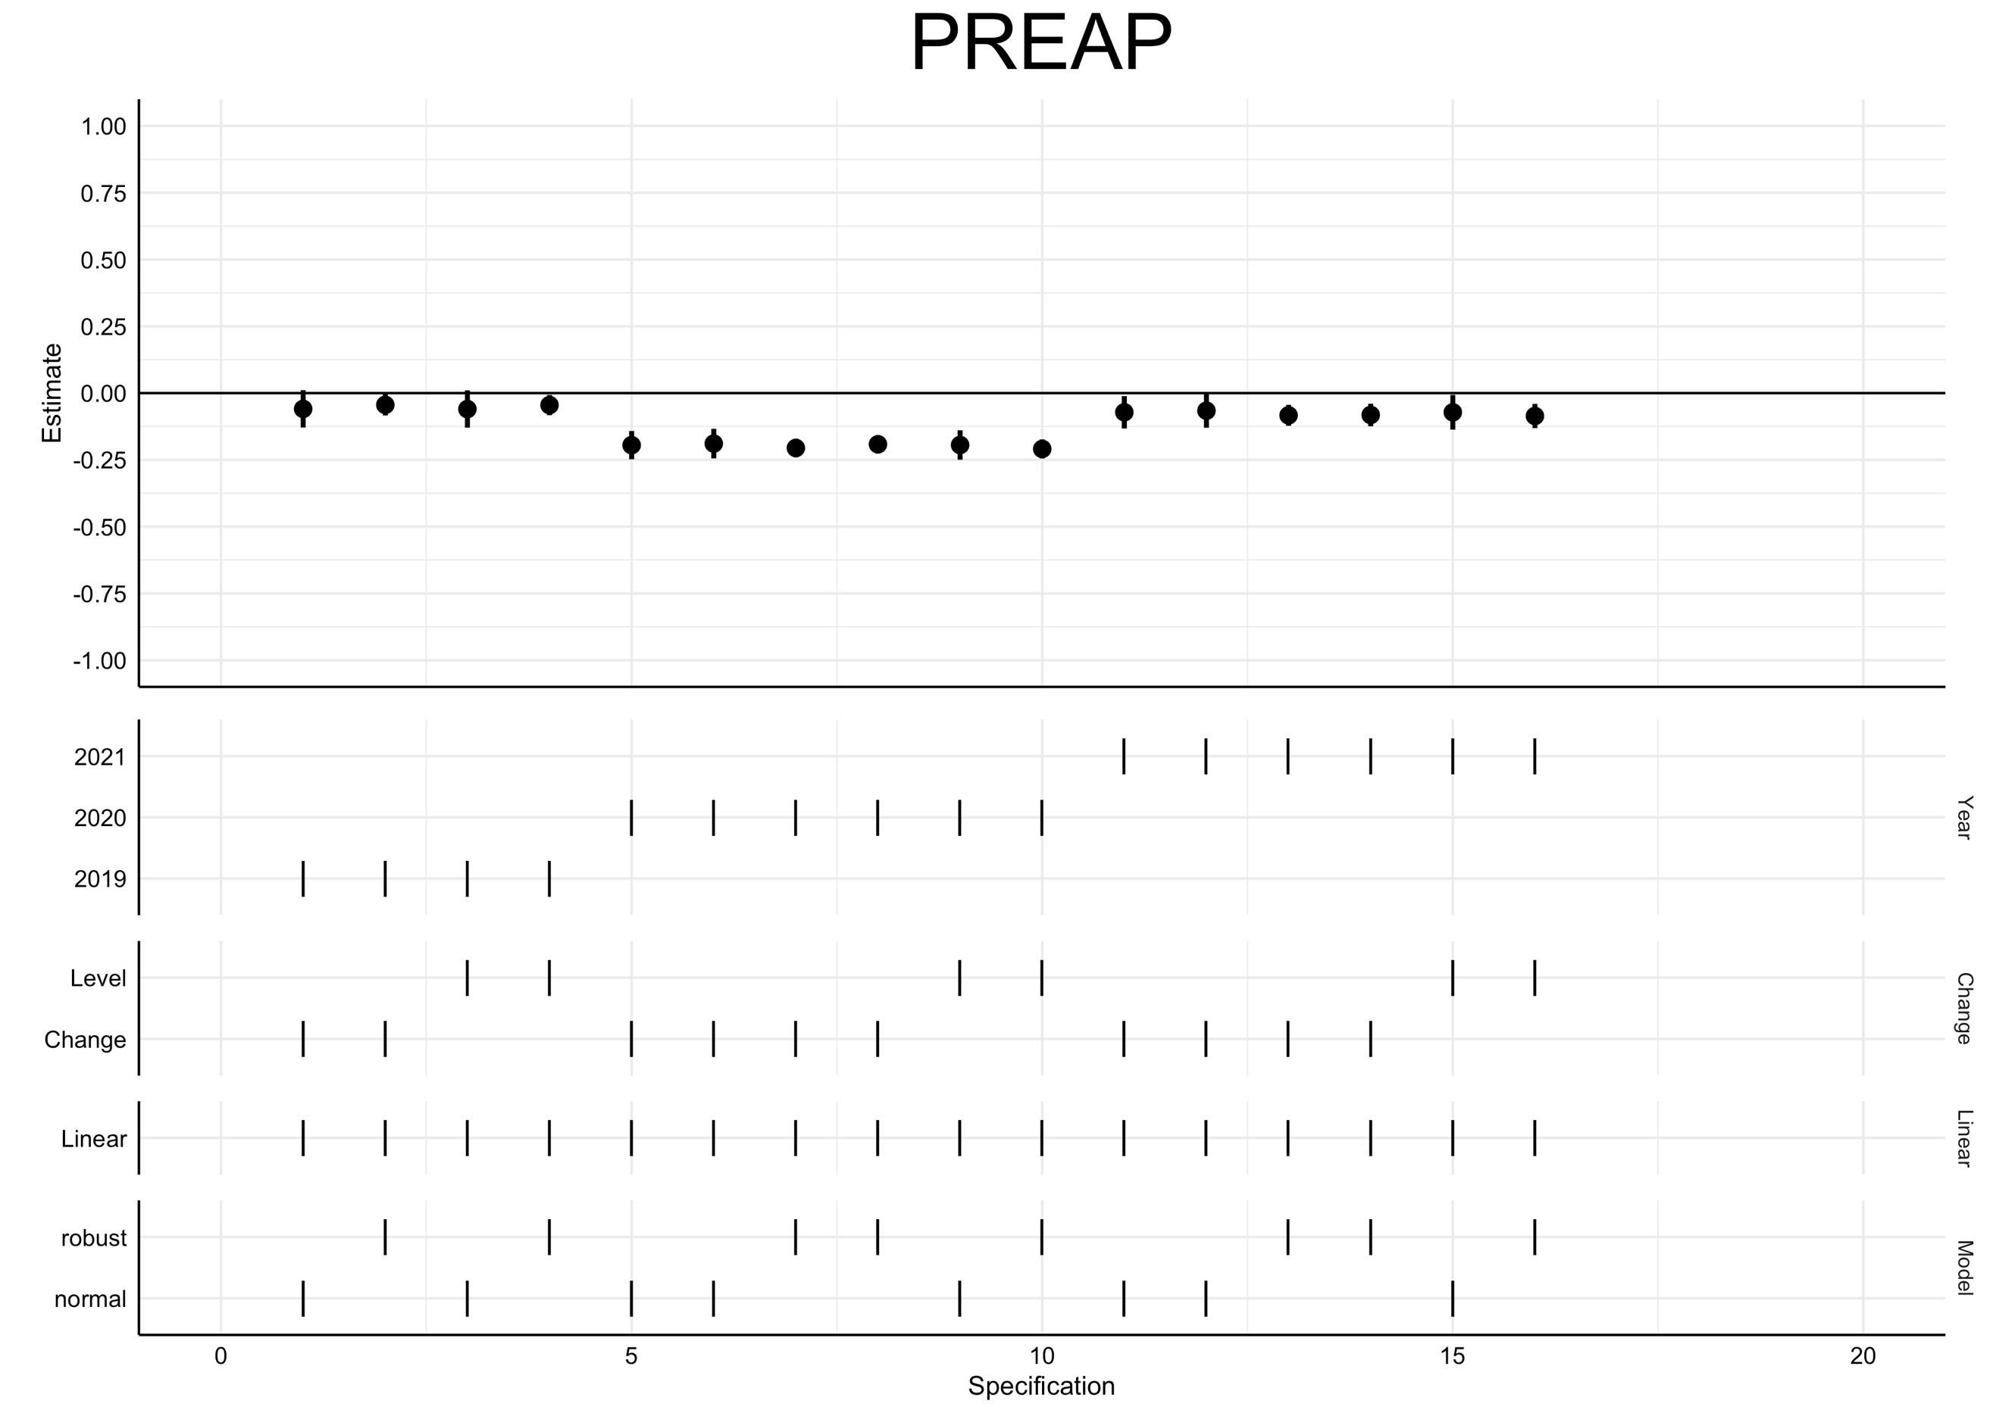
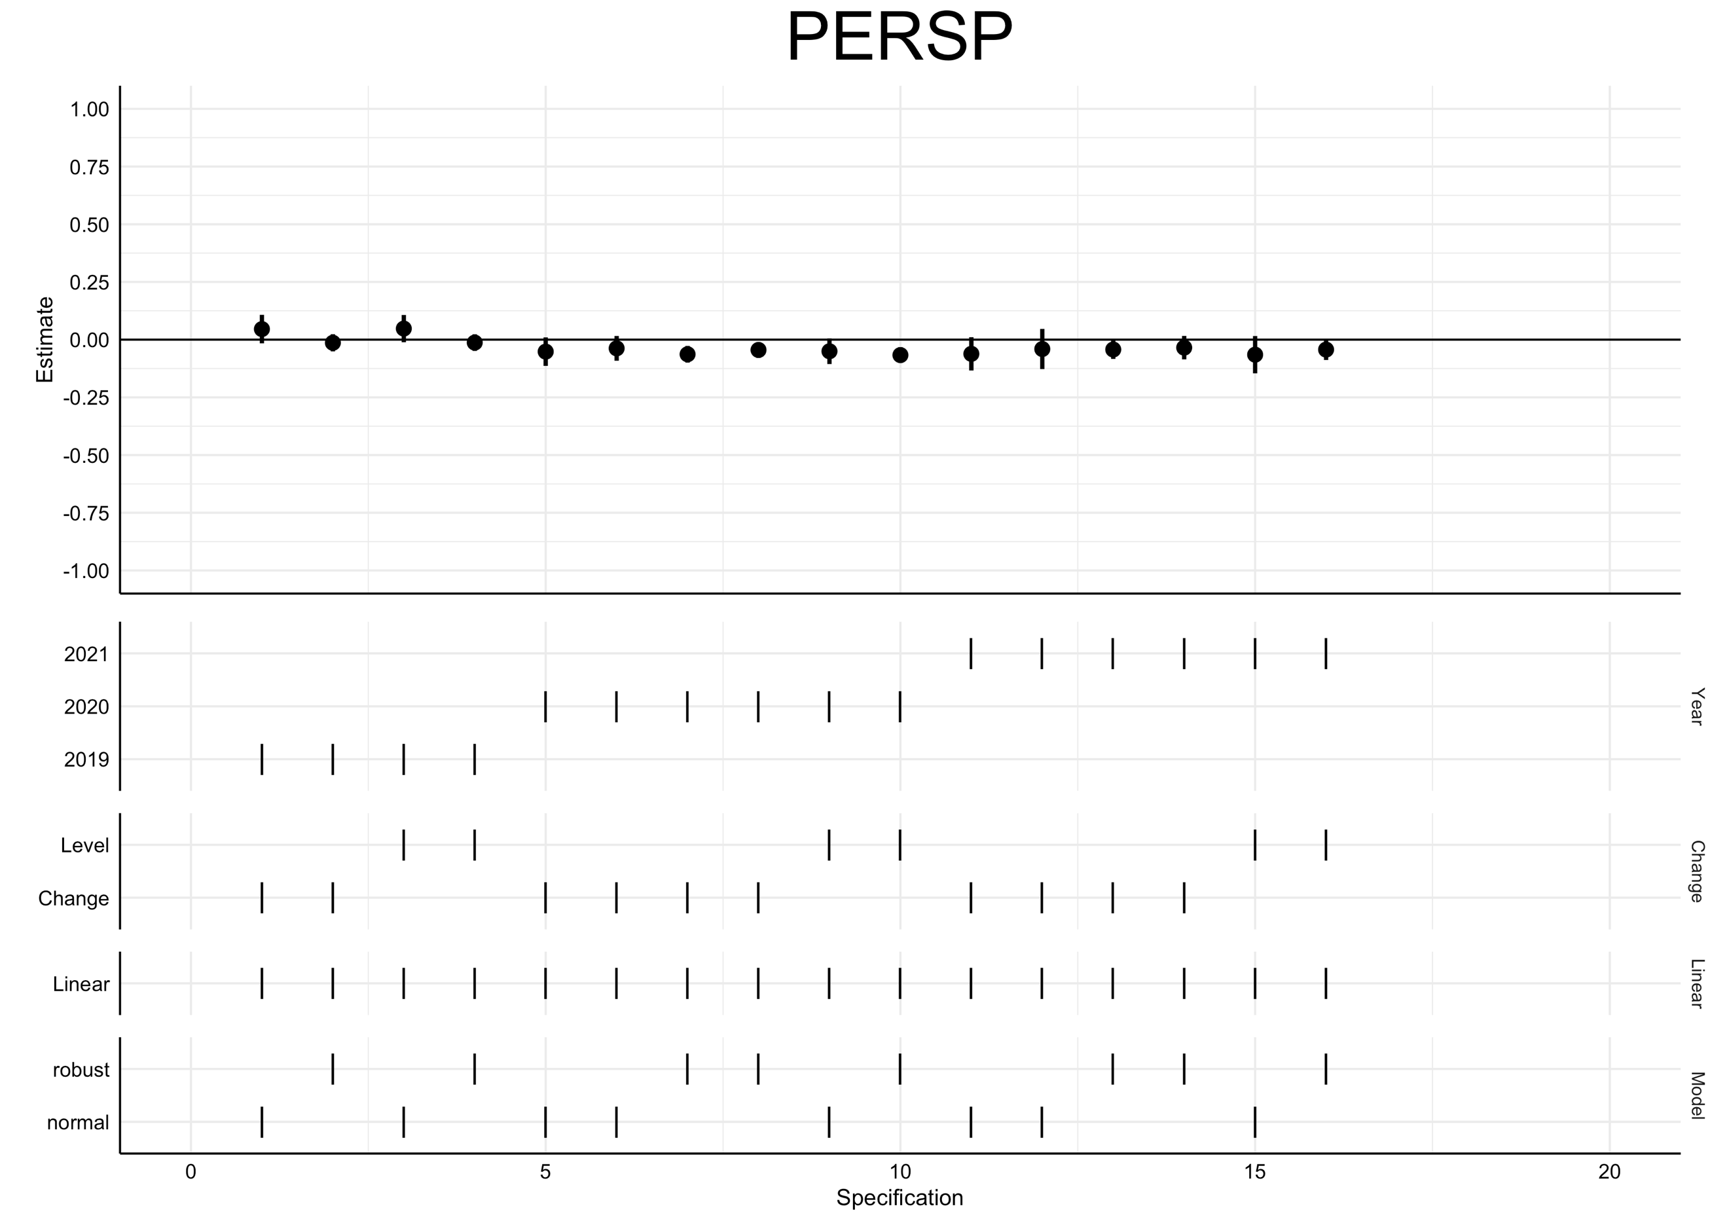
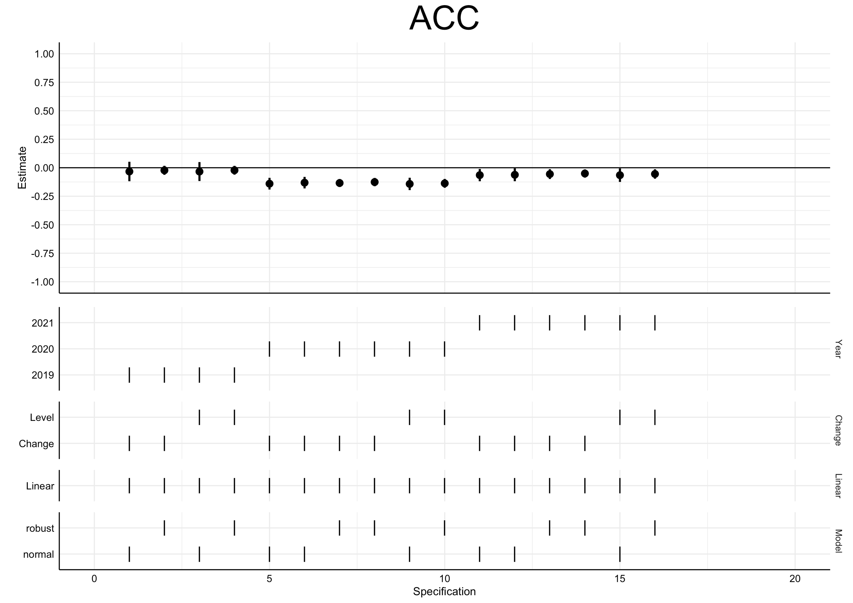
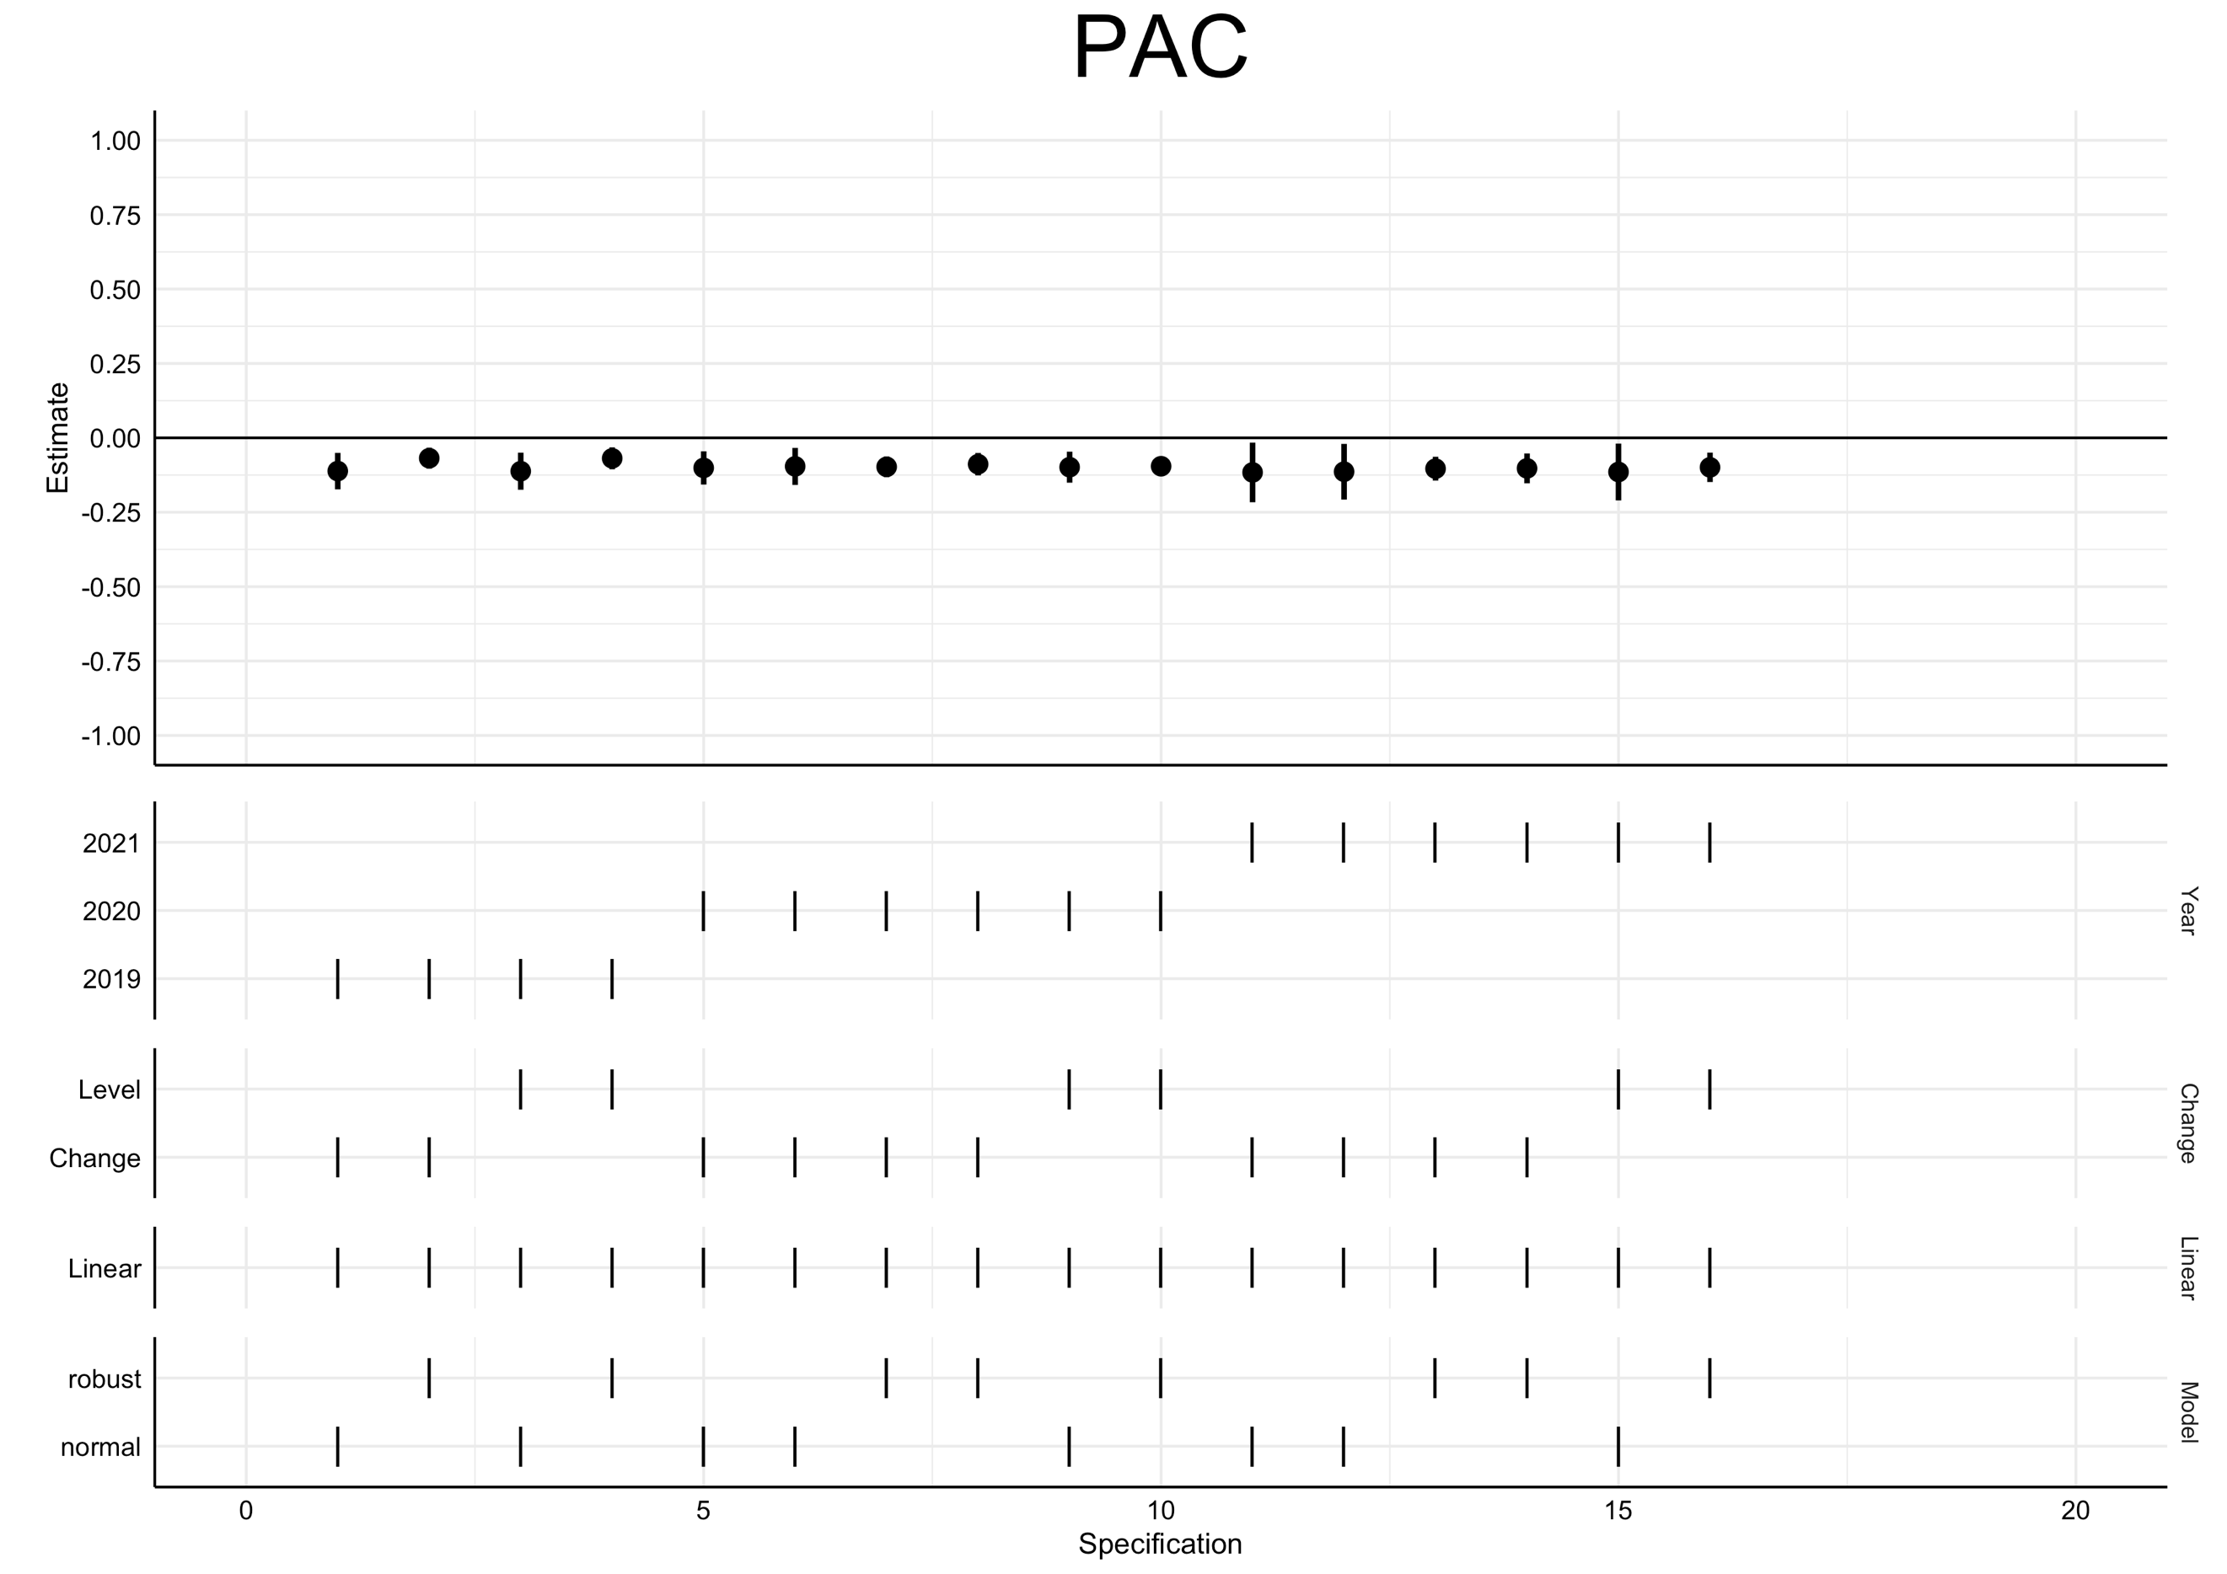
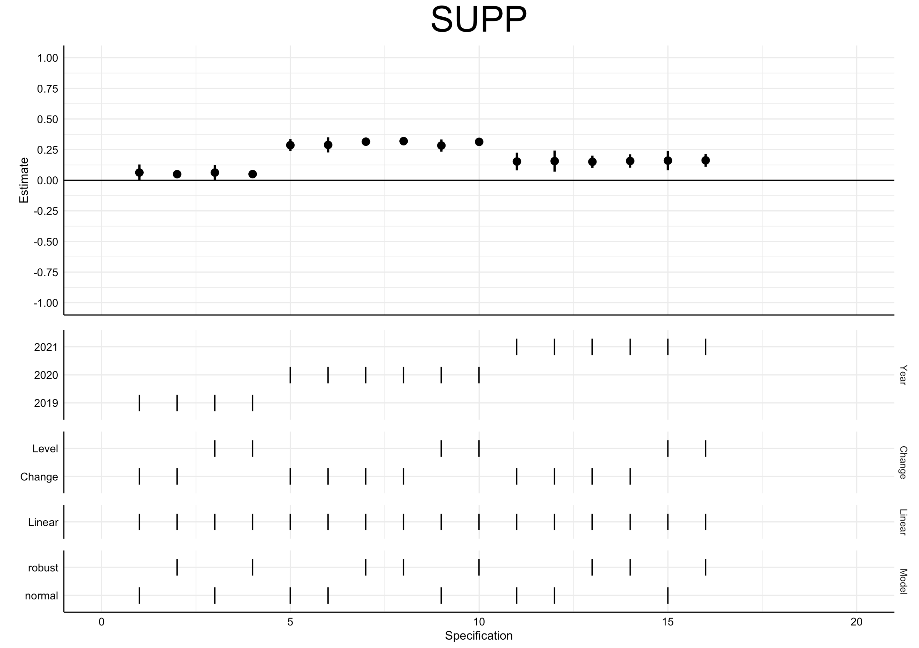
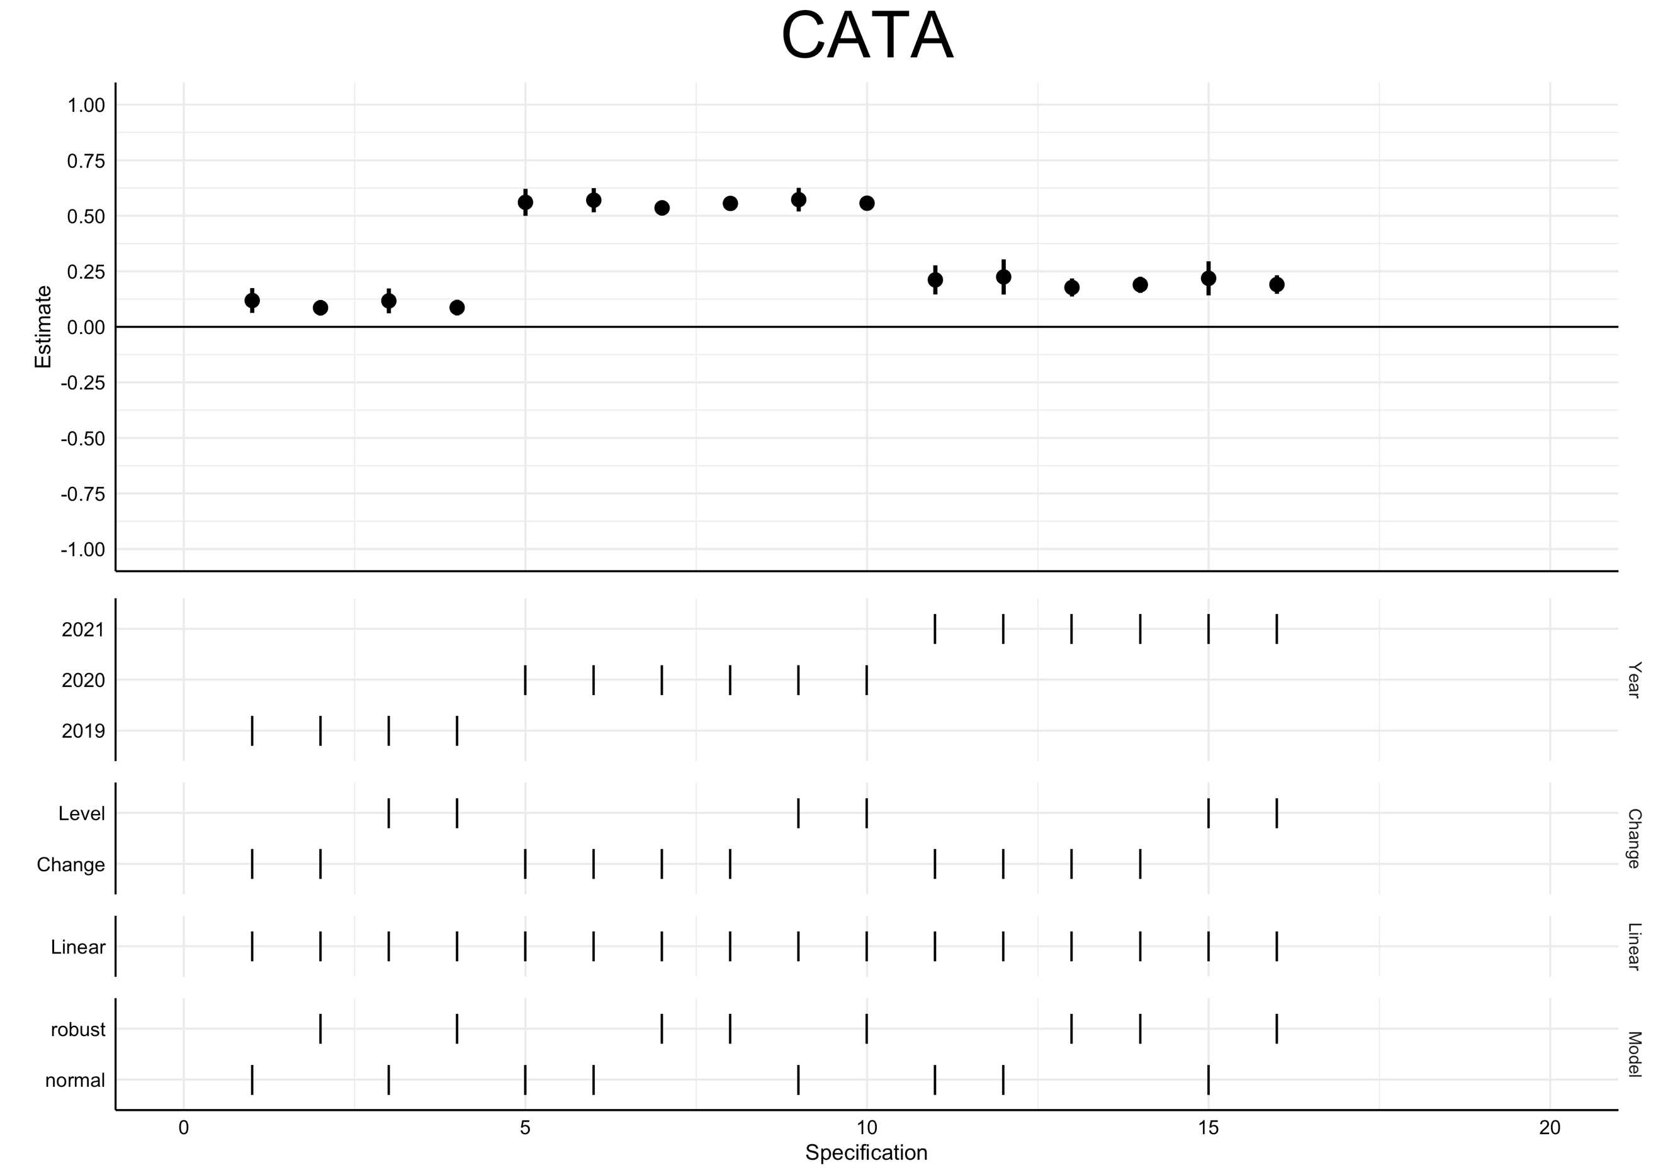
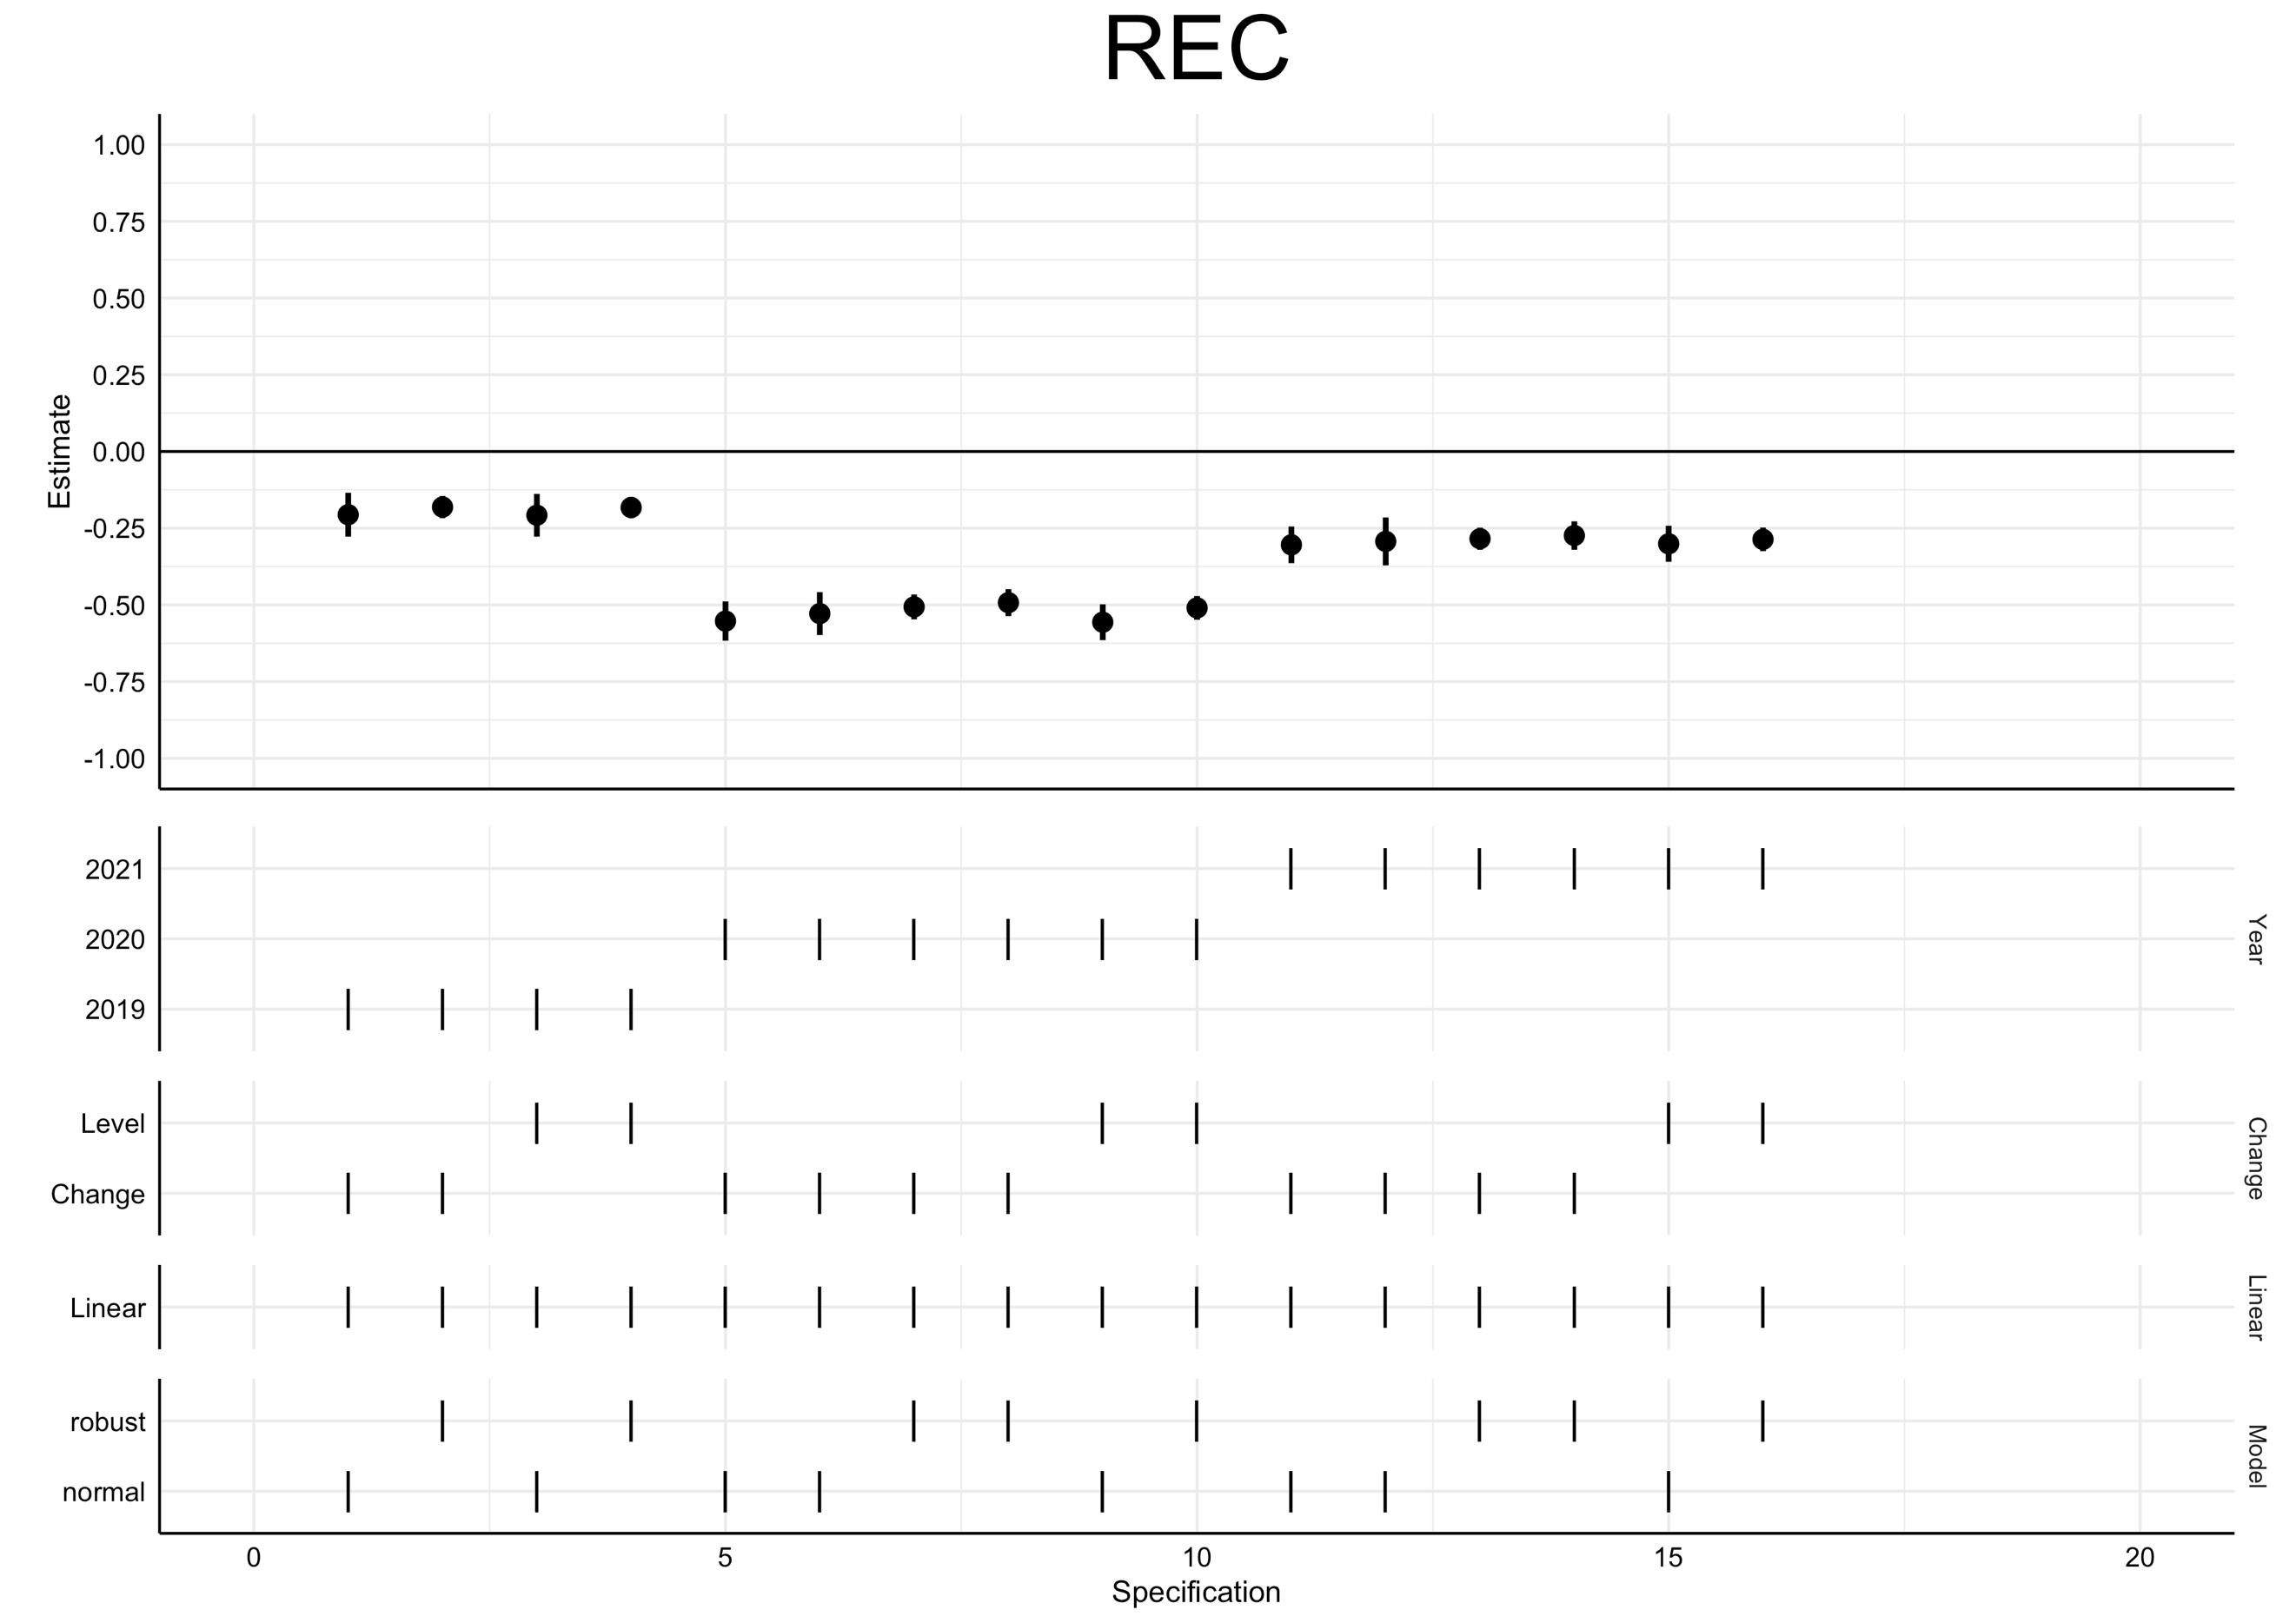
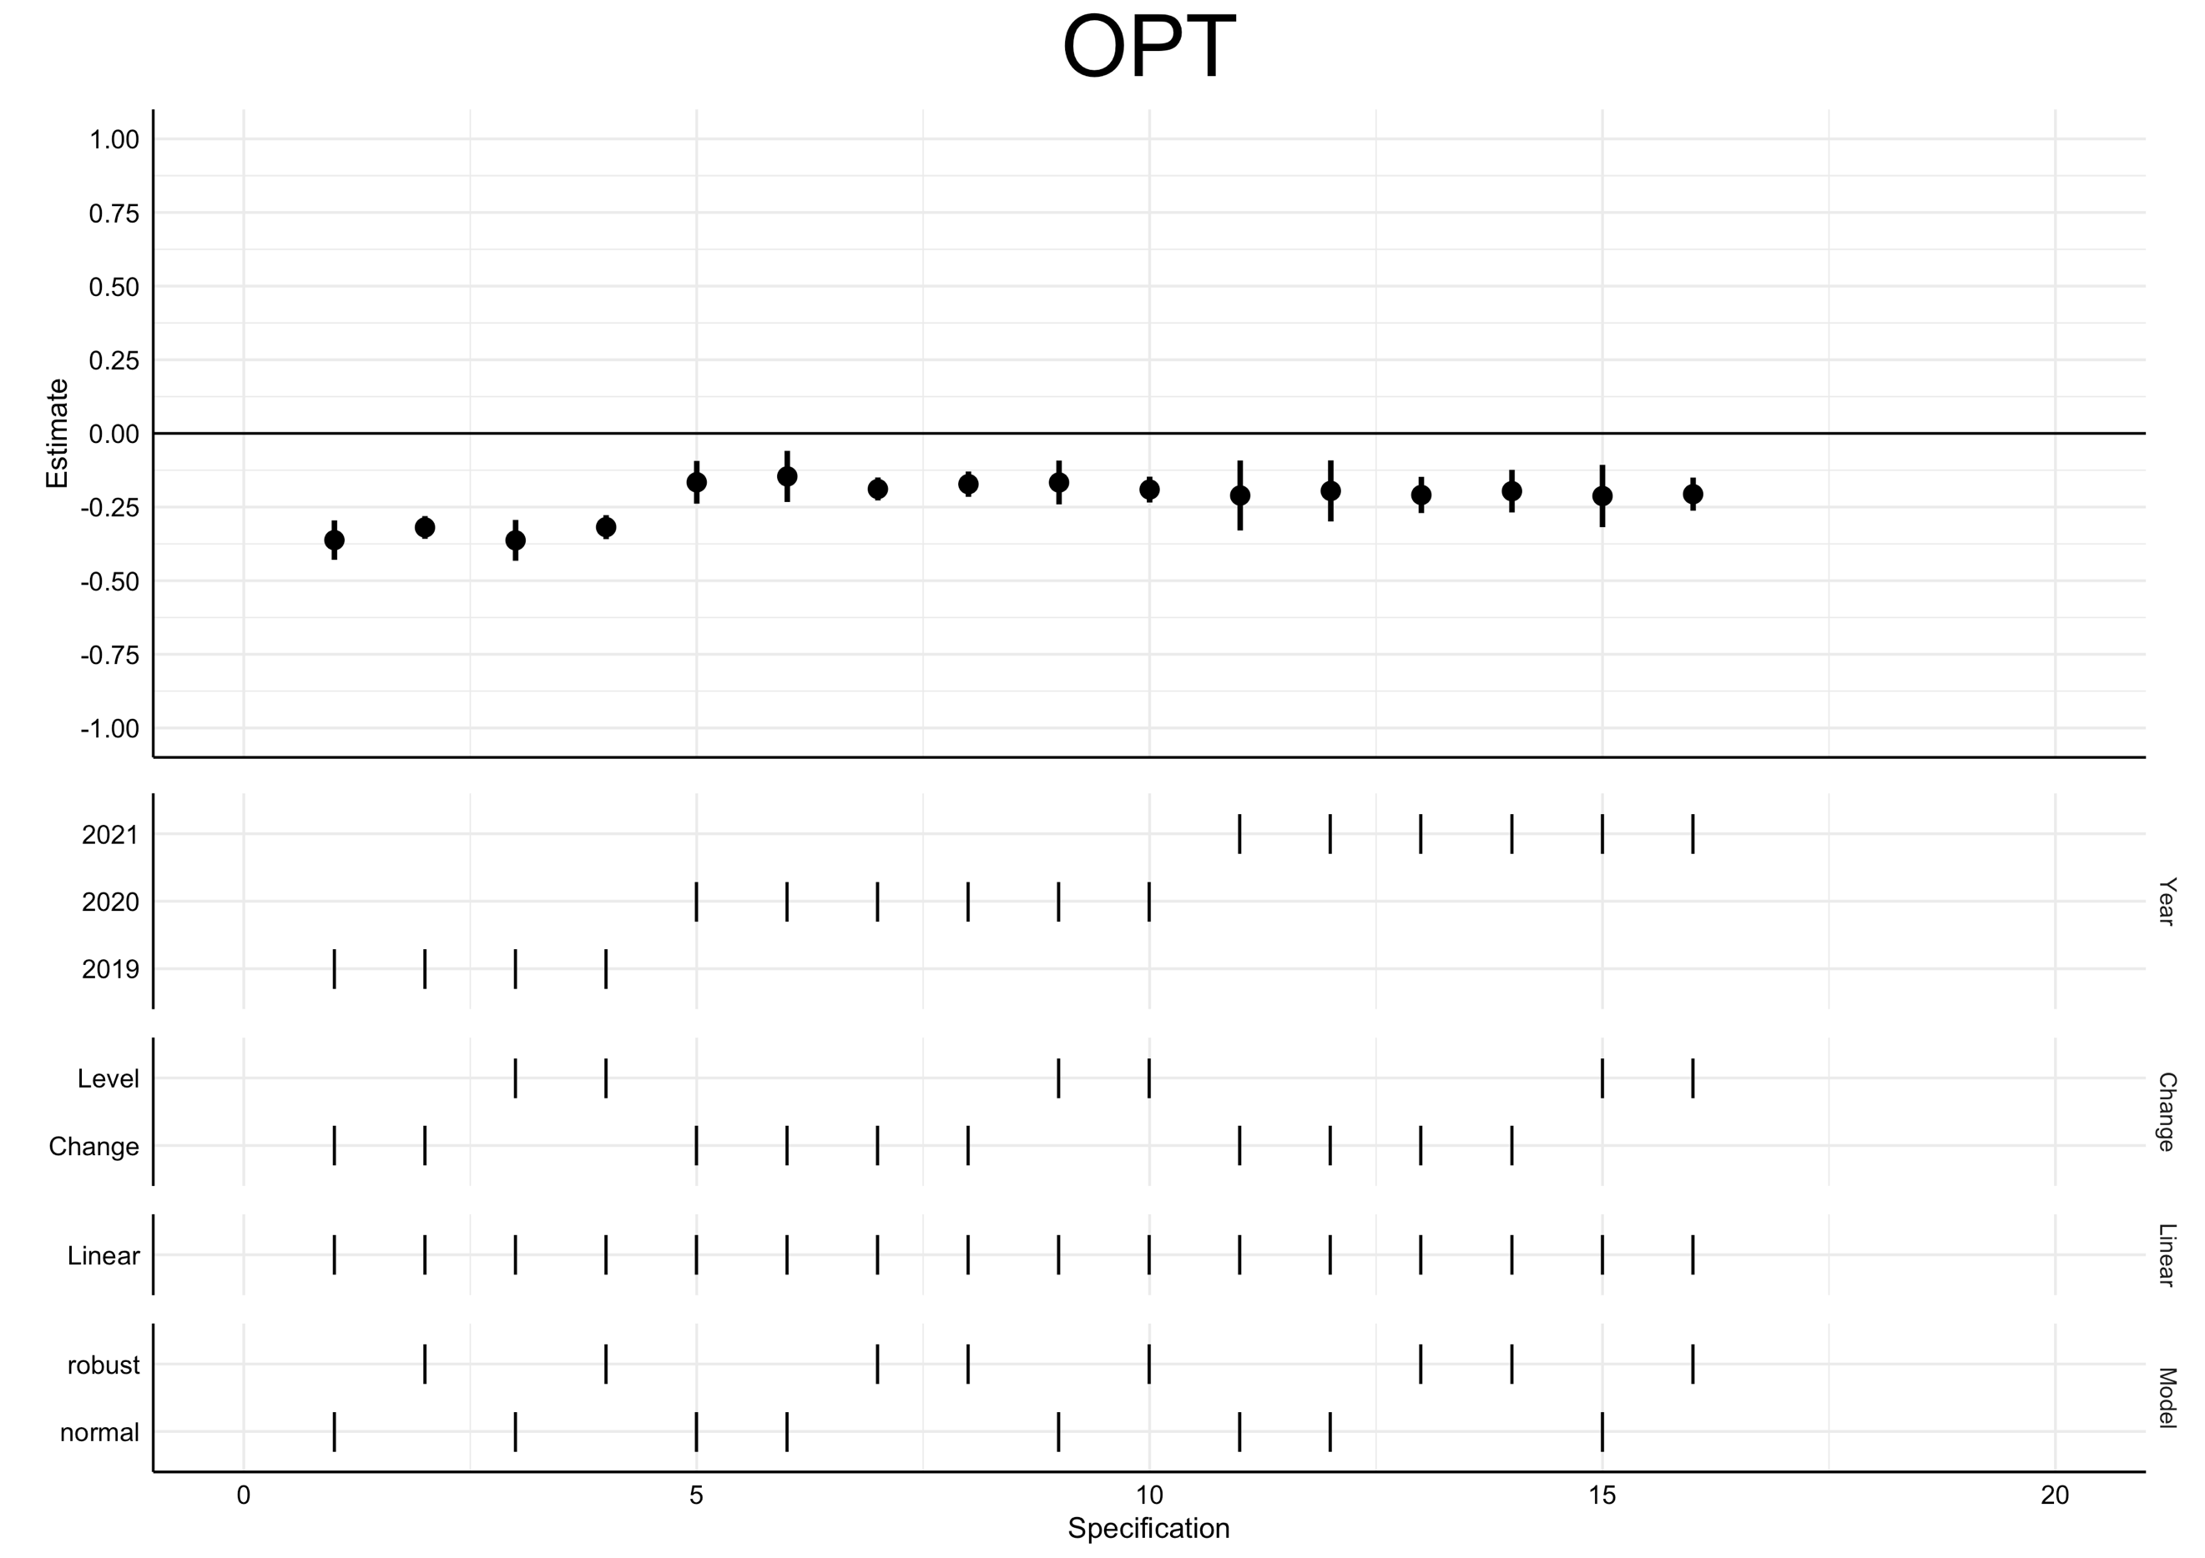
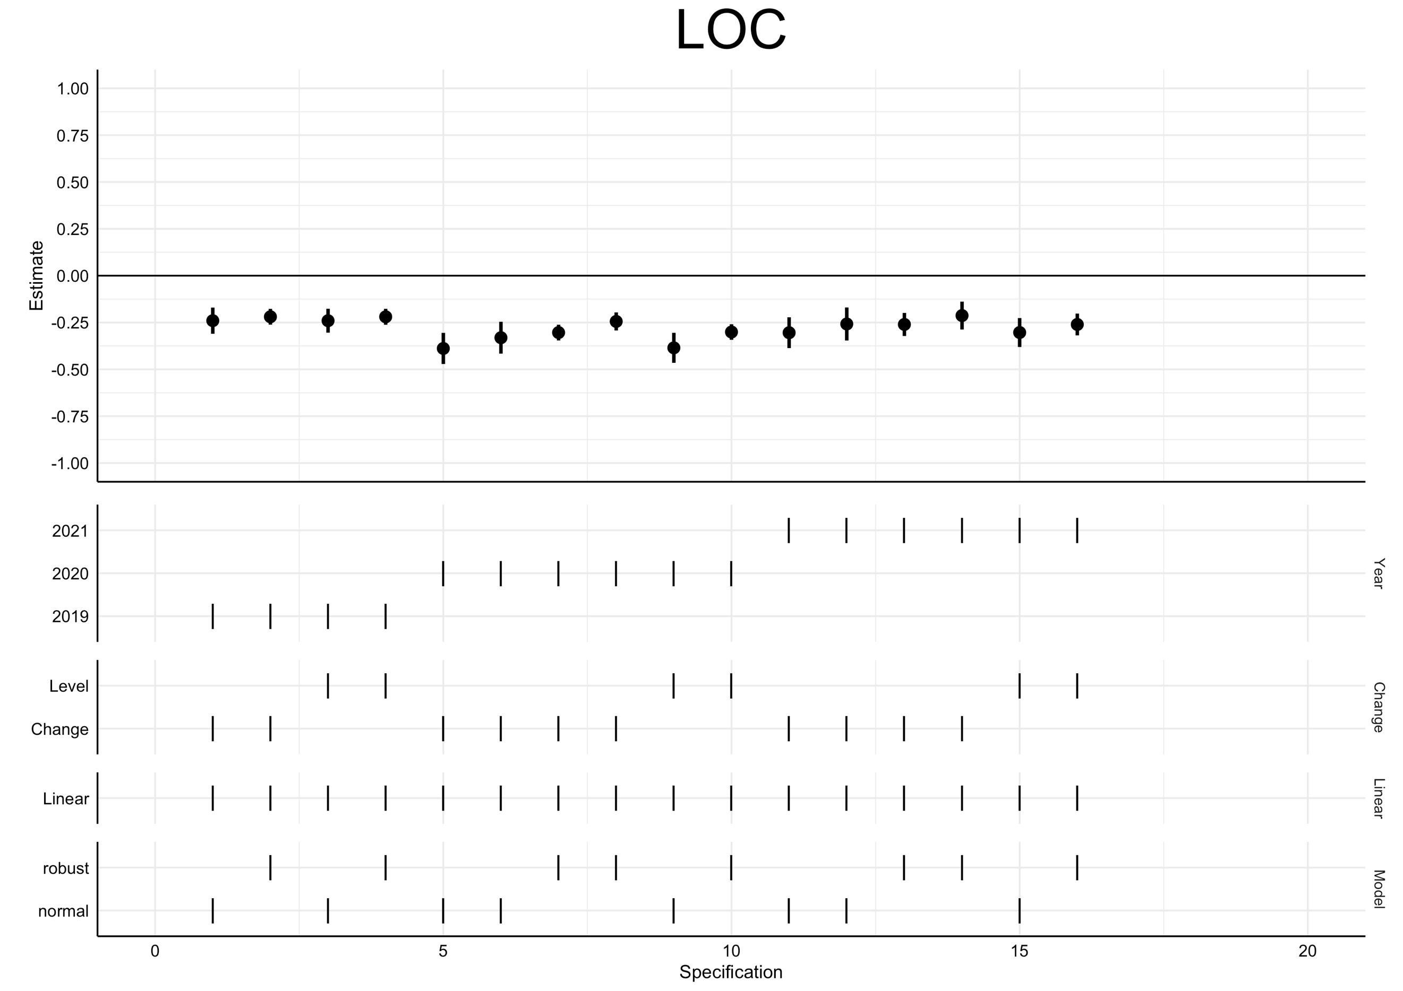
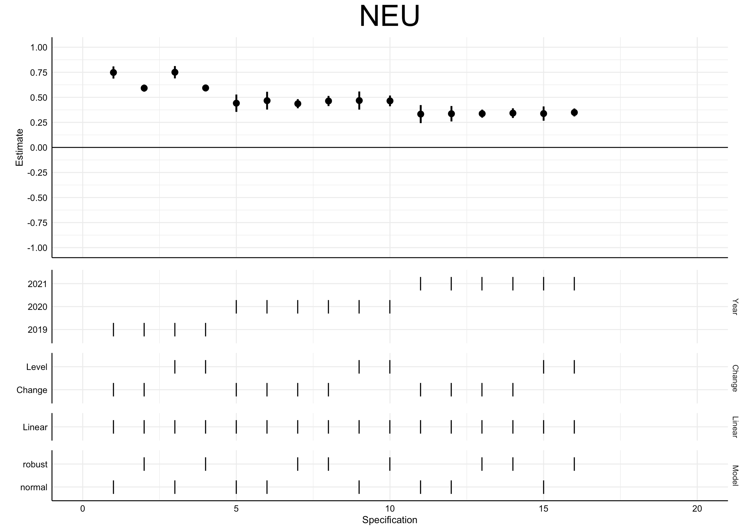

- Linear Mixed Models
To investigate how the psychological factors are associated with PHQ-4 in the individual years (vs. the change between years), we ran linear mixed models with PHQ-4 as the outcome. As fixed effects we included the respective psychological factor, all covariates, year, and the interaction of psychological factor x year, next to a random intercept for subject. Given that we investigated ten psychological factors, this resulted in 10 individual linear mixed models. Results of these mixed models are displayed in Table S9.
For each psychological factor, we then predicted marginal effects at mean±1SD of the respective psychological factor, using the ggeffect() function of the ggeffects R package (Lüdecke et al., 2021), which holds all covariates constant at their respective marginal mean. Results of these predictions are shown in Figure S1. The graphs of Figure S1 can be interpreted as follows, here using the example of neuroticism in 2021: A hypothetical individual whose neuroticism score is exactly at the mean of the entire sample is predicted to have a PHQ-4 score of 2.1. An individual with a neuroticism score exactly one standard deviation lower than the mean will have a PHQ-4 score of 1.6, and an individual with a neuroticism score exactly one standard deviation higher than the mean is expected to have a PHQ-4 score of 2.6.

Table S9
Results of Linear Mixed Models
 | Model 1 | Model 2 | Model 3 | Model 4 | Model 5 | Model 6 | Model 7 | Model 8 | Model 9 | Model 10
(Intercept) | 1.447 (0.108)*** | 1.446 (0.106)*** | 1.435 (0.106)*** | 1.448 (0.106)*** | 1.445 (0.104)*** | 1.516 (0.110)*** | 1.530 (0.106)*** | 1.514 (0.107)*** | 1.478 (0.112)*** | 1.568 (0.101)***
PREAP | -0.120 (0.034)**
PERSP |  | -0.064 (0.034)
ACC |  |  | -0.108 (0.036)*
PAC |  |  |  | -0.096 (0.034)*
SUPP |  |  |  |  | 0.017 (0.036)
CATA |  |  |  |  |  | 0.154 (0.032)***
REC |  |  |  |  |  |  | -0.223 (0.033)***
OPT |  |  |  |  |  |  |  | -0.231 (0.043)**
LOC |  |  |  |  |  |  |  |  | -0.004 (0.003)
NEU |  |  |  |  |  |  |  |  |  | 0.322 (0.038)***
Age: 18-24 | 0.302 (0.215) | 0.317 (0.208) | 0.317 (0.207) | 0.318 (0.208) | 0.259 (0.215) | 0.314 (0.195) | 0.317 (0.203) | 0.331 (0.206) | 0.358 (0.204) | 0.201 (0.211)
Age: 25-34 | 0.272 (0.100) | 0.280 (0.101) | 0.283 (0.100) | 0.280 (0.101) | 0.249 (0.097) | 0.286 (0.100)* | 0.281 (0.099) | 0.285 (0.100)* | 0.287 (0.101) | 0.216 (0.101)
Age: 35-44 | 0.163 (0.157) | 0.159 (0.154) | 0.156 (0.154) | 0.156 (0.153) | 0.149 (0.157) | 0.166 (0.164) | 0.143 (0.152) | 0.178 (0.147) | 0.165 (0.148) | 0.120 (0.159)
Age: 55-64 | -0.006 (0.099) | 0.005 (0.096) | 0.009 (0.097) | 0.001 (0.096) | 0.006 (0.100) | -0.019 (0.106) | 0.005 (0.093) | -0.022 (0.091) | 0.009 (0.095) | 0.026 (0.101)
Age: 65-74 | -0.369 (0.093)** | -0.361 (0.091)** | -0.345 (0.091)** | -0.357 (0.091)** | -0.334 (0.092)** | -0.375 (0.091)*** | -0.347 (0.089)** | -0.386 (0.090)*** | -0.358 (0.090)*** | -0.322 (0.096)*
Age: 75-84 | -0.242 (0.107) | -0.234 (0.107) | -0.213 (0.107) | -0.233 (0.107) | -0.222 (0.108) | -0.280 (0.104) | -0.236 (0.106) | -0.279 (0.110) | -0.241 (0.107) | -0.204 (0.097)
Age: 85+ | -0.038 (0.240) | -0.044 (0.248) | -0.024 (0.250) | -0.043 (0.248) | -0.052 (0.252) | -0.204 (0.239) | -0.064 (0.242) | -0.099 (0.240) | -0.046 (0.255) | 0.033 (0.239)
Gender: female | 0.354 (0.056)*** | 0.341 (0.056)*** | 0.349 (0.056)*** | 0.351 (0.056)*** | 0.336 (0.055)*** | 0.302 (0.055)*** | 0.280 (0.055)*** | 0.344 (0.055)*** | 0.334 (0.055)*** | 0.190 (0.056)**
Household net income: low | 0.391 (0.080)*** | 0.390 (0.080)*** | 0.378 (0.080)*** | 0.390 (0.080)*** | 0.374 (0.080)*** | 0.343 (0.076)*** | 0.342 (0.078)** | 0.373 (0.078)*** | 0.393 (0.081)*** | 0.330 (0.080)**
Household net income: high | -0.118 (0.088) | -0.131 (0.087) | -0.128 (0.088) | -0.131 (0.087) | -0.128 (0.086) | -0.101 (0.088) | -0.101 (0.084) | -0.107 (0.085) | -0.127 (0.087) | -0.097 (0.082)
Education: low | 0.086 (0.098) | 0.103 (0.100) | 0.089 (0.100) | 0.099 (0.100) | 0.121 (0.102) | 0.051 (0.099) | 0.076 (0.100) | 0.097 (0.102) | 0.099 (0.101) | 0.071 (0.097)
Education: high | 0.051 (0.121) | 0.049 (0.122) | 0.052 (0.121) | 0.038 (0.121) | 0.039 (0.120) | 0.072 (0.115) | 0.060 (0.115) | 0.046 (0.121) | 0.044 (0.122) | 0.054 (0.119)
History of diagnosed depression | 1.772 (0.091)*** | 1.784 (0.091)*** | 1.791 (0.091)*** | 1.769 (0.091)*** | 1.766 (0.091)*** | 1.748 (0.090)*** | 1.611 (0.092)*** | 1.597 (0.097)*** | 1.784 (0.091)*** | 1.452 (0.094)***
COVID-19 risk group | 0.224 (0.069)* | 0.235 (0.069)* | 0.239 (0.070)* | 0.229 (0.070)* | 0.248 (0.068)** | 0.204 (0.068) | 0.200 (0.070) | 0.206 (0.071) | 0.235 (0.070)* | 0.176 (0.066)
Year: 2019 | -0.350 (0.035)*** | -0.355 (0.035)*** | -0.350 (0.034)*** | -0.350 (0.034)*** | -0.351 (0.035)*** | -0.352 (0.034)*** | -0.350 (0.034)*** | -0.356 (0.034)*** | -0.343 (0.037)*** | -0.349 (0.035)***
Year: 2020 | 0.309 (0.035)*** | 0.311 (0.035)*** | 0.310 (0.035)*** | 0.312 (0.035)*** | 0.308 (0.035)*** | 0.273 (0.035)*** | 0.313 (0.034)*** | 0.302 (0.034)*** | 0.287 (0.035)*** | 0.302 (0.036)***
Year: 2021 | 0.107 (0.035)* | 0.107 (0.035)* | 0.107 (0.035)* | 0.109 (0.035)* | 0.105 (0.035)* | 0.093 (0.035) | 0.107 (0.034)* | 0.108 (0.034)* | 0.074 (0.036) | 0.092 (0.036)
PREAP*year: 2019 | 0.017 (0.032)
PREAP*year: 2020 | -0.142 (0.032)***
PREAP*year: 2021 | -0.010 (0.033)
PERSP*year: 2019 |  | 0.097 (0.034)
PERSP*year: 2020 |  | 0.001 (0.035)
PERSP*year: 2021 |  | -0.006 (0.035)
ACC*year: 2019 |  |  | 0.056 (0.032)
ACC*year: 2020 |  |  | -0.053 (0.033)
ACC*year: 2021 |  |  | 0.001 (0.032)
PAC*year: 2019 |  |  |  | -0.056 (0.032)
PAC*year: 2020 |  |  |  | -0.026 (0.032)
PAC*year: 2021 |  |  |  | -0.063 (0.033)
SUPP*year: 2019 |  |  |  |  | 0.049 (0.035)
SUPP*year: 2020 |  |  |  |  | 0.304 (0.037)***
SUPP*year: 2021 |  |  |  |  | 0.208 (0.038)***
CATA*year: 2019 |  |  |  |  |  | 0.008 (0.029)
CATA*year: 2020 |  |  |  |  |  | 0.444 (0.032)***
CATA*year: 2021 |  |  |  |  |  | 0.143 (0.032)***
REC*year: 2019 |  |  |  |  |  |  | -0.012 (0.032)
REC*year: 2020 |  |  |  |  |  |  | -0.319 (0.041)***
REC*year: 2021 |  |  |  |  |  |  | -0.178 (0.034)***
OPT*year: 2019 |  |  |  |  |  |  |  | -0.163 (0.035)**
OPT*year: 2020 |  |  |  |  |  |  |  | 0.062 (0.036)
OPT*year: 2021 |  |  |  |  |  |  |  | -0.011 (0.038)
LOC*year: 2019 |  |  |  |  |  |  |  |  | 0.001 (0.003)
LOC*year: 2020 |  |  |  |  |  |  |  |  | 0.004 (0.003)
LOC*year: 2021 |  |  |  |  |  |  |  |  | 0.004 (0.003)
NEU*year: 2019 |  |  |  |  |  |  |  |  |  | 0.337 (0.036)***
NEU*year: 2020 |  |  |  |  |  |  |  |  |  | 0.035 (0.046)
NEU*year: 2021 |  |  |  |  |  |  |  |  |  | 0.118 (0.040)
Observations | 24542 | 24542 | 24542 | 24542 | 24542 | 24542 | 24542 | 24542 | 24542 | 24542

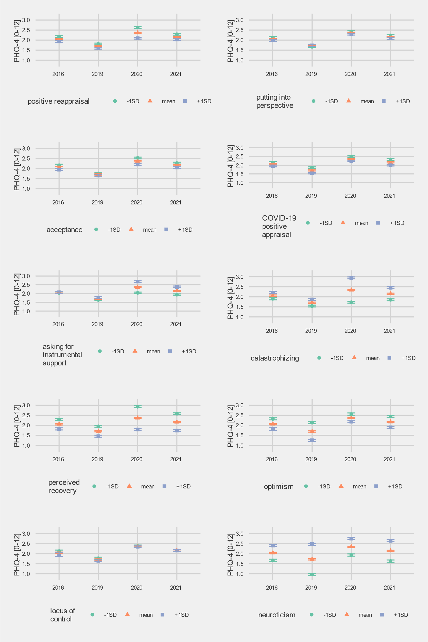

Figure S1. Predicted PHQ-4 levels in the individual years are displayed for a hypothetical individual with average values (orange triangle), or values one standard deviation below (green circle) or above (violet square) the mean regarding the respective psychological factor. All covariates are held constant at their marginal mean.
References
Breslau, J., Finucane, M. L., Locker, A. R., Baird, M. D., Roth, E. A., & Collins, R. L. (2020). A longitudinal study of psychological distress in the United States before and during the COVID-19 pandemic. Preventive Medicine, 106362. https://doi.org/10.1016/j.ypmed.2020.106362
Cheng, Z., Mendolia, S., Paloyo, A. R., Savage, D. A., & Tani, M. (2021). Working parents, financial insecurity, and childcare: Mental health in the time of COVID-19 in the UK. Review of Economics of the Household, 1–22. https://doi.org/10.1007/s11150-020-09538-3
Chmitorz, A., Wenzel, M., Stieglitz, R.-D., Kunzler, A., Bagusat, C., Helmreich, I., Gerlicher, A., Kampa, M., Kubiak, T., Kalisch, R., Lieb, K., & Tüscher, O. (2018). Population-based validation of a German version of the Brief Resilience Scale. PLOS ONE, 13(2), e0192761. https://doi.org/10.1371/journal.pone.0192761
Daly, M., & Robinson, E. (2020). Psychological distress and adaptation to the COVID-19 crisis in the United States. Journal of Psychiatric Research. https://doi.org/10.1016/j.jpsychires.2020.10.035
Daly, M., Sutin, A. R., & Robinson, E. (2020). Longitudinal changes in mental health and the COVID-19 pandemic: Evidence from the UK Household Longitudinal Study. Psychological Medicine, 1–10. https://doi.org/10.1017/S0033291720004432
Daly, M., Sutin, A. R., & Robinson, E. (2021). Depression reported by US adults in 2017-2018 and March and April 2020. Journal of Affective Disorders, 278, 131–135. https://doi.org/10.1016/j.jad.2020.09.065
Dawel, A., Shou, Y., Smithson, M., Cherbuin, N., Banfield, M., Calear, A. L., Farrer, L. M., Gray, D., Gulliver, A., Housen, T., McCallum, S. M., Morse, A. R., Murray, K., Newman, E., Rodney Harris, R. M., & Batterham, P. J. (2020). The Effect of COVID-19 on Mental Health and Wellbeing in a Representative Sample of Australian Adults. Frontiers in Psychiatry, 11, 579985. https://doi.org/10.3389/fpsyt.2020.579985
Du, J., Boss, J., Han, P., Beesley, L. J., Goutman, S. A., Batterman, S., Feldman, E. L., & Mukherjee, B. (2020). Variable selection with multiply-imputed datasets: Choosing between stacked and grouped methods. ArXiv:2003.07398 [Stat]. http://arxiv.org/abs/2003.07398
Ettman, C. K., Abdalla, S. M., Cohen, G. H., Sampson, L., Vivier, P. M., & Galea, S. (2020). Prevalence of Depression Symptoms in US Adults Before and During the COVID-19 Pandemic. JAMA Network Open, 3(9), e2019686. https://doi.org/10.1001/jamanetworkopen.2020.19686
Friedman, J., Hastie, T., & Tibshirani, R. (2010). Regularization Paths for Generalized Linear Models via Coordinate Descent. Journal of Statistical Software, 33(1). https://doi.org/10.18637/jss.v033.i01
Hastie, T., Tibshirani, R., & Wainwright, M. (2015). Statistical Learning with Sparsity: The Lasso and Generalizations. CRC Press.
Holman, E. A., Thompson, R. R., Garfin, D. R., & Silver, R. C. (2020). The unfolding COVID-19 pandemic: A probability-based, nationally representative study of mental health in the United States. Science Advances, 6(42). https://doi.org/10.1126/sciadv.abd5390
Kalisch, R., Köber, G., Binder, H., Ahrens, K. F., Basten, U., Chmitorz, A., Fiebach, C., Goldbach, N., Horstmann, R., Kampa, M., Kollmann, B., Lieb, P. D. K., Plichta, M., Reif, A., Schick, A., Sebastian, A., Wessa, M., Yuen, K., Tüscher, O., & Engen, H. (2020). A generic solution for the operationalization and measurement of resilience and resilience processes in longitudinal observations: Rationale and basic design of the MARP and LORA studies. PsyArXiv. https://doi.org/10.31234/osf.io/jg238
Kampa, M., Schick, A., Sebastian, A., Wessa, M., Tüscher, O., Kalisch, R., & Yuen, K. (2020). Replication of fMRI group activations in the neuroimaging battery for the Mainz Resilience Project (MARP). NeuroImage, 204, 116223. https://doi.org/10.1016/j.neuroimage.2019.116223
Kampa, M., Schick, A., Yuen, K., Sebastian, A., Chmitorz, A., Saase, V., Wessa, M., Tüscher, O., & Kalisch, R. (2018). A Combined Behavioral and Neuroimaging Battery to Test Positive Appraisal Style Theory of Resilience in Longitudinal Studies (p. 470435). https://doi.org/10.1101/470435
Krstajic, D., Buturovic, L. J., Leahy, D. E., & Thomas, S. (2014). Cross-validation pitfalls when selecting and assessing regression and classification models. Journal of Cheminformatics, 6(1), 10. https://doi.org/10.1186/1758-2946-6-10
Lüdecke, D., Aust, F., Crawley, S., & Ben-Shachar, M. S. (2021). ggeffects: Create Tidy Data Frames of Marginal Effects for “ggplot” from Model Outputs (1.1.1) [Computer software]. https://CRAN.R-project.org/package=ggeffects
Niedzwiedz, C. L., Green, M. J., Benzeval, M., Campbell, D., Craig, P., Demou, E., Leyland, A., Pearce, A., Thomson, R., Whitley, E., & Katikireddi, S. V. (2020). Mental health and health behaviours before and during the initial phase of the COVID-19 lockdown: Longitudinal analyses of the UK Household Longitudinal Study. Journal of Epidemiology and Community Health. https://doi.org/10.1136/jech-2020-215060
Peters, A., Rospleszcz, S., Greiser, K. H., Dallavalle, M., & Berger, K. (2020). The Impact of the COVID-19 Pandemic on Self-Reported Health. Deutsches Aerzteblatt Online. https://doi.org/10.3238/arztebl.2020.0861
Pieh, C., Budimir, S., & Probst, T. (2020). The effect of age, gender, income, work, and physical activity on mental health during coronavirus disease (COVID-19) lockdown in Austria. Journal of Psychosomatic Research, 136, 110186. https://doi.org/10.1016/j.jpsychores.2020.110186
Pierce, M., Hope, H., Ford, T., Hatch, S., Hotopf, M., John, A., Kontopantelis, E., Webb, R., Wessely, S., McManus, S., & Abel, K. M. (2020). Mental health before and during the COVID-19 pandemic: A longitudinal probability sample survey of the UK population. The Lancet Psychiatry, 7(10), 883–892. https://doi.org/10.1016/S2215-0366(20)30308-4
Rix, A., & Du, J. (2020). miselect: Variable Selection for Multiply Imputed Data (0.9.0) [Computer software]. https://CRAN.R-project.org/package=miselect
Sauerbrei, W., Buchholz, A., Boulesteix, A.-L., & Binder, H. (2015). On stability issues in deriving multivariable regression models. Biometrical Journal, 57(4), 531–555. https://doi.org/10.1002/bimj.201300222
Sibley, C. G., Greaves, L. M., Satherley, N., Wilson, M. S., Overall, N. C., Lee, C. H. J., Milojev, P., Bulbulia, J., Osborne, D., Milfont, T. L., Houkamau, C. A., Duck, I. M., Vickers-Jones, R., & Barlow, F. K. (2020). Effects of the COVID-19 pandemic and nationwide lockdown on trust, attitudes toward government, and well-being. The American Psychologist, 75(5), 618–630. https://doi.org/10.1037/amp0000662
Simonsohn, U., Simmons, J. P., & Nelson, L. D. (2020). Specification curve analysis. Nature Human Behaviour, 4(11), 1208–1214. https://doi.org/10.1038/s41562-020-0912-z
Steegen, S., Tuerlinckx, F., Gelman, A., & Vanpaemel, W. (2016). Increasing Transparency Through a Multiverse Analysis. Perspectives on Psychological Science, 11(5), 702–712. https://doi.org/10.1177/1745691616658637
Twenge, J. M., & Joiner, T. E. (2020). Mental distress among U.S. adults during the COVID-19 pandemic. Journal of Clinical Psychology, 76(12), 2170–2182. https://doi.org/10.1002/jclp.23064
van der Velden, P. G., Contino, C., Das, M., van Loon, P., & Bosmans, M. W. G. (2020). Anxiety and depression symptoms, and lack of emotional support among the general population before and during the COVID-19 pandemic. A prospective national study on prevalence and risk factors. Journal of Affective Disorders, 277, 540–548. https://doi.org/10.1016/j.jad.2020.08.026
Winkler, P., Formanek, T., Mlada, K., Kagstrom, A., Mohrova, Z., Mohr, P., & Csemy, L. (2020). Increase in prevalence of current mental disorders in the context of COVID-19: Analysis of repeated nationwide cross-sectional surveys. Epidemiology and Psychiatric Sciences, 29, e173. https://doi.org/10.1017/S2045796020000888
Zajacova, A., Jehn, A., Stackhouse, M., Choi, K. H., Denice, P., Haan, M., & Ramos, H. (2020). Mental health and economic concerns from March to May during the COVID-19 pandemic in Canada: Insights from an analysis of repeated cross-sectional surveys. SSM - Population Health, 12, 100704. https://doi.org/10.1016/j.ssmph.2020.100704

