Risk thresholds for the association between frequency of cannabis use and the development of psychosis: A systematic review and meta-analysis

Supplementary Materials

eTable 1. PRISMA 2020 Checklist
eMethods 1. Database Search Strategies
eMethods 2. Full text exclusions and reasoning
eTable 2. Risk of Bias Assessments
eFigure 1. Additional Heterogeneity Assessment
eFigure 2. Funnel Plot Tests for Publication Bias
eTable 3. Certainty of the Evidence Assessment Using the GRADE Approach

eTable 1. PRISMA 2020 Checklist

Section and Topic | Item # | Checklist item | Location where item is reported
TITLE
Title | 1 | Identify the report as a systematic review. | Page 1
ABSTRACT
Abstract | 2 | See the PRISMA 2020 for Abstracts checklist. | Page 3
INTRODUCTION
Rationale | 3 | Describe the rationale for the review in the context of existing knowledge. | Page 5–7
Objectives | 4 | Provide an explicit statement of the objective(s) or question(s) the review addresses. | Page 7
METHODS
Eligibility criteria | 5 | Specify the inclusion and exclusion criteria for the review and how studies were grouped for the syntheses. | Page 8-9
Information sources | 6 | Specify all databases, registers, websites, organisations, reference lists and other sources searched or consulted to identify studies. Specify the date when each source was last searched or consulted. | Page 8
Search strategy | 7 | Present the full search strategies for all databases, registers and websites, including any filters and limits used. | Supplementary eMethods 1
Selection process | 8 | Specify the methods used to decide whether a study met the inclusion criteria of the review, including how many reviewers screened each record and each report retrieved, whether they worked independently, and if applicable, details of automation tools used in the process. | Page 9
Data collection process | 9 | Specify the methods used to collect data from reports, including how many reviewers collected data from each report, whether they worked independently, any processes for obtaining or confirming data from study investigators, and if applicable, details of automation tools used in the process. | Page 9-10
Data items | 10a | List and define all outcomes for which data were sought. Specify whether all results that were compatible with each outcome domain in each study were sought (e.g. for all measures, time points, analyses), and if not, the methods used to decide which results to collect. | Page 9-10
 | 10b | List and define all other variables for which data were sought (e.g. participant and intervention characteristics, funding sources). Describe any assumptions made about any missing or unclear information. | Page 9-10
Study risk of bias assessment | 11 | Specify the methods used to assess risk of bias in the included studies, including details of the tool(s) used, how many reviewers assessed each study and whether they worked independently, and if applicable, details of automation tools used in the process. | Page 11
Effect measures | 12 | Specify for each outcome the effect measure(s) (e.g. risk ratio, mean difference) used in the synthesis or presentation of results. | Page 10
Synthesis methods | 13a | Describe the processes used to decide which studies were eligible for each synthesis (e.g. tabulating the study intervention characteristics and comparing against the planned groups for each synthesis (item #5)). | Page 10
 | 13b | Describe any methods required to prepare the data for presentation or synthesis, such as handling of missing summary statistics, or data conversions. | Page 10-11
 | 13c | Describe any methods used to tabulate or visually display results of individual studies and syntheses. | Table 2 /  Figure 2  Figure 3
 | 13d | Describe any methods used to synthesize results and provide a rationale for the choice(s). If meta-analysis was performed, describe the model(s), method(s) to identify the presence and extent of statistical heterogeneity, and software package(s) used. | Page 10-11
 | 13e | Describe any methods used to explore possible causes of heterogeneity among study results (e.g. subgroup analysis, meta-regression). | Supplemental eFigure 1
 | 13f | Describe any sensitivity analyses conducted to assess robustness of the synthesized results. | Page 10-11
Reporting bias assessment | 14 | Describe any methods used to assess risk of bias due to missing results in a synthesis (arising from reporting biases). | Page 11
Certainty assessment | 15 | Describe any methods used to assess certainty (or confidence) in the body of evidence for an outcome. | Page 11
RESULTS
Study selection | 16a | Describe the results of the search and selection process, from the number of records identified in the search to the number of studies included in the review, ideally using a flow diagram. | Page 12  Figure 1
 | 16b | Cite studies that might appear to meet the inclusion criteria, but which were excluded, and explain why they were excluded. | Supplemental  eMethods 2
Study characteristics | 17 | Cite each included study and present its characteristics. | Page 12  Table 1
Risk of bias in studies | 18 | Present assessments of risk of bias for each included study. | Supplementary eTable 2
Results of individual studies | 19 | For all outcomes, present, for each study: (a) summary statistics for each group (where appropriate) and (b) an effect estimate and its precision (e.g. confidence/credible interval), ideally using structured tables or plots. | Figure 3
Results of syntheses | 20a | For each synthesis, briefly summarise the characteristics and risk of bias among contributing studies. | Figure 3
 | 20b | Present results of all statistical syntheses conducted. If meta-analysis was done, present for each the summary estimate and its precision (e.g. confidence/credible interval) and measures of statistical heterogeneity. If comparing groups, describe the direction of the effect. | Figure 3
 | 20c | Present results of all investigations of possible causes of heterogeneity among study results. | Page 13  Supplemental  eTable 2
 | 20d | Present results of all sensitivity analyses conducted to assess the robustness of the synthesized results. | Page 13
Reporting biases | 21 | Present assessments of risk of bias due to missing results (arising from reporting biases) for each synthesis assessed. | Page 13  Supplemental eFigure 2
Certainty of evidence | 22 | Present assessments of certainty (or confidence) in the body of evidence for each outcome assessed. | Page 14  Supplemental  eTable 3
DISCUSSION
Discussion | 23a | Provide a general interpretation of the results in the context of other evidence. | Page 14
 | 23b | Discuss any limitations of the evidence included in the review. | Page 16-17
 | 23c | Discuss any limitations of the review processes used. | Page 16-17
 | 23d | Discuss implications of the results for practice, policy, and future research. | Page 15-16
OTHER INFORMATION
Registration and protocol | 24a | Provide registration information for the review, including register name and registration number, or state that the review was not registered. | Page 7
 | 24b | Indicate where the review protocol can be accessed, or state that a protocol was not prepared. | Page 7
 | 24c | Describe and explain any amendments to information provided at registration or in the protocol. | N/A
Support | 25 | Describe sources of financial or non-financial support for the review, and the role of the funders or sponsors in the review. | Page 19
Competing interests | 26 | Declare any competing interests of review authors. | Page 18
Availability of data, code and other materials | 27 | Report which of the following are publicly available and where they can be found: template data collection forms; data extracted from included studies; data used for all analyses; analytic code; any other materials used in the review. | Page 7

From: Page MJ, McKenzie JE, Bossuyt PM, Boutron I, Hoffmann TC, Mulrow CD, et al. The PRISMA 2020 statement: an updated guideline for reporting systematic reviews. BMJ 2021;372:n71. doi: 10.1136/bmj.n71

eMethods 1. Database Search Strategies

Embase search strategy (OVID)

- Exp cannabis/
- Exp cannabis addiction/
- Exp “cannabis use”/
- Cannab*.mp.
- Hashish.mp.
- Marijuana.mp.
- Marihuana.mp.
- 1 or 2 or 3 or 4 or 5 or 6 or 7
- Exp psychosis/
- Psychos*.mp.
- Psyhchotic.mp.
- Psychiatr*.mp.
- Psychopathol*.mp.
- “Psychotic feature*.mp.
- Delusion*.mp.
- Hallucinat*.mp.
- Schizo*.mp.
- 9 or 10 or 11 or 12 or 13 or 14 or 15 or 16 or 17 or 18
- Exp “dose response”.mp.
- “Dose response”.mp,
- “Dose-response”.mp.
- Frequen*.mp.
- “Heavy use”.mp.
- 19 or 20 or 21 or 22 or 23
- 8 and 18 and 24
- Limit 25 to (yr=”2010–current”)

Medline Search Strategy (OVID)

- Exp Marijuana Abuse/
- Exp Cannabis/
- Cannab*.mp.
- Hashish.mp.
- Marijuana.mp.
- Marihuana.mp.
- 1 or 2 or 3 or 4 or 5 or 6
- Exp Psychotic Disorders/
- Psychos*.mp.
- Psychotic.mp.
- Psychiatr*.mp.
- Psychopathol*.mp.
- “Psychotic feature*”.mp.
- Delusion*.mp.
- Hallucinat*.mp.
- Schizo*.mp.
- 8 or 9 or 10 or 11 or 12 or 12 or 14 or 15 or 16
- Exp Dose-Response Relationship, Drug/
- “Dose response”.mp.
- “Dose-response”.mp.
- Frequen*.mp.
- “Heavy use”.mp.
- 18 or 19 or 20 or 21 or 22
- 7 and 17 and 23
- Limit 24 to yr=”2010–current”

PsychINFO Search Strategy (OVID)

- Exp Cannais/
- Exp Marijuana Usage/
- Exp “Cannabis Use Disorder”/
- Cannab*.mp.
- Hashish.mp.
- Marijuana.mp.
- Marihuana.mp.
- 1 or 2 or 3 or 4 or 5 or 6 or 7
- Exp Psychosis/
- Psychotic.mp.
- Psycho*.mp.
- Psychiatr*.mp.
- Psychopathol*.mp.
- “Psychotic feature*”.mp.
- Delisuon*.mp.
- Hallucinat*.mp.
- Schizo*.mp.
- 9 or 10 or 11 or 12 or 13 or 14 or 15 or 16 or 17
- “Dose response”.mp.
- “Dose-response”.mp.
- Frequen*.mp.
- “Heavy use”.mp.
- 19 or 20 or 21 or 22
- 8 and 18 and 23
- Limit 24 to yr=”2010–current”

CINAHL Search Strategy (EBSCO)

S1. (MH “Cannabis+”)
S2. “Cannab*”
S3. “Marijuana”
S4. “Marihuana”
S5. “Hashish”
S6. S1 OR S2 OR S3 OR S4 OR S5
S7. (MH “Psychotic Disorders+”)
S8. “Psychotic”
S9. Psychiatr*
S10. “Psychopathol*”
S11. “Psychotic feature”
S12. “Delusion*”
S13. “Hallucinat*”
S14. “Schizo*”
S15. S7 OR S8 OR S9 OR S10 OR S11 OR S12 OR S13 OR S14
S16. (MH “Dose-Response Relationship, Drug”)
S17. (MH “Dose-Response Relationship)
S18. “Dose-response”
S19. “Dose response”
S20. “Frequen*”
S21. “Heavy use”
S22. S16 OR S17 OR S18 OR S19 OR S20 OR S21
S23. S6 AND S15 AND S22
S24. Limiters – published date: 20100101-20211231

Web Of Science (Clarivate)

#1 ALL=(cannab* OR hashish OR marijuana OR marihuana)
#2 ALL=(psychos* OR psychiatr* OR psychopathol* OR psychotic feature OR delusion* OR hallucinat* OR schizo*)
#3 ALL=(dose response OR dose-response OR frequen* OR heavy use)
#4 #1 AND #2 AND #3
#5 #1 AND #2 AND #3
Refined by: PUBLICATION YEARS: (2021 OR 2020 OR 2019 OR 2018 OR 2017 OR 2016 OR 2015 OR 2014 OR 2013 OR 2012 OR 2011 OR 2010)

eMethods 2. Full text exclusions and reasoning

- Aas M, Melle I, Bettella F, et al. Psychotic patients who used cannabis frequently before illness onset have higher genetic predisposition to schizophrenia than those who did not. Psychol Med. 2018;48(1):43–9.

Reason for exclusion: incorrect outcomes

- Addington J, Buchy L, Cadenhead K, et al. Substance use in individuals at clinical high risk of psychosis. Schizophr Bull. 2015;41(SUPPL. 1):S104.

Reason for exclusion: conference abstract

3 Addington J, Piskulic D, Liu L, et al. Comorbid diagnoses for youth at clinical high risk of psychosis. Schizophr Res. 2017;190(90–5).

Reason for exclusion: incorrect study population

4 Ahsan MS, Mullick MS, Begum K, et al. Substance use among the patients with first episode psychosis. Mymensingh Med J. 2018;27(2):213–20.

Reason for exclusion: incorrect study design

5 Albertella L, Le Pelley ME, Yucel M, Copeland J. Age moderates the association between frequent cannabis use and negative schizotypy over time. Addict Behav. 2018;87(183–89).

Reason for exclusion: incorrect outcomes

6 Alibrahim O, Elawad N, Misau YA, Shaikh TM, Allam N. Drug dependence and psychotic symptoms: A retrospective study of adolescents who abuse drugs at Al-Amal hospital in Jeddah, Saudi Arabia. J Public Health Afr. 2012;3(1):19–21.

Reason for exclusion: incorrect outcomes

- Allegri F. Cannabis use and age of onset in first episode of psychosis: A gender issue? Schizophr Res. 2012;136(SUPPL. 1):S25.

Reason for exclusion: conference abstract

- Anglin D, Tayler R, Tikhonov A, DeVylder J. The role of aberrant salience in the association between early cannabis use and psychotic-like experiences. Schizophr Bull. 2019;45(SUPPL. 2):S168.

Reason for exclusion: conference abstract

9 Arbabzadeh-Bouchez S, Guillem E, Vorspan F, Bellivier F. Comorbidity in 207 cannabis users in a specific outpatient setting. Encephale. 2015;41(SUPPL. 1):S22-S7.

Reason for exclusion: incorrect outcomes

- Auther A. Cannabis use and prodromal symptoms of psychosis. Schizophr Res. 2010;117(2-3):164.

Reason for exclusion: conference abstract

11 Barrigón ML, Gurpegui M, Ruiz-Veguilla M, et al. Temporal relationship of first-episode non-affective psychosis with cannabis use: a clinical verification of an epidemiological hypothesis. J Psychiatr Res. 2010;44(7):413–20.

Reason for exclusion: incorrect study design

- Barrigón ML, Ruiz-Veguilla M, Moreno JM, et al. Drug use and age at onset of psychosis. Eur Psychiatry. 2010;25(SUPPL. 1).

Reason for exclusion: conference poster

13 Barrera A, Rocha MP, Leiderman E. Use of cannabis and incidence of psychotic symptoms: Evidence from Buenos Aires. Vertex. 2016;XXVII(130):447–51.

Reason for exclusion: incorrect study design

14 Barrowclough C, Emsley R, Eisner E, Beardmore R, Wykes T. Does change in cannabis use in established psychosis affect clinical outcome? Schizophr Bull. 2013;39(2):339–48.

Reason for exclusion: incorrect study population

15 Bechtold J, Hipwell A, Lewis DA, Loeber R, Pardini D. Concurrent and sustained cumulative effects of adolescent marijuana use on subclinical psychotic symptoms. Am J Psychiatry. 2016;173(8):781–9.

Reason for exclusion: incorrect outcomes

16 Beck K, Wursch L, Studerus E, et al. Cannabis use and clinical correlates in patients with an at-risk mental state and first episode of psychosis. Eur Psychiatry. 2018;48(SUPPL. 1):S122.

Reason for exclusion: conference abstract

17 Bereza Z. Six-month outcome of patients with bipolar disorder and cannabis abuse following hospitalization for a first manic or mixed episode. Eur Neuropsychopharmacol. 2016;26(SUPPL. 2):S690–S91.

Reason for exclusion: conference abstract

18 Bernardini F, Gobbicchi C, Attademo L, et al. Cannabis use, psychotic-like experiences and aberrant salience in a sample of Belgian students. J Nerv Ment Dis. 2018;206(7):493–500.

Reason for exclusion: incorrect outcomes

19 Bernardini F, Puchalski S, Gobbicchi C, et al. Cannabis use, psychotic-like experiences and aberrant salience in a sample of Belgian students. Schizophr Bull. 2018;44(Supplement 1):S363–S64.

Reason for exclusion: conference abstract

20 Bianconi F, Bonomo M, Marconi A, et al. Differences in cannabis-related experiences between patients with a first episode of psychosis and controls. Psychol Med. 2016;46(5):995–1003.

Reason for exclusion: incorrect outcomes

21 Boks MPM, Van Gastel WA, Schubart CD, et al. Cigarette smoking is equally strongly associated with psychotic-like experiences as cannabis use. Schizophr Res. 2014;153(SUPPL. 1):S9.

Reason for exclusion: conference abstract

22 Bonomo M, Bianconi F, Di Forti M, et al. Differences in cannabis-related experiences between patients with a first episode of psychosis and healthy controls. Schizophr Res. 2014;153(SUPPL. 1):S287.

Reason for exclusion: conference poster

23 Bourque J, O'Leary-Barrett M, Conrod P. The impact of cannabis use and emerging psychotic experiences explained by sleep problems and anxiety symptoms. J Am Acad Child Adolesc Psychiatry. 2016;55(10 SUPPL. 1):S233.

Reason for exclusion: conference poster

24 Brañas A, Barrigón ML, Garrido-Torres N, et al. U-shaped curve of psychosis according to cannabis use: New evidence from a snowball sample. J Psychopharm. 2016;30(12):1331–38.

Reason for exclusion: incorrect outcomes

25 Brennan D, Madigan K, Lawlor E, Turner N, Clarke M, O'Callaghan E. Age at onset of first psychotic sign of those who abuse substances in a first episode psychosis cohort. Early Interv. 2012;6(SUPPL.1):116.

Reason for exclusion: conference abstract

26 Calvo E, Ellman L, Mittal V, Schiffman J. Alcohol and Cannabis Use in Individuals at Clinical High-Risk for Psychosis - Relationship Between Symptom Course and Patterns of Use. Biol Psychiatry. 2020;87(9 SUPPL):S247.

Reason for exclusion: conference abstract

27 Cohen AS, Buckner JD, Najolia GM, Stewart DW. Cannabis and psychometrically-defined schizotypy: Use, problems and treatment considerations. J Psychiatr Res. 2011;45(4):548–54.

Reason for exclusion: incorrect outcomes

28 Colizzi M, Murray R. Cannabis and psychosis: What do we know and what should we do? Br J Psychiatry. 2018;212(4):195–6.

Reason for exclusion: editorial

29 Compton MT, Broussard B, Kelley M, Wan CR. Premorbid cannabis use and earlier age at onset of psychosis: Findings from two studies in the U.S. Schizophr Res. 2014;153(SUPPL. 1):S169.

Reason for exclusion: conference poster

30 Corsi-Zuelli F, Marques L, Da Roza DL, et al. Cannabis consumption increases risk of psychosis in a subgroup of patients with high peripheral blood inflammation. Schizophr Bull. 2020;46(SUPPL. 1):S21–S2.

Reason for exclusion: conference abstract and missed duplicate

31 Coutinho L, Higuchi C, Cavalcante DA, et al. Cannabis use impacts symptom presentation in antipsychotic naive patients in first episode of psychosis (FEP). Schizophr Bull. 2018;44(SUPPL. 1):S153.

Reason for exclusion: conference abstract

32 Coyne J. Cannabis and psychosis. The Lancet Psychiatry. 2015;2(5):380–1.

Reason for exclusion: letter to the editor

33 Cretu A, Garaz G. Cannabis use and psychosis onset. Eur Neuropsychopharmacol. 2012;22(SUPPL. 2):S401.

Reason for exclusion: conference abstract

34 Davis GP, Compton MT, Wang S, Levin FR, Blanco C. Association between cannabis use, psychosis, and schizotypal personality disorder: findings from the National Epidemiologic Survey on Alcohol and Related Conditions. Schizophr Res. 2013;151(1–3):197–202.

Reason for exclusion: incorrect outcomes

35 Davis GP, Levin FR, Wang S, Blanco C. The relationship between cannabis use and psychosis in a nationally representative sample. Am J Addict. 2013;22(3):308.

Reason for exclusion: conference abstract

36 Degenhardt L, Saha S, Lim CCW, et al. The associations between psychotic experiences and substance use and substance use disorders: findings from the World Health Organization World Mental Health surveys. Addiction. 2018;113(5):924–34.

Reason for exclusion: incorrect study design

37 De Hert M, Wampers M, Jendricko T, et al. Effects of cannabis use on age at onset in schizophrenia and bipolar disorder. Schizophr Res. 2011;126(1-3):270–6.

Reason for exclusion: Incorrect study population

38 Del Cacho N, Nunez C, Ochoa S, et al. Cannabis use and cognitive function in first episode psychosis: Differential effect of heavy use. Psychopharmacology. 2016;233(5):809–21.

Reason for exclusion: incorrect study population

39 Dervaux A, Krebs MO, Laqueille X. Is cannabis responsible for early onset psychotic illnesses? Neuropsychiatry. 2011;1(3):203–7.

Reason for exclusion: editorial

40 Di Forti M, Morgan C, Stilo S, et al. The role of high potency cannabis use and psychosis genetic liability in moderating the risk for onset of psychotic disorders. Early Interv. 2010;4(SUPPL. 1):34.

Reason for exclusion: conference abstract

41 Di Forti M, Murray R, Lewis C, Quattrone D, Morgan C, Lynskey M. Cannabis use across Europe: A ticket to psychosis? Schizophr Bull. 2017;43(SUPPL. 1):S30.

Reason for exclusion: conference abstract

42 Di Forti M, Murray R, Stilo SA, Morgan C. Additive interaction between cannabis use and social adversity on predicting psychosis: Beyond the main effects. Schizophr Bull. 2015;41(SUPPL. 1):S154.

Reason for exclusion: conference abstract

43 Di Forti M, Quattrone D, Tripoli G, et al. Some of the individual differences in risk to develop psychosis among cannabis users can be explained by where they live and by their age at first use. Schizophr Bull. 2018;44(SUPPL. 1):S110.

Reason for exclusion: conference abstract

44 Di Forti M, Murray R. The role of high potency cannabis use and psychosis genetic liability in moderating the risk for onset of psychotic disorders. Schizophr Bull. 2011;37(SUPPL. 1):50.

Reason for exclusion: conference abstract

45 Dragt S, Nieman DH, Wesselius C, et al. Does cannabis use influence the severity of symptoms and impair daily functioning in help-seeking young people with an at-risk mental state for psychosis? Early Interv. 2010;4(SUPPL. 1):98.

Reason for exclusion: conference abstract

46 Eren F, Dilbaz N, Sonmez EO, Turan O, Gündüz N, Turan H. Evaluation of the effect of schizotypy on cannabis use predictors. Psychiatr Clin Psychopharmacol. 2017;27(4):337–43.

Reason for exclusion: incorrect outcomes

47 Eren F, Sonmez EO, Dilbaz N. Evaluation of the effect of schizotypy on cannabis use predictors. Klinik Psikofarmakoloji Bulteni. 2015;25(SUPPL. 1):S79.

Reason for exclusion: conference abstract

48 Evins AE, Green AI, Kane JM, Murray RM. The effect of marijuana use on the risk for schizophrenia. J Clin Psychiatry. 2012;73(11):1463–8.

Reason for exclusion: commentary

49 Falcone A, Murray R, Iyegbe C, Powell J, Di Forti M. Vulnerability to cannabis-related psychosis: Association with frequency and potency of cannabis use, and interaction with genes regulating dopamine signaling. Lancet. 2014;383(SUPPL. 1):S41.

Reason for exclusion: conference abstract

50 Fekih-Romdhane F, Labidi A, Ridha R, Cheour M. Assessment of mental states at risk of psychotic transition in a sample of young male prisoners in Tunisia. Encephale. 2020;46(5):348–55.

Reason for exclusion: incorrect study population

51 Fidalgo TM, Sanchez ZM, Caetano SC, Maia LO, Carlini EA, Martins SS. The association of psychiatric symptomology with patterns of alcohol, tobacco, and marijuana use among Brazilian high school students. Am J Addict. 2016;25:416–25.

Reason for exclusion: incorrect study population

52 Fraser S, Hides L, Philips L, Proctor D, Lubman DI. Differentiating first episode substance induced and primary psychotic disorders with concurrent substance use in young people. Schizophr Res. 2012;136(1-3):110–15.

Reason for exclusion: incorrect study population

53 Gage S, Hickman M, Heron J, Munafo M, Zammit S. Cannabis use and psychotic experiences in UK teenagers - A longitudinal study. Eur Neuropsychopharmacol. 2012;22(SUPPL. 2):S315.

Reason for exclusion: conference abstract

54 Gage SH, Munafo MR, Smith GD, MacLeod J, Hickman M. Cannabis and psychosis. Lancet Psychiatry. 2015;2(5):380.

Reason for exclusion: letter to the editor

55 Galletly C, Clark L, McFarlane A, et al. Childhood lead exposure, childhood trauma, substance use and subclinical psychotic experiences – a longitudinal cohort study. Psychiatry Res. 2016;239:54–61.

Reason for exclusion: incorrect outcomes

56 Germann M, Marschall T, Brederoo S, Sommer I. Drug abuse affects the risk of stressful hallucinations in the general Dutch population. Schizophr Bull. 2020;46(SUPPL. 1):S72.

Reason for exclusion: conference abstract

57 Gicas KM, Cheng A, Panenka WJ, et al. Differential effects of cannabis exposure during early versus later adolescence on the expression of psychosis in homeless and precariously housed adults. Prog Neuropsychopharmacol Biol Psychiatry. 2021;106:110084.

Reason for exclusion: incorrect outcomes

58 Gilman JM, Sobolewski SM, Evins AE. Cannabis use as an independent risk factor for, or component cause of, schizophrenia and related psychotic disorders. In: Compton MT, Manseau MW, editors. The complex connection between cannabis and schizophrenia. San Diego, CA, US: Elsevier Academic Press US; 2018. p. 221–46.

Reason for exclusion: book chapter

59 Gonçalves-Pinho M, Bragança M, Freitas A. Psychotic disorders hospitalizations associated with cannabis abuse or dependence: A nationwide big data analysis. Int J Methods Psychiatr Res. 2020;29(1):e1813.

Reason for exclusion: incorrect study design

60 Goyal RG, Bangalore S, Mermon D, Montrose D, Prasad K, Keshavan M. Impact of cannabis on individuals at high risk for psychosis. Biol Psychiatry. 2012;71(8 SUPPL. 1):96S.

Reason for exclusion: conference abstract

61 Hammond CJ. Adolescent marijuana use and vulnerability for neuropsychiatric disorders. Psychiatr Times. 2014;31(12):1-3.

Reason for exclusion: commentary

62 Hides L, Quinn C. Are Cannabis Induced Psychotic-Like Experiences (PLEs) Associated with the Frequency of Cannabis Use? Early Interv. 2016;10:105.

Reason for exclusion: conference abstract

63 Huijbregts SCJ, Griffith-Lendering MFH, Vollebergh WAM, Swaab H. Neurocognitive moderation of associations between cannabis use and psychoneuroticism. J Clin Exp Neuropsychol. 2014;36(8):794–805.

Reason for exclusion: incorrect study population

64 Icick R, Guillaume S, Gard S, et al. Correlates of cannabis use disorders among bipolar outpatients enrolled in the Bipolar Expert Centers French network. Eur Psychiatry. 2013;28(SUPPL. 1).

Reason for exclusion: conference abstract

65 Iruretagoyena B, Crossley N, Gonzalez-Valderrama A, et al. Clinical factors associated with cannabis use in a Chilean sample of first episode psychosis patients. Schizophr Bull. 2018;44(SUPPL. 1):S364.

Reason for exclusion: conference abstract

66 Jones JD, Calkins ME, Scott JC, Bach EC, Gur R, E. Cannabis use, polysubstance use, and psychosis spectrum symptoms in a community-based sample of U.S. youth. J Adolesc Health. 2017;60(6):653–59.

Reason for exclusion: incorrect study population

67 Joye A, Morgan C, McEvoy S, Curran HV. Dependency, psychosis and frequency of use in high vs. low potency cannabis preference. J Psychopharm. 2011;25(8):A37.

Reason for exclusion: conference abstract

68 Kirli U, Elbi H, Kayahan B, et al. Quitting cannabis decreases but does not eliminate psychosis risk: Evidence from a 7 years large population-based cohort. Eur Neuropsychopharmacol. 2016;26(SUPPL. 1):S53–S4.

Reason for exclusion: conference poster

69 Knopf A. Cannabis use precedes psychosis symptoms in teens: Research. Alcoholism & Drug Abuse Weekly. 2018;30(31):6–7.

Reason for exclusion: editorial

70 Knopf A. Daily, high‐potency cannabis linked to first psychosis. Alcoholism & Drug Abuse Weekly. 2019;31(14):3–5.

Reason for exclusion: editorial

71 Korver N, Nieman DH, Becker HE, et al. Symptomatology and neuropsychological functioning in cannabis using subjects at ultra-high risk for developing psychosis and healthy controls. Aust N Z J Psychiatry. 2010;44(3):230–36.

Reason for exclusion: incorrect outcomes

72 Kumar A, Solanki RK, Satija Y, Swami MK. Correlations of psychotic severity with variables of cannabis abuse: An Indian experience. Indian J Psychiatry. 2012;54(SUPPL. 1):S59.

Reason for exclusion: conference abstract

73 La Cascia C, Ferraro L, Seminerio F, et al. First episode of psychosis patients who used cannabis develop their illness at a significantly younger age than those who never used consistently across Europe and Brazil. Schizophr Bull. 2018;44(SUPPL. 1):S258–S9.

Reason for exclusion: conference poster

74 Lagerberg TV, Kvitland L, Aas M, et al. Indications of a dose-response relationship between cannabis use and age at onset in bipolar disorder. Bipolar Disord. 2014;16(SUPPL. 1):62.

Reason for exclusion: conference abstract

75 Lagerberg TV, Kvitland LR, Aminoff SR, et al. Indications of a dose-response relationship between cannabis use and age at onset in bipolar disorder. Psychiatry Res. 2014;215(1):101–4.

Reason for exclusion: incorrect study population

76 Large M, Nielssen O. Daily use of high-potency cannabis is associated with an increased risk of admission and more intervention after first-episode psychosis. Evid-Based Ment Health. 2017;20(2):58.

Reason for exclusion: commentary

77 Lawn W, Mokrysz C, Petrilli K, et al. Teenagers, compared to adults, are more vulnerable to the psychotic-like and addiction-forming risks associated with chronic cannabis use. Biol Psychiatry. 2020;87(9 SUPPL.):S227.

Reason for exclusion: conference poster

78 Levy S, Weitzman ER. Acute mental health symptoms in adolescent marijuana users. JAMA Pediatrics. 2019;173(2):185–6.

Reason for exclusion: letter to the editor

79 Linszen D, Korver N, Nieman D, et al. Symptomology and neuropsychological functioning in cannabis using subjects at ultra-high risk for developing psychosis and healthy controls. Schizophr Res. 2010;117(2-3):164–5.

Reason for exclusion: conference abstract.

80 Lombardo LE, Fineberg AM, Puleo CM, Gibson LE, Ellman LM, Anglin DM. Mood and anxiety symptoms do not influence the relation of cannabis use with subthreshold psychotic symptoms. Biol Psychiatry. 2012;71(8 SUPPL. 1):144S.

Reason for exclusion: conference abstract

81 Lombardo LE, Heimberg RG, Fineberg AM, et al. Trait anxiety mediates the association between cannabis and risk of psychosis. Schizophr Bull. 2013;39(SUPPL. 1):S296.

Reason for exclusion: conference abstract

82 Mackie CJ, Wilson J, Freeman TP, Craft S, De La Torre TE, Lynskey MT. A latent class analysis of cannabis use products in a general population sample of adolescents and their association with paranoia, hallucinations, cognitive disorganisation and grandiosity. Addict Behav. 2021;117:106837.

Reason for exclusion: incorrect study design

83 Mallet J, Le Strat Y, Dubertret C, Ramoz N, Gorwood P. Heavy cannabis use prior psychosis in schizophrenia: clinical, cognitive and neurological evidences for a new endophenotype? Eur Arch Psychiatry Clin Neurosci. 2017;267(7):629–38.

Reason for exclusion: incorrect study population

84 Manrique-Garcia E, Zammit S, Dalman C, Hemmingsson T, Andreasson S, Allebeck P. Cannabis, schizophrenia and other non-affective psychoses: 35 years of follow-up of a population-based cohort. Psychol Med. 2012;42(6):1321–8.

Reason for exclusion: incorrect outcomes

85 Matsumoto T, Kawabata T, Okita K, et al. Risk factors for the onset of dependence and chronic psychosis due to cannabis use: Survey of patients with cannabis-related psychiatric disorders. Neuropsychopharmacol Rep. 2020;40(4):331–41.

Reason for exclusion: incorrect study design

86 Mazzoncini R, Donoghue K, Doody GA, et al. Illicit substance use and its correlates in first episode psychosis. Acta Psychiatr Scand. 2010;121(5):351–8.

Reason for exclusion: incorrect study design

87 Miller B. Novel Insights on Cannabis and Psychosis. Psychiatr Times. 2020;37(7):46–7.

Reason for exclusion: editorial

88 Morgan C, Stilo SA, Papparelli A, et al. Use of high potency cannabis is particularly associated with onset of psychosis. Schizophr Res. 2010;117(2-3):299.

Reason for exclusion: conference poster

89 Murray R. How does cannabis increase risk of schizophrenia? Neuropsychopharmacol. 2011;36(SUPPL. 1):S49.

Reason for exclusion: conference abstract

90 Murray RM, Hall W. Will Legalization and Commercialization of Cannabis Use Increase the Incidence and Prevalence of Psychosis? JAMA Psychiatry. 2020;77(8):777–8.

Reason for exclusion: commentary

91 Nieman DH, Dragt S, van Duin EDA, et al. COMT Val(158)Met genotype and cannabis use in people with an at risk mental state for psychosis: Exploring gene x environment interactions. Schizophr Res. 2016;174(1-3):24–8.

Reason for exclusion: incorrect study design

92 Nordentoft M, Clausen L, Hjorthoj C, Thorup A, Jeppesen P, Bertelsen M. Time changes in cannabis use in a cohort of patients with first episode psychosis and association with clinical and social outcome: A 5-year follow-up of the OPUS cohort. Early Interv. 2012;6(SUPPL.1):28.

Reason for exclusion: conference abstract

93 Paruk S, Jhazbhay K, Singh K, Sartorius B, Burns JK. A comparative study of socio-demographic and substance use correlates in early-onset psychosis. Early Interv. 2018;12(3):339–47.

Reason for exclusion: incorrect study population

94 Patel R, Dominguez M-D-G, Hodes M, Fisher H, Johnson S. Clinical characteristics in early onset first-episode psychosis with cannabis use. Schizophr Res. 2014;153(SUPPL. 1):S287–S8.

Reason for exclusion: conference abstract

95 Patel R, Stewart R, McGuire P, Colling C, Jyoti J, Jackson R. Clinical outcomes associated with illicit substance use in first episode psychosis (FEP): A text mining study of electronic health records. Schizophr Bull. 2019;45(SUPPL. 2):S276.

Reason for exclusion: conference abstract

96 Patel R, Wilson R, Jackson R, et al. Cannabis use and treatment resistance in first episode psychosis: a natural language processing study. Lancet. 2015;385(SUPPL. 1):S79.

Reason for exclusion: abstract only

97 Pierre JM. Risks of increasingly potent Cannabis: The joint effects of potency and frequency. Current Psychiatry. 2017;16(2):14–20.

Reason for exclusion: review paper

98 Pope LG, Manseau MW, Kelley ME, Compton MT. Symptomatology and neurocognition among first-episode psychosis patients with and without cannabis use in the three months prior to first hospitalization. Schizophr Res. 2021;228:83–8.

Reason for exclusion: incorrect study design

99 Quattrone D, Gayer-Anderson C, Tripoli G, et al. First episode psychotic patients with a history of frequent cannabis use express more positive symptoms at illness onset than those who never used cannabis. Schizophr Bull. 2018;44(SUPPL. 1):S158–S9.

Reason for exclusion: conference poster

100 Quattrone D, Lewis C, Murray R, et al. Does cannabis use worsen psychotic symptom presentation? Schizophr Bull. 2017;43(SUPPL. 1):S99.

Reason for exclusion: conference abstract

101 Richardson T, Gallagher A, Garavan H. Cannabis use and psychotic experiences in an international sample of undergraduate students. Psychosis. 2010;3(2):141–44.

Reason for exclusion: incorrect outcomes

102 Rodriguez-Cintas L, Daigre C, Barral C, et al. Substance-induced psychotic symptoms in Borderline Personality Disorder among substance use disorder samples in Spain. Psychiatry Res. 2018;260:313–17.

Reason for exclusion: incorrect study population

103 Ruiz-Veguilla M, Ferrin M. Use of cannabis in adolescence modifies its psychomimetic effects in early adulthood: Evidence from a snowball sample. Schizophr Bull. 2013;39(SUPPL. 1):S75–S6.

Reason for exclusion: conference abstract

104 Ruiz-Veguilla M, Ferrin M, Barrigon M, et al. Cannabis use is associated with sub-clinical psychosis symptoms in non-clinical population: Evidence from snow-ball sample. Schizophr Bull. 2011;37(SUPPL. 1):62.
Reason for exclusion: conference abstract

105 Ruiz-Veguilla M, Barrigon ML, Hernandez L, et al. Dose-response effect between cannabis use and psychosis liability in a non-clinical population: Evidence from a snowball sample. J Psychiatr Res. 2013;47(8):1036–43.

Reason for exclusion: incorrect outcomes

106 Rumeo MV, Sideli L, La Barbera D, Mule A, Di Forti M, Murray RM. Effect of cannabis use on age of onset. Findings from a sample of Italian first episode psychotic patients. Schizophr Res. 2012;136(SUPPL. 1):S343.

Reason for exclusion: conference poster

107 Sami M, Lynskey M, Bhattacharyya S. Change in patterns of cannabis and other substance use over time in early psychosis-examining the effect of development of psychosis. Schizophr Bull. 2018;44(SUPPL. 1):S259–S60.

Reason for exclusion: conference abstract

108 Sami M, Quattrone D, Tripoli G, et al. Association of extent of cannabis use and acute intoxication experiences in a multi-national sample of first episode psychosis patients and controls. Schizophr Bull. 2019;45(SUPPL. 2):S165–S6.

Reason for exclusion: conference abstract and missed duplicate (x2)

109 Sara G, Burgess P. Cannabis, stimulants and first episode psychosis in new south wales 2005-2011. Aust N Z J Psychiatry. 2012;46(SUPPL. 1):53–4.

Reason for exclusion: conference abstract

110 Schubart CD, Boks MP, Breetvelt EJ, et al. Association between cannabis and psychiatric hospitalization. Acta Psychiatr Scand. 2011;123(5):368–75.

Reason for exclusion: incorrect outcomes

111 Schoeler T, Petros N, Di Forti M, et al. Association between continued cannabis use and risk of relapse in first-episode psychosis: A quasi-experimental investigation within an observational study. JAMA Psychiatry. 2016;73(11):1173–79.

Reason for exclusion: incorrect study population

112 Schubart CD, Van Gastel WA, Breetvelt EJ, Sommer IE, Kahn RS, Boks MP. Initial age and amount of cannabis exposure are strongly associated with psychosis vulnerability in a sample of 18,000 Dutch adolescents. Schizophr Res. 2010;117(2-3):297–8.

Reason for exclusion: conference poster

113 Selakovic M, Dikeos D. Relationship of stress, cannabis use and first psychotic episode. Eur Neuropsychopharmacol. 2013;23(SUPPL. 2):S452–S3.

Reason for exclusion: conference poster

114 Serpa M, Loch AA, Chianca C, et al. Illicit drugs use and ultra-high risk (UHR) for psychosis status in a Latin-American sample. Schizophr Bull. 2018;44(SUPPL. 1):S195.

Reason for exclusion: conference abstract

115 Serra LMA, Crossley N, Aguero CPC, Undurraga J, Gonzalez A, Iruretagoyena B. Case control study of cannabis use in first episode psychosis in Chile. Schizophr Bull. 2019;45(SUPPL. 2):S230.

Reason for exclusion: conference abstract

116 Sharma P, Hammond CJ, Young AS, Tarter RE, Reynolds MD, Horner MS. Adolescent cannabis use and preadolescent vulnerability factors differentially contribute to the development of paranoid and schizotypal symptoms in young adulthood. J Am Acad Child Adolesc Psychiatry. 2019;58(10 SUPPL.):S175.

Reason for exclusion: conference abstract

117 Spriggens L, Hides L. Patterns of cannabis use, psychotic-like experiences and personality styles in young cannabis users. Schizophr Res. 2015;165(1):3–8.

Reason for exclusion: incorrect study design

118 Stilo S, Di Forti M, Murray R, Morgan C. Additive interaction between cannabis use and social adversity on predicting psychosis: Beyond the main effects. Eur Psychiatry. 2015;30(SUPPL. 1):380.

Reason for exclusion: conference poster and missed duplicate (x2)

119 Tosato S. The impact of cannabis use on age of onset in first-episode psychotic patients. Schizophr Res. 2012;136(SUPPL. 1):S41–S2.

Reason for exclusion: conference abstract

120 Tosato S, Lasalvia A, Bonetto C, et al. The impact of cannabis use on age of onset and clinical characteristics in first-episode psychotic patients. Data from the Psychosis Incident Cohort Outcome Study (PICOS). J Psychiatr Res. 2013;47(4):438–44.

Reason for exclusion: incorrect study design

121 Trabsa A, De Dios M, Sanagustin D, et al. Differences in PANSS score progression at first-episode psychosis in children and adolescents with cannabis use; A longitudinal prospective study. Eur Neuropsychopharmacol. 2019;29(SUPPL. 1):S490–S1.

Reason for exclusion: conference abstract

122 van Gastel WA, MacCabe JH, Schubart CD, et al. Cigarette smoking and cannabis use are equally strongly associated with psychotic-like experiences: a cross-sectional study in 1929 young adults. Psychol Med. 2013;43(11):2393–401.

Reason for exclusion: incorrect study design

123 van Gastel WA, Wigman JTW, Monshouwer K, et al. Cannabis use and subclinical positive psychotic experiences in early adolescence: findings from a Dutch survey. Addiction. 2012;107(2):381–7.

Reason for exclusion: incorrect study design

124 van Ours JC, Williams J. Cannabis use and mental health problems. J Appl Econom. 2011;26(7):1137–56.

Reason for exclusions: incorrect outcomes

125 Vreeker A, Kahn RS, Boks MPM, Schubart CD, MacCabe JH, van Gastel WA. Change in cannabis use in the general population: A longitudinal study on the impact on psychotic experiences. Schizophr Res. 2014;157(1-3):266-70.

Reason for exclusion: incorrect outcomes

126 Werb D, Fischer B, Wood E. Cannabis policy: time to move beyond the psychosis debate. Int J Drug Policy. 2010;21(4):261–4.

Reason for exclusion: editorial

127 Wright AC, Cather C, Farabaugh A, et al. Relationship between cannabis use and psychotic experiences in college students. Schizophr Res. 2021;231:198–204.

Reason for exclusion: incorrect study design

128 Zammit S, Owen MJ, Evans J, Heron J, Lewis G. Cannabis, COMT and psychotic experiences. Br J Psychiatry. 2011;199(5):380–5.

Reason for exclusion: incorrect study design

eTable 2. Risk of Bias Assessments

Newcastle Ottawa Scale risk of bias assessments for cohort studies
Reference | Selection |  |  |  |  |  |  | Comparability |  | Outcome |  |  |  |  |  | Total |  | Quality
 | Representativeness of the exposed cohort |  |  | Selection of the non exposed cohort |  | Ascertainment of exposure | Demonstration that outcome of interest was not present at start of study | Comparability of cohorts on the basis of design or analysis |  | Assessment of outcome |  | Was follow-up long enough for outcomes to occur |  | Adequacy of follow-up of cohorts
Bugra, 2013 | * |  |  | * |  | * | * | ** |  |  |  |  |  |  |  | 6 |  | Moderate
Rössler, 2012 | * |  |  | * |  | * |  | ** |  | * |  | * |  | * |  | 8 |  | High
Valmaggia, 2014 |  |  |  | * |  | * | * |  |  |  |  | * |  | * |  | 5 |  | Moderate
Newcastle Ottawa Scale risk of bias assessments for case-control studies
Reference |  | Selection |  |  |  |  |  |  | Comparability |  | Outcome |  |  |  |  |  | Total |  | Quality
 |  | Is the case definition adequate? | Representativeness of the cases |  | Selection of controls |  | Definition of controls |  | Comparability of cases and controls on the basis of design or analysis |  | Ascertainment of exposure |  | Same method of ascertainment for cases and controls |  | Non-response rate
Arranz, 2018 |  | * | * |  | * |  | * |  | ** |  |  |  | * |  |  |  | 7 |  | High
Buchy, 2015 |  | * | * |  |  |  | * |  |  |  |  |  | * |  |  |  | 4 |  | Moderate
Castañeda, 2020 |  | * | * |  | * |  | * |  | ** |  |  |  | * |  |  |  | 7 |  | High
Di Forti, 2015 |  | * | * |  | * |  | * |  | ** |  |  |  | * |  |  |  | 7 |  | High
Di Forti, 2019 |  | * | * |  | * |  | * |  | ** |  |  |  | * |  |  |  | 7 |  | High
Núñez, 2016 |  | * | * |  | * |  | * |  | ** |  |  |  | * |  |  |  | 7 |  | High
Sideli, 2018 |  | * | * |  | * |  | * |  | ** |  |  |  | * |  |  |  | 7 |  | High

eFigure 1. Additional Heterogeneity Assessment

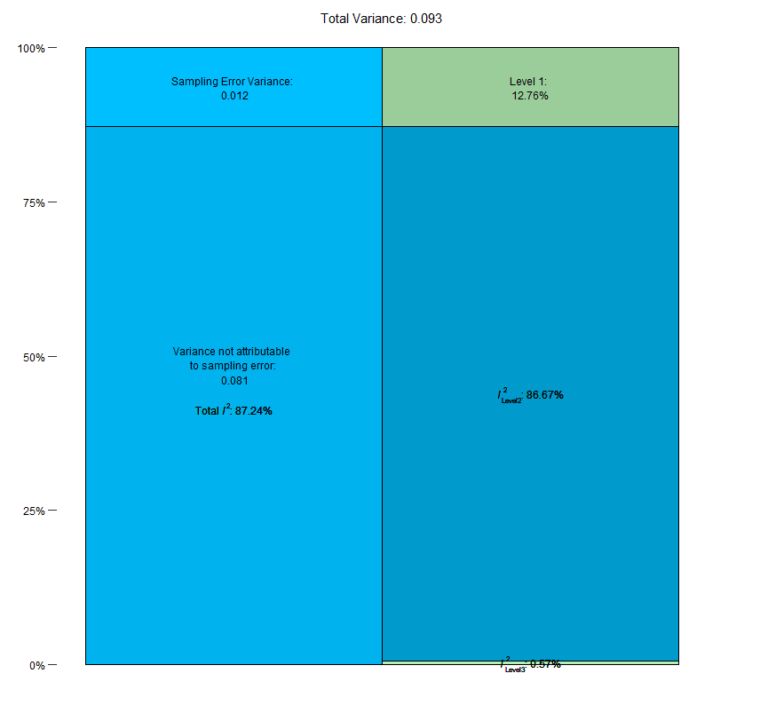

The sampling error variance on level 1 is small, making up only roughly 12.78%. The value of I² at Level-2 (the amount of heterogeneity variance across estimates within study), is much higher, totaling roughly 86.67%. Between-study heterogeneity makes up I² Level-3=0.57% of the total variation in our data. Overall, this indicates that there is substantial within-study heterogeneity on the 2nd level. Hence, a large proportion of the total variance, can be explained by differences within studies.

eFigure 2. Funnel Plot Tests for Publication Bias

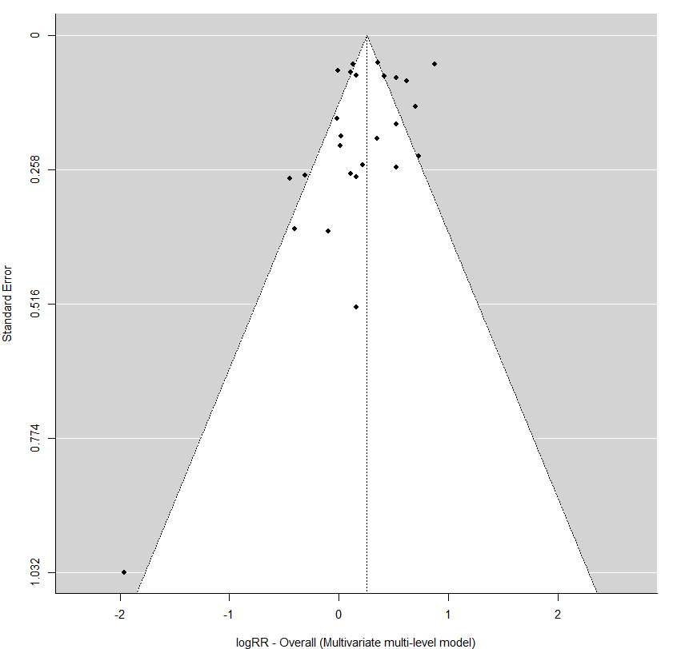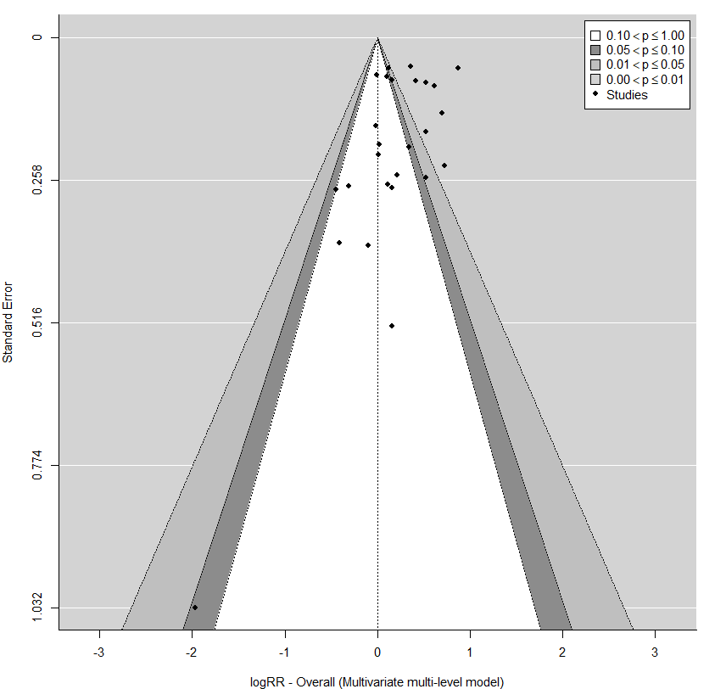

Some evidence of funnel plot asymmetry for overall, however, majority of estimates are clustered around summary effect estimate. The counter enhanced funnel plot did not reveal studies to be missing in areas of low statistical significance. Also need to be interpret with caution as response categories are not equal across studies and such trend was not observed across individual response categories. Another limitation is number of studies, minimum recommended number of studies to test publication bias is 10 or more.

eTable 3. Certainty of the Evidence Assessment Using the GRADE Approach

Quality Assessment |  |  |  |  |  |  | # of Patients |  | Effect | Quality | Importance
# of Studies  (design) | Risk of Bias | Inconsistency | Indirectness | Imprecision | Publication Bias | Other | Cannabis | No cannabis | RR  (95% CI)
Development of Psychosis – Daily/Near daily use
10  (7 case-control,  3 cohort) | Low | Not serious¹ | Not serious | Not serious | Not serious² | Evidence of dose-response gradient³ | 3415 | 12301 | OR 1.77  (1.04-3.01) | ⨁⨁⨁◯  Moderate | CRITICAL

¹ Significant heterogeneity (Q = 66.27; df = 7; p = 0.00; I² = 87.2%) identified. A large proportion of the heterogeneity was due to variance within studies (86.67%) with a small amount being due to heterogeneity across studies (I² = 0.57%). Because a large proportion of the variance was due to heterogeneity within studies, certainty of the evidence was not rated down due to heterogeneity. A possible reason for observed heterogeneity is the small versus large effects observed across studies, as seen in manuscript Figure 3.
² The counter-enhanced funnel plot did not reveal studies to be missing in areas of low statistical significance.
³ Evidence of a dose-response gradient with increasing risk of psychosis with increasing frequency of cannabis use. Rate up (+1) from low certainty to moderate.

