Etable 1. Logistic regression models testing the effect of juvenile justice history on adult outcomes.
Outcomes | N(%) | OR | CI | P value
Criminal records
Misdemeanor charge | 463(31.0) | 1.7 | [0.8 , 3.3] | 0.1500
Felony charge | 133(7.7) | 2.8 | [1.2 , 6.7] | 0.0208
Violent crime felony charge | 87(5.8) | 2.6 | [1. , 8.7] | 0.0021
Self-reported
Recent police contact | 212(12.4) | 3.3 | [1.6 , 6.8] | 0.0014
Assault | 44(2.6) | 3.3 | [1.3 , 11.0] | 0.0365
Jail | 188(8.1) | 3.9 | [2.0 , 7.7] | 0.0007
Odds ratios combined from 10 multiply-imputed datasets with Rubin’s formula. Models adjusted survey weights and all covariates.

Etable 2. Heterogeneity in ATT among people with juvenile justice history based on trimming and IPW adjusted models.
Outcomes | Probation/Service/Treatment |  |  | Detention/Prison
 | OR | CI | p value | OR | CI | P value
Criminal records
Misdemeanor charge | 1.3 | [0.7, 2.3] | 0.4442 | 4.6 | [1.8,11.8] | 0.0014
Felony charge | 2.1 | [1.0, 4.5] | 0.0547 | 6.4 | [2.3,18.4] | 0.0005
Violent crime felony charge | 2.4 | [1.0, 5.6] | 0.0510 | 7.2 | [2.6,19.9] | 0.0001
Self-reported
Recent police contact | 2.7 | [1.4,5.2] | 0.0042 | 1.8 | [0.8,9.8] | 0.2427
Assault | 2.2 | [0.8,6.2] | 0.1377 | 1.0 | [0.5,20.0] | 0.9685
Jail | 2.6 | [1.2,5.4] | 0.0112 | 6.3 | [2.0,19.8] | 0.0001
Odds ratios combined from 10 multiply-imputed datasets with Rubin’s formula. The study sample and ATT weights are the same as in Table 2.

Etable 3. Logistic regression models testing the effect of juvenile justice history (non-residential v. no history and residential v. no history) on adult outcomes

 | non-residential v. no history |  |  |  | residential v. no history
 | OR | CI | P value | OR |  | CI | P value
Outcomes
Criminal records
Misdemeanor charge | 1.4 | [0.6 , 3.0] | 0.4008 | 2.9 |  | [1.1 , 7.6] | 0.0283
Felony charge | 2.2 | [0.8 , 5.6] | 0.1091 | 5.8 |  | [1.8 , 18.9] | 0.0032
Violent crime felony charge | 2.3 | [0.9 , 6.0] | 0.0920 | 4.4 |  | [1.2 , 16.4] | 0.0272
Self-reported
Recent police contact | 2.9 | [0.8 , 8.0] | 0.0123 | 1.4 |  | [0.5 , 3.9] | 0.5024
Assault | 2.8 | [1.1 , 11.6] | 0.0856 | 0.5 |  | [0.0 , 8.4] | 0.6393
Jail | 2.7 | [1.2 , 6.0] | 0.0126 | 4.7 |  | [1.7 , 12.7] | 0.0023
Odds ratios combined from 10 multiply-imputed datasets with Rubin’s formula. Models adjusted survey weights and all covariates.

Efigure1. Ascertainment of the original Great Smoky Mountains study sample
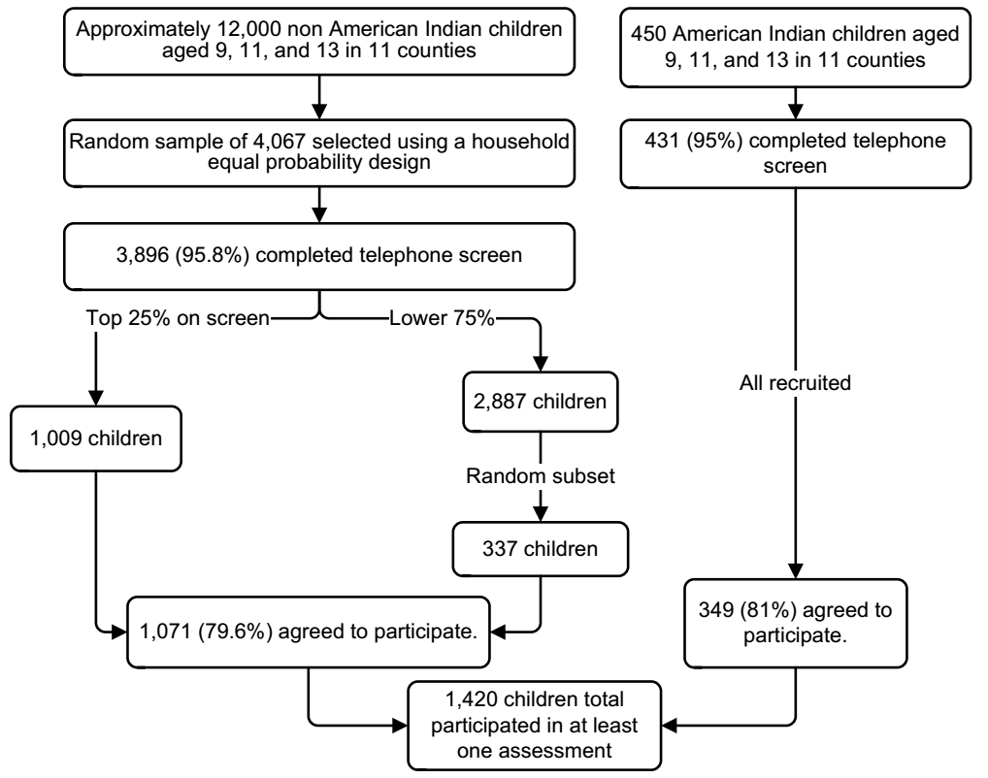

Efigure 2. Covariate balance plot for probation/treatment/service vs. no history in childhood using no weights and IPW with different trimming thresholds for ATT.
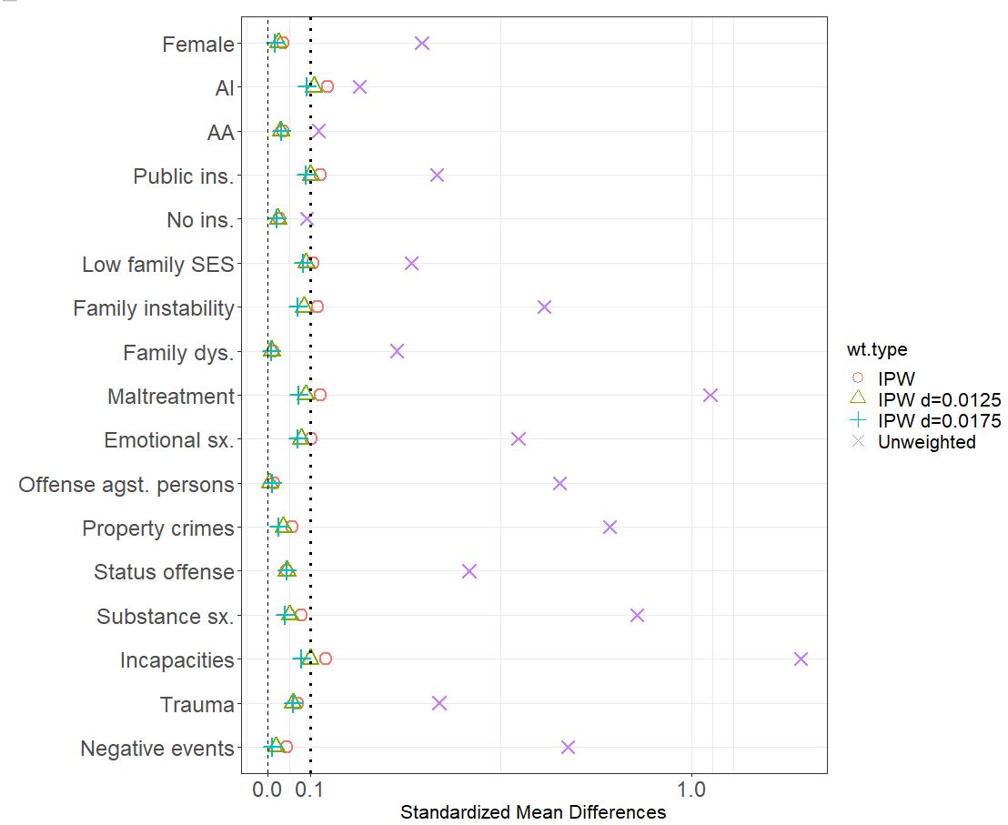
AI=American Indian; AA=African-American; SES=socioeconomic status; Dys=dysfunction; Sx=symptoms; Ins=insurance. “d” indicates trimming thresholds. SMD threshold at 0.10 is marked with a dashed line. d=0.0175 enables all covariates to have SMD below 0.10. Results are average of ten multiply-imputed datasets. The trimmed data have 166 (165-166) observations in the probation/treatment/service group and 810 (804-813) observations in the no history group.

Efigure 3. Covariate balance plot for detention/jail vs. vs. no history in childhood using no weights and IPW for ATT.
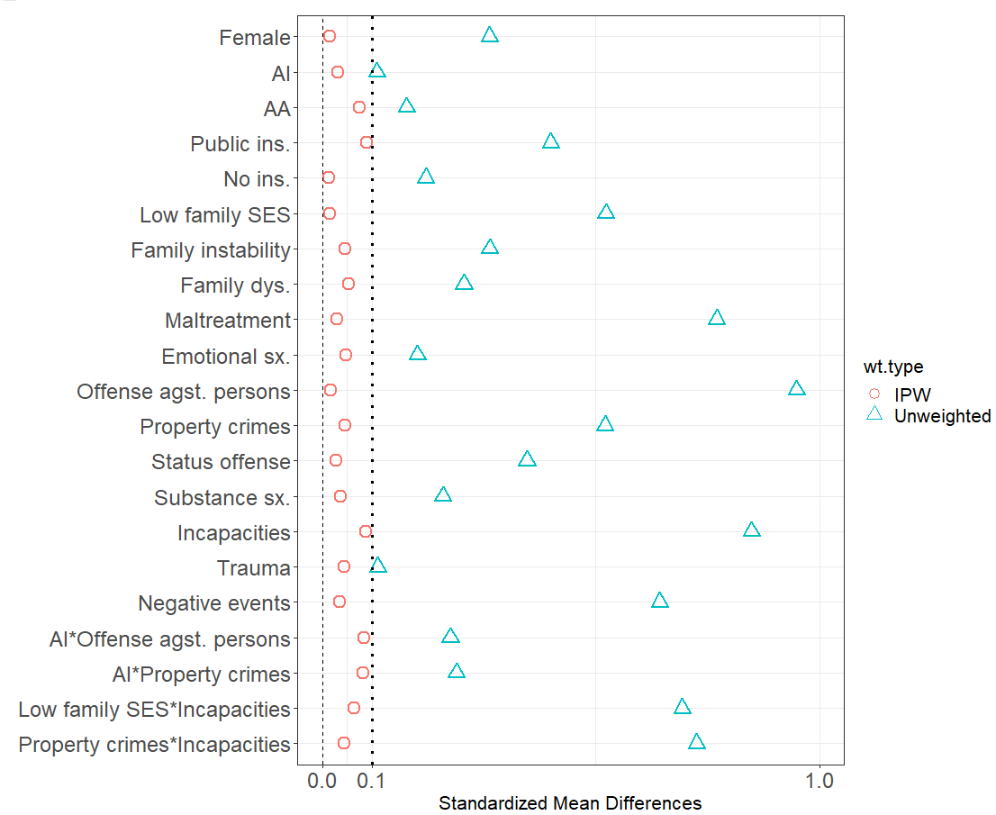
AI=American Indian; AA=African-American; SES=socioeconomic status; Dys=dysfunction; Sx=symptoms; Ins=insurance. Variable “Trauma” in log scale. “d” indicates trimming thresholds. SMD threshold at 0.10 is marked with a dashed line. Results are average of ten multiply-imputed datasets. The propensity score model for residential v. no history used no trimming and all the 57 observations in the residential involvement group are reserved.

