Supplementary material

Brain structural abnormalities in adult major depressive disorder using voxel- and source-based morphometry: findings from the REST-meta-MDD Consortium

KangCheng Wang, YuFei Hu, ChaoGan Yan, MeiLing Li, YanJing Wu, Jiang Qiu, XingXing Zhu, the REST-meta-MDD Consortium

Interaction between MDD group with age and gender

For the VBM analysis, we examined the effects of the interaction between age and gender in the general linear model with Matlab 2019b. In this model, the grey matter volume of the 6 significant regions (MDD vs HCs) were extracted and included as the dependent variable, separately. Group, age, gender, the interaction between group and age, education, and sites were included as the independent variables. Results were corrected with Bonferroni method at p < 0.05 (i.e. threshold was p_{uncorrected} < 0.05/n = 0.0083, 6 means number of regions). A significant interaction between group and age was found for precuneus (t = -3.442, p < 0.0001). Within the MDD patient group, patients tended to have less age-related decreases in precuneus. Detailed results were shown in the following Table S2.

Then, we performed the general linear model for examining the interaction between group and gender, with the same analyses as interaction between group and age. No significant findings were found for the 6 regions in the interaction between group and gender (Table S2).

Also. we performed the source-based morphometry analysis again. This time, we applied the general linear model with Matlab 2019b. In this model, the loading coefficients of 13 structural networks were included as dependent variable, separately. Group, age, gender, the interaction between group and age, education, and sites were included as the independent variables. Results were corrected with Bonferroni method at p < 0.05 (i.e. threshold was p_{uncorrected} < 0.05/n = 0.0038, n =13 means number of ICs). No significant findings were found for 13 networks in the interaction between group and age. Same analyses were then performed for the interaction between group and gender in the general linear model. Detailed results for these significances were shown in the following Table S3.

Figure S1. Thirteen structural sources identified by source-based morphometry method. Sagittal, coronal, and axial slices are shown with the ICBM52 MNI brain template.
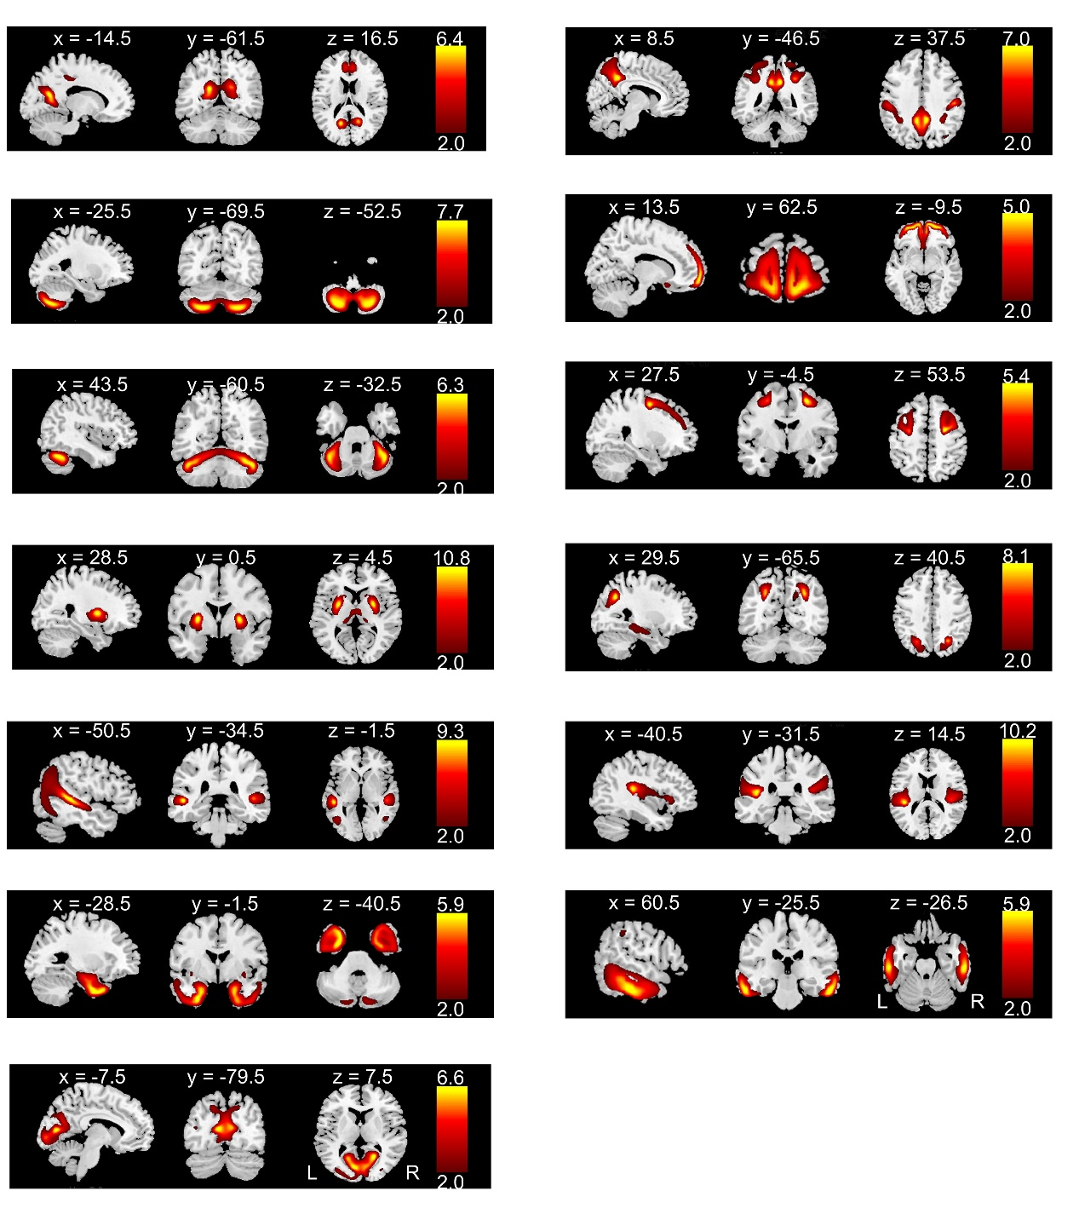

Figure S2. Decreased grey matter volume in FEDN MDD patients (A) and recurrent MDD patients (B), compared to healthy controls. These results were shown at an uncorrected p < 0.05.
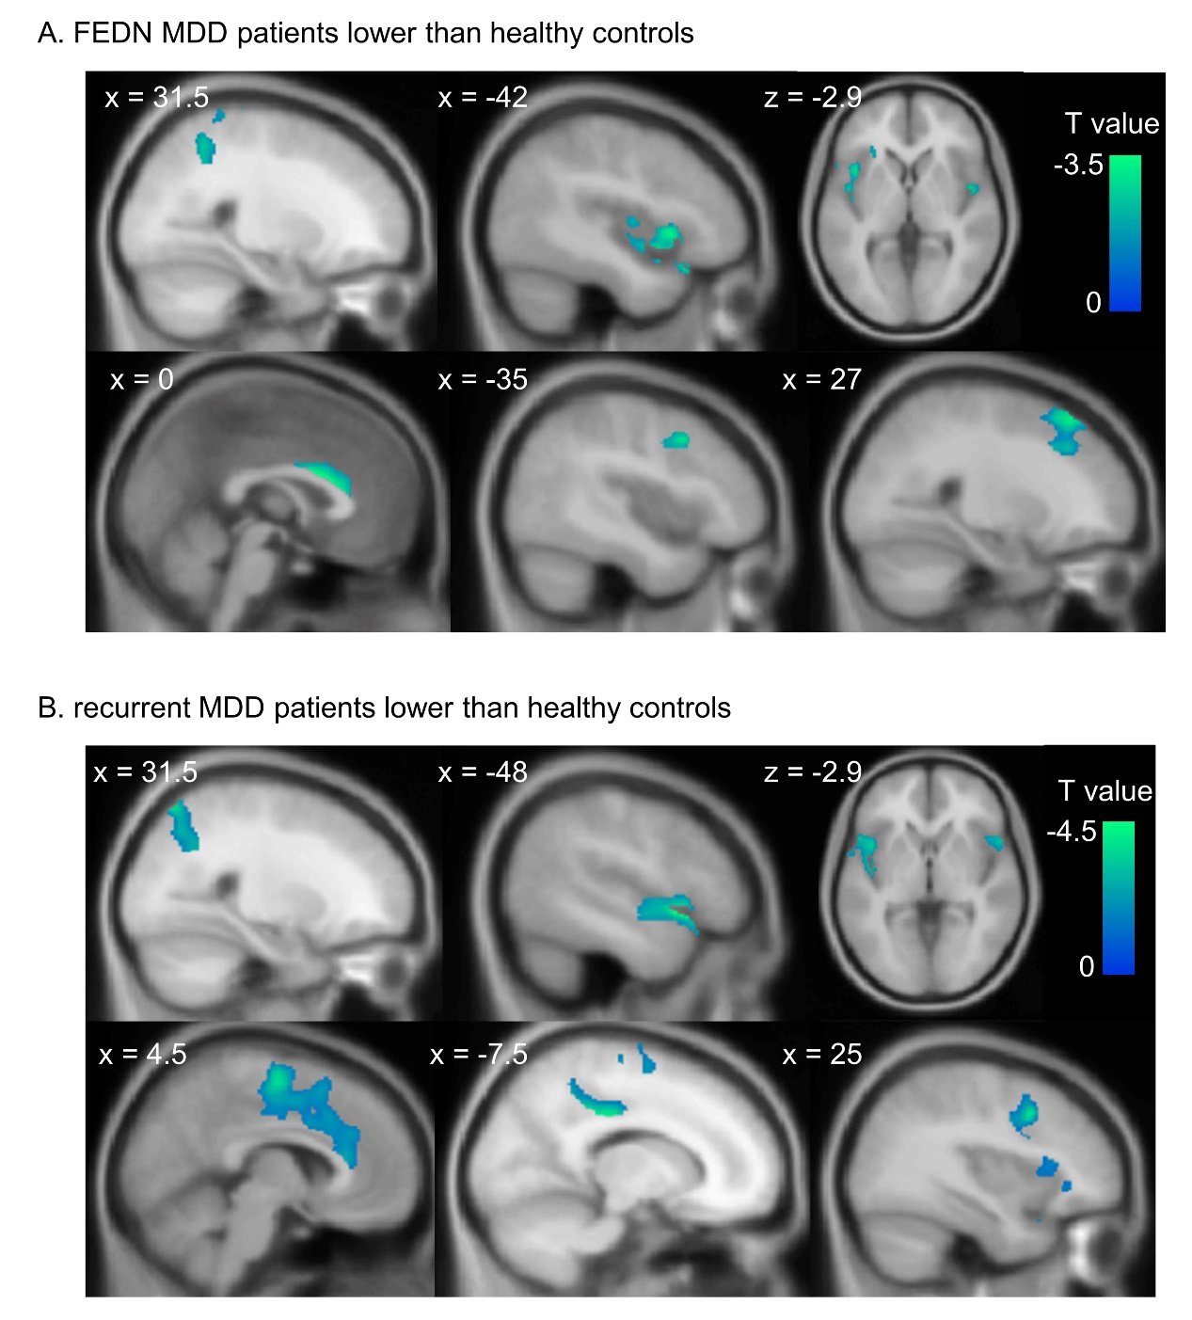

Figure S3. Validation analyses of thirty structural covariance networks in MDD patients vs. healthy controls, and FEDN patients vs. recurrent patients. (A) The loading coefficients in the prefrontal network and superior temporal networks were significantly lower in MDD patients compared to healthy subjects. Compared to recurrent MDD patients, FEDN patients showed higher loading coefficients in ten networks (B), and a lower loading coefficient in the prefrontal network (C).
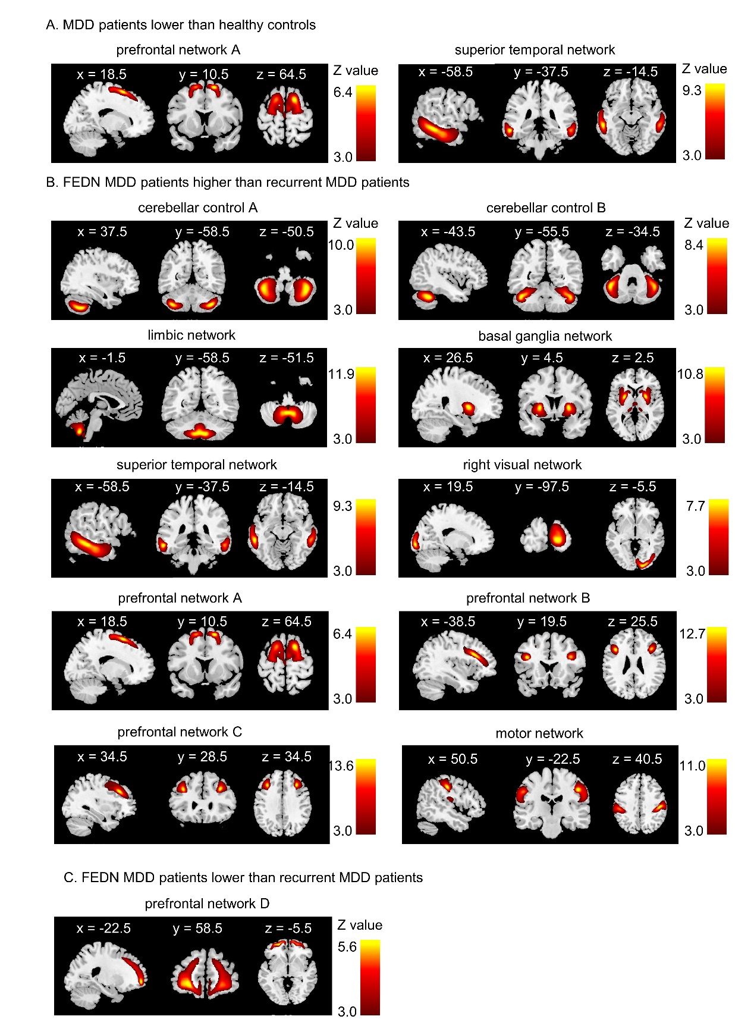

Table S1. Sample characteristics of 1082 depressive patients and 990 healthy controls for each site
Site | Sample size  N |  | Gender  male, N(%) |  |  |  | Age  years, mean(SD) |  |  |  | Education  years, mean(SD) |  |  |  | Illness duration  months, mean(SD) | HAMD | HAMA
 | MDD | HC | MDD | HC | X² | p | MDD | HC | t | p | MDD | HC | t | p | MDD | MDD | MDD
S1 | 74 | 74 | 31(41.89) | 32(43.24) | 0.03 | 0.868 | 31.72(8.19) | 31.80(8.99) | -0.06 | 0.954 | 13.80(2.94) | 15.23(2.26) | -3.32 | 0.001 | 5.37 (5.23) | 24.86 (4.81) | NA
S2 | 30 | 30 | 6(20.00) | 9(30.00) | 0.80 | 0.371 | 43.87(12.94) | 44.60(12.39) | -0.22 | 0.823 | 10.30(4.30) | 10.40(4.75) | -0.09 | 0.932 | 41.16(90.57) | 23.60 (3.30) | NA
S6 | 15 | 15 | 6(40.00) | 6(40.00) | 0.00 | 1.000 | 30.80(10.94) | 28.47(10.89) | 0.59 | 0.563 | 12.73(4.06) | 14.67(3.54) | -1.39 | 0.175 | 36.40 (39.75) | 23.13 (6.25) | NA
S7 | 38 | 49 | 15(39.47) | 19(38.78) | 0.00 | 0.947 | 42.58(11.85) | 41.43(13.41) | 0.42 | 0.677 | 10.37(4.63) | 13.16(6.07) | -2.36 | 0.021 | 43.89 (44.04) | 22.24(4.42) | 22.24(4.41)
S8 | 59 | 63 | 21(35.59) | 26(41.27) | 0.41 | 0.520 | 32.20(9.34) | 31.06(10.52) | 0.63 | 0.529 | 10.85(4.01) | 13.16(2.46) | -3.87 | <0.001 | 16.62 (24.78) | 23.98 (8.57) | 18.92 (10.59)
S9 | 45 | 50 | 22(48.89) | 31(62.00) | 1.65 | 0.199 | 29.00(8.77) | 28.92(8.59) | 0.04 | 0.964 | 13.64(2.74) | 15.72(3.04) | -3.48 | 0.001 | 29.59 (42.65) | NA | 12.36(6.71)
S10 | 50 | 29 | 22(44.00) | 19(65.52) | 3.40 | 0.065 | 33.00(10.63) | 33.14(8.21) | -0.06 | 0.952 | 11.28(3.39) | 12.21(3.12) | -1.20 | 0.232 | 10.95 (21.76) | 20.70 (3.77) | 16.72 (5.12)
S11 | 28 | 29 | 11(39.29) | 10(34.48) | 0.14 | 0.707 | 31.50(10.40) | 32.83(9.98) | -0.49 | 0.625 | 11.43(2.75) | 15.17(3.49) | -4.49 | <0.001 | 30.13(22.64)* | 23.38(4.37)* | NA
S13 | 25 | 17 | 11(44.00) | 6(35.29) | 0.32 | 0.573 | 32.28(9.30) | 34.00(10.50) | -0.56 | 0.580 | 13.64(2.08) | 13.12(2.32) | 0.76 | 0.450 | NA | 25.24 (3.90) | NA
S14 | 64 | 32 | 21(32.81) | 15(46.88) | 1.80 | 0.180 | 30.53(7.09) | 29.59(5.00) | 0.67 | 0.505 | 13.72(3.35) | 14.59(2.82) | -1.27 | 0.207 | 6.08 (4.17) | 21.33(3.44) | NA
S15 | 43 | 50 | 14(32.56) | 26(52.00) | 3.57 | 0.059 | 51.02(11.89) | 46.48(17.65) | 1.43 | 0.156 | 9.12(5.16) | 11.80(4.45) | -2.69 | 0.008 | 30.54 (51.52) | 27.63(5.87) | NA
S17 | 41 | 41 | 14(34.15) | 13(31.71) | 0.06 | 0.814 | 21.68(3.00) | 20.63(1.77) | 1.93 | 0.058 | 13.15(1.48) | 13.78(1.57) | -1.88 | 0.063 | NA | 20.66(5.69) | 15.22(4.91)
S18 | 21 | 20 | 6(28.57) | 8(40.00) | 0.60 | 0.440 | 31.43(6.98) | 30.10(7.52) | 0.59 | 0.561 | 12.29(3.99) | 12.40(3.14) | -0.10 | 0.920 | 12.05(10.84) | 24.76 (5.55) | 26.19 (8.20)
S19 | 51 | 36 | 14(27.45) | 18(50.00) | 4.61 | 0.032 | 38.25(11.51) | 35.86(10.27) | 1.00 | 0.321 | 8.78(3.90) | 9.94(3.84) | -1.38 | 0.172 | 73.50 (86.11) | 22.18(8.07) | NA
S20 | 257 | 242 | 95(36.96) | 78(32.23) | 1.23 | 0.267 | 39.37(13.00) | 39.99(15.86) | -0.48 | 0.629 | 10.88(3.48) | 12.88(3.97) | -6.00 | <0.001 | 50.49(66.34) | 20.97 (5.80) | 22.72 (8.85)
S21 | 86 | 70 | 38(44.19) | 31(44.29) | 0.00 | 0.990 | 34.71(12.63) | 36.13(12.64) | -0.70 | 0.486 | 11.65(2.89) | 12.83(2.59) | -2.65 | 0.009 | 85.82(92.05) | 14.37 (8.17) | 13.94 (8.73)
S22 | 29 | 20 | 14(48.28) | 12(60.00) | 0.65 | 0.419 | 34.14(9.95) | 24.35(7.07) | 3.79 | 0.000 | 11.59(2.81) | 13.30(2.13) | -2.31 | 0.026 | 38.90 (43.63) | 23.00 (5.12) | 9.63(7.67)
S23 | 27 | 29 | 14(51.85) | 11(37.93) | 1.10 | 0.295 | 26.67(8.43) | 33.28(11.81) | -2.39 | 0.020 | 13.37(3.34) | 14.45(4.16) | -1.06 | 0.292 | 23.04(28.12) | 19.19(8.55) | NA
S24 | 31 | 31 | 8(25.81) | 11(35.48) | 0.68 | 0.409 | 32.06(8.19) | 31.61(7.49) | 0.23 | 0.821 | 12.77(4.04) | 14.42(1.88) | -2.06 | 0.044 | 11.97(8.04) | 24.10(4.00) | 20.19 (6.42)
S25 | 68 | 63 | 21(30.88) | 29(46.03) | 3.18 | 0.075 | 66.75(6.29) | 69.63(5.86) | -2.71 | 0.008 | 11.44(2.94) | 12.83(3.01) | -2.66 | 0.009 | NA | 6.66(4.83) | NA
Total/Mean | 1082 | 990 | 404(0.37) | 410(0.41) | 3.60 | 0.058 | 37.23(14.20) | 37.45(15.67) | -0.34 | 0.732 | 11.63(3.71) | 13.25(3.73) | -9.95 | <0.001 | 38.34(61.51) | 20.75(7.48) | 19.09 (9.04)
Abbreviation: SD, standard deviation; MDD, major depressive disorder; HAMD, Hamilton depression rating scale; HAMA, Hamilton anxiety scale

Table S2. Statistics for the interactions with age and gender for VBM significant regions
Region ID | Name | Interaction with age |  | Interaction with gender
 |  | t | p_{uncorrected} | t | p_{uncorrected}
region1 | Dorsal anterior cingulate cortex | -1.466 | 0.143 | 0.005 | 0.996
region2 | Left super temporal gyrus | -0.906 | 0.365 | 0.137 | 0.891
region3 | Right super temporal gyrus | -0.442 | 0.658 | -0.461 | 0.645
region4 | Right inferior frontal gyrus | -0.127 | 0.899 | 0.147 | 0.883
region5 | Precuneus | -3.442 | <0.001* | -0.714 | 0.475
region6 | Middle cingulate cortex | 0.129 | 0.897 | 0.864 | 0.388
Note. p threshold after Bonferroni multiple comparison method is p_{uncorrected} = 0.0083.

Table S3. Statistics for the interactions with age and gender for structural networks
Network ID | Name | Interaction with age |  | Interaction with gender
 |  | t | p_{uncorrected} | t | p_{uncorrected}
network1 | Medial default mode network | 0.450 | 0.653 | -0.582 | 0.560
network2 | Cerebellar network A | 0.375 | 0.708 | 0.767 | 0.443
network3 | Cerebellar network B | -0.468 | 0.640 | 1.124 | 0.261
network4 | Basal ganglia network | -0.079 | 0.937 | 0.999 | 0.318
network5 | Superior temporal network | 0.681 | 0.496 | -1.119 | 0.263
network6 | Posterior default mode network | -0.629 | 0.530 | 2.263 | 0.024
network7 | Temporal pole network | -1.115 | 0.265 | -0.268 | 0.789
network8 | Prefrontal network | -1.774 | 0.076 | 0.184 | 0.854
network9 | Medial prefrontal network | 0.536 | 0.592 | -0.758 | 0.449
network10 | Angular network | -1.800 | 0.072 | 1.459 | 0.145
network11 | Superior temporal network | -0.334 | 0.738 | 0.855 | 0.393
network12 | Parietal network | -0.527 | 0.598 | 0.619 | 0.536
network13 | Visual network | -0.654 | 0.513 | 1.109 | 0.268
Note. p threshold after Bonferroni multiple comparison method is p_{uncorrected} = 0.0038.

