Altered prefrontal activation during the inhibition of eating responses in women with bulimia nervosa
Supplementary Material
Supplementary Methods
Participants
The Edinburgh Handedness Inventory (Oldfield, 1971) assessed handedness, and only right-handed participants were included. Exclusion criteria for both groups were: 1) current significant medical illness; 2) DSM-IV-TR substance or alcohol abuse or dependence in the past 6 months; 3) pregnancy, lactation, or planning pregnancy during the study period; 4) current or past neurological disorder, history of a seizure or head trauma with loss of consciousness; 5) lifetime attention deficit hyperactivity disorder (ADHD) diagnosis; 6) difficulty swallowing (e.g., dysphagia); 7) Full-Scale IQ < 75; 8) allergy to study foods; and 9) rated liking of the yogurt shake < 6 on a 9-point Likert-type scale.
Women in the BN group with any current DSM-IV-TR Axis I disorder apart from major depressive disorder (MDD) or generalized anxiety disorder (GAD; in light of the frequent comorbidity of these disorders with BN (Hudson, Hiripi, Pope, & Kessler, 2007)) were excluded. In addition, women with BN regularly taking any psychoactive medications other than selective serotonin reuptake inhibitors (SSRIs) were excluded. All participants with BN refrained from taking occasionally used, as-needed (pro re nata) anxiolytic medications for one week before imaging. Healthy controls (HC) who took any psychoactive medications in the last 6 months, endorsed any current or past eating disorder symptoms, or met criteria for any DSM-IV-TR Axis I diagnosis were excluded.
Task Design Considerations
There are no accepted standard parameters for go/no-go tasks beyond requiring a motor response to all stimuli except some infrequent, different (“no-go”) stimulus. Interstimulus intervals across task versions differ, and there are no standards for the ratio of go to no-go stimuli (Buchsbaum, Greer, Chang, & Berman, 2005; Chikazoe, Konishi, Asari, Jimura, & Miyashita, 2007). Therefore, the parameters of both go/no-go tasks included in the present study were modeled to 1) best match the parameters of fNIRS, 2) permit block data analysis, 3) ensure that participants could complete both tasks in succession while minimizing the risk of discomfort, 4) assess response inhibition, not simply target detection, and 5) represent a close adaptation of the task used by Rodrigo and colleagues (2014).
Early fMRI studies of go/no-go tasks utilized block designs in which all-go blocks (GO blocks) are contrasted with mixed go/no-go blocks (NO-GO blocks). As noted by Simmonds and colleagues (2008), this approach’s limitations include the potential confounds of differences in task difficulty, attention and stimuli between block types. More recent studies have employed event-related designs, and correct no-go response activation is contrasted either with resting baseline or correct go-response activation.
Previous research utilizing fNIRS to examine prefrontal cortex (PFC) activation during go/no-go tasks have, to date, used block, not event-related designs to compare average hemodynamic activation during blocks of intermixed go and no-go stimuli (NO-GO blocks) with blocks of only go stimuli (GO blocks). Despite the disadvantages of block designs, in the present project, to maintain consistency with prior fNIRS research (Rodrigo et al., 2014) and because sipping and swallowing responses could not be completed fast enough to permit a rapid, event-related design, a block design was used. Of note, tasks that include mixed blocks of go and no-go trials compared with blocks of all-go trials may more accurately assess the proactive inhibitory control that seems more relevant to psychiatric disorders (Aron, 2011).
We considered inclusion of a second type of go stimulus presented as frequently as no-go stimuli to control for potential “oddball” effects of the rare no-go stimulus (e.g., Smith, Taylor, Brammer, Toone, & Rubia, 2006); however, because inclusion of these oddball events would necessitate lengthening each task and would significantly increase the total amount of shake consumed during the eating task, this was not feasible.
Although it may be unlikely that individuals with BN binge eat yogurt shakes in their everyday lives, the strawberry yogurt shake used in the eating go/no-go task (fruit-on-the-bottom strawberry yogurt, 8% sucrose solution, heavy cream) has been used in numerous laboratory studies of eating behavior in BN, and prior research has demonstrated that individuals with BN are willing to “binge eat” the shake in laboratory settings (Kissileff, Walsh, Kral, & Cassidy, 1986; Kissileff, Zimmerli, Torres, Devlin, & Walsh, 2008; LaChaussee, Kissileff, Walsh, & Hadigan, 1992; Schebendach, Broft, Foltin, & Walsh, 2013; Zimmerli, Devlin, Kissileff, & Walsh, 2010). In addition, because the go/no-go task explicitly instructs participants to adopt the goal of controlling their eating responses to no-go stimuli, future research, perhaps using a different task or instructions, is needed to examine whether patients with different types of LOC eating (e.g., planned vs. unplanned binges) have different neurocognitive substrates.
The standard, button-pressing task was matched to the eating task in number of each trial type, stimulus appearance, and inter-stimulus intervals to facilitate between-task comparison.

Eating Task Video Instructions Transcript
For the sipping task portion of this study, we’re going to need to be able to tell whether you have taken a sip, or you haven’t taken a sip. This means that in between the sips that you take, you will need to release the “vacuum” in the straw, let some air in, and let the liquid go back down.
An incorrect series of sips looks like this [series of five sips with no suction release demonstrated]. You can see that the liquid didn’t go back down in the straw until I took my mouth completely off of the straw at the end, but I had sipped several times.
A correct series of sips looks like this [series of five sips with suction release demonstrated].
Notice that between the sips, I’m not moving my head back and forth. We want the movement that you make in between sips to be minimal. This means that you would not sip like this [series of five sips with head movement and full release of straw from mouth demonstrated].
We’d like you to keep your mouth on the straw, and only create the smallest amount of space possible between your lips and the straw between your sips. This will help with speed on the task.
Once again a series of sips that are correct will look like this [series of five correct sips demonstrated].
If you still have any questions, please ask your study assessor.”

Neuroimaging Study Procedures and Pre-Processing
The fNIR Imager Model 1000® (fNIR Devices LLC; Potomac, MD) system collects 16 channel measurements from dorsolateral prefrontal cortex (dlPFC), ventrolateral prefrontal cortex (vlPFC), and medial prefrontal cortex (mPFC; sampling rate = 2Hz; temporal resolution = 500 ms per scan; source-detector separation = 2.5 cm; depth of penetration = 1.25 cm; light source wavelengths = 730 nm and 850 nm) (Ayaz et al., 2012; Ayaz et al., 2011; Rodrigo et al., 2014; Rodrigo et al., 2016; Ruocco et al., 2016). See Figure S2 for prefrontal coverage of the fNIRS sensor used in the current study. The fNIRS sensor pad includes four sources and 10 detectors resulting in 16 source/detector pairs (channels). The sensor was placed with respect to vertical and horizontal symmetry axes, with the center detectors in both rows aligned with the nasion (Ayaz et al., 2006; Ayaz et al., 2011).
FNIRS data were low-passed filtered with a finite impulse response, linear phase filter with a cut-off frequency set to 0.1 Hz to suppress high-frequency noise, respiration, and cardiac cycle effects (Ayaz et al., 2012). We matched our filtering approach to that used in other recent publications from other groups using fNIRS (e.g., Cooper, Gagnon, Goldenholz, Boas, & Greve, 2012; Ranchet et al., 2020; Rezazadeh Sereshkeh, Yousefi, Wong, Rudzicz, & Chau, 2019). Although additional high-pass filters may be preferable for event-related designs, this FIR low-pass filter with the suggested cut-off frequency have been effectively used in other studies with block designs (Cooper et al., 2012; Ranchet et al., 2020; Rezazadeh Sereshkeh et al., 2019).
Each channel was scanned for artifacts using a sliding-window motion artifact rejection (SMAR) procedure (Ayaz, Izzetoglu, Shewokis, & Onaral, 2010), which is a statistical filter using coefficient of variation to eliminate nuisance, and confirmed with visual inspection. Data were inspected for potential saturation (when light intensity at the detector is greater than the analog-to-digital converter limit, caused by insufficient skin contact or because of signal interference from hair). Consistent with prior research (e.g., Rodrigo et al., 2014), on average, 3.2 (SD = 2.8) channels were excluded from analyses for each participant due to saturation. Changes in oxygenated-hemoglobin concentrations relative to local baselines were calculated from the artifact-removed raw intensity measurements at λ1 = 730 nm and λ2 = 850 nm using the modified Beer-Lambert law with the differential path-length factor (DPF) = 6 for all wavelengths and ages with and with molar extinction coefficients as follows: ε730 = 0.390, ε850 = 1.058. We did not use an age-dependent DPF because our sample included only young adults within a narrow age range, and our groups were age-matched. In addition, some prior studies including wider age ranges have found no difference in overall outcomes with the use of an age-dependent DPF (Izzetoglu & Holtzer, 2020). However, future studies of BN, especially if they include pediatric or adolescent populations and adults comparisons may still need to consider using an age-dependent DPF to ensure reliable estimation of group differences in activation (Scholkmann & Wolf, 2013).
All analyses focus on oxygenated hemoglobin because of its superior signal-to-noise ratio and its stronger correlation with the fMRI blood-oxygenation level-dependent signal compared with de-oxygenated hemoglobin (Strangman, Culver, Thompson, & Boas, 2002).

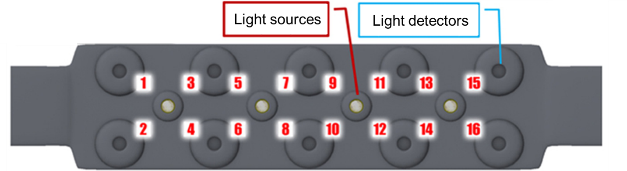
A

B
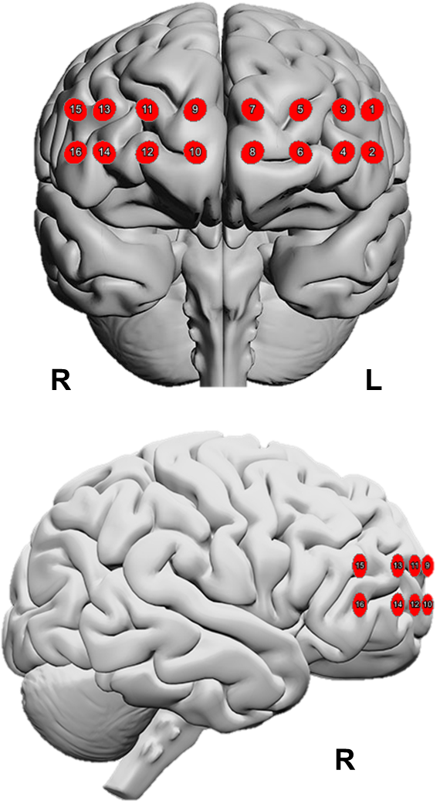

Figure S1. A) The flexible forehead sensor pad includes four sources and 10 detectors resulting in 16 source/detector pairs (channels); B) Locations of the 16 channels of the fNIRS sensor in MNI space as estimated in fnirSoft (Ayaz, 2010) using methodology described in (Ayaz et al., 2006)
Statistical Analysis
Model Fit Optimization for Linear Mixed Effects Models. Data were examined for normality, homogeneity of variance, and patterns of missingness. For all linear mixed effects models that tested group differences in performance and activation, we used the lmer function in the lme4 package in R with full maximum likelihood estimations. Time-series data were nested within participant, subject was included as a random effect, and we used an unstructured covariance matrix. To remove temporal trends from the blocked time series, linear time and quadratic time were tested as both fixed and random effects using full random effect models. Results of analyses of variance (ANOVAs) comparing models determined that for all a priori hypotheses, the optimal model fit included both linear time (over four blocks, centered at 0) and quadratic time as fixed effects. Effect sizes (semi-partial R²) and confidence intervals were estimated in R using the r2beta function in the r2mlmm package (Edwards Lloyd, Muller Keith, Wolfinger Russell, Qaqish Bahjat, & Schabenberger, 2008). All tests were two-tailed.
Median Split Approach. To facilitate comparison of our results to the only prior neuroimaging study that assessed both food-specific and general inhibitory control in the same sample of adults with BN, we replicated the approach of Skunde and colleagues (2016) and divided the BN group based on median measures of symptom severity: 1) ELOCS severity score, and 2) the frequency of LOC episodes in the last month. Given the novelty of the eating go/no-go task, we also explored the potential link between altered activation and subjective experience during the task by dividing the BN group based on the median strength of the reported sense of binge eating during the task.
There was a moderate association between ELOCS severity scores and LOC eating frequency (z = 0.03, p = 0.041), but the strength of the feeling of binge eating during the task was unrelated to either of these measures (ps > 0.412). In addition, we found no association between the strength of the feeling of binge eating during the task and the amount of shake consumed during the task (p = 0.916), suggesting that feeling of binge eating ratings were not driven by the amount consumed. LOC severity and frequency in the last month and the feeling of binge eating during the task were all unrelated to commission errors on either task (ps > 0.287).
Individuals with ELOCS scores greater than 7.2 were assigned to the high-severity LOC group (n = 12), those with more than 23 LOC eating episodes in the last month were assigned to the high-frequency binge-eating group (n = 12) and those with ratings higher than 68.0 were assigned to the strong endorsement of binge eating during the task group (n = 12). There was 58.3% agreement in group assignment by ELOCS severity and LOC eating frequency (i.e., 58.3% of the women assigned to the high LOC severity group were also assigned to the high LOC eating frequency group), 59.1% agreement in group assignment by ELOCS severity and by the endorsement of binge eating during the task, and 33.3% agreement in group assignment by frequency of LOC eating and endorsement of binge eating during the task. The low and high severity, low and high frequency of LOC eating, and the mild and strong binge eating endorsement groups did not differ on BMI, FSIQ, days since last menstrual period, other eating disorder symptom frequency, beverage ratings, amount consumed during the eating task, state-related negative affect, comorbidities, or medication use (see Tables S1-3). We repeated our main fNIRS Group x Condition analyses comparing 1) women in the high LOC severity group to HC on both tasks and 2) women in the high frequency group to HC on both tasks. Exploratory analyses compared women in the strong binge eating endorsement during the task group to HC on the eating task only.
Sensitivity Analyses. To explore the contribution of potential confounds to our findings, we re-ran primary, Group x Condition fNIRS analyses excluding 1) participants who had a comorbid diagnosis of MDD, GAD, or were taking psychotropic medication (given the high overlap of these conditions), and 2) participants with a history of anorexia nervosa (AN). In addition, we conducted Condition x Lowest past post-morbid BMI linear mixed effect models in the full BN sample to further examine the association of lower past BMIs with neural activation.
Table S1. Comparison of BN Subgroups: High and Low LOC Eating Severity in the Past Month
 | Low LOC Severity Group  (n = 11) | High LOC Severity Group  (n = 12)
Characteristic | M (SD) or n (%) | M (SD) or n (%) | t or χ² | p
Age (years) | 23.9 (4.3) | 25.7 (3.3) | -1.12 | 0.275
Years of Education | 15.5 (2.4) | 16.9 (2.2) | -1.55 | 0.137
Body Mass Index | 23.24 (1.91) | 21.63 (1.94) | 1.99 | 0.059
Days Since Last Menstrual Period | 18.4 (11.5) | 16.8 (8.3) | 0.36 | 0.723
Full-Scale IQ | 110 (15) | 117 (8) | -1.34 | 0.195
LOC Eating Episodes (past month) | 23.6 (17.5) | 32.3 (21.2) | -1.07 | 0.298
Self-Induced Vomiting (past month) | 13.9 (22.5) | 25.1 (21.7) | -1.21 | 0.238
Laxative Misuse (past month) | 1.6 (3.2) | 1.1 (2.6) | 0.38 | 0.707
Diuretic Misuse (past month) | 2.0 (5.7) | 0.2 (0.6) | 1.12 | 0.277
Driven/Compelled Exercise (days in past month) | 7.1 (9.2) | 15.8 (25.0) | -1.09 | 0.287
Standard Task Commission Errors | 8.6 (3.3) | 11.3 (5.3) | -1.44 | 0.164
Eating Task Commission Errors | 6.3 (42.) | 5.5 (4.3) | 0.44 | 0.664
Shake Consumed (g) | 581.86 (276.03) | 409.53 (340.05) | 1.29 | 0.213
Time between Standardized Meal and Eating Task (mins) | 255 (50) | 271 (44) | -0.81 | 0.425
Rating of Beverage Taste | 7.1 (0.7) | 7.0 (0.6) | 0.35 | 0.730
Negative Affect before Standard Task | 11.9 (3.1) | 12.8 (3.9) | -0.57 | 0.575
Negative Affect after Standard, before Eating Task | 12.5 (3.3) | 15.4 (5.5) | -1.53 | 0.142
Negative Affect after Eating Task | 14.2 (4.2) | 19.3 (7.7) | -1.9 | 0.076
Major Depressive Disorder | 1 (9.1) | 2 (16.7) | 0.29 | 0.590
Generalized Anxiety Disorder | 2 (18.2) | 3 (25,0) | 0.16 | 0.692
Past Anorexia Nervosa | 3 (27.3) | 8 (66.7) | 3.57 | 0.059
Selective Serotonin Reuptake Inhibitor (SSRI)1 | 4 (36.4) | 2 (16.7) | 1.16 | 0.283
BN, bulimia nervosa; LOC, loss of control
Table S2. Comparison of BN Subgroups: High vs. Low Frequency of LOC Eating in the past month
 | Low Frequency LOC Eating Group  (n = 11) | High Frequency LOC Eating Group  (n = 12)
Characteristic | M (SD) or n (%) | M (SD) or n (%) | t or χ² | p
Age (years) | 25.7 (3.6) | 24.0 (4.0) | 1.09 | 0.288
Years of Education | 16.6 (2.2) | 15.8 (2.5) | 0.82 | 0.423
Body Mass Index | 22.4 (2.3) | 22.4 (1.8) | -0.04 | 0.969
Days Since Last Menstrual Period | 14.9 (10.9) | 20.6 (7.6) | -1.29 | 0.213
Full-Scale IQ | 115.2 (12.2) | 112.0 (12.1) | 0.63 | 0.537
ELOCS Severity | 7.1 (1.4) | 7.7 (1.0) | -1.24 | 0.228
Self-Induced Vomiting (past month) | 10.5 (7.8) | 28.3 (27.8) | -2.13 | 0.053
Laxative Misuse (past month) | 2.2 (3.7) | 0.5 (1.4) | 1.40 | 0.186
Diuretic Misuse (past month) | 2.0 (5.7) | 0.2 (0.6) | 1.12 | 0.277
Driven/Compelled Exercise (days in past month) | 15.4 (26.4) | 8.3 (9.0) | 0.88 | 0.389
Standard Task Commission Errors | 10.0 (4.0) | 9.9 (5.3) | 0.04 | 0.967
Eating Task Commission Errors | 7.3 (4.8) | 4.5 (3.0) | 1.66 | 0.117
Shake Consumed (g) | 380.5 (186.4) | 595.3 (389.7) | -1.65 | 0.121
Time between Standardized Meal and Eating Task (mins) | 259 (51) | 268 (44) | -0.46 | 0.650
Rating of Beverage Taste | 7.3 (0.8) | 6.8 (0.4) | 1.70 | 0.109
Negative Affect before Standard Task | 12.5 (4.3) | 12.3 (2.7) | 0.14 | 0.892
Negative Affect after Standard, before Eating Task | 15.1 (5.7) | 13.3 (3.8) | 0.90 | 0.378
Negative Affect after Eating Task | 18.6 (6.4) | 15.5 (7.0) | 1.1 | 0.288
Major Depressive Disorder | 0 (0%) | 3 (25%) | 3.16 | 0.075
Generalized Anxiety Disorder | 2 (18.2%) | 3 (25%) | 0.16 | 0.692
Past Anorexia Nervosa | 5 (45.5%) | 6 (50.0%) | 0.05 | 0.827
Selective Serotonin Reuptake Inhibitor (SSRI)¹ | 2 (18.2%) | 4(33.3%) | 0.68 | 0.408
BN, bulimia nervosa; LOC, loss of control

Table S3. Comparison of BN Subgroups: Strong and Weak Endorsement of Binge Eating During the Eating Go/No-Go Task
 | Weak Sense of Binge Eating during Task Group  (n = 10) | Strong Sense of Binge Eating during Task Group  (n = 12)
Characteristic | M (SD) or n (%) | M (SD) or n (%) | t or χ² | p
Age (years) | 25.6 (4.3) | 24.8 (3.1) | 0.50 | 0.623
Years of Education | 16.0 (2.5) | 16.7 (2.1) | -0.67 | 0.508
Body Mass Index | 22.75 (2.14) | 22.28 (2.04) | 0.53 | 0.601
Days Since Last Menstrual Period | 20.1 (11.0) | 15.3 (8.3) | 1.09 | 0.292
Full-Scale IQ | 111 (13) | 117 (10) | -1.15 | 0.265
LOC Eating Episodes (past month) | 33.3 (24.0) | 21.0 (10.3) | 1.61 | 0.123
Self-Induced Vomiting (past month) | 20.4 (25.0) | 14.3 (11.9) | 0.75 | 0.463
Laxative Misuse (past month) | 0.9 (1.7) | 1.8 (3.7) | -0.67 | 0.508
Diuretic Misuse (past month) | 2.1 (6.0) | 0.3 (0.6) | 1.07 | 0.297
Driven/Compelled Exercise (days in past month) | 16.4 (27.3) | 8.7 (9.6) | 0.92 | 0.368
Standard Task Commission Errors | 10.7 (2.6) | 9.9 (5.7) | 0.40 | 0.691
Eating Task Commission Errors | 4.0 (2.0) | 7.4 (4.9) | -2.06 | 0.052
Shake Consumed (g) | 551.83 (401.47) | 434.55 (232.39) | 0.86 | 0.402
Time between Standardized Meal and Eating Task (mins) | 273 (42) | 260 (50) | 0.65 | 0.523
Rating of Beverage Taste | 6.9 (0.6) | 7.2 (0.7) | -0.95 | 0.353
Negative Affect before Standard Task | 12.1 (2.8) | 12.8 (4.1) | -0.42 | 0.678
Negative Affect after Standard, before Eating Task | 14.5 (5.2) | 14.0 (4.7) | 0.23 | 0.820
Negative Affect after Eating Task | 15.7 (7.3) | 18.1 (6.4) | -0.83 | 0.416
Major Depressive Disorder | 2 (20.0) | 1 (8.3) | 0.63 | 0.427
Generalized Anxiety Disorder | 3 (30.0) | 2 (16.7) | 0.55 | 0.457
Past Anorexia Nervosa | 5 (50.0) | 5 (41.7) | 0.15 | 0.696
Selective Serotonin Reuptake Inhibitor (SSRI)1 | 3 (30.0) | 3 (25.0) | 0.07 | 0.793
BN, bulimia nervosa; LOC, loss of control

Supplementary Results

Task Performance
To replicate the approach of prior fNIRS studies that have compared groups on behavioral task performance, we conducted additional, independent samples t tests to compare groups on commission errors. Results were similar to those of mixed-effects models and indicated that women with BN made more commission errors on the eating (t(42) = 2.420, p = 0.020, d = 0.73) and standard (t(44) = 2.439, p = 0.019, d = 0.72) go/no-go tasks.

Full-Sample Group Differences in Oxygenated Hemoglobin

Table S4. Full-Sample Group x Condition Mixed Effects Models Comparing Bulimia Nervosa and Control Participant Oxygenated Hemoglobin Changes on the Eating Task and the Standard Task (p < 0.05, uncorrected)
Eating Task
Channel | Hem | b | SE | df | t | R²_{β} | 95% CI of Effect Size | Post-hoc Pairwise Comparisons
8 | L | 0.31 | 0.11 | 224.00 | 2.86** | 0.041 | 0.004, 0.111 | NO-GO: HC > BN p = 0.002
 |  |  |  |  |  |  |  | HC: NO-GO > GO p = 0.016
10 | R | 0.30 | 0.12 | 193.29 | 2.52* | 0.032 | 0.002, 0.098 | NO-GO: HC > BN p = 0.010
14 | R | 0.23 | 0.10 | 225.39 | 2.17* | 0.021 | <0.001, 0.074 | NO-GO: HC > BN p = 0.026
 |  |  |  |  |  |  |  | BN: NO-GO < GO p = 0.047
Standard Task
Channel | Hem | b | SE | df | t | R²_{β} | 95% CI of Effect Size | Post-hoc Pairwise Comparisons
8 | L | 0.31 | 0.13 | 246.00 | 2.35* | 0.025 | 0.001, 0.082 | NO-GO: HC > BN p = 0.034
 |  |  |  |  |  |  |  | HC: NO-GO > GO p = 0.0004
10 | R | 0.28 | 0.14 | 232.00 | 2.05* | 0.021 | <0.001, 0.076 | HC: NO-GO > GO p = 0.0004
*p < 0.05, uncorrected; **p < 0.005, uncorrected; Hem, hemisphere; CI, confidence interval. The Satterthwaite method was used to estimate degrees of freedom.

Full-Sample Group Differences in De-oxygenated Hemoglobin

On the eating task, no Group x Condition effects on de-oxygenated hemoglobin were statistically significant, even at uncorrected levels (uncorrected ps > 0.060). On the standard task, a Group x Condition effect was detected in the left vLPFC (p < 0.05, uncorrected), but this effect did not survive multiple-comparisons correction (Table S5).

Table S5. Full-Sample Group x Condition Mixed Effects Models Comparing Bulimia Nervosa and Control Participant De-Oxygenated Hemoglobin Changes on the Standard Task (p < 0.05, uncorrected)
Channel | Hem | b | SE | df | t | R²_{β} | 95% CI of Effect Size | Post-hoc Pairwise Comparisons
2 | L | 0.001 | 0.0005 | 308 | 2.33* | 0.020 | 0.001, 0.065 | HC: NO-GO > GO p = 0.011
*p < 0.05, uncorrected; Hem, hemisphere; CI, confidence interval. The Satterthwaite method was used to estimate degrees of freedom.

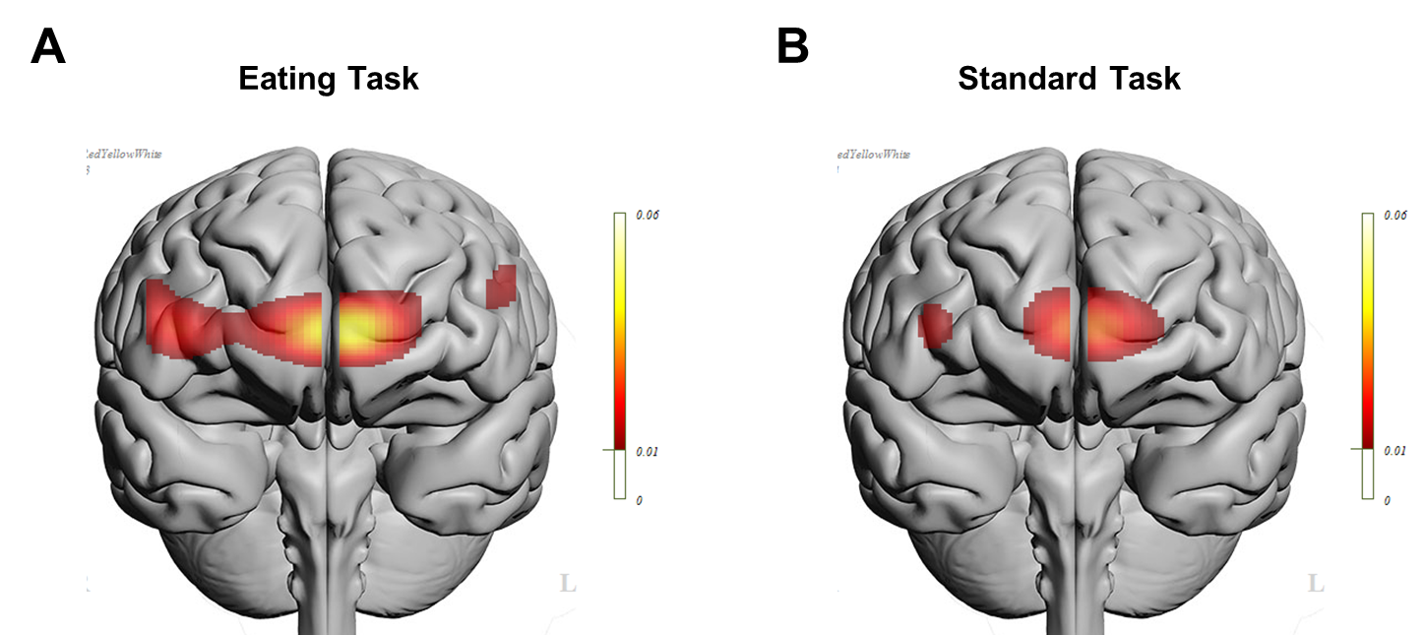

Figure S2. Eating and standard go/no-go task effect size maps in the full sample. Group x Condition interaction effect sizes (R²_{β}) are shown for the (A) eating and (B) standard tasks. Effect size maps are thresholded at 0.01, which corresponds with a small effect size.

Table S6. Eating Go/No-Go Task Group x Condition Mixed Effects Models Comparing Activation in Healthy Controls to Participants with Bulimia Nervosa and Frequent LOC Eating (p < 0.05, uncorrected)
Channel | Hem | b | SE | df | t | R²_{β} | 95% confidence interval | Post-hoc Pairwise Comparisons
8 | L | 0.34 | 0.13 | 133.35 | 2.62** | 0.053 | 0.004, 0.151 | NO-GO: HC >BN p = 0.011
 |  |  |  |  |  |  |  | HC: NO-GO > GO p = 0.019
10 | R | 0.31 | 0.14 | 131.91 | 2.24* | 0.040 | <0.001, 0.131 | NO-GO: HC >BN p = 0.021
14 | R | 0.28 | 0.13 | 164.38 | 2.14* | 0.030 | 0.001, 0.106
16 | R | 0.31 | 0.13 | 199.00 | 2.51* | 0.037 | 0.002, 0.113 | BN: NO-GO < GO p = 0.019
*p < 0.05, uncorrected; **p < 0.005, uncorrected; Hem, hemisphere; CI, confidence interval. The Satterthwaite method was used to estimate degrees of freedom. There were no uncorrected group x condition interactions on the standard task when participants with frequent LOC eating were compared with controls.

Table S7. Standard Go/No-Go Task Group x Condition Mixed Effects Models Comparing Activation in Healthy Controls to Participants with Bulimia Nervosa and Severe LOC Eating (p < 0.05, uncorrected)
Channel | Hem | b | SE | df | t | R²_{β} | 95% CI of Effect Size | Post-hoc Pairwise Comparisons
8 | L | 0.42 | 0.15 | 177 | 2.81** | 0.053 | 0.005, 0.142 | NO-GO: HC > BN p = 0.015
 |  |  |  |  |  |  |  | HC: NO-GO > GO p = 0.0002
10 | R | 0.39 | 0.15 | 163 | 2.56* | 0.048 | 0.003, 0.139 | NO-GO: HC > BN p = 0.037
 |  |  |  |  |  |  |  | HC: NO-GO > GO p = 0.0002
*p < 0.05, uncorrected; **p < 0.01, uncorrected; Hem, hemisphere; CI, confidence interval. The Satterthwaite method was used to estimate degrees of freedom.

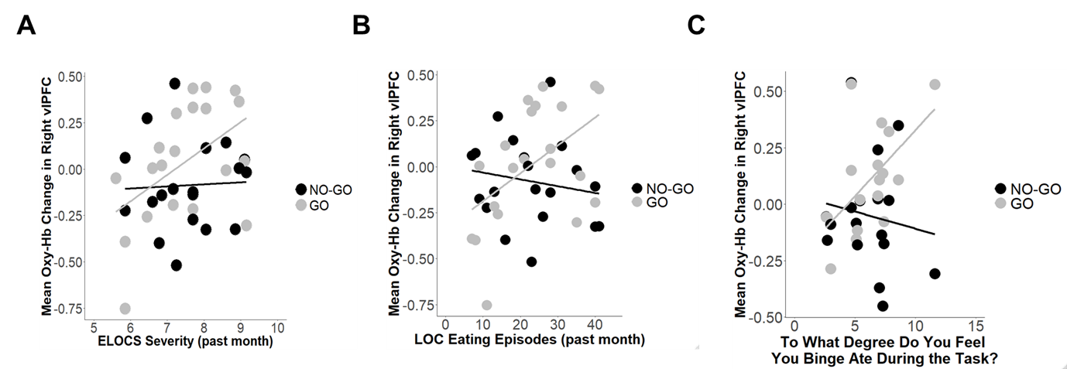

Figure S3. Exploratory brain-behavior association scatterplots: dysregulated eating severity. A Condition x Eating Loss of Control Scale (ELOCS) severity score interaction (A) and a Condition x Loss-of-Control (LOC) eating episode frequency interaction (B) within the bulimia nervosa group were detected in the right ventrolateral prefrontal cortex, such that more severe LOC and more frequent LOC were associated with less activation during NO-GO blocks relative to GO blocks. C) A similar interaction effect indicated that participants with bulimia nervosa who endorsed the strongest sense of binge eating during the eating task showed less activation during NO-GO blocks relative to GO blocks. Corresponding statistics are presented in Table S6.

Table S8. Exploratory Mixed Effects Models in the Full BN Sample: Effect of Dysregulated Eating Severity on Activation during the Eating Go/No-Go Task (p < 0.05, uncorrected)
Channel | Hem | Region | b | SE | df | t | R²_{β} | 95% CI of Effect Size
ELOCS Severity Score x Condition
16 | R | vlPFC | -0.14 | 0.06 | 155.00 | -2.21 | 0.040 | 0.001, 0.133
LOC Eating Episodes in the Past Month x Condition
16 | R | vlPFC | -0.02 | 0.007 | 155.00 | -2.42 | 0.047 | 0.002, 0.145
Sense of Binge Eating During the Eating Task x Condition
14 | R | vlPFC | -0.07 | 0.04 | 131.00 | -2.06 | 0.045 | 0.001, 0.158
Hem, hemisphere; ELOCS, Eating Loss of Control Scale; vlPFC, ventrolateral prefrontal cortex; CI, confidence interval. The Satterthwaite method was used to estimate degrees of freedom.

Table S9. Exploratory Group x Commission Errors Mixed Effects Models Examining the Effect of Task Performance on Group Differences in Activation during NO-GO Blocks (p < 0.05, uncorrected)
Eating Task
Channel | Hem | b | SE | df | t | R²_{β} | 95% CI of Effect Size
5 | L | -0.20 | 0.06 | 102.00 | -3.29*** | 0.106 | 0.019, 0.243
7 | L | -0.08 | 0.04 | 161.00 | -2.06* | 0.028 | <0.001, 0.101
9 | R | -0.10 | 0.04 | 103.60 | -2.17* | 0.032 | 0.001, 0.111
11 | R | -0.10 | 0.04 | 158.00 | -2.50* | 0.041 | 0.002, 0.124
12 | R | -0.10 | 0.07 | 122.00 | -1.40* | 0.018 | <0.001, 0.096
13 | R | -0.10 | 0.04 | 150.00 | -2.21* | 0.034 | 0.001, 0.116
16 | R | -0.14 | 0.06 | 138.00 | -2.28* | 0.040 | 0.001, 0.129
Standard Task
Channel | Hem | b | SE | df | t | R²_{β} | 95% CI of Effect Size
1 | L | -0.19 | 0.07 | 103.82 | -2.89*** | 0.070 | 0.008, 0.182
2 | L | -0.12 | 0.06 | 155.00 | -2.00* | 0.027 | <0.001, 0.102
4 | L | -0.16 | 0.06 | 149.00 | -2.53* | 0.044 | 0.002, 0.131
6 | L | -0.14 | 0.07 | 147.00 | -2.05* | 0.030 | <0.001, 0.108
8 | L | -0.20 | 0.07 | 118.00 | -2.63** | 0.060 | 0.004, 0.170
9 | R | -0.12 | 0.05 | 137.10 | -2.46* | 0.040 | 0.002, 0.120
11 | R | -0.15 | 0.05 | 137.99 | -2.83*** | 0.053 | 0.006, 0.139
12 | R | -0.15 | 0.07 | 127.71 | -2.02* | 0.034 | 0.001, 0.123
13 | R | -0.18 | 0.05 | 143.92 | -3.28*** | 0.074 | 0.014, 0.172
14 | R | -0.27 | 0.08 | 120.44 | -3.45*** | 0.099 | 0.021, 0.217
16 | R | -0.18 | 0.07 | 132.33 | -2.66** | 0.050 | 0.004, 0.139
*p < 0.05, uncorrected; **p < 0.01, uncorrected; ***p <0.005, uncorrected; Hem, hemisphere; CI, confidence interval. The Satterthwaite method was used to estimate degrees of freedom.

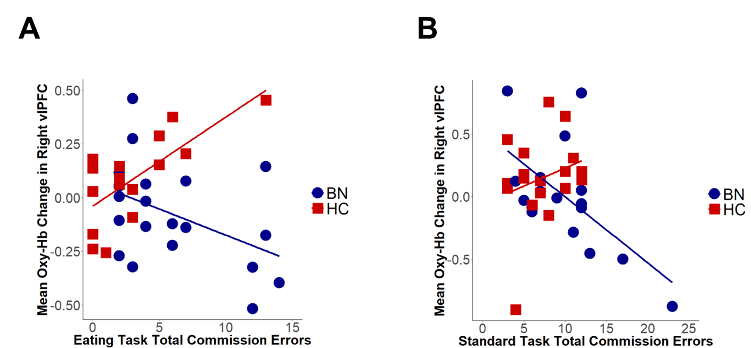

Figure S4. Exploratory brain-behavior association scatterplots: task performance. A) Eating go/no-go task group x commission error interaction in right lateral prefrontal cortex. B) Standard-task group x commission error interaction in right ventrolateral prefrontal cortex.

Sensitivity Analyses: Effects of Comorbidities and Medications
Current Comorbidities and Medications. Results of Group x Condition fNIRS analyses comparing un-medicated BN participants without co-morbid MDD or GAD to HC participants were similar to full-sample results (Table S10). However, effect sizes of bilateral vmPFC differences between this “pure” BN subgroup and HC on the eating task were larger than in full-sample analyses (p_{FDR} < 0.001; Figure S5).
To further explore specifically whether inclusion of the six medicated participants with BN may have masked results on the eating task in the full sample, we repeated analyses comparing the 16 unmedicated women with BN, regardless of potential comorbidity, to HC. Results confirmed that unmedicated women with BN showed medium-size deficits in bilateral vmPFC activation compared with controls on the eating task (p_{FDR} < 0.05).

History of Anorexia Nervosa. Group x Condition interactions comparing BN participants without past AN to HC on the eating go/no-go task revealed reduced activation in the BN group in vmPFC that were similar in effect size to full-sample analyses (Table S11), but Group x Condition interactions in right vlPFC on the eating go/no-go task were less robust than in full-sample analyses (p = 0.096, uncorrected, R²_{β} = 0.018;). Follow-up Condition x Lowest post-morbid adult BMI LMEs revealed no association of eating-task activation with lowest past BMI (ps > 0.245), suggesting that a history of low weight did not confound findings on the eating task.
On the standard task, however, the BN subgroup without past AN showed reduced activation of bilateral vmPFC and vlPFC compared with HC, with medium to large effect sizes (p_{FDR} < 0.05; Table S11, Figure S6). Follow-up Condition x Lowest Past BMI LMEs confirmed that women with BN who had a history of lower past BMIs showed stronger recruitment of bilateral vlPFC during NO-GO vs. GO blocks of the standard task (Table S12; Figure S7), further suggesting that perhaps inclusion of women with lower past BMIs in the full BN sample masked standard-task group differences.

Table S10. Exploratory Group x Condition Mixed Effects Models Comparing Controls (n = 23) to Bulimia Nervosa Participants with no GAD, MDD, or SSRI Use (n = 13; p < 0.05, uncorrected)
Eating Task
Channel | Hem | b | SE | df | t | R²_{β} | Post-hoc Pairwise Comparisons
6 |  | 0.23 | 0.11 | 218.00 | 2.04* | 0.022
8 | L | 0.60 | 0.13 | 131.25 | 4.64*** | 0.145 | NO-GO: HC > BN p = 0.0001
 |  |  |  |  |  |  | BN: GO > NO-GO p = 0.0002
 |  |  |  |  |  |  | HC: NO-GO > GO p = 0.012
10 | R | 0.55 | 0.15 | 129.95 | 3.70*** | 0.100
12 | R | 0.26 | 0.13 | 169.04 | 2.02* | 0.024
14 | R | 0.30 | 0.12 | 172.79 | 2.47* | 0.036 | NO-GO: HC > BN p = 0.014
 |  |  |  |  |  |  | BN: GO > NO-GO p = 0.025
16 | R | 0.27 | 0.12 | 205.00 | 2.22* | 0.028 | NO-GO: HC > BN p = 0.021
 |  |  |  |  |  |  | BN: GO > NO-GO p = 0.041
Standard Task
Channel | Hem | b | SE | df | t | R²_{β} | Post-Hoc Pairwise Comparisons
8 | L | 0.32 | 0.15 | 180.00 | 2.10* | 0.028 | HC: NO-GO > GO p = 0.0003
*p < 0.05, uncorrected; ***p_{FDR} < 0.001; GAD, generalized anxiety disorder; MDD, major depressive disorder; SSRI, selective serotonin reuptake inhibitor; Hem, hemisphere

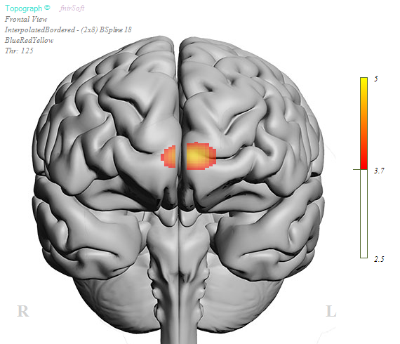

Figure S5. Exploratory Group x Condition interactions comparing bulimia nervosa participants with no GAD, MDD, or SSRI use to healthy control participants on the eating go/no-go task (p_{FDR} < 0.05).

Table S11. Exploratory Group x Condition Mixed Effects Models Comparing Controls (n = 23) to BN Participants with No History of Anorexia Nervosa (n = 12; p < 0.05, uncorrected)

Eating Task
Channel |  | Hem | b | SE |  | df |  | t |  | R²_{β} |  | Post-hoc Pairwise Comparisons
8 |  | L | 0.34 | 0.13 |  | 131.54 |  | 2.66* |  | 0.053 |  | NO-GO: HC > BN p = 0.0004
 |  |  |  |  |  |  |  |  |  |  |  | HC: NO-GO > GO p = 0.015
10 |  | R | 0.36 | 0.14 |  | 131.19 |  | 2.60* |  | 0.05 |  | NO-GO: HC > BN p = 0.0005
Standard Task
Channel | Hem |  | b | SE | df |  | t |  | R²_{β} |  | Post-Hoc Pairwise Comparisons
2 | L |  | 0.39 | 0.10 | 232.00 |  | 3.81*** |  | 0.068 |  | GO: BN > HC p = 0.0003
 |  |  |  |  |  |  |  |  |  |  | BN: GO > NO-GO p = 0.0498
 |  |  |  |  |  |  |  |  |  |  | HC: NO-GO > GO p = 0.0004
4 | L |  | 0.46 | 0.13 | 197.81 |  | 3.61*** |  | 0.062 |  | NO-GO: HC > BN p = 0.031
 |  |  |  |  |  |  |  |  |  |  | GO: BN > HC p = 0.007
 |  |  |  |  |  |  |  |  |  |  | BN: GO > NO-GO p = 0.0499
 |  |  |  |  |  |  |  |  |  |  | HC: NO-GO > GO p = 0.001
6 |  |  | 0.37 | 0.14 | 225.00 |  | 2.55** |  | 0.033
8 | L |  | 0.46 | 0.15 | 161.04 |  | 3.11** |  | 0.057 |  | NO-GO: HC > BN p = 0.020
 |  |  |  |  |  |  |  |  |  |  | HC: NO-GO > GO p = 0.0003
10 | R |  | 0.38 | 0.15 | 146.53 |  | 2.59** |  | 0.044 |  | HC: NO-GO > GO p = 0.0002
14 | R |  | 0.59 | 0.16 | 183.00 |  | 3.68*** |  | 0.082 |  | NO-GO: HC > BN p = 0.017
 |  |  |  |  |  |  |  |  |  |  | GO: BN > HC p = 0.006
 |  |  |  |  |  |  |  |  |  |  | BN: GO > NO-GO p = 0.009
 |  |  |  |  |  |  |  |  |  |  | HC: NO-GO > GO p = 0.007
*p < 0.01, uncorrected; **p_{FDR} < 0.05; ***p_{FDR} < 0.005; Hem, hemisphere

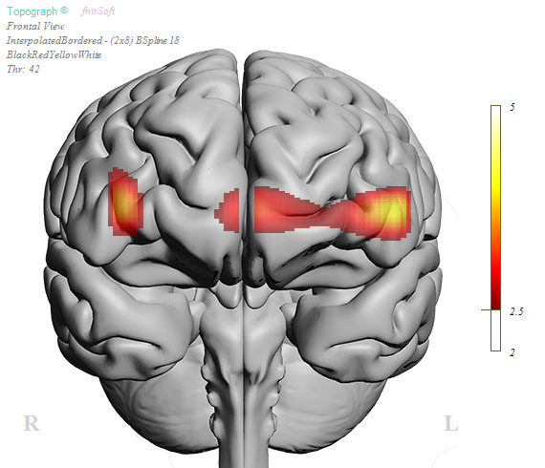

Figure S6. Exploratory group x condition interactions comparing bulimia nervosa participants with no history of anorexia nervosa to healthy controls on the standard task (p_{FDR} < 0.05).

Table S12. Exploratory Mixed Effects Models Examining the Effect of Lowest BMI on Activation during the Standard Go/No-Go Task in the BN Group (p < 0.05, uncorrected)
Channel | Hem | b | SE | df | t | R²_{β} | 95% CI of Effect Size
1 | L | -0.08 | 0.03 | 107.00 | -3.06** | 0.122 | 0.018, 0.289
2 | L | -0.10 | 0.03 | 148.00 | -3.38** | 0.097 | 0.018, 0.220
4 | L | -0.09 | 0.03 | 147.00 | -2.64** | 0.060 | 0.004, 0.168
6 | L | -0.06 | 0.03 | 146.00 | -0.04* | 0.039 | 0.001, 0.136
11 | R | -0.05 | 0.02 | 139.00 | -2.28** | 0.050 | 0.001, 0.160
12 | R | -0.08 | 0.03 | 113.00 | -2.38** | 0.068 | 0.003, 0.203
13 | R | -0.08 | 0.03 | 133.00 | -3.03** | 0.088 | 0.012, 0.216
14 | R | -0.14 | 0.05 | 106.00 | -2.82** | 0.100 | 0.010, 0.256
15 | R | -0.08 | 0.03 | 102.00 | -2.74** | 0.102 | 0.009, 0.267
16 | R | -0.10 | 0.04 | 131.00 | -2.59** | 0.066 | 0.003, 0.176
*p < 0.05, uncorrected; **p_{FDR} < 0.05; Hem, hemisphere; vlPFC, ventrolateral prefrontal cortex; vmPFC, ventromedial prefrontal cortex; CI, confidence interval. The Satterthwaite method was used to estimate degrees of freedom. Statistics presented correspond to the condition x lowest past BMI interaction effect.

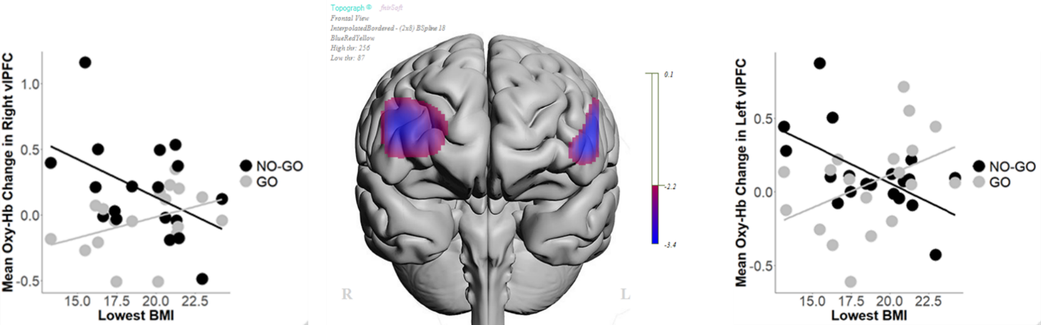

Figure S7. Exploratory brain-lowest past BMI associations on the standard task. Condition x Lowest Past BMI interaction analyses revealed that women in the BN group with lower past BMIs showed more activation in bilateral prefrontal cortices during NO-GO relative to GO blocks of the standard task (p_{FDR} < 0.05). Scatterplots depict interactions in right and left ventrolateral prefrontal cortices.

References

Aron, A. R. (2011). From reactive to proactive and selective control: developing a richer model for stopping inappropriate responses. Biological Psychiatry, 69(12), e55-e68. doi:10.1016/j.biopsych.2010.07.024
Ayaz, H. (2010). Functional Near Infrared Spectroscopy Based Brain Computer Interface. Drexel University, Philadelphia, PA. (214)
Ayaz, H., Izzetoglu, M., Platek, S. M., Bunce, S., Izzetoglu, K., Pourrezaei, K., & Onaral, B. (2006, Aug. 30 2006-Sept. 3 2006). Registering fNIR data to brain surface image using MRI templates. Paper presented at the Engineering in Medicine and Biology Society, 2006. EMBS '06. 28th Annual International Conference of the IEEE.
Ayaz, H., Izzetoglu, M., Shewokis, P. A., & Onaral, B. (2010). Sliding-window motion artifact rejection for Functional Near-Infrared Spectroscopy. Conference Proceedings of the Annual International Conference of the IEEE Engineering in Medicine and Biology Society, 2010, 6567-6570. doi:10.1109/iembs.2010.5627113
Ayaz, H., Shewokis, P. A., Bunce, S., Izzetoglu, K., Willems, B., & Onaral, B. (2012). Optical brain monitoring for operator training and mental workload assessment. Neuroimage, 59(1), 36-47. doi:10.1016/j.neuroimage.2011.06.023
Ayaz, H., Shewokis, P. A., Curtin, A., Izzetoglu, M., Izzetoglu, K., & Onaral, B. (2011). Using MazeSuite and Functional Near Infrared Spectroscopy to Study Learning in Spatial Navigation. (56), e3443. doi:10.3791/3443
Buchsbaum, B. R., Greer, S., Chang, W.-L., & Berman, K. F. (2005). Meta-analysis of neuroimaging studies of the Wisconsin Card-Sorting task and component processes. Human Brain Mapping, 25(1), 35-45. doi:10.1002/hbm.20128
Chikazoe, J., Konishi, S., Asari, T., Jimura, K., & Miyashita, Y. (2007). Activation of right inferior frontal gyrus during response inhibition across response modalities. Journal of Cognitive Neuroscience, 19(1), 69-80. doi:10.1162/jocn.2007.19.1.69
Cooper, R. J., Gagnon, L., Goldenholz, D. M., Boas, D. A., & Greve, D. N. (2012). The utility of near-infrared spectroscopy in the regression of low-frequency physiological noise from functional magnetic resonance imaging data. Neuroimage, 59(4), 3128-3138. doi:https://doi.org/10.1016/j.neuroimage.2011.11.028
Edwards Lloyd, J., Muller Keith, E., Wolfinger Russell, D., Qaqish Bahjat, F., & Schabenberger, O. (2008). An R2 statistic for fixed effects in the linear mixed model. Statistics in Medicine, 27(29), 6137-6157. doi:10.1002/sim.3429
Hudson, J. I., Hiripi, E., Pope, H. G., & Kessler, R. C. (2007). The prevalence and correlates of eating disorders in the National Comorbidity Survey replication. Biological Psychiatry, 61(3), 348-358.
Izzetoglu, M., & Holtzer, R. (2020). Effects of Processing Methods on fNIRS Signals Assessed During Active Walking Tasks in Older Adults. IEEE Trans Neural Syst Rehabil Eng, 28(3), 699-709. doi:10.1109/tnsre.2020.2970407
Kissileff, H. R., Walsh, B. T., Kral, J. G., & Cassidy, S. M. (1986). Laboratory studies of eating behavior in women with bulimia. Physiology & Behavior, 38, 563-570.
Kissileff, H. R., Zimmerli, E., Torres, M. I., Devlin, M. J., & Walsh, B. T. (2008). Effect of eating rate on binge size in bulimia nervosa. Physiology & Behavior, 93, 481-485.
LaChaussee, J. L., Kissileff, H. R., Walsh, B. T., & Hadigan, C. M. (1992). The single-item meal as a measure of binge-eating behavior in patients with bulimia nervosa. Physiology & Behavior, 51(3), 593-600.
Oldfield, R. (1971). The assessment and analysis of handedness: the Edinburgh inventory. Neuropsychologia, 9(1), 97-113.
Ranchet, M., Hoang, I., Cheminon, M., Derollepot, R., Devos, H., Perrey, S., . . . Paire-Ficout, L. (2020). Changes in Prefrontal Cortical Activity During Walking and Cognitive Functions Among Patients With Parkinson's Disease. Frontiers in Neurology, 11(1658). doi:10.3389/fneur.2020.601686
Rezazadeh Sereshkeh, A., Yousefi, R., Wong, A. T., Rudzicz, F., & Chau, T. (2019). Development of a ternary hybrid fNIRS-EEG brain–computer interface based on imagined speech. Brain-Computer Interfaces, 6(4), 128-140. doi:10.1080/2326263X.2019.1698928
Rodrigo, A. H., Di Domenico, S. I., Ayaz, H., Gulrajani, S., Lam, J., & Ruocco, A. C. (2014). Differentiating functions of the lateral and medial prefrontal cortex in motor response inhibition. Neuroimage, 85, Part 1(0), 423-431. doi:10.1016/j.neuroimage.2013.01.059
Rodrigo, A. H., Di Domenico, S. I., Graves, B., Lam, J., Ayaz, H., Bagby, R. M., & Ruocco, A. C. (2016). Linking trait-based phenotypes to prefrontal cortex activation during inhibitory control. Social cognitive and affective neuroscience, 11(1), 55-65. doi:10.1093/scan/nsv091
Ruocco, A. C., Rodrigo, A. H., McMain, S. F., Page-Gould, E., Ayaz, H., & Links, P. S. (2016). Predicting Treatment Outcomes from Prefrontal Cortex Activation for Self-Harming Patients with Borderline Personality Disorder: A Preliminary Study. Frontiers in human neuroscience, 10, 220. doi:10.3389/fnhum.2016.00220
Schebendach, J., Broft, A., Foltin, R. W., & Walsh, B. T. (2013). Can the reinforcing value of food be measured in bulimia nervosa? Appetite, 62, 70-75. doi:10.1016/j.appet.2012.11.009
Scholkmann, F., & Wolf, M. (2013). General equation for the differential pathlength factor of the frontal human head depending on wavelength and age. J Biomed Opt, 18(10), 105004. doi:10.1117/1.Jbo.18.10.105004
Simmonds, D. J., Pekar, J. J., & Mostofsky, S. H. (2008). Meta-analysis of go/no-go tasks demonstrating that fMRI activation associated with response inhibition is task-dependent. Neuropsychologia, 46(1), 224-232. doi:10.1016/j.neuropsychologia.2007.07.015
Skunde, M., Walther, S., Simon, J. J., Wu, M., Bendszus, M., Herzog, W., & Friederich, H.-C. (2016). Neural signature of behavioural inhibition in women with bulimia nervosa. Journal of psychiatry & neuroscience: JPN, 41(5), E69.
Smith, A. B., Taylor, E., Brammer, M., Toone, B., & Rubia, K. (2006). Task-speficif hypoactivation in prefrontal and temporoparietal brain regions during motor inhibition and task switching in medication-naive children and adolescents with attention deficit hyperactivity disorder. American Journal of Psychiatry, 163(6), 1044-1051.
Strangman, G., Culver, J. P., Thompson, J. H., & Boas, D. A. (2002). A quantitative comparison of simultaneous BOLD fMRI and NIRS recordings during functional brain activation. Neuroimage, 17(2), 719-731.
Zimmerli, E., Devlin, M. J., Kissileff, H. R., & Walsh, B. T. (2010). The development of satiation in bulimia nervosa. Physiology & Behavior, 100, 346-349. doi:10.1016/j.physbeh.2010.03.010

