Supplementary Online Content

INDEX

- eAppendix 1. Methods
  - 1.1 Recruitment of the sample
  - 1.2 Sociodemographics characteristics
  - 1.3 Genotyping and PRS building
  - 1.4 PCA analyses and definition of European ancestry based on PC
  - 1.5 Justification of regression model and detailed regression analysis
  - 1.6 Power calculation of main analyses
  - 1.7 Representability of included sample
- eAppendix 2. Results (eTables and eFigures)
  - 2.1 Sociodemographics comparison with effect sizes
    - 2.1.1 eTable 2. Case-control comparison of sociodemographic in European subsample
    - 2.1.2 eTable 3. Affective vs Schizophrenia-spectrum disorder sociodemographic comparison in European subsample
  - 2.2 Case-control variance explained of employed PRSs (eFigure1)
  - 2.3 Visual representation of data
    - 2.3.1 eFigure2. Three-dimensional scatterplot of the PRS distribution in the three groups of affective, non-affective psychosis and controls
  - 2.4. Detailed results of association analyses.
    - 2.4.1 eTable 4. Association of different PRSs (SZ, BD, D and IQ) with DSMIV OPCRIT clinical groups adjusted with 10 PCs in European population
    - 2.4.2 eTable 5. Association of different PRSs (SZ, BD, D and IQ) with DSMIV OPCRIT AP diagnostic categories adjusted with 10 PCs in European population (using non-affective psychosis as reference)
  - 2.5 Goodness of fit of data of join model combining three major psychiatric disorder polygenic scores (SZ, BD, MDD-P) and polygenic score for intelligence (eFigure3)

- eBibliography

This supplementary material has been provided by the authors to give readers additional
information about their work

SUPPLEMENTARY
- eAppendix 1. Methods
1.1 Recruitment of the sample
All identified subjects aged 18 to 64 years who were resident within the 17 study areas and presented to the adult psychiatric services with an untreated FEP (ICD-10 codes F20-F33) not related to organic cause between May 1, 2010 and April 1, 2015 and fulfilling inclusion criteria¹ were initially included as part of the incidence sample. Local research ethics committees in each catchment area approved the extraction of basic demographic and clinical details from patient’s records. The 17 catchment areas belonged to 6 countries: UK (Southeast London, Cambridgeshire), the Netherlands (Amsterdam, Gouda and Voorhout), Italy (Bologna, Veneto, Palermo), France (Paris, Val-de-Marne, Puy-de-Dôme), Spain (Madrid, Barcelona, Valencia, Oviedo, Santiago, Cuenca) and Brazil (Ribeirão Preto). Among the total of 2774 cases included in the incidence sample and that were invited to take part of the study, 1130 patients agreed to be included in the case-control study, for whom written consent was obtained.
Besides, 1499 unaffected controls were recruited with a quota sampling approach to represent the local population living in the areas served by the services.
1.2 Sociodemographics characteristics
Socio-demographic data was collected using the Medical Research Council (MRC) Socio-demographic Schedule modified version² and supplemented by clinical records. For educational level, we stratified the sample into three categories: No qualification, school education (GCSE, ‘O’ levels and ‘A’ levels equivalent) and tertiary education (vocational, college, university or professional qualification). We dichotomized employment (employed vs. unemployed), marital status (married/in a stable relationship vs. no relationship) and living arrangement (independent living vs. no independent living).
1.3 Genotyping and PRS building
DNA from blood tests or saliva sample was obtained from most participants at baseline (73.6% of cases and 78.5% of controls). EUGEI sample was genotyped at Cardiff University Institute of Psychological Medicine and Clinical Neurology, using custom Illumina HumanCoreExome-24 BeadChip genotyping arrays containing probes for 570038 genetic variants (Illumina, San Diego, CA). Genotype data were called using the GenomeStudio package and transferred into PLINK format for further analysis.
Quality control was conducted in PLINK v1.07³ or with custom Perl scripts. Variants with call rate < 98% and with Hardy-Weinberg Equilibrium p-value < 1e-6 were excluded from the dataset. After QC, 559505 variants remained. Samples with call rate < 98% were excluded from the dataset. A linkage disequilibrium pruned set of variants was calculated using the --indep-pairwise command in PLINK (maximum r2=0.25, window size=500 SNPs, window step size = 50 SNPs) and used for further analyses. Homozygosity F values were calculated using the --het command in PLINK, and outlier samples (F < -0.11 or F > 0.15) excluded. The genotypic sex of samples was calculated from X chromosome data using the --check-sex command in PLINK, and samples with different genotypic sex to their database sex excluded.
Identity-by-descent (IBD) values were calculated for the sample in PLINK. Samples with 2 or more database siblings in the database that were not supported by the genotypic data, or with 1 or more siblings among the genotyped samples according to the database but no identified genotypic siblings (defined as PI-HAT > 0.35 and < 0.65) were excluded. After visually observing clustering of errors by genotyping chip, we decided to further exclude chips with a high proportion of errors. All samples on chips with 5 or more sample exclusions due to heterozygosity or call rate (out of 12 possible samples) were excluded. All samples on chips with 4 or more sample exclusions due to sex or relative checks were also excluded, unless their identity was corroborated by concordance between database and genotype relatedness data with a sample on another chip
For constructing PRSs, clumping was performed in imputed best-guess genotypes for each dataset using PLINK (maximum r2=0.1, window size=500kb, minimum MAF=5%), and variants within regions of long-range LD around the genome (including the MHC) excluded⁴. PRS were then constructed from best-guess genotypes using PLINK at 10 different p-value thresholds (PT=1, 0.5, 0.2, 0.1, 0.05, 0.01, 1x10⁻⁴, 1x10⁻⁵, 1x10⁻⁶, 5x10⁻⁸). We used PT=0.05 for our primary analysis, as this explained the most variation in the phenotype of schizophrenia⁵, bipolar disorder⁶, depression⁷ and IQ⁸.
1.4 PCA analyses and definition of European ancestry based on PC
Principal components were calculated in PLINK using LD pruned variants across the whole sample. We ranked the sample in centiles based on PC1, and calculated proportion of self-reported European ethnicity in a dichotomy fashion (yes/no) on each centile. We established the cut-off point in the stacked PC1 when three groups in a row reported less than 0.5 of whiteness. We repeated the process for PC2 and used the two cut-off point as threshold in which those who fell within them were considered as European.
1.5 Justification of regression model and detailed regression analysis
We built our models on multinomial logistic regression as it is used when the dependent variable is multicategorical (or multinomial), when there are more than two categories and these can’t be ordered in a meaninful way. This regression model assumes that: 1) each independent variable has a specific value for each observation; 2) the independent variable can’t predict perfectly the dependent variable in any case; 3) collinearity is relatively low. For using multinomial logistic regression there is no need for the independent variables to be statistically different, and after checking for multicollinearity within our independent variables using Stata command estat vif , overall VIF was 2.56, which falls below suggested tolerance threshold stablish on 10.0 ¹⁰.
Firstly, a multinomial logistic regression model was built to compare the association of SSD and AP with controls; followed by a simple logistic regression model comparing the association between SSD and AP groups. In our second multinomial logistic model, we tested how PRSs performed in differenciating BD and PD from SSD as reference group. Additionally and only included in supplementary material we built an additional model to analyse how PRSs distribute across all psychotic diagnostic categories. We included a multicategorial variable as dependent variable using control as reference group and the four PRSs as independent variable. The diagnostic categories included in this multicategorical variable were: schizophrenia (SZ), schizoaffective disorder (SAD), other psychosis (OP), Bipolar disorder (BD) and Psychotic depression (PD). Lastly, an individual multiple logistic regression model was performed to compare PRSs associations between BD and PD.
The effect size output provided by multinomial logistic regression is Relative Risk Ratio - RRR -, which should be interpreted as the Odds Ratio between each category and always the stablished reference category. For our model 1, control is the reference category, while in model 2 we stablished as reference group the SSD.

1.6 Power calculation of main analyses
We conducted power calculation analyses utilising the R-package AVENGEME¹¹, which allows power calculation for PRS analyses. We calculated the required SNP-h² or fix covariance in our target sample to obtain 80% of power on each regression model and per each PRS (SZ, BD and D). Whenever the estimated covariance was too low, reflecting a SNP-h² in our target sample lower than the SNP-h² of the training sample, it was considered plausible, and therefore we accepted the 80% power. A limitation is that this procedure only allows calculating power on associations with phenotypes tested on training samples, which prevent us to calculate power of those associations between PRSs with the other phenotypes (i.e associations with PRS IQ, or power of PRS BD in the “SSD vs control” association).
AVENGEME calculations assumed the following values:
 | PRS SZ | PRS BD | PRS D
Number of SNP after QC on target sample | 559505 | 559505 | 559505
Training sample size | 150064 | 51710 | 807553
p-value threshold in training samples | 0.1 | 0.1 | 0.1
Fix variance value (SNP-h) | 0.21⁴ | 0.17-0.23 (0.20)⁶ | 0.089⁷
Fix null prop to value | 0.95 | 0.95 | 0.95
Training trait prevalence | 0.01 | 0.015 | 0.15
Training sampling factor | 0.246488 | 0.39358 | 0.305073
Target trait prevalence | 0.01 | 0.015 | 0.15

Estimated covariance and SNP-h² values for 80% of power of the different comparison for the appropriate PRSs are provided on the table below.
Info in target sample | Sample size | Sampling factor | Estimated covariance | Estimated SNP-h² | Power
SSD vs CONTROL  .PRS SZ | 1414 | 0.2893 | 0.12 | 0.069 | 84%
AP vs CONTROL  .PRS BD  .PRS D | 1169 | 0.1403  0.1403 | 0.26  0.14 | 0.338  0.22 | 78.9%  83.6%
AP vs SSD  .PRS SZ  .PRS BD  .PRS D | 573 | 0.7138  0.2862  0.2862 | 0.18  0.29  0.15 | 0.154  0.42  0.25 | 80.9%  80%  81%
BD vs SSD  .PRS SZ  .PRS BD | 483 | 0.8468  0.1532 | 0.22  0.4 | 0.23  0.8 | 79.9%  81%
MDD-P vs SSD  .PRS SZ  .PRS D | 499 | 0.8196  0.1804 | 0.21  0.18 | 0.21  0.36 | 81.2%  79%
BD vs MDD-P  .PRS BD  .PRS D | 164 | 0.4451  0.5549 | 0.48  0.24 | 2.589  0.65 | 79.8%  78.7%

1.7 Representability of included sample
No differences in gender, educational level and diagnosis but only small differences on age were found between included subjects with genotype data and those without DNA information available; suggesting a good representability of the whole sample.
1.8.1 eTable 1. Comparison of sociodemographic of included and excluded samples based on genetic availability
DESCRIPTIVE AT BASELINE | Number (%)/Mean(SD) |  | Statistics
Gender  Male  Female  Age (years), mean (SD) | Subjects with DNA  n= 2026  1079 (53.3)  947 (46.7)  34.3 (12.3) | Subjects without PRS  n= 605  328 (54.2)  277 (45.8)  33 (12.3) | Tests (df)  Χ2(1)=0.172  U=-2.7 | p value  0.679  0.009
EDUCATION LEVEL  No qualification  School education  Tertiary education  YEARS IN EDUCATION | 199 (9.9)  888 (44.1)  925 (46)  14.29 (6.5) | 57 (9.6)  290 (48.9)  246 (41.5)  15.52 (12.3) | Χ2(2)=4.39  U=0.216 | 0.111  0.829
OPCRIT DSM IV DIAGNOSIS  Schizophrenia-spectrum disorder  Affective psychosis  Bipolar disorder  Psychotic depression | 542 (73.1)  95 (12.8)  104 (14.1) | 197 (74.3)  35 (13.2)  33 (12.5) | Χ2(2)=0.42 | 0.811
SD: standard deviation; df: degrees of freedom
- eAppendix 2. Results

2.1 Sociodemographics comparison with effect sizes
2.1.1 eTable 2. Case-control comparison of sociodemographic in European subsample (n=1659)
DESCRIPTIVE AT BASELINE | Number (%)/Mean(SD) |  | Statistics
Gender  Male  Female  Age (years), mean (SD) | Cases  n= 654  412 (63)  242 (37)  31.8 (10.95) | Control  n= 1005  474 (47.2)  531 (52.8)  36.9 (13) | Tests (df)  Χ2(1)=39.91  U=7.66 | Effect sizes  V=.15 (.11-.20)  r= 0.19 | p value  <0.001  <0.001
EVER USED CANNABIS  No  Yes | 224 (35.3)  410 (64.7) | 528 (53)  469 (47) | Χ2(1)=48.46 | V=0.17 (0.13-0.22) | <0.001
EDUCATION LEVEL  No qualification  School education  Tertiary education  YEARS IN EDUCATION | 100 (15.4)  327 (50.5)  221 (34.1)  12.87 (4.08) | 40 (4)  416 (41.5)  546 (54.5)  14.69 (4.19) | Χ2(2)=102.87  U=8.26 | V=0.25 (0.20-0.3)  r=0.20 | <0.001  <0.001
SOCIAL FUNCTIONING  Employment status  Employed  Unemployed  Marital status  Steady relationship  No relationship  Living arrangements  Independent living  No independent living | 256 (50.3)  253 (49.7)  201 (33.5)  399 (66.5)  220 (42.5)  298 (57.5) | 615 (61.6)  383 (38.4)  626 (62.4)  378 (37.7)  683 (68.5)  314 (31.5) | Χ2(1)=17.7  Χ2(1)=125.2  Χ2(1)=95.96 | V=0.11 (0.06-0.16)  V=0.28 (0.23-0.33)  V=0.25 (0.2-0.3) | <0.001  <0.001  <0.001
OPCRIT DSM IV DIAGNOSIS  Schizophrenia-spectrum disorder  Affective psychosis  Bipolar disorder  Psychotic depression | 409 (71.4)  164 (28.4)  73 (12.7)  91 (15.8) | -  -  -  -
SD: standard deviation; df: degrees of freedom

2.1.2 eTable 3. Affective vs Schizophrenia-spectrum disorder sociodemographic comparison in European subsample (n=573)
DESCRIPTIVE AT BASELINE | Number (%)/Mean(SD) |  | Statistics
Gender  Male  Female  Age (years), mean (SD) | Affective psychosis  n= 164  83 (50.6)  81 (49.4)  32.84 (11.56) | Schizophrenia-spectrum disorder  n= 409  278 (68)  131 (32)  31.63 (10.92) | Tests (df)  Χ2(1)=15.14  z=-1.013 | Effect sizes  V=0.16 (0.09-0.25)  r= -0.042 | p value  <0.001  0.240
EVER USED CANNABIS  No  Yes | 58 (36)  103 (64) | 136 (34.2)  262 (65.8) | Χ2(1)=0.17 | V=0.018 (0.04-0.1) | 0.677
EDUCATION LEVEL  No qualification  School education  Tertiary education  YEARS IN EDUCATION | 25 (15.3)  87 (53.4)  51 (31.3)  12.58 (3.84) | 65 (16.1)  197 (48.6)  143 (35.3)  12.94 (4.12) | Χ2(2)=1.107  Z=0.55 | V=0.04 (0.06-1.13)  r: 0.023 | 0.575  0.581
SOCIAL FUNCTIONING  Employment status  Employed  Unemployed  Marital status  Steady relationship  No relationship  Living arrangements  Independent living  No independent living | 79 (58.5)  56 (41.5)  74 (48.1)  80 (52)  73 (53.7)  63 (46.3) | 141 (45.5)  169 (54.5)  105 (28.3)  266 (71.7)  119 (37.5)  198 (62.5) | Χ2(1)=6.39  Χ2(1)=18.89  Χ2(1)=10.15 | V=0.12 (0.05-0.22)  V=0.19 (0.12-0.28)  V=0.15 (0.08-0.25) | 0.011  <0.001  0.001
SD: standard deviation; df: degrees of freedom

2.2 Case-control variance explained of employed PRSs (eFigure1)
2.2.1 eFigure1. Variance expressed by Nagelkerke R Square of PRS SZ, BD, D and IQ at 10 different p-values thresholds on case-control (all psychosis vs control) associations adjusted by 10PCs

2.3 Visual representation of data
2.3.1 eFigure2. Three-dimensional scatterplot of the PRS distribution in the three groups of affective, non-affective psychosis (SSD) and controls
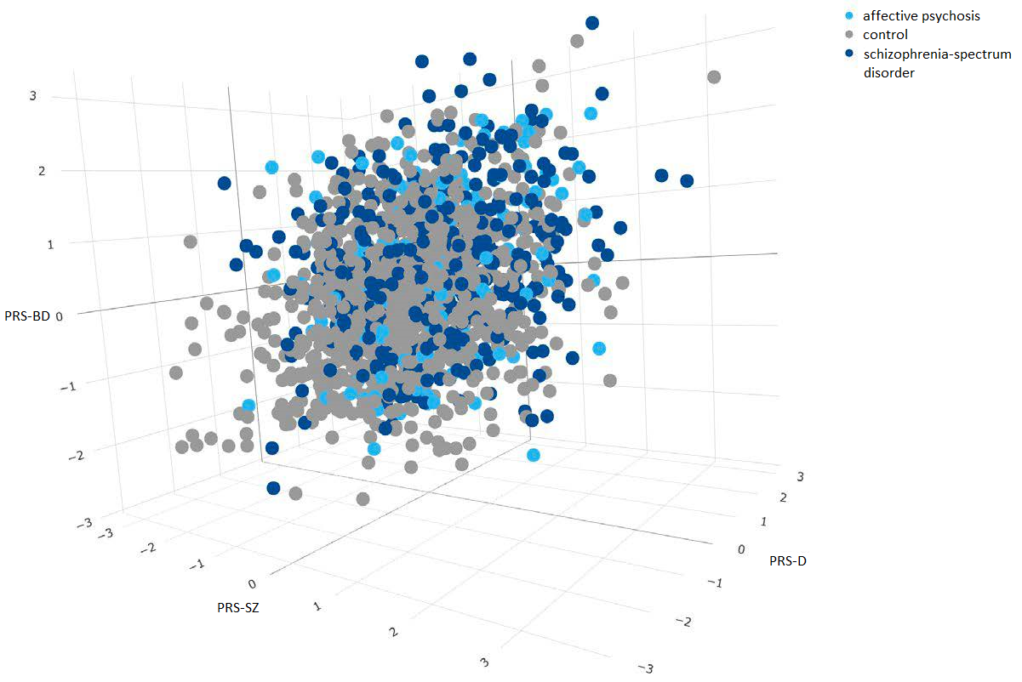
Three-dimensional scatterplot of the PRS distribution in the three groups of affective (AP), non-affective psychosis (SSD) and controls. The three axes correspond to each PRS (z-score after adjustment for PCs and site) and the dots are coloured by group. We observed a large overlap of PRS between the three groups of affective, non-affective psychosis and controls.
2.4. Detailed results of association analyses.
2.4.1 eTable 4. Association of different PRSs (SZ, BD, D and IQ) with DSMIV OPCRIT clinical groups adjusted with 10 PCs in European population (total n=1576)

MNLR | PseudoR | Prob > chi2
N=1578 | 0.1089 | <0.001
 | OR | p value | 95% CI
SSD vs CONTROL
PRS SZ | 1.87 | <0.001 | 1.57 | 2.2
PRS BD | 1.34 | <0.001 | 1.15 | 1.57
PRS D | 1.04 | 0.566 | 0.91 | 1.19
PRS IQ | 0.88 | 0.056 | 0.77 | 1.00
AP vs CONTROL
PRS SZ | 1.34 | 0.014 | 1.06 | 1.68
PRS BD | 1.35 | 0.006 | 1.09 | 1.67
PRS D | 1.37 | 0.001 | 1.14 | 1.64
PRS IQ | 0.85 | 0.074 | 0.71 | 1.02
SLR | PseudoR | Prob > chi2
N=573 | 0.0858 | 0.0013
AP vs SSD
PRS SZ | 0.7 | 0.010 | 0.54 | 0.92
PRS BD | 1.02 | 0.857 | 0.81 | 1.3
PRS D | 1.31 | 0.011 | 1.06 | 1.61
PRS IQ | 0.99 | 0.979 | 0.81 | 1.23
MNLR: multinomial logistic regression; SLR: simple logistic regression; SSD: schizophrenia-spectrum disorder; AP: affective psychosis, SZ: schizophrenia; BD: bipolar disorder; D: depression; IQ: intelligence quotient

2.4.2 eTable 5. Association of different PRSs (SZ, BD, D and IQ) with DSMIV OPCRIT AP diagnostic categories adjusted with 10 PCs in European population (non-affective psychosis as reference)

MNLRa | PseudoR | Prob > chi2
N=573 | 0.1106 | 0.0008
 | OR | p value | 95% CI
BD vs SSD
PRS SZ | 0.97 | 0.865 | 0.68 | 1.39
PRS BD | 0.98 | 0.893 | 0.71 | 1.35
PRS D | 1.14 | 0.364 | 0.86 | 1.41
PRS IQ | 1.07 | 0.315 | 0.81 | 1.41
MDD-P vs SSD
PRS SZ | 0.52 | <0.001 | 0.37 | 0.74
PRS BD | 1.04 | 0.814 | 0.77 | 1.4
PRS D | 1.49 | 0.003 | 1.14 | 1.94
PRS IQ | 0.94 | 0.655 | 0.72 | 1.23
SLR | PseudoR | Prob > chi2
N=164 | 0.20 | 0.0347
BD vs MDD-P
PRS SZ | 2.14 | 0.007 | 1.23 | 3.74
PRS BD | 1.01 | 0.959 | 0.64 | 1.61
PRS D | 0.71 | 0.092 | 0.48 | 1.06
PRS IQ | 1.03 | 0.878 | 0.71 | 1.49
MNLR: multinomial logistic regression; SLR: simple logistic regression; SSD: schizophrenia-spectrum disorder; AP: affective psychosis, SZ: schizophrenia; BD: bipolar disorder; D: depression; IQ: intelligence quotient

2.5 Goodness of fit of data of join model combining three major psychiatric disorder polygenic scores (SZ, BD, MDD-P) and polygenic score for intelligence for SSD and AP comparison.
eFigure1.
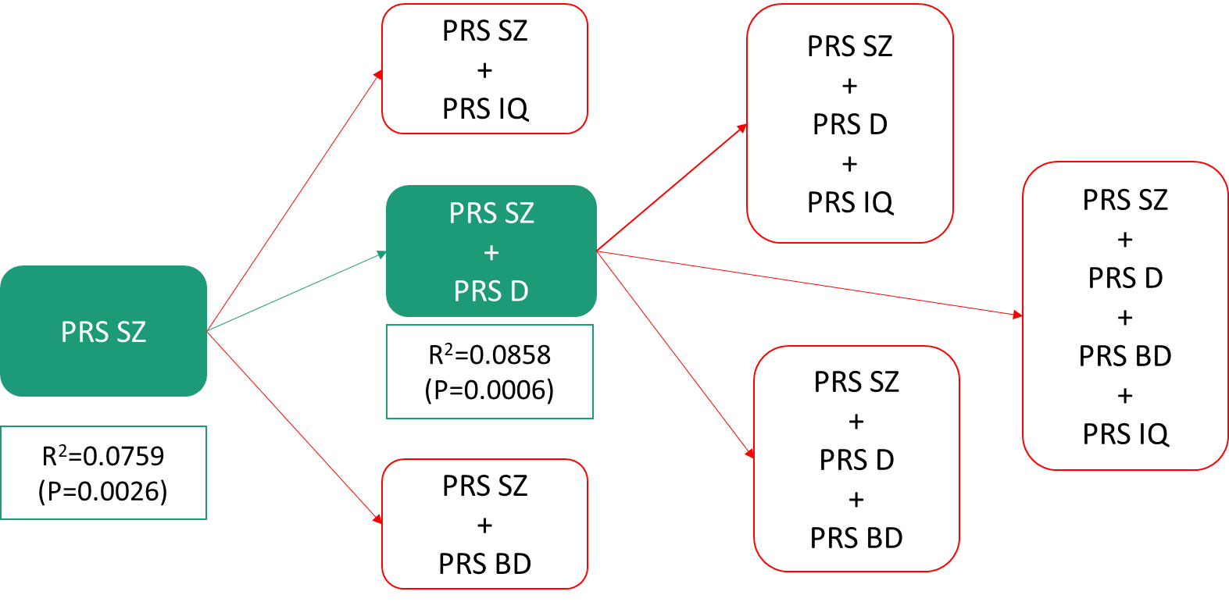
Green lines represent improvement of model. Red lines represent non-significant likelihood-ratio tests. SZ: schizophrenia; BD: bipolar disorder; D: depression; IQ: intelligence quotient

Goodness of fit of data was explored through likelihood ratio test by building a series of regression models. We started with a baseline model including PRS-SZ alongside 10PCs and sites as covariates, and we sequentially added the other three PRSs variables, once at a time, in order to identify those PRS adding value to the discriminability between clinical groups (SSD and AP). The best fitness of data by per likelihood ratio test was by adding PRS-SZ and PRS-D to the model (Δχ²(1) = 6.74, p = 0.0094).

eAppendix 3. References
1 Jongsma, HE. et al. Treated incidence of psychotic disorders in the multinational EU-GEI study. JAMA Psychiatry; 75: 36–46 (2018).
2 Mallett, R., Leff, J., Bhugra, D., Pang, D. & Zhao, JH. Social environment, ethnicity and schizophrenia. Soc Psychiatry Psychiatr Epidemiol; 37: 329–335 (2002).
3 Purcell, S. et al. PLINK: A tool set for whole-genome association and population-based linkage analyses. Am J Hum Genet; 81: 559–575 (2007).
4 Price, AL. et al. Long-Range LD Can Confound Genome Scans in Admixed Populations. Am. J. Hum. Genet. ; 83: 132–135 (2008).
5 Ripke, S., Neale, BM., Corvin, A., Walters, JT. & Schizophrenia Working Group of the Psychiatric Genomics Consortium. Biological insights from 108 schizophrenia-associated genetic loci. Nature; 511: 421–427 (2014).
6 Stahl, EA. et al. Genome-wide association study identifies 30 loci associated with bipolar disorder. Nat Genet; 51: 793–803 (2019).
7 Howard, DM. et al. Genome-wide meta-analysis of depression identifies 102 independent variants and highlights the importance of the prefrontal brain regions. Nat Neurosci; 22: 343–352 (2019).
8 Savage, JE. et al. Genome-wide association meta-analysis in 269,867 individuals identifies new genetic and functional links to intelligence. Nat Genet; 50: 912–919 (2018).
9 American Psychiatric Association. Diagnostic and statistical manual of mental disorders : DSM-IV. 4th ed., T. American Psychiatric Association: Washington, DC, 1994.
10 Hair, J., Black, W., Babin, B. & Anderson, R. Multivariate Data Analysis. 7th Editio. 2014www.pearsoned.co.uk (accessed 29 Apr2020).
11 Dudbridge, F. Power and Predictive Accuracy of Polygenic Risk Scores. PLoS Genet; 9: e1003348 (2013).
12 Ripke, S. et al. Biological insights from 108 schizophrenia-associated genetic loci. Nature; 511: 421–427 (2014).

