Supplementary Materials
Table S1. Proportion of invalid volumes and mean framewise displacement in two groups
 | FES (n=84) | HC (n=93) | t | p
Proportion of invalid volumes, mean (s.d.) | 0.07 (0.08) | 0.07 (0.05) | 0.098 | 0.922
Framewise displacement, mean (s.d.) | 0.13 (0.09) | 0.14 (0.05) | -0.877 | 0.382

Table S2. ROIs chosen from the Human Brainnetome Atlas (86 ROIs in total).
Lobe | Gyrus | ROIs
Fronto Lobe | SFG, Superior frontal gyrus | A8m_l, A8m_r, A8dl_l, A8dl_r, A9l_l, A9l_r, A6dl_l, A6dl_r, A6m_l, A6m_r, A9m_l, A9m_r, A10m_l, A10m_r
 | MFG, Middle frontal gyrus | A9/46d_l, A9/46d_r, IFJ_l, IFJ_r, A46_l, A46_r, A9/46v_l, A9/46v_r, A8vl_l, A8vl_r, A6vl_l, A6vl_r, A10l_l, A10l_r
 | IFG, Inferior frontal gyrus | A44d_l, A44d_r, IFS_l, IFS_r, A45c_l, A45c_r, A45r_l, A45r_r, A44op_l, A44op_r, A44v_l, A44v_r
 | OrG, Orbital frontal gyrus | A14m_l, A14m_r, A12/47o_l, A12/47o_r, A11l_l, A11l_r, A11m_l, A11m_r, A13_l, A13_r, A12/47l_l, A12/47l_r
Temporal Lobe | STG, Superior temporal gyrus | A38m_l, A38m_r, A41/42_l, A41/42_r, TE1.0/1.2_l, TE1.0/1.2_r, A22c_l, A22c_r, A38l_l, A38l_r, A22r_l, A22r_r
 | MTG, Middle temporal gyrus | A21c_l, A21c_r, A21r_l, A21_r, A37dl_l, A37dl_r, aSTS_l, aSTS_r
 | ITG, Inferior temporal gyrus | A20iv_l, A20iv_r, A37elv_l, A37elv_r, A20r_l, A20r_r, A20il_l, A20il_r, A37vl_l, A37vl_r, A20cl_l, A20cl_r, A20cv_l, A20cv_r

Table S3. The associations between SzPRS-related FA/FC and PANSS scores.
 | Region | PANSS positive score | PANSS negative score | PANSS general score
FA | Genu of CC | R=0.101 P=0.361 | R=-0.063 P=0.571 | R=-0.022 P=0.844
 | Body of CC | R=0.054 P=0.625 | R=-0.185 P=0.091 | R=0.038 P=0.732
 | Right ACR | R=0.173 P=0.116 | R=-0.164 P=0.136 | R=-0.012 P=0.916
 | Right SCR | R=0.186 P=0.090 | R=-0.154 P=0.162 | R=0.139 P=0.206
FC | IFS_L - A20iv_L | R=0.005 P=0.963 | R=0.131 P=0.237 | R=0.205 P=0.062
 | IFS_R - A20iv_L | R=0.106 P=0.341 | R=-0.035 P=0.752 | R=0.317 P=0.004
 | IFS_R – IFJ_L | R=0.045 P=0.688 | R=0.204 P=0.064 | R=0.176 P=0.111
 | IFS_R – IFJ_R | R=-0.080 P=0.474 | R=0.097 P=0.384 | R=0.109 P=0.328

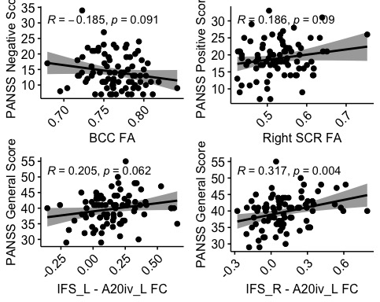
Figure S1. Association between SzPRS-related FA/FC and PANSS scores in FES group.
FA in right superior corona radiata showed marginally correlation with PANSS positive score, while FA in the body of corpus callosum showed marginally correlation with PANSS negative score. FC between the right IFG - left intermediate ventral ITG was found significantly associated with PANSS general score, FC left IFG - left intermediate ventral ITG also showed marginal correlation with PANSS general score.

