Appendices

Appendix A. Full serch string for PubMed 2
Appendix B. Funnel plot for depressive symptoms 4
Appendix C. Forest and funnel plots for secondary outcomes 5
C.1. Forest plot for Social support 5
C.2. Funnel plot for Social support 5
C.3. Forest plot for Anxiety 6
C.4. Funnel plot for Anxiety 6
C.5. Forest plot for Functional impairment 7
C.6. Forest plot for Parental stress 7
C.7. Forest plot for Marital stress 7
C.8. Forest plot for Weight 8
C.9. Forest plot for Height 8

Appendix A. Full serch string for PubMed

PubMed Psychotherapy [MH] OR psychotherap*[All Fields] OR cbt[All Fields] OR "behavior therapies"[All Fields] OR "behavior therapy"[All Fields] OR "behavior therapeutic"[All Fields] OR "behavior therapeutical"[All Fields] OR "behavior therapeutics"[All Fields] OR "behavior therapeutist"[all Fields] OR "behavior therapeutists"[All Fields] OR "behavior treatment"[All Fields] OR "behavior treatments"[All Fields] OR "behaviors therapies"[All Fields] OR "behaviors therapy"[All Fields] OR "behaviors therapeutics"[All Fields] OR "behaviors therapeutic"[All Fields] OR "behaviors therapeutical"[All Fields] OR "behaviors therapeutist"[All Fields] OR "behaviors therapeutists"[All Fields] OR "behaviors treatment"[All Fields] OR "behaviors treatments"[All Fields] OR "behavioral therapies"[All Fields] OR "behavioral therapy"[All Fields] OR "behavioral therapeutics"[All Fields] OR "behavioral therapeutic"[All Fields] OR "behavioral therapeutical"[All Fields] OR "behavioral therapeutist"[All Fields] OR "behavioral therapeutists"[All Fields] OR "behavioral treatment"[All Fields] OR "behavioral treatments"[All Fields] OR "behaviour therapies"[All Fields] OR "behaviour therapy"[All Fields] OR "behaviour therapeutic"[All Fields] OR "behaviour therapeutical"[All Fields] OR "behaviour therapeutics"[All Fields] OR "behaviour therapeutist"[all Fields] OR "behaviour therapeutists"[All Fields] OR "behaviour treatment"[All Fields] OR "behaviour treatments"[All Fields] OR "behaviours therapies"[All Fields] OR "behaviours therapy"[All Fields] OR "behaviours therapeutics"[All Fields] OR "behaviours therapeutic"[All Fields] OR "behaviours therapeutical"[All Fields] OR "behaviours therapeutist"[All Fields] OR "behaviours therapeutists"[All Fields] OR "behaviours treatment"[All Fields] OR "behaviours treatments"[All Fields] OR "behavioural therapies"[All Fields] OR "behavioural therapy"[All Fields] OR "behavioural therapeutics"[All Fields]OR "behavioural therapeutic"[All Fields] OR "behavioural therapeutical"[All Fields] OR "behavioural therapeutist"[All Fields] OR "behavioural therapeutists"[All Fields] OR "behavioural treatment"[All Fields] OR "behavioural treatments"[All Fields] OR "cognition therapies"[All Fields] OR "cognition therapie"[All Fields] OR "cognition therapy"[All Fields] OR "cognition therapeutical"[All Fields] OR "cognition therapeutic"[All Fields] OR "cognition therapeutics"[All Fields] OR "cognition therapeutist"[All Fields] OR "cognition therapeutists"[All Fields] OR "cognition treatment"[All Fields] OR "cognition treatments"[All Fields] OR psychodynamic[All Fields] OR Psychoanalysis[MH] OR psychoanalysis[All Fields] OR psychoanalytic*[All Fields] OR counselling[All Fields] OR counseling[All Fields] OR Counseling[MH] OR "problem-solving"[All Fields] OR mindfulness[All Fields] OR (acceptance[All Fields] AND commitment[All Fields] ) OR "assertiveness training"[All Fields] OR "behavior activation"[All Fields] OR "behaviors activation"[All Fields] OR "behavioral activation"[All Fields] OR "cognitive therapies"[All Fields] OR "cognitive therapy"[All Fields] OR "cognitive therapeutic"[All Fields] OR "cognitive therapeutics"[All Fields] OR "cognitive therapeutical"[All Fields] OR "cognitive therapeutist"[All Fields] OR "cognitive therapeutists"[All Fields] OR "cognitive treatment"[All Fields] OR "cognitive treatments"[All Fields] OR "cognitive restructuring"[All Fields] OR (("compassion-focused"[All Fields] OR "compassion-focussed"[All Fields]) AND (therapy[SH] OR therapies[All Fields] OR therapy[All Fields] OR therape*[All Fields] OR therapis*[All Fields]OR Therapeutics [OR treatment*[All Fields])) OR ((therapy[SH] OR therapies[All Fields] OR therapy [All Fields] OR therape*[All Fields] OR therapis*[All Fields] OR Therapeutics[MH] OR treatment*[All Fields]) AND constructivist*[All Fields]) OR "metacognitive therapies"[All Fields] OR "metacognitive therapy"[All Fields] OR "metacognitive therapeutic"[All Fields] OR "metacognitive therapeutics"[All Fields] OR "metacognitive therapeutical"[All Fields] OR "metacognitive therapeutist"[All Fields] OR "metacognitive therapeutists"[All Fields] OR"metacognitive treatment"[All Fields] OR "metacognitive treatments"[All Fields] OR "meta-cognitive therapies"[All Fields] OR "meta-cognitive therapy"[All Fields] OR "meta-cognitive therapeutic"[All Fields] OR "meta-cognitive therapeutics"[All Fields] OR "meta-cognitive therapeutical"[All Fields] OR "meta-cognitive therapeutist"[All Fields] OR "meta-cognitive therapeutists"[All Fields] OR "meta-cognitive treatment"[All Fields] OR "meta-cognitive treatments"[All Fields] OR "solution-focused therapies"[All Fields] OR "solution-focused therapy"[All Fields] OR "solution-focused therapeutic"[All Fields] OR "solution-focused therapeutics"[All Fields] OR "solution-focused therapeutical"[All Fields] OR "solution focused therapies"[All Fields] OR "solution focused therapy"[All Fields] OR "solution focused therapeutic"[All Fields] OR "solution focused therapeutics"[All Fields] OR "solution focused therapeutical"[All Fields]OR "solution-focussed therapies"[All Fields] OR "solution-focussed therapy"[All Fields] OR "solution-focussed therapeutic"[All Fields] OR "solution-focussed therapeutics"[All Fields] OR "solution-focussed therapeutical"[All Fields]OR "solution focussed therapies"[All Fields] OR "solution focussed therapy"[All Fields] OR "solution focussed therapeutic"[All Fields] OR "solution focussed therapeutics"[All Fields] OR "solution focussed therapeutical"[All Fields] OR "self-control therapies"[All Fields] OR "self-control therapy"[All Fields] OR "self-controltherapeutics"[All Fields] OR "self-control therapeutical"[All Fields] OR "self-control therapeutic"[All Fields] OR "self-control training"[All Fields] OR "self-control trainings"[All Fields] OR "self control therapies"[All Fields] OR "self control therapy"[All Fields] OR "self control therapeutics"[All Fields] OR "self control therapeutical"[All Fields] OR "self control therapeutic"[All Fields] OR "self control training"[All Fields] OR "self control trainings"[All Fields] AND (Depressive Disorder[MH] OR Depression[MH]OR dysthymi*[All Fields] OR "affective disorder"[All Fields]OR "affective disorders"[All Fields] OR "mood disorder"[All Fields] OR "mood disorders"[All Fields] OR depression*[AllFields] OR depressive*[All Fields] OR "dysthymic disorder"[MeSH Terms]) Limits: RCTs

Appendix B. Funnel plot for depressive symptoms

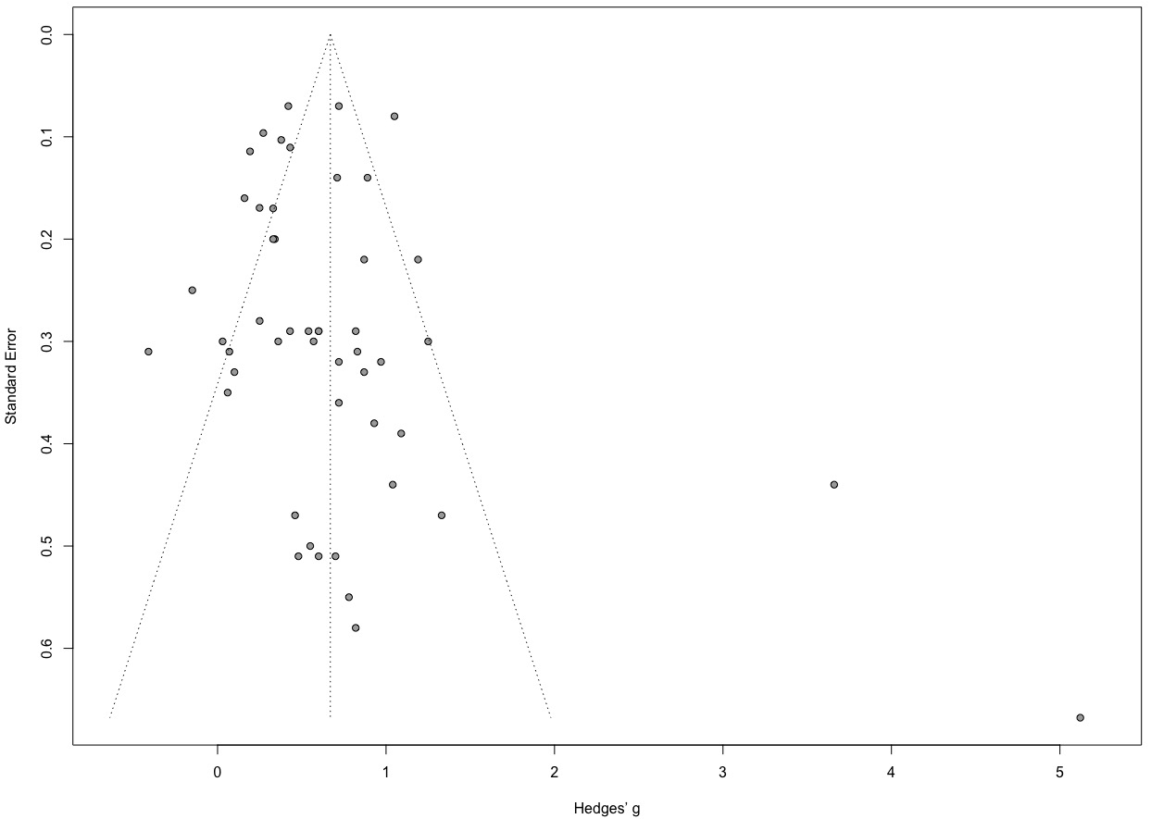

Appendix C. Forest and funnel plots for secondary outcomes
(funnel plots are only given when the number of studies is larger than 10; Borenstein et al., 2009)

C.1. Forest plot for Social support

C.2. Funnel plot for Social support

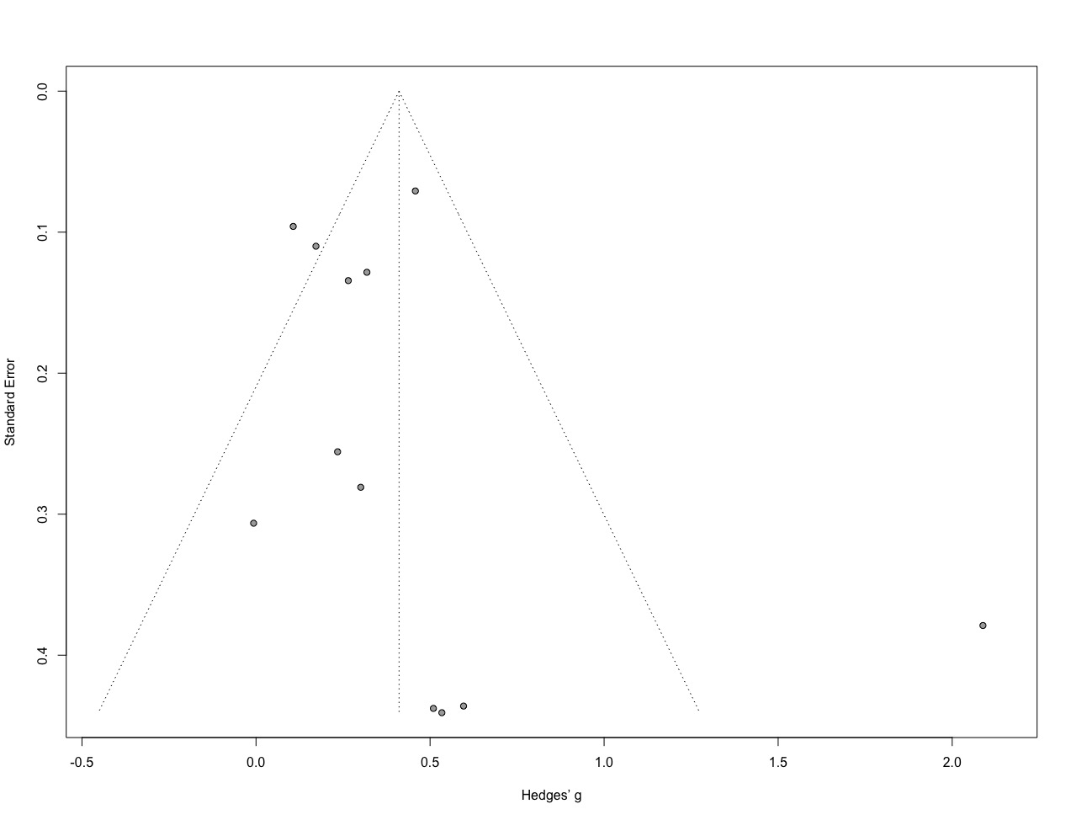

C.3. Forest plot for Anxiety

C.4. Funnel plot for Anxiety

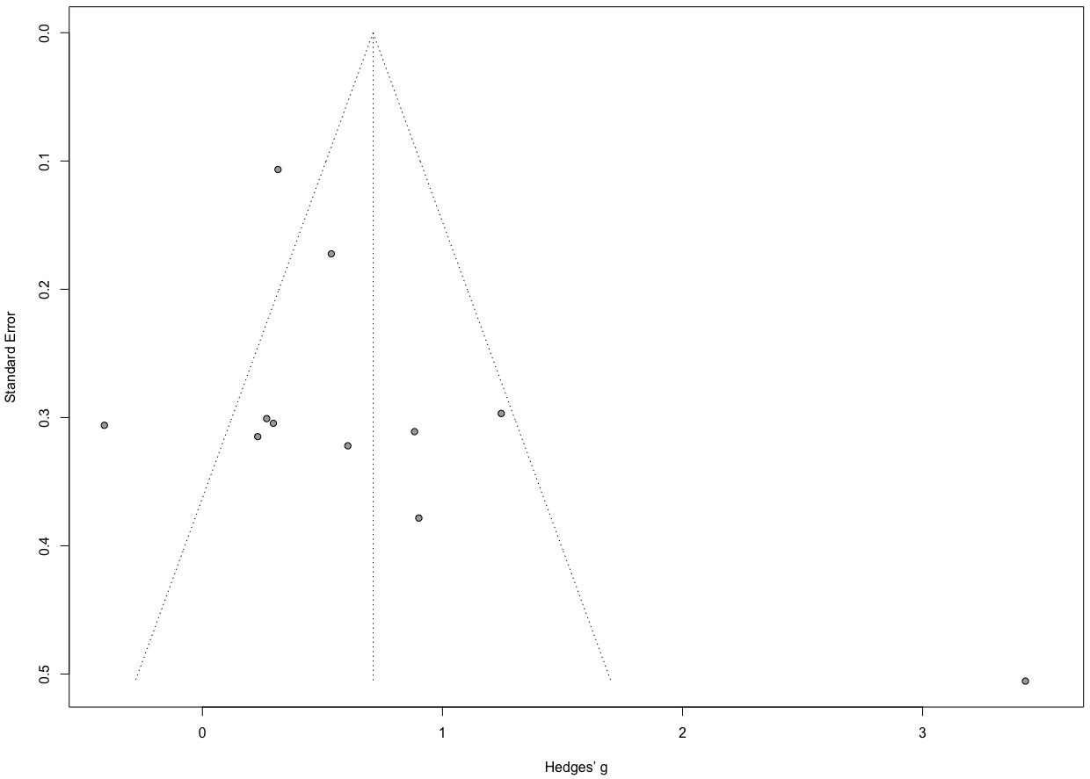

C.5. Forest plot for Functional impairment

C.6. Forest plot for Parental stress

C.7. Forest plot for Marital stress

C.8. Forest plot for Weight

C.9. Forest plot for Height

