Supplementary Figure 1: Flowchart of children with familial high-risk of schizophrenia (FHR-SZ), bipolar disorder (FHR-BP) and population-based controls (PBC) who participated in the Early Adolescence-Home Observation for Measurement of the Environment Inventory (EA-HOME Inventory) in the Danish High Risk and Resilience Study VIA 7 and 11.
ª Danish National Registries: Danish Civil Registration System and Danish Psychiatric Central Research Register¹ ².
^{b} FHR-SZ: Children of parents with schizophrenia spectrum disorders. (ICD-10 codes: F20, F22, F25 or ICD-8-codes: 295, 297, 298.29, 298.39, 298.89 or 298.99),
^{c} Double diagnosed parents: Parents with diagnoses of schizophrenia and bipolar disorder were assigned to the schizophrenia high risk group as per the ICD-10 hierarchy.
^{d} FHR-BP: Children of parents with bipolar disorder. (ICD-10 codes: F30 or F31, or ICD 8-codes: 296.19, 296.39).
^{e} PBC: Population-based control children of parents with no diagnoses of schizophrenia spectrum disorders or bipolar disorder.
^{f} Research protection: As of May 2011, legislation was enacted to protect individuals´ phone numbers from being called for participation in scientific research. Therefore, there were eligible children who were not contacted and enrolled in VIA 7.
^{g} Controls selection: Up to 10 controls were retrieved for each child in the schizophrenia spectrum disorder group and the bipolar disorder group. Controls were matched to cases on gender, municipality and exact age. The original intent was to only select control cases that were matched to children in the schizophrenia familial high-risk group. However, there are 38 BP-controls among the 200 total controls.
^{h} Definition of contact: First through letters sent to the child´s address. If the family did not respond, contact by telephone was attempted (calls and text messages), if a phone number could be found.
^{i} Re-assigned control parent: One control parent was found to have a diagnosis of bipolar disorder made by a private doctor, therefore the diagnosis was not present/visible in the National Registry extract, as private doctors do not report to the National Registry. This family/parent was therefore reassigned to the bipolar disorder familial high-risk group. Therefore, the N=201 for controls is now N=200.
^{j}Control children not in the extract: Two younger siblings were included to VIA 7 by request of the parents. They were not in the original extract.

Supplementary Table 1: Cut-off values for an inadequate home environment as defined by 2 SD below the mean of the population-based control (PBC) group.
Assessment | Mean (SD) of PBC | Cutoff-value | Cuff-off definition for inadequate home environment
Age 7 (The VIA 7 Study) (N=196) | 49.026 (4.346) | 40.334 | ≤40 = inadequate  ≥41 = adequateª
Age 11 (The VIA 11 Study) (N=170)^{b} | 49.253 (4.365) | 40.523 | ≤40 = inadequate  ≥41 = adequate
ªA previous study³ of the proportion of inadequate home environments at age seven defined the threshold slightly different due to a decision to round down to 40 and thus make a cut-off of 40. Therefore, in this previous study, numbers of inadequate home environments are slightly different. We, however, decided to keep an exact cutoff-value and thus, any score below this threshold is inadequate.
^{b}One child in the control group has a missing item and thus does not have a total score. Therefore, this child is not included in the analysis.

Supplementary Table 2: Dropout analyses of children participating in Middle Childhood-Home Observation for Measurement of the Environment Inventory (MC-HOME Inventory) versus in the Early Adolescence-Home Observation for Measurement of the Environment Inventory (EA-HOME Inventory) in the Danish High Risk and Resilience Study VIA 7 and 11.
Supplementary Table 2a: Dropout by inadequate HOME environment.
Participated in HOME VIA 11: | Inadequate HOME environment in VIA 7 | Adequate HOME environment in VIA 7
Yes, N (%) | 52 (78.8) | 376 (85.1)
No, N (%) | 14 (21.5) | 66 (14.9)
Pearson Chi-Square:
Value | df | Asymptotic Significance (2-sided)
5.221 | 2 | 0.074
Fisher’s Exact Test
Value |  | Exact significance (2-sided)
4.698 |  | 0.083
1 cell has an expected count less than 5

Supplementary table 2b: Dropout by sex of the child.
Participated in HOME VIA 11: | Female | Male
Yes, N (%) | 200 (93.9) | 228 (91.9)
No, N (%) | 13 (6.1) | 47 (8.1)
Pearson Chi-Square:
Value | df | Asymptotic Significance (2-sided)
508.731 | 4 | <0.001
Fishers exact test:
Value |  | Exact Significance (2-sided)
298.414 |  | <0.001
2 cells have expected counts less than 5.

Supplementary table 2c: Dropout by risk group: Familial high-risk of schizophrenia (FHR-SZ), bipolar disorder (FHR-BP) or population-based controls (PBC).
Participated in HOME VIA 11: | FHR-SZ | FHR-BP | PBC
Yes, N (%) | 160 (81.6) | 98 (84.5%) | 170 (86.7)
No, N (%) | 36 (18.4) | 18 (15.5) | 26 (13.3)
Pearson Chi-Square:
Value | df | Asymptotic Significance (2-sided)
3.076 | 4 | 0.545
0 cells have an expected count less than 5.

Supplementary table 2d: Dropout by inadequate home environment according to risk group: Children of parents with schizophrenia (FHR-SZ), of parents with bipolar disorder (FHR-BP) and population-based controls (PBC).
Participated in HOME VIA 11: | FHR-SZ, inadequate in VIA 7 | FHR-SZ, adequate in VIA 7 | Pearson Chi-Square, value (df) | Fishers Exact test | Asymptotic Significance (2-sided)
Yes, N (%) | 33 (71.7) | 127 (84.7) | 10.038 (2) | 8.711 | 0.010
No, N (%) | 13 (28.2) | 23 (15.3)
Participated in HOME VIA 11: | FHR-BP, inadequate in VIA 7 | FHR-BP, adequate in VIA 7 | Pearson Chi-Square, value (df) | Fishers Exact test | Asymptotic Significance (2-sided)
Yes, N (%) | 10 (90.9) | 88 (83.8) | 0.706 (2) | 0.212 | 1.000
No, N (%) | 1 (9.1) | 17 (16.2)
Participated in HOME VIA 11: | PBC, inadequate in VIA 7 | PBC, adequate in VIA 7 | Pearson Chi-Square, value (df) | Fishers Exact test | Asymptotic Significance (2-sided)
Yes, N (%) | 9 (100) | 161 (86.1) | 1.443 (2) | 0.267 | 0.367
No, N (%) | 0 (0.00) | 26 (13.9)

Supplementary table 3: Analysis of covariance of the home environment total score at age 11, adjusted for parental level of functioning as measured with the Personal and Social Performance Scale (PSP) across children with familial high-risk of schizophrenia (FHR-SZ), bipolar disorder (FHR-BP) and population-based controls (PBC) (N=419).
Source | Type III Sum of Squares | Degrees of freedom | Mean Square | F | Significance | Partial Eta Squared | Noncent. Parameter | Observed Power
Corrected model | 2542.297ª | 3 | 847.432 | 39.090 | <0.001 | 0.220 | 117.270 | 1.000
Intercept | 18961.392 | 1 | 18961.392 | 874.644 | <0.001 | 0.678 | 874.644 | 1.000
Parental level of functioning (PSP) | 1736.790 | 1 | 1736.790 | 80.114 | <0.001 | 0.162 | 80.114 | 1.000
Risk status (FHR-SZ, FHR-BP or PBC) | 86.923 | 2 | 43.461 | 2.005 | 0.136 | 0.010 | 4.010 | 0.414
Error | 8996.777 | 415 | 21.679 | - | - | - | - | -
Total | 959427.000 | 419 | - | - | - | - | - | -
Corrected total | 11539.074 | 418 | - | - | - | - | - | -
ª R Squared= 0.220 (Adjusted R Squared = 0.215)
^{b} Computed using alpha = 0.05

Supplementary figure 2: Time changes and group differences in home environment between age 7 and age 11 for children of parents with schizophrenia (FHR-SZ), bipolar disorder (FHR-BP) or population-based controls PBC in The Danish High Risk and Resilience Study. Mixed model for total score (2a) and proportion with an inadequate home environment (2b) for all participants from the child’s age of 7 to the child’s age of 11.
2a: Total score

2b: Proportion with an inadequate home environment
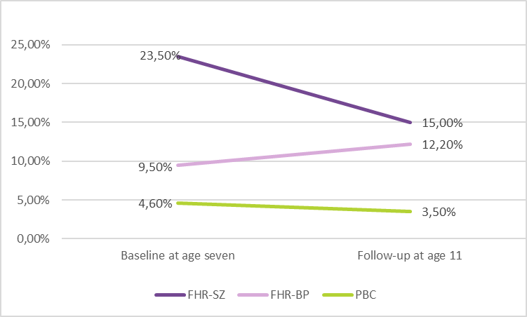

1. Pedersen CB, Gøtzsche H, Møller JØ, Mortensen PB. The Danish Civil Registration System. A cohort of eight million persons. Dan Med Bull. 2006.
2. Mors O, Perto GP, Mortensen PB. The Danish psychiatric central research register. Scand J Public Health. 2011. doi:10.1177/1403494810395825
3. Gantriis DL, Thorup AAE, Harder S, et al. Home visits in the Danish High Risk and Resilience Study - VIA 7: assessment of the home environment of 508 7-year-old children born to parents diagnosed with schizophrenia or bipolar disorder. Acta Psychiatr Scand. June 2019. doi:10.1111/acps.13057

