**Supplementary Materials**

Figure S1 depicts strength centrality indices, estimating the relative importance of each node within the overall network. Values reflect the sum of the edge weights incident on each node. Higher values indicate greater centrality and thus greater potential importance. Plots depict the normalized (*z*-scored) strength centrality values.

Figure S2 shows average symptom level by treatment group plotted over time in the study.

Figures S3-S11 display the sampling distributions for each edge weight (i.e., magnitude of associations between nodes) and proportion of estimates whose values are nonzero. All pairwise effects are included. The horizontal lines show the 5% and 95% quantiles of the bootstrapped sampling distributions. The number is the proportion of bootstrap samples in which a parameter has been estimated to be nonzero, and the number is placed at the location of the mean of the sampling distribution. ThTim=time occupied by thoughts. ThInt=interference due to thoughts. ThDis=distress due to thoughts. ThRes=resistance of thoughts. ThCon=degree of control over thoughts. BeTim=time spent in repetitive behaviors related to body defects. BeDis=distress if repetitive behaviors are/were prevented. BeRes=resistance of repetitive behaviors. BeCon=degree of control over repetitive behavior. Insig=insight. BeInt=avoidance behavior/interference.

**Figure S1.** Strength centrality estimates

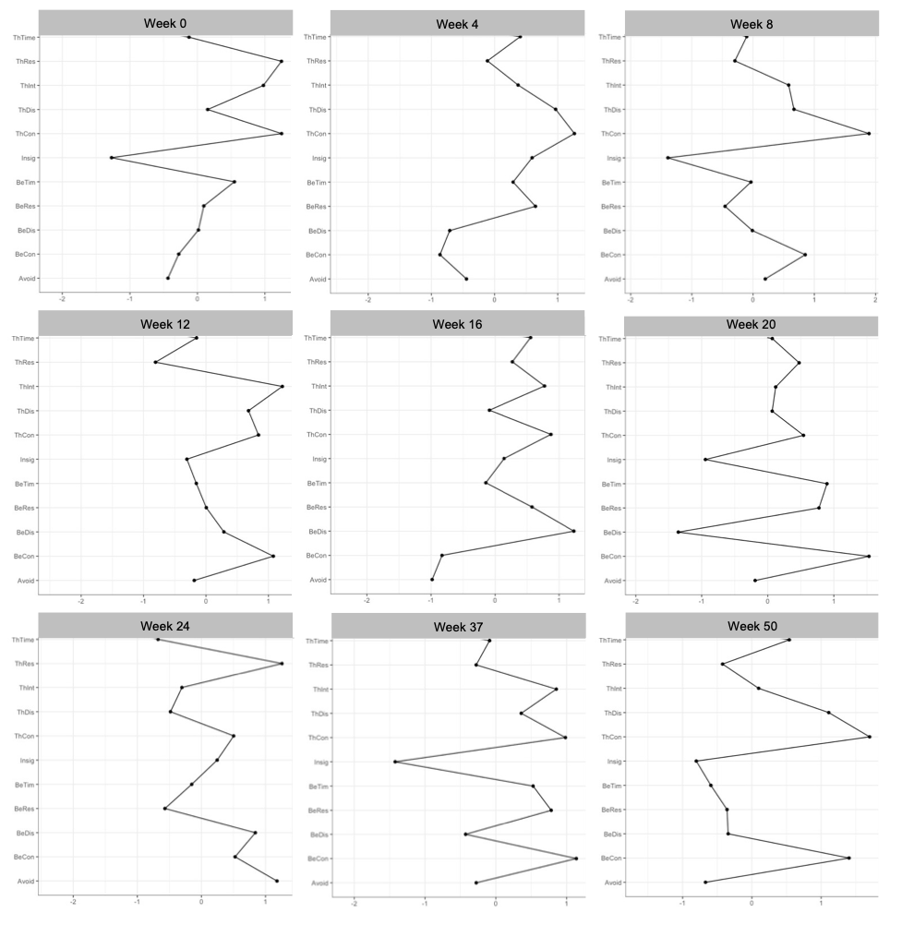

*Note*.ThTim=time occupied by thoughts. ThInt=interference due to thoughts. ThDis=distress due to thoughts. ThRes=resistance of thoughts. ThCon=degree of control over thoughts. BeTim=time spent in repetitive behaviors due to appearance preoccupations. BeDis=distress if repetitive behaviors are/were prevented. BeRes=resistance of repetitive behaviors. BeCon=degree of control over repetitive behavior. Insig=insight. Avoid=avoidance of activities due to appearance concerns.

**Figure S2.** Symptom level

*****Note*.SPT=supportive psychotherapy. CBT=cognitive behavioral therapy. ThTim=time occupied by thoughts. ThInt=interference due to thoughts. ThDis=distress due to thoughts. ThRes=resistance of thoughts. ThCon=degree of control over thoughts. BeTim=time spent in repetitive behaviors due to appearance preoccupations. BeDis=distress if repetitive behaviors are/were prevented. BeRes=resistance of repetitive behaviors. BeCon=degree of control over repetitive behavior. Insig=insight. Avoid=avoidance of activities due to appearance concerns.

**Figure S3.** Bootstrapped sampling distribution of edge weight estimates at Week 0



**Figure S4.** Bootstrapped sampling distribution of edge weight estimates at Week 4



**Figure S5.** Bootstrapped sampling distribution of edge weight estimates at Week 8



**Figure S6.** Bootstrapped sampling distribution of edge weight estimates at Week 12



**Figure S7.** Bootstrapped sampling distribution of edge weight estimates at Week 16



**Figure S8.** Bootstrapped sampling distribution of edge weight estimates at Week 20



**Figure S9.** Bootstrapped sampling distribution of edge weight estimates at Week 24



**Figure S10.** Bootstrapped sampling distribution of edge weight estimates at Week 37



**Figure S11.** Bootstrapped sampling distribution of edge weight estimates at Week 50

