Online Supplementary Material
Contents

eTable 1: Variable properties 1
eTable 2: STROBE checklist 2
eTable 3: Comparison of demographic and clinical data for adult and paediatric patients with catatonia 6
eTable 4: Additional exploratory laboratory results for patients with catatonia and without catatonia 7
eTable 5: Longitudinal comparison of creatine kinase and iron in patients with catatonia 8
eTable 6: Comparison of patients with catatonia with and without low serum iron 8
eTable 7: Association of creatine kinase with rigidity and immobility 8
eTable 8: Comparison of associations with missing and non-missing data (as measured by inpatients having 3 or more valid laboratory test results) 9
eFigure 1: Receiver operating charcteristic curve for CK and diagnosis of catatonia 10
eFigure 2: Unadjusted Kaplan-Meier curve for hospital discharge 11
eFigure 3: Unadjusted Kaplan-Meier curve for hospital discharge restricted to first 100 days 12
eFigure 4: Unadjusted Kaplan-Meier curve for mortality 13

eTable 1: Variable properties
Variable |  | Structured field | NLP-derived | Free text analysed by researcher | Measurement
Demographic | Age | ⚫ |  |  | For patients with catatonia, this was age at index date. For comparison group, this was age on 1st June of the year they were admitted as an inpatient.
 | Date of birth | ⚫ |  |  | Adjusted to first date of the month to preserve anonymisation
 | Date of death | ⚫ |  |  | Linked to NHS Spine
 | Ethnicity | ⚫ |  |  | Dichotomised as Black and not Black when used for adjustment in regression analyses
 | Sex | ⚫
 | Index date | ⚫ |  |  | Date of admission to hospital
Diagnosis | Presence of catatonia |  |  | ⚫ | According to Bush-Francis Catatonia Screening Instrument
 | Diagnosis | ⚫ |  |  | Where an ICD-10 diagnosis had been coded prior to the index date, the most recent diagnostic code prior to the index date was used. Where there was no diagnostic code prior to the index, the earliest diagnostic code up to 6 months after the index date was used.
Treatment | Date of first referral accepted | ⚫ |  |  | First date on which a referral to the Trust was accepted
 | Admission date | ⚫ |  |  | Date of admission to hospital
 | Discharge date | ⚫ |  |  | Date of discharge from hospital
 | Detention under the Mental Health Act | ⚫ |  |  | Included any active inpatient section from the index date until 2 weeks later
 | Health of the Nation Outcomes Scale (HoNOS) | ⚫ |  |  | Latest before index date and earliest after index date.
Blood pressure | Systolic blood pressure |  | ⚫ |  | Earliest blood pressure within 2 weeks of index date
 | Diastolic blood pressure |  | ⚫
Laboratory results | Full blood count | ⚫ |  |  | Earliest from index date to 14 days later
 | Urea and electrolytes | ⚫
 | Thyroid function and autoantibodies | ⚫
 | Iron studies | ⚫
 | Vitamin B12 and folate | ⚫
 | Creatine kinase | ⚫
 | D-dimer | ⚫
 | Autoantibody profile | ⚫ |  |  | Earliest from index date to 1 year

eTable 2: STROBE checklist
 | Item No | Recommendation | Location
Title and abstract | 1 | (a) Indicate the study’s design with a commonly used term in the title or the abstract | - Abstract
 |  | (b) Provide in the abstract an informative and balanced summary of what was done and what was found | - Abstract
Introduction
Background/rationale | 2 | Explain the scientific background and rationale for the investigation being reported | - Introduction
Objectives | 3 | State specific objectives, including any prespecified hypotheses | - Introduction
Methods
Study design | 4 | Present key elements of study design early in the paper | - Method
Setting | 5 | Describe the setting, locations, and relevant dates, including periods of recruitment, exposure, follow-up, and data collection | - Method/Setting
Participants | 6 | (a) Cohort study—Give the eligibility criteria, and the sources and methods of selection of participants. Describe methods of follow-up  Case-control study—Give the eligibility criteria, and the sources and methods of case ascertainment and control selection. Give the rationale for the choice of cases and controls  Cross-sectional study—Give the eligibility criteria, and the sources and methods of selection of participants | - Method/Identifying patients with catatonia; Descriptive analyses; Cases-control study; Cohort study
 |  | (b) Cohort study—For matched studies, give matching criteria and number of exposed and unexposed  Case-control study—For matched studies, give matching criteria and the number of controls per case | - N/A
Variables | 7 | Clearly define all outcomes, exposures, predictors, potential confounders, and effect modifiers. Give diagnostic criteria, if applicable | - Method/Identifying patients with catatonia; Descriptive analyses; Cases-control study; Cohort study  - eTable 1
Data sources/ measurement | 8* | For each variable of interest, give sources of data and details of methods of assessment (measurement). Describe comparability of assessment methods if there is more than one group | - Method/Identifying patients with catatonia; Descriptive analyses; Cases-control study; Cohort study  - eTable 1
Bias | 9 | Describe any efforts to address potential sources of bias | - Method/Cohort study
Study size | 10 | Explain how the study size was arrived at | - Method/Identifying patients with catatonia  - Figure 1
Quantitative variables | 11 | Explain how quantitative variables were handled in the analyses. If applicable, describe which groupings were chosen and why | - Method/Identifying patients with catatonia; Descriptive analyses; Cases-control study; Cohort study
Statistical methods | 12 | (a) Describe all statistical methods, including those used to control for confounding | - Method/Identifying patients with catatonia; Descriptive analyses; Cases-control study; Cohort study; Statistical analysis
 |  | (b) Describe any methods used to examine subgroups and interactions | - N/A
 |  | (c) Explain how missing data were addressed | - Method/Case-control study
 |  | (d) Cohort study—If applicable, explain how loss to follow-up was addressed  Case-control study—If applicable, explain how matching of cases and controls was addressed  Cross-sectional study—If applicable, describe analytical methods taking account of sampling strategy | - Method/Cohort study
 |  | (e) Describe any sensitivity analyses | - Method/Cohort study

Results
Participants | 13* | (a) Report numbers of individuals at each stage of study—eg numbers potentially eligible, examined for eligibility, confirmed eligible, included in the study, completing follow-up, and analysed | - Figure 1
 |  | (b) Give reasons for non-participation at each stage | - Figure 1
 |  | (c) Consider use of a flow diagram | - Figure 1
Descriptive data | 14* | (a) Give characteristics of study participants (eg demographic, clinical, social) and information on exposures and potential confounders | - Table 1
 |  | (b) Indicate number of participants with missing data for each variable of interest | - Table 1
 |  | (c) Cohort study—Summarise follow-up time (eg, average and total amount) | - Results/Cohort study
Outcome data | 15* | Cohort study—Report numbers of outcome events or summary measures over time | - Results/Cohort study
 |  | Case-control study—Report numbers in each exposure category, or summary measures of exposure | - Results/Case-control study  - Table 2
 |  | Cross-sectional study—Report numbers of outcome events or summary measures | - N/A
Main results | 16 | (a) Give unadjusted estimates and, if applicable, confounder-adjusted estimates and their precision (eg, 95% confidence interval). Make clear which confounders were adjusted for and why they were included | - Results/Case-control study; Cohort study  - Table 2
 |  | (b) Report category boundaries when continuous variables were categorized | - N/A
 |  | (c) If relevant, consider translating estimates of relative risk into absolute risk for a meaningful time period | - N/A
Other analyses | 17 | Report other analyses done—eg analyses of subgroups and interactions, and sensitivity analyses | - Results/Case-control study  - eTables 3-8
Discussion
Key results | 18 | Summarise key results with reference to study objectives | - Discussion
Limitations | 19 | Discuss limitations of the study, taking into account sources of potential bias or imprecision. Discuss both direction and magnitude of any potential bias | - Discussion/Strengths and limitations
Interpretation | 20 | Give a cautious overall interpretation of results considering objectives, limitations, multiplicity of analyses, results from similar studies, and other relevant evidence | - Conclusions
Generalisability | 21 | Discuss the generalisability (external validity) of the study results | - Discussion
Other information
Funding | 22 | Give the source of funding and the role of the funders for the present study and, if applicable, for the original study on which the present article is based | - Source of funding  - Method/Role of the funding source

eTable 3: Comparison of demographic and clinical data for adult and paediatric patients with catatonia
 |  | Paediatric presentation (1st episode at <18 years) | Adult presentation (1st episode ≥18 years) | Total sample
 | Number of patients | 119 | 1,337 | 1,456
 | Number of episodes | 203 | 1,927 | 2,130
 | Number of episodes per patient, median (IQR) | 1 (1 to 2) | 1 (1 to 1) | 1 (1 – 2)
 | Number of episodes per patient, mean (SD) | 1.7 (2.6) | 1.4 (1.0) | 1.5 (1.2)
Figures provided per patient (first episode) | Age at first episode, mean (s.d.) | 14.6 (2.7) | 37.3 (15.6) | 35.4 (16.2)
 | Age at first episode, median (range, IQR) | 15 (5 to 17; 14 to 17) | 34 (18 to 91; 25 to 46) | 32 (5 to 91; 23 to 45)
 | Sex (n, %)
 | - Male | 77 (64.7) | 726 (54.3) | 803 (55.2)
 | - Female | 42 (35.3) | 611 (45.7) | 653 (44.9)
 | Ethnicity (n, %)
 | - White | 28 (23.5) | 469 (35.1) | 497 (34.1)
 | - Asian / Asian British | 12 (10.1) | 81 (6.1) | 93 (6.4)
 | - Black / African / Caribbean / Black British | 55 (46.2) | 646 (48.3) | 701 (48.1)
 | - Mixed / Multiple ethnic groups | 10 (8.4) | 39 (2.9) | 49 (3.4)
 | - Other ethnic groups | 10 (8.4) | 77 (5.8) | 87 (6.0)
 | - Not stated | 4 (3.4) | 25 (1.9) | 29 (2.0)
 | BFCSI score, median (IQR) | 3 (2-5) | 3 (2-4) | 3 (2-5)
 | BFCSI score, mean (SD) | 3.9 (1.9) | 3.6 (1.7) | 3.6 (1.7)
Figures provided per episode | Treatment setting (n, %)
 | - Psychiatric ward | 69 (34.0) | 977 (50.7) | 1,046 (49.1)
 | - Community mental health team | 72 (35.5) | 390 (20.2) | 462 (21.7)
 | - General hospital | 11 (5.4) | 206 (10.7) | 217 (10.2)
 | - Crisis resolution and home treatment team | 2 (1.0) | 52 (2.7) | 54 (2.5)
 | - Health-based place of safety | 0 (0.0) | 28 (1.5) | 28 (1.3)
 | - Not specified | 49 (24.1) | 274 (14.2) | 323 (15.2)
 | Detention under Mental Health Act for compulsory treatment within 2 weeks of index date (n, %)
 | - Detained | 58 (28.6) | 964 (50.0) | 1,022 (48.0)
 | - Not detained | 145 (71.4) | 963 (50.0) | 1,108 (52.0)

eTable 4: Additional exploratory laboratory results for patients with catatonia and without catatonia
Test | Patients with catatonia (n=787) |  | Control patients (n=24,956) |  | Unadjusted analysis |  | Adjusted analysis ª
 | n | Mean (+/- S.D.) | n | Mean (+/- S.D.) | OR (95% CI) | p | aOR (95% CI) | p
Erythrocyte sedimentation rate (mm/hr) ^{b} | 28 | 14.1 (11.9) | 1146 | 14.8 (18.4) | 0.96 (0.65 to 1.42) | 0.84 | 0.87 (0.55 to 1.37) | 0.54
Full blood count
- Haemoglobin (g/L) ^{b} | 195 | 134 (16) | 8723 | 137 (16) | 0.82 (0.72 to 0.94) | 0.004 | 0.93 (0.79 to 1.09) | 0.35
- Mean corpuscular volume (fL) ^{b} | 195 | 88.6 (7.3) | 8723 | 91.2 (7.1) | 0.71 (0.62 to 0.81) | <0.001 | 0.76 (0.66 to 0.87) | <0.001
- Neutrophil count (10⁹/L) ^{b} | 195 | 4.69 (2.38) | 8719 | 4.49 (2.15) | 1.09 (0.95 to 1.24) | 0.22 | 1.18 (1.04 to 1.34) | 0.01
- Lymphocyte count (10⁹/L) | 195 | 1.86 (0.70) | 8719 | 2.05 (1.03) | 0.70 (0.57 to 0.86) | 0.001 | 0.67 (0.54 to 0.83) | <0.001
- Monocyte count (10⁹/L) | 195 | 0.46 (0.19) | 8719 | 0.46 (0.19) | 0.89 (0.41 to 1.92) | 0.77 | 1.31 (0.61 to 2.81) | 0.50
- Eosinophil count (10⁹/L) ^{b} | 195 | 0.12 (0.09) | 8717 | 0.17 (0.16) | 0.58 (0.46 to 0.73) | <0.001 | 0.61 (0.48 to 0.77) | <0.001
- Basophil count (10⁹/L) ^{b} | 195 | 0.032 (0.020) | 8705 | 0.038 (0.024) | 0.73 (0.60 to 0.87) | 0.001 | 0.79 (0.66 to 0.95) | 0.012
- Platelets (10⁹/L) ^{b} | 195 | 266 (78) | 8723 | 262 (87) | 1.05 (0.91 to 1.20) | 0.52 | 1.02 (0.89 to 1.18) | 0.74
- Neutrophil-lymphocyte ratio | 195 | 3.0 (2.6) | 8719 | 2.5 (1.6) | 1.13 (1.07 to 1.19) | <0.001 | 1.16 (1.10 to 1.23) | <0.001
- Monocyte-lymphocyte ratio | 195 | 0.27 (0.14) | 8719 | 0.25 (0.12) | 3.47 (1.45 to 8.30) | 0.005 | 6.02 (2.54 to 14.2) | <0.001
- Platelet-lymphocyte ratio ^{b} | 195 | 163 (83) | 8719 | 144 (72) | 1.21 (1.09 to 1.34) | <0.001 | 1.22 (1.10 to 1.36) | <0.001
Thyroid function
- Free T₄ (pmol/L) ^{b} | 140 | 15.9 (3.37) | 8027 | 14.8 (3.0) | 1.20 (1.08 to 1.34) | 0.001 | 1.20 (1.06 to 1.35) | 0.003
- Thyroid stimulating hormone (mIU/L) ^{c} | 140 | 0.84 (0.54)  2.0 | 7953 | 0.90 (0.42)  1.8 | 0.69 (0.44 to 1.07) | 0.10 | 0.74 (0.48 to 1.15) | 0.18
Haematinics
- Ferritin (µg/L) ^{c} | 96 | 4.41 (1.10)  135 | 4588 | 4.33 (1.04)  137 | 1.08 (0.89 to 1.31) | 0.44 | 1.16 (0.94 to 1.44) | 0.16
- Vitamin B12 (ng/L) ^{b} | 120 | 553 (291) | 6959 | 498 (258) | 1.19 (1.03 to 1.37) | 0.02 | 1.11 (0.95 to 1.29) | 0.20
- Folate (µg/L) ^{b} | 117 | 8.8 (6.1) | 6624 | 8.8 (5.6) | 1.02 (0.85 to 1.22) | 0.86 | 1.01 (0.84 to 1.21) | 0.92
Albumin (g/L) | 188 | 43.4 (4.0) | 7978 | 43.9 (3.7) | 0.97 (0.93 to 1.00) | 0.09 | 0.99 (0.95 to 1.03) | 0.48
Creatinine (µmol/L) | 192 | 77.7 (46.3) | 8030 | 74.0 (39.2) | 1.00 (1.00 to 1.00) | 1.00 (1.00 to 1.00)
‘Voltage-gated potassium channel’ antibodies (pM/L) ^{c} | 42 | 1.73 (1.92)  73 | 389 | 2.05 (1.73)  37 | 0.90 (0.74 to 1.09) | 0.27 | 0.88 (0.73 to 1.08) | 0.23
ªAdjusted for age, sex and ethnicity. ^{b} Due to very small confidence intervals, these odds ratios have been calculated by dividing the laboratory result by its standard deviation. ^{c} Due to positive skew, these results underwent a natural logarithm transformation. Log_{n} results are in normal text with original results in italics (analyses performed using log_{n} results)

eTable 5: Longitudinal comparison of creatine kinase and iron in patients with catatonia
Laboratory result | n | Result when catatonia present, mean (+/- S.D.) | Result when catatonia not present (+/- S.D.) | Mean difference (95% CI) | p
Creatine kinase ª | 20 | 6.3 (1.7) | 5.6 (1.1) | 0.7 (-0.1 to 1.5) | 0.08
Iron | 15 | 9.5 (3.5) | 11.9 (4.6) | -2.4 (-5.4 to 0.6) | 0.11
ª Due to positive skew, creatine kinase results underwent a natural logarithm transformation.

eTable 6: Comparison of patients with catatonia with and without low serum iron
 | Serum iron low (n=33) |  | Serum iron normal or high (n=13) |  | Unadjusted analysis |  | Adjusted analysis ª
 | n | Mean (+/-SD) | n | Mean (+/-SD) | OR (95% CI) | p | OR (95% CI) | p
Haemoglobin (g/L) | 32 | 130 (16) | 12 | 139 (20) | 0.97 (0.93 to 1.01) | 0.14 | 1.00 (0.95 to 1.06) | 0.92
White cell count (10⁹/L) | 32 | 7.0 (2.4) | 12 | 6.8 (2.4) | 1.0 (0.8 to 1.4) | 0.85 | 1.1 (0.7 to 1.7) | 0.63
C-reactive protein (mg/L) ^{b} | 28 | 1.7 (1.2)  11 | 9 | 1.1 (0.8)  5 | 1.8 (0.7 to 4.3) | 0.22 | 1.3 (0.5 to 3.5) | 0.58
Erythrocyte sedimentation rate (mm/hr) | 5 | 19 (11) | 4 | 14 (16) | 1.0 (0.9 to 1.2) | 0.50 | 0.6 (0.1 to 2.0) | 0.41
Ferritin (µg/L) ^{b} | 32 | 4.6 (1.0)  168 | 11 | 4.6 (1.0)  129 | 1.0 (0.5 to 2.1) | 0.92 | 2.0 (0.6 to 6.7) | 0.25
Albumin (g/L) | 33 | 43 (3) | 12 | 46 (4) | 0.75 (0.58 to 0.96) | 0.03 | 0.87 (0.65 to 1.15) | 0.32
NMDA receptor antibodies | 6 | Negative in 6 | 1 | Negative in 1 | - | - | - | -
ª Adjusted for age, sex and Black ethnicity. ^{b} Due to positive skew, these results underwent a natural logarithm transformation. Log_{n} results are in normal text with original results in italics (analyses performed using log_{n} results)

eTable 7: Association of creatine kinase with rigidity and immobility
Creatine kinase (IU/L) ª | Patients with catatonia (n=787) |  | Unadjusted analysis |  | Adjusted analysis ^{b}
 | n | Mean (+/- S.D.) | OR (95% CI) | p | aOR (95% CI) | p
Rigidity  - Present  - Absent | 20  54 | 5.66  5.94 | 0.86 (0.58 to 1.27) | 0.45 | 0.80 (0.53 to 1.22) | 0.30
Immobility / stupor  - Present  - Absent | 51  23 | 5.82  5.98 | 0.92 (0.66 to 1.30) | 0.66 | 0.95 (0.66 to 1.35) | 0.76
ª Due to positive skew, creatine kinase underwent a natural logarithm transformation. ^{b} Adjusted for age, sex and ethnicity.

eTable 8: Comparison of associations with missing and non-missing data (as measured by inpatients having 3 or more valid laboratory test results)
 |  | n(%) missing |  | n(%) missing | p
Sex | Male | 19,646 (94.2) | Female | 16,404 (93.0) | <0.001
Ethnicity | Black | 10,675 (93.2) | Not Black | 25,046 (93.9%) | 0.009
Group | Catatonia | 951 (90.9) | Comparison | 35,103 (93.7) | <0.001
 |  | n(%) missing | Mean (+/-) SD for missing | Mean (+/-) SD for not missing | p
Age (years) |  | 36,051 (93.6) | 40.1 (16.2) | 39.1 (16.5) | 0.002

eFigure 1: Receiver operating characteristic curve for CK and diagnosis of catatonia
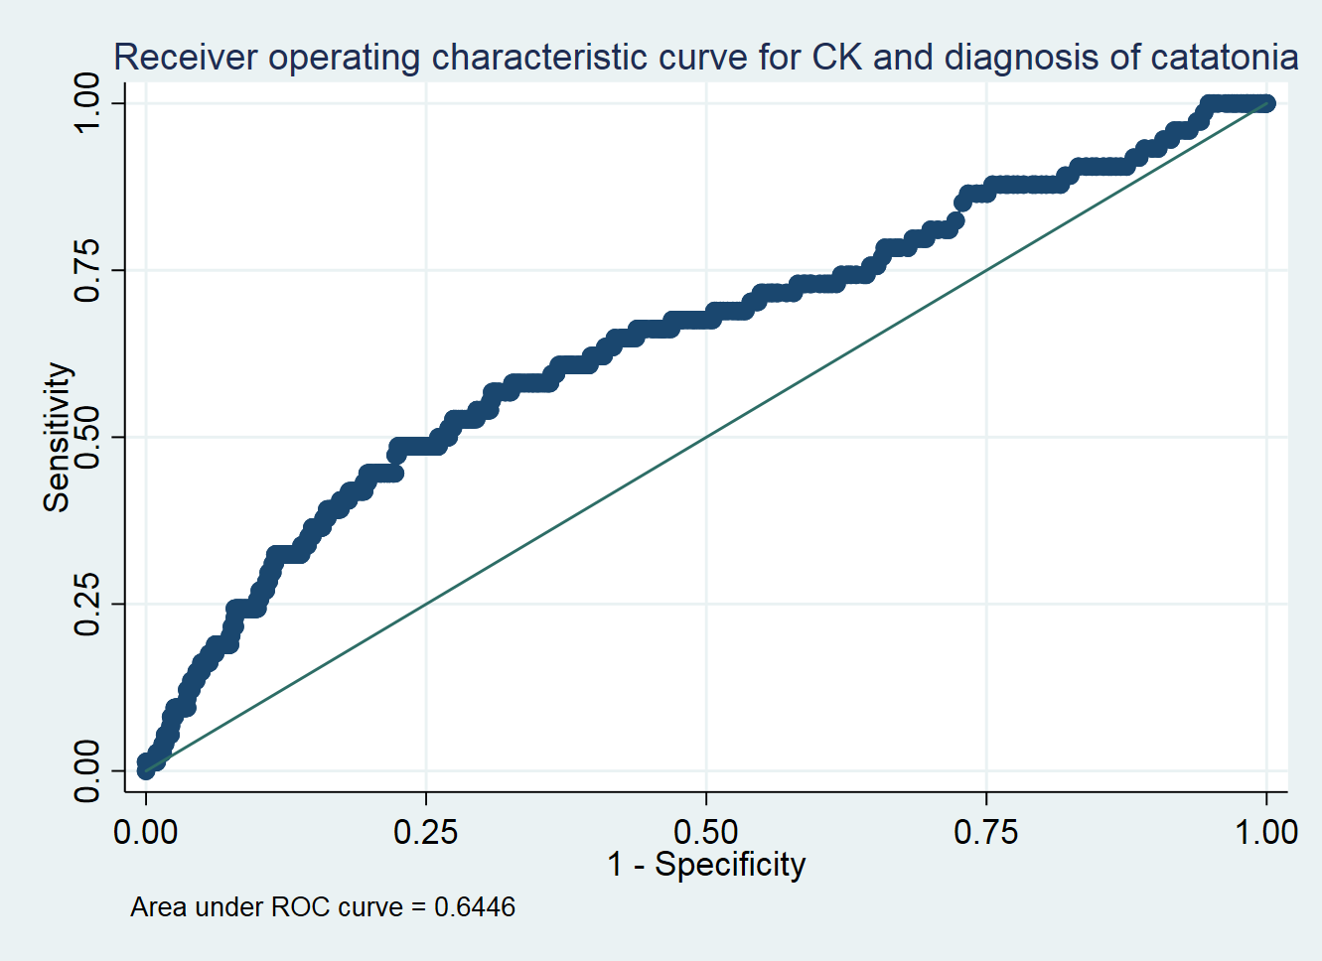

eFigure 2: Unadjusted Kaplan-Meier curve for hospital discharge
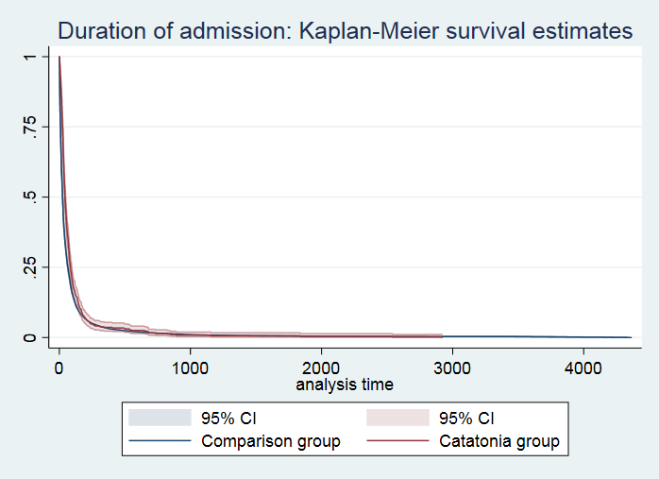

eFigure 3: Unadjusted Kaplan-Meier curve for hospital discharge restricted to first 100 days
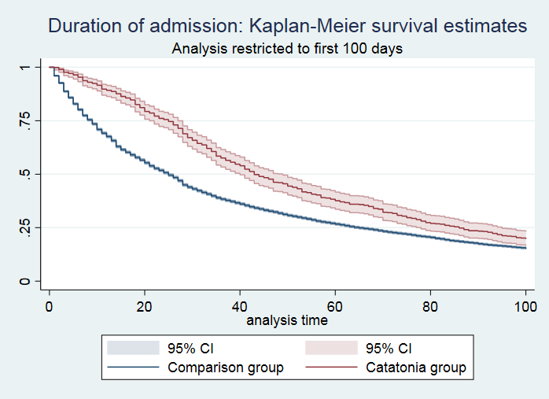

eFigure 4: Unadjusted Kaplan-Meier curve for mortality
