Supplementary Figure 1. The reaction time(ms) of three levels N-back task for two groups at baseline and Day 15th. (A) N-back reaction time in1-back task, (B) N-back reaction time in 2-back task, (C) N-back reaction time in 3-back task.

Supplementary Figure 2. The absolute EEG power at CL, PL, and CC in the iTBS group and sham group. (A) the absolute EEG power at the left-central subregion (CL) in the iTBS group. (B) the absolute EEG power at the left-central subregion (CL) in the sham group. (C) the absolute EEG power at the left-parietal subregion (PL) in the iTBS group. (D) the absolute EEG power at the left-parietal subregion (PL) in the sham group. (E) the absolute EEG power at the central subregion (CC) in the iTBS group. (F) the absolute EEG power at the central subregion (CC) in the sham group. Thin lines indicate the SEM across subjects. Red and black lines above the X-axes indicate the frequency at which differentiated between two sessions. * Represent FDR adjusted p-value<0.01, ** represent FDR adjusted p-value<0.001.

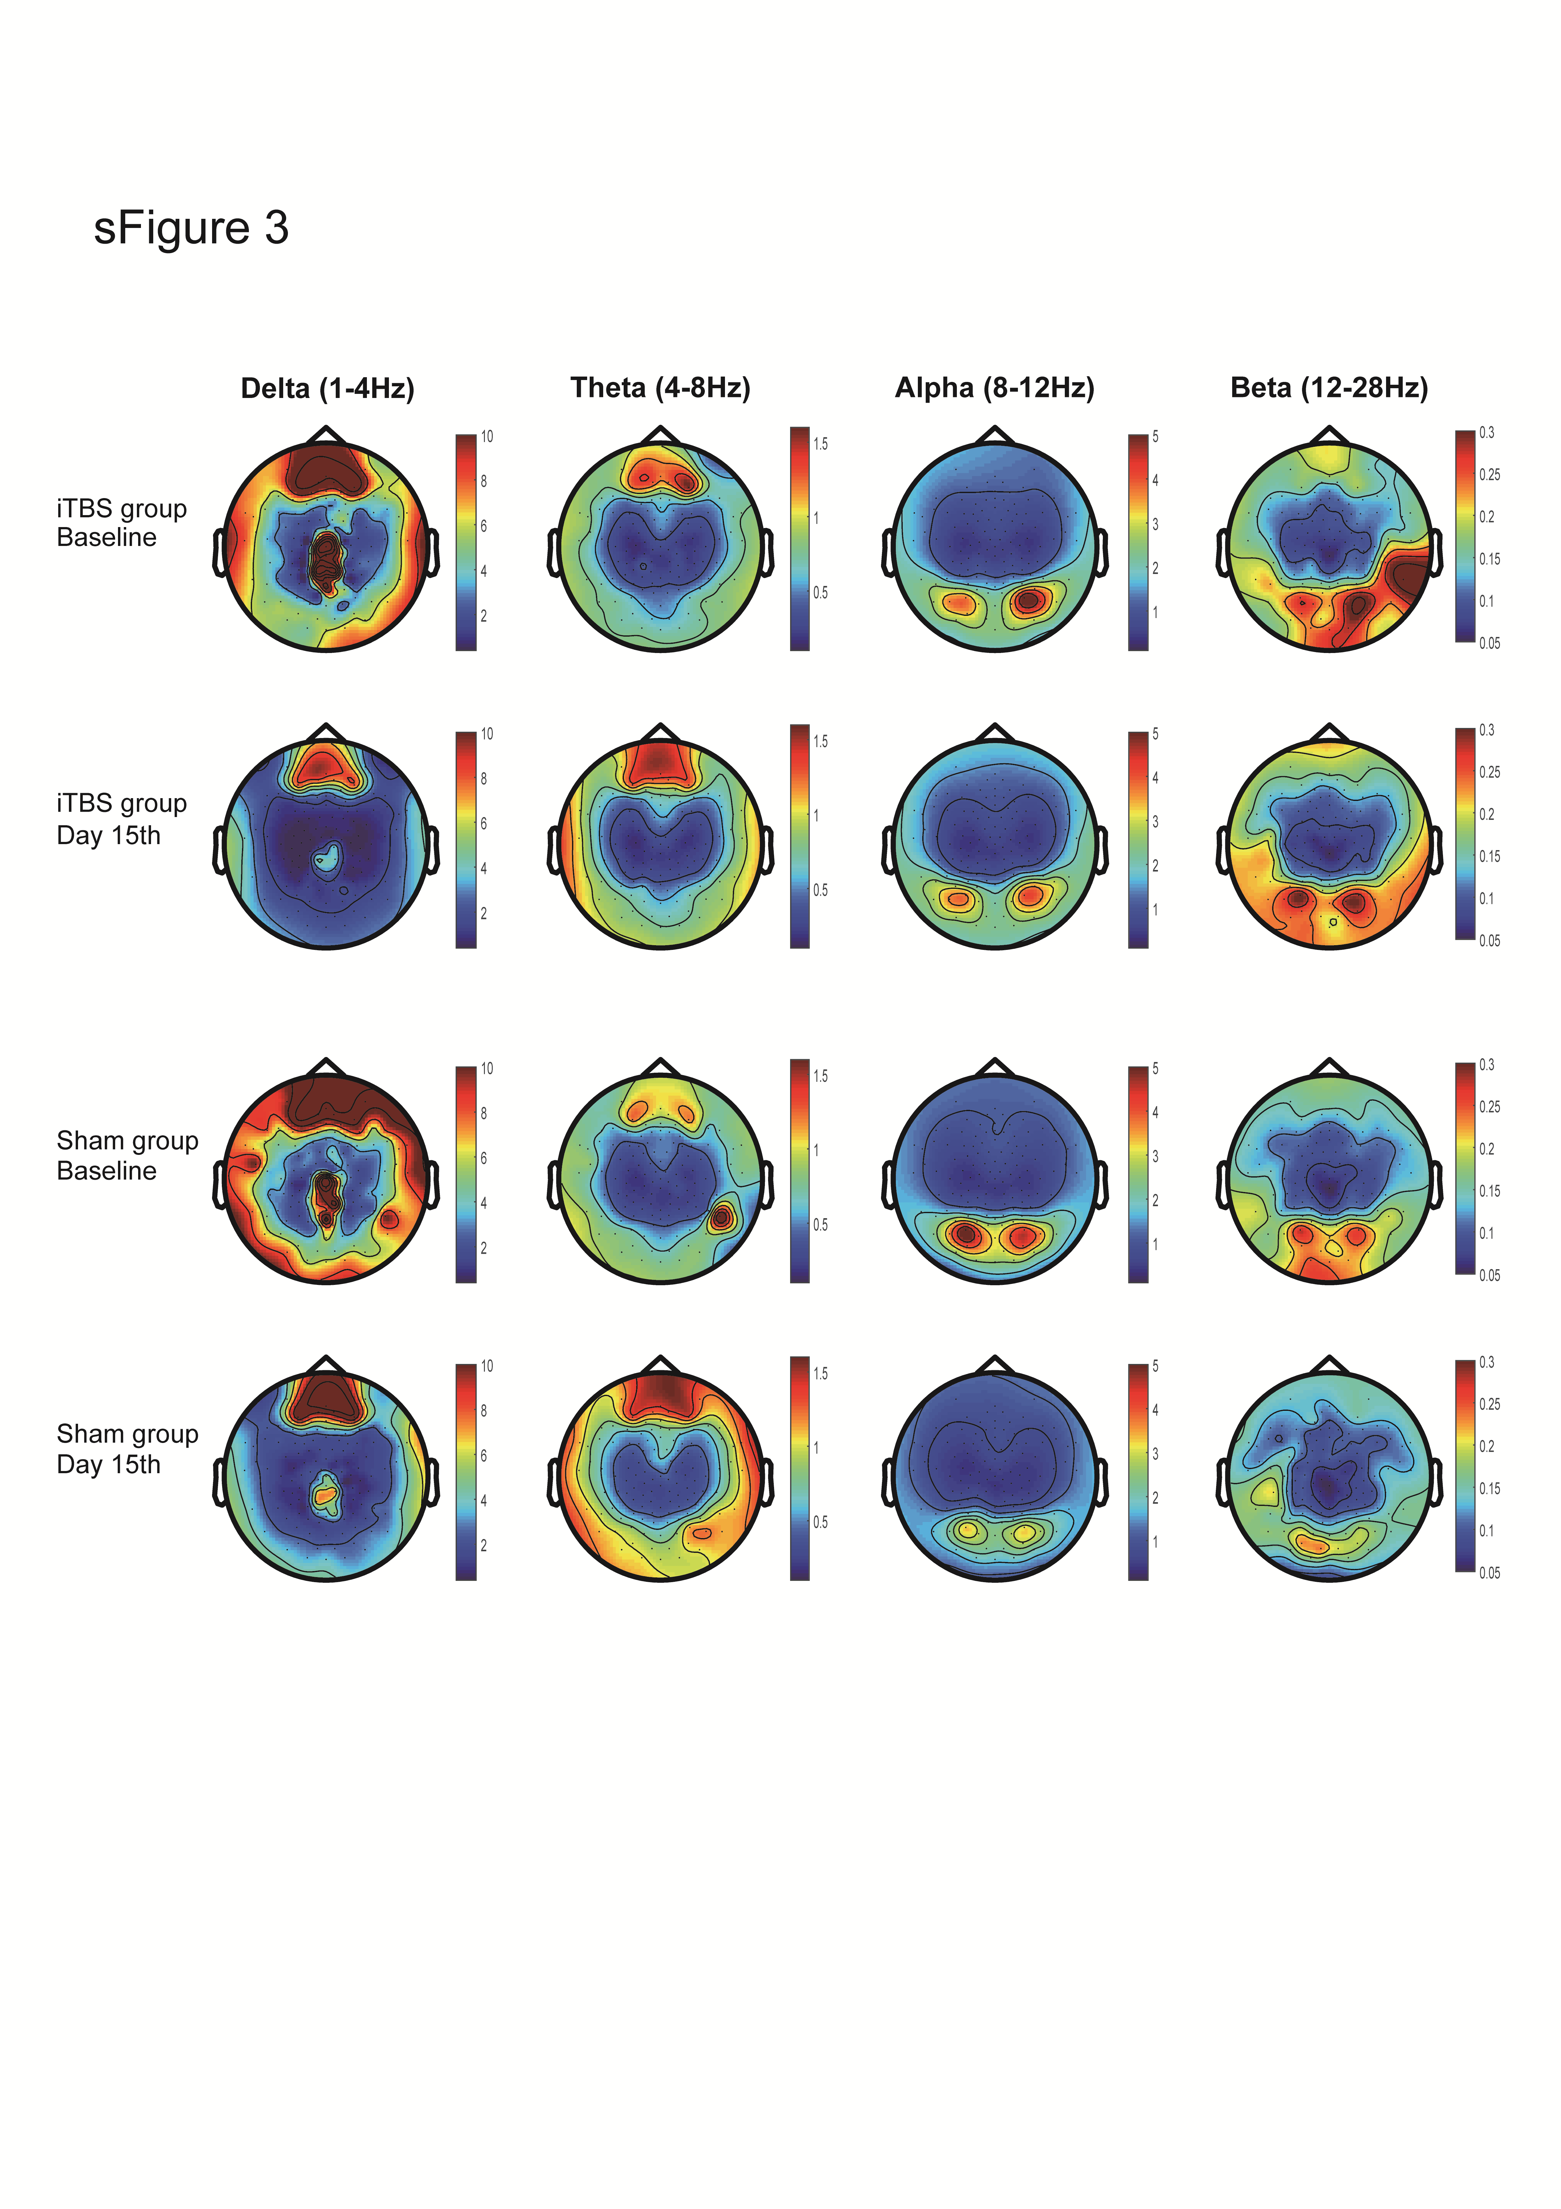
Supplementary Figure 3. The absolute EEG power topographies of Delta, Theta, Alpha, and Beta bands in the iTBS group and sham group.

Supplementary Figure 4. Correlation between changed delta power and changed N-back indexes at CL and PL. (A) correlation between changes in 3-back accuracy and changes in Delta power at left-central (CL). (B) correlation between percent changes in 3-back accuracy and changes in Delta power at left-parietal (PL).

sTable 1. The statistics of reaction time, accuracy, d-prime, hit rate, and correct reject rate for 1-back, 2-back, and 3-back task among iTBS group and sham group in baseline and Day 15th.
RT: reaction time; ACC: accuracy; d’: d-prime; CR: correct reject.

 |  | F | p | η_{p}² | BF₁₀
1-back | RT | 0.982 | 0.330 | 0.034 | 0.355
 | ACC | 4.521 | 0.042 | 0.139 | 3.040
 | d’ | 4.165 | 0.051 | 0.129 | 3.731
 | Hit | 3.443 | 0.074 | 0.110 | 1.063
 | CR | 0.725 | 0.402 | 0.025 | 0.956
2-back | RT | 0.076 | 0.784 | 0.003 | 0.347
 | ACC | 4.802 | 0.037 | 0.146 | 1.320
 | d’ | 7.427 | 0.011 | 0.210 | 1.382
 | Hit | 4.445 | 0.044 | 0.137 | 2.011
 | CR | 0.013 | 0.911 | 4.51e-4 | 0.368
3-back | RT | 2.757 | 0.108 | 0.093 | 1.155
 | ACC | 16.710 | 0.001 | 0.382 | 11.772
 | d’ | 16.870 | 0.001 | 0.385 | 6.847
 | Hit | 12.571 | 0.001 | 0.310 | 4.863
 | CR | 0.248 | 0.622 | 0.009 | 0.451

