Appendix

Table 1 – ICD Codes Used for Key Diagnoses
 | Registers Used | Definition
Major Depression (MD) | The Swedish Hospital Discharge Register (coverage 1973-2017); Outpatient Care Register (national coverage 2001-2017); Primary Care Registry (Partly coverage from 1999-2017) | ICD-8: 296.2, 298.0, 300.4; ICD-9: 296.2, 296.4, 298.0, 300.4; ICD-10: F32, F33.  all individuals with a registration for BD were excluded.
Anxiety Disorder (AD) | The Swedish Hospital Discharge Register (coverage 1973-2017); Outpatient Care Register (national coverage 2001-2017); Primary Care Registry (Partly coverage from 1999-2017) | ICD-8: 300.0, 300.2 ; ICD-9: 300A, 300C; ICD-10: F40, F41
Obsessive-Compulsive Disorder [OCD] | The Swedish Hospital Discharge Register (coverage 1973-2017); Outpatient Care Register (national coverage 2001-2017); Primary Care Registry (Partly coverage from 1999-2017) | ICD-9: 300D; ICD-10: F42
Bipolar Disorder (BD) | The Swedish Hospital Discharge Register (coverage 1973-2017); Outpatient Care Register (national coverage 2001-2017); Primary Care Registry (Partly coverage from 1999-2017) | ICD-8: 296.1, 296.3, 296.8, 296.9, 298.1; ICD-9: 296A, 296C, 296D, 296E, 296W, 298B; ICD-10: F30, F31
Schizophrenia (SZ) | The Swedish Hospital Discharge Register (coverage 1973-2017); Outpatient Care Register (national coverage 2001-2017); Primary Care Registry (Partly coverage from 1999-2017) | ICD-8: 295.1, 295.2, 2953, 295.9, 295.6; ICD-9: 295B, 295C, 295D, 295G, 295X; ICD-10: F200, F201, F202, F203, F205, F209
Alcohol Use Disorder (AUD) | The Swedish Hospital Discharge Register (coverage 1973-2017); Outpatient Care Register (national coverage 2001-2017); Primary Care Registry (Partly coverage from 1999-2017); the Swedish Drug Register (2005-2017); the Swedish Mortality Register, and the Swedish Criminal Register (1973-2017) and the Swedish Suspicion Register (1998-2017) | Alcohol Use Disorder (AUD) was identified in the Swedish medical and mortality registries by ICD codes: ICD9: V79B, 305A, 357F, 571A-D, 425F, 535D, 291, 303, 980; ICD 10: E244, G312, G621, G721, I426, K292, K70, K852, K860, O354, T51, F10); in the Crime Register by codes 3005, 3201, which reflect crimes related to alcohol abuse; in the Suspicion Register by codes 0004, 0005 (Only those individuals with at least two alcohol-related crimes or suspicion of crimes from both Crime Register and Suspicion Register were included); in the Prescribed Drug Register by the drugs disulfiram (Anatomical Therapeutic Chemical (ATC) Classification System N07BB01), acamprosate (N07BB03), and naltrexone (N07BB04).
Drug Use Disorder (DUD) | The Swedish Hospital Discharge Register (coverage 1973-2017); Outpatient Care Register (national coverage 2001-2017); Primary Care Registry (Partly coverage from 1999-2017); the Swedish Drug Register (2005-2017); the Swedish Mortality Register, and the Swedish Criminal Register (1973-2017) and the Swedish Suspicion Register (1998-2017) | Drug abuse (DA) was identified in the Swedish medical and mortality registries by ICD codes (ICD8: Drug dependence (304); ICD9: Drug psychoses (292) and Drug dependence (304); ICD10: Mental and behavioral disorders due to psychoactive substance use (F10-F19), except those due to alcohol (F10) or tobacco (F17)); in the Suspicion Register by codes 3070, 5010, 5011, and 5012, that reflect crimes related to DA; and in the Crime Register by references to laws covering narcotics (law 1968:64, paragraph 1, point 6) and drug-related driving offences (law 1951:649, paragraph 4, subsection 2 and paragraph 4A, subsection 2). DA was identified in individuals (excluding those suffering from cancer) in the Prescribed Drug Register who had retrieved (in average) more than four defined daily doses a day for 12 months from either of Hypnotics and Sedatives (Anatomical Therapeutic Chemical (ATC) Classification System N05C and N05BA) or Opioids (ATC: N02A).
ADHD | The Swedish Hospital Discharge Register (coverage 1973-2017); Outpatient Care Register (national coverage 2001-2017); Primary Care Registry (Partly coverage from 1999-2017) | ICD-9: 314; ICD-10: F90
Autism spectrum disorder (ASD) | The Swedish Hospital Discharge Register (coverage 1973-2017); Outpatient Care Register (national coverage 2001-2017); Primary Care Registry (Partly coverage from 1999-2017) | ICD-9: 299; ICD-10: F840, F841, F845, F849

Table 2 Steps for the Calculation of Familial genetic risk score (FGRS):
The dataset for the calculations includes:
Column1 = Identification number of the proband (Born 1932-1995)
Column2 = Identification number of the relative (1st to 5th degree relatives)
Column3 = Proportion of shared additive genetic effects (0.03125 to 0.50) with the proband
Column4 = Year of Birth of relative
Column5 = Sex of relative
Column6 = Age at registration for the disorder
Column7 = Age at end of follow-up (2017-12-31 or age at death, or age at emigration whichever came first)
Step 1: Using all unique relatives with a registration for the disorder of interest, we non-parametrically estimated the distribution of Age at first registration. The empirical distribution is used to obtain weights for relatives without a registration for the disorder, in order to account for the proportion of the time-at-risk period they had completed at the end of follow-up. For example, for relatives at age x at end of follow-up, the weight corresponds to the proportion of relatives registered for the disorder that had been registration at age x. For relatives born prior to 1958 we subtracted age at the end of follow-up with the following formula: 1958 - Year of birth of relative. This modification was done in order to control for registration effects (i.e, most registers in Sweden start in 1973 suggesting that relatives from early birth cohorts do not have the possibility to be registered at younger ages). Note that all relatives with the disorder are weighted one.
Step 2: Transform the binary variable (disorder yes/no) into a z-score based on the threshold for each disorder. The underlying liability of the individual is not assessable. Instead we estimated the mean of the underlying liability to obtain sex and birth decade specific Z-scores for relatives with the disorder registration and relatives without the disorder. We generate n random numbers from a N(0, 1) distribution and estimate the mean for relatives registered with the disorder (i.e., mean of the observations above the threshold) and for relatives without a registration (i.e., mean of all observation below the threshold). The thresholds are calculated for each decade of birth and sex.
Step 3: Correct for cohabitation effects. To estimate the cohabitation effect (i.e. “shared environment”), we created a database with all individuals in the Swedish population born in Sweden 1955-1990. We also included the number of years, during ages 0-15, that individuals resided in the same household as their biological father. We thereby were able to define two kinds of families i) “not-lived-with” father families (offspring never resided for more than 1 year in the same household or in the same community as their biological father); ii) “lived-with” father (offspring resided a minimum of 13 year in the same household as their biological father. We performed a logistic regression model with the binary disorder in offspring as outcome and the binary disorder in father, type of father, and their interaction as predictors. We used the interaction term as the difference of effect between genes only and genes + environment. The same approach was performed for half-siblings where we compared those who were reared together versus reared apart. The following interaction terms were used in the calculations for each of our nine main disorders:

 | Parent/Children | Siblings
MD | 0.80 | 0.85
AD | 0.87 | 0.81
BD | 0.67 | 0.77
SZ | 0.93 | 0.84
AUD | 0.99 | 0.69
DUD | 0.92 | 0.52
ADHD | 0.42 | 0.81
ASD | 0.83 | 0.61
OCD | 0.79 | 0.74
Step 4: Calculate the product for each relative using the four components:
- Z-score (reflecting sex and year of birth adjusted rates)
- Weight (reflecting the proportion of risk period they had completed)
- Cohabitation effects
- Proportion of shared genetic (0.03125 to 0.50) with the proband
Step 5: Average the product calculated in step 4 across all relatives to a proband
Step 6: Correct for the number of relatives. We multiplied the results from step 5 with a shrinkage factor. Shrinkage factor (SF): B / (B+A/C). It produces more shrinkage if B and C are small and A is large.
- the variance of the z-score of the disorder across all relatives,
- the variance in the mean z-score across all probands,
- the weighted number of relatives for each proband (sum of Column 3 across each proband).
Step 7: Correct for difference by year of birth and county differences. There are 21 counties in Sweden. For each proband we used the county they had resided in during the maximum number of years (measured from 1969 and onwards) We standardized the risk score by year of birth and county of the proband into a z-score with mean 0 and SD 1. This was then used as the FGRS in the analyses.

For those seeking the SAS code that implements these calculations, please contact Henrik Ohlsson at henrik.ohlsson@med.lu.se.

Figure 1. Genetic Profiles for Comorbidity between Three Disorders: Major Depression (MD), Drug Use Disorder (DUD) and Alcohol Use Disorder (AUD)
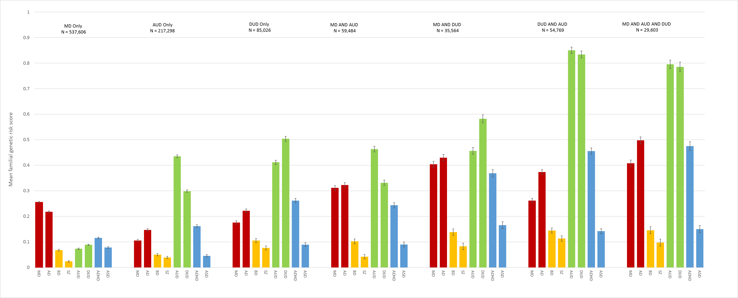
Table 3
Standardized FGRS Scores for All Affected and Unaffected Individuals by Disorders in Each of our 9 Groups of Affected Individuals Including FGRS Scores in those with One and Two Affected Parents

FGRS |  | MD | AD | BD | SZ | AUD | DUD | ADHD | ASD | OCD
MD | A | 0.275 | 0.254 | 0.283 | 0.057 | 0.188 | 0.272 | 0.378 | 0.263 | 0.276
 | B | 1.076 | 0.637 | 0.229 | 0.156 | 0.330 | 0.579 | 0.712 | 0.589 | 0.714
 | C | 2.133 | 1.108 | -0.003 | -0.374 | 0.497 | 0.649 | 0.988 | 1.183 | 0.664
 | D | -0.035 | -0.030 | -0.003 | 0.000 | -0.012 | -0.010 | -0.005 | -0.002 | -0.002
AD | A | 0.251 | 0.314 | 0.303 | 0.120 | 0.239 | 0.338 | 0.415 | 0.280 | 0.360
 | B | 0.579 | 1.259 | 0.640 | 0.555 | 0.428 | 0.813 | 0.868 | 0.741 | 1.100
 | C | 1.045 | 2.396 | 1.223 | 1.271 | 0.718 | 1.126 | 1.278 | 2.018 | 2.880
 | D | -0.032 | -0.037 | -0.004 | -0.001 | -0.016 | -0.012 | -0.006 | -0.002 | -0.002
BD | A | 0.078 | 0.088 | 0.551 | 0.167 | 0.081 | 0.127 | 0.165 | 0.199 | 0.109
 | B | 0.093 | 0.190 | 4.473 | 4.239 | 0.149 | 0.340 | 0.469 | 0.710 | 0.421
 | C | 0.092 | 0.357 | 8.611 | 9.682 | 0.228 | 0.387 | 0.707 | 0.774 | 0.095
 | D | -0.010 | -0.010 | -0.007 | -0.001 | -0.005 | -0.005 | -0.002 | -0.001 | -0.001
SZ | A | 0.032 | 0.047 | 0.145 | 0.616 | 0.055 | 0.090 | 0.082 | 0.239 | 0.092
 | B | 0.041 | 0.083 | 0.188 | 0.987 | 0.104 | 0.201 | 0.151 | 0.915 | 0.117
 | C | 0.064 | 0.159 | 0.138 | 1.616 | 0.191 | 0.412 | 0.093 | 2.532 | -0.206
 | D | -0.004 | -0.006 | -0.002 | -0.003 | -0.004 | -0.003 | -0.001 | -0.002 | -0.001
AUD | A | 0.161 | 0.200 | 0.244 | 0.185 | 0.532 | 0.592 | 0.484 | 0.200 | 0.121
 | B | 0.298 | 0.445 | 0.521 | 0.554 | 1.834 | 1.502 | 1.029 | 0.531 | 0.346
 | C | 0.534 | 0.840 | 0.777 | -0.429 | 3.472 | 2.497 | 1.620 | 1.662 | 1.382
 | D | -0.021 | -0.024 | -0.003 | -0.001 | -0.035 | -0.022 | -0.007 | -0.001 | -0.001
DUD | A | 0.168 | 0.206 | 0.260 | 0.168 | 0.425 | 0.646 | 0.551 | 0.234 | 0.143
 | B | 0.313 | 0.481 | 0.697 | 0.628 | 0.839 | 2.670 | 1.369 | 0.635 | 0.495
 | C | 0.549 | 0.963 | 1.647 | 1.116 | 1.748 | 4.689 | 2.552 | 2.270 | -0.267
 | D | -0.022 | -0.025 | -0.003 | -0.001 | -0.028 | -0.024 | -0.008 | -0.002 | -0.001
ADHD | A | 0.157 | 0.167 | 0.224 | 0.081 | 0.245 | 0.363 | 0.787 | 0.335 | 0.131
 | B | 0.243 | 0.301 | 0.419 | 0.233 | 0.420 | 0.770 | 2.832 | 1.093 | 0.233
 | C | 0.396 | 0.543 | 0.495 | -0.181 | 0.708 | 1.353 | 4.584 | 3.512 | -0.493
 | D | -0.020 | -0.020 | -0.003 | 0.000 | -0.016 | -0.013 | -0.011 | -0.002 | -0.001
ASD | A | 0.087 | 0.090 | 0.211 | 0.259 | 0.076 | 0.125 | 0.294 | 0.501 | 0.144
 | B | 0.123 | 0.143 | 0.642 | 0.970 | 0.138 | 0.257 | 0.720 | 6.175 | 0.449
 | C | 0.186 | 0.240 | 0.892 | 3.513 | 0.220 | 0.352 | 1.048 | 13.028 | -0.320
 | D | -0.011 | -0.011 | -0.003 | -0.001 | -0.005 | -0.005 | -0.004 | -0.003 | -0.001
OCD | A | 0.067 | 0.089 | 0.087 | 0.064 | 0.033 | 0.054 | 0.094 | 0.117 | 0.307
 | B | 0.119 | 0.188 | 0.189 | 0.323 | 0.054 | 0.131 | 0.176 | 0.358 | 6.388
 | C | 0.226 | 0.337 | 0.215 | -0.233 | 0.083 | 0.143 | 0.350 | 1.000 | 9.285
 | D | -0.009 | -0.011 | -0.001 | 0.000 | -0.002 | -0.002 | -0.001 | -0.001 | -0.002
- FGRS for those diagnosed with the column disorder
- FGRS for those diagnosed with column disorder and one parent with the disorder
- FGRS for those diagnosed with column disorder and two parents with the disorder
- FGRS for those without the disorder

Table 4
ORs for all of the Combinations of Our Disorders
 | AD | BD | SZ | AUD | DUD | ADHD | ASD | OCD
MD | 11. 2  (11.1; 11.3) | - | 1.5  (1.4; 1.5) | 2.9  (2.9; 2.9) | 3.8  (3.8; 3.9) | 5.1  (5.0; 5.1) | 3.5  (3.4; 3.5) | 6.5  (6.4; 6.7)
AD |  | 7.3  (7.1; 7.4) | 2.3  (2.3; 2.4) | 3.7  (3.7; 3.7) | 5.5  (5.4; 5.5) | 6.4  (6.3; 6.5) | 4.0  (3.9; 4.1) | 12.7  (12.4; 13.0)
BD |  |  | 15.0  (14.5; 15.6) | 5.0  (4.9; 5.0) | 8.2  (8.0; 8.3) | 11.1  (10.8; 11.3) | 15.0  (14.6; 15.5) | 6.7  (6.5; 7.0)
SZ |  |  |  | 4.0  (3.9; 4.1) | 9.0  (8.7; 9.3) | 2.9  (2.7; 3.2) | 63.2  (61.1; 65.3) | 7.5  (6.9; 8.0)
AUD |  |  |  |  | 18.9  (18.7; 19.1) | 7.9  (7.7; 8.0) | 3.2  (3.2; 3.3) | 2.7  (2.6; 2.8)
DUD |  |  |  |  |  | 11.0  (10.8; 11.1) | 4.6  (4.4; 4.7) | 3.1  (3.0; 3.2)
ADHD |  |  |  |  |  |  | 15.9  (15.5; 16.3) | 4.9  (4.7; 5.1)
ASD |  |  |  |  |  |  |  | 10.6  (10.1; 11.0)

Figure 2. MD-SZ
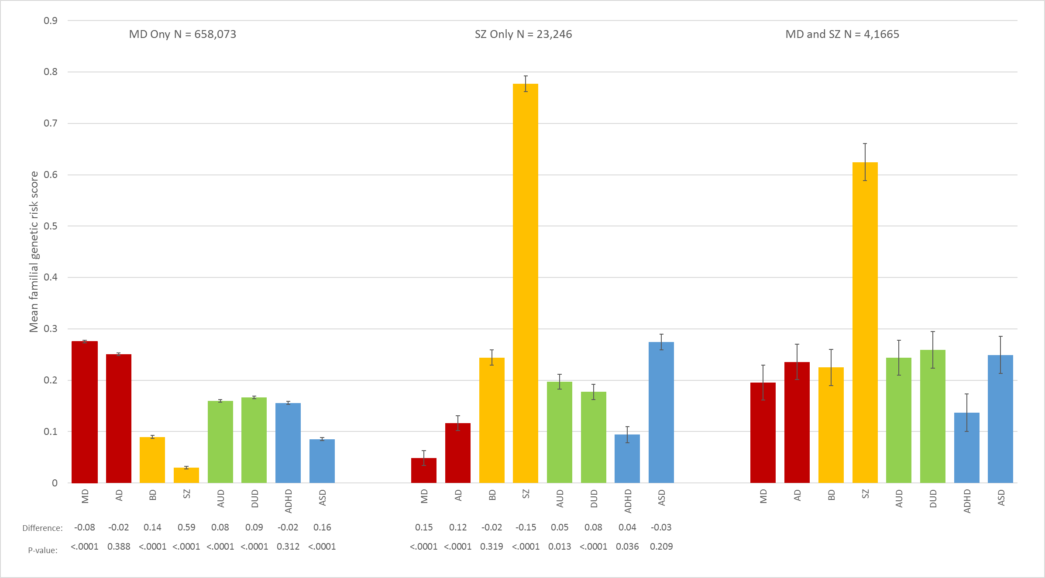

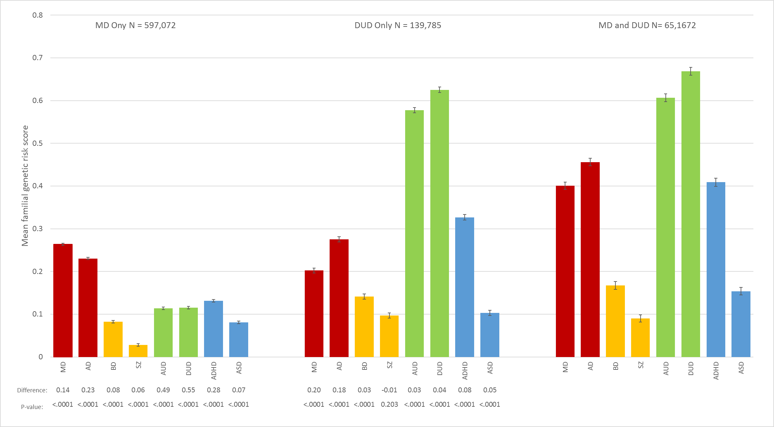
Figure 3. MD-DUD

Figure 4 MD-ADHD
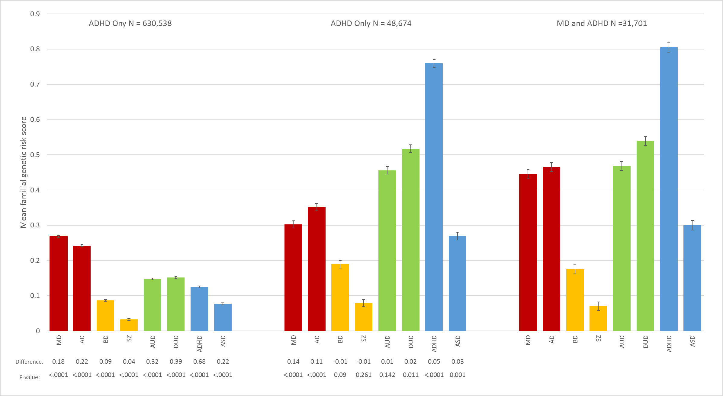
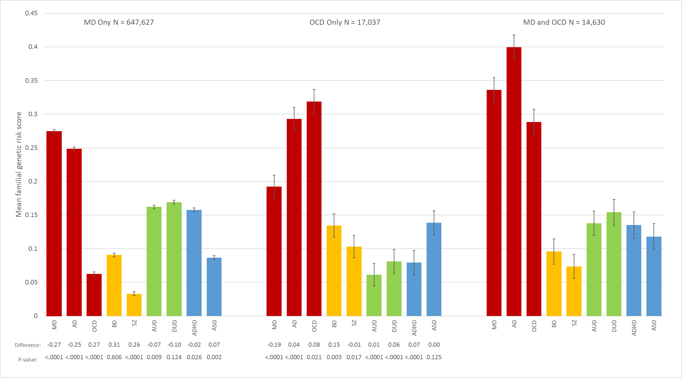
Figure 5 MD-OCD

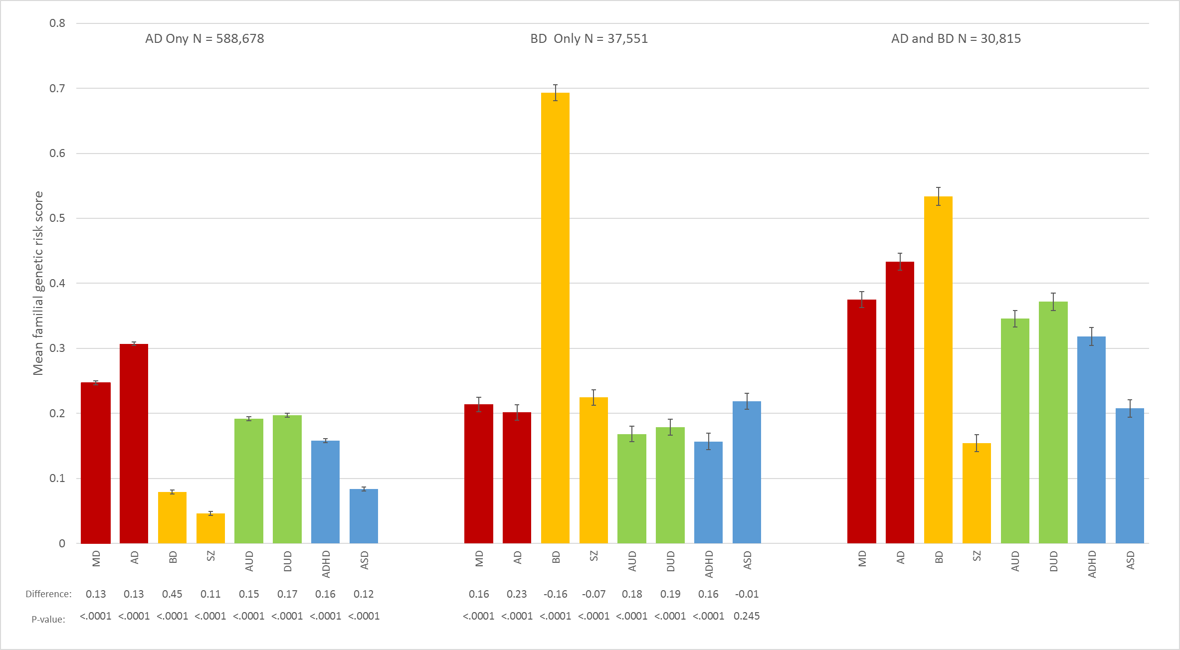
Figure 6 AD-BD

Figure 7 - AD-AUD
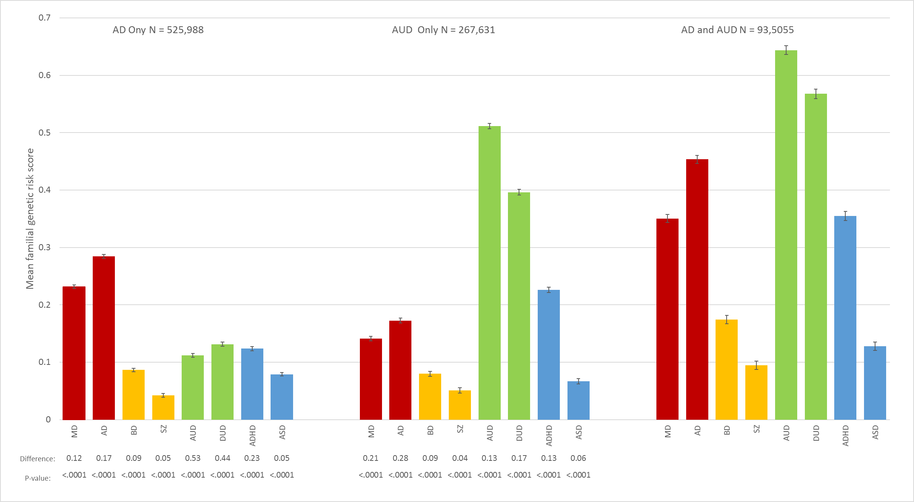
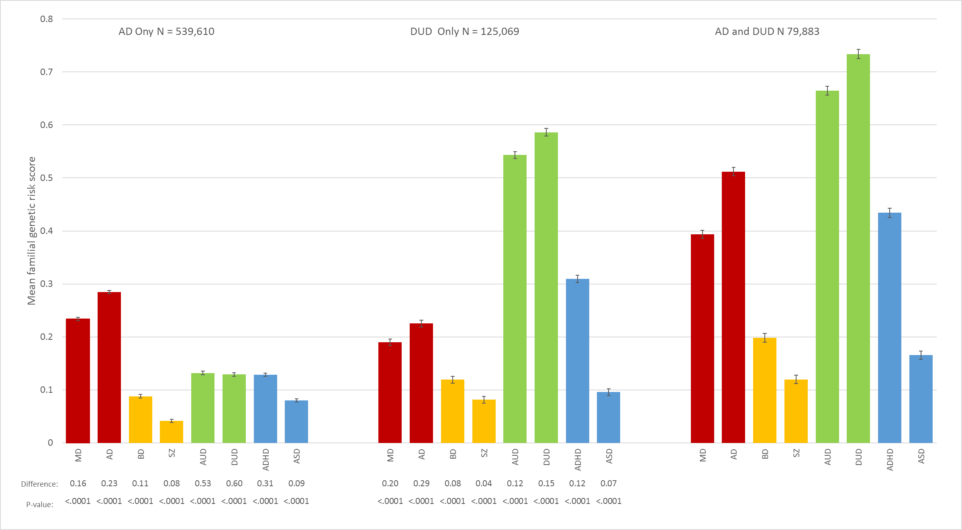
Figure 8 - AD-DUD

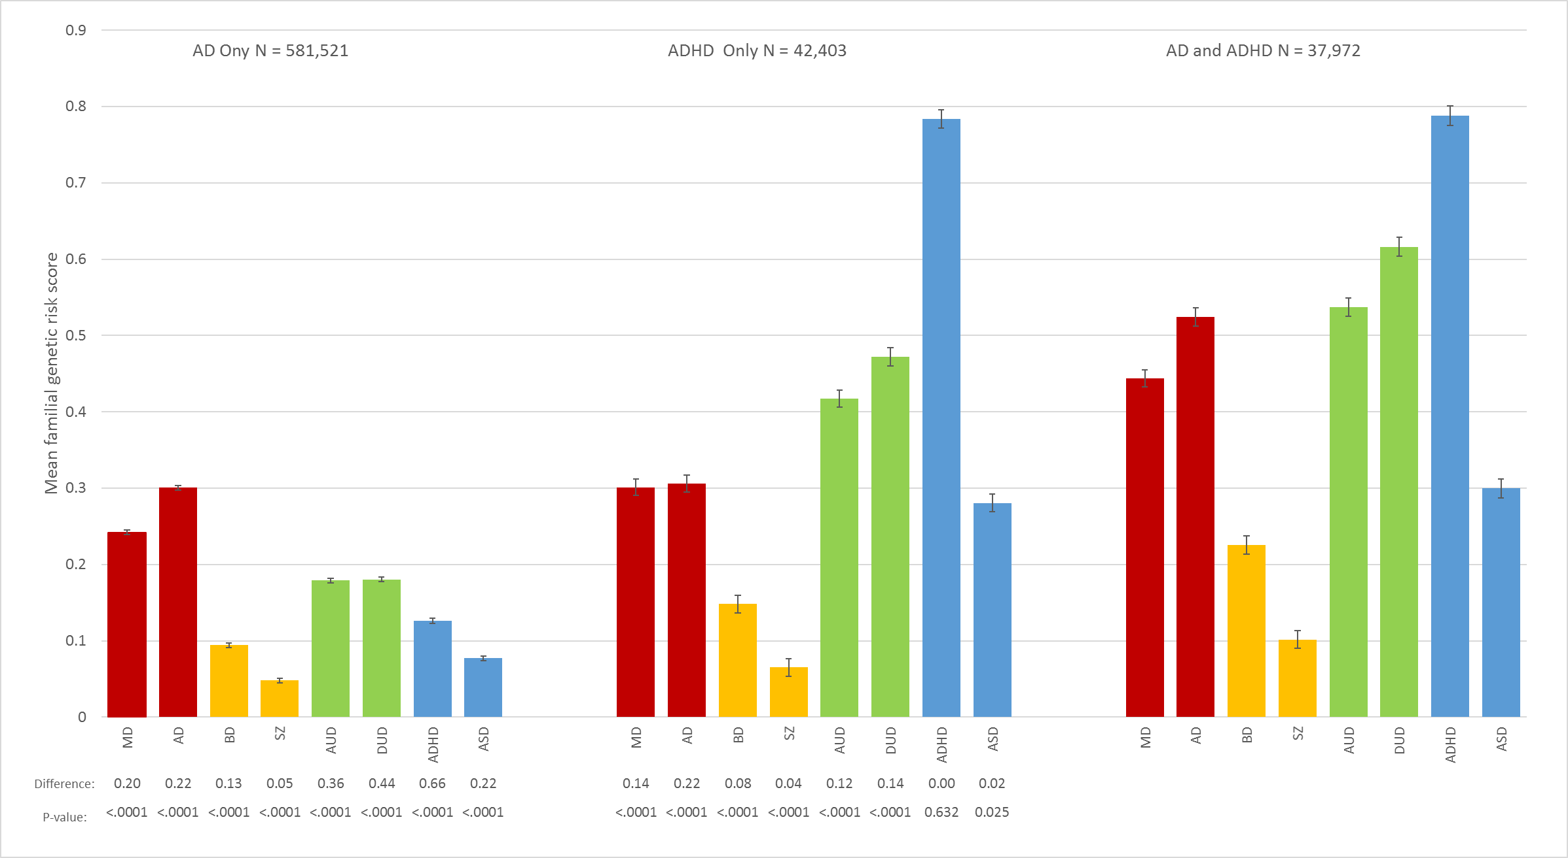
Figure 9 AD-ADHD

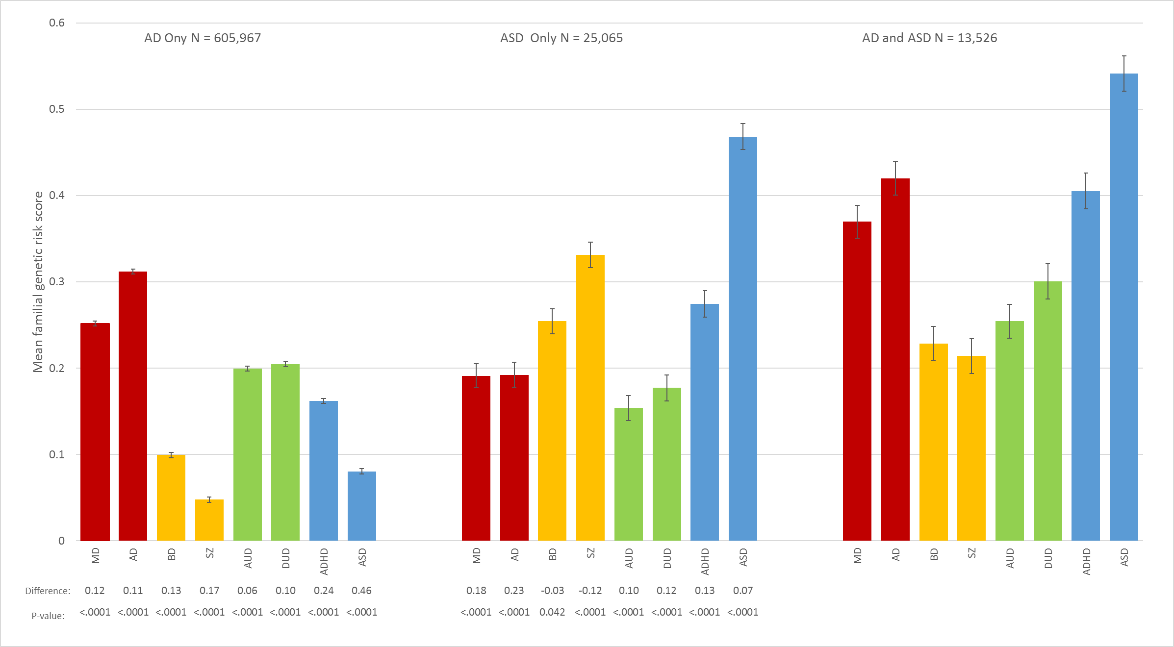
Figure 10 AD-ASD

Figure 11 - BD-SZ
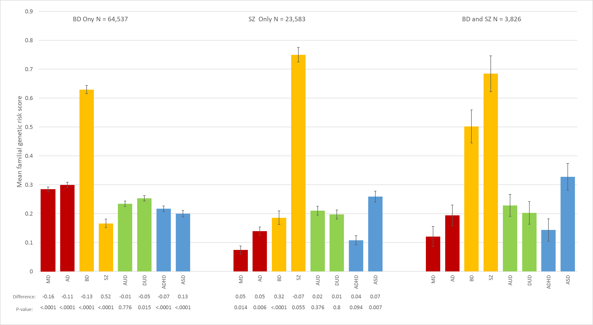
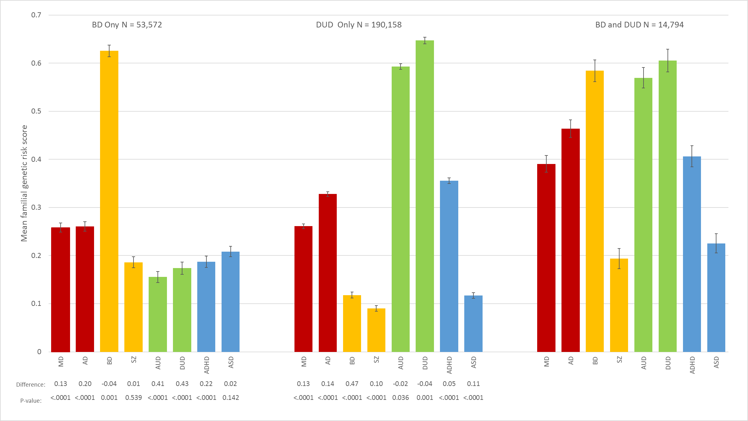
Figure 12 - BD-DUD

Figure 13 - BD-ADHD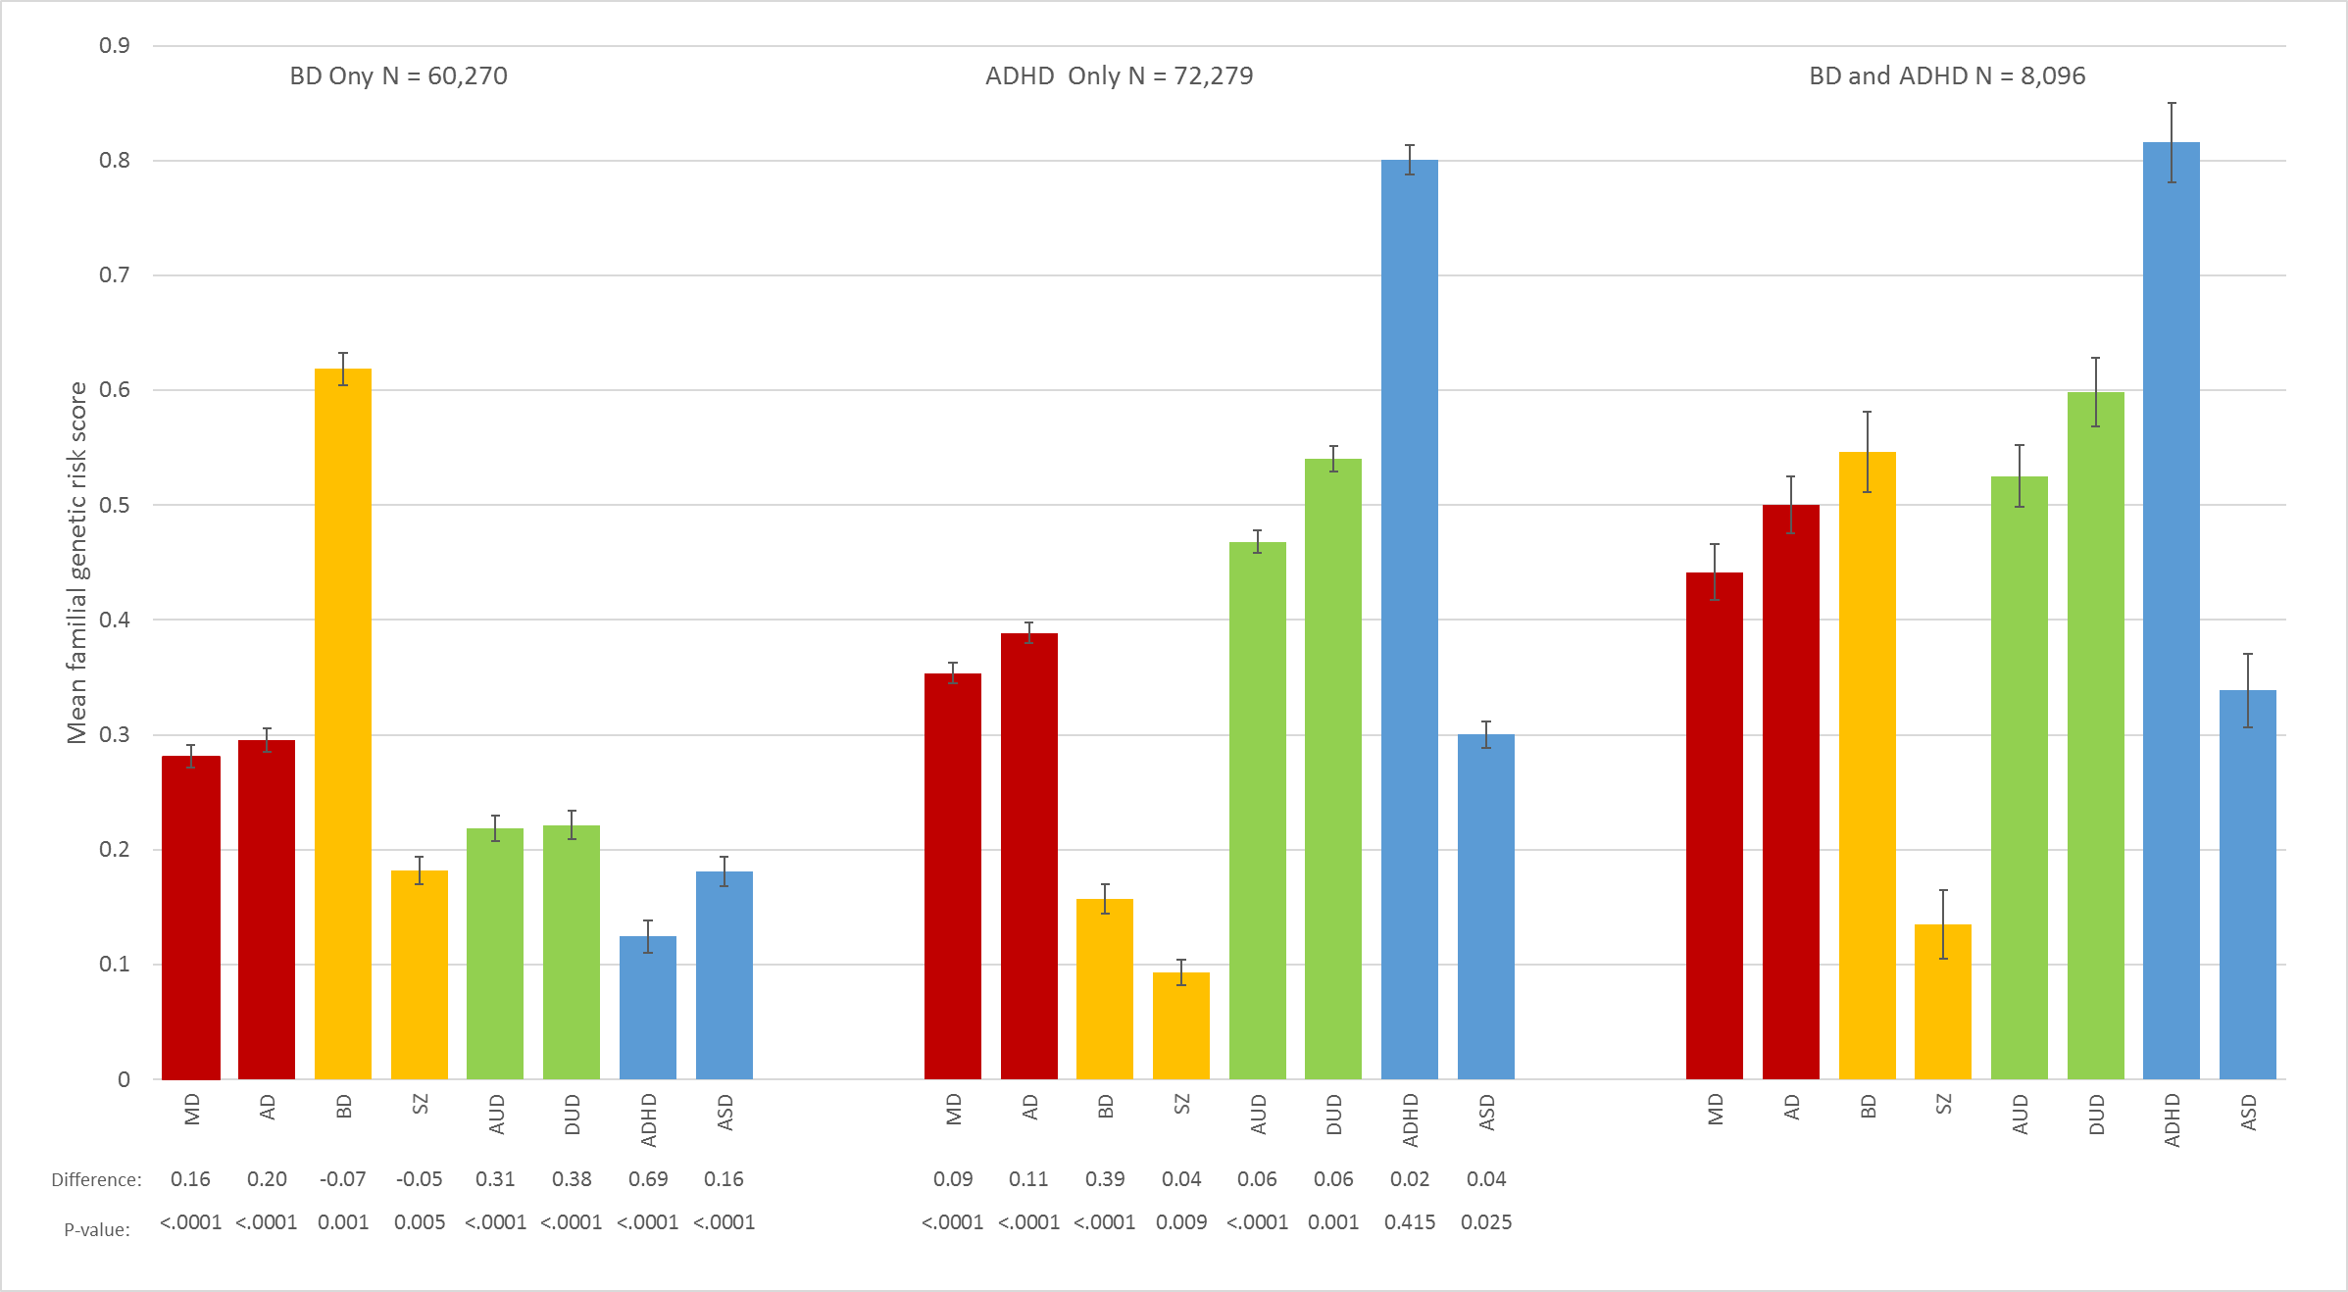

Figure 14 -BD-ASD
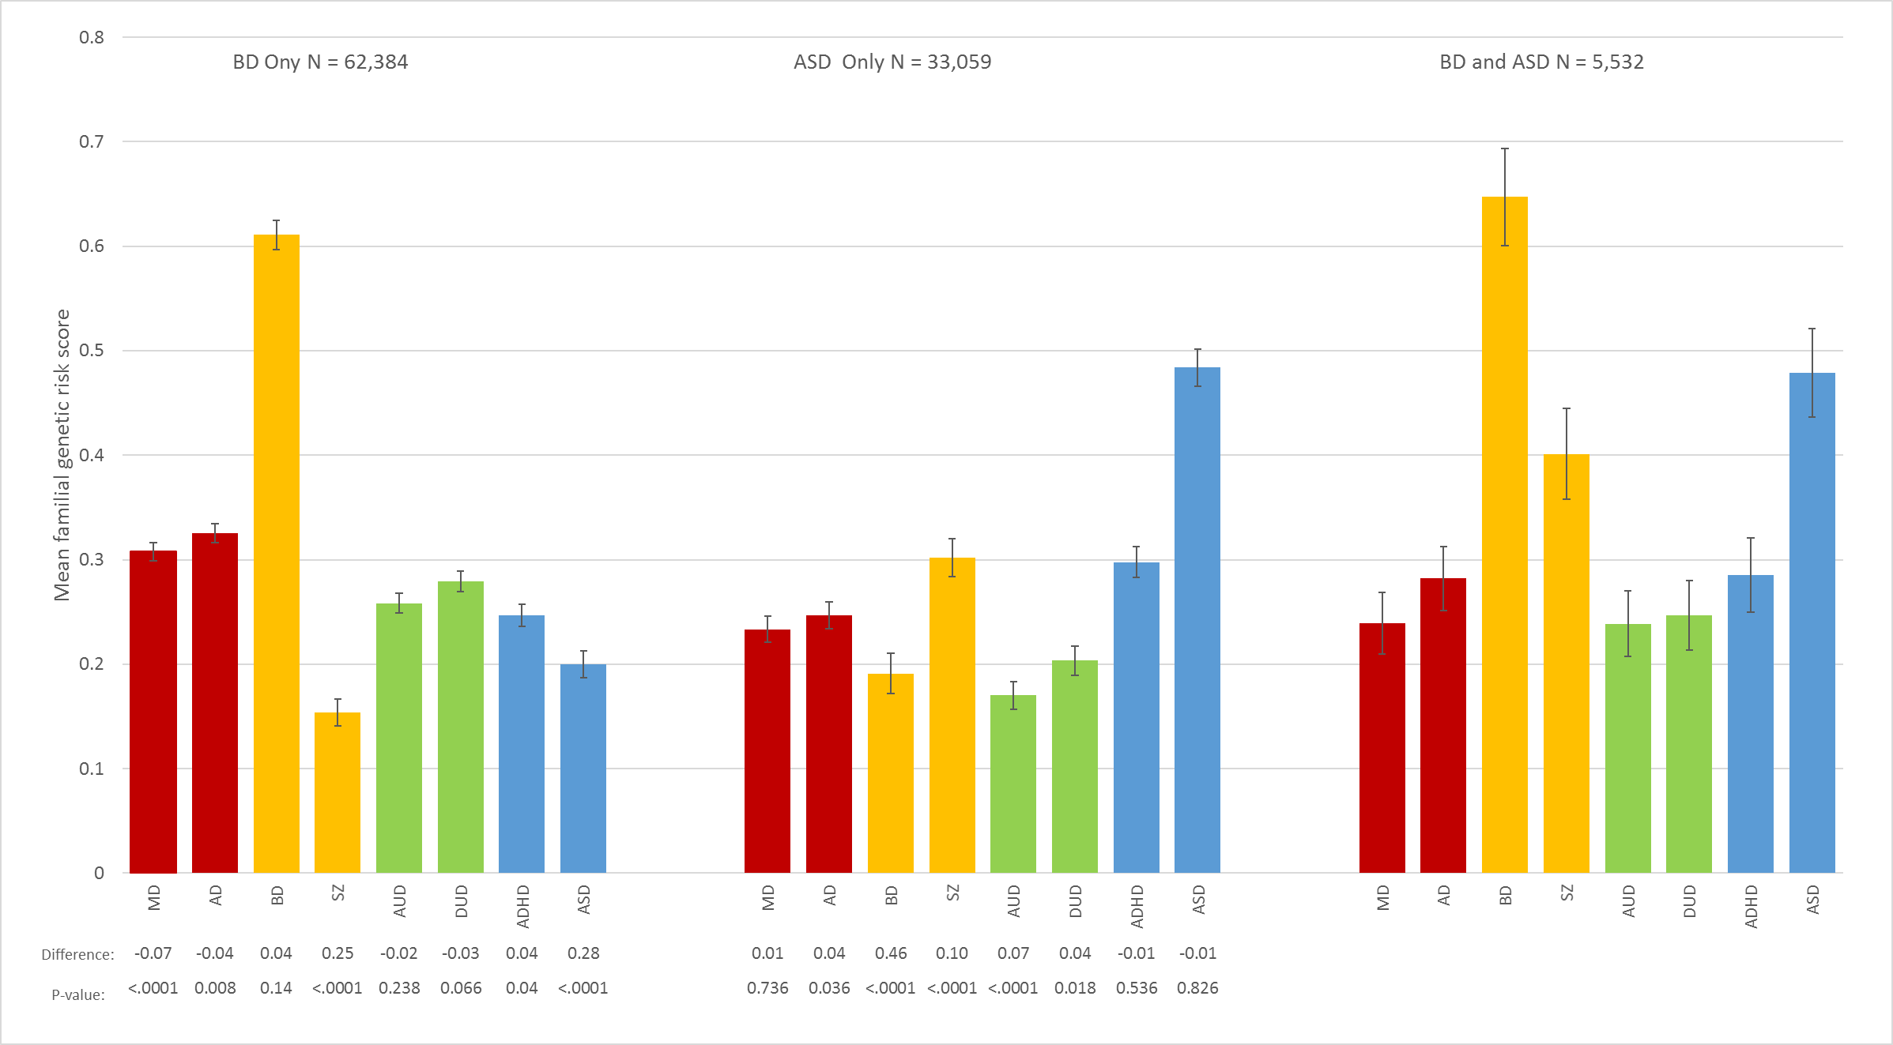
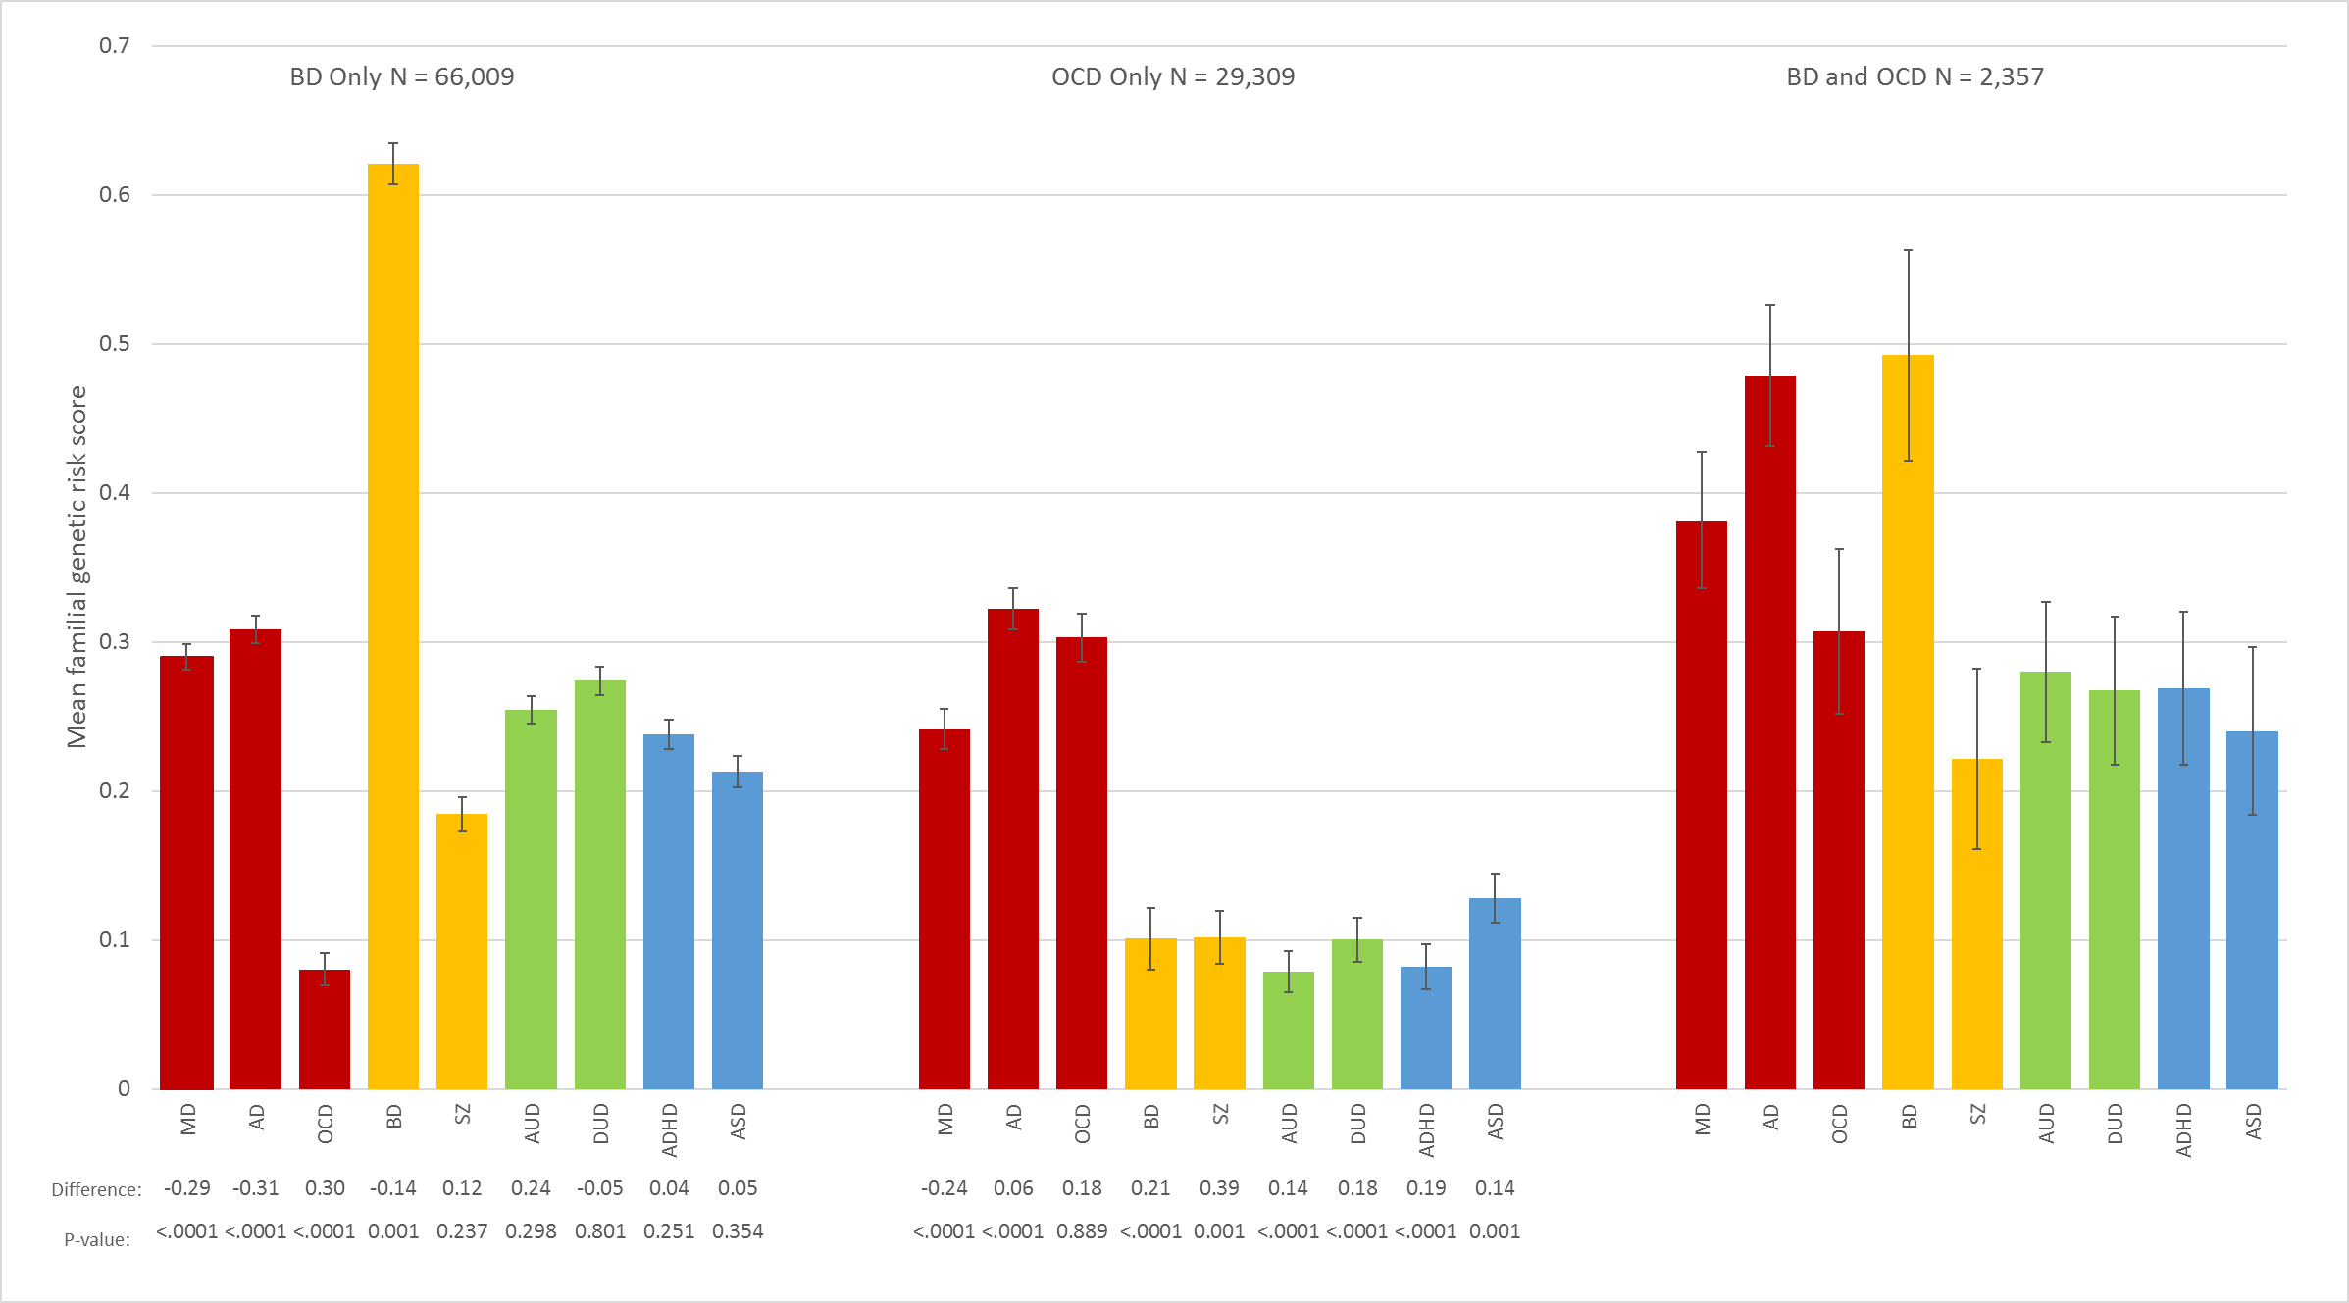
Figure 15 - BD-OCD

Figure 16 - SZ-AUD
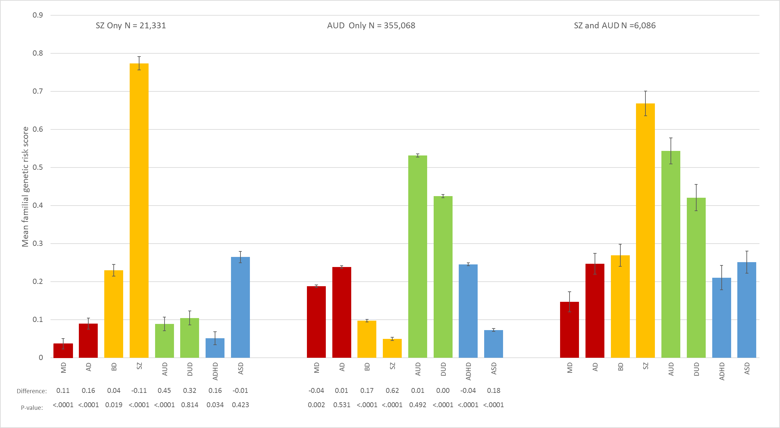

Figure 17 - SZ-ADHD
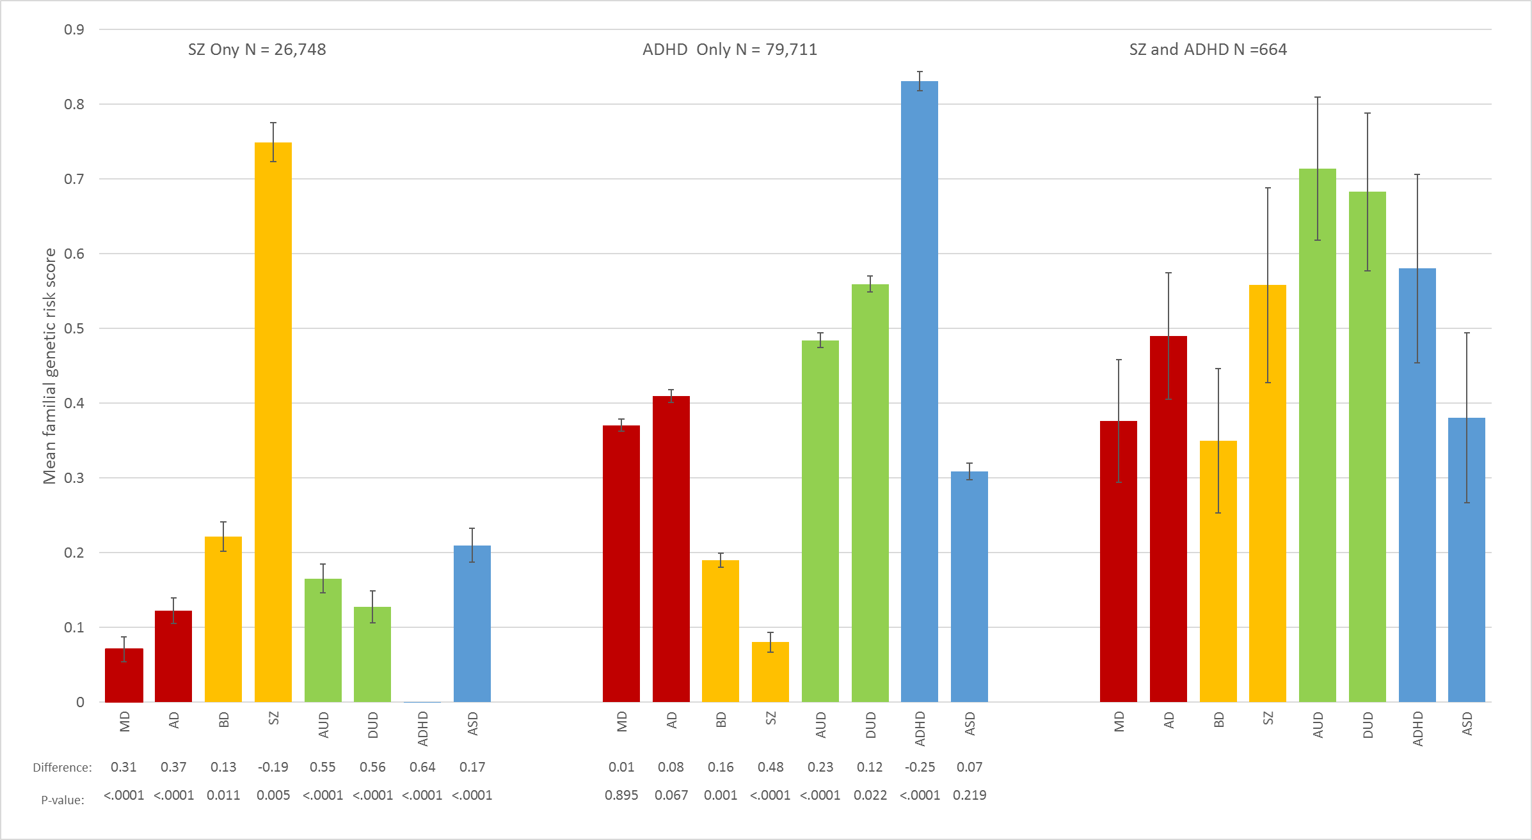

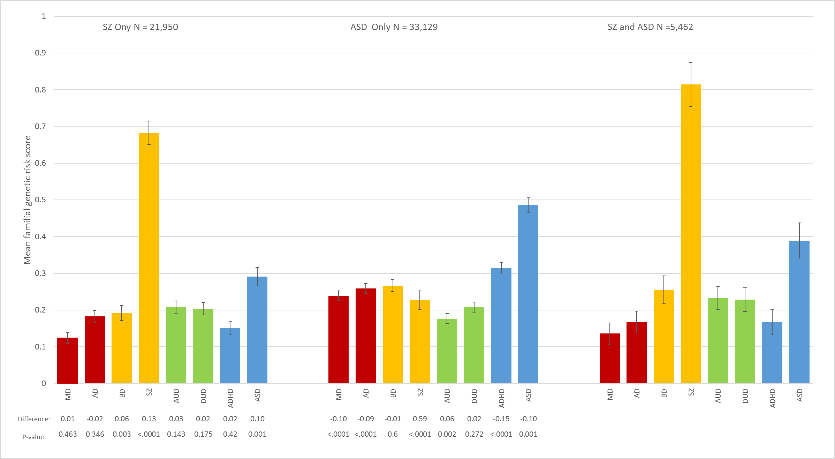
Figure 18 - SZ-ASD

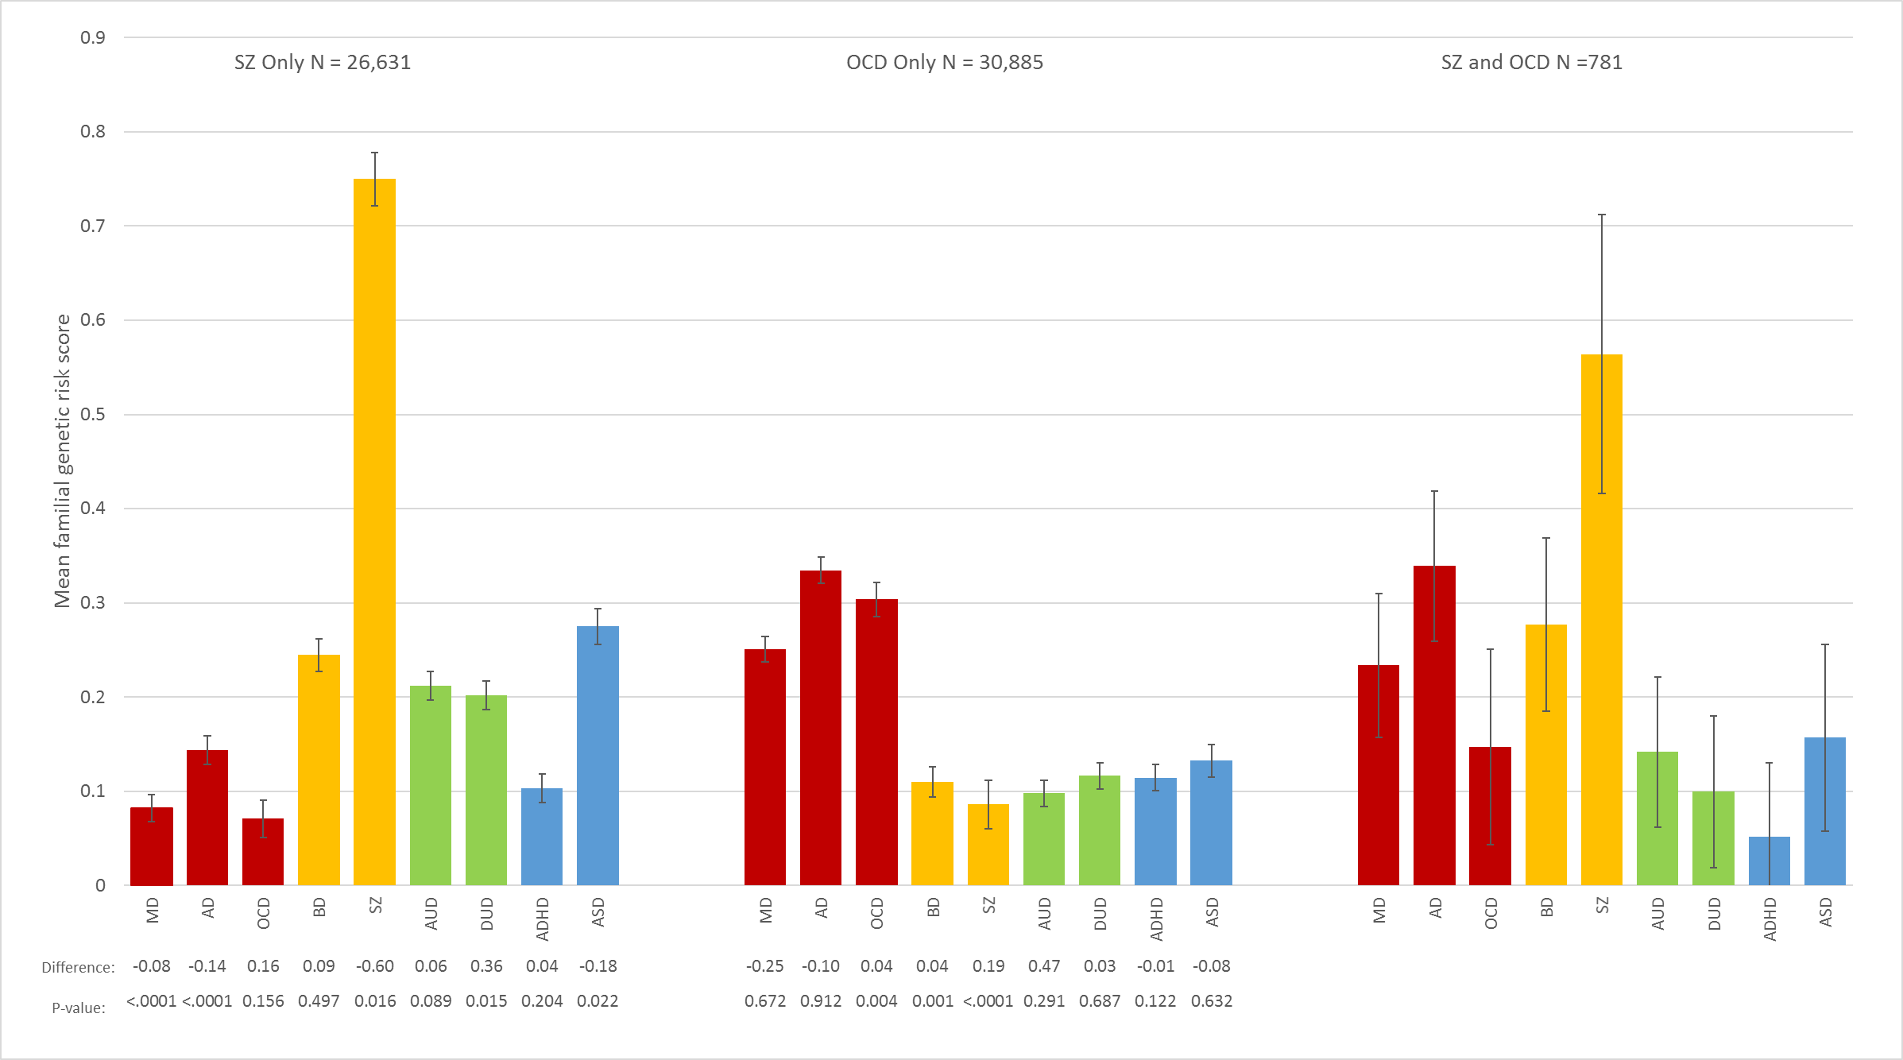
Figure 19 - SZ-OCD

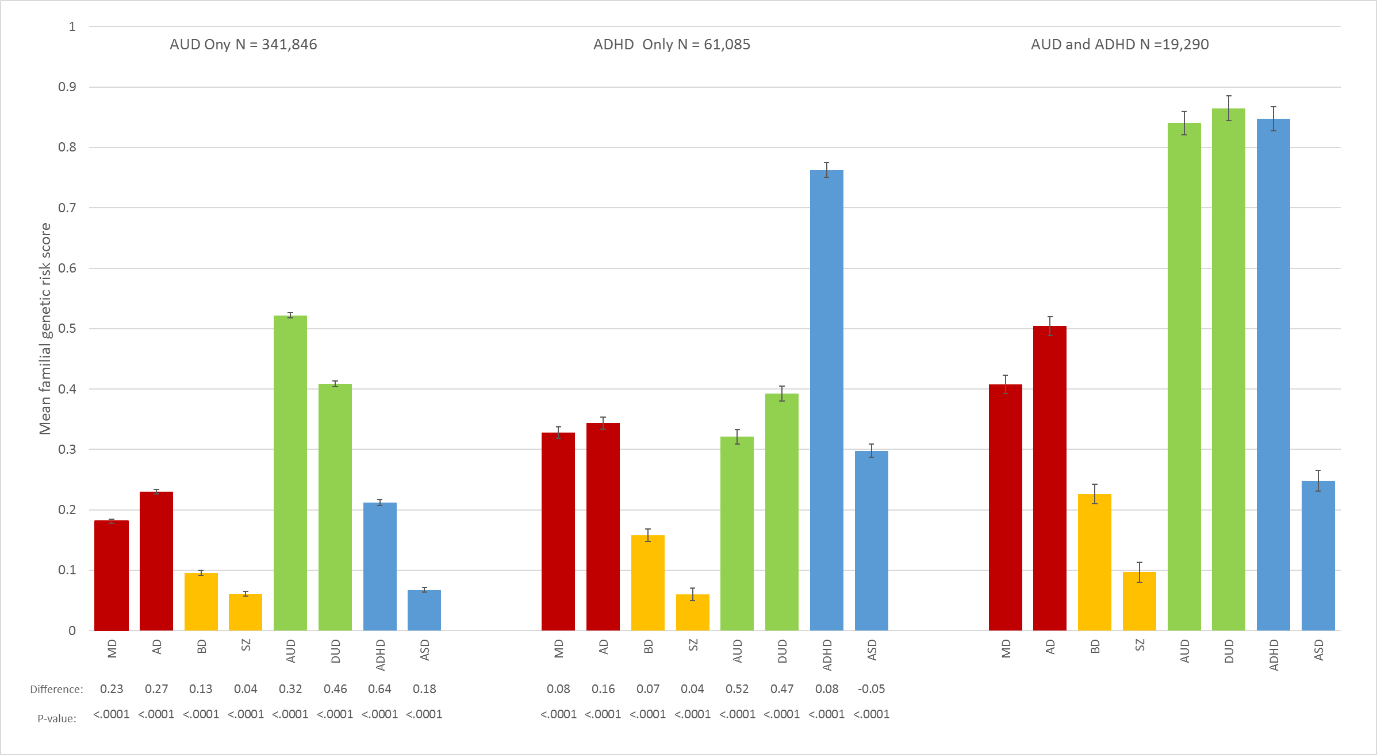
Figure 20 - AUD-ADHD

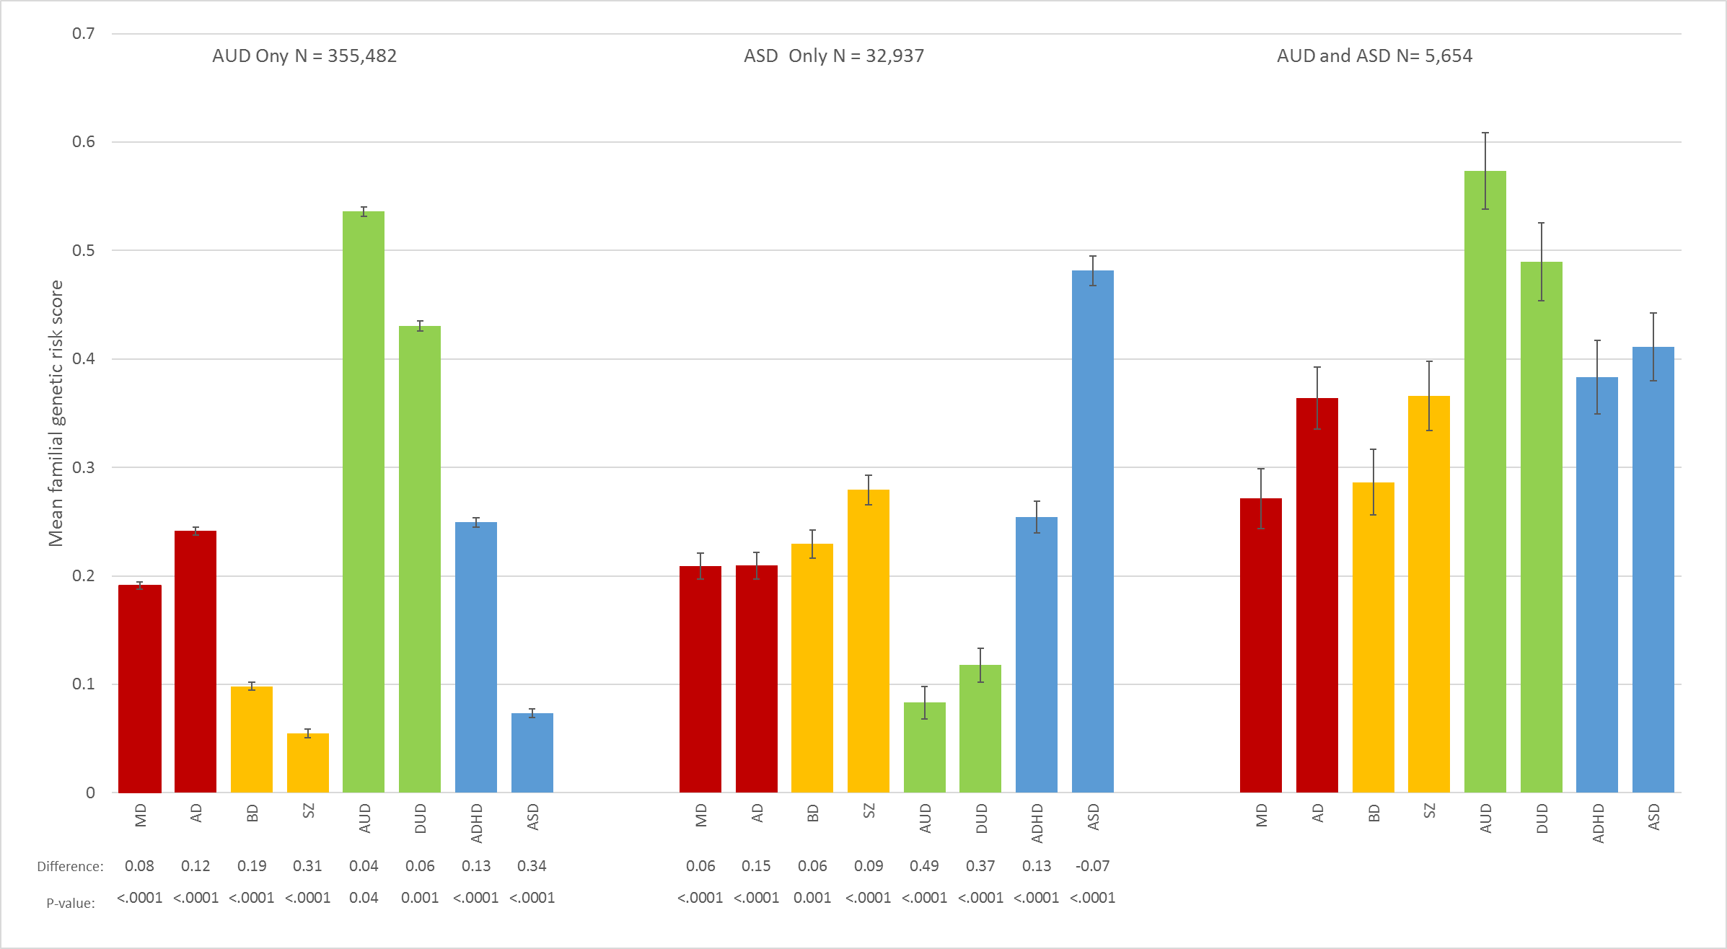
Figure 21 - AUD-ASD

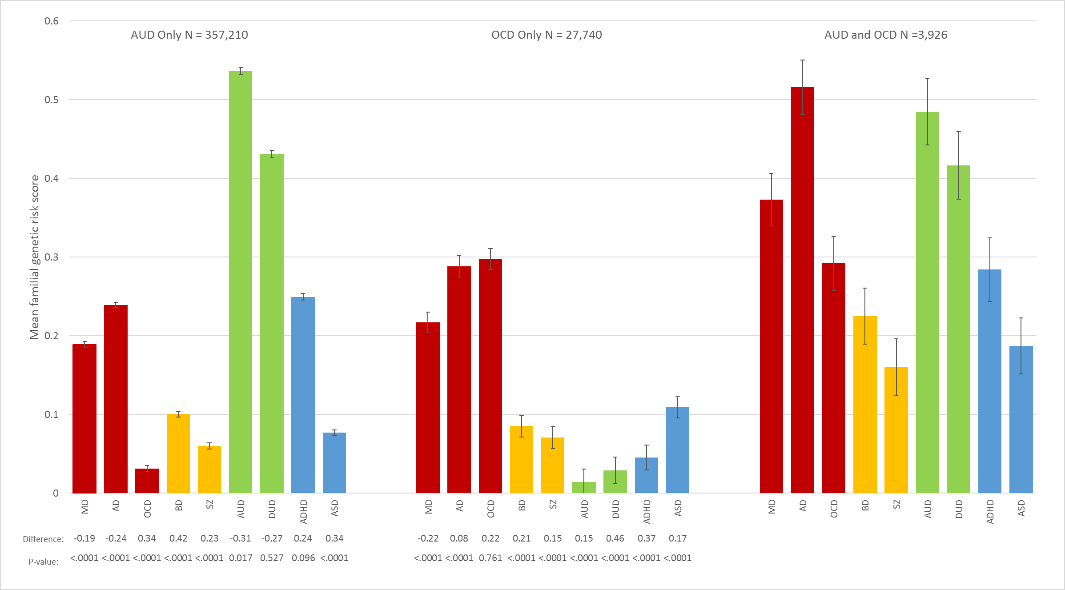
Figure 22 - AUD-OCD

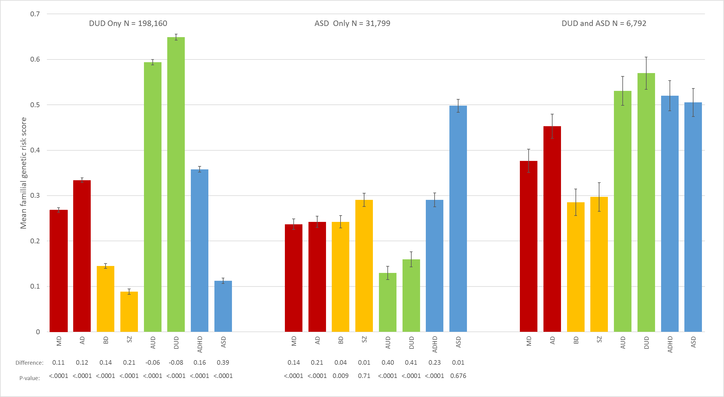
Figure 23 - DUD-ASD

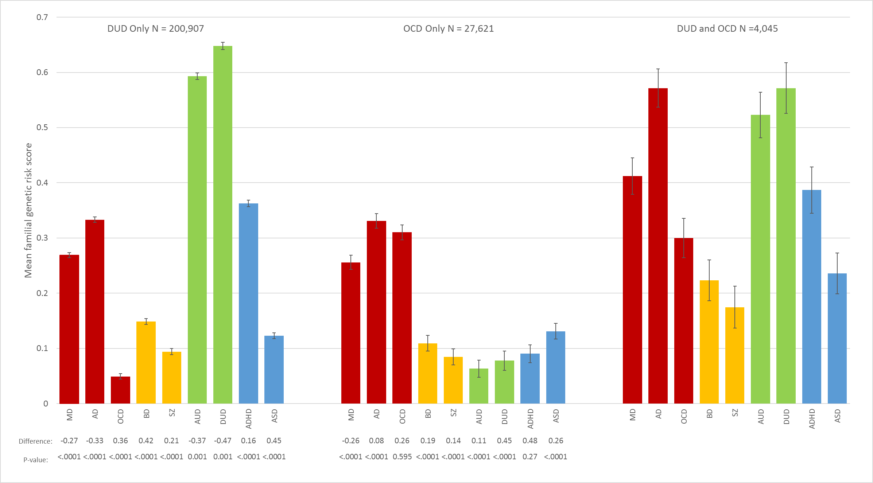
Figure 24 - DUD-OCD

Figure 25 - ADHD-OCD
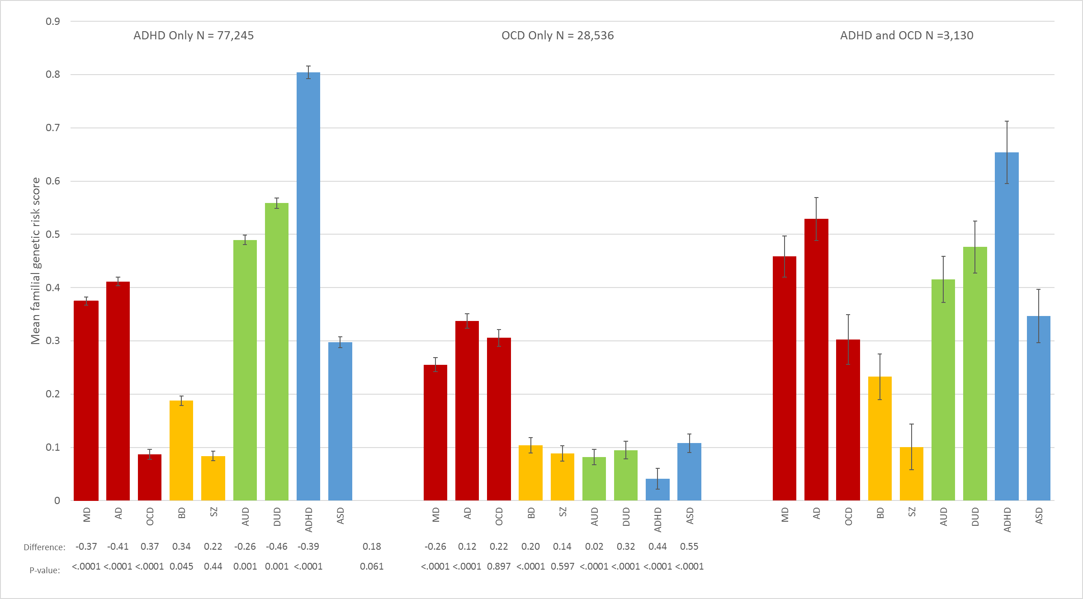
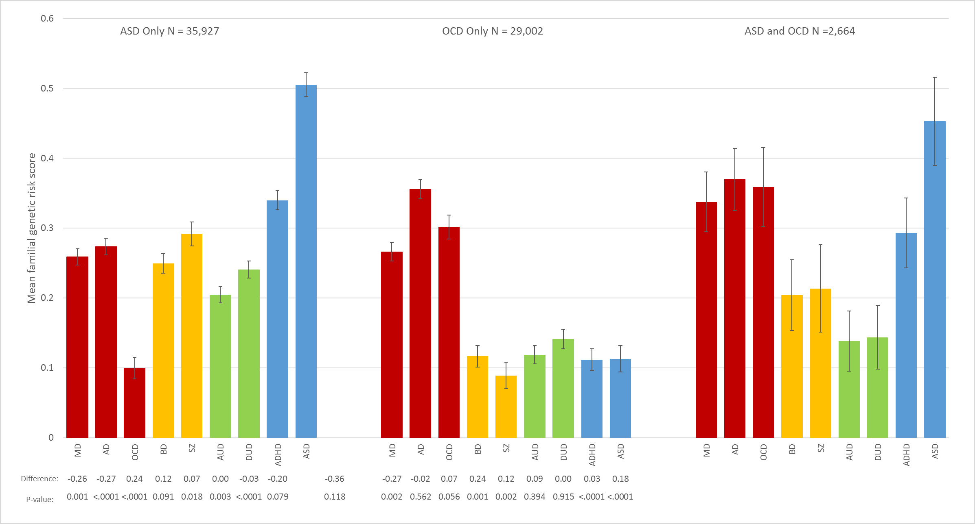
Figure 26 - ASD-OCD

