Supplementary material

Comparison with proband data
Data was available for 68 affected probands of the unaffected relatives included in this paper.
Of these patients, 39 (57%) were ‘emotionally preserved’, 14 (21%) ‘emotionally blunted’, and 15 (22%) ‘emotionally volatile’. These proportions are in line with our previous findings of 57% of patients with mood disorders being ‘emotionally preserved’, 26% ‘emotionally blunted’, and 17% ‘emotionally volatile’ (Varo et al., 2021).
Moreover, of the unaffected relatives categorised as ‘emotionally preserved’, 66% (n=25) of their affected probands were also categorised as ‘emotionally preserved’, whereas the remaining 34% presented with impaired emotional cognition (n=13; emotionally blunted n=5 and emotionally volatile n=8). Of the unaffected relatives categorised as ‘emotionally blunted’, 53% of their affected probands also presented with aberrant emotional cognition (n=16; emotionally blunted n=9 and emotionally volatile n=7), whereas the remaining 47% (n=14) were ‘emotionally preserved’.

Table S1. Measures of emotional cognition

Name | Abbreviation | Description
The Social Scenarios Task (Kjærstad et al., 2016) | SST | Emotion reactivity and regulation to positive and negative social scenarios
Facial Expression Recognition Task (Harmer, Shelley, Cowen, & Goodwin, 2004) | FERT | Recognition of six basic facial expressions: anger, disgust, fear, happiness, sadness, and surprise
Faces Dot-Probe Task (Murphy, Downham, Cowen, & Harmer, 2008) | Faces Dot-Probe | Attention allocation toward emotional stimuli

Table S2. Established neurocognitive tests (BIO-study) and matched SCIP subtests (NEAD-study) that make up calculated composite neurocognitive domains
Composite domain | BIO-study | NEAD-study
Attention and psychomotor speed | TMT-A, RBANS digit-symbol coding, RBANS digit-span-forward, RVP accuracy and mean latency | TMT-A, SCIP PST
Verbal learning | RAVLT trial I-V correct, trial VI correct, delayed recall, recognition | SCIP VLT-I, SCIP VLT-D
Working memory and executive function | TMT-B, WAIS letter-number sequencing, SWM between errors and strategy | TMT-B, SCIP WMT
Verbal fluency | Verbal fluency S and D | SCIP VLF
Abbreviations: TMT-A = Trail Making Test part A; RBANS = Repeatable Battery for the Assessment of Neuropsychological Status; RVP = Rapid Visual Processing (CANTAB); RAVLT = Rey Auditory Verbal Learning Test; TMT-B = Trail Making Test part B; WAIS = Weschler’s Adult Intelligence Scale; SWM = Spatial Working Memory (CANTAB), SCIP = Screen for Cognitive Impairment in Psychiatry, PST = Processing Speed Test; VLT-I = Verbal Learning Test - Immediate; VLT-D = Verbal Learning Test - Delayed, WMT = Working Memory Test; VLF = Verbal Fluency Test.

Table S3. Measure of functioning

Name | Abbreviation | Description
Functioning Assessment Short Test  (Rosa et al., 2007) | FAST | Domains
 |  | Autonomy
 |  | Capacity of the patient of doing things alone and take his/her own decisions
 |  | Occupational functioning
 |  | Capacity to maintain a paid job, efficiency of performing tasks at work, working in the field in which the patient was educated and earning according to the level of the employment position
 |  | Cognitive functioning
 |  | Ability to concentrate, perform simple mental calculations, solve problems, learn new information and remember learned information
 |  | Financial issues
 |  | Capacity of managing the finances and spending in a balanced way
 |  | Interpersonal relationships
 |  | Relations with friends, family, involvement in social activities, sexual relations and the ability to defend ideas and opinions
 |  | Leisure Time
 |  | Capacity of performing physical activities (sport, exercise) and the enjoyment of hobbies
 |  | Total Fast
 |  | Rates of psychosocial functional impairment

Table S4. Emotional cognition variables for unaffected first-degree relatives in the BIO-study (n=51) and the NEAD-study (n=43)
 | BIO-study | NEAD-study | t | p-value
 | M (SD) | M (SD)
Social Scenarios Task
Negative reactivity | 0.06 (0.92) | 0.31 (0.90) | -1.29 | 0.20
Positive reactivity | -0.07 (1.16) | 0.14 (0.91) | -0.97 | 0.33
Dampen negative | 0.12 (1.07) | 0.61 (1.18) | -2.09 | 0.04
Dampen positive | -0.10 (1.15) | 0.39 (0.88) | -2.28 | 0.03
Facial Expression Recognition Task, Discrimination accuracy
Negative emotions | -0.24 (0.94) | -0.32 (1.10) | 0.36 | 0.72
Positive emotions | -0.08 (0.86) | -0.25 (1.12) | 0.79 | 0.43
Facial Expression Recognition Task, ms
Negative emotions | 0.08 (0.84) | -0.38 (1.01) | 2.40 | 0.02
Positive emotions | 0.10 (0.77) | -0.21 (0.80) | 1.90 | 0.06
Facial Dot-Probe, Median vigilance scores
Masked fear | 0.22 (1.08) | -0.24 (1.12) | 2.02 | 0.047
Masked happy | -0.15 (0.88) | -0.06 (1.07) | -0.48 | 0.63
Unmasked fear | 0.13 (0.89) | -0.03 (1.10) | 0.80 | 0.43
Unmasked happy | -0.17 (0.72) | -0.00 (0.74) | -1.12 | 0.26

Figure S1. Dendrogram
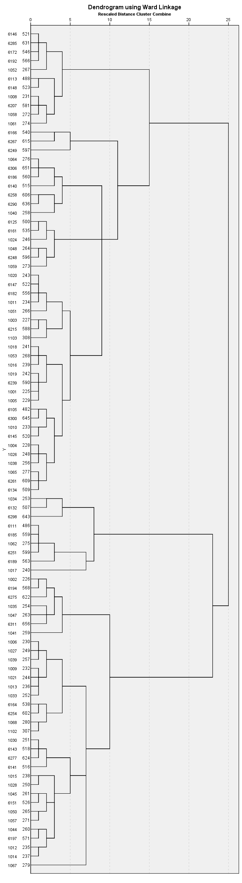

Figure S2. (a) Agglomeration schedule and (b) scree plot of coefficients by stage
