Supplementary Material
Supplementary Table S1. Conversion values of educational levels.
Conversion values of the highest achieved and completed educational level
Educational level (CASH-III) | Years of education
None | 0
Primary school | 6
Lower secondary education/domestic science school | 10
Middle general secondary vocational education | 10
Higher general secondary education | 11
Pre-university education | 12
Community college/intermediate vocational education | 14
Higher vocational education | 15
Academic education | 17
CASH-III, Comprehensive Assessment of Symptoms and History part III Andreasen et al., 1992)

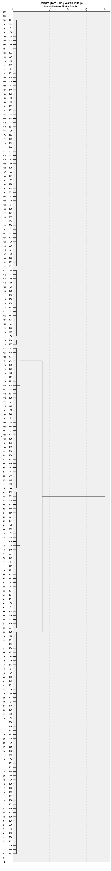
Supplementary Figure S1. Dendrogram Hierarchical Clustering Analysis using Ward’s Method

Supplementary Figure S2. Agglomeration schedule coefficients Hierarchical Clustering Analysis using Ward’s Method
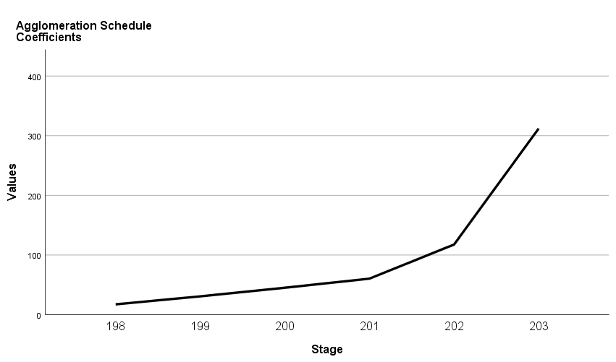

Supplementary Table S2. Mean (SD) baseline demographic, cognitive and clinical characteristics for FEP patients and healthy controls
 | FEP patients (n=204) | Healthy controls (n=40) | Test statistic  F, χ2 | df | p-value
Male, n (%) | 148 (72.5%) | 32 (80.0%) | χ2 = 0.96 | 1 | p = 0.327
Age | 27.93 (8.90) | 24.48 (4.98) | F = 5.67 | 1 | p = 0.018
Years of education | 13.77 (2.53) | 14.95 (1.95) | F = 7.71 | 1 | p = 0.006
Years of education parents | 12.84 (3.30) | 13.63 (2.20) | F = 2.06 | 1 | p = 0.153
Chlorpromazine equivalent | 238.67 (137.68) | N.A. | N.A. | N.A. | N.A.
BACS, Z-score
Composite score | -1.44 (1.24) | 0.13 (1.15) | F = 54.34 | 1 | p < 0.001
Verbal memory | -0.70 (1.08) | 0.43 (1.01) | F = 37.29 | 1 | p < 0.001
Working memory | -0.95 (1.20) | 0.07 (1.05) | F = 25.23 | 1 | p < 0.001
Motor speed | -0.95 (1.37) | -0.15 (0.96) | F = 12.17 | 1 | p = 0.001
Verbal fluency | -1.06 (1.16) | 0.11 (1.05) | F = 35.05 | 1 | p < 0.001
Attention & Processing speed | -1.32 (0.90) | -0.23 (1.19) | F = 42.77 | 1 | p < 0.001
Executive function | -0.17 (1.25) | 0.24 (0.87) | F = 3.98 | 1 | p = 0.047
PANSS
Total | 44.24 (10.06) | N.A. | N.A. | N.A. | N.A.
Positive | 9.34 (2.74) | N.A. | N.A. | N.A. | N.A.
Negative | 11.84 (4.32) | N.A. | N.A. | N.A. | N.A.
General | 23.05 (5.22) | N.A. | N.A. | N.A. | N.A.
FEP=first episode psychosis; PANSS=Positive and Negative Syndrome Scale; BACS=Brief Assessment of Cognition in Schizophrenia;

